**Engineering Professions Department**

**Computer Systems Engineering**

**Android-Arduino Platform for Detecting and Monitoring Obstructive Sleep Apnea (OSA)**

Prepared by:

Amjad Abu Jedyan  
1649011023  
Mohammed Altubji

1649011022

Supervised by:

Dr. Ezzaldeen Edwan

A Graduation Project Proposal Submitted to the Engineering professions Department in partial fulfillment of the requirement of Bachelor of Science in Computer Systems Engineering.

Palestine, Gaza

2020-2021

Table of Contents

Abstract 4

1. Introduction 5

1.1 Problem Statement 6

1.2 Objectives 7

**1.2.1** **Main objective** 7

**1.2.2** **Specific objectives** 7

1.3 Importance of the project 7

1.4 Scope and limitations of the project 7

2. State of the art/review of related works 8

3. Methodology 9

3.1 Theories and Methods 9

3.2 Software Tools and Equipment Requirements 10

**3.2.1** **Software Tools** 10

**3.2.2** **Equipment Requirements** 11

3.3 Time Table 13

4. Expected Outcome/ Deliverables 14

5. Bibliography 15

Table of Figures

Figure 3. 1: Implementation process flowchart 10

Figure 3. 2: Arduino Uno 11

Figure 3. 3: Bluetooth Module 11

Figure 3. 4: MPU6050 IMU 12

Figure 3. 5: Gantt chart 13

# Abstract

Obstructive sleep apnea (OSA) is a sleep disorder in which breathing stops due to repeated obstruction of the upper airway during sleep. This serious medical condition leads to serious health problems. It causes a sudden drop in the oxygen level in the blood, which leads to high blood pressure, which is a risk factor for multiple cardiovascular and cerebrovascular diseases. One of the most common diagnostic methods for sleep disorders is a polysomnogram (PSG) generally by recording physiological signals such as: (brain waves, blood oxygen level, heart rate, and breathing) in a hospital's sleep laboratory. This work provides an accurate system for detecting and monitoring obstructive sleep apnea (OSA) at home by analyzing the accelerometer and gyroscope readings obtained with the MPU6050 segment. Our objectives are to develop an algorithm to detect chest movement caused by respiratory distress and to determine the position of the sleeping person by the accelerometer and gyroscope. The method could be an alternative to polysomnography (PSG) by developing an app that makes it easier for the user to know his vital signs while sleeping.

# Introduction

Sleep is one of the most important daily aspects of human health. Not getting enough sleep on a daily basis results in health complications such as (mental disorders, fatigue, cardiovascular disease).

One of the main problems is Obstructive sleep apnea (OSA) is a sleep disorder in which breathing stops due to repeated obstruction of the upper airway during sleep. Estimated 22 million Americans suffer from sleep apnea, with the vast majority of cases still undiagnosed. Some statistics on sleep apnea mortality estimate that at least 38,000 people die annually from heart disease directly complicated by sleep apnea. Moreover, most patients it remains undiagnosed and untreated. This issue, side by side With a higher prevalence of obstructive sleep apnea, which is estimated to affect between 9% and 38% of the total population, makes OSA is a huge public health burden.

Untreated, this sleep disorder can cause high blood pressure and other cardiovascular disease, memory problems, weight gain, impotence, and headaches. A definitive diagnosis of sleep apnea can be made only with a sleep study conducted during a visit to a sleep lab, usually overnight, or a home study performed with special equipment.

Polysomnography (PSG) is a comprehensive test used to diagnose sleep disorders. Polysomnography records your brain waves, the oxygen level in your blood, heart rate and breathing, as well as eye and leg movements during the study, may be done at a sleep disorders unit within a hospital or at a sleep center's has some important limitations, Moreover, OSA diagnosis is usually performed with a one-night sleep assessment, which does not account for the variability of sleep performance in the patient. The reproducibility of PSG tests with regard to a patient’s regular sleep performance is also low because the patient is not sleeping in his or her regular bed at home, but rather in a hospital sleep lab. The equipment the patient must be connected to in order to collect data, such as masks or electrodes, also reduces sleep comfort. All these limitations affect sleep performance assessment and diagnose of OSA. There are multiple treatments for OSA with different degrees of clinical impact. The most invasive methods consist of surgery to modify the air pathway and resolve the cause of the obstruction. Less invasive therapies include devices that aim to unblock the air pathways by regulating air pressure, such as continuous positive air pressure (CPAP) machines. The least invasive methods are based on behavioral therapy, including weight control with specific diet strategies and sleep positional therapy.

The main goal is to design and develop an accurate system to detect and monitor obstructive sleep apnea (OSA) at home by analyzing the accelerometer and gyroscope readings attached to a chest strap. Our objectives were: (1) to conclude and develop an algorithm to detect chest movement caused by respiratory distress. (2) Determine the position of the sleeping person by the accelerometer and gyroscope. (3) The method could be an alternative to polysomnography (PSG). (4) Provide an interface that makes it easier for the user to know his vital signs while he is sleeping.

## Problem Statement

It is difficult for anyone to undergo a PSG test because of its high cost because it requires a lot of equipment and qualified medical staff to analyze the signals and diagnose the patient and thus it will not be readily available to all patients. The accuracy of the examination is not good because it is performed for one night only and because of the difference The patient's sleep environment and the large number of equipment that is connected to the patient to take data work on the patient's discomfort during sleep and thus incorrect readings. In this project, we design and develop an accurate system to detect and monitor Obstructive Sleep Apnea (OSA) at home by analyzing scale readings Accelerometer and gyroscope attached to the chest strap. Thus it is available for all patients to use at home at a low cost compared to (PSG) and with almost the same results.

## Objectives

### **Main objective**

The main goal is to design and develop an accurate system to detect and monitor obstructive sleep apnea (OSA) at home by analyzing the accelerometer and gyroscope readings attached to a chest strap.

### **Specific objectives**

1. To conclude and develop an algorithm to detect chest movement caused by respiratory distress.
2. Determine the position of the sleeping person by the accelerometer and gyroscope.
3. The method could be an alternative to polysomnography (PSG).
4. Provide an interface that makes it easier for the user to know his vital signs while he is sleeping.

## Importance of the project

Maintaining general health by monitoring sleep in order to reduce the problems caused by OSA easily at home without the need to go to the hospital and thus try to treat it early without complications.

## Scope and limitations of the project

Obtaining a home examination for OSA using an accelerometer and gyroscope to determine the respiratory rate and dispensing with the PSG test that should be done in the hospital. Moreover, our project cannot measure diseases or other symptoms resulting from OSA.

# State of the art/review of related works

In recent years, there are previous studies that are considered a major reference in this field, including what used the accelerometer to estimate the signals of breathing or flow during sleep and other studies that used sound signals to measure breathing and snoring, and also other studies that used pulse oximetry to estimate the severity of apnea. Here we describe recent contributions. Bucklin et al. [1] worked on developing an algorithm based on the MEMS accelerometer to check sleep apnea and ease of implementation on a microprocessor. Yao et al. [2] designed a system that relies on a three-axis accelerometer installed on the chest to monitor the position of the body during sleep by calculating the angles between the gravitational vector and its three axes. The system is driven by an inexpensive, low-power microcontroller. Some works combined a microphone and an accelerometer for developing a portable Android monitoring system [3] , [4]. Srividya et al. [5] developed an algorithm to detect sleep apnea by installing a breathing sensor placed on the nostrils of the patient, and the position is determined by the accelerometer sensor. Wu et al. [6] designed and developed a portable four level system equipped with two triaxial accelerometers that measures thoracic and abdominal breathing efforts and an oximeter to measure oxygen saturation to determine sleep apnea events. Although several portable health approaches have been proposed to improve the diagnosis and monitoring of sleep apnea at home, more studies are still needed to obtain greater accuracy. In this work, the gyroscope sensor will be used alongside the accelerometer sensor to obtain better and more accurate results, and then the results will be displayed on the smartphone.

# Methodology

## Theories and Methods

We will rely on a smartphone-based device to know OSA and determine the position of the sleeper as shown in Figure 3.1. The prototype device includes a chest strap on which the MPU6050 segment, Arduino segment, and Bluetooth module are installed.

The sensor is used to measure diaphragm / chest movement during breathing is the MPU6050. And it is an electrical component that consists of a three-axis accelerometer and a three-axis gyroscope.

Through the Arduino these values ​​will be sent to the smartphone via the Bluetooth module.

We will build an application capable of receiving this data obtained from the movement of the diaphragm / chest and the movement of the patient in general, and then processing and analyzing it according to an algorithm capable of identifying the respiratory rate and respiratory cycle disorders and locating the sleeper.

In the end, the results are presented to the user.

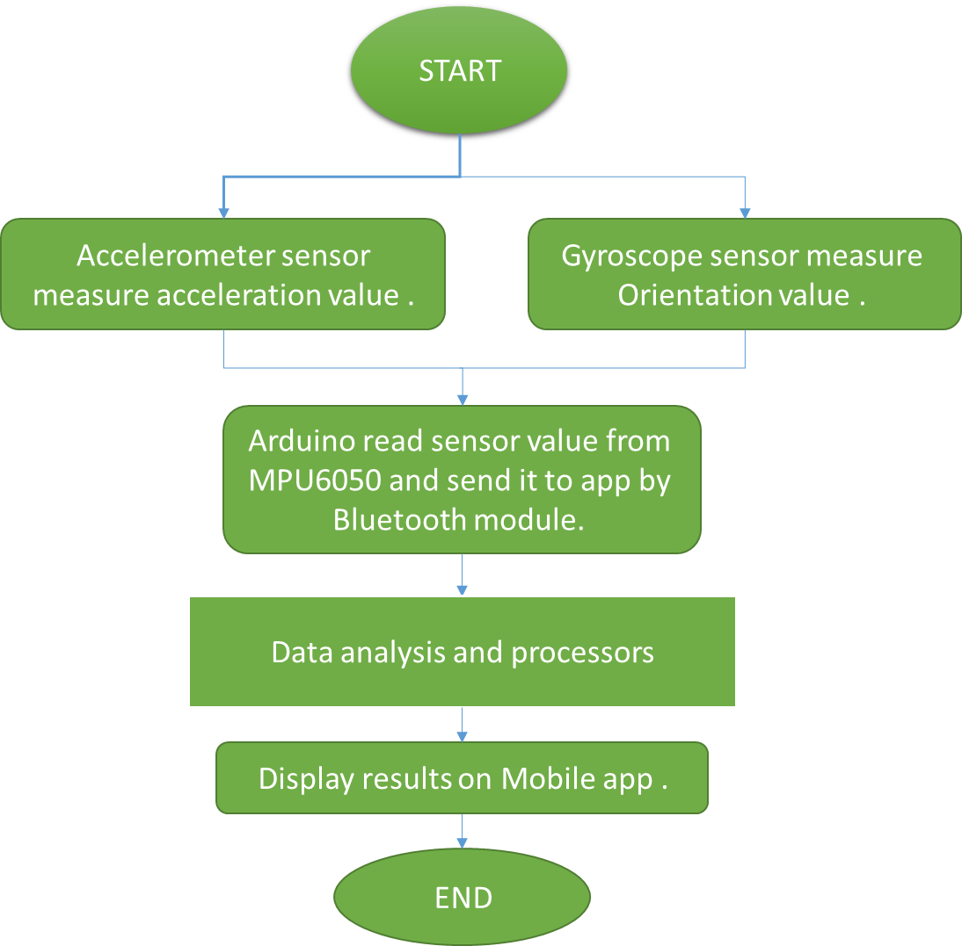

Figure 3. 1: Implementation process flowchart

## Software Tools and Equipment Requirements

### **Software Tools**

1. Arduino IDE.
2. Android Studio.

### **Equipment Requirements**

1. Arduino Uno

Is an open source electronics platform based on easy to use hardware and software. Arduino boards are able to read inputs light on a sensor, a finger on a button, or a Twitter message and turn it into an output activating a motor, turning on an LED, publishing something online.

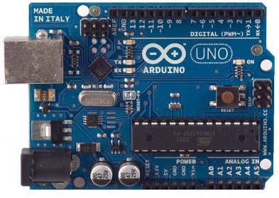  
Figure 3. 2: Arduino Uno

1. Hc-05 Bluetooth Module

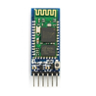 Is a Bluetooth module which is designed for wireless communication. We use it to send value from Arduino micro to smartphone.

Figure 3. 3: Bluetooth Module

1. MPU6050 IMU

The MPU6050 has both 3-Axis accelerometer and 3-Axis gyroscope integrated on a single chip.

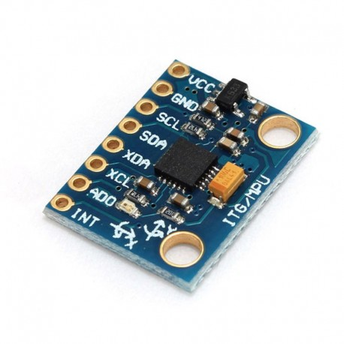

Figure 3. : MPU6050 IMU

1. Connecting wires.
2. Computer.

## Time Table

|  |  |  |  |
| --- | --- | --- | --- |
| Task Name | Duration | Start | Finish |
| Survey and Analysis | 34 days | Mon 10/26/20 | Thu 12/10/20 |
| Specification of Proposal System | 4 days | Fri 12/11/20 | Wed 12/16/20 |
| Determine and collect requirement | 11 days | Thu 12/17/20 | Thu 12/31/20 |
| Software & Hardware Design at Implementation | 68 days | Fri 1/1/21 | Tue 4/6/21 |
| Feed back | 5 days | Wed 4/7/21 | Tue 4/13/21 |
| Optimal Design | 3 days | Wed 4/14/21 | Fri 4/16/21 |
| Writing of Report | 30 days | Mon 4/19/21 | Fri 5/28/21 |

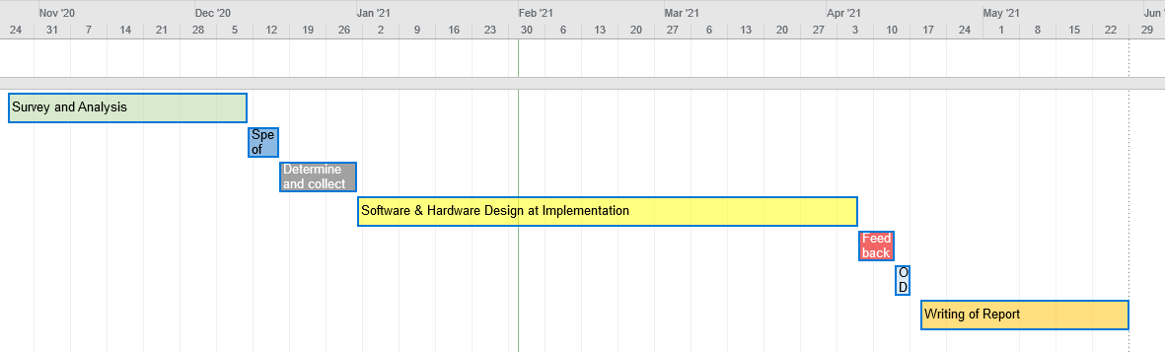

Figure 3. : Gantt chart

# Expected Outcome/ Deliverables

1. Improving health and wellness by reducing the number of deaths from obstructive sleep apnea (OSA).
2. Facilitating the measurement of a person's vital signs during sleep without complications or external help.
3. Measuring human vital signs during sleep in a simple and cost-effective way.
4. Helping patients to take their precautions before complications from the disease.

# Bibliography

1. Bucklin, C.L., M. Das, and S.L. Luo. *An inexpensive accelerometer-based sleep-apnea screening technique*. in *Proceedings of the IEEE 2010 National Aerospace & Electronics Conference*. 2010. IEEE.

2. Yao, X., et al. *The design of a real-time accelerometer-based sleeping position monitoring system and its application on obstructive sleep apnea syndrome*. in *2012 International Conference on Systems and Informatics (ICSAI2012)*. 2012. IEEE.

3. Guul, M.K., P. Jennum, and H.B. Sorensen. *Portable prescreening system for sleep apnea*. in *2016 38th Annual International Conference of the IEEE Engineering in Medicine and Biology Society (EMBC)*. 2016. IEEE.

4. Bonnesen, M.P., H.B. Sorensen, and P. Jennum. *Mobile Apnea Screening System for at-home Recording and Analysis of Sleep Apnea Severity*. in *2018 40th Annual International Conference of the IEEE Engineering in Medicine and Biology Society (EMBC)*. 2018. IEEE.

5. Srividya, K., et al. *Diagnosing the obstructive sleep APNEA from multi parameter values*. in *2018 International Conference on Communication and Signal Processing (ICCSP)*. 2018. IEEE.

6. Wu, J.-C., et al. *A Portable Monitoring System with Automatic Event Detection for Sleep Apnea Level-IV Evaluation*. in *2018 IEEE International Symposium on Circuits and Systems (ISCAS)*. 2018. IEEE.

7. Polysomnography -MAYOCLINIC. [Online] https://www.mayoclinic.org/tests-procedures/polysomnography/about/pac-20394877.

8. Sleep apnea -MAYOCLINIC. [Online] https://www.mayoclinic.org/diseases-conditions/sleep-apnea/symptoms-causes/syc-20377631.

9. American sleep apnea association -sleepapnea. [Online] https://www.sleepapnea.org/carrie-fisher-yes-you-can-die-from-sleep-apnea/.