Codebase Architecture Map
D2L SCORM Authoring Demo
This document explains the codebase as a page builder: the editor changes a live JSON blueprint, and the exporter turns that blueprint into a SCORM package for an LMS.
How to read this
The diagrams start simple and add detail each time. By the final image, every major folder and workflow is visible: startup, state, authoring UI, insertion, saving, export, helpers, styles, and local serving.
Plain-language architecture summary
1. index.html is the doorway. It loads the D2L component bundle, the app stylesheet, and app.js.
2. app.js starts src/main.js, which acts as the traffic controller for the browser app.
3. pageState JSON is the page blueprint. It holds the title, metadata, blocks, layout regions, quiz details, and export-ready content.
4. The authoring modules render that blueprint as toolbar controls, an editable canvas, dialogs, and a live JSON panel.
5. The SCORM modules package the same blueprint as either an editable LMS package or a production learner package.
Iteration 1: The shortest path
From browser entry to the visible editor.
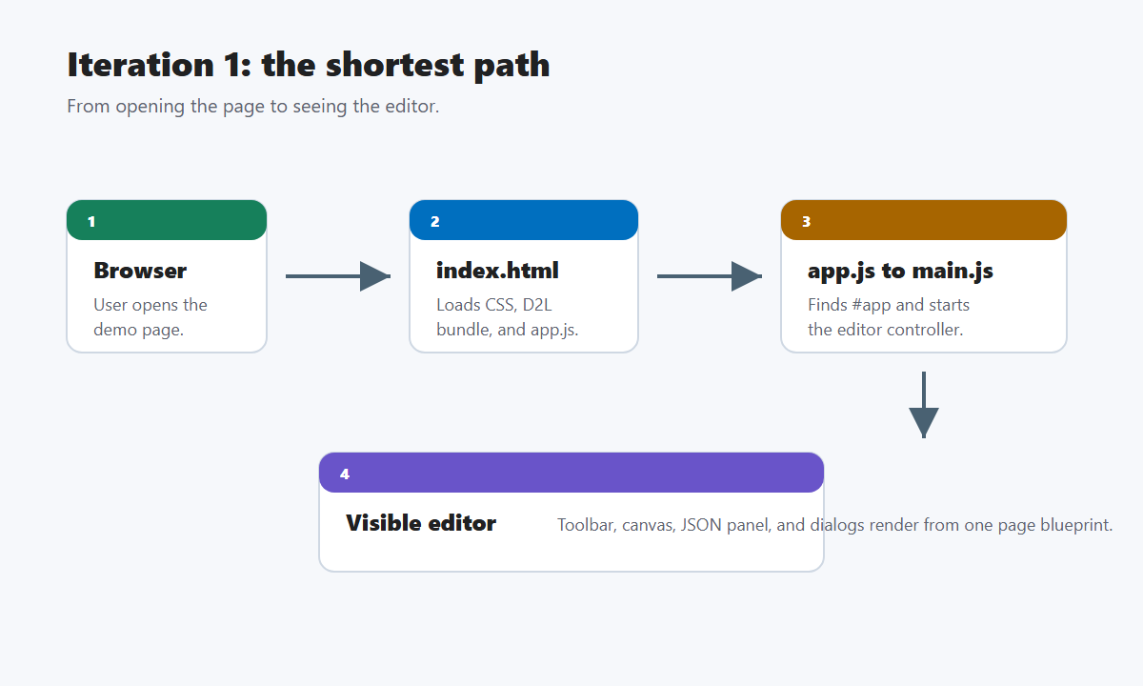

Iteration 2: Add the live page blueprint
Adds pageState JSON, the render layer, the JSON panel, and localStorage.
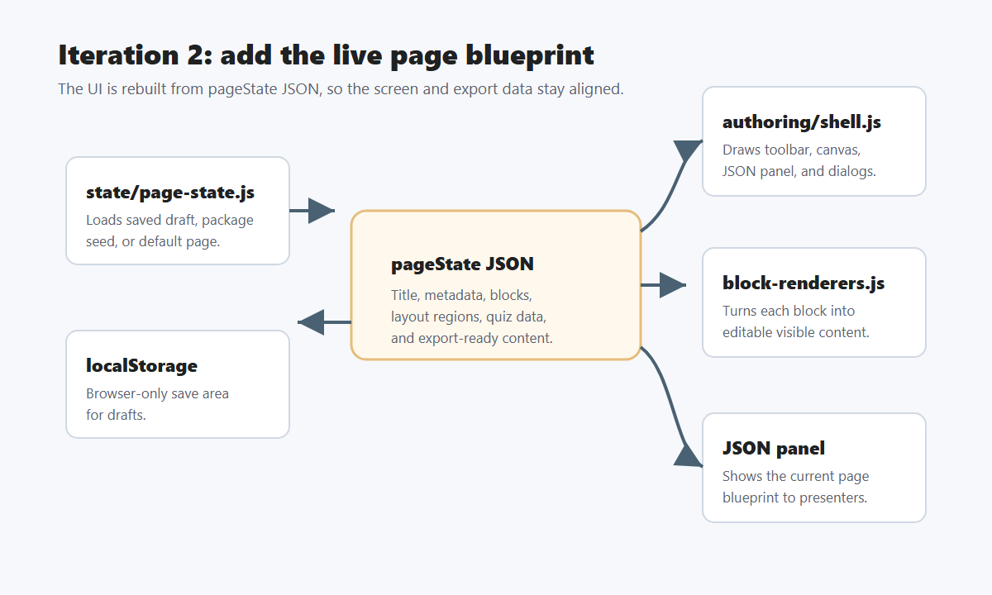

Iteration 3: Add authoring behavior
Shows typing, insertion, layout selection, block actions, saving, preview, and re-rendering.
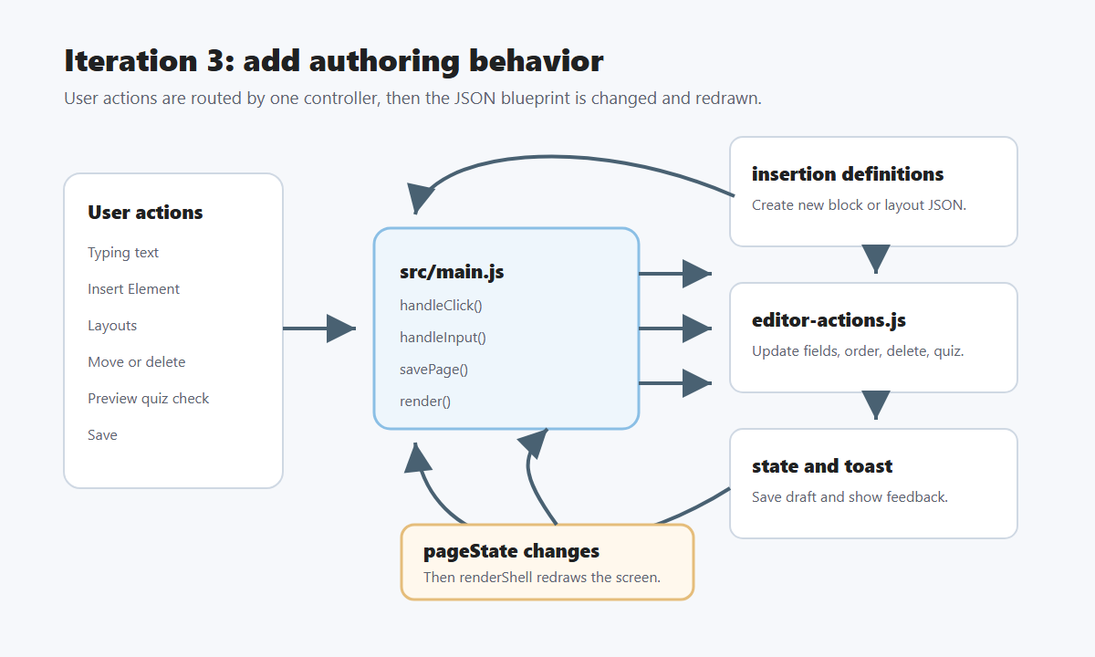

Iteration 4: Add SCORM export
Shows editable and production package paths through manifest, template, and zip generation.
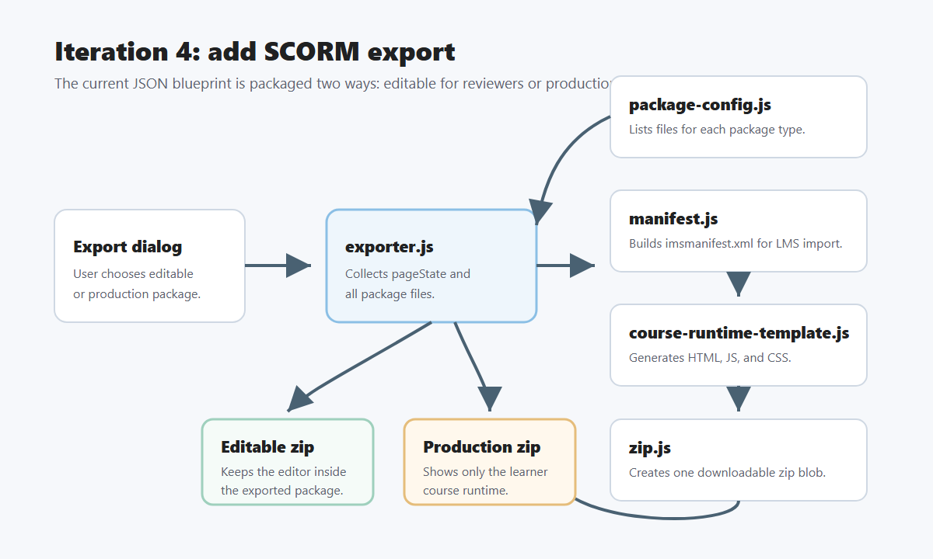

Iteration 5: Full codebase map
Shows the browser, controller, UI modules, state, insertion, helpers, styles, server, and SCORM export modules.
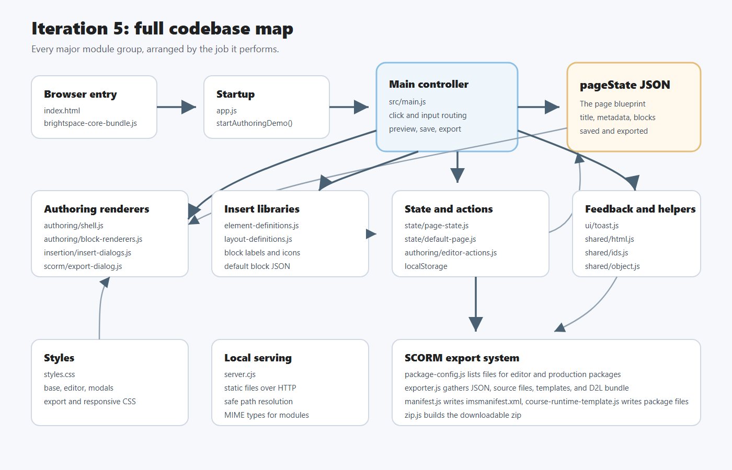

Module guide
index.html: browser doorway for the live editor.
app.js: small starter switch that hands #app to src/main.js.
src/main.js: traffic controller for clicks, typing, preview, save, insert, and export.
src/state/: loads the default page, a saved browser draft, or an exported package seed.
src/authoring/: renders the editor shell, visible blocks, and block-level changes.
src/insertion/: defines insertable content blocks and layout shapes.
src/scorm/: builds the export dialog, manifest, package templates, and zip file.
src/shared/ and src/ui/: small safety and feedback helpers.
styles/: visual layout for the editor, dialogs, export panel, responsive behavior, and this architecture page.
server.cjs: local static server used so modules, CSS imports, fetch calls, and export packaging work over HTTP.

