**Digital System Design**

**Project**

**Smoke Alarm**

*Team Leader : Abdallah Ehab Abdelfatah*

*ID :49-15636*

*T-15*

*Eamil :abdallah.alkashawy@student.guc.edu.eg*

*Member : Hassan Sherif Hassan Haridy*

*ID :49-5516*

*T-16*

*Email:* [*hassan.haridy@student.guc.edu.eg*](mailto:hassan.haridy@student.guc.edu.eg)

*Member : Hussein Mostafa Elsawaf*

*ID : 49-19337*

*T-19*

*Email:* [*hussein.elsawaf@student.guc.edu.eg*](mailto:hussein.elsawaf@student.guc.edu.eg)

*Member: Ahmed tarek elsherif*

*ID :49-10441*

*T-16*

*Email:ahmed.elsherif@student.guc.edu.eg*

*Member: Hassan usama mohamed*

*ID : 49-12045*

*T-16*

*Email:* [*hassan.abdelqader@student.guc.edu.eg*](mailto:hassan.abdelqader@student.guc.edu.eg)

IDEA : When There is a fire in a place Smoke sensor Should detect that then fire sprinklers should work and alarm to tell people that there is fire in that place ,last when water in the place reaches a specific level ,alarm turned off and fire sprinklers also

Sensors :

Water Sensor

Smoke Sensor

Buzzer

Components:

ALTERA FPGA board

Breadboard

Jumpers

CODE:

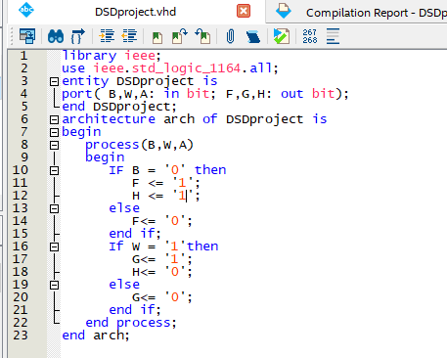

PIN ASSIGNMENTS :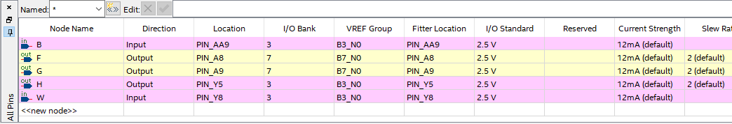

B -> Input of smoke sensor

W -> Input of Water sensor

F -> Smoke sensor's output LED

G -> Water sensor's output LED

H -> Buzzer Bit Output

PIN TOPS:

