GibJohn Tutoring

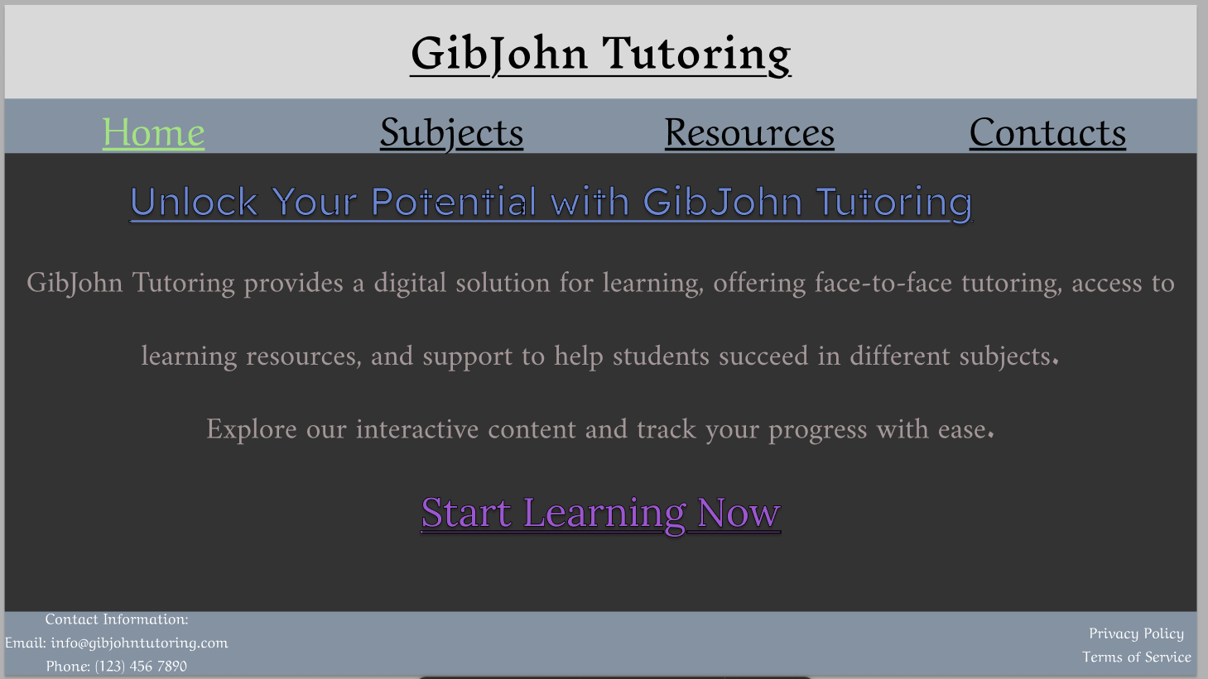
This is my index, it has got a nav with 4 items in it, the top bar has the main title, and my content has everything of what the page does.
I also added a special color to notify the user what page they are on!
I also added the contact information, Privacy Policy and Terms of Service for the footer.

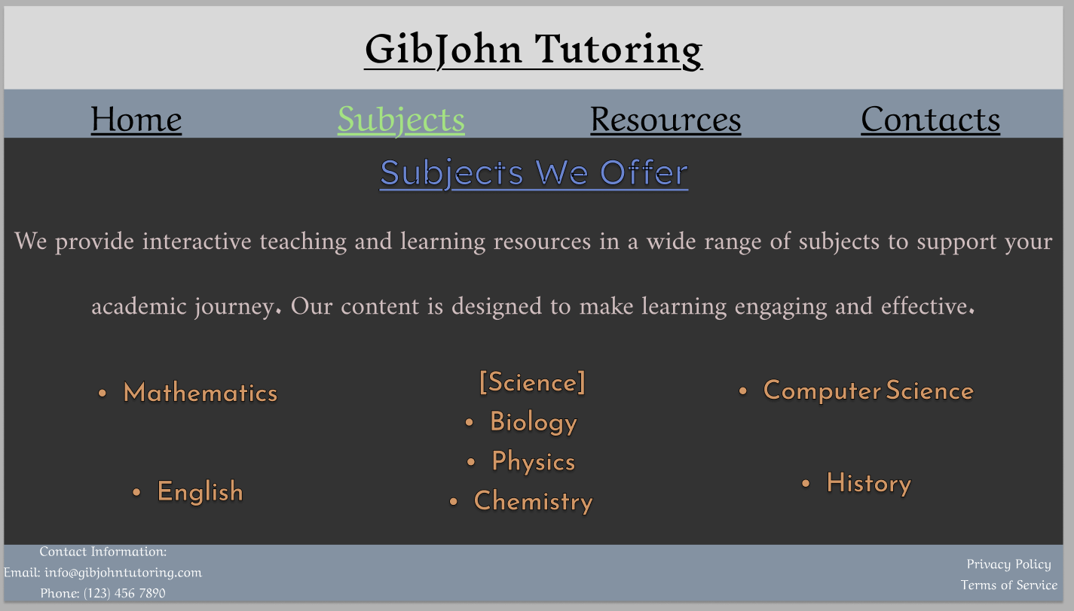
This one is my subject page, as you can see here, the nav is also highlighted!
I am not that good at sorting, for now, so the subjects possibly look as worse as they can.
This is just a mock up, though.

As the non-negotiable say, the pages so far has a consistent look / layout (do not worry, all the pages have this, but we are just at page 2 for now).

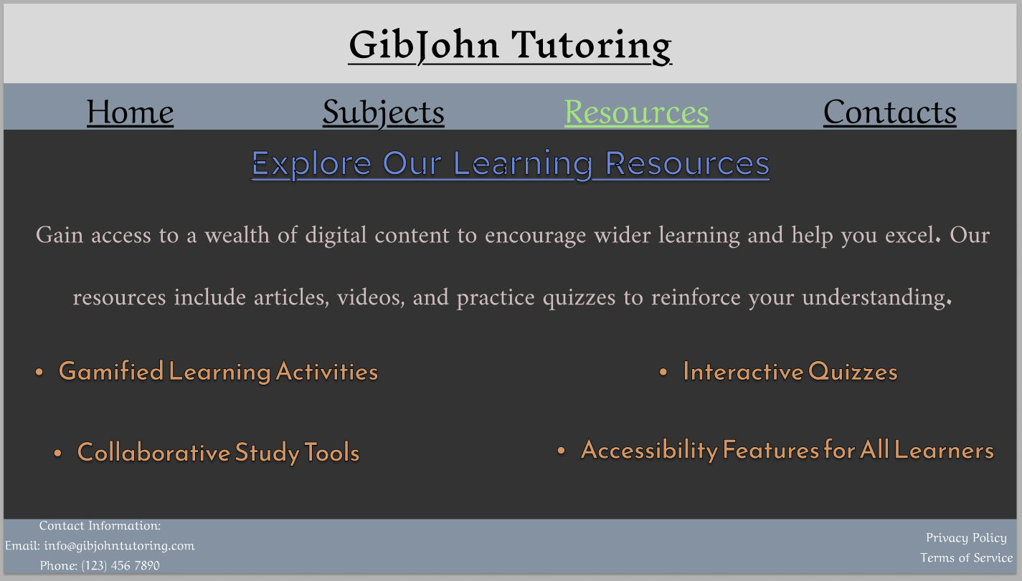
This is the third and next page, it is the one for Resources, nav is still highlighted and also the style looks and feels consistent.
I also added the gamified learning option that the brief has wanted (along with the learning tools and collaborative learning).

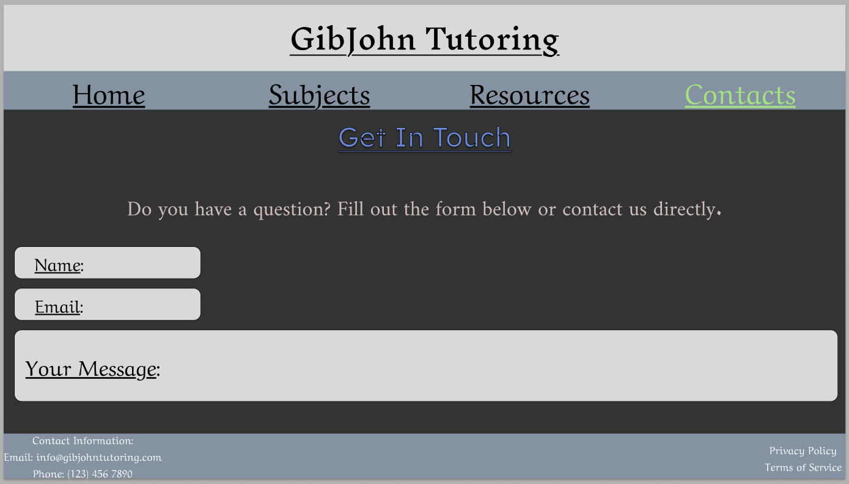
The last page is the contacts, and I have also mocked up placeholder texts for the place that users should right.
Nav is still highlighted.
And this should close the minimum of the 4 pages of the site I should make.

My design decisions first of all was to make it easy for the eyes, and the font, a reasonable size so people can see, I did not have much time for color accessibility, like the WCAG, but definitely for the real deal (and not for a mock-up) will need to put that to consideration (unless if it is not needed).

Now time for the HTML.
Bye.

