**00 : Green**  **01 : Yellow (when changing from green)**

**10 : Red 11 : Red-Yellow (when changing from red)**

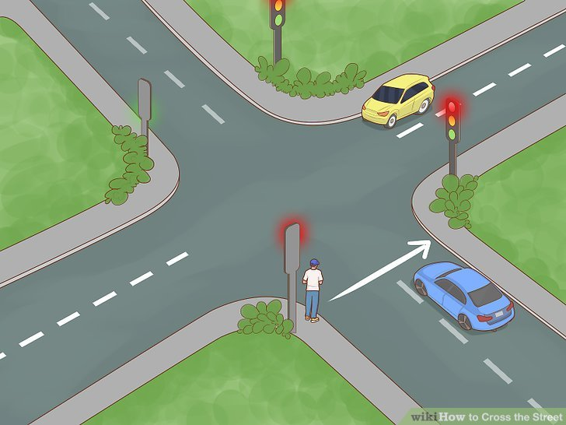

|  |  |  |  |  |  |  |
| --- | --- | --- | --- | --- | --- | --- |
| State | Highway TL1 | Highway TL2 | Farm TL1 | Farm TL2 | Delay [Sec] | First clk S appear in |
| S0 | 10 | 10 | 10 | 10 | 1 | 0 then 107 |
| S1 | 11 | 11 | 10 | 10 | 2 | 1 |
| S2 | 00 | 00 | 10 | 10 | 30 | 3 |
| S3 | 00 | 01 | 10 | 10 | 2 | 33 |
| S4 | 00 | 10 | 10 | 10 | 10 | 35 |
| S5 | 01 | 10 | 10 | 10 | 2 | 45 |
| S6 | 10 | 10 | 10 | 10 | 1 | 47 |
| S7 | 10 | 10 | 11 | 11 | 2 | 48 |
| S8 | 10 | 10 | 00 | 00 | 15 | 50 |
| S9 | 10 | 10 | 00 | 01 | 2 | 65 |
| S10 | 10 | 10 | 00 | 10 | 5 | 67 |
| S11 | 10 | 10 | 01 | 11 | 2 | 72 |
| S12 | 10 | 10 | 10 | 00 | 10 | 74 |
| S13 | 10 | 10 | 10 | 01 | 2 | 84 |
| S14 | 10 | 10 | 10 | 10 | 1 | 86 |
| S15 | 10 | 11 | 10 | 10 | 2 | 87 |
| S16 | 10 | 00 | 10 | 10 | 15 | 89 |
| S17 | 10 | 01 | 10 | 10 | 3 | 104 |