**Analytical SQL Case Study**

**Name: Abdallah Galal Abdallah**

**Q1)**

* write at least **5 analytical SQL** queries that tells a story about the data
* write small **description** about the business meaning behind each query

1. **Who is the customer with the most sales?**

**This information is important for businesses to understand their customer behavior and make informed decisions about customer relationship management, sales strategy, and resource allocation. By identifying the customer with the most sales, businesses can evaluate the reasons behind their loyalty or high purchase volume and develop strategies to retain and attract similar customers in the future.** **business may want to explore opportunities to offer personalized promotions or incentives to encourage repeat purchases and brand loyalty.**

**Query**

*-----first i will sum price for each customer to get sales for each customer*

*---second i will rank customer per each sales the highst will ranking 1 and the last will be 110*

*----here we find that the highst customer achieve sales is 12748*

select customer_id,sales_,rank() over(order by sales_ desc) rank_

from

(select customer_id,sales_

from(

select customer_id ,invoicedate,price,sum(price) over(partition by customer_id order by invoicedate rows between unbounded preceding and unbounded following ) as sales_

from tableRetail

)

group by customer_id,sales_

order by sales_ desc);

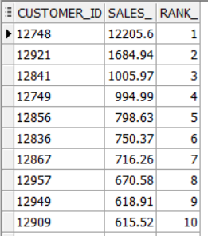

1. **What is the month with the highest sales?**

**I want to know the month in which I achieve the most sales in order to know this is related to certain offers in this month or is related to a specific season,** **Indeed, I noticed that the most month in which it achieved the highest sales is the month of November, and I think that this is related to the Black Friday offers**

**Query**

*-- which month achieve highst sales the highst month on sales is november and the less month is jaun*

select month, sales_per_month

from(

select m.* ,sum(price) over(partition by month) as sales_per_month

from

(select t.*,to_char(to_date(invoicedate,'mm/dd/yyyy hh24:mi'),'mm')as month

from tableRetail t) m

order by sales_per_month desc)

group by month , sales_per_month

order by sales_per_month desc;

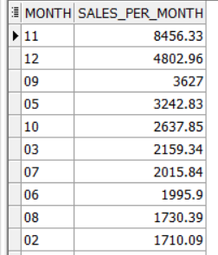

1. **What quarter in the year achieved the highest sales?**

**This information is important for businesses to understand their sales patterns and make informed decisions about resource allocation, inventory management, marketing strategy, and other aspects of their operations. By identifying which quarter had the highest sales, businesses can evaluate the reasons behind this success and develop strategies to replicate it in future years**

**Query**

*-- the highst quarter achieve sales is the 4 quarter this mean almostly this because the offer at the end of the year and the black friday sales*

select distinct quarter,sum(price) over(partition by quarter) as quarter_sales

from(

select t.*,to_char(to_date(invoicedate,'mm/dd/yyyy hh24:mi'),'q')as quarter

from tableRetail t)

order by quarter_sales desc;

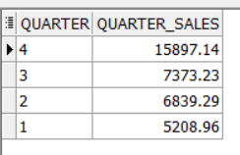

1. **What is the most sold stock?**

**From a business perspective, understanding which stock is being sold the most can provide valuable insights into market trends and investor sentiment. By monitoring the volume of shares sold or traded, companies can evaluate their own stock performance and reputation in the market, as well as the performance of their competitors.**

**Query**

*-- we have 2335 stock saled in 2010 and 2011*

*-- we want see which stock is return highst sales*

select count(distinct stockcode)

from tableRetail;

*--- which stock return highst sales*

*-- the highst stock is the stock with code : M so we can increase this stock to achieve more sales*

select distinct stockcode,stock_sales

from(

select stockcode,quantity,price ,sum(price) over(partition by stockcode) stock_sales

from tableRetail)

order by stock_sales desc;

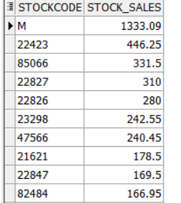

1. **which year acheive highst sales ?**

**if a company achieved its highest sales in a particular year, the company may want to evaluate the reasons behind the success. Possible reasons could include successful marketing campaigns, new product launches, or strong economic conditions. On the other hand, if a company's sales have been declining year over year, the company may want to evaluate the reasons behind the decline and develop new strategies to improve sales and revenue.**

**Query**

*----2011 is highst than 2010*

*----in 2011 achieve sales 29489.72 more than 2010*

select year ,year_sales,lag(year_sales) over(order by year_sales ) as lag ,(year_sales-nvl(lag(year_sales) over(order by year_sales ),0)) as diff

from(

select distinct year ,sum(price) over(partition by year) as year_sales

from(

select t.*,to_char(to_date(invoicedate,'mm/dd/yyyy hh24:mi'),'yyyy')as year

from tableRetail t)

order by year_sales desc);

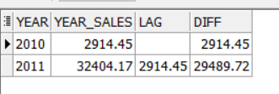

1. **What is the average quantity per each stock?**

**companies can identify which stocks are in high demand and which stocks are not, and adjust their business strategies accordingly.**

**Query**

select distinct stockcode ,avg(quantity) over(partition by stockcode) q_avg

from tableRetail

order by q_avg desc;

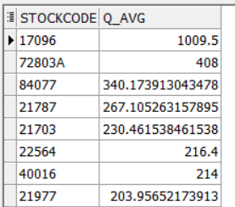

**Q2)** After exploring the data now you are required to implement a Monetary model for

customers behavior for product purchasing and segment each customer based on the below

groups

**Query**

*--The customers will be grouped based on 3 main values*

*--• Recency => how recent the last transaction is (Hint: choose a reference date, which is*

*--the most recent purchase in the dataset )*

*--• Frequency => how many times the customer has bought from our store*

*--• Monetary => how much each customer has paid for our products*

select distinct customer_id,recency,frequency,mentory,r_score,fm_score,

case

when r_score =4 and fm_score=5 or r_score=5 and fm_score=5 or r_score=5 and fm_score=4 then 'champions'

when (r_score =5 and fm_score=2) or (r_score=4 and fm_score=2) or (r_score=3 and fm_score=3) or (r_score=4 and fm_score=3) then 'potential loyalists'

when (r_score =5 and fm_score=3) or (r_score=4 and fm_score=4) or (r_score=3 and fm_score=5) or (r_score=3 and fm_score=4) then 'Loyal Customers'

when (r_score =5 and fm_score=1) then 'recent customers'

when (r_score =4 and fm_score=1) or (r_score=3 and fm_score=1) then 'promising'

when (r_score =3 and fm_score=2) or (r_score=2 and fm_score=3) or (r_score=2 and fm_score=2) then 'Customers Needing Attention'

when (r_score =2 and fm_score=5) or (r_score=2 and fm_score=4) or (r_score=1 and fm_score=3) then 'At Risk'

when (r_score =1 and fm_score=5) or (r_score=1 and fm_score=4) then 'Cant Lose Them'

when (r_score =1 and fm_score=2) then 'Hibernating'

else 'Lost'

end cust_seement

from(

select distinct customer_id,recency,frequency,mentory,r_score,ntile(5) over(order by avg_fm_score) as fm_score

from(

select distinct customer_id,recency,frequency,mentory,ntile(5) over(order by recency desc) as r_score,(frequency+mentory)/2 as avg_fm_score

from(

select distinct customer_id,last_cust,max_date,recency,count(invoice) over(partition by customer_id) as frequency,sum(price) over(partition by customer_id) as mentory

from (

select distinct customer_id,price,invoice,last_cust,max_date,round(max_date-last_cust) as recency

from(

select distinct customer_id,price ,invoice ,max(to_date(invoicedate,'mm/dd/yyyy hh24:mi'))over() max_date,

last_value( to_date(invoicedate , 'MM/DD/YYYY hh24:mi'))over(partition by customer_id order by to_date(invoicedate , 'MM/DD/YYYY hh24:mi') rows between unbounded preceding and unbounded following ) last_cust

from tableretail) ))))

order by customer_id;

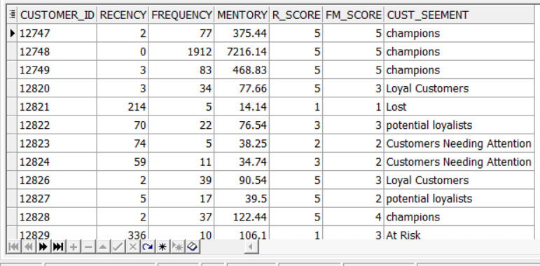

**Q3-A)** a- What is the maximum number of consecutive days a customer made purchases?

*--Q3*

*--a--What is the maximum number of consecutive days a customer made purchases?*

*---My algorithm*

*---- first iwill select the prev of each transaction day to get different between them*

*---- second i will get diffeet between the current day (transaction day ) and the previous day in the order and i will ranking its partition by cust_id order by calendar_dt desc*

*---- third i will filterf it where diff between current day and prev not = null or not=1 and i will get diff between each rank and the prev rank this will return all number of connceive for each customer*

*----fourth iwill get max conn days for each customer*

select cust_id,max(con_days) max_con_days

from(

select gap.*,lag(rank_) over(partition by cust_id order by calendar_dt desc) as lag,rank_-nvl(lag(rank_) over(partition by cust_id order by calendar_dt desc),0) as con_days

from(

select l.*,calendar_dt-perv_day as diff, rank ()

over (partition by cust_id order by calendar_dt desc) as rank_

from

(

select cust_id,calendar_dt,lead (calendar_dt)

over(partition by cust_id order by calendar_dt desc ) as perv_day

from customer_purchacing) l) gap

where diff!=1 or diff is null

)

group by cust_id

order by max_con_days desc

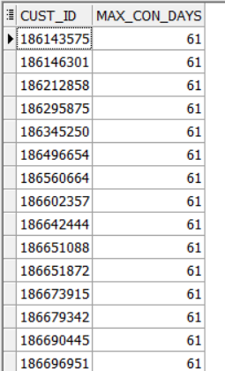

**Q3-B)** On average, How many days/transactions does it take a customer to reach a spent

threshold of 250 L.E?

*--1 first t want to sum amt_le partirion by cusromer*

*--2 i will ranking each row(transaction) partition by customer oreder by date to make me able to access the nunmber of the transaction that customer acheive 250*

*--3 new column calendar_dt - first day that the customer make transaction (dufference between first day and the current day(wich the day the customer achieve 250)*

*--4 iwill extract notransaction and day for each customer distinct and get averge*

select avg(trans),avg(days)

from(

select distinct cust_id,first_value(num_of_trans) over(partition by cust_id order by calendar_dt) trans,first_value(no_days) over(partition by cust_id order by calendar_dt) days

from(

select customer_purchacing.* , sum(amt_le) over(partition by cust_id order by calendar_dt) as sum_sales,rank() over(partition by cust_id order by calendar_dt) as num_of_trans,

calendar_dt -first_value(calendar_dt) over(partition by cust_id order by calendar_dt) as no_days

from customer_purchacing)

where sum_sales>=250

order by cust_id);

