**Hotel Booking Report**

**Analysis Scope**

The analysis is based on the Hotel Booking dataset, which contains booking information for two type of hotels, city hotels and resort hotels. The scope of the analysis is limited to bookings cancellation rate, what the feature that affect on cancellation rate . The time frame for the analysis is from 2018 to 2020. The dataset includes 141947 observations and 27 features.

**Analysis and Insights**

1. **Cancellation Rate Per Each Hotel**

* City hotel 42% of booking cancelled
* Resort hotel 28% of booking cancelled

1. **Cancellation Rate by Months**

* The august month has high number of booking and also high number of canceled booking
* The top 2 months of reservation is (July-August)

1. **Cancellation Rate By lead time (time Between Reservation and arrival)**

* I notice that There is a direct relationship between the period between the booking and the arrival and the cancellation rate

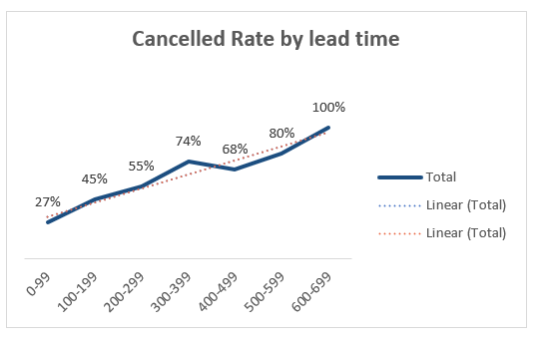

1. **Cancellation Rate per Market Segment**

The cancellation rate is very high in a groups by 62%

And also very high in offline TA/To ,online TA ,so we need to understand why the cancellation rate is high in this segments

1. **Cancellation Rate By channel**

The cancellation rate is very high in TA/TO channel 41%

So we must understand why this channel cancellation rate it is very high on it

1. **The cancellation Rate by number of previous cancellation**

I notice that There is a direct relationship between the number of previous cancellation and the cancellation rate

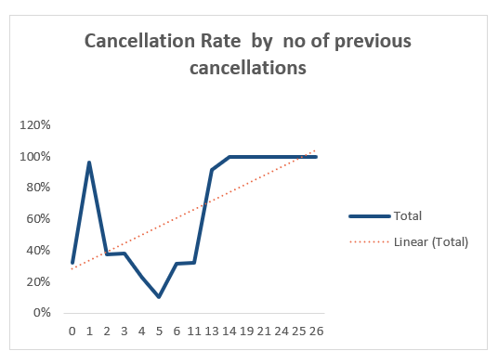

1. **Cancellation Rate by deposit Type**

The top 1 in cancellations as per Deposit type is NON Refund. The high rate of it is possible that the high rate of cancellations in the Non Refund category is due to the hotel's booking policies. When a hotel offers Non Refundable rates, it means that the guest will not receive a refund if they cancel their reservation. In some cases, this type of rate may be offered at a discounted price compared to Refundable rates

1. **Cancellation Rate by customer Type**

The high rate of cancellation in the transient customers by 40% and also high in a contract type by 34%

**Recommendations :**

* For City hotels, the cancellation rate is higher compared to Resort hotels. To address this, City hotels could consider implementing more flexible booking policies, providing incentives for early bookings, or improving communication with customers to better understand their needs and reasons for cancellation.
* August is the busiest month with the highest number of bookings and cancellations. Hotels could consider adjusting their pricing or booking policies during this period to better manage demand and reduce the cancellation rate.
* There is a direct relationship between the period between the booking and the arrival and the cancellation rate. Hotels could consider offering more flexible rates or policies, such as free cancellations up to a certain period before arrival, to reduce the impact of cancellations due to changes in travel plans.
* Group bookings and offline TA/To and online TA have high cancellation rates. Hotels could consider implementing stricter cancellation policies for these segments or providing incentives for early bookings to encourage more commitment.
* TA/TO channel has the highest cancellation rate. Hotels could consider reviewing their contracts with these channels to negotiate better cancellation policies or to provide more incentives for early bookings.
* There is a direct relationship between the number of previous cancellations and the cancellation rate. Hotels could consider implementing stricter cancellation policies for customers with a history of cancellations or providing incentives for early bookings to encourage more commitment.
* Non-Refundable rates have the highest cancellation rate. Hotels could consider reviewing their pricing strategy for Non-Refundable rates to ensure that the discount offered is sufficient to offset the higher risk of cancellations.
* Transient customers have the highest cancellation rate. Hotels could consider implementing more flexible booking policies or providing incentives for early bookings to encourage more commitment from these customers. For contract customers, hotels could consider implementing stricter cancellation policies or providing more personalized services and incentives to encourage more commitment.