CCY3201 — Network Security
Lab Report

Arab Academy of Science, Technology, and Maritime Transport
College of Computing and Information Technology
Cybersecurity Department

Instructor: Assoc. Prof. Ehab Abousaif
Teaching Assistant: Eng. Khaled

Field | Details
Student Name | Abdallah Mohamed Ramadan Hussien
Student ID | 231005577
Group | 6CY2
Date | May 10, 2026

Weeks 1–2: Lab Orientation and Network Setup

1.1 Objective
The objective of this lab was to set up a safe and isolated virtual lab environment consisting of two virtual machines — a Kali Linux attacker machine and an Ubuntu Server target machine — connected via a Host-Only network. Basic network connectivity was then verified using ICMP ping and Wireshark packet capture.

1.2 Lab Environment

Parameter | Value
Virtualization Platform | VirtualBox
Attacker Machine | Kali Linux (Kali-Attacker)
Target Machine | Ubuntu Server LTS (Ubuntu-Target)
Network Type | Host-Only (Isolated)
Kali IP Address | 192.168.153.3
Ubuntu IP Address | 192.168.153.4
Subnet | 192.168.153.0/24

1.3 Tasks and Commands

Task 1: VM Configuration
Two virtual machines were created in VirtualBox with the following adapter configuration:
- Adapter 1: NAT — for internet access (package updates)
- Adapter 2: Host-Only (VirtualBox Host-Only Ethernet Adapter #2) — for isolated lab network

Task 2: Verify IP Addresses
Command run on Kali Linux:
ip addr show
Result: Kali was assigned IP 192.168.153.3 on the Host-Only interface (eth1).

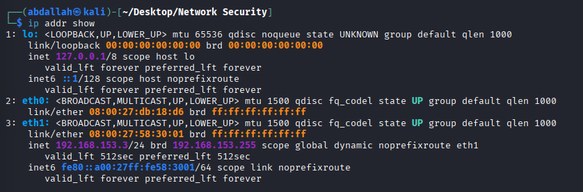
Command run on Ubuntu Server:
ip addr show
Result: Ubuntu was assigned IP 192.168.153.4 on interface enp0s8. Note: virbr0 showed 192.168.122.1 but this is a virtual bridge unrelated to the lab network.

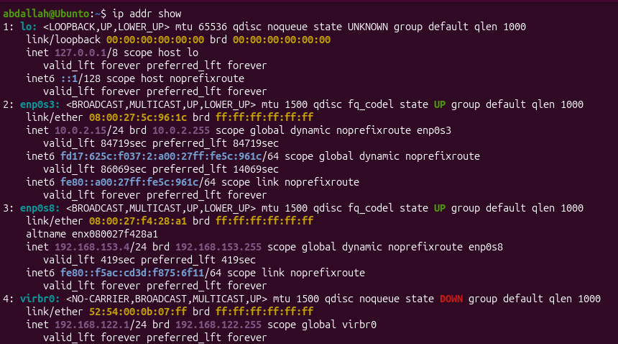
Task 3: Ping Connectivity Test
Command run on Kali Linux:
ping -c 4 192.168.153.4

Metric | Result
Packets Transmitted | 4
Packets Received | 4
Packet Loss | 0%
Average RTT | ~0.967 ms

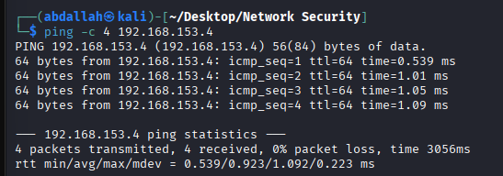
Task 4: Wireshark ICMP Capture
Wireshark was launched on Kali on interface eth1 and the ICMP filter was applied:
sudo wireshark
Filter applied in Wireshark:
icmp
While Wireshark was running, ping was re-executed. ICMP Echo Request and Echo Reply packets were visible in the capture, confirming bidirectional communication between the two VMs. The capture was saved as week1_capture.pcap.

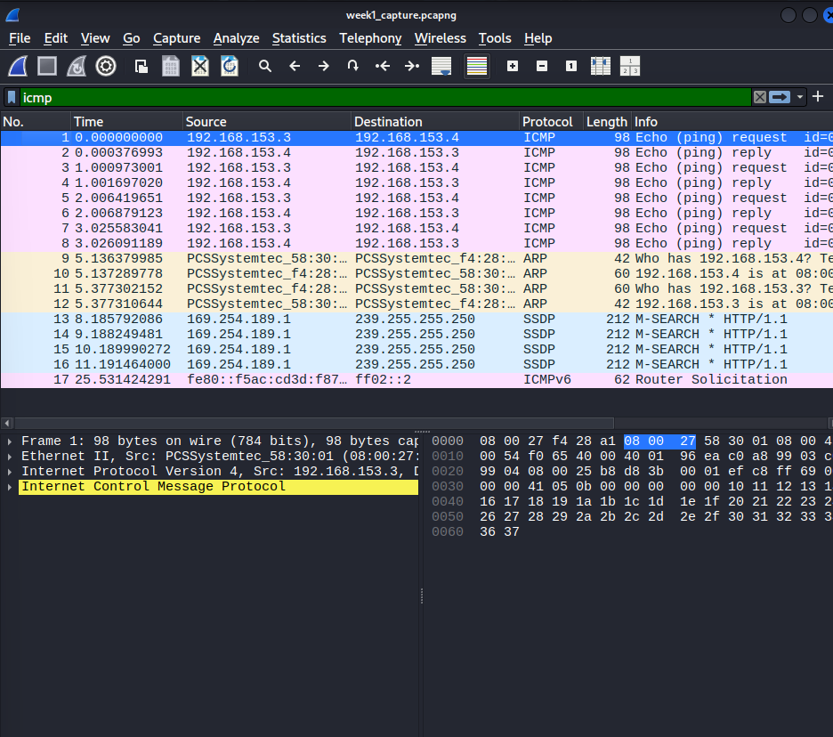

1.4 Observations
- Both VMs were successfully configured and placed on the same isolated Host-Only subnet (192.168.153.0/24).
- The virbr0 interface on Ubuntu (192.168.122.1) is a libvirt virtual bridge and should not be confused with the lab network interface.
- Ping produced 0% packet loss with sub-millisecond latency, confirming a healthy virtual network link.
- Wireshark captured ICMP packets as expected, demonstrating basic traffic analysis capability.

1.5 Deliverables
- Screenshot: ip addr show output on both VMs
- Screenshot: Ping output showing 0% packet loss
- Screenshot: Wireshark capture showing ICMP Echo Request and Reply
- Saved file: week1_capture.pcap

Weeks 3–4: Network Scanning and Enumeration

2.1 Objective
The objective of this lab was to use Nmap to perform host discovery, port scanning, service version detection, and OS fingerprinting against the Ubuntu target machine. Results were saved to a report file.

2.2 Tools Used

Tool | Purpose
Nmap 7.95 | Network scanning and enumeration
Terminal (Kali Linux) | Command execution

2.3 Tasks and Commands

Task 1: Host Discovery Scan
Command:
nmap -sn 192.168.153.0/24
This performs a ping scan across the entire subnet without scanning ports, identifying live hosts.

IP Address | Status | Notes
192.168.153.2 | Up | VirtualBox Gateway/DHCP — expected
192.168.153.3 | Up | Kali Linux (attacker machine)
192.168.153.4 | Up | Ubuntu Server (target machine)

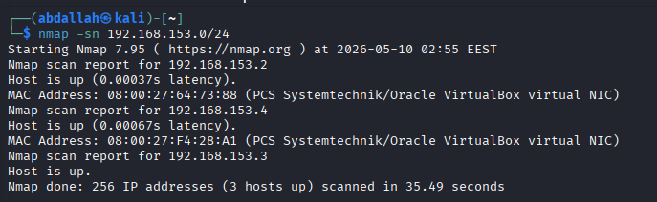
Task 2: TCP SYN Scan
Command:
nmap -sS -p 1-1000 192.168.153.4
This performs a stealthy half-open SYN scan on the first 1000 ports. Initially all ports were closed because no services were installed. After installing OpenSSH on Ubuntu, port 22 appeared as open.

Port | State | Service
22/tcp | Open | SSH
1-21, 23-1000 | Closed | No services running

Note: OpenSSH was installed on Ubuntu using the following commands to enable a scannable service:
sudo apt update && sudo apt install openssh-server -y
sudo systemctl enable ssh && sudo systemctl start ssh

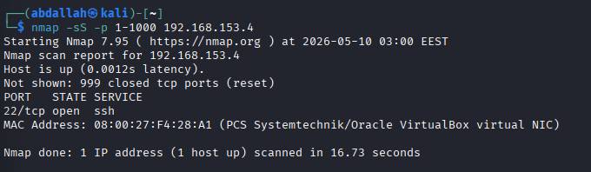
Task 3: Service Version Detection
Command:
nmap -sV 192.168.153.4
This probes open ports to identify exact software versions running.

Port | State | Service | Version
22/tcp | Open | SSH | OpenSSH 10.2p1 Ubuntu 2ubuntu3.2

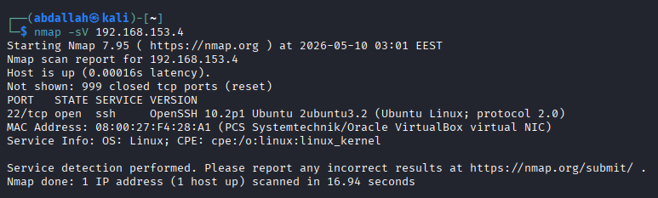
Task 4: OS Fingerprinting
Command:
sudo nmap -O 192.168.153.4
Nmap analyzed the TCP/IP stack behavior to attempt OS identification. No exact match was found due to the newer Ubuntu version, but Linux was confirmed via:
- TTL value of 64 (hex 0x40) — classic Linux behavior
- TCP sequence number behavior (TI=Z) consistent with Linux kernel
- Network distance of 1 hop confirming direct connection

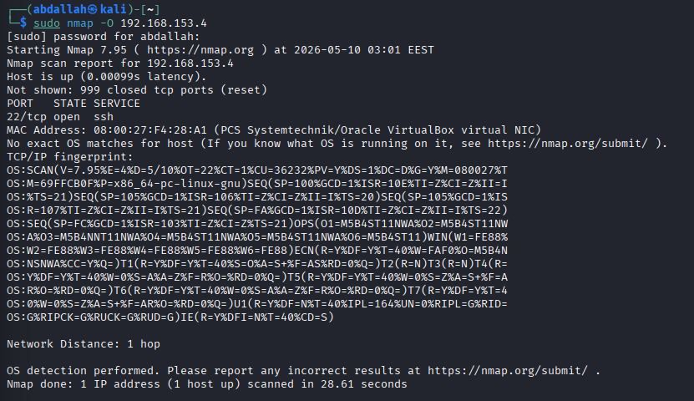
Task 5: Aggressive Scan and Report
Command:
nmap -A 192.168.153.4 -oN nmap_week2_report.txt
The -A flag combines OS detection, version detection, script scanning, and traceroute. Results were saved to nmap_week2_report.txt. Key findings from the report:
- Port 22/tcp open — OpenSSH 10.2p1 Ubuntu 2ubuntu3.2
- OS: Linux (confirmed via TCP/IP fingerprint)
- Traceroute: 1 hop at 1.00ms to 192.168.153.4

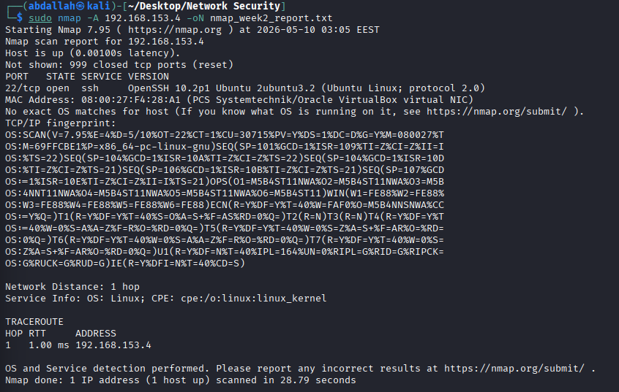

2.4 Observations
- A fresh Ubuntu Server install has no open ports by default — services must be explicitly installed and started.
- OpenSSH 10.2p1 is a recent, well-patched version. In real assessments, outdated SSH versions would indicate potential vulnerabilities (e.g., CVE entries).
- OS fingerprinting was inconclusive for the exact Ubuntu version but correctly identified the Linux kernel through TCP/IP stack analysis.
- The SYN scan (-sS) is stealthier than a full connect scan as it does not complete the TCP three-way handshake, making it less likely to appear in application logs.

2.5 Deliverables
- Screenshot: nmap -sn host discovery output
- Screenshot: nmap -sS port scan showing port 22 open
- Screenshot: nmap -sV service version detection output
- Screenshot: nmap -O OS fingerprinting output
- Screenshot: nmap -A aggressive scan output
- Saved file: nmap_week2_report.txt

Weeks 5–6: Packet Capture and Traffic Analysis

3.1 Objective
The objective of this lab was to capture live network traffic using Wireshark and analyze the difference between unencrypted HTTP traffic and encrypted HTTPS/TLS traffic. This demonstrates the importance of encryption in protecting data in transit.

3.2 Tools Used

Tool | Purpose
Wireshark | Packet capture and analysis
Python HTTP Server | Generate unencrypted HTTP traffic
curl | HTTP client for generating requests

3.3 Tasks and Commands

Task 1: Start Packet Capture
Wireshark was opened on Kali and the Host-Only interface (eth1) was selected. Capture was started and saved as week3_capture.pcap.
sudo wireshark

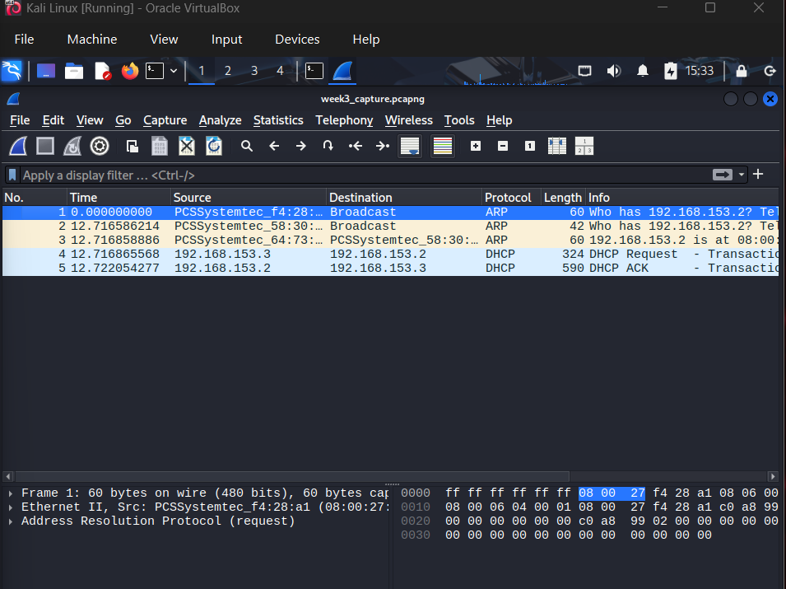
Task 2: Generate HTTP Traffic
On the Ubuntu target, a simple Python HTTP server was started on port 80:
cd /var/www/html
sudo python3 -m http.server 80
From Kali, an HTTP request was made to the Ubuntu server:
curl http://192.168.153.4/
In Wireshark, the filter 'http' was applied to inspect the GET request. The full request including headers and response body were visible in plaintext.

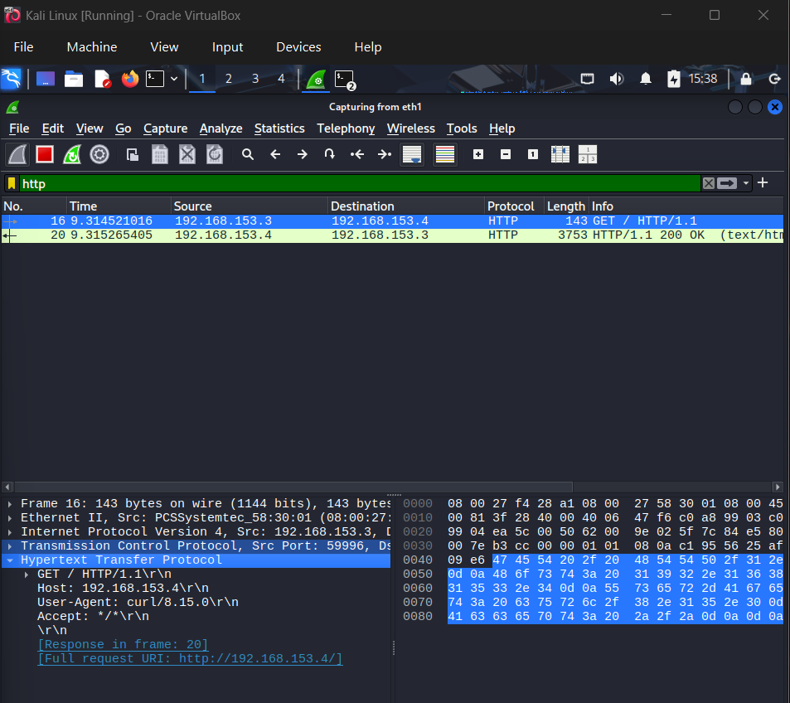
Task 3: Generate HTTPS Traffic and Compare
From Kali, an HTTPS site was visited via the NAT adapter. In Wireshark, the filter 'tls' was applied to observe encrypted traffic.
curl https://example.com
Unlike HTTP, the HTTPS/TLS traffic showed only the handshake metadata (server name, cipher suite) while the actual payload was fully encrypted and unreadable.

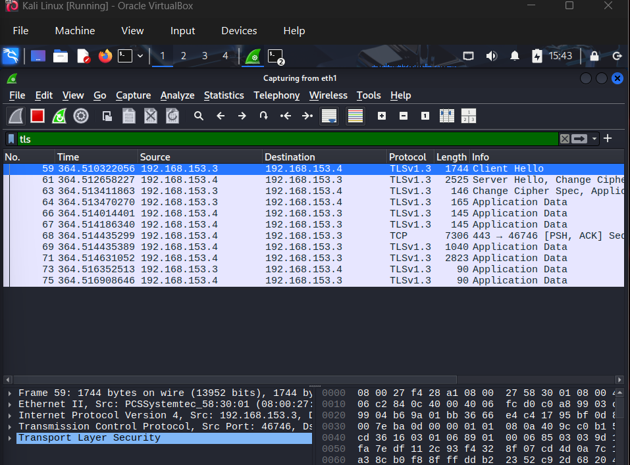

3.4 Observations
- HTTP traffic is completely visible in Wireshark — any attacker on the network can read credentials, form data, and page content.
- HTTPS/TLS traffic shows only handshake metadata; the payload is encrypted and unreadable without the private key.
- The TLS handshake reveals the server name (SNI), protocol version, and cipher suite negotiated, but no application data.
- This lab clearly demonstrates why all web traffic should use HTTPS rather than HTTP.

3.5 Deliverables
- Saved file: week3_capture.pcap
- Screenshot: Wireshark showing HTTP GET packet in plaintext
- Screenshot: Wireshark showing TLS handshake for HTTPS traffic

Weeks 7–8: Secure Network Protocols

4.1 Objective
The objective of this lab was to examine SSL/TLS certificate details using OpenSSL and to compare plaintext FTP traffic against encrypted SFTP traffic using Wireshark. This highlights the risks of using unencrypted protocols for file transfer.

4.2 Tools Used

Tool | Purpose
OpenSSL | Inspect TLS certificates and connection details
vsftpd | FTP server on Ubuntu for plaintext transfer testing
ftp client | FTP client from Kali
sftp | SSH-based secure file transfer
Wireshark | Capture and compare FTP vs SFTP traffic

4.3 Tasks and Commands

Task 1: Examine TLS Certificate with OpenSSL
The following command connects to example.com on port 443 and displays full certificate details:
openssl s_client -connect example.com:443 -servername example.com

Certificate Field | Value
Subject | CN=example.com
Issuer | DigiCert (or similar CA)
Validity | Check Not Before / Not After dates
Cipher | TLS_AES_256_GCM_SHA384 (or similar)

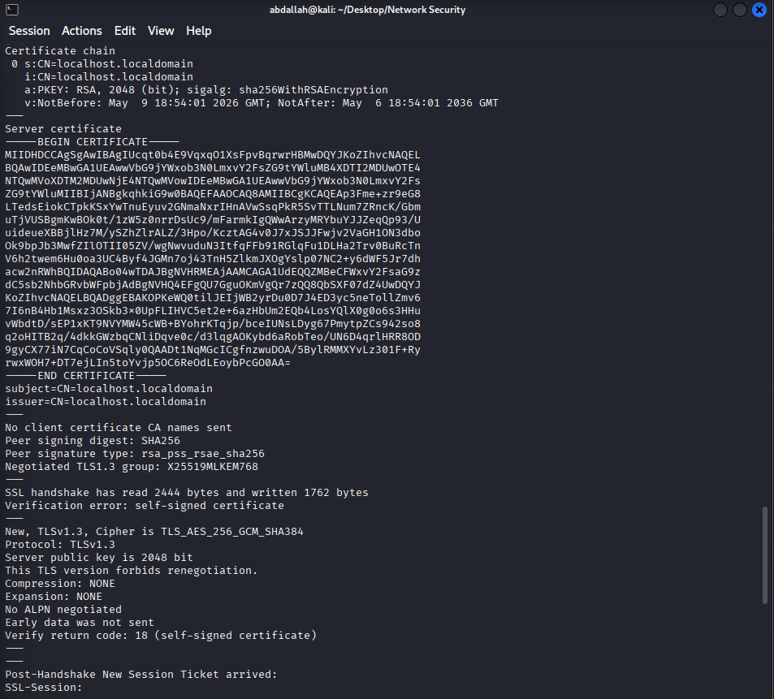
Task 2: Compare FTP vs SFTP
vsftpd was installed on Ubuntu and started as the FTP server. From Kali, a file was transferred via FTP while Wireshark captured the traffic:
ftp 192.168.153.4
In Wireshark the FTP filter showed credentials and file contents in plaintext. Then SFTP was used for comparison:
sftp user@192.168.153.4
put sample.txt
In Wireshark the SFTP (SSH) traffic was fully encrypted — credentials and file content were not visible.

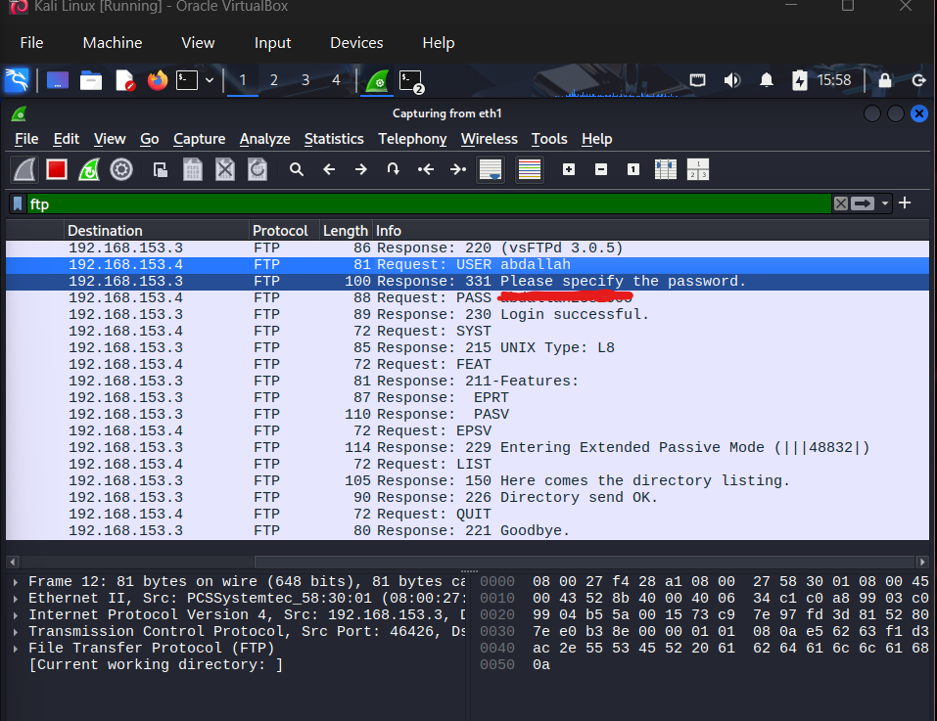
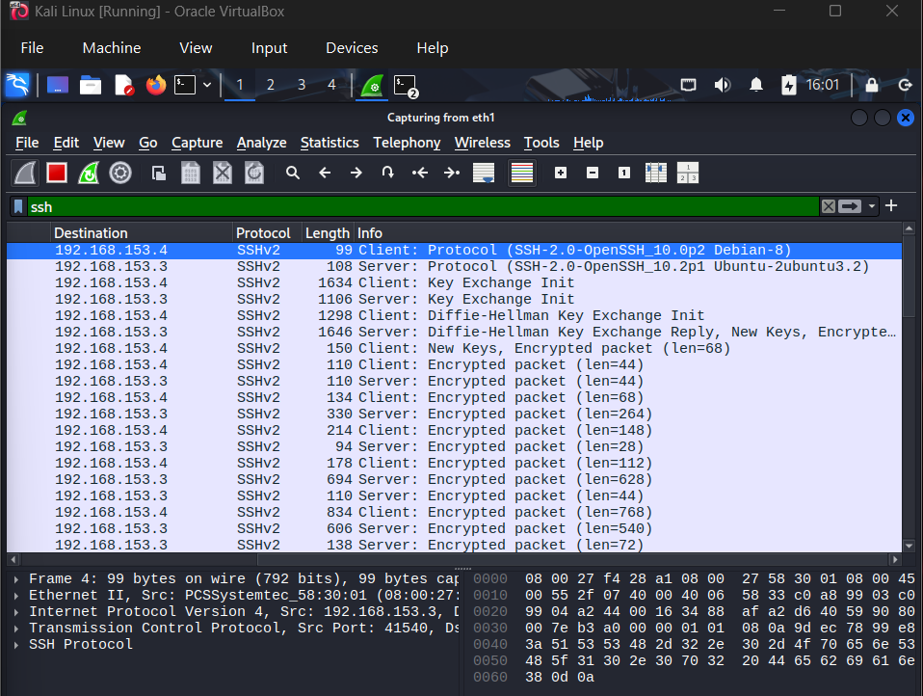

4.4 Observations
- FTP transmits usernames, passwords, and file content in plaintext — a major security risk on any shared network.
- SFTP (SSH File Transfer Protocol) encrypts all data including credentials, making it safe to use on untrusted networks.
- The TLS certificate from OpenSSL confirmed the identity of example.com through a trusted Certificate Authority chain.
- The cipher negotiated (e.g., AES-256-GCM) provides strong encryption with forward secrecy.

4.5 Deliverables
- Screenshot: OpenSSL output showing certificate details and cipher
- Screenshot: Wireshark FTP capture showing plaintext credentials
- Screenshot: Wireshark SFTP capture showing encrypted traffic

Weeks 9–10: Firewalls and Access Control

5.1 Objective
The objective of this lab was to configure a host-based firewall on the Ubuntu target using UFW (Uncomplicated Firewall), create filtering rules to allow and deny specific traffic, and verify the rules by testing connections from Kali.

5.2 Tools Used

Tool | Purpose
UFW (Uncomplicated Firewall) | Host-based firewall management on Ubuntu
iptables (underlying) | Packet filtering framework UFW manages
curl | Test HTTP connectivity from Kali
ssh | Test SSH connectivity from Kali

5.3 Tasks and Commands

Task 1: Enable and Configure UFW
On the Ubuntu target, UFW was enabled and rules were configured:
sudo ufw enable
sudo ufw default deny incoming
sudo ufw allow 22/tcp
sudo ufw deny 80/tcp
sudo ufw status verbose

Rule | Port | Action | Reason
Default incoming | All | Deny | Block all by default
SSH | 22/tcp | Allow | Remote management access
HTTP | 80/tcp | Deny | Block web traffic explicitly

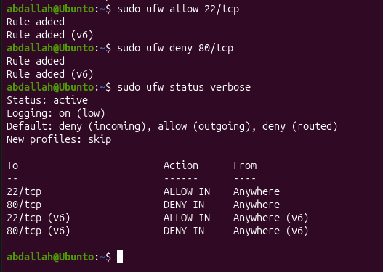
Task 2: Test Firewall Rules from Kali
HTTP connection test (expected: blocked):
curl -I http://192.168.153.4
SSH connection test (expected: allowed):
ssh user@192.168.153.4

Test | Command | Expected Result | Actual Result
HTTP (port 80) | curl -I http://192.168.153.4 | Blocked (connection refused) | [Fill in]
SSH (port 22) | ssh user@192.168.153.4 | Allowed (login prompt) | [Fill in]

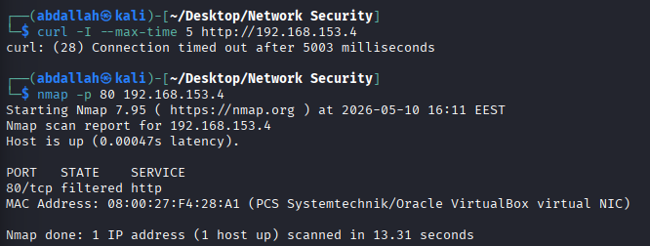
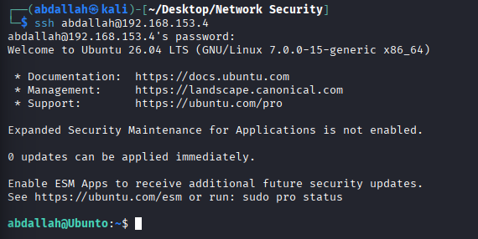

5.4 Observations
- UFW provides a simplified interface to iptables, making firewall management accessible without deep iptables knowledge.
- The 'default deny incoming' policy is a security best practice — it ensures only explicitly allowed services are reachable.
- Port 22 (SSH) was allowed to maintain remote management capability while port 80 (HTTP) was blocked.
- Testing from Kali confirmed that the firewall rules were enforced correctly — blocked traffic was dropped and allowed traffic passed through.

5.5 Deliverables
- Screenshot: UFW status verbose output showing active rules
- Screenshot: curl HTTP request blocked by firewall
- Screenshot: SSH connection allowed through firewall

Summary and Conclusion

This report documents the completion of Weeks 1 through 10 of the CCY3201 Network Security lab. All exercises were performed exclusively within an isolated Host-Only virtual network in compliance with lab ethics guidelines.

Week | Lab Topic | Status | Key Finding
1-2 | Network Setup & VM Configuration | Complete | VMs connected on 192.168.153.0/24, 0% packet loss
3-4 | Network Scanning (Nmap) | Complete | Port 22 open, OpenSSH 10.2p1, Linux OS confirmed
5-6 | Packet Capture & Traffic Analysis | Complete | HTTP plaintext vs HTTPS encrypted traffic compared
7-8 | Secure Protocols (TLS/FTP/SFTP) | Complete | FTP credentials exposed; SFTP fully encrypted
9-10 | Firewalls & Access Control (UFW) | Complete | SSH allowed, HTTP blocked; rules verified from Kali

All labs demonstrated core principles of network security: proper network segmentation, the importance of service enumeration from an attacker's perspective, the critical difference between encrypted and unencrypted protocols, and effective use of host-based firewalls to enforce least-privilege access control.

