# Method

The research method is based on creating a simulation that resembles real-life scenarios when users react to news on a social media platform. The reactions of the agents to the news posted on the social media site will be that they determine if a news article is fake or real. We were able to estimate these decisions by incorporating the important features that were used to build fake news classifiers found in previous literature.

The figure below illustrates the concept of recreating a social network in the interest of learning about news events from the users. The users are distributed in a social network according to a graph generating algorithm that determines that nature of the communities that produce the whole network. The green nodes in the graph represents the users who have not shared fake news yet and are not labeled as spammers while the nodes in red are users who have been identified as spammers. We will discuss each of the following approaches to create a social network graph in the Agent-Based Model Design section.

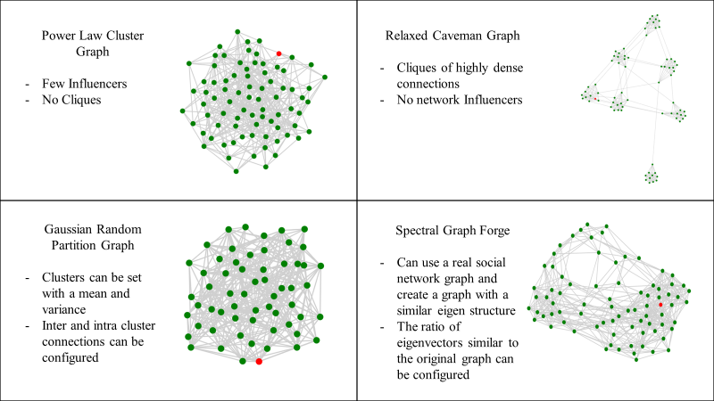

# Agent-Based Model Design

In our design we have accounted for designing the user in a social network who will be the agent along with the news events and the overall network structure. Each feature from the user or the news events has a corresponding function that generates the values of this feature according to its distribution function.

For the user, we have added a feature that determines the preferences for the user and assumes that the user’s personal preference will be on a spectrum where the user on one extreme can be fully in favor of the subject and on the opposite side of the spectrum can be fully against it. This means that the user can also have a neutral stand on the subject or a mild preference. For example, if we were to create a simulation of financial news, then we assume that every node created in the network is interested in financial news. The users and news sources that are not interested will simply not be considered since both news sources and users are not involved in that particular subject and do not have an interest to participate. The primary use of this feature is to extend the theory of the Illusory of Truth as the user will be likely to believe repetitive news shared in their circles if they happen to share the same core preferences.

The distribution function of user preferences is based on the gaussian distribution where the users preferences are likely to not be extreme, however, they will have a direction on the spectrum to be either in favor of the subject or against it. The values of the mean μ and standard deviation σ of the distribution can be altered for a more polarized network of users or a less polarized network as well. The following figure highlights the repetitive process of generating users with preferences where on the scale of [-1,1] of user preference, they will have a mean of either 0.5 or -0.5 with a standard deviation of 1.

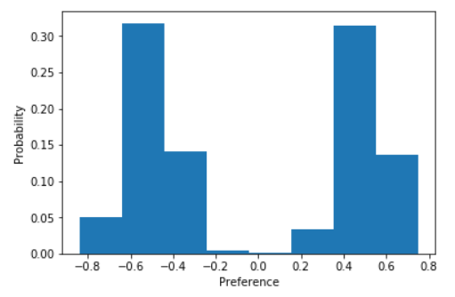

The table below contains a summary of the most important features we found in prior literature that would be required to classify a news article as fake or real:

|  |  |
| --- | --- |
| **Feature** | **Feature details** |
| Sentiment of the news article headline | Score is on a scale of (-5,-1) for negative sentiment and (1,5) for positive sentiment |
| Number of shares | Count of other users who have shared the news article. It must be a natural number. |
| Source credibility | A percentage that reflects the user’s perception about the source of the news article being a reliable reporting agency or not. |
| Analytical ability and motivation | A binary value where 1 means the user is analytical and motivated, and 0 means the user does not have the ability or motivation to analyze a news event. |

The flow chart below explains the steps of running our simulation on a high level. We consider each news event generated as a new step in the simulation:

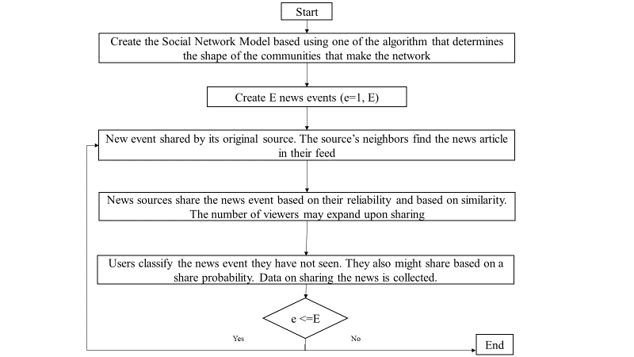

There are two main decisions the users make during every step. These decisions are whether the news event that is being shared on their news feed is fake or real, and if the user wants to share it or not. The decisions made by each user inherently affect others in the network which makes the problem of understanding the mass effect of fake news more complicated than a study on the individual level.

After a small period of when an event has passed through the network, the nature of previously shared news articles is revealed which mimics the idea that the nature of the news event it being fake or not becomes common knowledge across the mass with small individual exceptions. We do not expect this knowledge to have an effect on the bias of a user or a news sources at least on the short term. But we do observe the changes in beliefs over many steps and expect a change over a relatively longer period of time.

Agent class

Attributes

State->spammer or not

Fake news spread chance

Fake news check frequency chance

Recovery chance?

Methods

Try_to_spread_news

Try_to_fact_check

Try_to_check_situation

Step

Class Social Netowrk

Attributes

Number of nodes

Average node degree

Initial outbreak size

Fake news spread chance

Fake news check frequency

Recovery chance?

Probability ~ function of average node degree / number of nodes

Alogrithms for the network

Relaxed Caveman allows to create small communities that are connected

l (int) – Number of groups, which should be a fraction of num_nodes

k (int) – Size of cliques

p (float) – Probabilty of rewiring each edge.

Powerlaw Cluster Graph creates a graph according to the power law distribution and follows Holme and Kim algorithm:

n (int) – the number of nodes

m (int) – the number of random edges to add for each new node

p (float,) – Probability of adding a triangle after adding a random edge

seed (int, optional) – Seed for random number generator (default=None).

# H = nx.gaussian_random_partition_graph(n=100,s=10,v=10,p_in=.25,p_out=.1)

# H = nx.geographical_threshold_graph(200, 60)

Datacollector

Gets the spammers and other users

Methods

Fake news ratio

Step

Run_model