مهنتي · Mehnaty
Architecture
Features, technologies and how people use the app
Version: 1.0
Date: 12 October 2026
Audience: Management, product owners and technical leads
Companion document: Mehnaty – How to Run

Contents
- Summary
- Who uses the app
- Technologies used
- How the system is built
- Expected user behavior – whole app
- Features, use cases and expected behavior (one section per feature)
- API and Postman collection
- Missing features and open items
- Short glossary

1. Summary
Mehnaty (مهنتي) is a platform for home businesses. Customers find home-made products and services. Home-business owners show their work and manage orders, stock and costs. Suppliers sell raw materials to the owners. Deliveries are recorded and tracked. The whole interface is in Arabic, right to left.
Item | Value
Platforms | Web browser (PC and phone) and Android, from one app
Language | Arabic, right-to-left layout
Currency | Israeli shekel (₪, ILS)
Payment | Cash on pickup or delivery. No online payment.
Status | Working. 68 automated backend tests pass (12 Oct 2026).
Main documents in the project | README.md, docs/DECISIONS.md, docs/REQUIREMENTS.md, docs/FEATURES.md

2. Who uses the app
One account can have several roles. Every account is a customer. It becomes a business owner or a supplier when the person creates that profile.
Role | What they do
Visitor (not signed in) | Browses and searches offers, businesses, suppliers and materials. Compares. Uses the smart assistant.
Customer | Orders products and services, tracks orders and shipments, cancels while pending, reviews completed orders, reports bad content.
Home-business owner | Manages the business page, offers, photos and stock. Handles customer orders and deliveries. Buys raw materials. Records expenses and reads financial reports. Uses AI writing and summary helpers.
Supplier | Manages the supplier page and raw materials (units, minimum order, stock). Handles purchase orders from owners. Reads own sales report.
Platform admin | Suspends or activates accounts and profiles, handles abuse reports, manages categories, cities and carriers, watches platform numbers.
Delivery company (future) | No account today. Shipments are entered by hand. A direct connection can be added later.
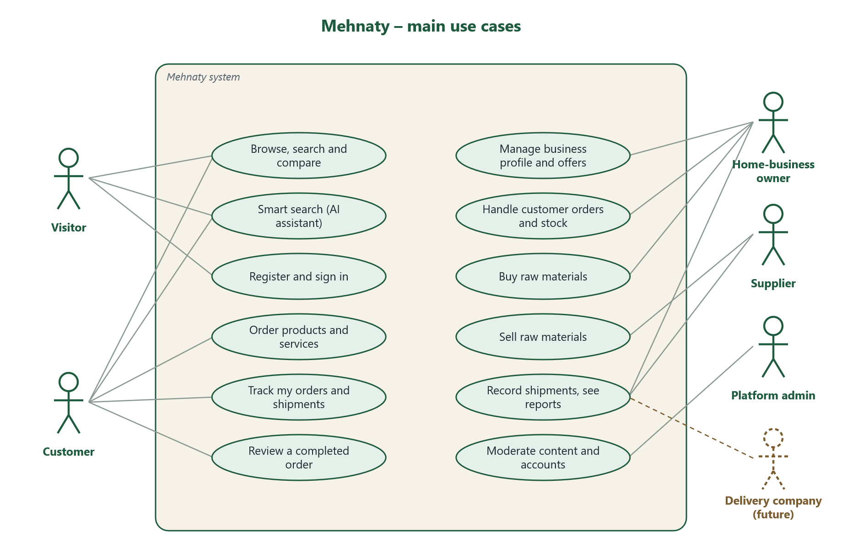
Figure 1 – Main use cases of the whole system

3. Technologies used
Part | Technology | Version | Why
App (web + Android) | React Native with Expo | Expo SDK 57, React Native 0.86, React 19.2 | One code base runs in the browser and on Android
App language | TypeScript | 6.0 | Catches mistakes before running
App screens | React Navigation | 7 | Tabs and screen-to-screen navigation
Arabic font | Cairo (Google font) | – | Clear Arabic text
Backend language | Python | 3.14 (3.12+ works) | Simple, popular, good libraries
Backend framework | Django (LTS) | 5.2.18 | Long-term support, built-in admin, security
API | Django REST Framework | 3.16 | Turns backend data into a JSON API for the app
Login tokens | SimpleJWT | 5.5 | Safe sign-in with short tokens and refresh
Database | PostgreSQL | 17 | Reliable, safe for stock and money data
Database driver | psycopg | 3.3 | Connects Django to PostgreSQL
Image checks | Pillow | 12.3 | Accepts only real JPEG/PNG/WEBP images
AI (optional) | Anthropic Claude API | SDK 1.13, model claude-opus-5-5 | Better Arabic understanding. App works without it.
Admin panel | Django admin (Arabic) | with Django | Ready-made admin screens
Run scripts | Windows batch + PowerShell | – | One command starts everything
API testing | Postman collection | v2.1 format | Try every API request by hand
All versions are locked: backend in backend/requirements.txt, app in mobile/package-lock.json.

4. How the system is built
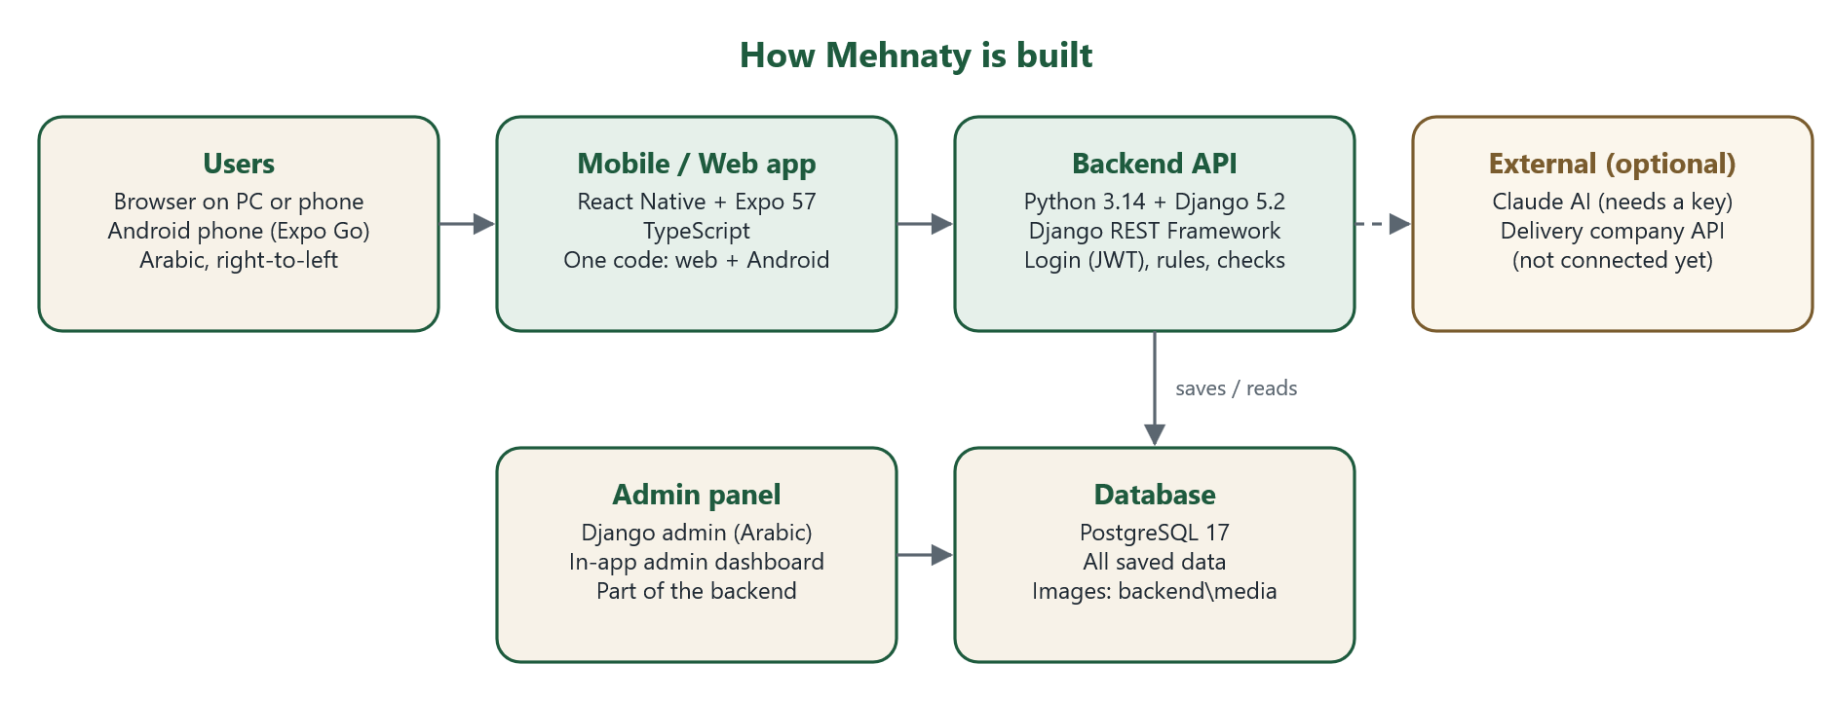
Figure 2 – Main parts of the system
- App: the screens people use. It holds no business rules; it asks the backend.
- Backend API: all rules live here: who may see what, order steps, stock, money math.
- Database: every record is saved in PostgreSQL. Photos are saved in backend/media.
- Admin: Django admin at /admin/ plus a small admin dashboard inside the app.
- External services: Claude AI is used only if a key is set. A delivery company API is not connected yet.

Project folders
Folder | Contains
backend/ | Django project. One module per area: accounts, catalog, suppliers, orders, inventory, shipping, reviews, notifications, reports, ai_assistant, core
mobile/ | Expo app. Screens in src/screens (public, auth, cart, account, orders, business, supplier, admin)
scripts/ | Start, database setup, stop and check scripts
docs/ | Decisions, requirements, feature checklist, these Word documents and diagrams (docs/diagrams)
postman/ | Postman collection and environment for the API
start.bat | One-command launcher

Safety built in
- Every request is checked on the server. Hiding a button is never the only protection.
- Passwords are hashed. Secrets are kept in backend/.env, never in code.
- Exact home addresses are private. Public pages show city and area only.
- Phone and WhatsApp are shown only if the owner agrees.
- Stock can never go below zero, even when two people buy the last item at the same time.
- Old orders keep the price and cost from the time of ordering.

5. Expected user behavior – whole app
These are the normal journeys. Menu names in Arabic are shown as they appear in the app.

Visitor
- Opens the app. Sees the home page: search box, categories, latest offers, featured businesses.
- Searches or uses filters, opens an offer, a business page or a raw material.
- May compare offers or ask the smart assistant «المساعد الذكي».
- To order, the app asks them to sign in or create an account.

Customer
- Signs in. Adds a private address in «حسابي ← عناويني» (needed for delivery).
- Adds items from one business to the cart «السلة», chooses pickup or delivery, confirms.
- Follows the order in «طلباتي». Gets in-app notifications when the status changes.
- Can cancel only while the order is still pending.
- After the order is completed, gives a 1–5 star review.

Home-business owner
- From «حسابي» creates a business profile: name, category, city, hours, pickup/delivery, photos.
- Adds offers: ready product (with stock), made-to-order product, or service.
- Receives new orders as notifications, accepts or rejects, moves them step by step to completed.
- For delivery orders: sets the delivery fee and records the shipment.
- Buys raw materials from suppliers through the materials cart.
- Records expenses and reads the financial report. Uses the AI helpers if wanted.

Supplier
- From «حسابي» registers as a supplier «سجّل كمورد» and fills the supplier profile.
- Adds raw materials with unit (metre, kg, piece…), price, stock and minimum order.
- Accepts purchase orders, prepares and ships them. The buyer confirms receipt.
- Reads the supplier report.

Platform admin
- Opens «حسابي ← لوحة مدير المنصة» or the Django admin at /admin/.
- Watches platform numbers, handles abuse reports, suspends bad accounts or profiles.
- Adds or edits categories, cities and delivery companies in the Django admin.

6. Features, use cases and expected behavior
Each feature below has: what it does, a use-case diagram (SVG) and the expected user behavior. The SVG files are also saved in docs/diagrams/.

6.1 Accounts and roles

What it does
- Register with email and password. Sign in, sign out, change password.
- Edit name, phone and city. Keep private delivery addresses.
- One account can become business owner and/or supplier by creating a profile.
- Admins can suspend an account; a suspended user cannot sign in.
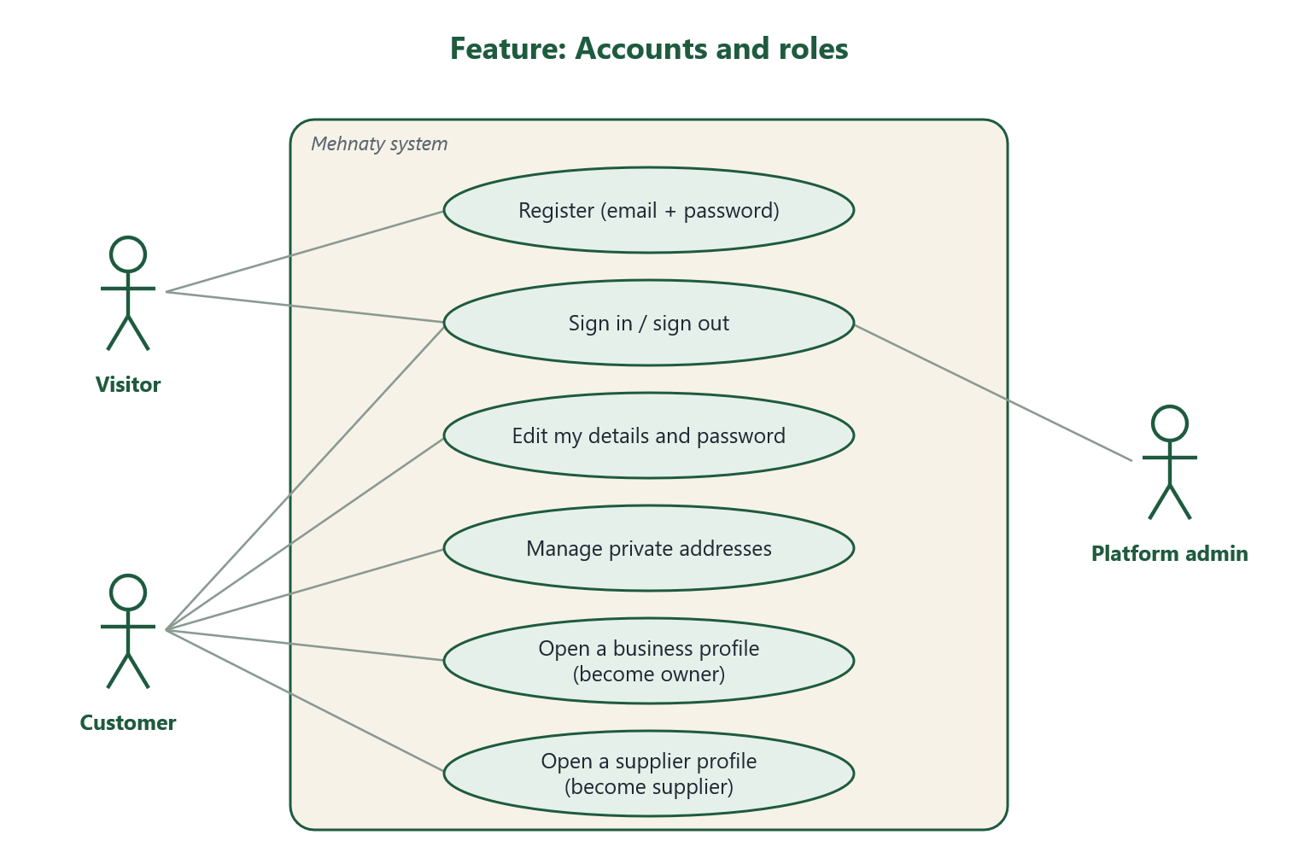
Figure 3 – Accounts and roles

Expected user behavior
- User taps «إنشاء حساب», enters name, email and a password of at least 8 characters.
- The app signs them in right away and keeps them signed in.
- User adds an address before the first delivery order.
- User opens a business or supplier profile only if they sell.

6.2 Business profile and offers

What it does
- Business page: name, description, category, city/area, hours, pickup/delivery, logo, work photos, rating.
- Three offer types: ready (has stock), made to order (no stock), service (no stock, optional date and duration).
- Up to 8 photos per offer. Only real images up to 5 MB are accepted.
- The owner’s cost per item is private and used only in reports.
- Deleting an offer hides it; old orders stay unchanged.
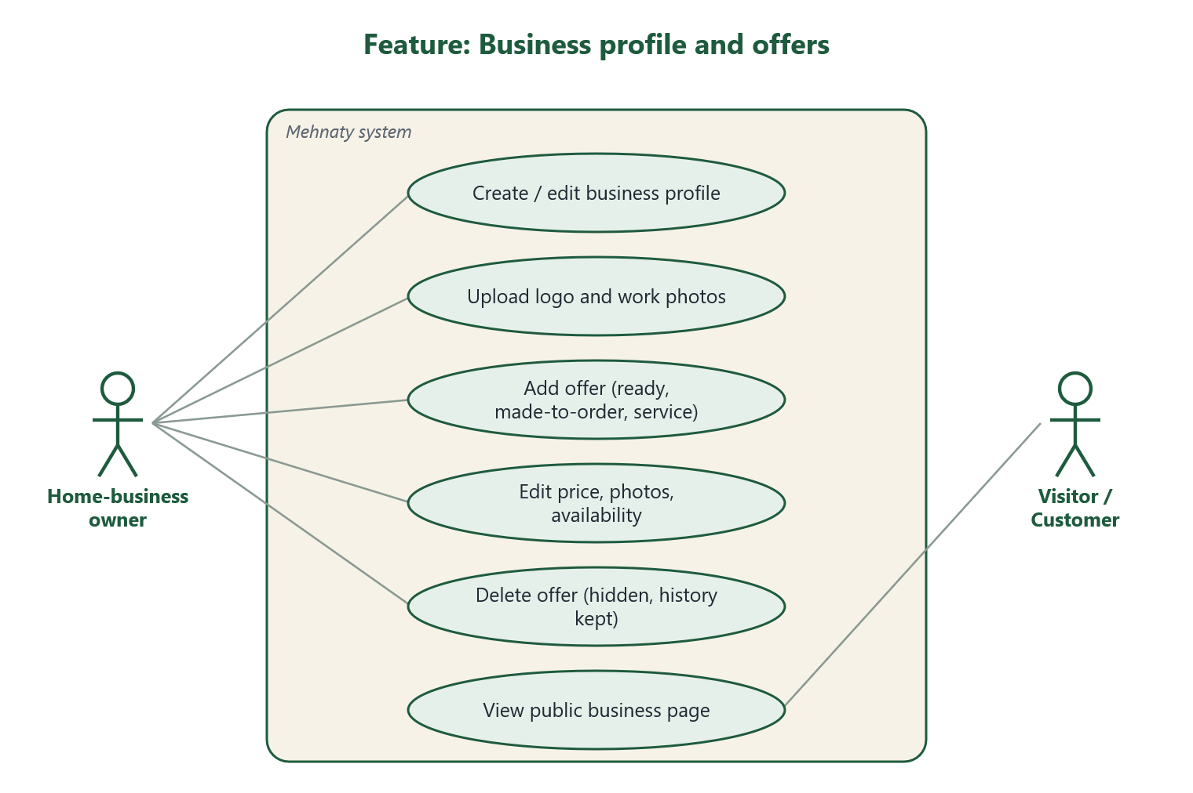
Figure 4 – Business profile and offers

Expected user behavior
- Owner fills the business profile and chooses at least one of pickup or delivery.
- Owner adds an offer with title, category, price, preparation days and, for ready items, the starting stock.
- Owner adds photos and checks the public page «عرض صفحتي العامة».
- Customers see only the city/area and, if allowed, the phone or WhatsApp.

6.3 Search, compare and smart assistant

What it does
- Normal search works without AI: keyword, category, city, area, price, rating, availability, preparation time, offer type, delivery, sorting.
- Arabic spelling differences are tolerated (أ/ا/إ, ة/ه, ى/ي).
- Compare 2–4 offers or materials side by side, with a warning if units differ.
- Smart assistant: the user writes a request in Arabic; the app turns it into filters and searches real records.
- It separates must-have conditions (e.g. max price) from preferences (e.g. city) and explains each result. It never invents products or prices.
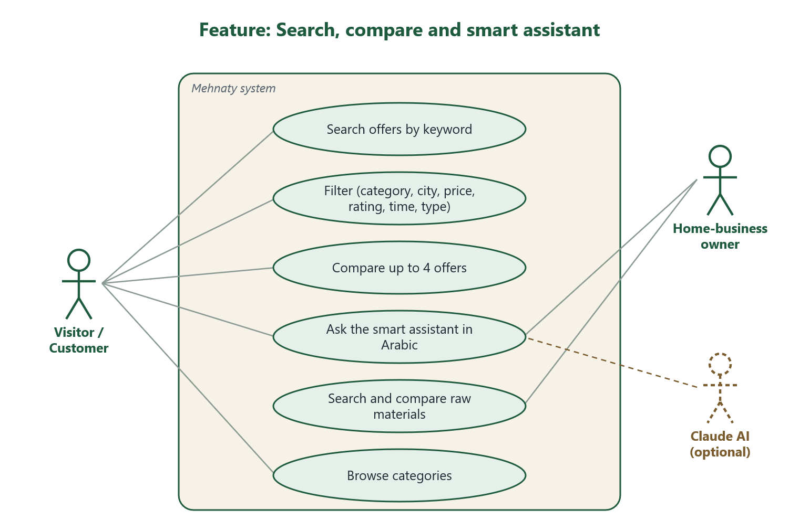
Figure 5 – Search, compare and smart assistant
Works without an AI key
Without a Claude key the assistant uses built-in Arabic rules. With a key it uses Claude, and falls back to the rules if Claude is down.

Expected user behavior
- User types a word or picks a category from the home page.
- User narrows results with filters, then opens an offer.
- User adds offers to compare and picks the best one.
- Or user writes: «أريد هدية مطرزة بأقل من 100 شيكل…» and reads the ranked results with reasons.

6.4 Customer orders (sales orders)

What it does
- One order = one business. Pickup or delivery. Optional preferred date for services.
- Prices and costs are saved in the order at ordering time.
- Ready items are reserved when the order is placed, released if it is rejected or cancelled, and sold when completed.
- Each role sees only the next steps it is allowed to do.
- The seller sets the delivery fee, who pays it, and whether it is final or an estimate.
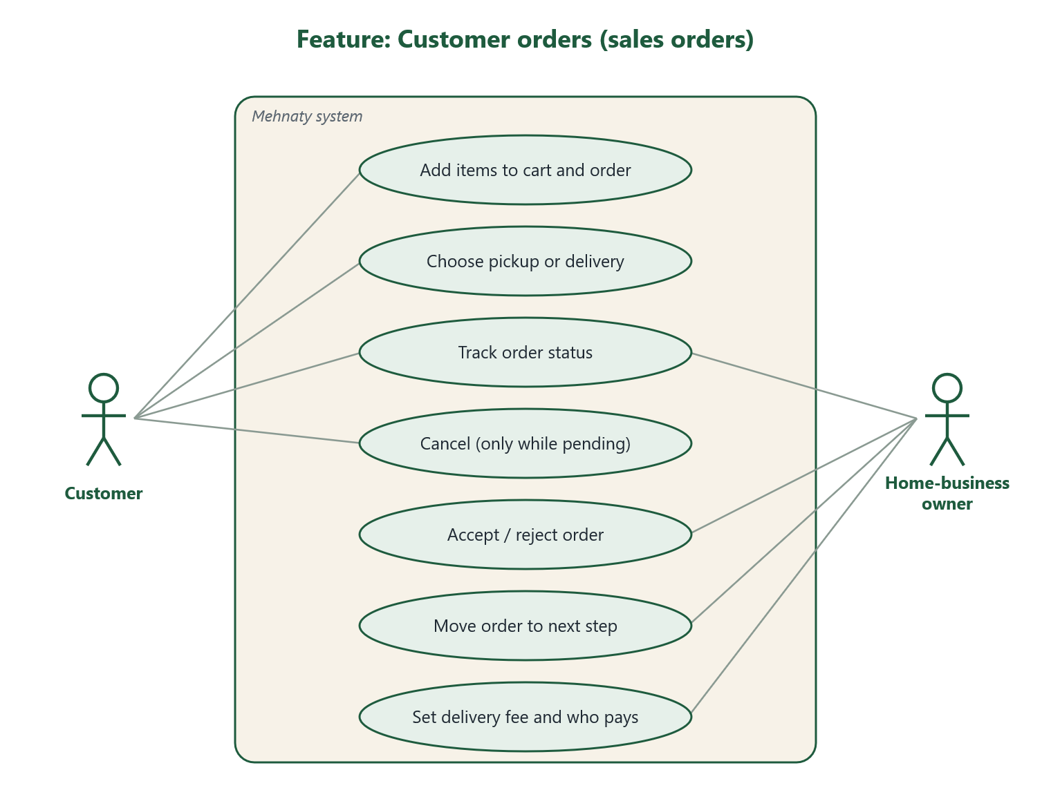
Figure 6 – Customer orders
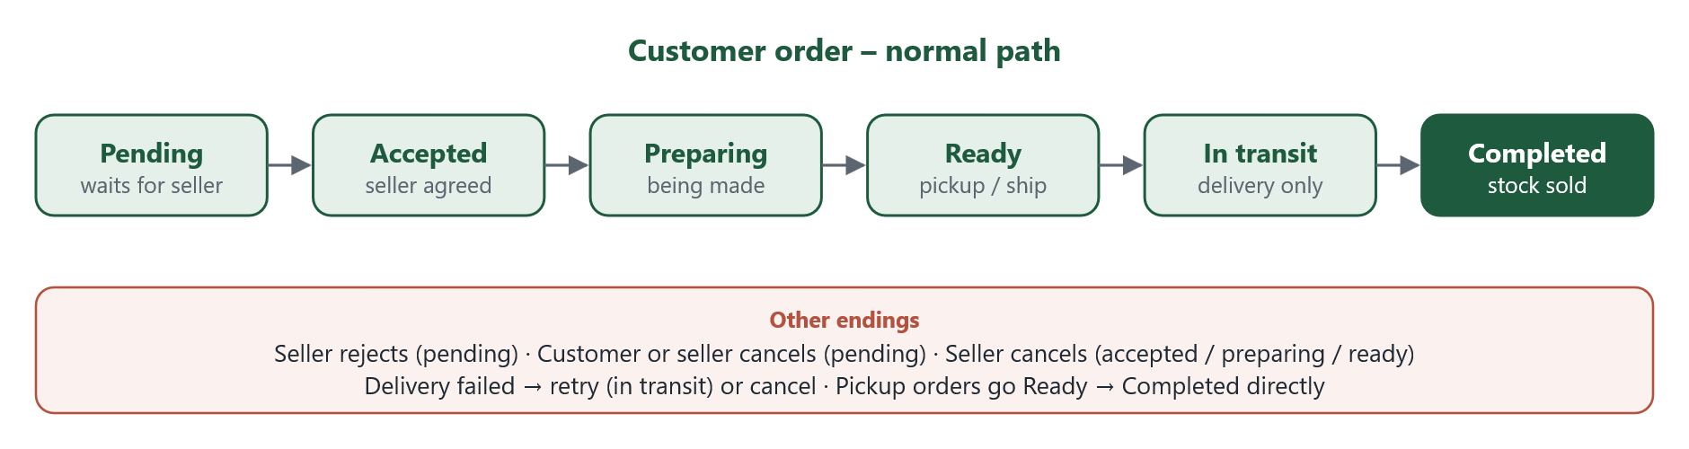
Figure 7 – Status steps of a customer order

Expected user behavior
- Customer adds items and confirms the order. Status: Pending.
- Seller accepts (or rejects), then marks Preparing, Ready, and Completed (or In transit for delivery).
- Customer follows the status and the history list in the order page.
- Customer can cancel only while Pending. After Completed, the customer can review.

6.5 Suppliers and raw-material purchases

What it does
- Supplier page with delivery cost and time. Materials with unit, specs, price, stock and minimum order.
- Owners search and compare materials, then order from one supplier per order.
- Quantity must be at least the minimum order. Stock is reserved, then deducted when shipped.
- Purchases are shown separately from sales in reports.
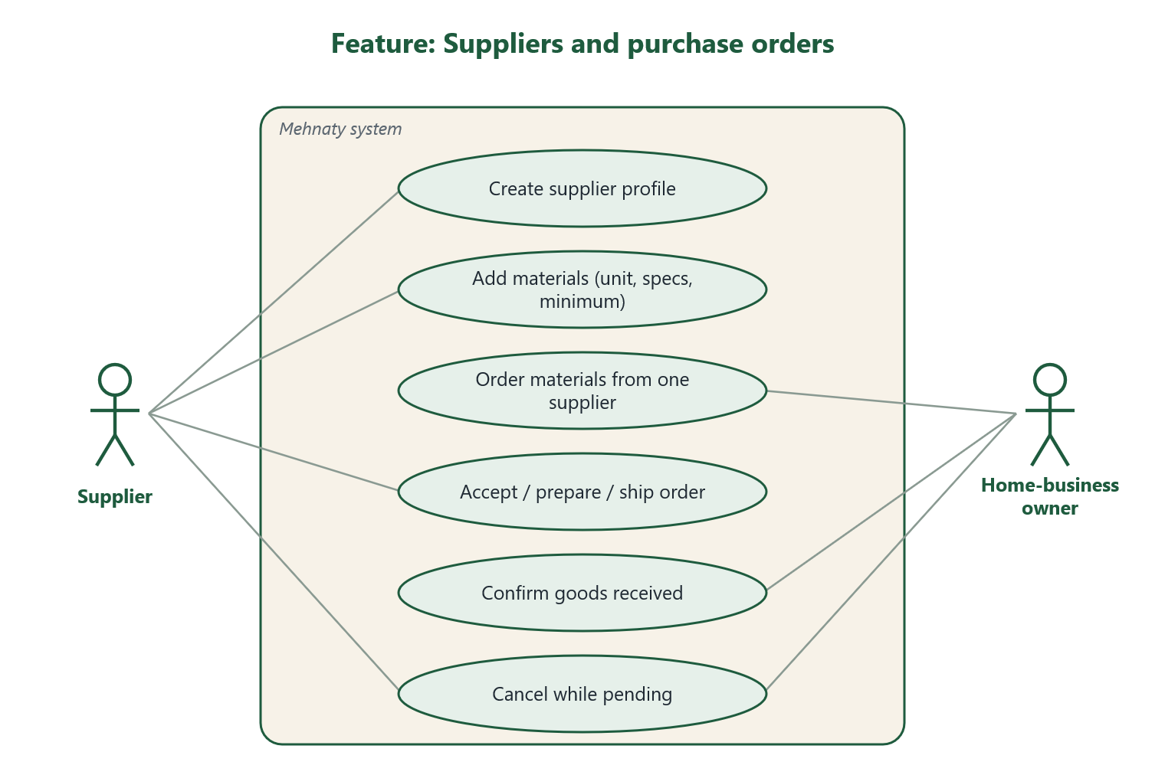
Figure 8 – Suppliers and purchase orders
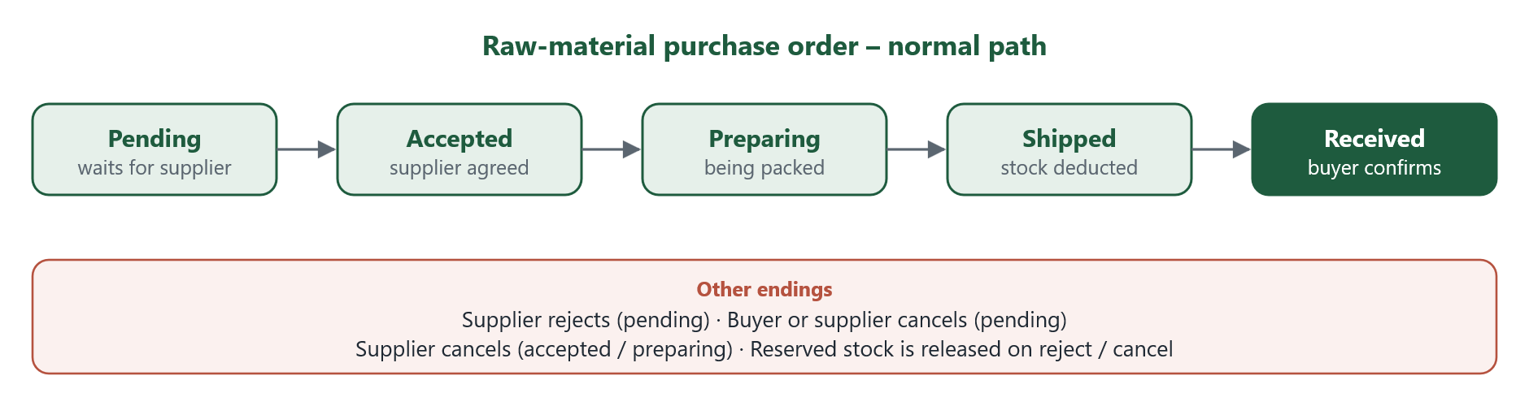
Figure 9 – Status steps of a purchase order

Expected user behavior
- Owner browses «المواد الخام», adds a material to the materials cart and confirms.
- Supplier accepts, prepares and marks Shipped.
- Owner confirms Received. Only then the supplier’s revenue counts.

6.6 Stock and shipments

What it does
- Owners and suppliers add or remove stock by hand; every change is logged with the reason.
- Low-stock alert when stock falls under the level the seller sets.
- Shipments are entered by hand: carrier name, tracking number, cost, expected date, status.
- One shipment per order. Repeating a request never creates a second shipment.
- Delivery company connection is prepared but not active (see section 8).
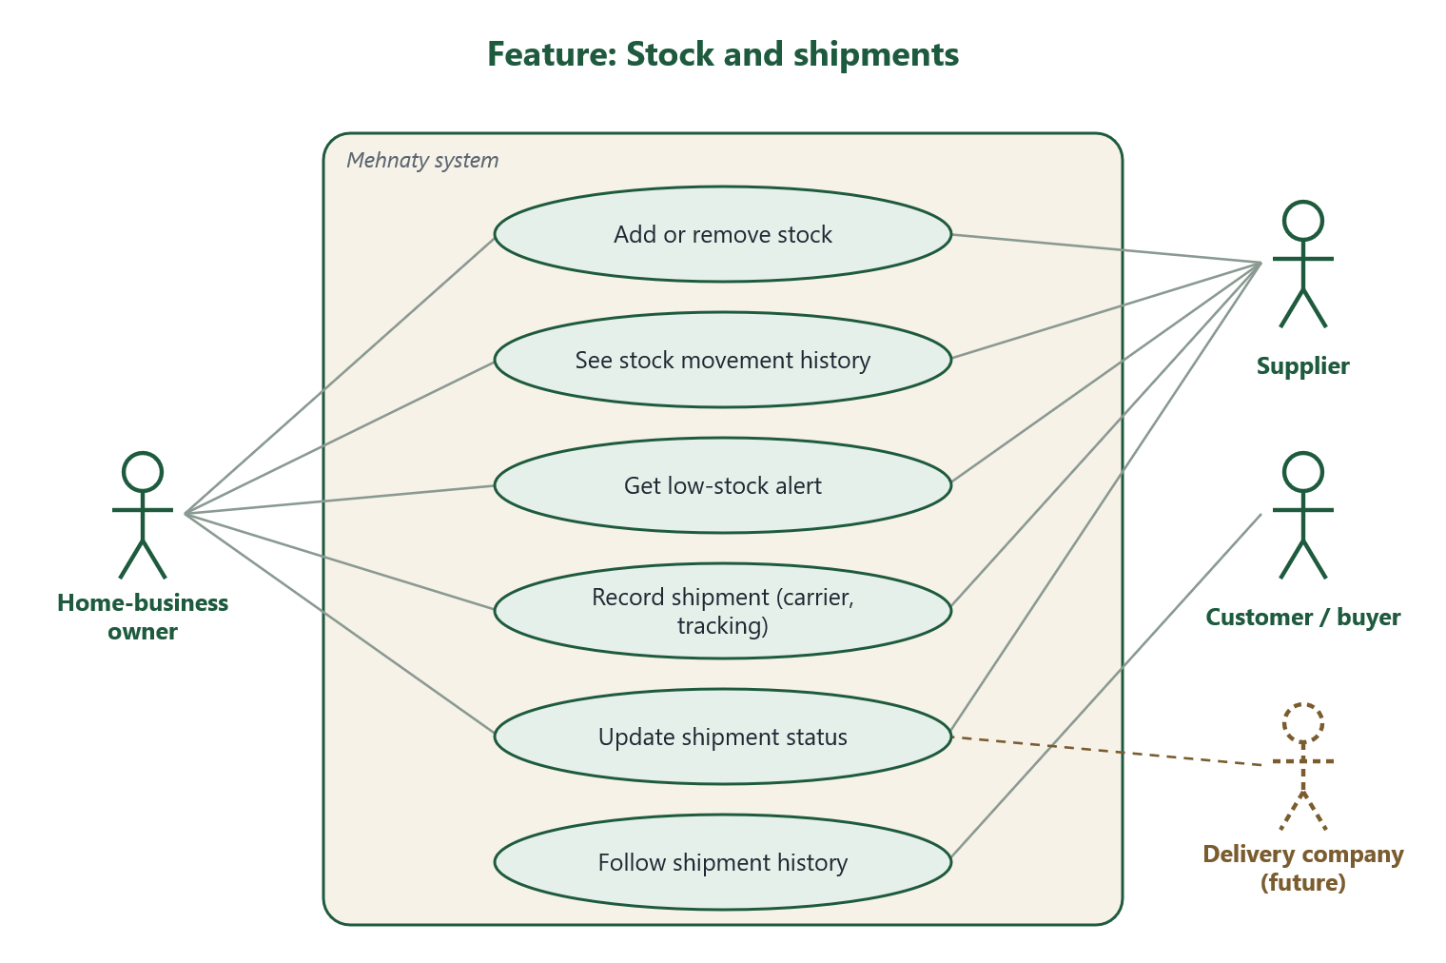
Figure 10 – Stock and shipments

Expected user behavior
- Seller opens an offer or material and adds stock when new items are ready.
- Seller sees a badge on «منتجاتي وخدماتي» when stock is low.
- For delivery, the seller records the shipment from the order page and updates its status.
- The buyer opens «الشحنات» to follow the shipment history.

6.7 Reviews, content reports and notifications

What it does
- One review (1–5 stars + comment) per completed order. Only that customer can write or edit it.
- Owners cannot edit or delete reviews; they can report them.
- Any signed-in user can report a review, offer, business, material or supplier.
- In-app notifications: new order, status change, low stock, shipment update, new review.
- A failed notification never breaks an order.
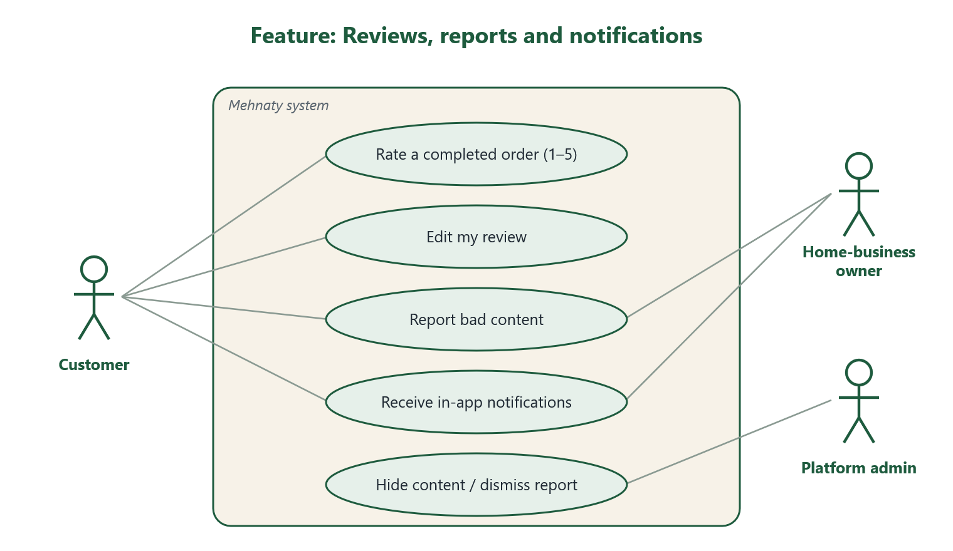
Figure 11 – Reviews, reports and notifications

Expected user behavior
- Customer opens a completed order and sends a star rating.
- User sees a badge on the bell icon and opens «الإشعارات».
- User reports bad content; the admin decides to hide it or dismiss the report.

6.8 Financial reports and AI helpers

What it does
- Business report per day, week, month or date range: revenue, cost of sold items, expenses, delivery paid by the business, estimated profit, best sellers, daily revenue chart.
- Estimated profit = completed revenue − recorded item cost − recorded expenses − delivery paid by the business. If some costs are missing the report says so.
- Expenses: packaging, delivery, commissions, used materials, other.
- Supplier report is separate from business figures.
- AI marketing draft from the offer’s real facts (never published automatically) and a short business summary. All numbers are calculated by code, not by AI.
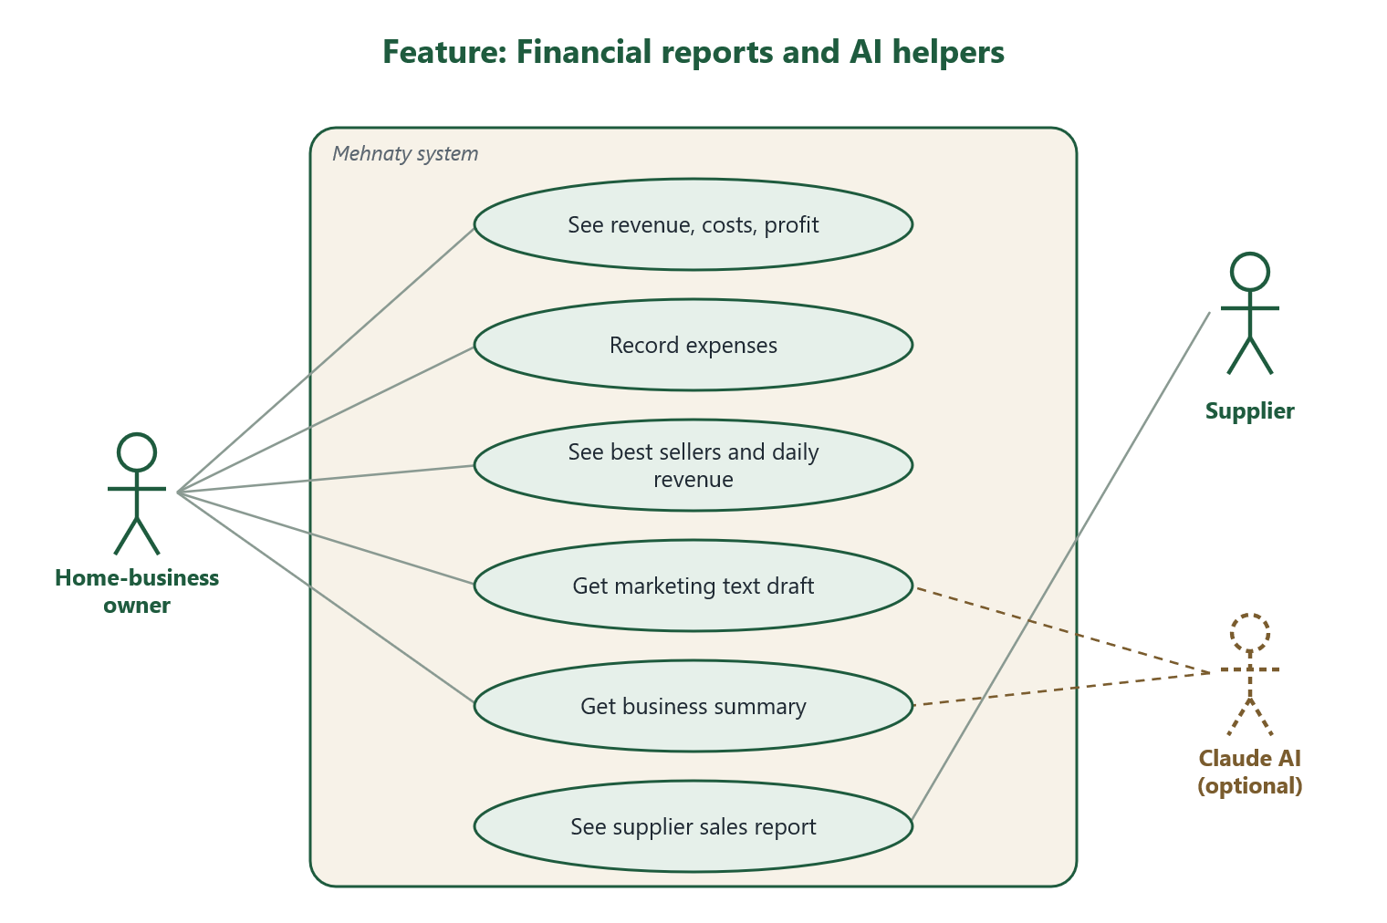
Figure 12 – Financial reports and AI helpers

Expected user behavior
- Owner opens «التقارير المالية والمصاريف» and picks a period.
- Owner adds expenses so the profit is more accurate.
- Owner taps «لخّص لي» for a short summary, or «اكتب لي مسودة» on an offer, reviews the text, then saves it.

6.9 Platform administration

What it does
- Dashboard numbers: users, businesses, suppliers, offers, materials, completed sales value, open reports.
- Suspend or activate accounts and business/supplier profiles.
- Handle abuse reports: hide content, mark handled, or dismiss.
- Manage categories, cities, areas and carriers in the Django admin.
- Admin actions are written to an audit log.
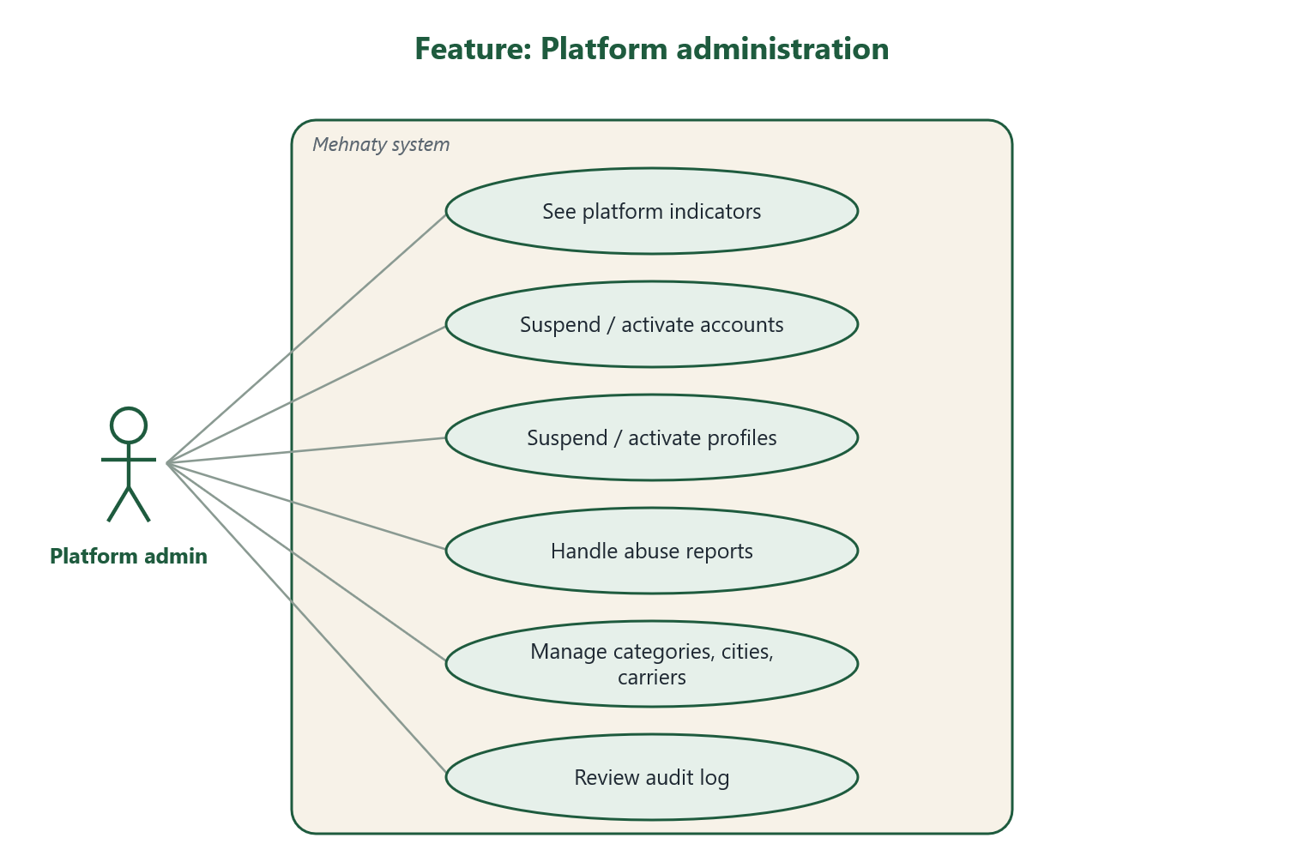
Figure 13 – Platform administration

Expected user behavior
- Admin opens the in-app dashboard daily and checks open reports.
- Admin decides each report and, if needed, suspends a profile.
- Admin uses the Django admin for lists like categories and cities.

7. API and Postman collection
The app talks to the backend through a JSON API under /api/. A Postman collection did not exist, so one was created.
File | Location (inside the project folder)
Collection (all requests) | postman/Mehnaty_API.postman_collection.json
Environment (local settings) | postman/Mehnaty_Local.postman_environment.json
Full API list (text) | docs/REQUIREMENTS.md (section "API")

Collection folders
Folder | Contents
0. Quick check (read-only) | Health, cities, categories, offers, AI status. Safe to run any time.
1. Auth | Register, login (saves tokens automatically), refresh, me, change password, logout
2. Browse and search | Offers, businesses, suppliers, materials, compare, reviews
3. Customer | Addresses, create/cancel order, review, report content, notifications, shipments
4. Home-business owner | Profile, offers, photos, stock, orders, delivery terms, shipments, purchases, expenses, reports, AI
5. Supplier | Profile, materials, stock, purchase orders, report
6. Smart assistant (AI) | Smart search for offers and materials
7. Platform admin | Indicators, users, profiles, abuse reports, categories
Tested on 12 Oct 2026 with the Postman CLI against the local API: 13 requests (quick check, login, account, orders, notifications, search, compare, smart search) – all passed.
How to use it: see the companion document "Mehnaty – How to Run", section "Postman".

8. Missing features and open items
Compared with the two requirement documents (تطبيق مهنتي.docx and ar_problem.docx), these items are not done or not fully checked.

Not built
Item | Why | What is needed
Online payment | Not requested yet; no gateway chosen | Payment rules + a payment provider
Real delivery company connection | No company or credentials given | Company API docs and keys; add an adapter in backend/shipping/carriers.py
Email and push notifications | Planned for a later phase | Email service (SMTP) and/or Expo push setup
"Forgot password" (reset by email) | Needs an email service | Email service, then a reset screen
In-app chat with the seller | Not in first release | Today: public phone/WhatsApp (with consent) and order notes
Full booking calendar for services | Only a preferred date is supported | Booking rules (slots, duration, confirmation)
One purchase order from many suppliers | One supplier per order by design | Decision to allow multi-supplier carts
Installable Android app (APK) and store release | Today it runs through Expo Go | Expo/EAS account, signing, Play Store account
Public deployment | Runs on one PC only | Server, domain, HTTPS certificate
Automated tests for the app screens | Only a TypeScript check exists | UI test tool (e.g. Jest / Playwright)

Built but not fully checked
Item | Status
Claude AI live calls | Code ready and safe fallback tested; not run with a real key
Android on a real phone | Same code as web; not tested on a device
iOS | Not requested and not tested

Future ideas from the project study
- Official check of skills and certificates of providers.
- Guarantee or insurance on services.
- Subscriptions or paid ads.
- More regions and markets.

9. Short glossary
Word | Meaning
API | The door the app uses to ask the backend for data
Backend | The server program that holds the rules and talks to the database
JWT token | A short-lived digital pass the app gets after sign-in
Expo Go | A free Android app that runs Mehnaty during development
Soft delete | Hidden from users but kept for history
Reservation | Stock held for an order that is not finished yet
Postman | A tool to send API requests by hand
SVG | A picture format that stays sharp at any size

