

**ITI**

**Embedded System Track**

**TEAM MEMBERS**

1. **Abdullah Nassar**
2. **Ahmed Samir Salem**
3. **Fakhreldin Ibrahim**
4. **Ahmed Ali Elyousfy**
5. **Ahmed Sherif Salem**

**ADAS MULTI MODES SYSTEM**

**Supervised By**

**Yousef Nofal**

**2023**

**TABLE OF CONTENTS**

CHAPTER 1 1

1.1 INTRODUCTION 3

1.2 OUR Project 4

1.3 Project State Machine 4

CHAPTER 2

2.1- What is [Adaptive](#_bookmark4) Cruise Control 5

2.2-ACC Flow Chart 5

2.3- ACC Layered Architecture 5

CHAPTER 3

3.1- What is LKA 5

3.2-LKA Flow Chart 5

3.3- LKA Layered Architecture 5

3.4- What is LDW 5

3.4.1-LDW Flow Chart 5

3.4.2- LDW Layered Architecture 5

CHAPTER 4

4.1- AEB 5

4.2-AEB Flow Chart 5

**CHAPTER 1**

# 1.1 INTRODUCTION

ADAS stands for Advanced Driver Assistance Systems. These are technologies designed to assist and enhance vehicle safety by providing functions such as lane-keeping assistance, adaptive cruise control, collision avoidance systems, and more. ADAS features often use sensors, cameras, and radar to monitor the vehicle's surroundings and provide real-time feedback to the driver or even take corrective actions autonomously.

ADAS technologies play a crucial role in improving road safety and reducing the risk of accidents. They can help drivers by providing warnings or intervening in critical situations, such as emergency braking or steering assistance. As technology advances, ADAS is evolving towards more sophisticated systems, contributing to the development of semi-autonomous and autonomous vehicles. However, it's important for users to stay informed about the capabilities and limitations of these systems and to remain vigilant while driving.

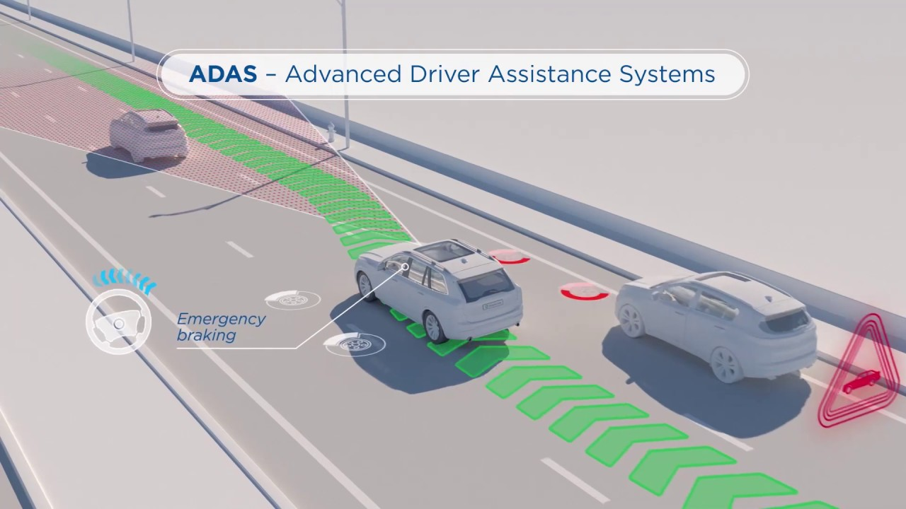

**Some common features of ADAS include:**

1-Adaptive Cruise Control (ACC): Adjusts the vehicle's speed to maintain a safe following distance from the vehicle ahead.

2-Lane Departure Warning (LDW) and Lane-Keeping Assist (LKA): Warns the driver if the vehicle unintentionally drifts out of its lane and may provide corrective steering input.

3-Automatic Emergency Braking (AEB): Monitors the road ahead and can apply the brakes if a collision is imminent, helping to avoid or mitigate the severity of a crash.

4-Lane-Keeping Assist (LKA): When LKA is engaged, it goes a step further than LDW by actively providing steering input to help the driver stay within the lane. If the system detects an unintentional lane departure and the driver doesn't take corrective action, LKA can apply steering force to bring the vehicle back into the lane.

5-Blind Spot Detection (BSD): Alerts the driver if there is a vehicle in their blind spot, typically with visual or audible warnings.

6-Parking Assistance: Helps drivers park their vehicles by providing guidance or even automatically steering the vehicle into a parking space.

7-Forward Collision Warning (FCW): Warns the driver of an imminent collision with a vehicle or obstacle in its path.

# 1.2 Our Project

We implemented four modes of ADAS which are: ACC, AEB, LKA, LDW

We used the following hardware components:

1-Raspberry Pi 3B

2-STM32F401RCT6 Micro-controller

3-Ultrasonic Sensor

4-Bluetooth

5-IR Sensor

6-H-Bridge

7-Motors

8-Camera

# 1.3 Project state Machine

**CHAPTER 2**

**Adaptive Cruise Control (ACC)**

# 2.1 What is Adaptive Cruise Control

Adaptive Cruise Control (ACC) is an advanced driver-assistance system that enhances traditional cruise control by automatically adjusting a vehicle's speed to maintain a safe following distance from the vehicle in front. Unlike traditional cruise control, which requires the driver to manually set a constant speed, ACC uses sensors to monitor the traffic environment and make real-time adjustments to the vehicle's speed and throttle.

**How ACC works:**

1. Sensors: ACC relies on various sensors, such as ultrasonic radar, lidar, or cameras, to monitor the road and traffic ahead. These sensors provide information about the distance and relative speed of the vehicle in front.

2. Set Speed and Following Distance: The driver can set a desired speed and following distance. The following distance is the minimum gap the driver wants to maintain between their vehicle and the one in front.

3. Speed Adjustment: ACC uses the sensor data to automatically adjust the vehicle's speed. If the road is clear and there is no vehicle in front, the vehicle will maintain the set speed. However, if a slower-moving vehicle is detected in the same lane, ACC will reduce the speed to maintain the preset following distance.

4. Throttle and Braking Control: ACC can adjust the throttle and, if necessary, apply the brakes to slow down or speed up the vehicle. It aims to keep the vehicle within the desired following distance without the driver's direct intervention.

5. Resume and Cancel: The driver can typically resume manual control by either tapping the accelerator, brake, or deactivating the ACC system. Additionally, the driver can cancel ACC at any time if they want to regain full control of the vehicle.

Adaptive Cruise Control is a valuable feature for highway driving and long-distance trips, as it reduces the need for constant speed adjustments and helps promote a more relaxed and safe driving experience. It's important to note that ACC is a driver-assistance system and not a fully autonomous driving feature, so the driver must remain attentive and be ready to take control of the vehicle when necessary. Different vehicle manufacturers may have their variations and names for this technology, such as "Dynamic Cruise Control" or "Intelligent Cruise Control," but the underlying principles are generally the same.

# 2.2 ACC Flow Chart:

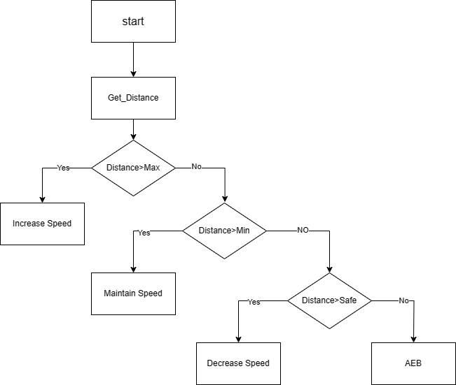

2.3 ACC layered Architecture **:**

**

**CHAPTER 3**

**Lane Keeping Assist-IR Sensor**

3.1 What is LKA  
Lane keeping assist (LKA) is a driver assistance system that helps the driver keep the vehicle within the lane markings. It works by using sensors to detect the lane lines and then steering the vehicle back into the lane if it starts to drift. LKA systems can use a variety of sensors, such as cameras, radar, and lidar. However, one of the simplest and most cost-effective ways to implement LKA is to use two IR sensors.

**How LKA works:**

To implement LKA using two IR sensors, the sensors are mounted on the front of the vehicle, one on each side. The sensors are positioned so that they are pointing at the lane lines.

The LKA system then continuously monitors the output of the two sensors. If both sensors are detecting black, then the vehicle is within the lane markings and the LKA system does nothing.

However, if one of the sensors detects white, then the vehicle is starting to drift out of the lane.

In this case, the LKA system will steer the vehicle back into the lane.

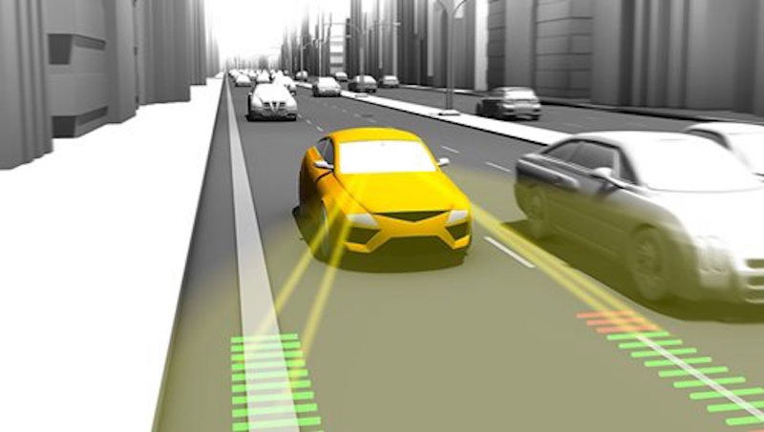

Benefits of lane keeping assist:

* Reduces the risk of lane departure accidents.
* Improves driver safety.
* Reduces driver fatigue.
* Improves fuel efficiency.

Limitations of lane keeping assist:

* May not work well in all conditions, such as when lane markings are not clear or when there is a lot of debris on the road.
* May not be able to detect lane lines correctly in curves or on hills.
* May not be compatible with all vehicles.

# 3.2 LKA-IR Sensor Flow Chart:

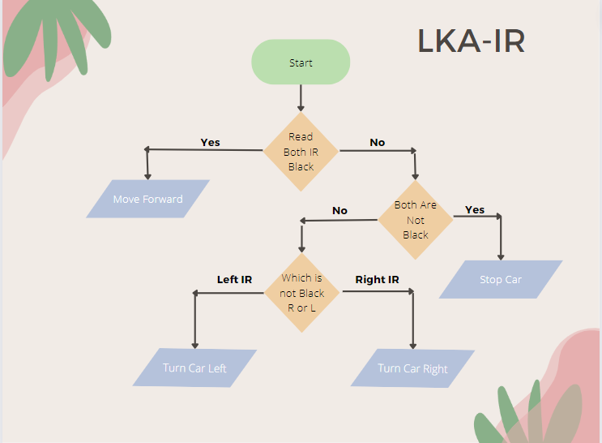

# 3.3 LKA-IR layered Architecture:

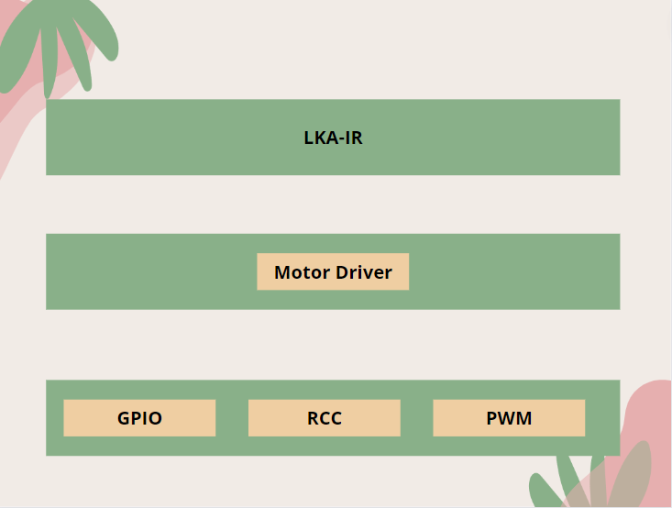

# 3.4 What is LDW

Lane departure warning (LDW) systems are safety features in vehicles that alert the driver if the vehicle is about to depart its lane.

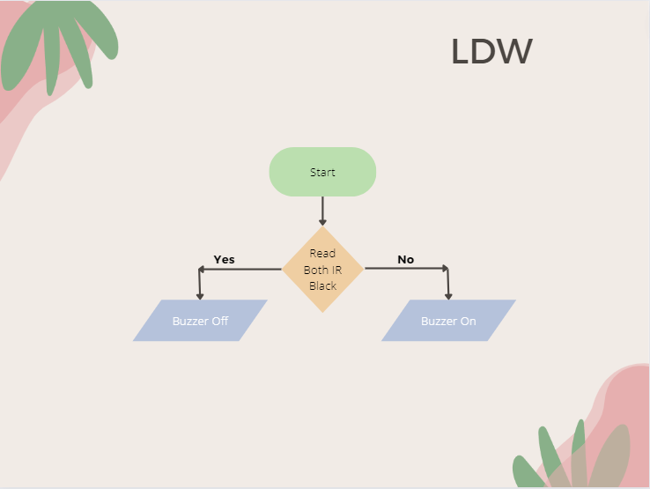3.4.1 LDW Flow Chart**:**

# 3.4.2 LDW layered Architecture:

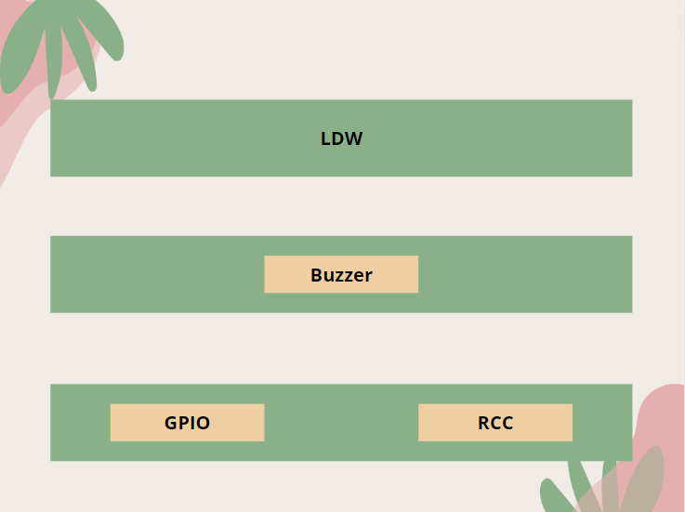

**CHAPTER 4**

# 4.1 AEB

AEB stands for Automatic Emergency Braking. It is a safety feature in vehicles designed to help prevent or mitigate collisions by automatically applying the brakes in certain situations where a frontal collision seems imminent. AEB systems use sensors, such as radar, cameras, or lidar, to monitor the road ahead and detect objects, vehicles, or obstacles in the vehicle's path.

Here's how Automatic Emergency Braking typically works:

Detection of Potential Collision: The system continuously monitors the road and identifies potential collision risks, such as a slower-moving or stopped vehicle, a pedestrian, or another obstacle. Warning to the Driver: Before taking any action, the AEB system may issue a warning to the driver, typically through visual or audible alerts, to prompt them to take evasive action.

Automatic Braking: If the driver does not respond or take sufficient action, the AEB system can autonomously apply the brakes to either reduce the severity of the collision or, in some cases, prevent it altogether.

AEB is an important component of Advanced Driver Assistance Systems (ADAS) and is considered a significant advancement in vehicle safety technology. It has the potential to mitigate or avoid collisions, especially in situations where a driver may be distracted or unable to react quickly enough.

As with other ADAS features, the performance, and capabilities of AEB systems can vary between different vehicle models and manufacturers. It's crucial for drivers to be aware of the specific functionality of AEB in their vehicles and to understand its limitations.

# 4.1 AEB Flow Chart

