TriageDesk — AWS Deployment Evidence
Production-style AWS lab documenting networking, security, database migration, load balancing, resilience, and auto scaling.
Final AWS architecture
Network  VPC across 2 AZs  Public / App / DB tiers | Compute  Golden AMI + Launch Template  ASG min 2 / max 4 | Data  Private RDS PostgreSQL  Public access disabled | Traffic  Internet-facing ALB  Path-based routing
Security  SG chaining + SSM  No SSH / no public EC2 IP | Secrets  Parameter Store  SecureString DB password | Resilience  ALB health checks  Self-healing tested | Scaling  CPU target tracking  50% target + scale-in/out
Scope: Evidence captured from the implemented AWS environment. The document intentionally focuses on the final design and validation results rather than every console click.

1. Final Architecture
The application tier is private and replicated across two Availability Zones. The ALB is the only public application entry point; state is centralized in private RDS.
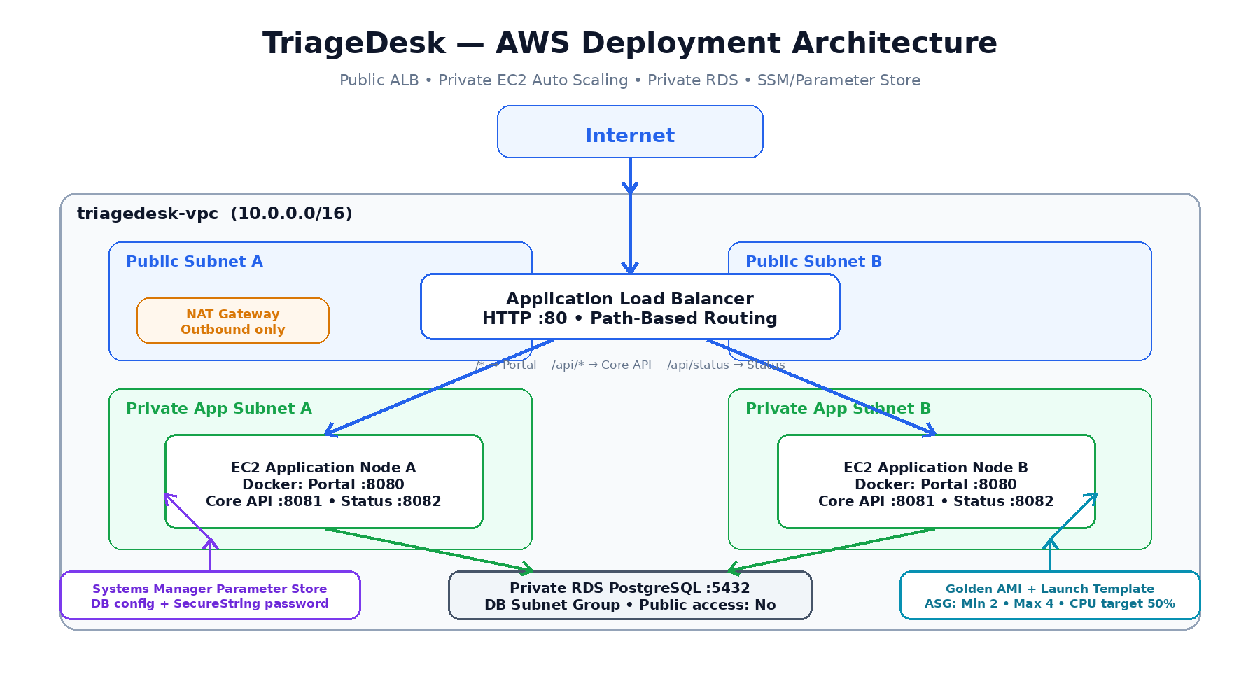
Final TriageDesk AWS architecture — ALB + private ASG application nodes + private RDS, with Golden AMI/Launch Template automation and Parameter Store configuration.

2. VPC & Subnet Segmentation
Six subnets separate public ingress, private application compute, and the database tier across two Availability Zones.
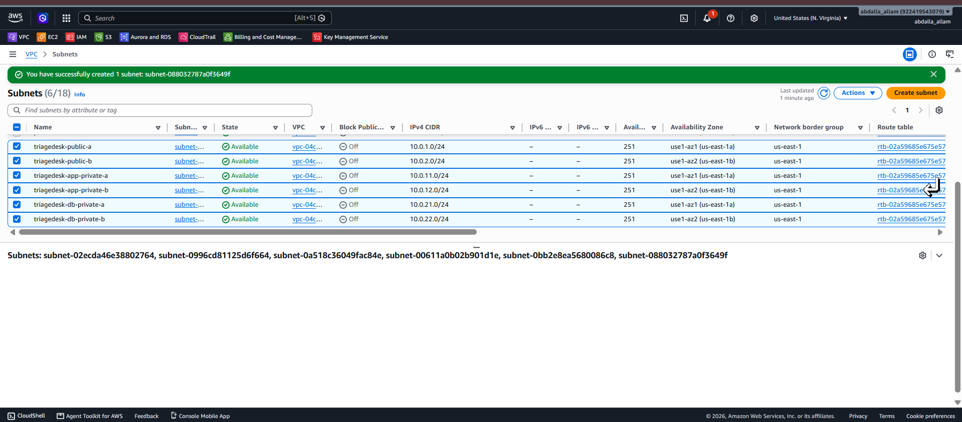
VPC subnet layout: two public, two private application, and two private database subnets.

3. Routing & Internet Egress
Public subnets route to the Internet Gateway. Private application subnets use NAT for outbound access, while database subnets remain isolated from direct internet routing.
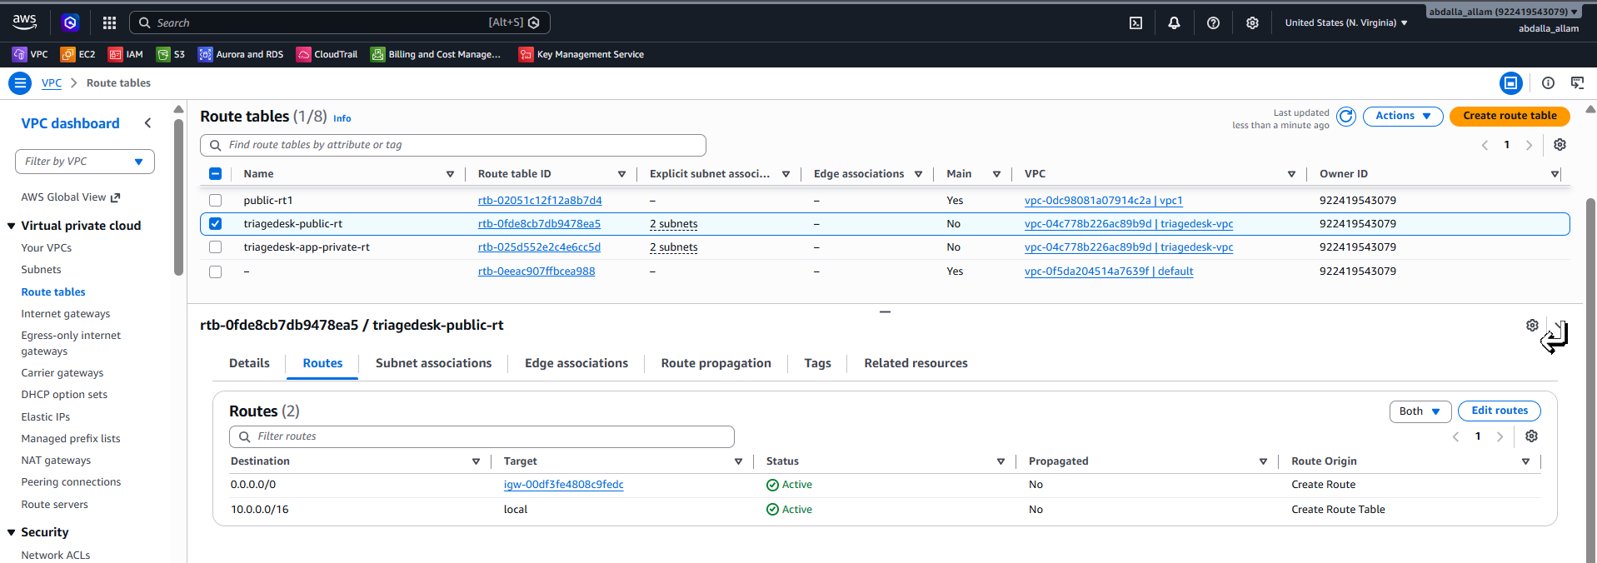  Public route table — internet route via IGW. | 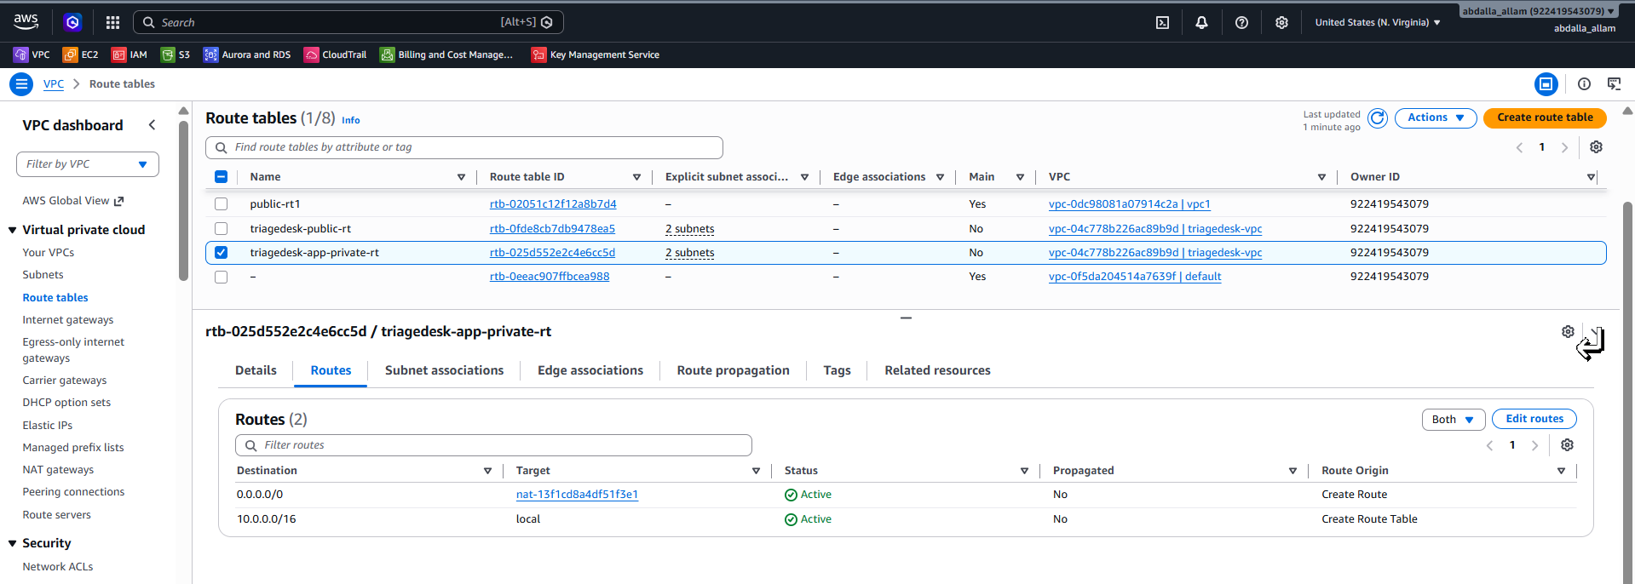  Private application route table — outbound route via NAT Gateway.
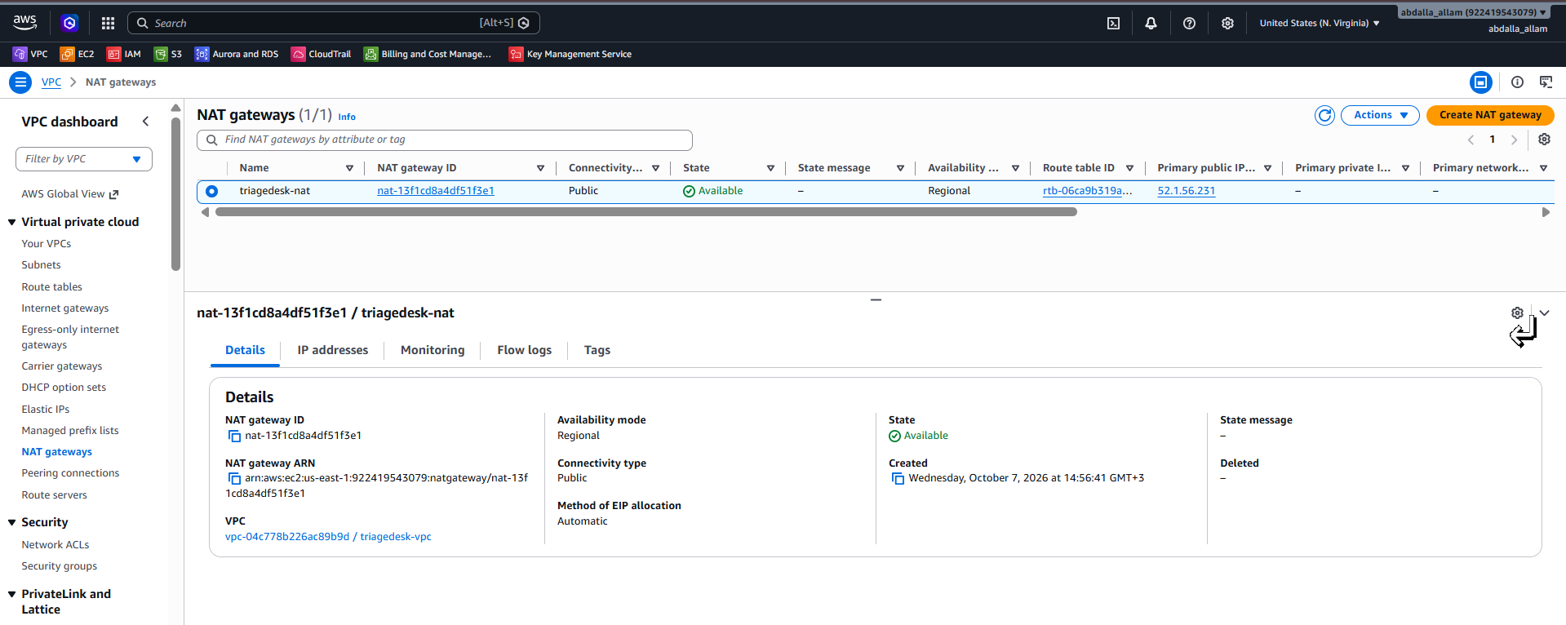
NAT Gateway available in the public tier for outbound-only access from private application instances.

4. Security Group Chaining
Traffic is constrained by security-group references rather than broad IP exposure.
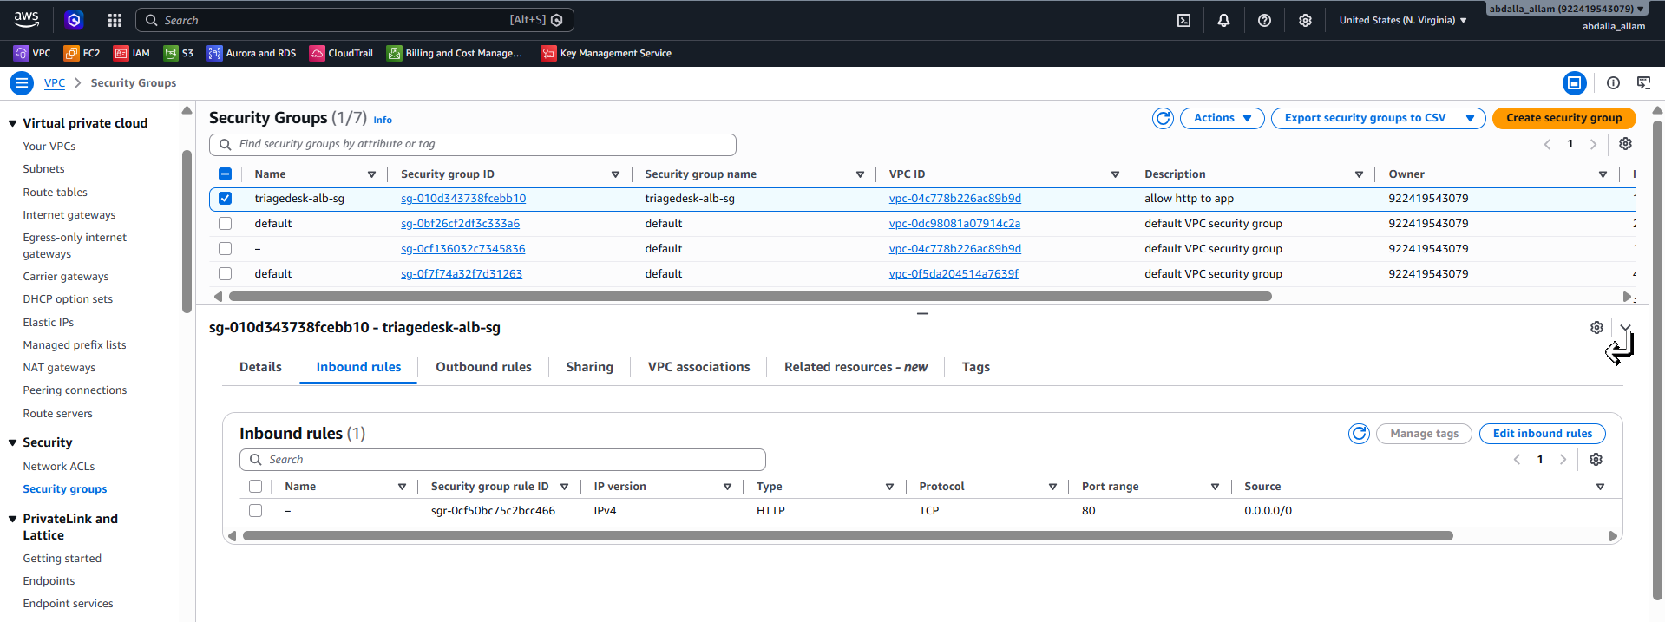  ALB security group — public HTTP ingress. | 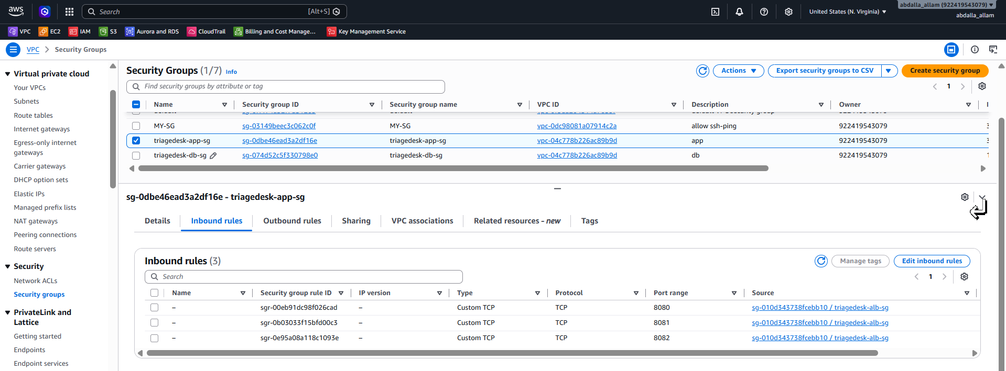  Application security group — ALB-only access to application ports.
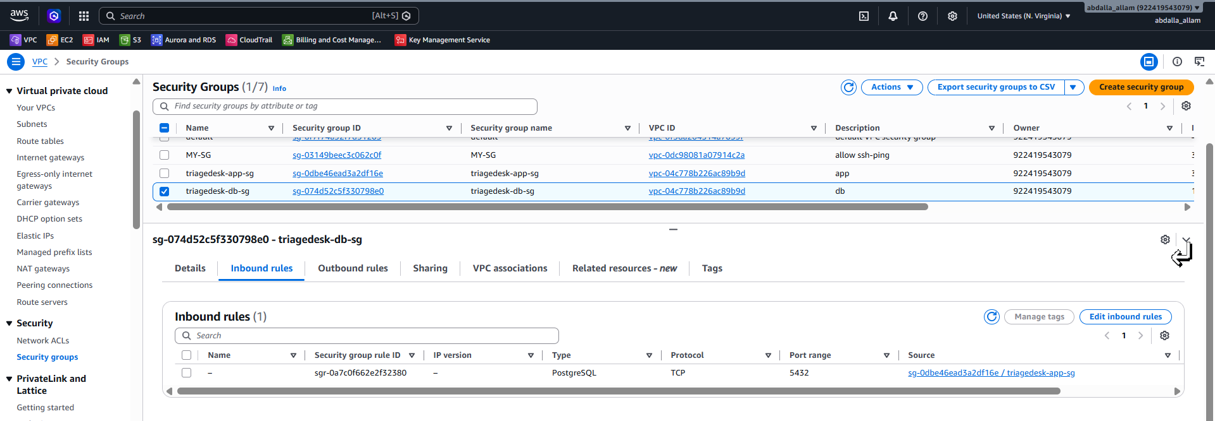
Database security group — PostgreSQL 5432 allowed only from the application security group.

5. Private EC2 Management & Runtime Baseline
Instances are administered through Systems Manager rather than public SSH. The Golden AMI baseline contains Git, Docker, Compose, Buildx, and AWS CLI.
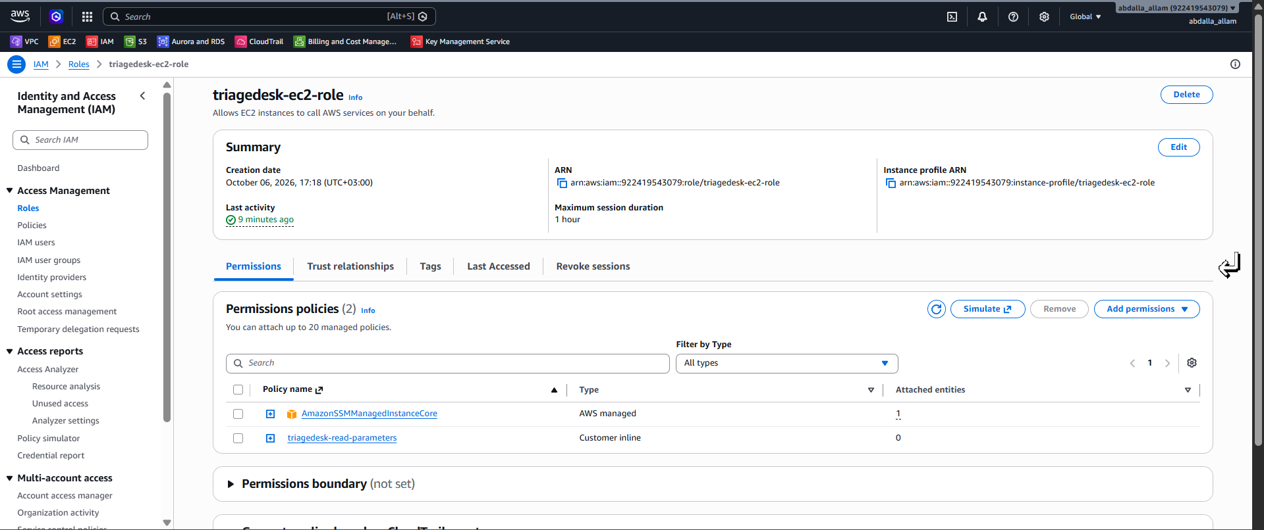  EC2 IAM role with Systems Manager permissions. | 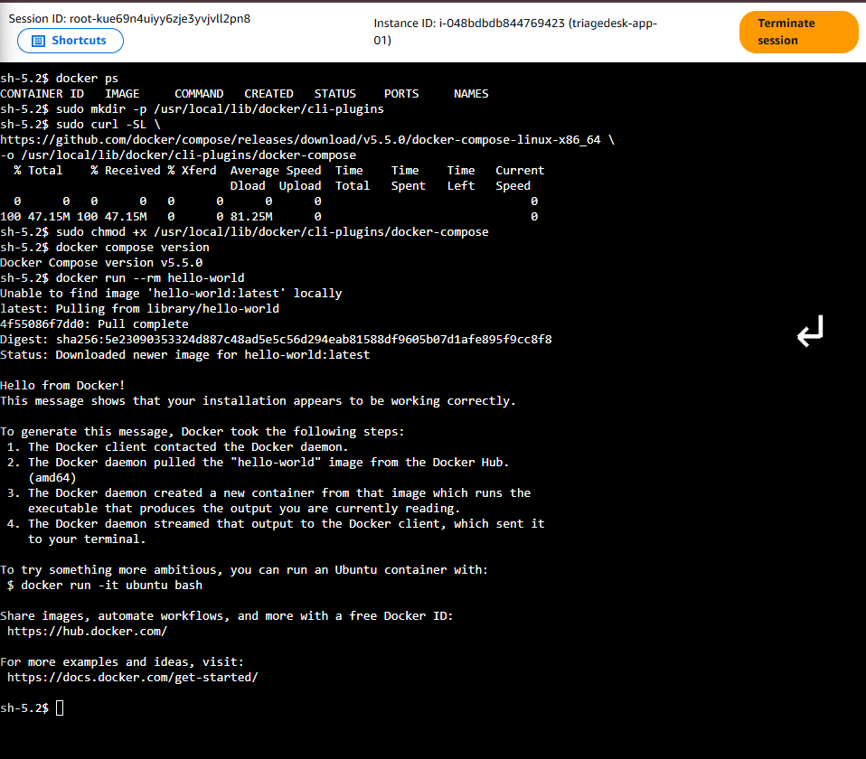  Docker / Compose validation on the private EC2 instance.
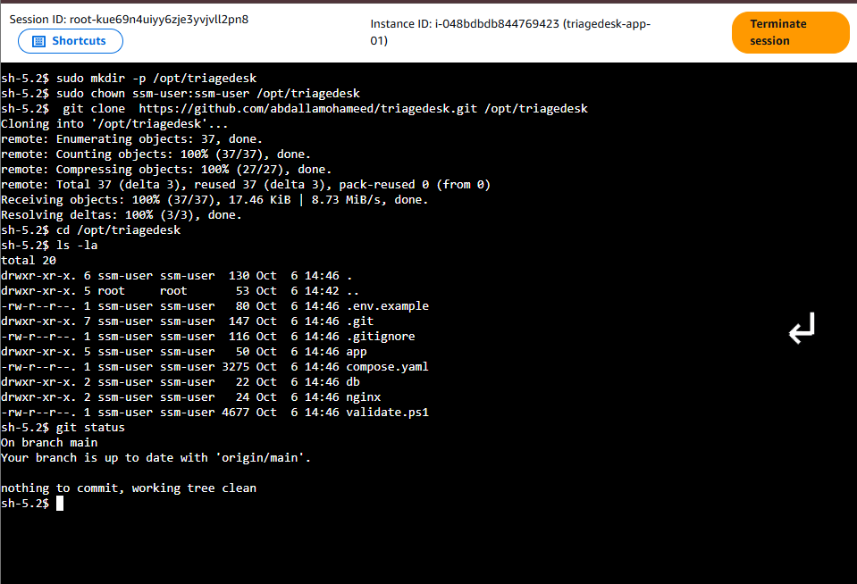
Application repository cloned from GitHub into /opt/triagedesk on the private instance.

6. RDS PostgreSQL Migration
PostgreSQL state was moved out of the EC2/Docker node into private Amazon RDS, making application nodes replaceable and horizontally scalable.
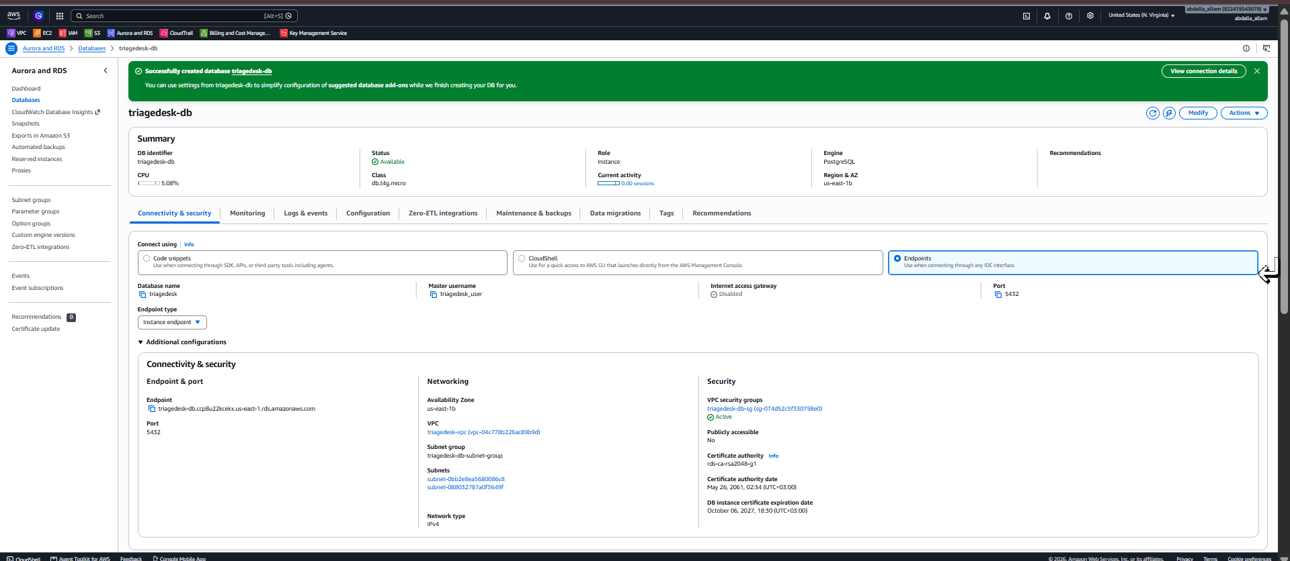
RDS PostgreSQL is Available, uses the private DB subnet group, and is not publicly accessible.
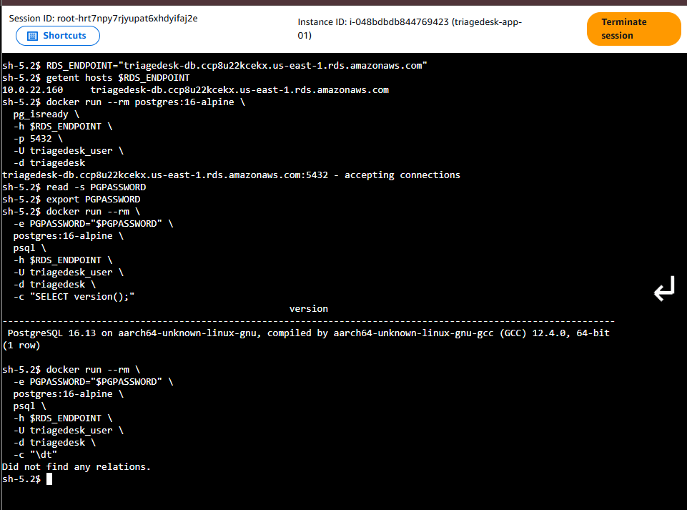  Private EC2 → RDS connectivity and authentication validation. | 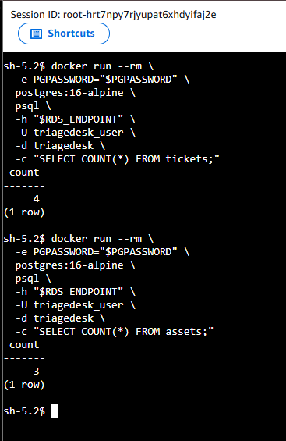  Post-migration validation: ticket and asset row counts confirmed.

7. Secrets & Configuration Management
Database configuration is retrieved at boot from Systems Manager Parameter Store; the DB password is stored as SecureString and read through the EC2 IAM role.
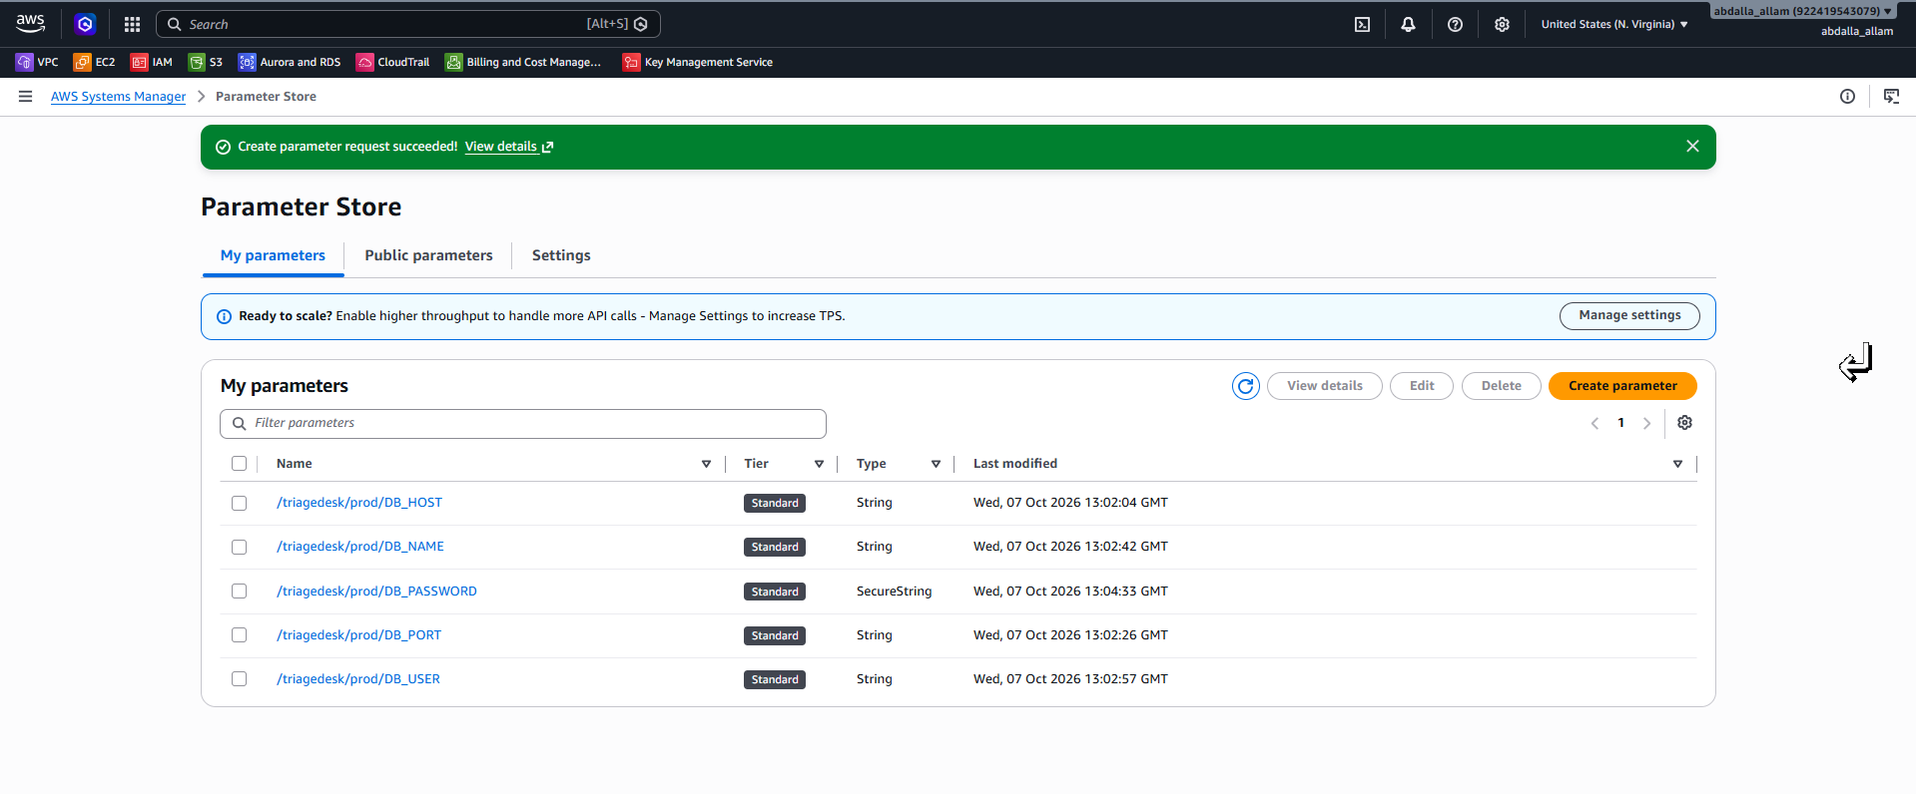  Parameter Store configuration; DB_PASSWORD is SecureString. | 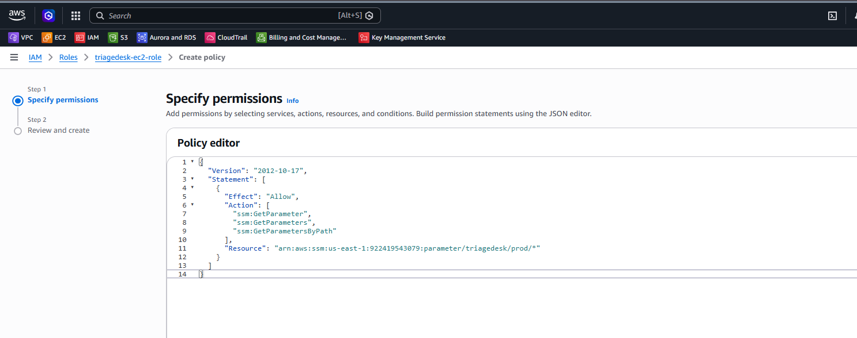  Least-privilege inline policy allowing access to the TriageDesk parameter path.

8. Golden AMI & Launch Template
A reusable Golden AMI reduces bootstrap time. Launch Template user data pulls the latest application code and Parameter Store values, then starts the Docker workload.
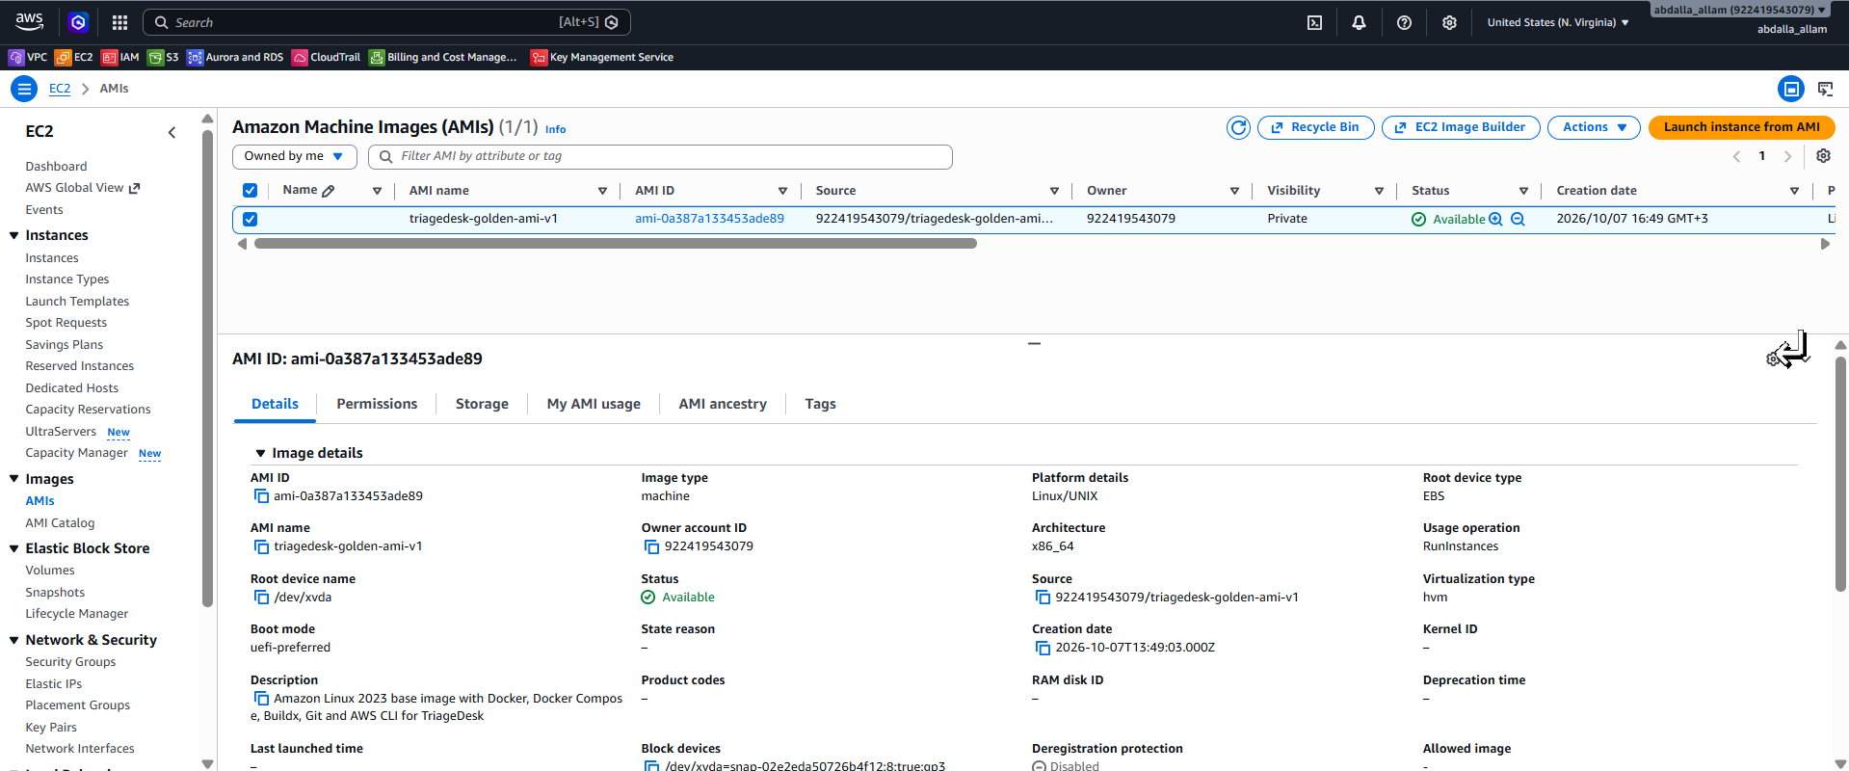  TriageDesk Golden AMI used as the reusable compute baseline. | 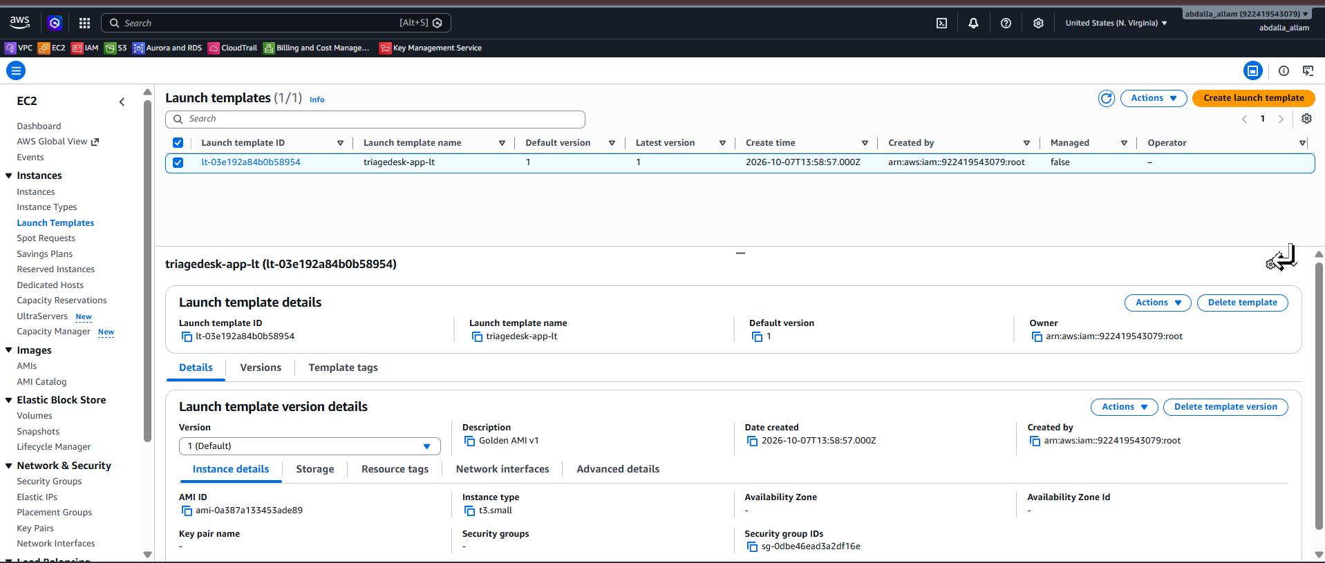  Launch Template created from the Golden AMI with the application security group and IAM instance profile.

9. Application Load Balancer & Target Groups
Three target groups map the ALB to the three services exposed on each application node.
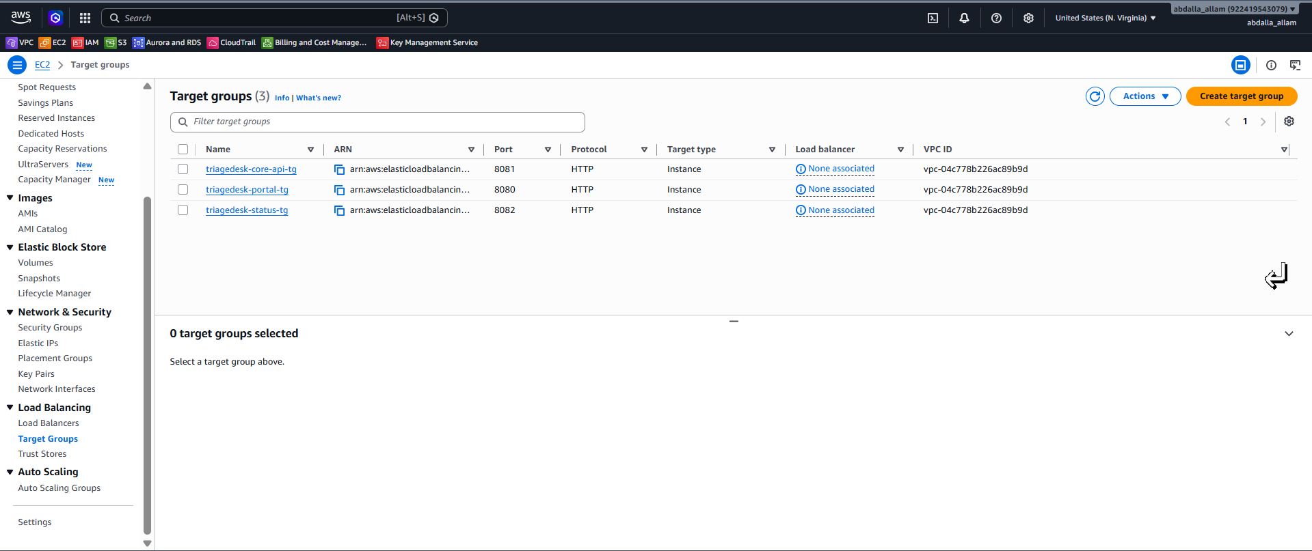  Target groups for Portal :8080, Core API :8081, and Status :8082. | 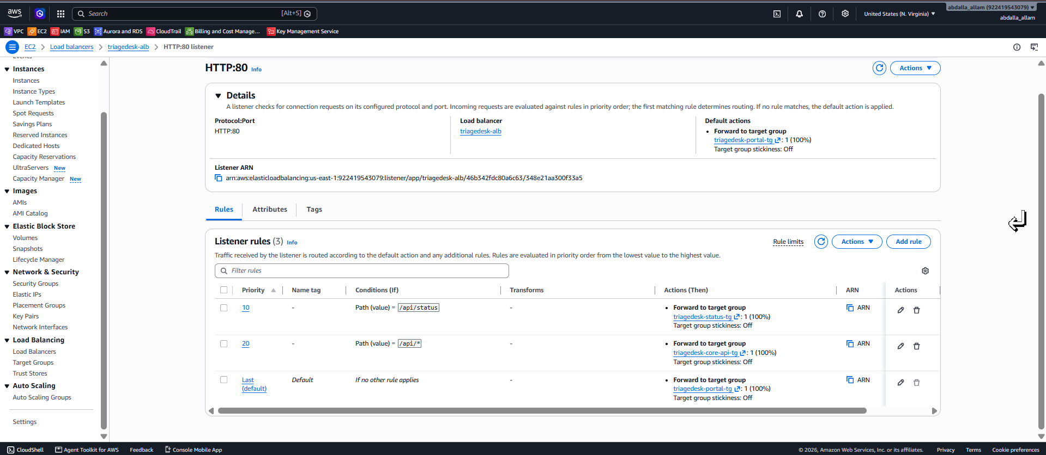  ALB listener rules: /api/status → Status, /api/* → Core API, default → Portal.
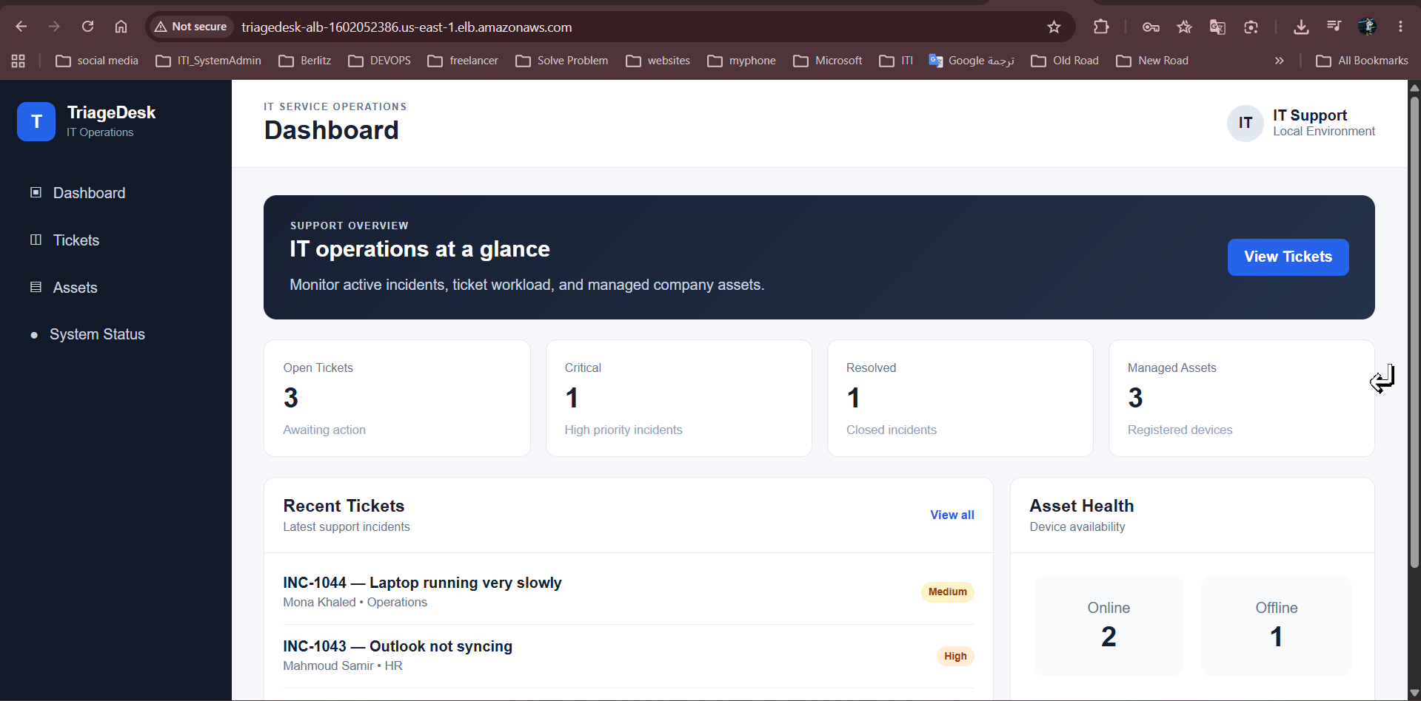
Application dashboard successfully served through the public ALB DNS name.

10. Auto Scaling Group & Multi-AZ Availability
The ASG maintains two application nodes across two Availability Zones and uses the Launch Template as the source of truth.
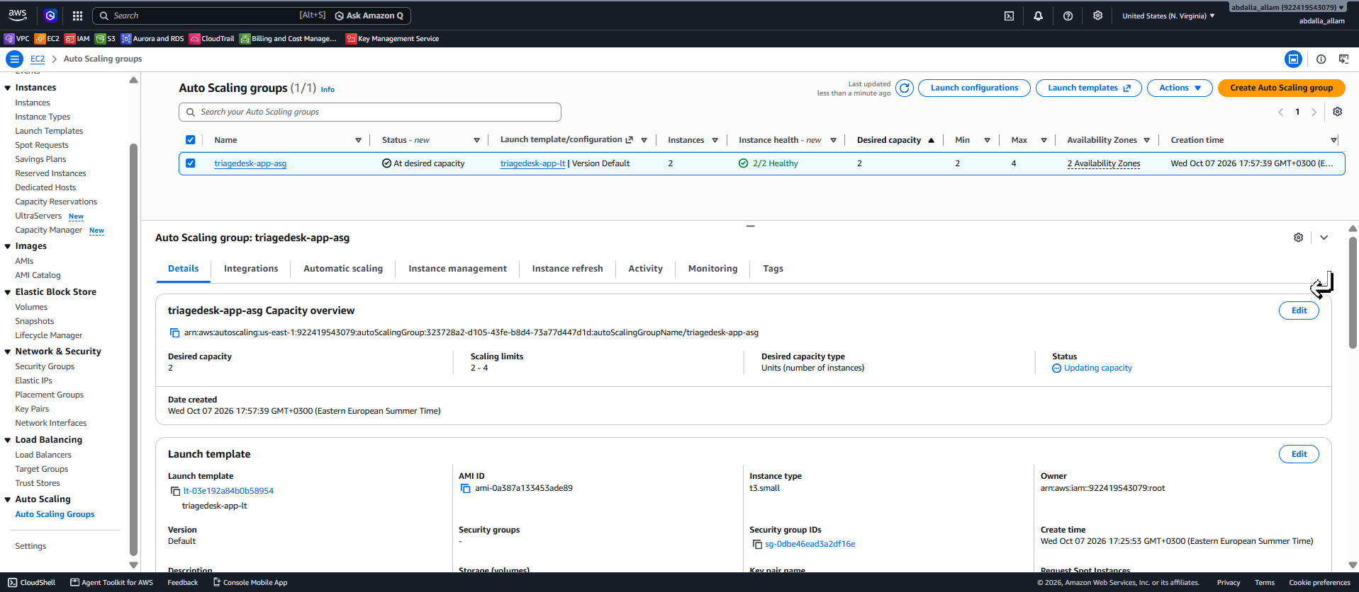
Auto Scaling Group at desired capacity with a two-instance baseline and multi-AZ placement.
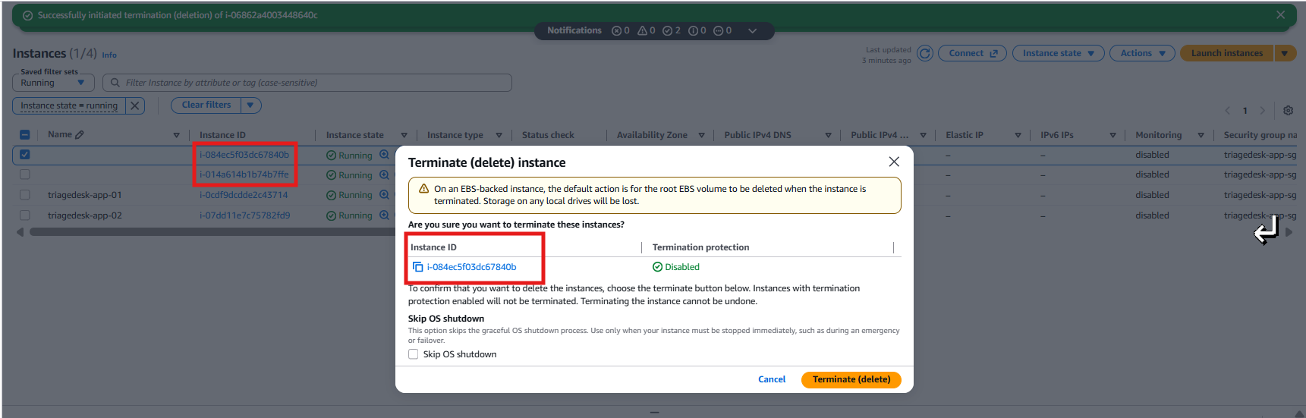  Failure test: an ASG-managed instance is terminated. | 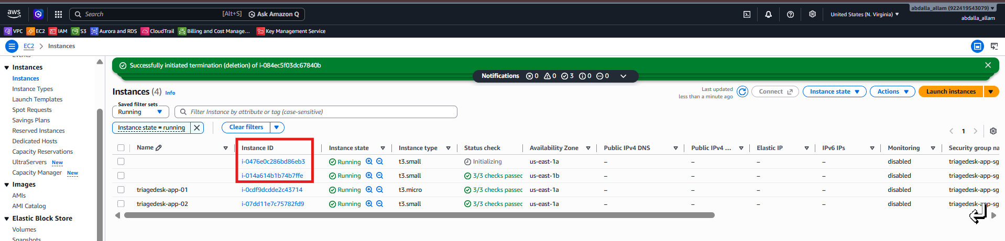  Replacement instance launched automatically, restoring desired capacity — self-healing verified.

11. Load Balancing Validation
The Core API health endpoint exposes both the EC2 instance ID and Docker container ID, making ALB distribution visible and easy to verify.
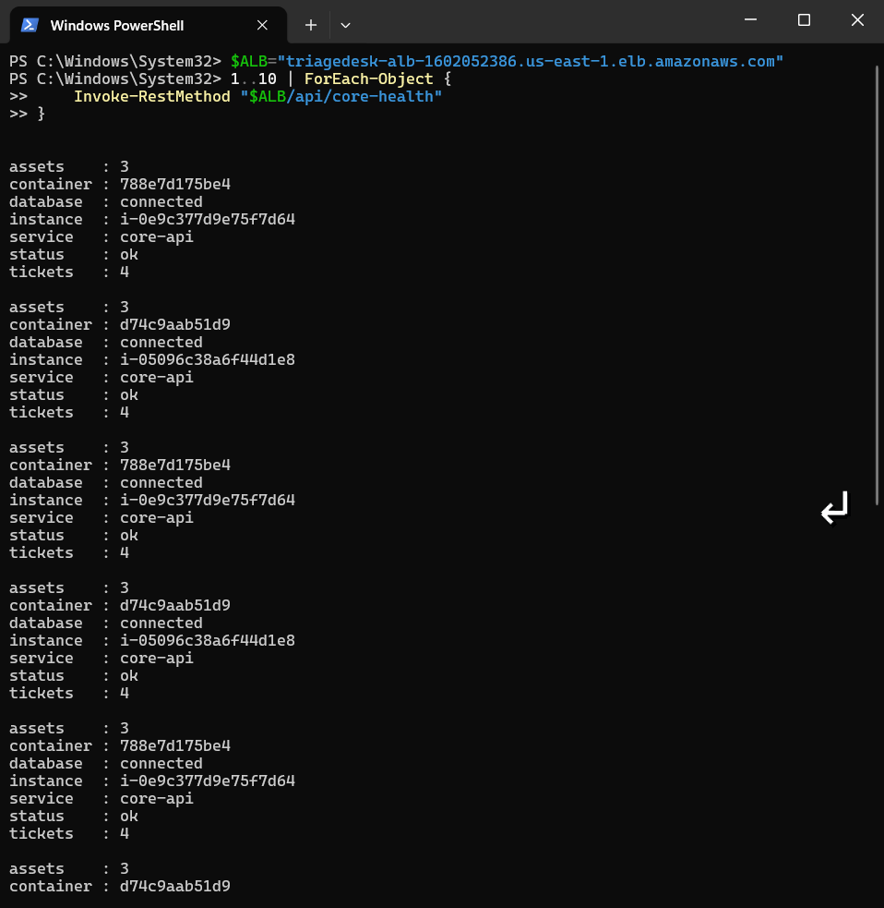
Repeated requests to /api/core-health alternate between distinct EC2 instance IDs and container IDs, proving traffic is distributed across application nodes.
VALIDATED: ALB path routing + multi-target load balancing + shared RDS state

12. Dynamic Auto Scaling
Target tracking maintains average CPU near 50%, with a 600-second warmup. The group can scale from 2 to 4 instances and scale back in after demand drops.
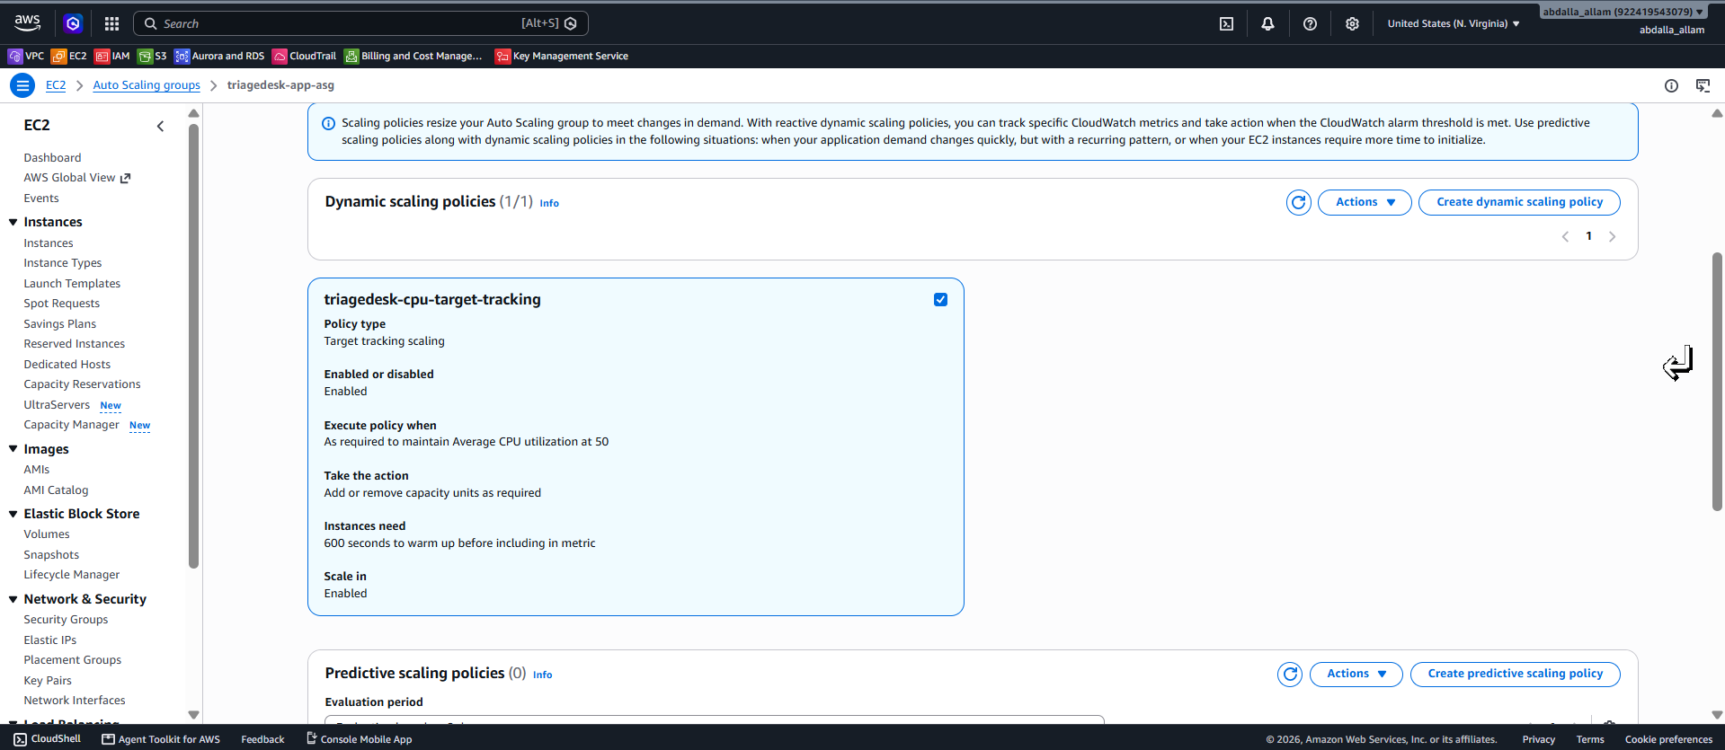
Target tracking scaling policy: Average CPU target 50%, scale-in enabled, 600-second warmup.
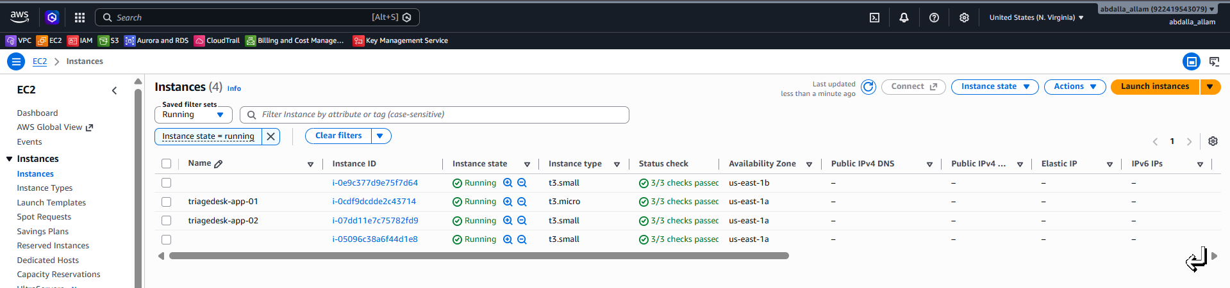  Before load: two-instance baseline. | 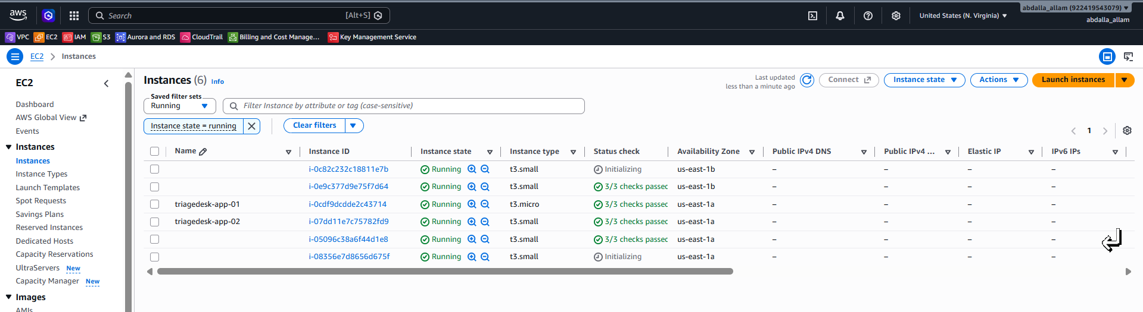  Under sustained CPU load: the ASG scales out toward maximum capacity.
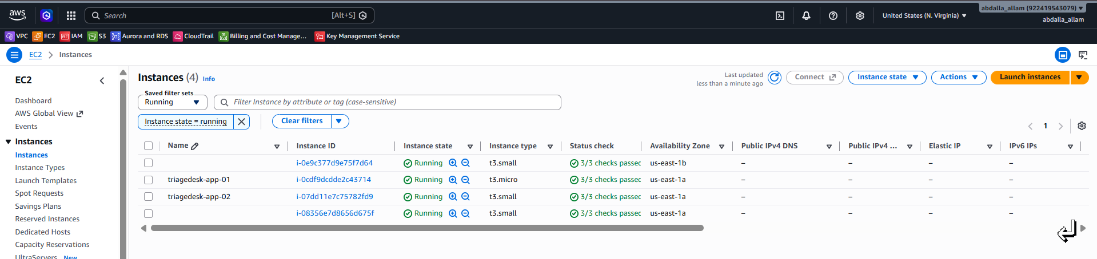
After load ends: capacity scales back in toward the minimum baseline.

13. Evidence Index & Portfolio Notes
This page summarizes what is already proven by the captured screenshots and identifies only the optional additions that would strengthen a public portfolio.
Evidence | Status | Notes
VPC segmentation | Captured | Subnets and tier separation are visible.
Public / private routing | Captured | IGW, NAT, and private route behavior are documented.
Security groups | Captured | ALB → App → DB chaining is shown.
Private EC2 management | Captured | IAM role and Session Manager-based workflow are documented.
Private RDS | Captured | RDS details show Publicly accessible: No and DB subnet group.
Parameter Store | Captured | SecureString password and IAM access are documented.
Golden AMI / Launch Template | Captured | Reusable compute baseline and launch configuration are shown.
ALB path routing | Captured | Three target groups and listener rules are shown.
Self-healing | Captured | Termination and automatic replacement are documented.
Load balancing | Captured | Distinct EC2 and container IDs are visible across repeated ALB requests.
Dynamic scaling | Captured | Policy plus before / scale-out / scale-in states are documented.
Target group health after ASG | Optional | One screenshot showing 2 healthy ASG targets in each target group would be useful but is not required.
ASG Activity history | Optional | A single Activity screenshot showing a scale-out and scale-in event would make the scaling evidence even stronger.

