TriageDesk
Local Environment - Technical Evidence
Dockerized IT Support Operations Portal
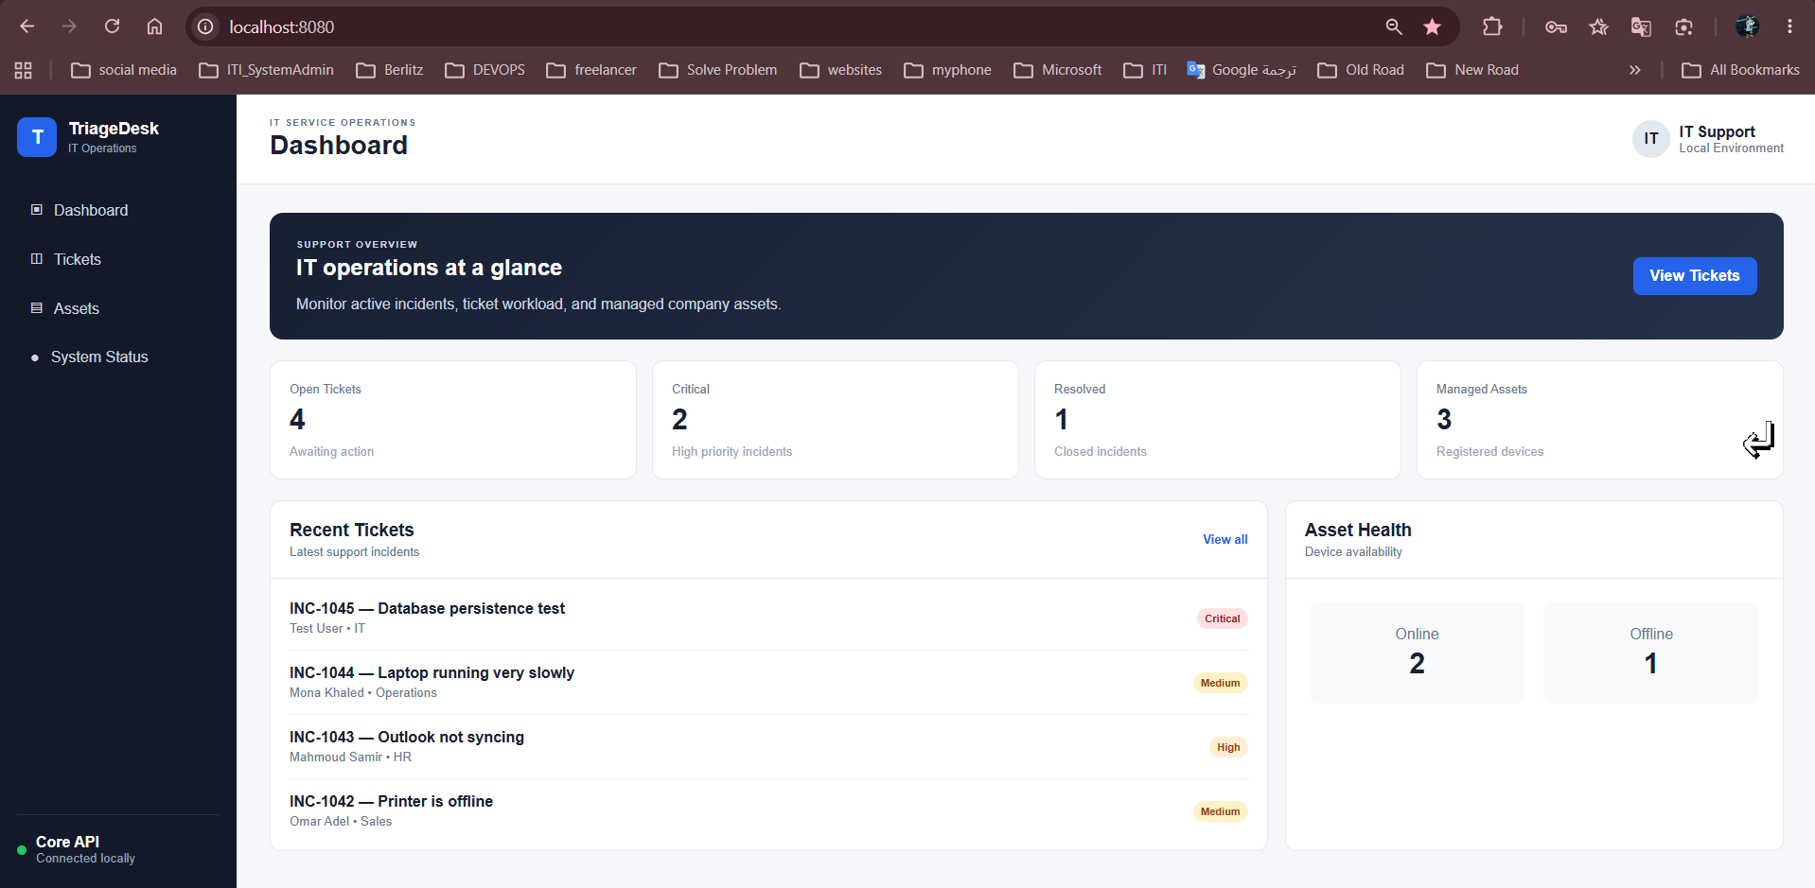
Frontend | Flask portal with HTML/CSS/JavaScript
Backend | Flask Core API + Status service
Data | PostgreSQL with persistent volume
Edge | NGINX reverse proxy and load balancing
Validation | Health checks, failover, backup/restore, security tests

1. Application Overview
The local environment provides a complete IT support workflow for incidents, assets, and runtime service visibility. The screenshots below show the core user-facing functions used during validation.
 | 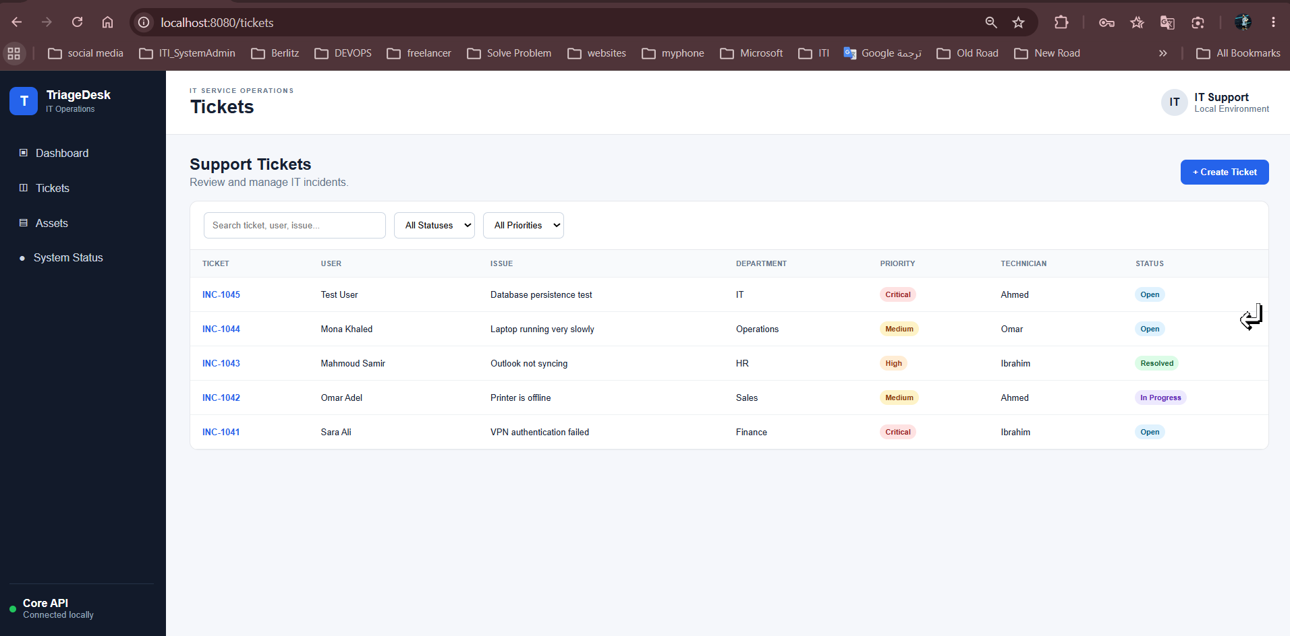
Dashboard - incident and asset health summary | Tickets - searchable incident management view
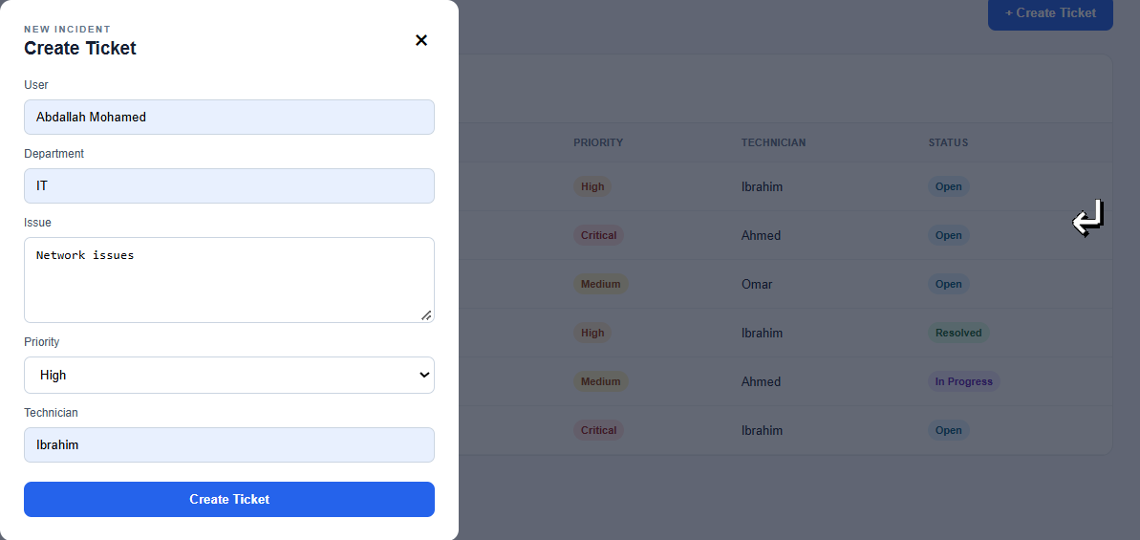 | 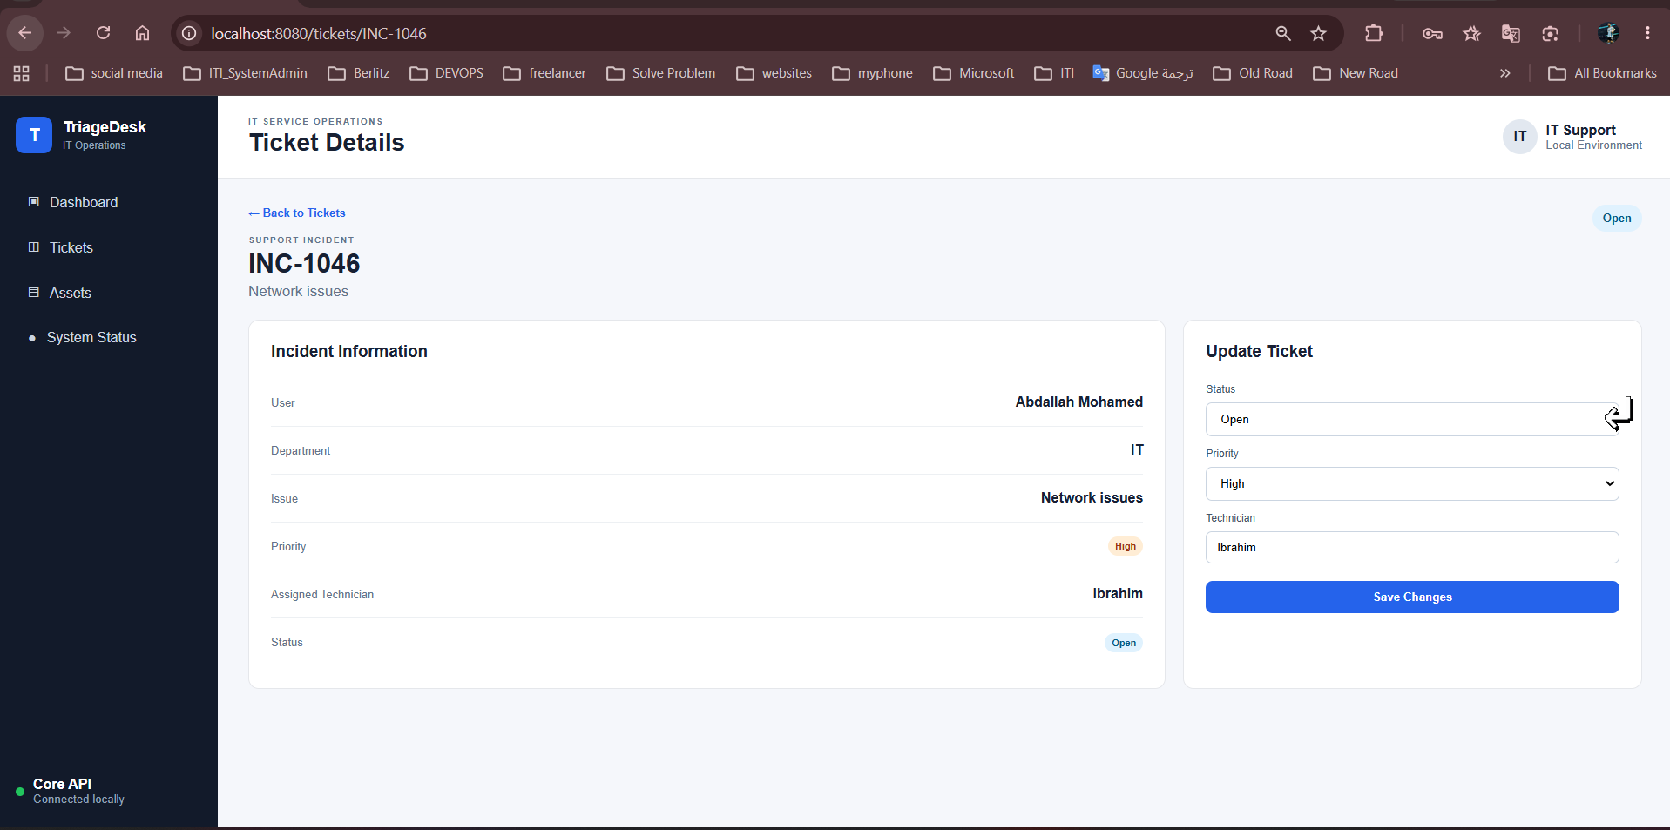
Create Ticket - structured incident intake | Ticket Details - update status, priority, and technician

2. Asset and Service Visibility
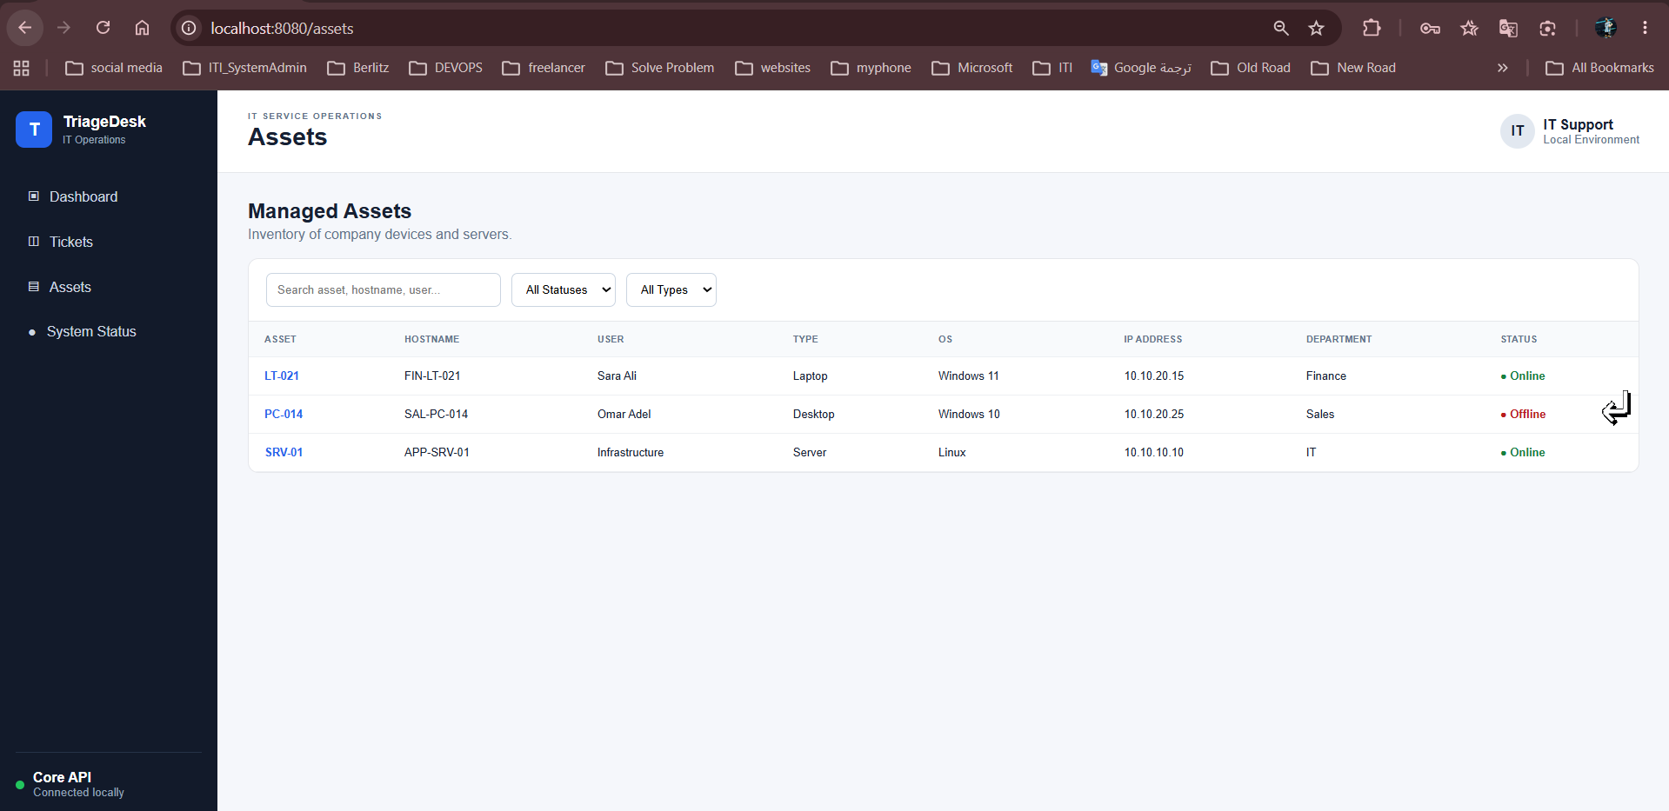 | 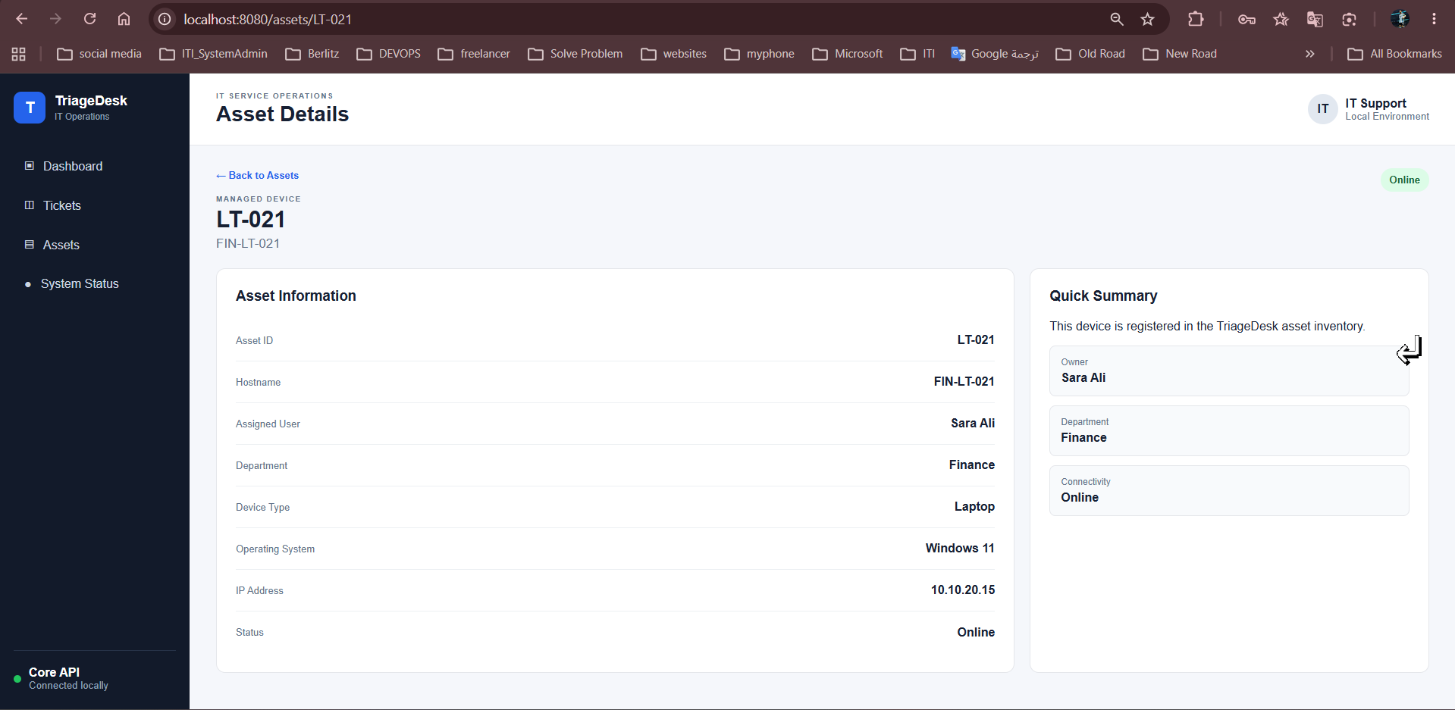
Managed Assets - endpoint and server inventory | Asset Details - ownership, OS, IP, and operational state
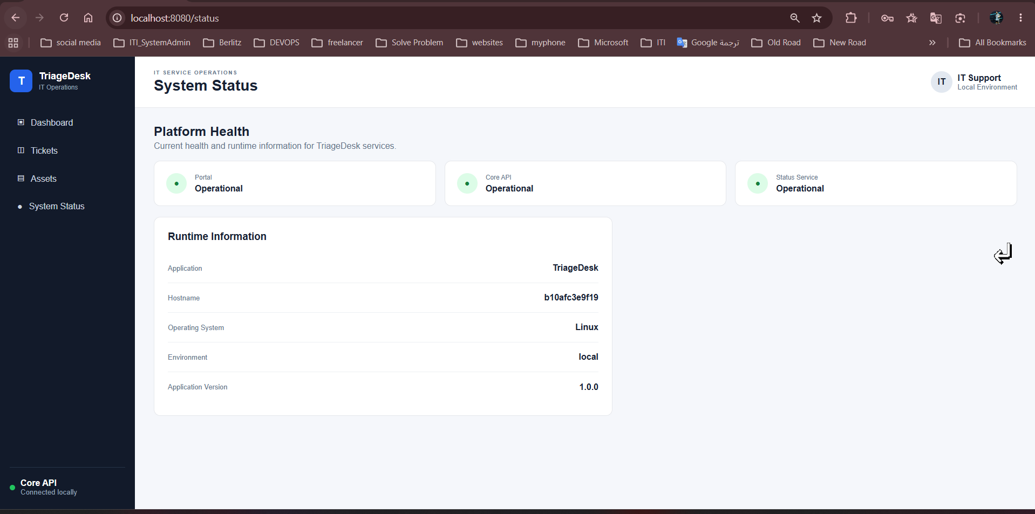
System Status - portal, Core API, and Status Service health information

3. Local Architecture
The architecture separates the public entry point, frontend traffic, API traffic, and database traffic. NGINX is the only host-published service; the application services and PostgreSQL remain private inside Docker networks.
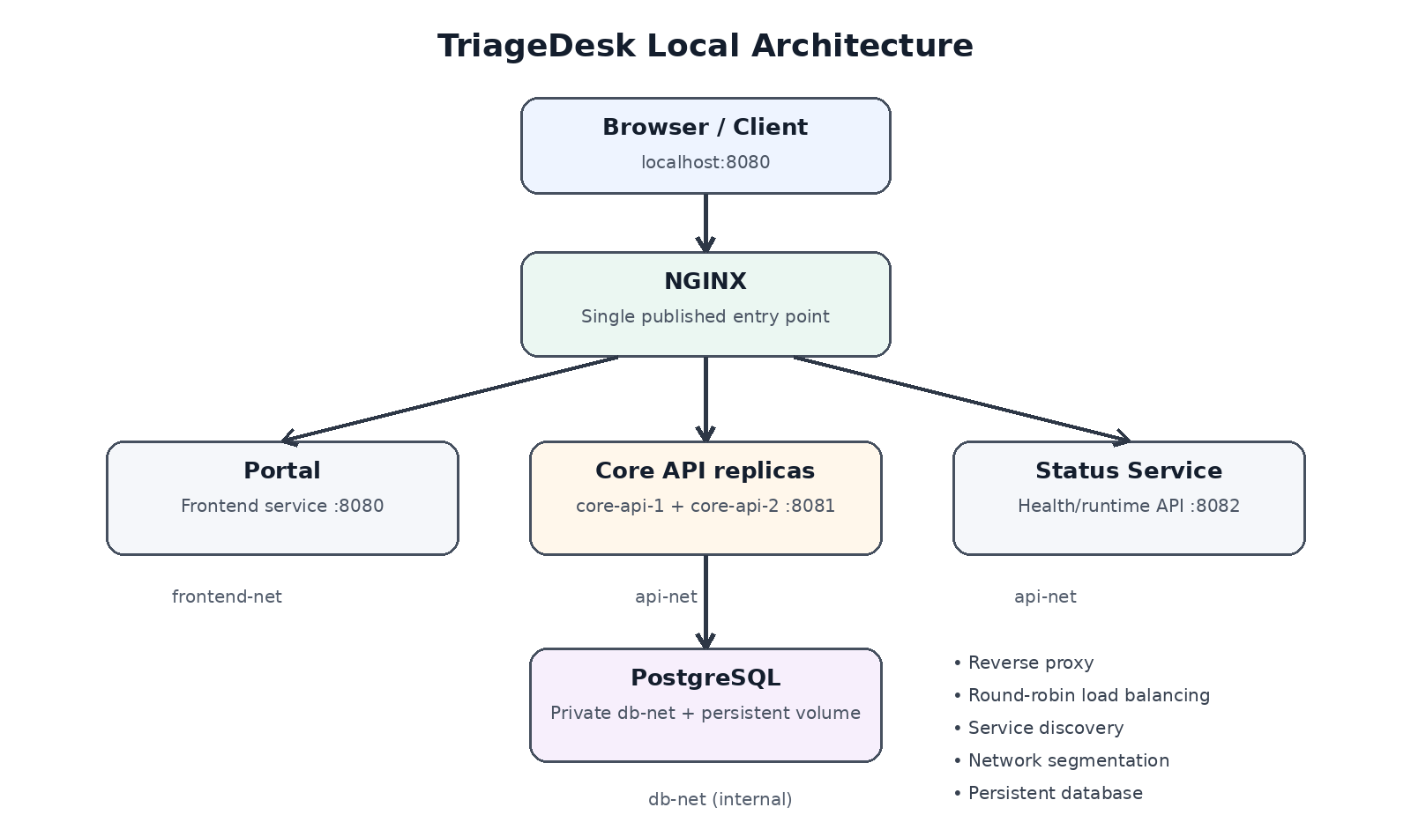
Clean local architecture used for the TriageDesk environment
Architecture highlights
frontend-net isolates Portal-facing traffic; api-net connects NGINX, Core API, and Status; db-net is internal and is used only by the Core API and PostgreSQL. PostgreSQL data persists in a named Docker volume.

4. Container Stack and Network Segmentation
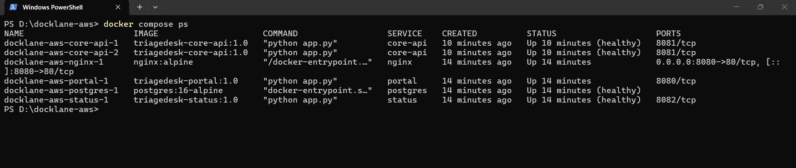
Docker Compose stack - application services, PostgreSQL, and NGINX running together
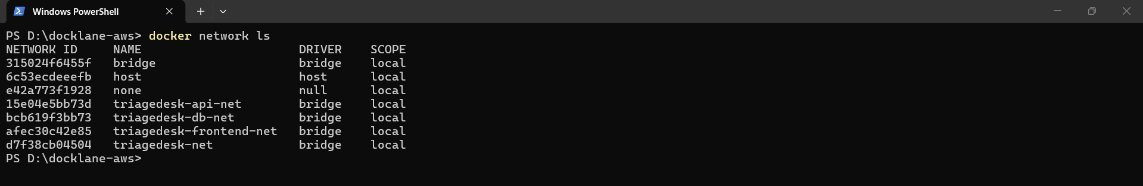
Docker networks - dedicated frontend, API, and database networks

5. Scaling, Load Balancing, and Failover
The Core API was scaled to multiple replicas. NGINX resolves the Docker service dynamically and distributes requests across replicas. A replica failure was then simulated to confirm that traffic continued through the remaining healthy instance.
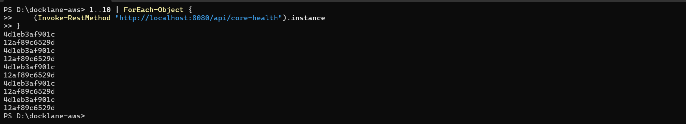
Round-robin verification - repeated health requests return different Core API instance IDs
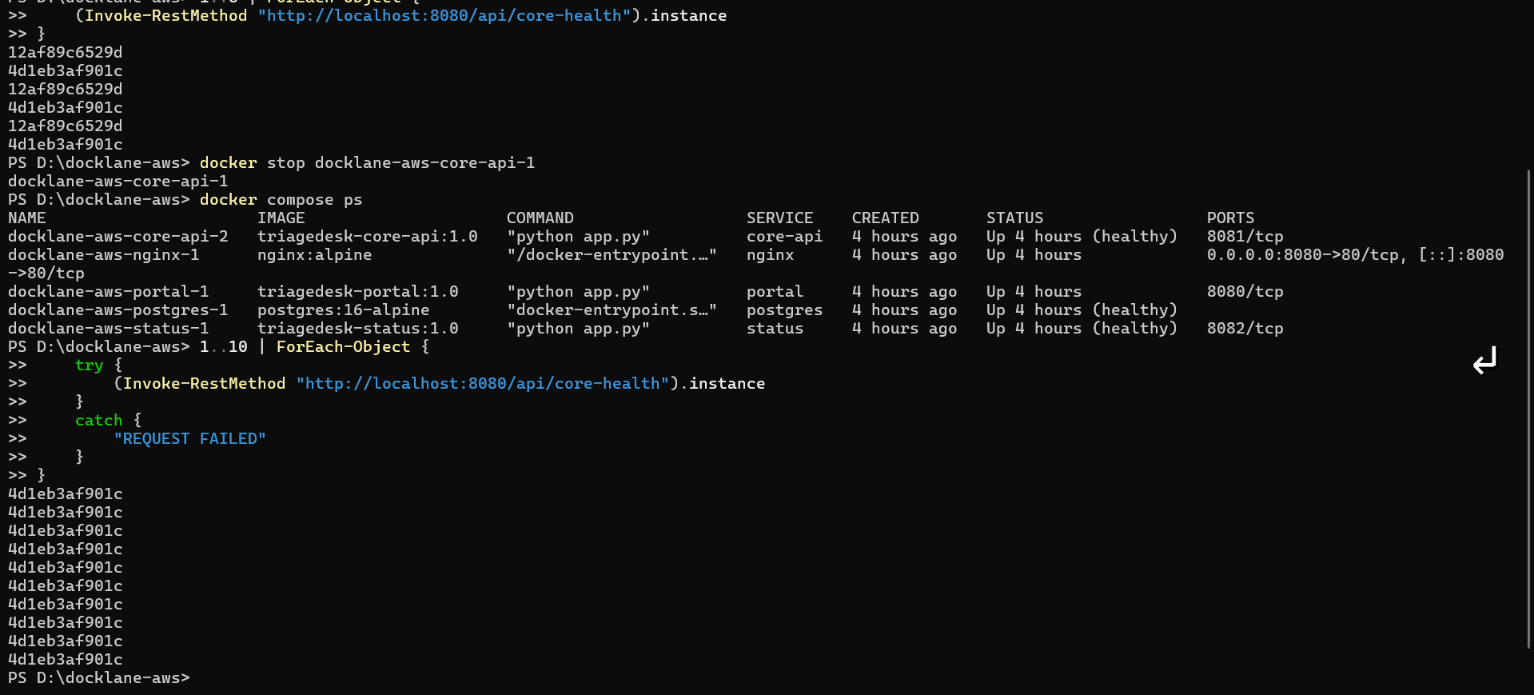
Failover test - one Core API replica was stopped while the remaining replica continued serving requests

6. PostgreSQL Backup and Restore
Database recovery was validated without touching the live database. A pg_dump backup was created, restored into a separate test database, and the restored record counts were verified.
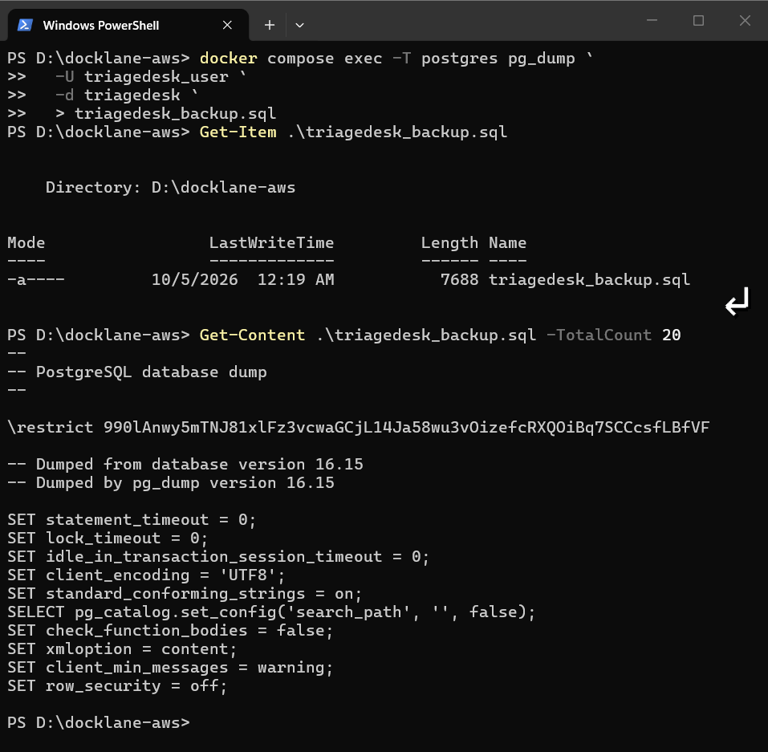
Backup - pg_dump creates triagedesk_backup.sql and the SQL dump is inspected
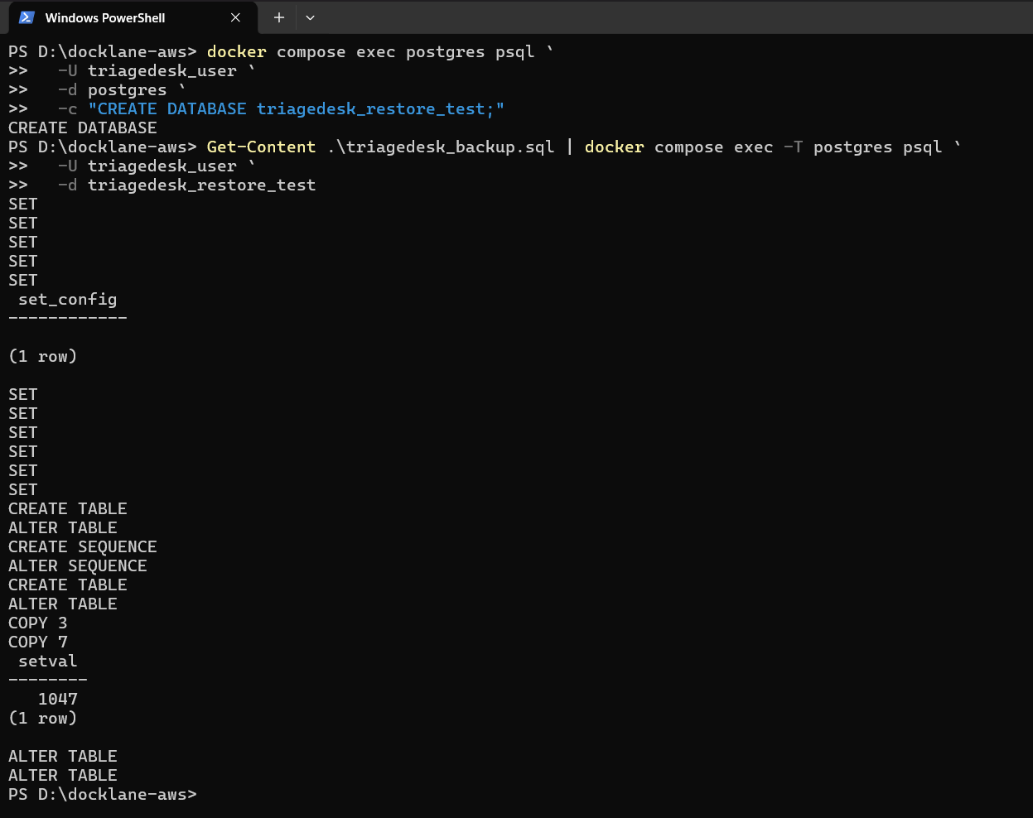
Restore - backup imported into triagedesk_restore_test
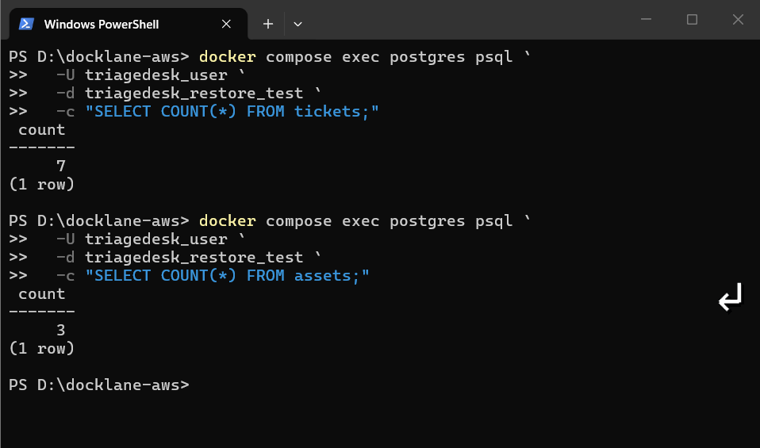
Verification - restored tickets and assets counts confirmed

7. Security Hardening Evidence
The local build includes input validation, output escaping, non-root application containers, private backend services, NGINX security headers, and protected environment configuration.
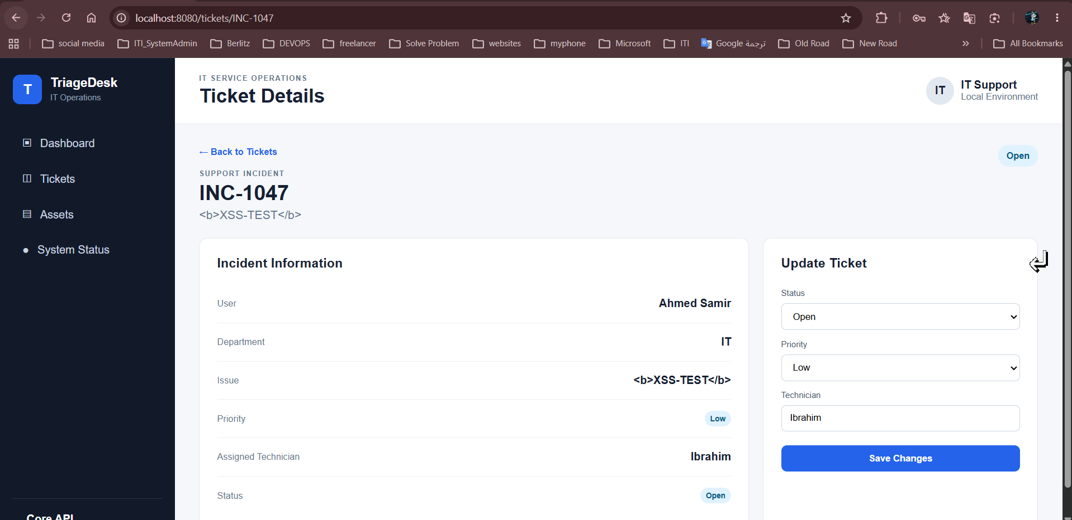
XSS hardening test - HTML-like user input is displayed as text instead of being interpreted as markup
Control | Local implementation
Secrets hygiene | .env ignored by Git; .env.example contains safe placeholders
Network exposure | Only NGINX publishes a host port; Portal/API/Status/PostgreSQL remain private
Input validation | POST/PATCH ticket inputs restricted to expected fields and allowed values
Output encoding | User-controlled values escaped before insertion into HTML
Container privilege | Portal, Core API, and Status run as appuser
NGINX headers | nosniff, frame denial, and Referrer-Policy enabled
Log retention | Docker json-file logs configured with size/file rotation

8. Final Local Validation
A PowerShell validation script performs repeatable checks of service state, HTTP endpoints, network exposure, non-root execution, and NGINX security headers.
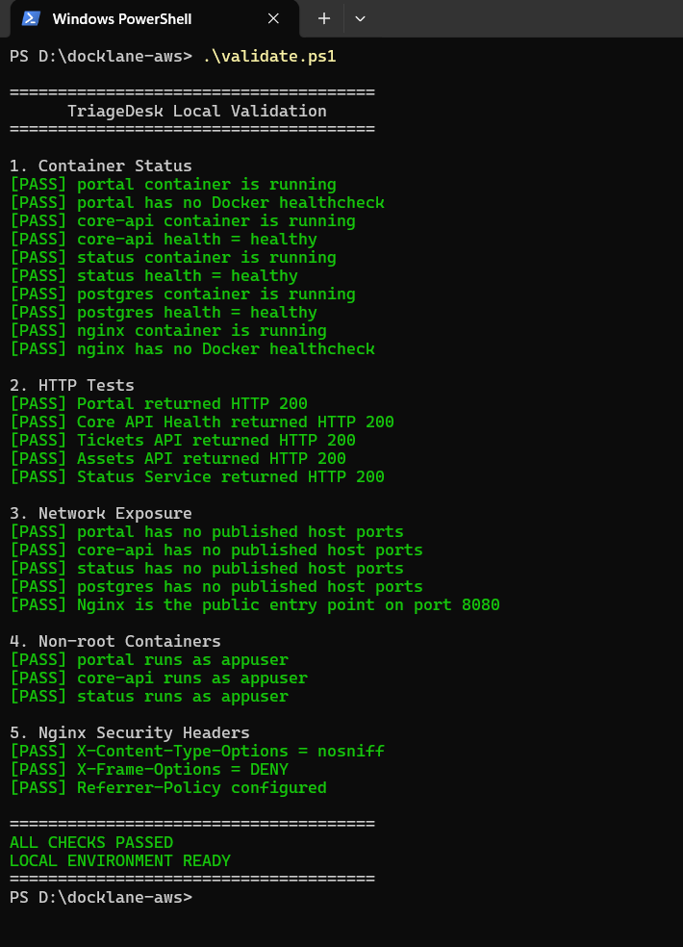
Final validation result - ALL CHECKS PASSED / LOCAL ENVIRONMENT READY

9. Evidence Index
Evidence | What it proves | Status
Application UI | Functional incident and asset workflows | Complete
Compose stack | Multi-service containerized deployment | Complete
Network segmentation | frontend-net / api-net / internal db-net | Complete
Load balancing | Multiple Core API replicas served via NGINX | Complete
Failover | Service remains available after one replica is stopped | Complete
Database recovery | Backup, restore, and record verification | Complete
XSS protection | Stored HTML-like input rendered safely as text | Complete
Security controls | Non-root containers, private ports, NGINX headers | Complete
Automated validation | All local validation checks pass | Complete
Ready for Phase 3: AWS Architecture and Deployment

