CMPS 312– Fall 2025
Lab Final Exam (Duration 2h)
Travel Journal App
Develop the TravelJournal App using Flutter to enable users to create, edit, and delete travel trips and their activities .
Your app should follow clean architecture and make use of Flutter features and packages covered in class. It must implement state management using Riverpod AsyncNotifier Providers and handle navigation with GoRouter.
For data handling, the app must connect to Supabase as a cloud backend, implementing the Repository Pattern to perform CRUD operations and using Streams for real-time data updates.
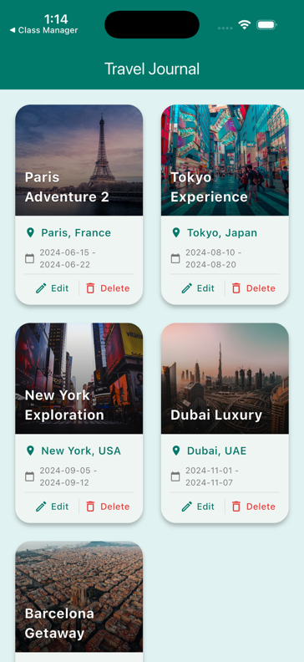 | 1. Dashboard Screen [45 points]: The Dashboard Screen displays all available trips in a clean grid layout, fetched in real-time from Supabase. Users can add new trips, edit existing ones, and delete trips directly from this screen.  Each trip card must provide two action buttons: Edit and Delete. The Edit button navigates to the Edit Trip screen for updating trip details, while the Delete button removes the selected trip from Supabase. When a trip card is tapped, the app navigates to the Activities by Trip screen to display all activities for that trip.  - Supabase Integration: All data must be stored and retrieved from Supabase using the Repository Pattern with real-time streams.
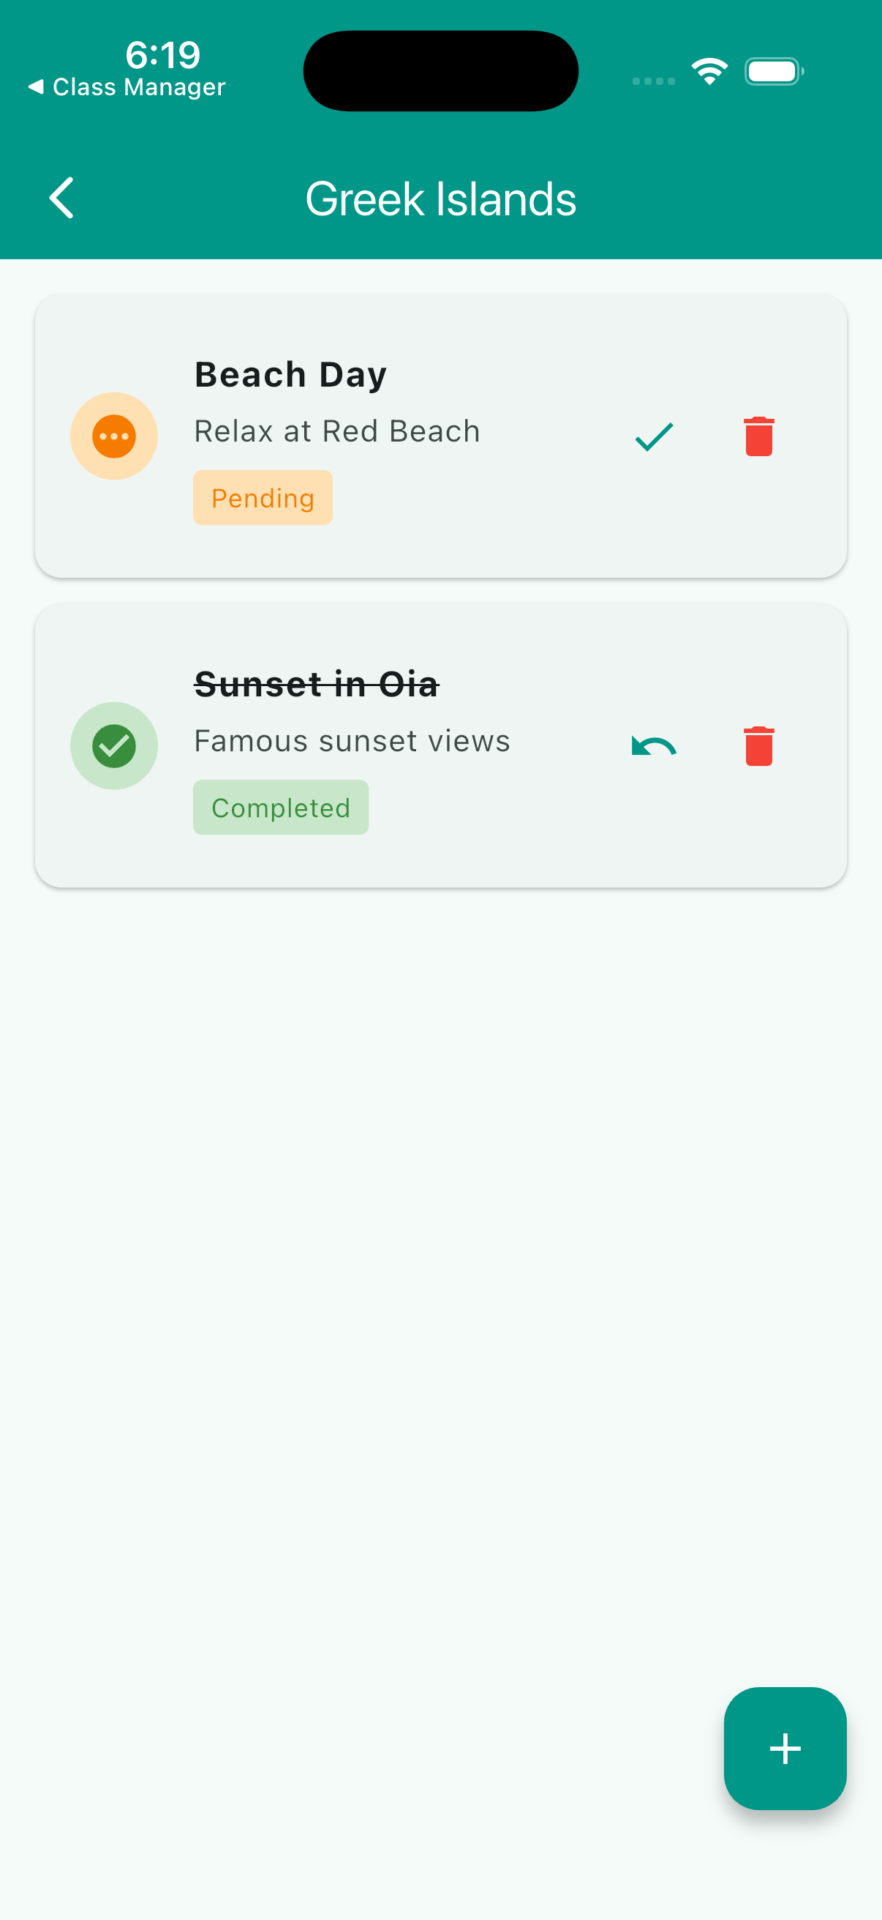 | 2. Activities by Trip Screen [25 points]:  The Activities by Trip Screen displays all activities related to a selected trip, fetched from Supabase using the trip ID. When the user taps on a trip from the dashboard, the app navigates to this screen, showing the trip name at the top and a list of its activities below.  Each activity card should include the activity title, description, and completion status (Completed/Pending), presented in a clean and readable layout using cards or list tiles.  Users can toggle the completion status of an activity and delete activities directly from this screen. Provide two action buttons for each activity: Toggle Complete (marks activity as completed/pending) and Delete (removes the activity from Supabase).
3. Add/Edit Trip Screen [20 points]: The Add/Edit Trip Screen allows users to add a new trip or modify the details of an existing trip. When adding a new trip, clicking the Save button inserts the trip into Supabase. When editing, clicking Save updates the existing trip record in Supabase. The trip list automatically refreshes using Riverpod state management with Supabase real-time streams.
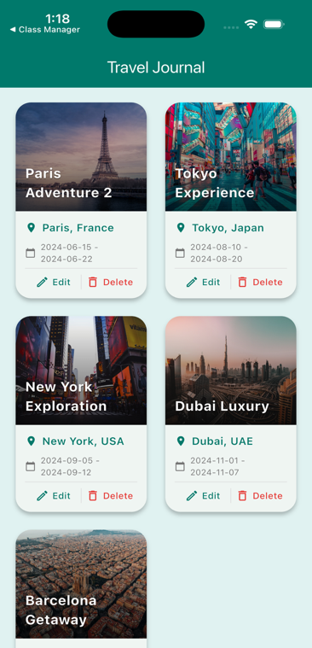
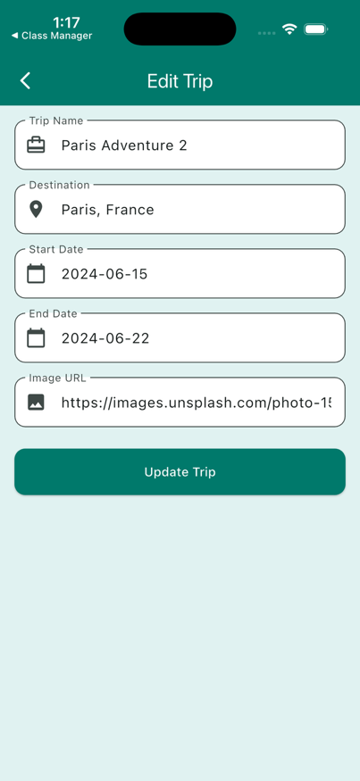
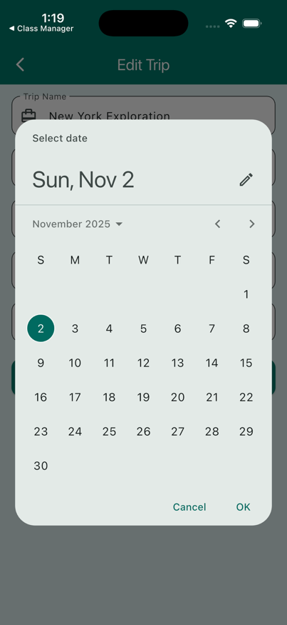

1

Category | Component | Points | Description
1. Repository Implementation |  | 35%
 | TripRepoSupabase | 15% | getTrips(), getTripById(), addTrip(), updateTrip(), deleteTrip()
 | ActivityRepoSupabase | 20% | getActivities(), getActivityById(), getActivitiesByTrip(), addActivity(), updateActivity(), deleteActivity()
2. State Provider Implementation |  | 40%
 | TripNotifier + Provider | 18% | build() with stream subscription, CRUD methods, provider declaration
 | ActivityNotifier + Provider | 22% | build() with stream subscription, CRUD methods, provider declaration
3. UI-Provider Connection |  | 25%
 | DashboardScreen | 6% | ref.watch() for trip list and deleteTrip()
 | EditTripScreen | 6% | getTripById(), addTrip(), updateTrip()
 | ActivitiesByTripScreen | 7% | getActivitiesByTrip(), updateActivity(), deleteActivity()
 | AddActivityScreen | 6% | addActivity()
Total |  | 100%

Possible grading for functionality:
- Complete and Working (get 70% of the assigned grade),
- Complete and Not working (lose 40% of assigned grade)
- Not done get 0.
- The remaining grade is assigned to the quality of the implementation.
Important
- Push your work to GitHub as your make progress to avoid surprises!
- The Exam is Open Book; however, AI tools are strictly prohibited. Any instance of plagiarism or use of AI-generated code will result in a score of 0 points. Do not share your code or accept code from others.
2

