
WEBSITE TECHNICAL SPECIFICATION
Samari Kuhsor Corporate and Product Catalogue Website
Legal entity: QOIM
Commercial brand: Самари Кӯҳсор / Samari Kuhsor
Production facility: Tem, Khorog, GBAO, Republic of Tajikistan
Document version | 1.0
Date | 26 June 2026
Target public launch | 9 September 2026
Document purpose | Requirements for design, development, content, testing and deployment
Prepared as a working Terms of Reference for the web development team

Document Control
Client / legal entity | QOIM
Public-facing brand | Samari Kuhsor
Primary website type | Corporate website and product catalogue
Primary languages | Tajik, Russian and English
Phase 1 status | Informational website; no e-commerce checkout

Contents
1. Project Context and Strategic Direction
2. Objectives, Audiences and Scope
3. Brand and Legal Architecture
4. Languages and URL Structure
5. Information Architecture and Sitemap
6. Page-by-Page Requirements
7. Product Catalogue and Data Model
8. User Experience and Visual Design
9. Content Management System
10. Functional Requirements
11. Non-Functional Requirements
12. SEO and Structured Data
13. Performance, Accessibility and Security
14. Technical Architecture
15. Analytics and Reporting
16. Content Governance and Publishing Workflow
17. Testing, Deployment and Operations
18. Implementation Schedule
19. Deliverables and Acceptance Criteria
Appendix A. Required Content Inputs
Appendix B. References
Important positioning decision
Samari Kuhsor is the public commercial brand. QOIM is the legal entity and must appear in the footer, legal policies, contact details, certificates and formal downloads. The website must not present QOIM or Samari Kuhsor as a government body.

1. Project Context and Strategic Direction
QOIM is developing a food and beverage production facility in Tem, Khorog, GBAO. The commercial brand Samari Kuhsor will initially present four product categories: direct-pressed apple juice, apricot jam, tomato paste and non-carbonated drinking water.
The website should establish the company as a modern Tajik producer connected to the Pamir region, local agricultural resources, responsible processing, quality control and professional packaging. The site must communicate trust without making claims that are not yet supported by approved recipes, laboratory testing or certificates.

1.1 Recommended market position
- A Tajik food and beverage brand with a clear regional identity.
- Modern production and packaging rather than a purely traditional or handmade image.
- Products inspired by the Pamir region and local agricultural resources.
- A credible partner for retailers, distributors, institutions and development partners.

1.2 Core message
Recommended umbrella message
A Tajik brand. A modern production facility. Products inspired by the Pamir region.

2. Objectives, Audiences and Scope

2.1 Website objectives
- Present QOIM and the Samari Kuhsor brand professionally.
- Provide an accurate and visually strong product catalogue.
- Build confidence through information about production, hygiene, packaging and quality control.
- Provide verified corporate, legal and contact information.
- Generate distributor, wholesale, supplier and partnership inquiries.
- Publish company news, launch milestones, photographs, videos and downloadable documents.

2.2 Primary audiences
Audience | Primary need | Desired action
Consumers | Understand the brand, products, packaging and availability | Explore products and contact the company
Retailers and distributors | Review formats, specifications and commercial readiness | Submit a wholesale or distributor inquiry
Government and institutions | Confirm enterprise identity, production location and development relevance | Access official corporate information
Suppliers and partners | Understand current production categories and procurement needs | Submit a supplier or cooperation proposal
Media and public | Access approved news, imagery and company background | Use official information and contact the media focal point

2.3 Phase 1 scope
- Multilingual public website in Tajik, Russian and English.
- Corporate pages, President page, product catalogue, production and quality pages.
- News, photo/video gallery, downloads, contact and distributor inquiry forms.
- Content management system with role-based publishing workflow.
- Responsive design, SEO, analytics, accessibility, security and backups.

2.4 Out of scope for Phase 1
- Online payment and e-commerce checkout.
- Consumer user accounts or loyalty programme.
- ERP, warehouse or accounting integration.
- Live stock availability and automated wholesale pricing.
- Public recruitment portal beyond a basic vacancy/contact form.

3. Brand and Legal Architecture
Element | Approved name | Website usage
Legal entity | QOIM | Footer, legal pages, certificates, formal downloads and contact/legal details
Commercial brand | Самари Кӯҳсор / Samari Kuhsor | Main navigation, logo, product pages and public marketing content
Production location | Tem, Khorog, GBAO, Republic of Tajikistan | Contact, About, Production and footer
Brand slogan | Тозагӣ аз табиат | Logo lock-up and selected brand sections
English support line | Purity from Nature | Optional supporting text, subject to brand approval

3.1 Recommended footer disclosure
Footer wording
Samari Kuhsor is a commercial brand of QOIM. Production facility: Tem, Khorog, GBAO, Republic of Tajikistan.

4. Languages and URL Structure
The website shall be fully available in Tajik, Russian and English. Tajik should be the default language unless the client decides otherwise before development begins. Each language version must be manually reviewed; automatic translation is not acceptable for final public content.
Language | Prefix | Example
Tajik | /tj/ | /tj/mahsulot/obi-nushoki
Russian | /ru/ | /ru/products/drinking-water
English | /en/ | /en/products/drinking-water
- The language selector must be visible in the desktop header and mobile menu.
- Switching language should open the equivalent translated page, not the homepage.
- Each translation must have an independent publication status and review date.
- Search engines must receive correct hreflang and canonical metadata.

5. Information Architecture and Sitemap
The proposed structure is intentionally broader than a simple brochure. It supports brand presentation, product discovery, institutional credibility and business inquiries while remaining manageable for a small content team.
Level 1 | Level 2 | Purpose
Home | - | Brand overview, products, trust, news and contact conversion
About Us | About the Brand; Our Story; Production Facility; Mission and Values | Company identity and background
Products | Apple Juice; Apricot Jam; Tomato Paste; Drinking Water | Product catalogue and technical consumer information
Production & Quality | Production Process; Quality Control; Packaging; Local Raw Materials | Trust-building and process transparency
Tajikistan | President of the Republic of Tajikistan; About Tajikistan; National Symbols (optional) | Institutional context without presenting the company as governmental
News & Media | Company News; Photo Gallery; Video Gallery | Updates and public communications
Downloads | Catalogue; Product Sheets; Certificates; Corporate Documents | Controlled document publication
Partners | Distributor and Cooperation Information | Lead generation
Contact Us | Contact Form; Map; Legal Details | Corporate contact and inquiries
Legal | Privacy Policy; Terms of Use; Cookie Policy | Compliance and transparency

5.1 Recommended top navigation
Desktop menu
Home | About Us | Products | Production & Quality | News | Tajikistan | Contact

The President page should exist, as requested, but placing it under a Tajikistan menu is preferable to making it a dominant commercial menu item. This reduces the risk that users interpret the private company as a state institution.

6. Page-by-Page Requirements

6.1 Home page
- Hero area with logo, product group image, Pamir visual context, short message and two calls to action.
- Four product cards with image, name, size, packaging and link.
- Short brand introduction and meaning of the name.
- Production facility block with location and manufacturing categories.
- Quality and process indicators.
- Latest three news items.
- Interactive location map and contact summary.
- Final distributor/cooperation call to action.

6.2 About Us
- About the brand and meaning of Samari Kuhsor.
- QOIM as legal entity and operator of the brand.
- Mission, vision and values.
- Production location and regional development relevance.
- Company milestones, presented only after verification.

6.3 President of the Republic of Tajikistan
The current President of the Republic of Tajikistan is Emomali Rahmon. The page must use the official presidential website as the authoritative source and must be reviewed before launch because office-holder information is time-sensitive. [1]
- Official portrait obtained from an authorised official source.
- Official name and title.
- Short, neutral biography rather than a copied full biography.
- Brief section on national priorities relevant to domestic production, entrepreneurship, processing, employment and regional development.
- Prominent external link to the official website of the President.
- Source note identifying official state resources.
Mandatory disclaimer
The page must not imply that the President endorses QOIM or Samari Kuhsor, that the enterprise is state-owned, or that the company is an official government body.

6.4 Product catalogue
- Grid/list view with category filters.
- Search by product name and package format.
- Cards showing image, product name, net quantity, packaging and “View Product”.
- No retail price unless explicitly approved.
- Downloadable catalogue and product data sheets.

6.5 Standard product detail page
- Product name
- Hero image and gallery
- Short description
- Ingredients
- Nutrition table
- Net quantity / container volume
- Packaging material
- Closure type
- Storage conditions
- Shelf life
- Conditions after opening
- Production address
- Certification status
- Downloadable technical sheet
- Distributor inquiry button

6.6 Production and Quality
- Raw-material reception and inspection.
- Fruit and vegetable processing stages.
- Water treatment and PET bottle blowing.
- Pasteurisation, filling, closure, cooling, labelling and packaging.
- Cleaning, hygiene, traceability and laboratory controls.
- Packaging formats and closure systems.

6.7 News and Media
- News posts with date, category, featured image, gallery and attachments.
- Photo galleries and videos with captions and alt text.
- Social sharing metadata and stable page URLs.
- Categories for construction, equipment, training, launch, products and partnerships.

6.8 Contact Us
Field | Required | Notes
Full name | Yes | Individual submitting the inquiry
Company | Conditional | Required for distributor/supplier inquiries
Email | Yes | Validated format
Telephone / WhatsApp | Yes | Country code supported
Country | Yes | Dropdown or searchable field
Reason for contact | Yes | General, wholesale, distribution, supplier, employment, media
Message | Yes | Minimum and maximum length
Consent checkbox | Yes | Required before submission
Attachment | Optional | Restricted formats and size; malware scanning

7. Product Catalogue and Data Model

7.1 Initial product range
Product | Package | Initial website name | Publication cautions
Apple juice | 1,000 ml clear glass bottle | Direct-Pressed Apple Juice | Claims such as 100% natural, no added sugar or no preservatives require technical approval.
Apricot jam | 212–228 ml clear glass jar | Apricot Jam | Website should show final net weight in grams after filling trials.
Tomato paste | 500 ml clear glass jar | Tomato Paste | Publish soluble-solids concentration and net weight only after recipe approval.
Drinking water | 500 ml and 1.5 L PET bottles | Non-Carbonated Drinking Water | Do not call it spring, mountain or mineral water without documented classification.

7.2 Product record fields
Group | Field | Requirement
Identity | Product ID / SKU | Unique and immutable internal identifier
Identity | Name in Tajik, Russian and English | Independent multilingual fields
Identity | Slug | Editable but unique per language
Description | Short and full descriptions | Separate fields with approval status
Composition | Ingredients and allergen statement | Structured, editable and versioned
Nutrition | Nutrition table | Values, units and serving basis
Packaging | Net quantity, container volume, material, closure | Separate fields, not embedded in prose
Storage | Shelf life and storage after opening | Date-reviewed and compliance-approved
Media | Hero image, gallery, label artwork | Alt text and copyright/source metadata
Compliance | Certificate status and technical sheet | Draft / approved / expired status
SEO | Title, description, share image | Per language
Governance | Owner, reviewer, last review date | Required for publication

7.3 Illustrative product visual direction
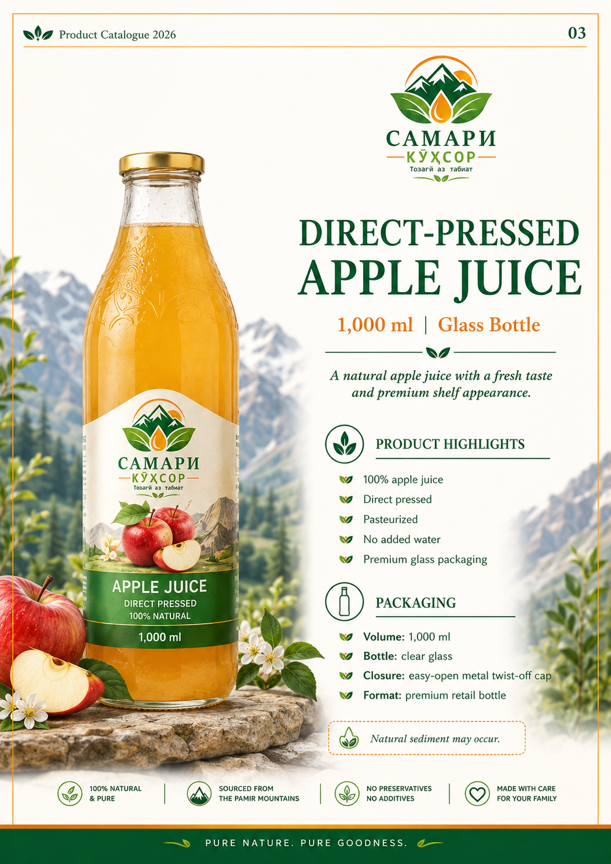  Apple juice catalogue concept | 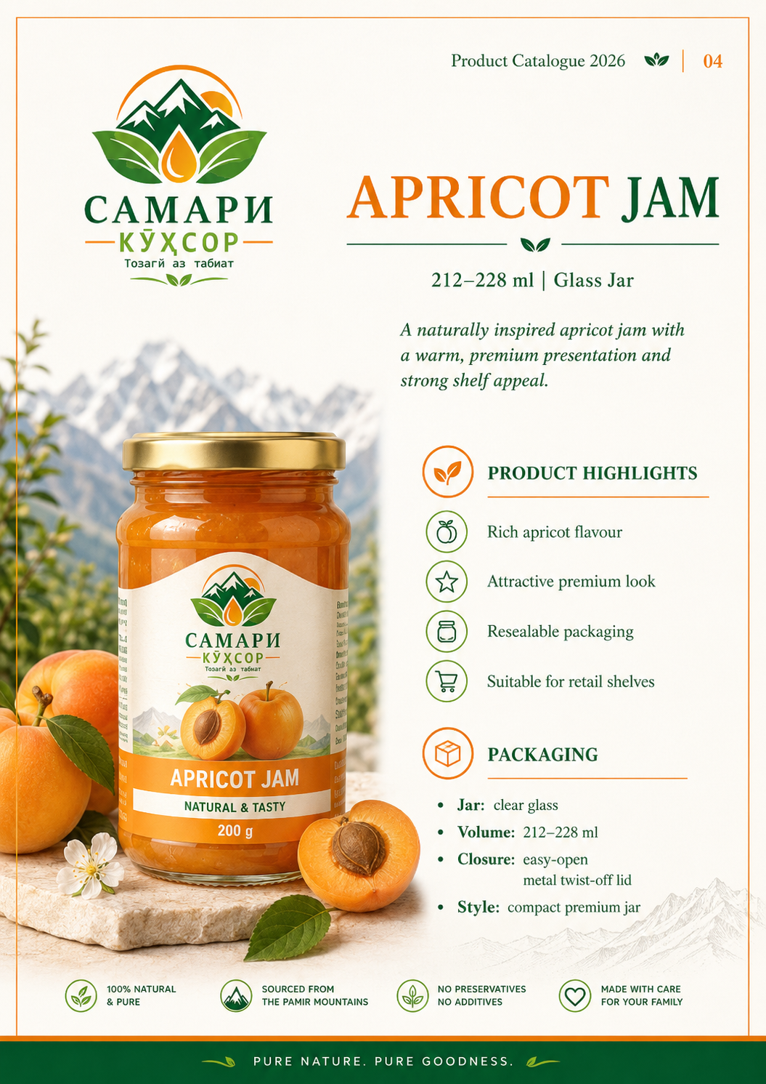  Apricot jam catalogue concept
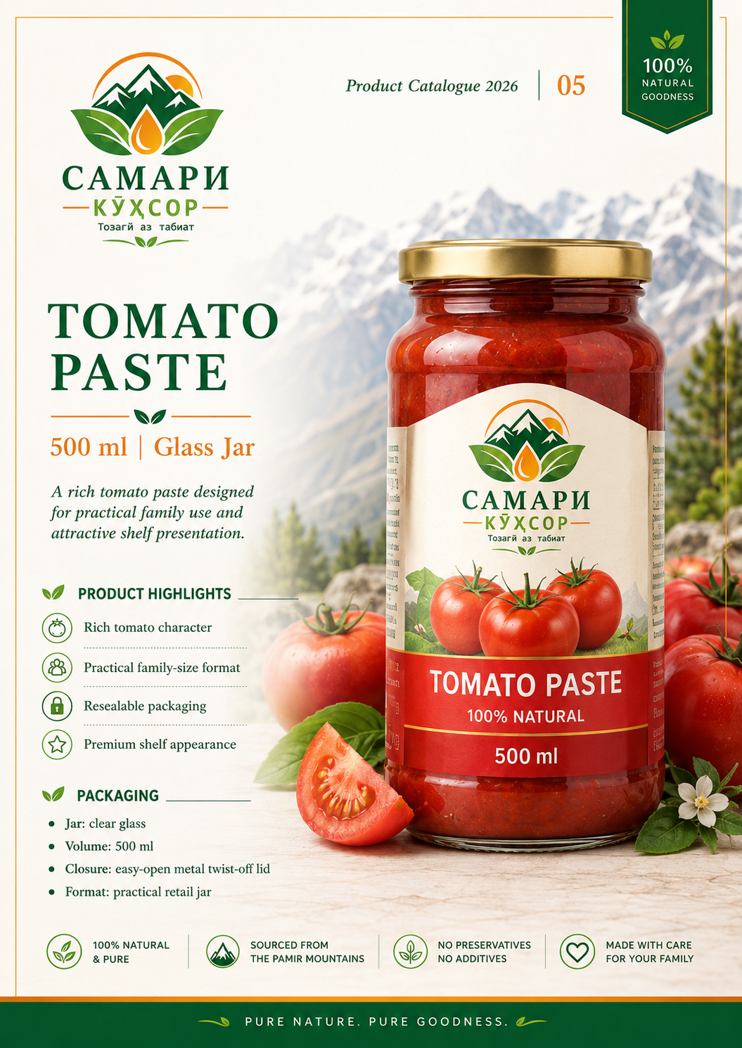  Tomato paste catalogue concept | 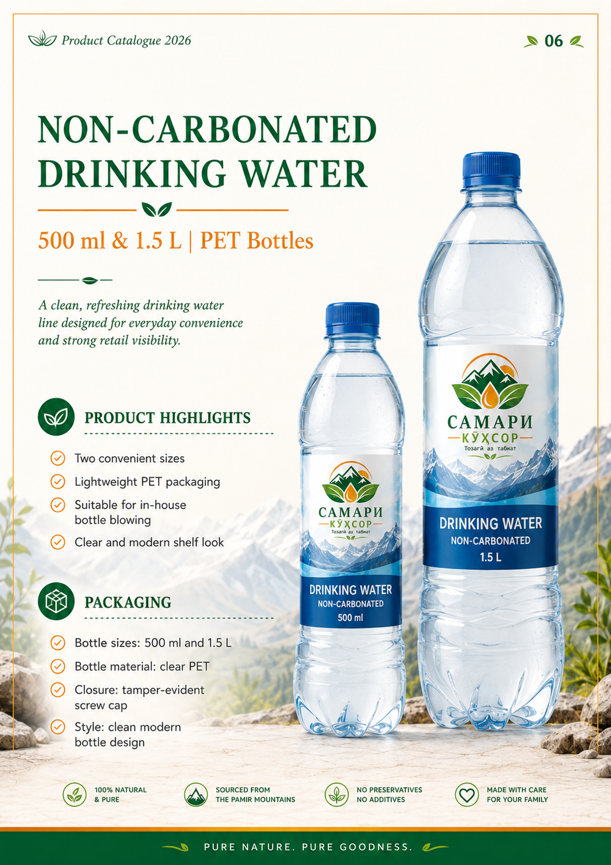  Drinking water catalogue concept
These images are design concepts, not final regulated label artwork. Product photography and label text must be replaced with approved production assets before launch.

8. User Experience and Visual Design

8.1 Design principles
- Clean, premium and trustworthy rather than visually crowded.
- Regional identity without making every screen a mountain poster.
- Strong product photography and simple information hierarchy.
- Mobile-first layouts suitable for slower connections.
- Clear distinction between corporate, product, institutional and legal content.

8.2 Colour system
Role | Colour direction | Application
Primary | Dark green | Navigation, headings, footer and trust elements
Secondary | Leaf green | Icons, highlights and natural-product cues
Accent | Orange / amber | Calls to action and fruit-product accents
Neutral | Warm white / cream | Backgrounds and content surfaces
Water line | Blue | Water product pages and labels
Tomato line | Red | Tomato-specific accents, used sparingly

8.3 Typography and media
- Use a readable sans-serif for body text and an optional restrained serif/display typeface for headings.
- Do not use text baked into images for essential information.
- Provide responsive WebP/AVIF derivatives and retain full-resolution originals.
- Photograph products on white background and in regional/lifestyle settings.
- Include factory, equipment, personnel, raw materials and packaging imagery after the facility is ready.

9. Content Management System

9.1 Editable content
- Pages and navigation.
- Products and product technical data.
- News, galleries and videos.
- President page and official external links.
- Contact details and maps.
- Downloads and certificates.
- SEO metadata and social images.
- Translations and publication status.

9.2 Roles and permissions
Role | Permissions | Restriction
Super Administrator | Full technical and content access | Limited to authorised senior staff
Content Manager | Pages, products, news, media and downloads | Cannot change system/security settings
Translator | Assigned language versions | Cannot publish without approval
Technical / Compliance Reviewer | Product claims, shelf life, ingredients, certificates | No infrastructure access
Media Manager | Images, videos and galleries | Cannot edit legal/product technical data
Contact Manager | View and respond to inquiries | No publishing rights

9.3 Publishing workflow
Required workflow
Draft → Technical Review → Language Review → Management Approval → Published

10. Functional Requirements
ID | Requirement | Priority | Acceptance evidence
FR-001 | The site shall provide Tajik, Russian and English versions. | Must | Equivalent pages can be opened in all three languages.
FR-002 | The CMS shall support separate translation status and review dates. | Must | Editors can manage each language independently.
FR-003 | The product catalogue shall support categories and filters. | Must | Users can display product groups without reloading the full site.
FR-004 | Each product shall have a structured detail page. | Must | Required fields are rendered from CMS data.
FR-005 | The site shall include a President page sourced from official resources. | Must | Page contains source note and official external link.
FR-006 | Contact and distributor forms shall send notifications and save submissions. | Must | Submission appears in CMS and email notification is received.
FR-007 | Forms shall implement validation, consent and anti-spam protection. | Must | Invalid/spam submissions are rejected appropriately.
FR-008 | Downloads shall display language, file type, version, date and size. | Should | Document list shows the required metadata.
FR-009 | News posts shall support galleries, video and attachments. | Should | Content manager publishes a test multimedia article.
FR-010 | The CMS shall provide role-based access and audit history. | Must | User permissions and change logs are demonstrated.
FR-011 | The site shall provide site search. | Should | Search returns pages, products, news and downloads.
FR-012 | Telephone, email, WhatsApp and map links shall be trackable events. | Should | Analytics test confirms event capture.

11. Non-Functional Requirements
ID | Area | Requirement | Target
NFR-001 | Responsive design | All public pages shall work at common mobile, tablet and desktop widths. | No horizontal scrolling; no clipped content
NFR-002 | Browser support | Current major versions of Chrome, Edge, Firefox and Safari. | Functional parity for public features
NFR-003 | Availability | Production site shall use monitored hosting and automated recovery procedures. | Target 99.5% monthly availability excluding approved maintenance
NFR-004 | Backups | Automated database and media backups with tested restoration. | Daily backups; documented restore test
NFR-005 | Maintainability | Content updates shall not require code changes. | Editors can manage pages/products in CMS
NFR-006 | Scalability | Architecture shall support new products, languages and pages. | No redesign required for normal catalogue growth
NFR-007 | Observability | Errors, uptime and failed form deliveries shall be monitored. | Alerts to designated administrators
NFR-008 | Ownership | QOIM shall receive source code, credentials and documentation. | Handover checklist signed

12. SEO and Structured Data
- Unique title and description for every indexable page.
- Readable multilingual URLs and canonical URLs.
- XML sitemap and robots.txt.
- hreflang links between equivalent language pages.
- Open Graph and social sharing metadata.
- Breadcrumb navigation.
- 301 redirects when a URL changes.
- Alt text and descriptive filenames for images.
- Structured data using Organization for QOIM, Brand for Samari Kuhsor, Product for products, BreadcrumbList for navigation and Article for news. Schema.org defines these standard types and properties. [5]

13. Performance, Accessibility and Security

13.1 Performance
The development team shall target the “good” Core Web Vitals thresholds: Largest Contentful Paint no more than 2.5 seconds, Interaction to Next Paint no more than 200 milliseconds and Cumulative Layout Shift no more than 0.1, measured at the 75th percentile where field data is available. [3]
- Responsive images and modern formats.
- Lazy loading below the first screen.
- No autoplay video with sound.
- Caching, compressed assets and minimal third-party scripts.
- Server-side rendering or static generation for public content.
- Initial homepage transfer target of approximately 2 MB or less, subject to design approval.

13.2 Accessibility
Target WCAG 2.2 Level AA. WCAG 2.2 is the current W3C Recommendation used in this specification. [2]
- Keyboard-accessible navigation and visible focus.
- Sufficient colour contrast.
- Text alternatives for meaningful images.
- Labels and clear errors for every form field.
- Captions/transcripts for important video content.
- Semantic headings and landmarks.
- No information conveyed by colour alone.
- Zoom and text resizing without loss of content.

13.3 Security
Security verification should be mapped to the OWASP Application Security Verification Standard, which provides a basis for testing web application technical security controls and secure-development requirements. [4]
- HTTPS on all environments exposed to users.
- Multi-factor authentication for administrators.
- Role-based access control and strong password policy.
- Rate limiting and brute-force protection.
- Input validation, output encoding, CSRF protection and secure sessions.
- Restricted file formats, size limits and malware scanning.
- Content Security Policy and secure HTTP headers.
- Dependency updates and vulnerability scanning.
- Audit logs and separate development, staging and production environments.

13.4 Privacy
- Privacy policy and cookie policy.
- Consent checkbox on forms.
- Defined retention period for inquiries.
- Restricted access to personal data.
- Process for correction and deletion requests.
- No non-essential tracking before consent where consent is required.
- Collect only data necessary for the stated inquiry.

14. Technical Architecture
The final platform should be selected according to the team’s maintenance capacity, not only its development preference. A technically elegant headless architecture is a poor choice if QOIM cannot maintain it after handover.
Option | Components | Advantages | Risks / conditions
A. Headless | Next.js or Nuxt; Strapi or Directus; PostgreSQL; object storage/CDN | High performance, structured content, clean separation | Requires stronger DevOps and developer maintenance
B. Managed WordPress | Custom theme; multilingual plugin; limited vetted plugins; managed hosting | Lower operational complexity and familiar editing | Plugin discipline and security maintenance are essential
Selection rule
Use the headless option only if the development team will provide documented deployment, monitoring, backups and long-term maintenance. Otherwise, a carefully controlled custom WordPress implementation may be the lower-risk business choice.

14.1 Environments and infrastructure
- Separate development, staging and production environments.
- Domain and DNS controlled by QOIM, not solely by the contractor.
- CDN and web application firewall where appropriate.
- Authenticated SMTP or transactional email service.
- Object/media storage with backups.
- Documented deployment and rollback procedure.

15. Analytics and Reporting
Event | Purpose | Minimum data
Product view | Measure product interest | Product ID, name, language
Catalogue download | Measure commercial engagement | File, language, page source
Contact submission | Measure lead generation | Inquiry type and language; no message text in analytics
Distributor inquiry | Measure B2B conversion | Country, product interest
Phone / WhatsApp / email click | Measure contact intent | Page and channel
Map click | Measure visit/location interest | Page and language
Language switch | Understand language demand | From/to language and page
Video play | Measure media engagement | Video ID and page

16. Content Governance and Publishing Workflow
Product information is regulated operational content, not ordinary marketing copy. Claims must be approved before publication and reviewed when recipes, packaging, certificates or shelf-life evidence change.
Content type | Owner | Required approver
Corporate identity and history | Management / communications | Director
Product composition, shelf life and storage | Technologist | Compliance reviewer / management
Certificates and laboratory documents | Compliance / quality | Director
President page | Communications | Director; source re-check before publication
News and media | Communications | Authorised manager
Legal policies | Management | Legal review where available

17. Testing, Deployment and Operations

17.1 Required testing
- Functional testing of all links, forms, filters, downloads and language switching.
- Responsive testing on representative mobile, tablet and desktop sizes.
- Cross-browser testing.
- Accessibility review combining automated and manual keyboard/screen-reader checks.
- Performance testing and image/network optimisation.
- Security testing, dependency scan and configuration review.
- Content and translation review by QOIM.
- Backup and restoration test.
- Email deliverability test for all forms.

17.2 Launch procedure
- Content freeze and final approval.
- Full staging backup.
- DNS and SSL validation.
- Production deployment and smoke test.
- Search engine indexing controls removed only after approval.
- Analytics verification.
- Post-launch monitoring for forms, errors and uptime.
- Rollback plan retained for the launch window.

17.3 Maintenance
- Monthly dependency/CMS updates and security review.
- Daily automated backups and periodic restore tests.
- Quarterly accessibility and broken-link checks.
- Monitoring of uptime, forms and email delivery.
- Content review reminders for product and President information.

18. Implementation Schedule
Period | Workstream | Exit criterion
29 June–3 July 2026 | Requirements confirmation, sitemap and content inventory | Signed scope and outstanding-input list
6–17 July | Wireframes and visual design | Approved desktop and mobile design system
13 July–7 August | Frontend, CMS and backend development | Core modules functional on staging
20 July–14 August | Content writing, translation and photography | Approved draft content in three languages
10–21 August | Product data entry and integrations | Products, forms, downloads and analytics configured
17–28 August | QA, security, performance and mobile testing | Critical defects closed
24–31 August | QOIM review and corrections | Formal pre-launch approval
1–4 September | Soft launch | Production environment stable and monitored
5–8 September | Final launch preparation | Launch checklist complete
9 September | Public launch | Website publicly available
Schedule dependency
This timeline is feasible only if QOIM supplies approved legal details, contact information, product text, translations, photographs and the final President-page content on time.

19. Deliverables and Acceptance Criteria

19.1 Contractor deliverables
1. Requirements and final sitemap.
2. Wireframes and desktop/mobile UI designs.
3. Design system and reusable components.
4. Responsive multilingual website and CMS.
5. Product catalogue, President page, news/media and downloads.
6. Contact and distributor forms.
7. SEO, analytics, accessibility and security configuration.
8. Staging and production deployment.
9. Source code and repository access.
10. Administrator training.
11. Technical, deployment, backup and recovery documentation.
12. Warranty and maintenance terms.

19.2 Acceptance criteria
Area | Acceptance requirement | Evidence
Content | All approved pages and products available in three languages | Signed content checklist
Responsive design | No clipping or unusable controls on target viewports | Device/browser QA report
CMS | Authorised users can edit and publish without developer assistance | Client demonstration
Forms | Notifications, storage, validation and anti-spam work | Test submissions
President page | Official sources, disclaimer and external link included | Content approval
Performance | Targets substantially met or exceptions documented | Lighthouse and field-readiness report
Accessibility | WCAG 2.2 AA issues addressed or documented | Accessibility checklist/report
Security | Critical/high findings closed; secure configuration applied | Security test summary
Operations | Backups, monitoring and recovery documented and tested | Restore test and runbook
Ownership | QOIM receives source, credentials and administrative control | Handover certificate

Appendix A. Required Content Inputs from QOIM
Input | Status | Required before
Registered legal name format and registration details | Confirmed: QOIM; remaining details pending | Legal pages and launch
Registered address, TIN and official contacts | Pending | Contact/footer build
Approved logo files in vector and web formats | Partially available | Final visual design
Approved product names in three languages | Pending final compliance review | Product content entry
Ingredients, nutrition, shelf life and storage | Pending production/technical approval | Product publication
Final package net quantities and label artwork | Pending | Product photography and pages
Official President portrait/content approval | Pending official-source selection | President page publication
Factory and staff photography | Pending facility readiness | Final content
Certificates and public laboratory documents | Pending issuance | Downloads/compliance sections
Telephone, email, WhatsApp, working hours and map pin | Pending | Contact integration
Social media accounts | Pending | Header/footer and sharing
Domain and hosting ownership decision | Pending | Deployment

Appendix B. References
[1] Official website of the President of the Republic of Tajikistan: https://www.president.tj/
[2] W3C, Web Content Accessibility Guidelines (WCAG) 2.2: https://www.w3.org/TR/WCAG22/
[3] web.dev, Web Vitals and Core Web Vitals thresholds: https://web.dev/articles/vitals
[4] OWASP Application Security Verification Standard: https://owasp.org/www-project-application-security-verification-standard/
[5] Schema.org types and vocabulary: https://schema.org/
All time-sensitive official information, particularly the identity and title of the President and any certificates or product claims, must be re-verified immediately before publication.

Approval
Role | Name / signature | Date
QOIM Director
Project Lead
Web Development Contractor

