The Screen:

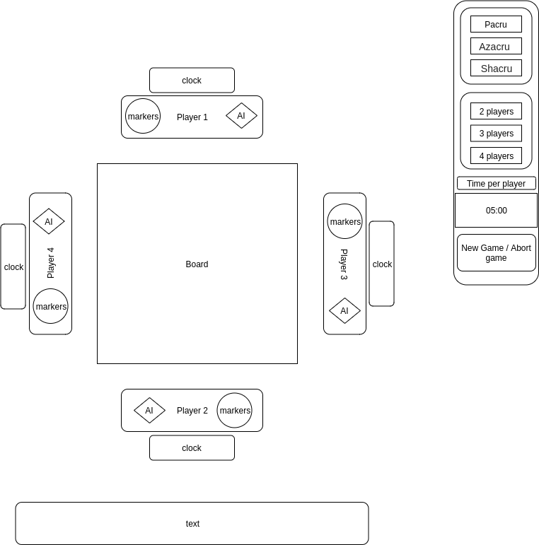

Side panel:

***Select Game:*** one of three options has to be selected, default = Pacru  
***Numbers of players:*** one of three options has to be selected, of 3 default = 2 players

***Time per player:*** values [0, 90:00] in resolution of seconds. default = 0 (no time limit)

This panel is active while no game is played.

***New Game:*** when "New Game" is pressed new game is starting. the "New Game" button become "Abort" button, all the buttons on this panel become inactive, excluding the "Abort" button. If cloak is set it become active.   
States:   
at start – panel active

"New Game" pressed – panel not active

"Abort" pressed – panel active

"Game ended" - panel active

Player panel:

***AI:*** selected / not selected, indicate that the computer is playing this position.

Active when the side panel is active.

***Markers:*** active when a game is in progress. Player click it to get a marker.

Clock:

Indicate time, active when the game is active.

Test:

Text based instruction ("select game", "player 1 to play", player 3 won" etc.)

The states machine:

