Alfred's Wyke
By Alain Dekker

The small town of Wyke Regis on the Dorset coast in south west England is an unlikely setting for a wonderful two-player game from designer, Andrew Perkis. I first met Andrew sometime in 2008 when he introduced me to Alfred's Wyke. Incidentally, Andrew has designed a number of high quality boardgames and puzzles. These include Owlman, Mirador and Cloud Nine, some of which have been presented in GAMES magazine. For those with access to a back catalogue of GAMES, the September 2008 issue features an article on Alfred's Wyke by Andrew Perkis.

The back-story for Alfred's Wyke is a struggle between the Saxons (or Builder) and the Vikings (or Destroyer). This delightful puzzle-game has an unique move selection mechanism and I was immediately captivated.

Introduction
The game board is a square grid of "plots" in two sizes, 4x4 or 6x6. On each plot there stands one "house". The Builder and Destroyer take turns adding or removing tiles from one or more houses, depending on the move selected. When a house is completely built (and claimed by the Builder) or destroyed (and claimed by the Destroyer), no further play is allowed on this plot. The Builder and Destroyer strive to meet certain conditions on the claimed plots to win the game. These conditions are discussed later.

Setup
For the 4x4 game, place a 2x2 grid of tiles (representing the lower floor of a 2x2x2 house) on each plot. Remove one tile from the lower right and upper left corners to create the starting position. This is shown in figure 1, along with the grid of available moves. "B" is used for the Builder and "D" is for the Destroyer.

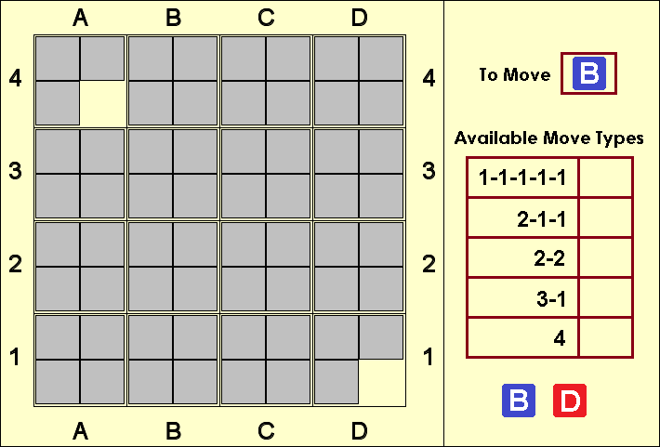
Figure 1: 4x4 starting position with available moves chart

The 6x6 game is similar but with six rows and columns. The starting plots with 3 tiles are at co-ordinates b5 and e2.

Rules of Play
The Builder moves first, and thereafter play alternates. Passes are not allowed. The player selects and places their marker next to one of the available options on the chart. Only options which do not have a marker next to it are available for selection. At the start of the game, the Builder can choose any of the five options. The Destroyer then has four choices available. Thereafter each player can choose between three options - those not played by the Builder or Destroyer on the previous turn.

The 1-1-1-1-1 move means the player adds (for the Builder) or removes (for the Destroyer) one tile from each of five different plots. Other moves are similar. For example, the 3-1 move allows the Builder to add three tiles to one plot and one tile to a different plot.

Moves must be completed in full. For example, if the 4 move is chosen then exactly four tiles must be added or removed from a plot - the player cannot "split" the move between plots or add or remove fewer than four tiles. There is only one exception to this: If only four plots remain which have not been claimed by either player, then the 1-1-1-1-1 move can be played as 1-1-1-1. This can only occur in the 4x4 game when players are tied on six plots each.

Capturing Plots
Whenever a 2x2x2 house is completed with a total of eight tiles, the plot is won by the Builder. Similarly, when all tiles are removed from a house, the plot is won by the Destroyer. It is possible for several plots to be won on a players' turn. Once claimed, no further play is allowed on that plot.

As noted in the previous section, to complete or demolish a house, the exact number of tiles must be added or removed. For example, if there were two files on a plot, and none of the moves which include a "2" were available, the Destroyer would not be permitted to claim the plot by using the 4 move or using the "3" component of the 3-1 move.

Object
The players strive to achieve one of the following win conditions.

A positional win is achieved when either player has won four plots that form either:
A four-in-a-row of houses (orthogonal along a row or column or diagonal)
A farmstead or two-by-two square of contiguous plots

A numerical win is achieved when either player has won a total of seven plots (in the 4x4 game) or twelve plots (in the 6x6 game).

A standing win is achieved if the player is unable to choose a legal move from the option chart. Note that this is highly unlikely and is probably only possible in a constructed game.

In practical tournament play, a draw may be agreed after, for example, a three-fold repetition.

Move Selection
This and the next section summarise some interesting statistics about the available moves and the board geometry.

In the starting position of the 4x4 game, the Builder has all five choices available. But these can be played in any legal way. A total of 528,014 different moves are legal, calculated as follows:

1-1-1-1-1: 16 x 15 x 14 x 13 x12 = 524,160
2-1-1: 16 x 15 x 14 = 3,360
2-2: 16 x 15 = 240
3-1: 16 x 15 = 240
4: 14

The number of legal moves at the start of a 6x6 game is an eye-watering 45,284,434!

Astute readers will note that board rotations and mirror images mean some moves are equivalent. Moreover, the number of legal moves fall as the game progresses for two reasons: Available options reduce to three after the first two moves, and legal options become fewer as the number of claimed plots increases.

All moves, with the exception of 1-1-1-1-1, add (or remove) exactly four tiles to the board. While the 1-1-1-1-1 move has a less dramatic impact, the cumulative advantage of the extra tile is significant and can build up with time. Whenever 1-1-1-1-1 becomes available, and the board position allows it, players will generally be wise to play it.

Board Geometry
The 4x4 board has a total of 9 "farmsteads" (2x2 block), 8 orthogonal lines of four (along a row or column), and two diagonals. Positional wins are therefore more likely by forming a farmstead or orthogonal four-in-a-row, than by a diagonal four-in-a-row. Practical games between experienced players are, however, likely to end in a 7-6 numerical win.

The geometry of the 6x6 board is more complex, though. The board has 25 farmsteads, 36 orthogonal lines of four, and 18 diagonals. With a numerical win requiring 12 plots, positional wins are much more likely. The 6x6 game geometry therefore makes for a more interesting and engaging game.

Practical and Online Play
Alfred's Wyke has not yet been published in physical form, but the game can be played using upturned word tiles (such as used in Scrabble) or in pen-and-paper form. The game can also be played online at superdupergames.org. The first game was played in February 2009, and to date approximately 250 games have been completed. The win rate for the Builder is 52.4%, with a similar "first move" advantage to games such as Chess.

The starting position of Alfred's Wyke gives the Destroyer a 2-tile advantage. However, since the Builder can (and should!) immediately take the powerful 1-1-1-1-1 move, a slight bias is to be expected in favour of the Builder.

Alfred's Wyke has not yet been submitted (some would say subjected!) to formal computer analysis, but I have written a program to analyse the game. The program performs Monte Carlo simulations by randomly selecting from among the available legal moves (with the option to choose the beneficial 1-1-1-1-1 move, when available). The idea is to gather statistics on win conditions, shortest and longest possible games, and to give an estimate to advantage enjoyed by the Builder. The results from millions of simulations are:

 | Builder Win Ratio | Max Game Length | Avg Game Length
4x4 | 56.6% | 135 | 44.2
6x6 | 52.1% | 157 | 65.9
The win percentage tallies closely with the win rate from completed games at superdupergames.org.

Tournament Play
The annual Mind Sports Olympiad (MSO) takes place in the United Kingdom and attracts international participants from all over the world. A huge variety of boardgames and mental disciplines are featured such as Chess, Poker, Settlers of Catan, Mental Calculations, and Creative Thinking. The standard is incredibly high. Alfred's Wyke has made two appearances at the MSO (in 2009 and 2010) where both tournaments were won by Martyn Hamer from England (with myself second). Martyn is a strong games player from Lancashire in the north of England and won the prestigious Pentamind in 2009.

Alfred's Wyke has not been published in physical form, so the MSO events used upturned Scrabble tiles. This is not ideal, though, since players need to have a steady hand - not easy during the tensions of playing in a tournament! Due to a slight bias towards the Builder, tournament play should always be double-sided (one game where Player 1 takes the Builder, and a return match where Player 1 takes the Destroyer). If time and equipment allows, the higher quality 6x6 game should be preferred for tournament play.

Example Position
To give readers a flavour of some of the intricacies of the game, have a look at figure 2a. The Builder in this game was Martyn Hamer and the Destroyer was played by myself. This complex position was reached after move 17. Before reading further, consider what you would play as Destroyer in this position.

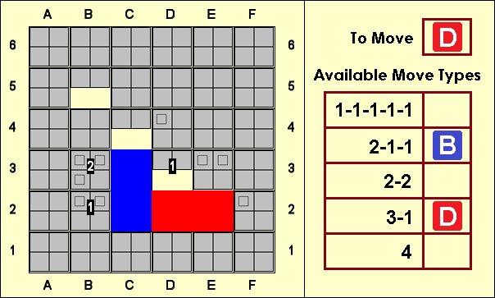
Figure 2a: A complex 6x6 game...what should Destroyer play?

Builder is threatening to complete the farmstead on b2,b3,c2,c3. The 1-1-1-1-1 move is also available and earlier advice rightly recommends to take this move whenever available. But the best move here is actually 2-2 (d3+,c4+) to reach the position shown in figure 2b.

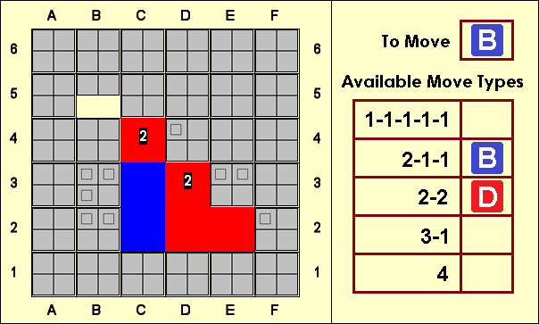
Figure 2b: A good response, pushing for the initiative

Gaining two central plots is useful, but the strength of this move lies primarily in gaining the initiative. Destroyer now threatens a diagonal four-in-a-row (b5-e2 or c4-f1), the e3 plot must now be defended and several possible lines and diagonals for Builder have been permanently cut off.

Builder cannot immediately win by completing the b2,b3,c2,c3 farmstead. Nor can Builder himself play the available 1-1-1-1-1 move because the b5 plot would be captured next turn. In the event, Builder chose 3-1 (f1,b5) and Destroyer was then able to play 1-1-1-1-1, keeping a lasting initiative to eventually win a tense, exciting game.

Example Game
This example 4x4 game was between user "Laurie_Menke" (Builder) and myself (Destroyer). Readers may follow the game from the text and figures, or by using pencil-and-paper. Alternatively, the game can be played through with this URL:
http://superdupergames.org/?page=archive_play&gid=15229

Laurie_Menke (Builder) abdekker (Destroyer)
1: 1-1-1-1-1 (b2,b3,c2,c3,a4) 2-1-1 (b3,c3,c2)
Builder makes a strong early move, using the 1-1-1-1-1 move to attack the central squares; Destroyer responds in kind
2: 3-1 (b2+,c2)
The immediate capture of a central plot works well, permanently removing possibilities from Destroyer
1-1-1-1-1 (c1,c2,c3,b3,d1)
3: 4 (c2+)
An excellent move, slicing the board in two and removing several future winning options from the Destroyer. Builder now enjoys a strong initiative with the threat to make a line of four in the 2nd row.

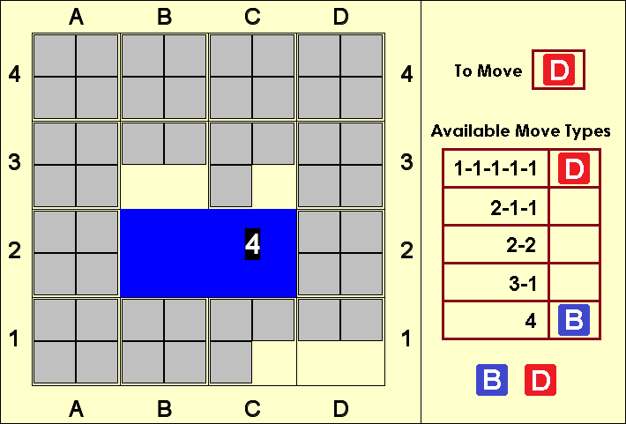

3-1 (d2,d1)
4: 1-1-1-1-1 (b3,c3,b1,b4,d2)
Taking the 1-1-1-1-1 move consistently gives the player a long-term cumulative advantage because it adds or removes an extra tile compared to the other moves.
2-2 (b3,c3)
5: 3-1 (d2,a2) 1-1-1-1-1 (a3,b3+,c3,d3,d1+)
Destroyer finally captures a plot, making a stake for the 3rd row.
6: 2-2 (a2,d2)
Very strong! The threats along the 2nd row must be answered immediately.

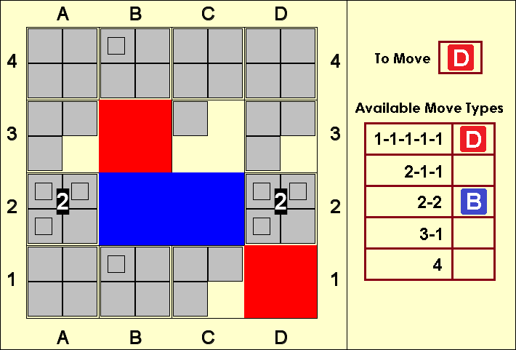

4 (d2)
Probably best. Destroyer keeps alive future threats along the D column. It is worthwhile considering the possibilities here. One or both of the moves 1-1-1-1-1 or 2-1-1 will be available to Builder next turn, and consequently Destroyer must therefore remove tiles from one or both the a2 and d2 plots to avoid immediate loss. 3 options are available: 2-1-1, 3-1 and 4. It is not easy to decide between them and care is required. For example, 3-1 (d2,c3+) is appealing since it defends against the immediate threat on the 2nd row and captures another plot. But Builder can respond 4 (d2+)! ending the game because a2 cannot be defended. One reasonable alternative is 4 (a2) which has the advantage of attacking Builder's threat on the a1,a2,b1,b2 farmstead.
7: 1-1-1-1-1 (a2+,d2,b1,a1,c3)
The threat along the 2nd row is renewed and a second threat has emerged on the a1,a2,b1,b2 farmstead, meaning Destroyer must now defend three plots (a1, b1 and d2).
3-1 (d2,b1)
A good response, which prevents Builder capturing any of the threatened plots.
8: 2-1-1 (d2,a1,b1) 1-1-1-1-1 (a1,b1,d2,d3,c3)
9: 3-1 (b1+,a1)
Capturing b1 is best as now both a1 and c1 are threats which must be defended by Destroyer. The alternative capture on a1 leaves only b1 as a threat on the bottom row.
2-1-1 (d2+,c3+,a1)
Cool defence under pressure! d2 is permanently removed as a threat and Destroyer tries to distract Builder by renewing threats along the 3rd row.

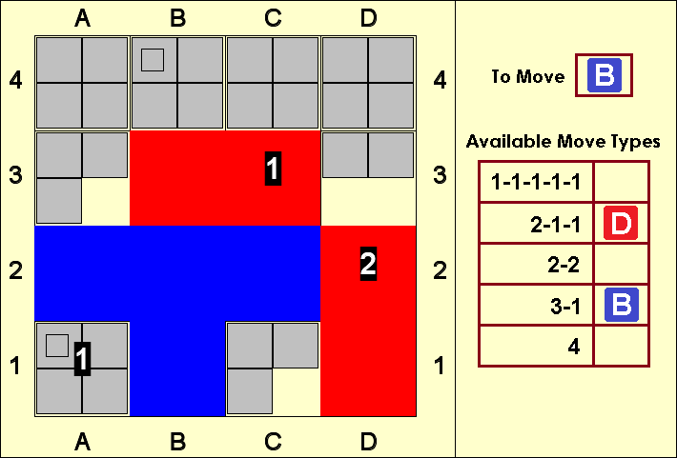

10: 1-1-1-1-1 (a1,c1,a4,c4,d4)
This move is fine, though more accurate might have been to add tiles to one or both of a3 and d3. Note that both a1 and c1 win for Builder and must be defended.
3-1 (c1,a1)
Care is required! For example, 3-1 (a1,c1) loses immediately to 4 (c1) and Destroyer cannot defend c1.
11: 2-1-1 (c1,a1,d3)
This is inaccurate. The key threat here is a1 and 2-1-1 (a1,c1,d3) would be strong. Destroyer would then be forced to play 4 (a1), whereafter Builder can follow up with 1-1-1-1-1 (a1,c1,a3,d3,d4). Destroyer would not be able to capture either a3 and d3.
2-2 (a3,d3)
Due to the mechanism for selecting moves, stubborn defense is possible for the resourceful defender. The move chosen defends a1 and renews the threat along the 3rd row. Builder is objectively still winning, but care is required!
12: 4 (d3)
Builder responds to the threat directly. Worth considering was the forcing sequence beginning with 1-1-1-1-1 (a1,c1,a3,d3,d4). Destroyer must defend with 4 (a1), when 2-2 (a1,d4+) captures another plot and leaves Destroyer with the problem of defending both a1 and c1 and unable to play the 1-1-1-1-1 move.
3-1 (d3,a1)?!
The move 2-1-1 (a1,a3+,d3) was more flexible. The extra plot and threats on the 2nd row gives Builder more to think about...always useful in a practical game!
13: 1-1-1-1-1 (d3,a1,a3,b4,c4) 4 (a1)
Forced in order to defend a1. If Destroyer had played 2-1-1 on the previous move, an additional option of 3-1 (a1,*) would have been available (where * means "any plot").
14: 2-2 (b4+,c4+)
Builder has now reached six plots and needs only one additional plot to achieve a numerical win of seven plots.

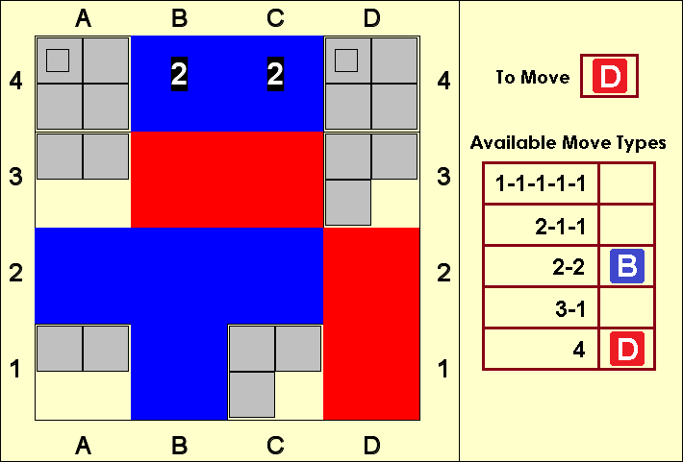

3-1 (d4,d3)
The 3-1 move is forced as there is no other way to defend both a4 and d4, but 3-1 (d3+,a3) was worth considering as the threat along the 3rd row may distract Builder.
15: 2-1-1 (a4,d3,a3) 4 (a4)
The only way to defend a4
16: 3-1 (c1,a1) 1-1-1-1-1 (c1,a1,a3,d3,d4)
Builder should have prevented Destroyer playing the 1-1-1-1-1 move by playing this himself!

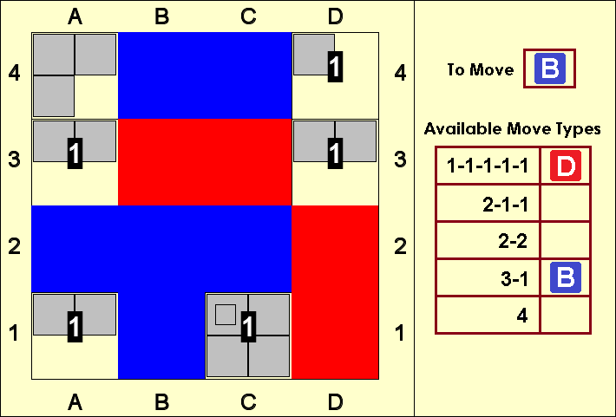

17: 4 (a1)
Builder blunders! The move 4 (d3) forces a winning sequence. If Destroyer plays 3-1 (a4+,d3), 1-1-1-1-1 (a1,c1,a3,d3,d4) follows by Builder when c1 and d3 cannot both be defended. Destroyer must therefore play 2-1-1 (d3,c1,d4+), but Builder is then able to play 2-2 (c1,d3), forcing the response 3-1 (d3,c1) from Destroyer. Builder responds 2-1-1 (c1,a3,a4), forcing 4 (c1). Finally Builder plays 1-1-1-1-1 (a1,c1,a3,d3,d4) and Destroyer is unable to defend c1,a3,d3 and a4).
3-1 (a1,d4+)
Oops, Destroyer overlooks two immediate wins. Can you see them? Both 2-2 (a3+,d3+) and 2-1-1 (d3+,d4+,*) would have won on the spot!
18: 2-1-1 (c1,a3,d3) 4 (c1)
19: 1-1-1-1-1 (a4,a3,a1,c1,d3) 3-1 (d3,a3)
The 4 move is unavailable and the game finally ends...
20: 4 (c1+)
A complex game, with both players missing chances!

Puzzle Position
We finish with the ending to a game between the owner of superdupergames.org, Aaron Dalton (Builder) and the games inventor, Andrew Perkis (Destroyer). In the position from figure 4, Builder has just played the move 1-1-1-1-1 (c3,b3,b2+,c4,d2) and is apparently in a commanding position with an additional plot and the threat to complete a farmstead on b3. But Destroyer has a powerful counter-stroke which starts a winning sequence. Can you spot the move?

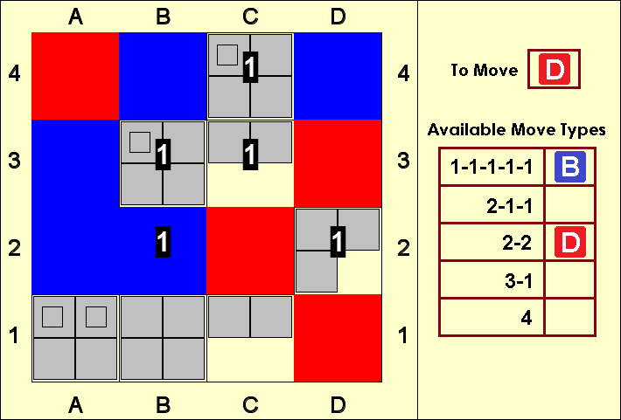
Figure 4: Can you spot the winning move and forcing sequence for Destroyer

The winning move is 3-1 (d2+,c3)! from Destroyer. This defends b3 and the twin threats to c1 and c3 must be answered with 2-1-1 (c3,c1,*). For example 2-1-1 (c3,c1,b3). Finally, Destroyer plays 2-2 (c1,c3), again defending b3 and Builder cannot defend both c1 and c3.

Acknowledgements
Graphics are courtesy superdupergames.org (head over there to try Alfred's Wyke for free). Thanks to GAMES magazine for requesting and agreeing to publish this article. Above all, my thanks to Andrew Perkis for creating this and many other wonderful games.
Alain Dekker (Guildford, UK and Berlin, Germany)

