Alfred's Wyke
A game for two players by Andrew Perkis

Introduction
Alfred's Wyke is a game for two players, one being the Builder the other being the Destroyer. The game is played on a four-by-four grid. Each cell in the grid is called a "plot". In the initial set-up, a partially built "house" stands on each plot. The game requires approximately 75 undifferentiated tiles which will represent building blocks or "bricks".

Players take turns to either add tiles to a house (the Builder) or to remove them (the Destroyer). Once a house has been fully built (and claimed by the Builder) or completely destroyed (and claimed by the Destroyer) there is no further play on the plot on which it stands - or has fallen.

Setting Up
Set up the tiles in 4x4 plots as shown below in Figure 1. Four tiles, each representing the lower floor of a 2x2x2 house are placed in each location, with the exception of two opposite-corner plots that are composed of three tiles each. Once the initial layout is complete, a dozen additional tiles is more than enough for play. The game can be played on any open table surface.

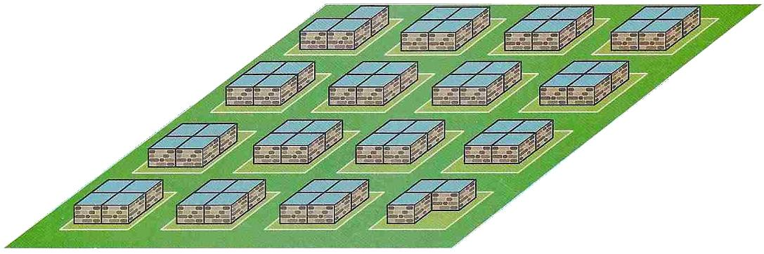
Figure 1: Initial setup

Next, you will need the chart shown in Figure 2. Each player will need a distinctive marker that can be placed beside their move choice on their turn of play.

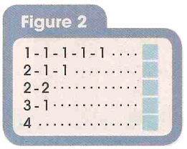
Figure 2: Option chart

Play
The Builder always starts play. Thereafter players take turns alternatively. There is no passing.

The first move on the option chart (1-1-1-1-1) means that the Builder can add one tile to each of five different plots. The plots so chosen must not be fully built (eight tiles) nor fully destroyed (no tiles). For the Destroyer, this move choice enables one tile to be removed from each of five different plots. Other move types are similar. For example, the 3-1 move would allow the Builder to add three tiles to one plot and one tile to another plot. Moves must always be played in full, with the exception that if both players control six plots (and therefore only four plots remain in play), the 1-1-1-1-1 move is played as 1-1-1-1.

At the start of play the Builder may choose any of the five types of move and will place their marker alongside this choice on the chart. The Destroyer may now play any type of move except the move just chosen by the Builder and will place their marker alongside this choice. Thereafter players takes turns to move, selecting from the three remaining choices that were not played by either themselves or the other player on the previous turn. They should then move their marker on the option chart to indicate their choice.

A player gains control of a plot when it is either completely built (made up to eight tiles by the Builder) or completely destroyed (all tiles are removed by the Destroyer). It is possible to win control of more than one plot in a turn.

When playing any move, the exact number of tiles must be added to a plot or taken from a plot. For example, if there were two tiles on a plot, and a move option which included a "2" was not available to the Destroyer, then he would not be permitted to win control of the plot by using either the "4" move or the "3" component of the 3-1 move.

No further play is permitted on a plot that has been claimed by either player. This will usually be indicated by placing a marker on the plot of the players' colour.

Object
The players strive to be the first to achieve one of the following winning conditions:

A positional win is achieved when either player has won four plots that form either
- a row of houses (four in a row, either diagonally or orthogonally)
- a farmstead (a two-by-two square of contiguous plots)

A numerical win is achieved when either player has won either
- four more plots than the other player
- a total of any seven plots

A standing win is achieved if the player is unable to choose a legal move type from the option chart. This is highly unlikely and is probably only possible in a constructed game.

Tournament Rules
In addition to the basic rules.

- Building blocks will be provided to represent bricks. These will probably be upturned Scrabble tiles. Play will be on the open surface of a table.

- An option chart will be provided on which to select the current move type eg. "2-1-1".

- Markers will be provided in two colours to indicate control of a plot. The same marker will also be used to indicate the move type selected on the option chart.

- Labelled disks with the numbers "1" to "4" written on them will be provided for indicating the move the player intends to make.

- Games will be played using electronic clocks. The time control will be a starting time of 10minutes with an increment of 30seconds per move. If electronic clocks are not available, the time control will be a flat 15minutes for each player.

- The tournament will be run as a Swiss system. The exact number of rounds will depend on the number of entrants, but is expected to be five or six rounds, time permitting. The winning player will score one point. In the event of a draw, each player will receive half a point.

- Players will either draw for who goes first (the Builder), or will be allocated their role by the pairing.

- On their turn, play should proceed in the following sequence:
- Place the labelled disks "1" to "4" (see point 4 above) on the plot(s) on which you intend to move. For example, if you are considering the "3-1" move, balance a "3" disk on one plot and a "1" disk on another. You may move these disks or change them for different disks as often as you like.
- When you have decided which move you will play, leave the disks on the playing board. Move your marker on the option chart to the appropriate option. The labelled disks must match the option selected.
- Once your marker has been moved on the option chart, you may not change your move and you must complete it exactly as indicated.
- If you have made an illegal move, unless allowed by the arbiter (allowance will usually be given in early rounds as players' become more familiar with the game), you will forfeit the game.
- It is the players' responsibility to point out illegal moves made by their opponent. Once they have made their own move on the option chart, the previous move made by their opponent cannot be corrected.
- Replace each labelled disk on the board with the appropriate move ie. as the Builder, replace a "2" disk by adding two bricks to the plot; as the Destroyer, remove a "3" disk and also remove three bricks from the plot.
- If you have won control of one or more plots during your turn, place your marker on the plot to indicate this.
- Only now may you press the clock to start your opponents' time.

- If you run out of time, you will lose the game. The exception is if you run out of time but are able to demonstrate the winning move to the arbiter. In this case you will win the game.

- You may only offer a draw at the end of your turn (just before or just after pressing your clock to start your opponents' time). Your opponent is under no obligation to accept the draw. If the offer is accepted, play should stop immediately.

- Any disputes (and we hope there will be none!) will be resolved, where possible, by the arbiter. This includes disputes over the interpretation of any rule. The arbiter's decision is final.

Additional Information and Resources...
The designer, Andrew Perkis, would appreciate feedback and comments at:
http://alfredswyke.blogspot.com/

Any players with anything really nice to say about the game would increase the chances of the game eventually being produced commercially by leaving a rating and comment on:
http://www.boardgamegeek.com/

Alfred's Wyke can be played online at:
http://superdupergames.org

