

**Module: Random Optimization**

**Generated Number Classification with fully connected neural networks using Pytorch**

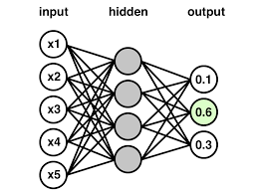

**Monitored by:**

**Pr. DABOUNOU Jaouad**

**Directed by:**

**SAWADOGO S. Abdel**

**University HASSAN 1st / Faculty of Science and Technology of SETTAT.**

**Field of study: Computer engineering**

**School year: 2024-2025/SEMESTRE 4.**

**Table of content**

Abstract

Chapter 1: Introduction

Chapter 2: Dataset generation

Chapter 3: Data quality check

Chapter 4: Clustering for validation

Chapter 5: Creation of the FCNNs for classification

Chapter 6: Results and discussions

Chapter 7: Conclusion