**Chapter 1**

## Introduction

# Solutions

**1.1S.** Suppose that you want to design an experiment to study the proportion of unpopped kernels of popcorn. Complete steps 1-3 of the guidelines for designing experiments in Section 1.4. Are there any major sources of variation that would be difficult to control?

Step 1 – Recognition of and statement of the problem. Possible problem statement would be – find the best combination of inputs that maximizes yield on popcorn – minimize unpopped kernels.

Step 2 – Selection of the response variable. Possible responses are number of unpopped kernels per 100 kernals in experiment, weight of unpopped kernels versus the total weight of kernels cooked.

Step 3 – Choice of factors, levels and range. Possible factors and levels are brand of popcorn (levels: cheap, expensive), age of popcorn (levels: fresh, old), type of cooking method (levels: stovetop, microwave), temperature (levels: 150C, 250C), cooking time (levels: 3 minutes, 5 minutes), amount of cooking oil (levels, 1 oz, 3 oz), etc.

**1.2.** Suppose that you want to investigate the factors that potentially affect cooked rice.

1. What would you use as a response variable in this experiment? How would you measure the response?
2. List all of the potential sources of variability that could impact the response.
3. Complete the first three steps of the guidelines for designing experiments in Section 1.4.

Step 1 – Recognition of and statement of the problem.

Step 2 – Selection of the response variable.

Step 3 – Choice of factors, levels and range.

**1.3.** Suppose that you want to compare the growth of garden flowers with different conditions of sunlight, water, fertilizer and soil conditions. Complete steps 1-3 of the guidelines for designing experiments in Section 1.4.

Step 1 – Recognition of and statement of the problem.

Step 2 – Selection of the response variable.

Step 3 – Choice of factors, levels and range.

**1.4.** Select an experiment of interest to you. Complete steps 1-3 of the guidelines for designing experiments in Section 1.4.

**1.5.** Search the World Wide Web for information about Sir Ronald A. Fisher and his work on experimental design in agricultural science at the Rothamsted Experimental Station.

Sample searches could include the following:

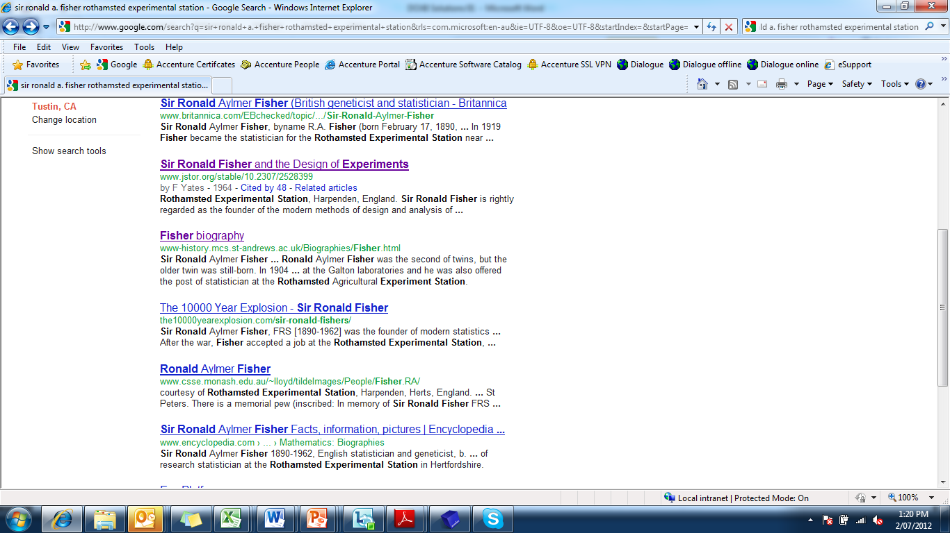

**1.6.** Find a Web Site for a business that you are interested in. Develop a list of factors that you would use in an experimental design to improve the effectiveness of this Web Site.

**1.7.** Almost everyone is concerned about the rising price of gasoline. Construct a cause and effect diagram identifying the factors that potentially influence the gasoline mileage that you get in your car. How would you go about conducting an experiment to determine any of these factors actually affect your gasoline mileage?

**1.8.** What is replication? Why do we need replication in an experiment? Present an example that illustrates the differences between replication and repeated measures.

Repetition of the experimental runs. Replication enables the experimenter to estimate the experimental error, and provides more precise estimate of the mean for the response variable.

**1.9S.** Why is randomization important in an experiment?

To assure the observations, or errors, are independently distributed randome variables as required by statistical methods. Also, to “average out” the effects of extraneous factors that might occur while running the experiment.

**1.10S.** What are the potential risks of a single, large, comprehensive experiment in contrast to a sequential approach?

The important factors and levels are not always known at the beginning of the experimental process. Even new response variables might be discovered during the experimental process. By running a large comprehensive experiment, valuable information learned early in the experimental process can not likely be incorporated in the remaining experimental runs.

Experimental runs can be expensive and time consuming. If an error were to occur while running the experiment, the cost of redoing the experiment is much more manageable with one of the small sequential experiments than the large comprehensive experiment.

**Reserved Problems**

**1.1R.** Have you received an offer to obtain a credit card in the mail? What “factors” were associated with the offer, such as introductory interest rate? Do you think the credit card company is conducting experiments to investigate which facors product the highest positive response rate to their offer? What potential factors in the experiment can you identify?

Interest rate, credit limit, old credit card pay-off amount, interest free period, gift points, others.

**1.2R.** What factors do you think an e-commerce company could use in an experiment involving their web page to encourage more people to “click-through” into their site?

Font size, font type, images/icons, color, spacing, animation, sound/music, speed, others.

**1.3R.** Two of the leading contributors to design of experiments over the last 60 years were George E. P. Box and J. Stuart Hunter. Search the World Wide Web for information on these two individuals and briefly summarize their contributions.

**1.4R.** Suppose that you want to make brownies. You plan to use a brownie mix, but there are a number of factors that could impact the results.

1. What would you use as a response variable? Could there be more than one response? Taste would probably be the primary factor. Other factors could be texture and aroma. Possibly a combination of all three.
2. Identify the factors that might impact the results. Amount of oil, number of eggs, amount of water, cost of mix – expensive or cheap, baking temperature, baking time, type of pan – glass or metal.
3. Complete the first three steps of the guidelines for designing experiments in Section 1-4.
4. Problem Statement – To maximize brownie tastiness. Or to make the best brownie while minimizing cost (Can a cheap mix give the results of an expensive one?)
5. Response Variable – Tastiness is the primary response. Secondary responses could also be texture and aroma.
6. Choice of factors, levels and range – for the maximize brownie tastiness: Mix cost (cheap, expensive), number of eggs (2,3), amount of oil (1/2 cup, ¾ cup), pan type (glass, metal), oven temp (350, 375), bake time (35 min, 45 min). One might want to reduce the number of factors from 6 to 3-4 to reduce the number of experimental runs.