

Projet Name :

Comprehensive Report on Speech Recognition

Realise par :
abdelaziz ouayazza

Encadré par
Pr. EL FAHSI Khalid

Comprehensive Report on Speech Recognition

1. Introduction
Speech recognition is the technological process of converting spoken language into written text. It lies at the intersection of signal processing, machine learning, and linguistics. Modern systems leverage deep learning, particularly CNNs, RNNs, and Transformers, to achieve high accuracy in real-time applications such as virtual assistants, transcription platforms, and accessibility tools.
This report explains the fundamental stages of speech recognition, presents architectural models, discusses feature extraction, and provides conceptual diagrams relevant to deep learning-based speech recognition systems.

2. Overview of the Speech Recognition Pipeline
A typical end-to-end speech recognition system follows these major steps:
- Audio Acquisition – Recording the raw audio waveform.
- Preprocessing – Cleaning and normalizing the signal.
- Feature Extraction – Converting the signal into meaningful numerical representations.
- Acoustic Model – Predicting phonemes or characters.
- Language Model – Improving predictions using grammatical and contextual information.
- Decoding – Converting predicted probabilities into final text.
The overall pipeline is a straightforward end-to-end process for speaker recognition:
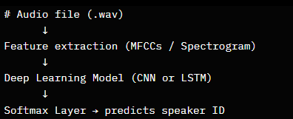

With graphical visualisation :
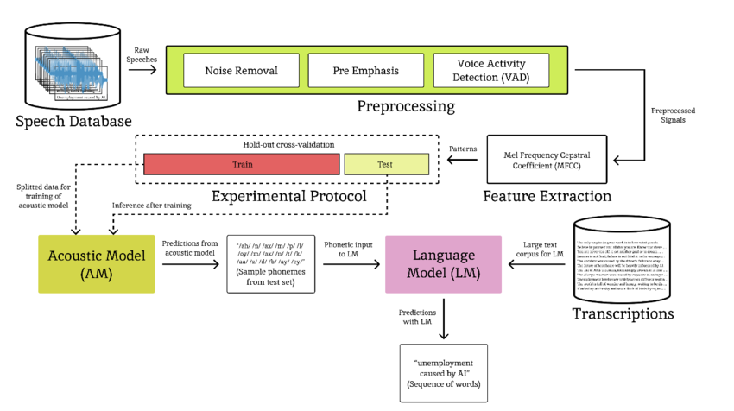

3. Audio Preprocessing
Before feeding audio into a machine learning model, preprocessing is required to enhance quality.

3.1 Common Preprocessing Steps
- Resampling (typically 16 kHz)
- Noise reduction and filtering
- Framing (divide signal into small time windows)
- Windowing (Hamming or Hann window)
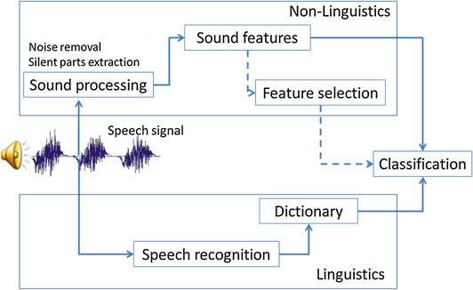
Each frame is processed independently to extract features that represent frequency and temporal characteristics.

4. Feature Extraction
Deep learning models work better with structured numerical representations. Common feature types include:

4.1 Spectrograms
A spectrogram is a visual representation of sound showing the frequency spectrum over time. It is produced using the Short-Time Fourier Transform (STFT).

4.2 Mel-Spectrogram
A Mel-spectrogram maps sound frequencies into the Mel scale, which is more aligned with human perception.

4.3 MFCC (Mel Frequency Cepstral Coefficients)
MFCCs are widely used in classical speech recognition pipelines. They capture the envelope of the frequency spectrum and are robust for speech variability.

4.4 Prosodic Features
Pitch
Energy
Speaking rate
These add additional information that improves accuracy in some settings.

The MFCC extraction process typically involves:
• Pre-emphasis and framing.
• Windowing (e.g., Hamming).
• FFT to get power spectrum.
• Mel filter bank application.
• Logarithm and DCT to get cepstral coefficients.
This architecture mimics human auditory processing by emphasizing lower frequencies. Here's a significant diagram showing the MFCC steps:
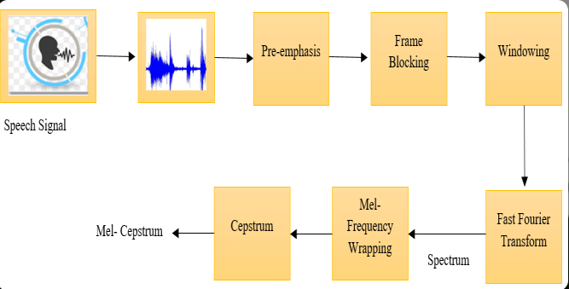

A more detailed computational flow:
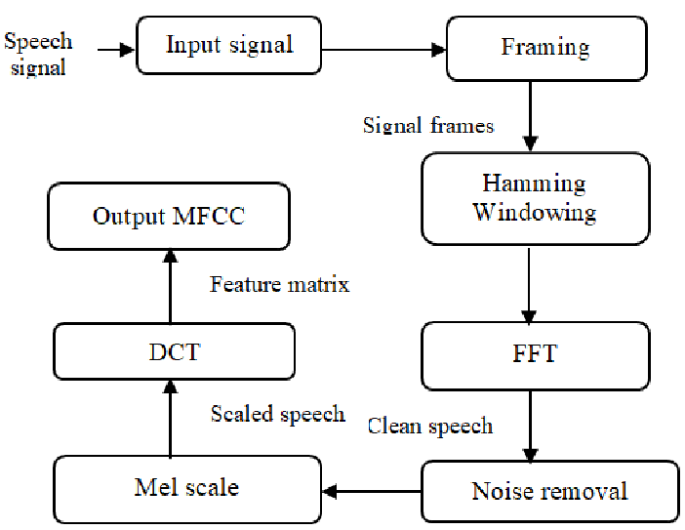
And a conceptual overview for speech applications:
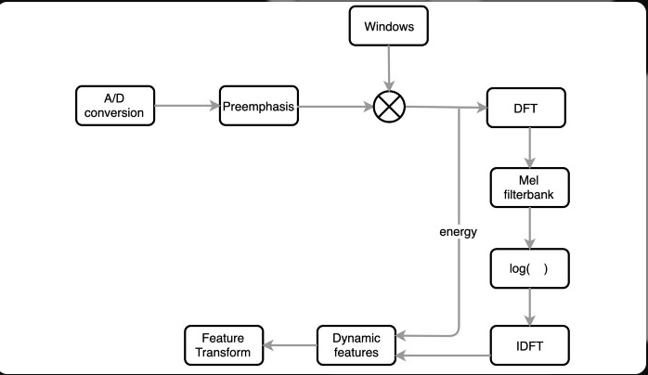
These images highlight why MFCCs are chosen: they compress audio into a compact, discriminative representation (40x200 matrix per sample), reducing dimensionality while capturing vocal characteristics unique to speakers.

5. Acoustic Model Architectures
Several neural network architectures are used in speech recognition.

5.1 Convolutional Neural Networks (CNN)
CNNs capture local temporal-frequency patterns in spectrograms.
Key layers in CNN-based models:
- Convolution layers
- MaxPool or AveragePool layers
- Batch Normalization
- Fully Connected layers
They are useful for feature extraction and pre-processing before feeding into recurrent or transformer models.

5.2 Recurrent Neural Networks (RNN)
RNNs, especially LSTM and GRU architectures, capture temporal dependencies.

Strengths:
- Good for sequence modeling
- Handles long-term context (LSTM/GRU)

Weaknesses:
- Slow training
- Difficulty handling very long sequences

5.3 Transformers
Transformers have become the state-of-the-art architecture.

Why Transformers?
- Self-attention allows global context modeling
- Faster training via parallelization
Transformers are the backbone of modern ASR systems such as Whisper, Wav2Vec2, Conformer, and Speech2Text.

5.4 Hybrid Architectures
Modern systems often combine:
- CNN front-end (feature extractor)
- Transformer encoder
- CTC or attention-based decoder

6. Language Models
Language models predict the probability of word sequences.

Types of Language Models:
- N-gram models
- Neural LMs (LSTM-based)
- Transformer LMs (GPT-like models)
Language models significantly improve recognition accuracy by providing context.

7. Decoding Methods
Once the acoustic model predicts phoneme/character probabilities, decoding algorithms are applied.

7.1 Greedy Decoding
Select highest probability at each step.

7.2 Beam Search
Keeps multiple hypotheses and selects globally probable sequences.

7.3 CTC Decoding (Connectionist Temporal Classification)
Used when alignment between audio frames and text is unknown.

Deep Learning Model Architecture
The core of the notebook is a CNN architecture applied to the 2D MFCC features (treated as images: height=40 MFCCs, width=200 time frames, channels=1).

CNN Model Details
The model is defined using Keras Sequential API:
- Input Shape: (40, 200, 1) – MFCC matrix as a grayscale "image".
- Layer 1: Conv2D(32 filters, kernel=3x3, ReLU activation) – Extracts local patterns in frequency-time space.
- Layer 2: MaxPooling2D(2x2) – Downsamples to reduce spatial dimensions and computational load.
- Layer 3: Conv2D(64 filters, kernel=3x3, ReLU) – Deeper feature extraction for complex patterns like formants or timbre.
- Layer 4: MaxPooling2D(2x2) – Further downsampling.
- Layer 5: Flatten() – Converts 2D feature maps to 1D vector.
- Layer 6: Dense(128 units, ReLU) – Fully connected layer for high-level abstraction.
- Layer 7: Dropout(0.3) – Regularization to prevent overfitting.
- Output Layer: Dense(num_classes, softmax) – Where num_classes is the number of unique speakers (inferred from labels).
Compilation: Adam optimizer, categorical cross-entropy loss, accuracy metric.
This is a lightweight CNN suitable for speaker recognition, leveraging convolutional layers to detect speaker-specific spectral patterns in MFCCs. Alternatives mentioned (but not implemented): LSTM for sequential modeling or Mel Spectrograms as input.
Here's a significant diagram of a similar CNN architecture for speech/speaker recognition:

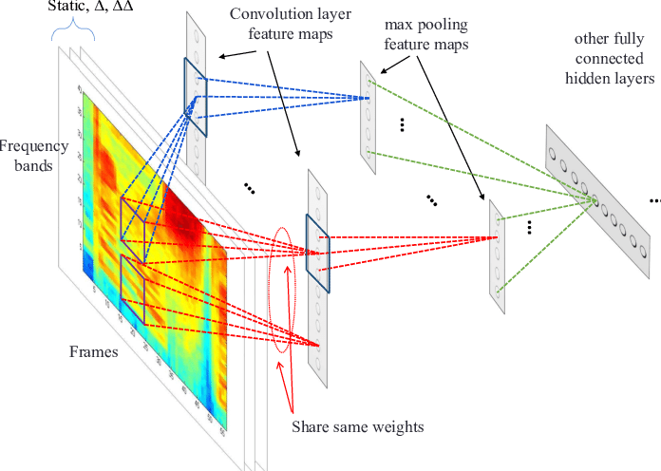

A broader view of deep learning in speech recognition:
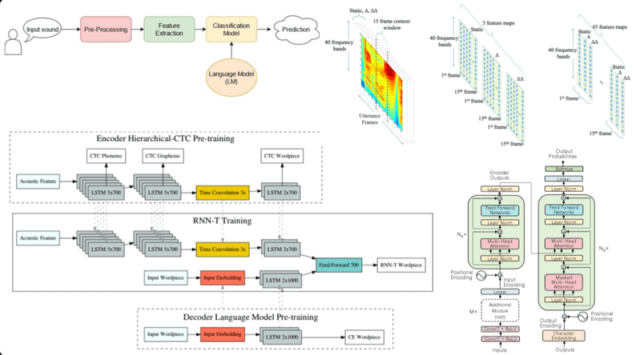

And a combined CNN variant for emotion/speaker recognition:
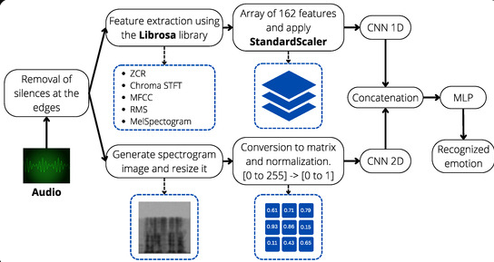

These architectures align closely with the notebook's model, showing how convolutions on spectrogram-like inputs lead to classification.

Data Preparation and Training
- Dataset Loading: Scans directories for .wav files, extracts features, and labels speakers.
- Preprocessing: Label encoding, one-hot encoding, train-test split (80/20).
- Training: 5 epochs, batch size 32, with validation.
- Evaluation: Computes test loss and accuracy.
- Inference: Predicts on a single test file (e.g., Julia Gillard sample).
The dataset shape after loading: X (num_samples, 40, 200), y (num_samples speakers).

8. Evaluation Metrics
To measure the quality of speech recognition, we use:

8.1 WER (Word Error Rate)
WER = (Substitutions + Deletions + Insertions) / Total words

8.2 CER (Character Error Rate)
Useful for languages with complex morphology.

9. Applications of Speech Recognition
Modern ASR systems are applied in:
- Virtual assistants (Siri, Google Assistant)
- Real-time transcription services
- Call center automation
- Accessibility tools for disabled users
- Language learning apps
- Voice biometrics

10. Conclusion
Speech recognition has evolved from classical signal processing into deep learning-driven systems capable of extraordinary accuracy. Architectures such as CNNs, RNNs, and especially Transformers have revolutionized the field. As computational power continues to grow, ASR systems will become increasingly accurate, adaptable, and multilingual.

