|  |  |  |  |
| --- | --- | --- | --- |
| Name | BN | Sec | Email |
| Abdelaziz Salah | 1 | 2 | Abdelaziz132001@gmail.com |

In this paper I am answering some questions about the basic concepts in communication engineering.

1. Give examples of Wi-Fi standards and mention the maximum bit rate and the  
   operating frequency band for each one.

Wi-fi is a catch-all term which explains a specific method by which you can connect to the internet. There are many types of Wi-Fi standards which are used by different devices in order to connect to the internet, which are updated every few years, each update brings a faster internet, a better connection and more simultaneous connections.

Wi-Fi standards are a set of services and protocols that dictate how your network acts.

Nowadays the most common wireless standard is IEEE 802.11 Wireless Lan, which has a lot of versions, the used now is the 802.11ax which was released in 2019 while the next generation is 802.11 be which should be released beyond 2024/2025.

The frequency of 802.11ax is 2.4GHz & 5GHz. Which allows the user to theoretically access a network with (10 – 12) Gbps which is the maximum bit rate it can achieve, which is around 40% improvement from its previous version which was (802.11ac).

The upcoming version should be 802.11be which should be the successor for 802.11ax which should double the bandwidth and increase the number of spatial streams which together should provide data rates up to 40 Gbps, which is a huge improvement in the data transfer.

802.11be should work on a frequency band 2.4GHz, 5Ghz and 6GHz.

1. Using a typical telephone hierarchy, explain how a toll call can be established  
   between two distant cities

* Caller and callee are attached to different end offices
* In this case, the end office of the caller sets up a connection with one or more connected toll offices, which then performs the switching job. This again has two cases −
  + 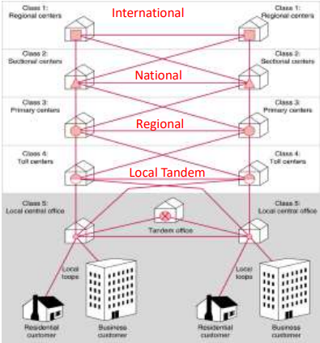If the end offices of the caller and the callee have a common toll office, then the toll office establishes a connection within itself.
  + If there are no common toll office between the caller and callee, then a path is established between the different toll offices, through intermediate switching office via intertoll trunks.

1. Briefly explain the role of each of the following exchanges: local central office,  
   and tandem office.

The local central office is the office which is directly connected to the subscribers so that it can connect them with other subscribers through some channels.

While the Tandem office is an office which connects two or more central offices together in order to create more channels which can be created to increase the paths and the connection between the subscribers.

Moreover, the Tandem office are used to manage the Traffic, which is the main role for it.

1. Common channel signaling does not ensure the connection between source and  
   destination, explain.

This is true because If there is a cut in the voice channel, so even if the connection is stablished between the two subscriber, they will not hear each other because the voice channel is cut, so to overcome this problem they have inserted a continuity signal to ensure that the channel exists and there is not errors so we can establish our connection.

1. Low frequency signaling cannot operate over carrier derived channels; explain

Because the Carrier signal can’t have a frequency less than the Message signal.

1. What is meant by: in-band, and out-of-band signaling?

In-band signaling uses the same channel to perform message exchanges between two devices. The same telephone channel is used to:

* + - transmit dial digits (in the form of pulse signals or Dual Tone Multi Frequency tones) from a subscriber to a local switch.
    - transmit dial tone, ringing tone, etc… from a local switch to a subscriber
  + In band is from 300 to 3400 HZ.
* Out band is from 0 – 300 or from 3400 to 4Khz in which we can:
  + Voice signals do not use full 4kHz bandwidth
  + Can be sent whethere or not voice signals are present
  + Need extra electronics
  + Slower signal rate (narrow bandwidth

1. Give examples of information exchanged between the subscribers and the central office or switch?

* Dial Tone. Clear signal.
* Adress digits. Answer Signal.
* Ring Tone. Voice Data.

1. State the advantages of Packet switching over conventional circuit switching.

Packet switching is different from circuit switching because there is no requirement to establish a channel. The channel is available to users throughout the data network. Long messages are broken down into packets and sent individually to the network.

**Advantages:**

* It is more efficient than the circuit switching
* Packets can find their own data paths to their destination address without the need for a dedicated channel.
* It is more reliable because it helps to eliminate packet loss.
* It reduces the costs associated with running the network.
* Packets are accepted even when the network is busy.
* Priorities can be used.

1. Compare virtual circuit to datagram in case of packet switching.

* **Virtual circuits**

• Network can provide sequencing and error control

• Packets are forwarded more quickly

• No routing decisions to make

• Less reliable

• Loss of a node looses all circuits through that node

* **Datagram**

• No call setup phase

• Better if few packets

• More flexible

• Routing can be used to avoid congested parts of the network