**The Original Signal:**

* 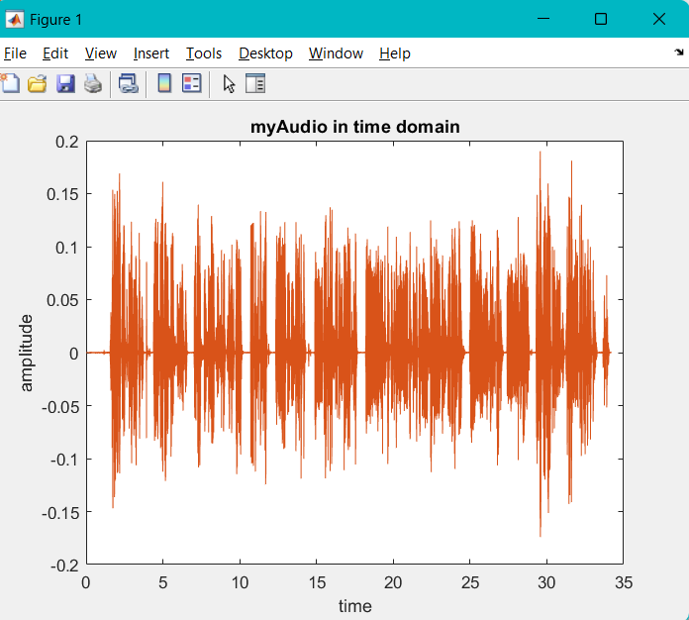Time Domain:
* Amplitude in Frequency Domain: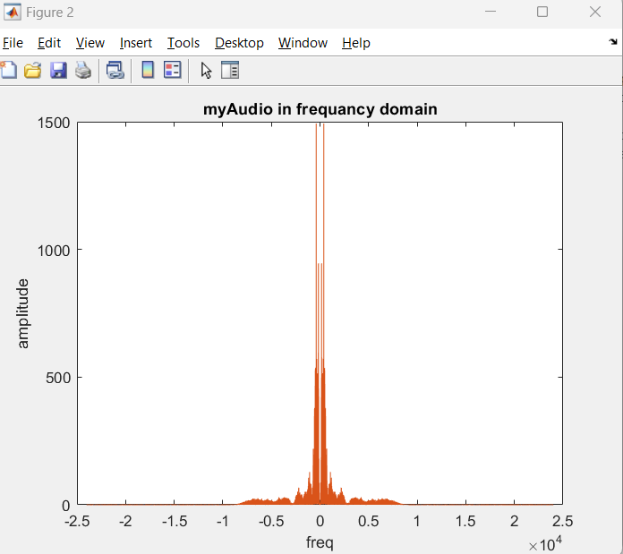
* Phase in the Frequency Domain:

Modulation:

* Signal After Modulation:
  + Signal in Time Domain:

* + Signal Amplitude in frequency Domain:

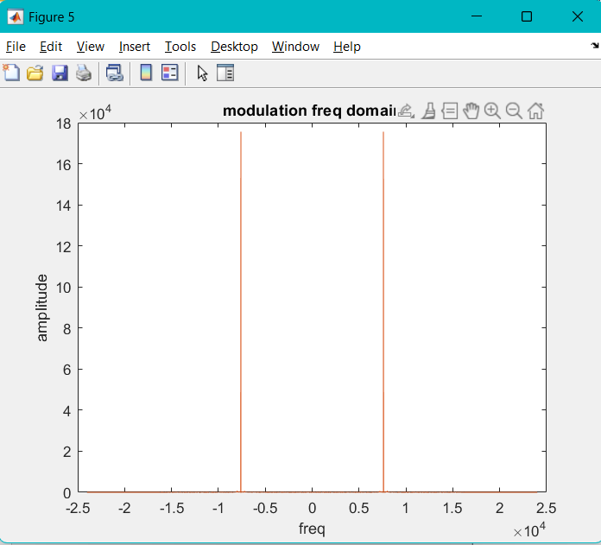

* + Signal Phase in frequency Domain:

I choose A as the absolute of the minimum value of the signal, that is because we need the modulation index to be in range [0,1] to avoid over modulation.

Overmodulation can distort the signal and lead to information loss, moreover the envelope detector will not be able to detect the original signal again.

I chose this w to be able to meet Nyquist criteria.

**Demodulation:**

* Signal after demodulation:
  + In Time Domain:

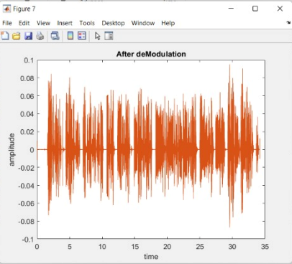

* + Amplitude in Frequency Domain:

* + Phase in frequency domain:

Notice here that the amplitude of the signal has been halved, this is because of the demodulation process.

This leads to having a little bit lower sound.

**Code Snippets:**



