Machine Learning milestone 2

|  |  |  |
| --- | --- | --- |
| Section | Id | Name |
| cs 3 | 20191700376 | عبدالعزيز جمال على محمد |
| cs 2 | 20191700365 | عبدالرحمن علاء حموده |
| cs 3 | 20191700368 | عبدالرحمن عمرو محمد احمد |
| cs 3 | 20191700433 | فارس احمد عبد التواب عثمان |
| cs 3 | 20191700769 | يوسف سامح رشدي عبدالحميد |

**Model’s statistics:**

1. **classification accuracy:**

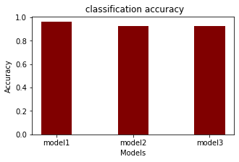

1. **total training time:**

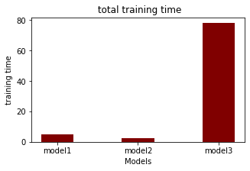

1. **total test time:**

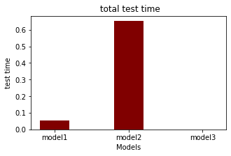

**Feature Selection:**

We used Association Rule Mining instead of Pearson method as it Can get the correlation between categorical and numerical variables. Pearson method not suitable with categorical data.

**hyperparameter tuning:**

* + 1. DecisionTreeClassifier

First make max_depth fixed = 13 and changing max_leaf_nodes value

|  |  |  |  |
| --- | --- | --- | --- |
| max_leaf_nodes | 10 | 30 | 50 |
| accuracy | 93.016% | 94.795% | 95.862% |

Second make max_leaf_nodes fixed = 50 and changing max_depth value

|  |  |  |  |
| --- | --- | --- | --- |
| max_depth | 2 | 10 | 13 |
| accuracy | 85.231% | 94.973 % | 95.862 % |

* + 1. SvmClassifierModel

First make C fixed = 1200 and changing gamma value

|  |  |  |  |
| --- | --- | --- | --- |
| gamma | 0.001 | 0.02 | 0.1 |
| accuracy | 90.569 % | 92.615 % | 90.302 % |

Second make gamma fixed = 0.02 and changing C value

|  |  |  |  |
| --- | --- | --- | --- |
| C | 100 | 500 | 1200 |
| accuracy | 85.231% | 92.170% | 92.615% |

* + 1. LogisticRegression_Classifier

First make degree of PolynomialFeatures fixed = 2 and changing C value

|  |  |  |  |
| --- | --- | --- | --- |
| C | 10 | 100 | 1000 |
| accuracy | 90.969% | 92.037% | 92.615% |

Second make C fixed = 1000 and changing degree value

|  |  |  |  |
| --- | --- | --- | --- |
| degree | 1 | 2 | 3 |
| accuracy | 90.702% | 92.615% | 90.080% |

**conclusion:**