

Task 3 report

AI5



Abdelaziz Wael Abdelaziz Mohamed 20191703020

Abdelrahman Maged Zaki Mostafa 20201701722

Adham Khaled Ali 20201701704

Ahmed Tarek Mousa 20201701702

Ali Rafeeq Amer 20201701705

|  |  |  |  |  |  |  |  |  |
| --- | --- | --- | --- | --- | --- | --- | --- | --- |
| Data | Activation Function | Epochs | Hidden leyers | LR | MSE | Bias | Train Accuracy | Test Accuracy |
| Penguins | Sigmoid | 500 | 5, 12 , 9 | 0.4 | 0.05 | 1 | 58.3 % | 95 % |

|  |  |  |  |  |  |  |  |  |
| --- | --- | --- | --- | --- | --- | --- | --- | --- |
| Data | Activation Function | Epochs | Hidden leyers | LR | MSE | Bias | Train Accuracy | Test Accuracy |
| Penguins | Hyperbolic Tangent | 1000 | 5, 12, 9 | 0.2 | 0.05 | 1 | 58.1 % | 65.0 % |

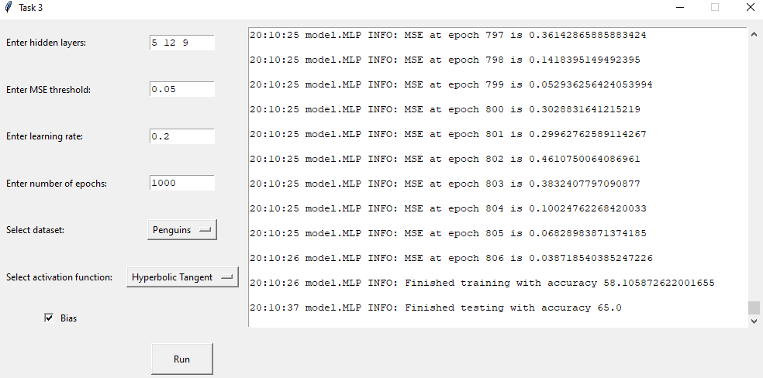

|  |  |  |  |  |  |  |  |  |
| --- | --- | --- | --- | --- | --- | --- | --- | --- |
| Data | Activation Function | Epochs | Hidden leyers | LR | MSE | Bias | Train Accuracy | Test Accuracy |
| Penguins | Sigmoid | 1000 | 8, 12, 14 | 0.2 | 0.02 | 1 | 67.6 % | 96.6 % |

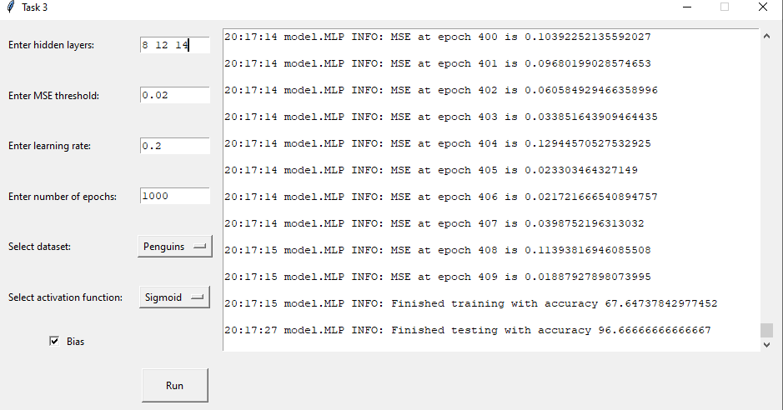

|  |  |  |  |  |  |  |  |  |
| --- | --- | --- | --- | --- | --- | --- | --- | --- |
| Data | Activation Function | Epochs | Hidden leyers | LR | MSE | Bias | Train Accuracy | Test Accuracy |
| Mnist | Sigmoid | 20 | 18 , 7, 9 | 0.03 | 0.046 | 1 | 84.9 % | 91.86 % |

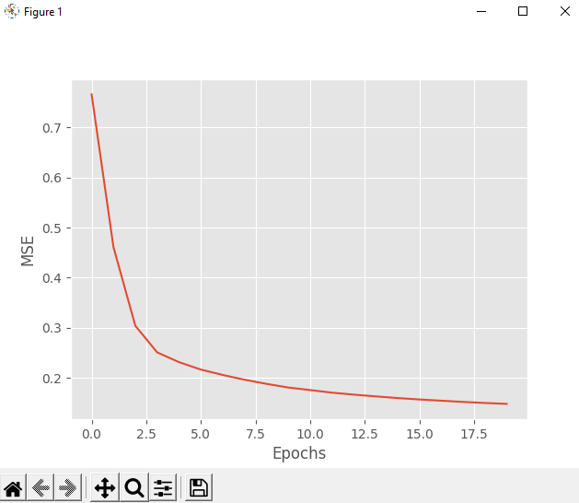

|  |  |  |  |  |  |  |  |  |
| --- | --- | --- | --- | --- | --- | --- | --- | --- |
| Data | Activation Function | Epochs | Hidden leyers | LR | MSE | Bias | Train Accuracy | Test Accuracy |
| Mnist | Sigmoid | 25 | 9 , 12, 8 | 0.4 | 0.08 | 1 | 87.3 % | 90.22 % |

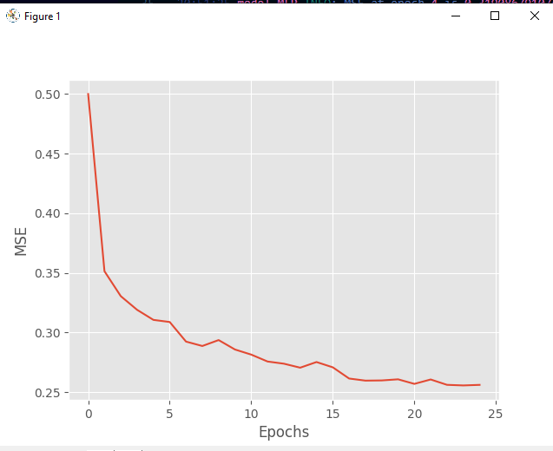

|  |  |  |  |  |  |  |  |  |
| --- | --- | --- | --- | --- | --- | --- | --- | --- |
| Data | Activation Function | Epochs | Hidden leyers | LR | MSE | Bias | Train Accuracy | Test Accuracy |
| Iris | Sigmoid | 50 | 20 ,12 ,8 | 0.3 | 0.08 | 1 | 73 % | 98.3 % |

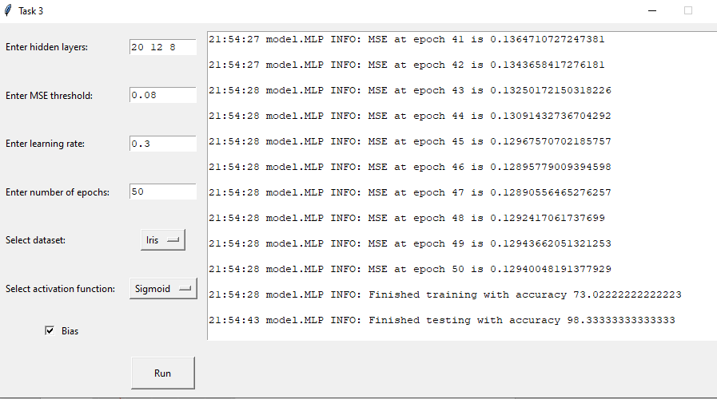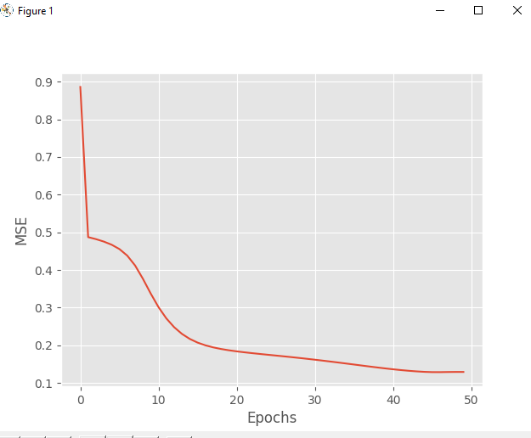

Using the backpropagation algorithm, the multilayer perceptron can do classification tasks with high accuracy.