Звіт

З виконання

Практичної роботи №3

Студента ІТШІ 21-5

Сарміні Абделя

Мета: Вивчення особливостей використання технології ASP.NET Core MVC для створення серверних програмних застосунків з елементами машинного навчання та/або штучного інтелекту.

Використання технології ASP.NET Core MVC для створення серверних програмних застосунків.

Датасет:

<https://archive.ics.uci.edu/dataset/73/mushroom>

Хід виконання:

Короткий опис предметної області та постановка задачі:  
 Предметна область: гриби та їх характеристики.

Постановка задачі: розробити ASP.Net Core додаток з використанням архітектури MVC, для виконання CRUD операцій та класифікації грибів по їх отруйності.

Класи та архітектура:

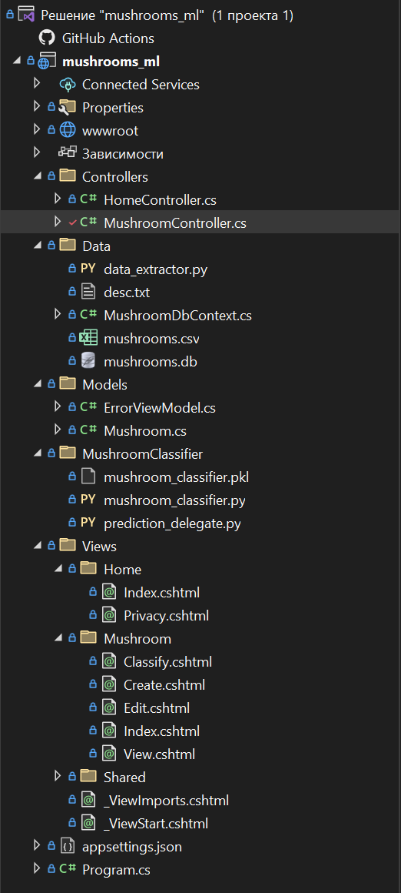

Інтерфейси класів моделі, опис моделі:  
 Клас Mushroom:

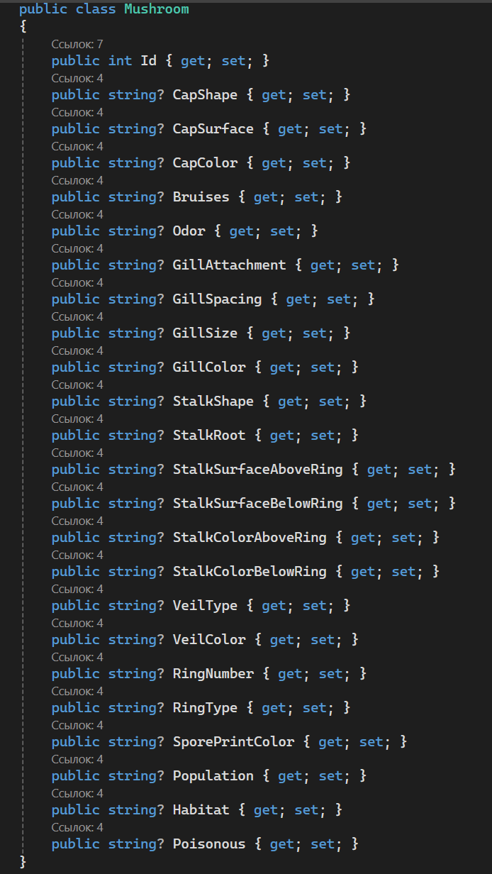

Інтерфейси класів контролерів, вихідний текст контроллера:

Основний контроллер застосунку це MushroomController, він відповідає за CRUD операціїї, та отримання результатів класифікаціїї з моделі:

public class MushroomController : Controller

{

private readonly MushroomDbContext dbContext;

public MushroomController(MushroomDbContext _context)

{

dbContext = _context;

}

public async Task<IActionResult> Index()

{

var mushroom = await dbContext.Mushrooms.ToListAsync();

return View(mushroom);

}

public IActionResult Create()

{

return View();

}

[HttpPost]

public async Task<IActionResult> Create(Mushroom mushroom)

{

if (ModelState.IsValid)

{

dbContext.Add(mushroom);

await dbContext.SaveChangesAsync();

return RedirectToAction(nameof(Index));

}

return View(mushroom);

}

public async Task<IActionResult> Edit(int id)

{

var mushroom = await dbContext.Mushrooms.FindAsync(id);

if (mushroom == null)

{

return NotFound();

}

return View(mushroom);

}

[HttpPost]

[ValidateAntiForgeryToken]

public async Task<IActionResult> Edit(int id, Mushroom mushroom)

{

bool MushroomExists(int id)

{

return dbContext.Mushrooms.Any(e => e.Id == id);

}

if (id != mushroom.Id)

{

return BadRequest();

}

if (ModelState.IsValid)

{

try

{

dbContext.Entry(mushroom).State = EntityState.Modified;

await dbContext.SaveChangesAsync();

return RedirectToAction("Index");

}

catch (DbUpdateConcurrencyException)

{

if (!MushroomExists(mushroom.Id))

{

return NotFound();

}

throw;

}

}

return View(mushroom);

}

[HttpPost]

public async Task<IActionResult> Delete(int id)

{

var mushroom = await dbContext.Mushrooms.FindAsync(id);

if (mushroom != null)

{

dbContext.Mushrooms.Remove(mushroom);

await dbContext.SaveChangesAsync();

}

return RedirectToAction("Index");

}

[HttpGet]

public IActionResult Classify()

{

return View();

}

[HttpPost]

public IActionResult Classify(string capShape, string capSurface, string capColor, string bruises,

string odor, string gillAttachment, string gillSpacing, string gillSize, string gillColor,

string stalkShape, string stalkRoot, string stalkSurfaceAboveRing, string stalkSurfaceBelowRing,

string stalkColorAboveRing, string stalkColorBelowRing, string veilType, string veilColor,

string ringNumber, string ringType, string sporePrintColor, string population, string habitat)

{

if (ModelState.IsValid)

{

string inputData = $"{capShape},{capSurface},{capColor},{bruises},{odor},{gillAttachment}," +

$"{gillSpacing},{gillSize},{gillColor},{stalkShape},{stalkRoot},{stalkSurfaceAboveRing}," +

$"{stalkSurfaceBelowRing},{stalkColorAboveRing},{stalkColorBelowRing},{veilType}," +

$"{veilColor},{ringNumber},{ringType},{sporePrintColor},{population},{habitat}";

string pythonScriptPath = Path.Combine(Directory.GetCurrentDirectory(), "MushroomClassifier", "prediction_delegate.py");

Debug.WriteLine(pythonScriptPath);

Debug.WriteLine(inputData);

var psi = new ProcessStartInfo

{

FileName = "python",

Arguments = $"\"{pythonScriptPath}\" \"{inputData}\"",

RedirectStandardOutput = true,

UseShellExecute = false,

CreateNoWindow = true

};

string prediction = "";

using (var process = Process.Start(psi))

{

using (var reader = process.StandardOutput)

{

prediction = reader.ReadToEnd();

Debug.WriteLine($"Prediction: {prediction}");

if (process.ExitCode != 0)

{

Debug.WriteLine(process.ExitCode);

}

}

}

ViewBag.PredictionResult = prediction;

}

return View();

}

}

Вихідні тексти представлень:

Mushroom/Create.cshtml:

У додатку А.

Mushroom/Edit.cshtml:

У додатку Б.

Mushroom/Classify.cshtml:

У додатку В.

Mushroom/Index.cshtml:

У додатку Г.

Скріни візуального інтерфейсу:

Головна сторінка:

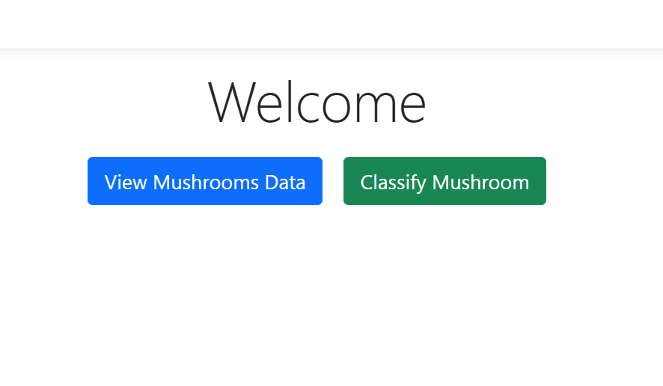

Сторінка класифікації:

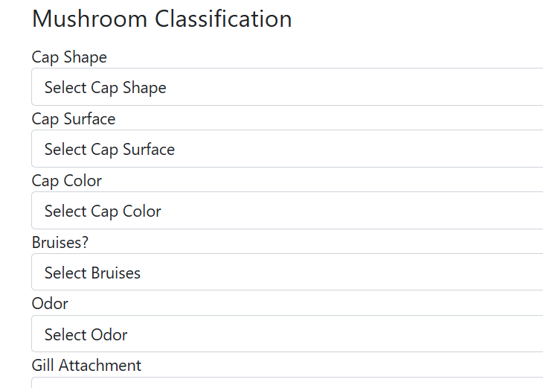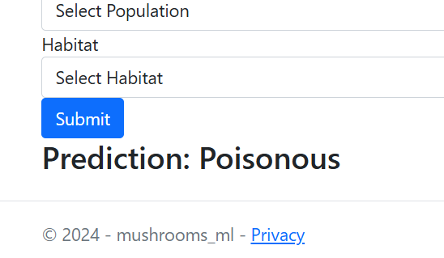

Висновки: Ми вивчили особливості використання технології ASP.NET Core MVC для створення серверних програмних застосунків з елементами машинного навчання та/або штучного інтелекту, а саме для класифікації грибів по їх отруйності.

Додаток А

Mushroom/Create.cshtml

@model mushrooms_ml.Models.Mushroom

@{

ViewData["Title"] = "Create Mushroom";

}

<h3>Create Mushroom</h3>

<form asp-action="Create" method="post">

<div class="form-group">

<label for="CapShape">Cap Shape</label>

<select class="form-control" name="CapShape" required>

<option value="">Select Cap Shape</option>

<option value="b">bell</option>

<option value="c">conical</option>

<option value="x">convex</option>

<option value="f">flat</option>

<option value="k">knobbed</option>

<option value="s">sunken</option>

</select>

</div>

<div class="form-group">

<label for="CapSurface">Cap Surface</label>

<select class="form-control" name="CapSurface" required>

<option value="">Select Cap Surface</option>

<option value="f">fibrous</option>

<option value="g">grooves</option>

<option value="y">scaly</option>

<option value="s">smooth</option>

</select>

</div>

<div class="form-group">

<label for="CapColor">Cap Color</label>

<select class="form-control" name="CapColor" required>

<option value="">Select Cap Color</option>

<option value="n">brown</option>

<option value="b">buff</option>

<option value="c">cinnamon</option>

<option value="g">gray</option>

<option value="r">green</option>

<option value="p">pink</option>

<option value="u">purple</option>

<option value="e">red</option>

<option value="w">white</option>

<option value="y">yellow</option>

</select>

</div>

<div class="form-group">

<label for="Bruises">Bruises?</label>

<select class="form-control" name="Bruises" required>

<option value="">Select Bruises</option>

<option value="t">Yes</option>

<option value="f">No</option>

</select>

</div>

<div class="form-group">

<label for="Odor">Odor</label>

<select class="form-control" name="Odor" required>

<option value="">Select Odor</option>

<option value="a">almond</option>

<option value="l">anise</option>

<option value="c">creosote</option>

<option value="y">fishy</option>

<option value="f">foul</option>

<option value="m">musty</option>

<option value="n">none</option>

<option value="p">pungent</option>

<option value="s">spicy</option>

</select>

</div>

<div class="form-group">

<label for="GillAttachment">Gill Attachment</label>

<select class="form-control" name="GillAttachment" required>

<option value="">Select Gill Attachment</option>

<option value="a">attached</option>

<option value="d">descending</option>

<option value="f">free</option>

<option value="n">notched</option>

</select>

</div>

<div class="form-group">

<label for="GillSpacing">Gill Spacing</label>

<select class="form-control" name="GillSpacing" required>

<option value="">Select Gill Spacing</option>

<option value="c">close</option>

<option value="w">crowded</option>

<option value="d">distant</option>

</select>

</div>

<div class="form-group">

<label for="GillSize">Gill Size</label>

<select class="form-control" name="GillSize" required>

<option value="">Select Gill Size</option>

<option value="b">broad</option>

<option value="n">narrow</option>

</select>

</div>

<div class="form-group">

<label for="GillColor">Gill Color</label>

<select class="form-control" name="GillColor" required>

<option value="">Select Gill Color</option>

<option value="k">black</option>

<option value="n">brown</option>

<option value="b">buff</option>

<option value="h">chocolate</option>

<option value="g">gray</option>

<option value="r">green</option>

<option value="o">orange</option>

<option value="p">pink</option>

<option value="u">purple</option>

<option value="e">red</option>

<option value="w">white</option>

<option value="y">yellow</option>

</select>

</div>

<div class="form-group">

<label for="StalkShape">Stalk Shape</label>

<select class="form-control" name="StalkShape" required>

<option value="">Select Stalk Shape</option>

<option value="e">enlarging</option>

<option value="t">tapering</option>

</select>

</div>

<div class="form-group">

<label for="StalkRoot">Stalk Root</label>

<select class="form-control" name="StalkRoot" required>

<option value="">Select Stalk Root</option>

<option value="b">bulbous</option>

<option value="c">club</option>

<option value="u">cup</option>

<option value="e">equal</option>

<option value="z">rhizomorphs</option>

<option value="r">rooted</option>

<option value="?">missing</option>

</select>

</div>

<div class="form-group">

<label for="StalkSurfaceAboveRing">Stalk Surface Above Ring</label>

<select class="form-control" name="StalkSurfaceAboveRing" required>

<option value="">Select Stalk Surface Above Ring</option>

<option value="f">fibrous</option>

<option value="y">scaly</option>

<option value="k">silky</option>

<option value="s">smooth</option>

</select>

</div>

<div class="form-group">

<label for="StalkSurfaceBelowRing">Stalk Surface Below Ring</label>

<select class="form-control" name="StalkSurfaceBelowRing" required>

<option value="">Select Stalk Surface Below Ring</option>

<option value="f">fibrous</option>

<option value="y">scaly</option>

<option value="k">silky</option>

<option value="s">smooth</option>

</select>

</div>

<div class="form-group">

<label for="StalkColorAboveRing">Stalk Color Above Ring</label>

<select class="form-control" name="StalkColorAboveRing" required>

<option value="">Select Stalk Color Above Ring</option>

<option value="n">brown</option>

<option value="b">buff</option>

<option value="c">cinnamon</option>

<option value="g">gray</option>

<option value="o">orange</option>

<option value="p">pink</option>

<option value="e">red</option>

<option value="w">white</option>

<option value="y">yellow</option>

</select>

</div>

<div class="form-group">

<label for="StalkColorBelowRing">Stalk Color Below Ring</label>

<select class="form-control" name="StalkColorBelowRing" required>

<option value="">Select Stalk Color Below Ring</option>

<option value="n">brown</option>

<option value="b">buff</option>

<option value="c">cinnamon</option>

<option value="g">gray</option>

<option value="o">orange</option>

<option value="p">pink</option>

<option value="e">red</option>

<option value="w">white</option>

<option value="y">yellow</option>

</select>

</div>

<div class="form-group">

<label for="VeilType">Veil Type</label>

<select class="form-control" name="VeilType" required>

<option value="">Select Veil Type</option>

<option value="p">partial</option>

<option value="u">universal</option>

</select>

</div>

<div class="form-group">

<label for="VeilColor">Veil Color</label>

<select class="form-control" name="VeilColor" required>

<option value="">Select Veil Color</option>

<option value="n">brown</option>

<option value="o">orange</option>

<option value="w">white</option>

<option value="y">yellow</option>

</select>

</div>

<div class="form-group">

<label for="RingNumber">Ring Number</label>

<select class="form-control" name="RingNumber" required>

<option value="">Select Ring Number</option>

<option value="n">none</option>

<option value="o">one</option>

<option value="t">two</option>

</select>

</div>

<div class="form-group">

<label for="RingType">Ring Type</label>

<select class="form-control" name="RingType" required>

<option value="">Select Ring Type</option>

<option value="c">cobwebby</option>

<option value="e">evanescent</option>

<option value="f">flaring</option>

<option value="l">large</option>

<option value="n">none</option>

<option value="p">pendant</option>

<option value="s">sheathing</option>

<option value="z">zone</option>

</select>

</div>

<div class="form-group">

<label for="SporePrintColor">Spore Print Color</label>

<select class="form-control" name="SporePrintColor" required>

<option value="">Select Spore Print Color</option>

<option value="k">black</option>

<option value="n">brown</option>

<option value="b">buff</option>

<option value="h">chocolate</option>

<option value="r">green</option>

<option value="o">orange</option>

<option value="u">purple</option>

<option value="w">white</option>

<option value="y">yellow</option>

</select>

</div>

<div class="form-group">

<label for="Population">Population</label>

<select class="form-control" name="Population" required>

<option value="">Select Population</option>

<option value="a">abundant</option>

<option value="c">clustered</option>

<option value="n">numerous</option>

<option value="s">scattered</option>

<option value="v">several</option>

<option value="y">solitary</option>

</select>

</div>

<div class="form-group">

<label for="Habitat">Habitat</label>

<select class="form-control" name="Habitat" required>

<option value="">Select Habitat</option>

<option value="g">grasses</option>

<option value="l">leaves</option>

<option value="m">meadows</option>

<option value="p">paths</option>

<option value="u">urban</option>

<option value="w">waste</option>

<option value="d">woods</option>

</select>

</div>

<div class="form-group">

<label for="Poisonous">Poisonous</label>

<select class="form-control" name="Poisonous" required>

<option value="">Poisonous</option>

<option value="e">No</option>

<option value="p">Yes</option>

</select>

</div>

<button type="submit" class="btn btn-primary">Submit</button>

</form>

<a asp-action="Index">Back</a>

Додаток Б

Mushroom/Edit.cshtml

@model mushrooms_ml.Models.Mushroom

@{

ViewData["Title"] = "Edit Mushroom";

}

<h3>Edit Mushroom</h3>

<form asp-action="Edit" method="post">

<input type="hidden" asp-for="Id" />

<div class="form-group">

<label asp-for="CapShape">Cap Shape</label>

@Html.DropDownListFor(m => m.CapShape, new SelectList(new[]

{

new { Value = "", Text = "Select Cap Shape" },

new { Value = "b", Text = "bell" },

new { Value = "c", Text = "conical" },

new { Value = "x", Text = "convex" },

new { Value = "f", Text = "flat" },

new { Value = "k", Text = "knobbed" },

new { Value = "s", Text = "sunken" }

}, "Value", "Text", Model.CapShape), new { @class = "form-control", required = "required" })

</div>

<div class="form-group">

<label asp-for="CapSurface">Cap Surface</label>

@Html.DropDownListFor(m => m.CapSurface, new SelectList(new[]

{

new { Value = "", Text = "Select Cap Surface" },

new { Value = "f", Text = "fibrous" },

new { Value = "g", Text = "grooves" },

new { Value = "y", Text = "scaly" },

new { Value = "s", Text = "smooth" }

}, "Value", "Text", Model.CapSurface), new { @class = "form-control", required = "required" })

</div>

<div class="form-group">

<label asp-for="CapColor">Cap Color</label>

@Html.DropDownListFor(m => m.CapColor, new SelectList(new[]

{

new { Value = "", Text = "Select Cap Color" },

new { Value = "n", Text = "brown" },

new { Value = "b", Text = "buff" },

new { Value = "c", Text = "cinnamon" },

new { Value = "g", Text = "gray" },

new { Value = "r", Text = "green" },

new { Value = "p", Text = "pink" },

new { Value = "u", Text = "purple" },

new { Value = "e", Text = "red" },

new { Value = "w", Text = "white" },

new { Value = "y", Text = "yellow" }

}, "Value", "Text", Model.CapColor), new { @class = "form-control", required = "required" })

</div>

<div class="form-group">

<label asp-for="Bruises">Bruises?</label>

@Html.DropDownListFor(m => m.Bruises, new SelectList(new[]

{

new { Value = "", Text = "Select Bruises" },

new { Value = "t", Text = "Yes" },

new { Value = "f", Text = "No" }

}, "Value", "Text", Model.Bruises), new { @class = "form-control", required = "required" })

</div>

<div class="form-group">

<label asp-for="Odor">Odor</label>

@Html.DropDownListFor(m => m.Odor, new SelectList(new[]

{

new { Value = "", Text = "Select Odor" },

new { Value = "a", Text = "almond" },

new { Value = "l", Text = "anise" },

new { Value = "c", Text = "creosote" },

new { Value = "y", Text = "fishy" },

new { Value = "f", Text = "foul" },

new { Value = "m", Text = "musty" },

new { Value = "n", Text = "none" },

new { Value = "p", Text = "pungent" },

new { Value = "s", Text = "spicy" }

}, "Value", "Text", Model.Odor), new { @class = "form-control", required = "required" })

</div>

<div class="form-group">

<label asp-for="GillAttachment">Gill Attachment</label>

@Html.DropDownListFor(m => m.GillAttachment, new SelectList(new[]

{

new { Value = "", Text = "Select Gill Attachment" },

new { Value = "a", Text = "attached" },

new { Value = "d", Text = "descending" },

new { Value = "f", Text = "free" },

new { Value = "n", Text = "notched" }

}, "Value", "Text", Model.GillAttachment), new { @class = "form-control", required = "required" })

</div>

<div class="form-group">

<label asp-for="GillSpacing">Gill Spacing</label>

@Html.DropDownListFor(m => m.GillSpacing, new SelectList(new[]

{

new { Value = "", Text = "Select Gill Spacing" },

new { Value = "c", Text = "close" },

new { Value = "w", Text = "crowded" },

new { Value = "d", Text = "distant" }

}, "Value", "Text", Model.GillSpacing), new { @class = "form-control", required = "required" })

</div>

<div class="form-group">

<label asp-for="GillSize">Gill Size</label>

@Html.DropDownListFor(m => m.GillSize, new SelectList(new[]

{

new { Value = "", Text = "Select Gill Size" },

new { Value = "b", Text = "broad" },

new { Value = "n", Text = "narrow" }

}, "Value", "Text", Model.GillSize), new { @class = "form-control", required = "required" })

</div>

<div class="form-group">

<label asp-for="GillColor">Gill Color</label>

@Html.DropDownListFor(m => m.GillColor, new SelectList(new[]

{

new { Value = "", Text = "Select Gill Color" },

new { Value = "k", Text = "black" },

new { Value = "n", Text = "brown" },

new { Value = "b", Text = "buff" },

new { Value = "h", Text = "chocolate" },

new { Value = "g", Text = "gray" },

new { Value = "r", Text = "green" },

new { Value = "o", Text = "orange" },

new { Value = "p", Text = "pink" },

new { Value = "u", Text = "purple" },

new { Value = "e", Text = "red" },

new { Value = "w", Text = "white" },

new { Value = "y", Text = "yellow" }

}, "Value", "Text", Model.GillColor), new { @class = "form-control", required = "required" })

</div>

<div class="form-group">

<label asp-for="StalkShape">Stalk Shape</label>

@Html.DropDownListFor(m => m.StalkShape, new SelectList(new[]

{

new { Value = "", Text = "Select Stalk Shape" },

new { Value = "e", Text = "enlarging" },

new { Value = "t", Text = "tapering" }

}, "Value", "Text", Model.StalkShape), new { @class = "form-control", required = "required" })

</div>

<div class="form-group">

<label asp-for="StalkRoot">Stalk Root</label>

@Html.DropDownListFor(m => m.StalkRoot, new SelectList(new[]

{

new { Value = "", Text = "Select Stalk Root" },

new { Value = "b", Text = "bulbous" },

new { Value = "c", Text = "club" },

new { Value = "u", Text = "cup" },

new { Value = "e", Text = "equal" },

new { Value = "z", Text = "rhizomorphs" },

new { Value = "r", Text = "rooted" },

new { Value = "?", Text = "missing" }

}, "Value", "Text", Model.StalkRoot), new { @class = "form-control", required = "required" })

</div>

<div class="form-group">

<label asp-for="StalkSurfaceAboveRing">Stalk Surface Above Ring</label>

@Html.DropDownListFor(m => m.StalkSurfaceAboveRing, new SelectList(new[]

{

new { Value = "", Text = "Select Stalk Surface Above Ring" },

new { Value = "f", Text = "fibrous" },

new { Value = "y", Text = "scaly" },

new { Value = "k", Text = "silky" },

new { Value = "s", Text = "smooth" }

}, "Value", "Text", Model.StalkSurfaceAboveRing), new { @class = "form-control", required = "required" })

</div>

<div class="form-group">

<label asp-for="StalkSurfaceBelowRing">Stalk Surface Below Ring</label>

@Html.DropDownListFor(m => m.StalkSurfaceBelowRing, new SelectList(new[]

{

new { Value = "", Text = "Select Stalk Surface Below Ring" },

new { Value = "f", Text = "fibrous" },

new { Value = "y", Text = "scaly" },

new { Value = "k", Text = "silky" },

new { Value = "s", Text = "smooth" }

}, "Value", "Text", Model.StalkSurfaceBelowRing), new { @class = "form-control", required = "required" })

</div>

<div class="form-group">

<label asp-for="StalkColorAboveRing">Stalk Color Above Ring</label>

@Html.DropDownListFor(m => m.StalkColorAboveRing, new SelectList(new[]

{

new { Value = "", Text = "Select Stalk Color Above Ring" },

new { Value = "n", Text = "brown" },

new { Value = "b", Text = "buff" },

new { Value = "c", Text = "cinnamon" },

new { Value = "g", Text = "gray" },

new { Value = "o", Text = "orange" },

new { Value = "p", Text = "pink" },

new { Value = "e", Text = "red" },

new { Value = "w", Text = "white" },

new { Value = "y", Text = "yellow" }

}, "Value", "Text", Model.StalkColorAboveRing), new { @class = "form-control", required = "required" })

</div>

<div class="form-group">

<label asp-for="StalkColorBelowRing">Stalk Color Below Ring</label>

@Html.DropDownListFor(m => m.StalkColorBelowRing, new SelectList(new[]

{

new { Value = "", Text = "Select Stalk Color Below Ring" },

new { Value = "n", Text = "brown" },

new { Value = "b", Text = "buff" },

new { Value = "c", Text = "cinnamon" },

new { Value = "g", Text = "gray" },

new { Value = "o", Text = "orange" },

new { Value = "p", Text = "pink" },

new { Value = "e", Text = "red" },

new { Value = "w", Text = "white" },

new { Value = "y", Text = "yellow" }

}, "Value", "Text", Model.StalkColorBelowRing), new { @class = "form-control", required = "required" })

</div>

<div class="form-group">

<label asp-for="VeilType">Veil Type</label>

@Html.DropDownListFor(m => m.VeilType, new SelectList(new[]

{

new { Value = "", Text = "Select Veil Type" },

new { Value = "p", Text = "partial" },

new { Value = "u", Text = "universal" }

}, "Value", "Text", Model.VeilType), new { @class = "form-control", required = "required" })

</div>

<div class="form-group">

<label asp-for="VeilColor">Veil Color</label>

@Html.DropDownListFor(m => m.VeilColor, new SelectList(new[]

{

new { Value = "", Text = "Select Veil Color" },

new { Value = "n", Text = "brown" },

new { Value = "o", Text = "orange" },

new { Value = "w", Text = "white" },

new { Value = "y", Text = "yellow" }

}, "Value", "Text", Model.VeilColor), new { @class = "form-control", required = "required" })

</div>

<div class="form-group">

<label asp-for="RingNumber">Ring Number</label>

@Html.DropDownListFor(m => m.RingNumber, new SelectList(new[]

{

new { Value = "", Text = "Select Ring Number" },

new { Value = "n", Text = "none" },

new { Value = "o", Text = "one" },

new { Value = "t", Text = "two" }

}, "Value", "Text", Model.RingNumber), new { @class = "form-control", required = "required" })

</div>

<div class="form-group">

<label asp-for="RingType">Ring Type</label>

@Html.DropDownListFor(m => m.RingType, new SelectList(new[]

{

new { Value = "", Text = "Select Spore Print Color" },

new { Value = "c", Text = "cobwebby" },

new { Value = "e", Text = "evanescent" },

new { Value = "f", Text = "flaring" },

new { Value = "l", Text = "large" },

new { Value = "n", Text = "none" },

new { Value = "p", Text = "pendant" },

new { Value = "s", Text = "sheathing" },

new { Value = "z", Text = "zone" }

}, "Value", "Text", Model.RingType), new { @class = "form-control", required = "required" })

</div>

<div class="form-group">

<label asp-for="SporePrintColor">Spore Print Color</label>

@Html.DropDownListFor(m => m.SporePrintColor, new SelectList(new[]

{

new { Value = "", Text = "Select Spore Print Color" },

new { Value = "k", Text = "black" },

new { Value = "n", Text = "brown" },

new { Value = "b", Text = "buff" },

new { Value = "h", Text = "chocolate" },

new { Value = "r", Text = "green" },

new { Value = "o", Text = "orange" },

new { Value = "u", Text = "purple" },

new { Value = "w", Text = "white" },

new { Value = "y", Text = "yellow" }

}, "Value", "Text", Model.SporePrintColor), new { @class = "form-control", required = "required" })

</div>

<div class="form-group">

<label asp-for="Population">Population</label>

@Html.DropDownListFor(m => m.Population, new SelectList(new[]

{

new { Value = "", Text = "Select Population" },

new { Value = "a", Text = "abundant" },

new { Value = "c", Text = "clustered" },

new { Value = "n", Text = "numerous" },

new { Value = "s", Text = "scattered" },

new { Value = "v", Text = "very abundant" },

new { Value = "y", Text = "solitary" }

}, "Value", "Text", Model.Population), new { @class = "form-control", required = "required" })

</div>

<div class="form-group">

<label asp-for="Habitat">Habitat</label>

@Html.DropDownListFor(m => m.Habitat, new SelectList(new[]

{

new { Value = "", Text = "Select Habitat" },

new { Value = "g", Text = "grasses" },

new { Value = "l", Text = "leaves" },

new { Value = "m", Text = "meadows" },

new { Value = "p", Text = "paths" },

new { Value = "u", Text = "urban" },

new { Value = "w", Text = "waste" },

new { Value = "d", Text = "woods" }

}, "Value", "Text", Model.Habitat), new { @class = "form-control", required = "required" })

</div>

<div class="form-group">

<label asp-for="Poisonous">Poisonous?</label>

@Html.DropDownListFor(m => m.Poisonous, new SelectList(new[]

{

new { Value = "", Text = "Select Poisonous" },

new { Value = "p", Text = "Yes" },

new { Value = "e", Text = "No" }

}, "Value", "Text", Model.Poisonous), new { @class = "form-control", required = "required" })

</div>

<button type="submit" class="btn btn-primary">Save</button>

</form>

<a asp-action="Index" class="btn btn-secondary">Back</a>

Додаток В

Mushroom/Classify.cshtml

@model mushrooms_ml.Models.Mushroom

<form asp-action="Classify" method="post">

<fieldset>

<legend>Mushroom Classification</legend>

<div class="form-group">

<label for="CapShape">Cap Shape</label>

<select class="form-control" name="CapShape" id="CapShape" required>

<option value="">Select Cap Shape</option>

<option value="b">bell</option>

<option value="c">conical</option>

<option value="x">convex</option>

<option value="f">flat</option>

<option value="k">knobbed</option>

<option value="s">sunken</option>

</select>

</div>

<div class="form-group">

<label for="CapSurface">Cap Surface</label>

<select class="form-control" name="CapSurface" id="CapSurface" required>

<option value="">Select Cap Surface</option>

<option value="f">fibrous</option>

<option value="g">grooves</option>

<option value="y">scaly</option>

<option value="s">smooth</option>

</select>

</div>

<div class="form-group">

<label for="CapColor">Cap Color</label>

<select class="form-control" name="CapColor" id="CapColor" required>

<option value="">Select Cap Color</option>

<option value="n">brown</option>

<option value="b">buff</option>

<option value="c">cinnamon</option>

<option value="g">gray</option>

<option value="r">green</option>

<option value="p">pink</option>

<option value="u">purple</option>

<option value="e">red</option>

<option value="w">white</option>

<option value="y">yellow</option>

</select>

</div>

<div class="form-group">

<label for="Bruises">Bruises?</label>

<select class="form-control" name="Bruises" id="Bruises" required>

<option value="">Select Bruises</option>

<option value="t">Yes</option>

<option value="f">No</option>

</select>

</div>

<div class="form-group">

<label for="Odor">Odor</label>

<select class="form-control" name="Odor" id="Odor" required>

<option value="">Select Odor</option>

<option value="a">almond</option>

<option value="l">anise</option>

<option value="c">creosote</option>

<option value="y">fishy</option>

<option value="f">foul</option>

<option value="m">musty</option>

<option value="n">none</option>

<option value="p">pungent</option>

<option value="s">spicy</option>

</select>

</div>

<div class="form-group">

<label for="GillAttachment">Gill Attachment</label>

<select class="form-control" name="GillAttachment" id="GillAttachment" required>

<option value="">Select Gill Attachment</option>

<option value="a">attached</option>

<option value="d">descending</option>

<option value="f">free</option>

<option value="n">notched</option>

</select>

</div>

<div class="form-group">

<label for="GillSpacing">Gill Spacing</label>

<select class="form-control" name="GillSpacing" id="GillSpacing" required>

<option value="">Select Gill Spacing</option>

<option value="c">close</option>

<option value="w">crowded</option>

<option value="d">distant</option>

</select>

</div>

<div class="form-group">

<label for="GillSize">Gill Size</label>

<select class="form-control" name="GillSize" id="GillSize" required>

<option value="">Select Gill Size</option>

<option value="b">broad</option>

<option value="n">narrow</option>

</select>

</div>

<div class="form-group">

<label for="GillColor">Gill Color</label>

<select class="form-control" name="GillColor" id="GillColor" required>

<option value="">Select Gill Color</option>

<option value="k">black</option>

<option value="n">brown</option>

<option value="b">buff</option>

<option value="h">chocolate</option>

<option value="g">gray</option>

<option value="r">green</option>

<option value="o">orange</option>

<option value="p">pink</option>

<option value="u">purple</option>

<option value="e">red</option>

<option value="w">white</option>

<option value="y">yellow</option>

</select>

</div>

<div class="form-group">

<label for="StalkShape">Stalk Shape</label>

<select class="form-control" name="StalkShape" id="StalkShape" required>

<option value="">Select Stalk Shape</option>

<option value="e">enlarging</option>

<option value="t">tapering</option>

</select>

</div>

<div class="form-group">

<label for="StalkRoot">Stalk Root</label>

<select class="form-control" name="StalkRoot" id="StalkRoot" required>

<option value="">Select Stalk Root</option>

<option value="b">bulbous</option>

<option value="c">club</option>

<option value="u">cup</option>

<option value="e">equal</option>

<option value="z">rhizomorphs</option>

<option value="r">rooted</option>

<option value="?">missing</option>

</select>

</div>

<div class="form-group">

<label for="StalkSurfaceAboveRing">Stalk Surface Above Ring</label>

<select class="form-control" name="StalkSurfaceAboveRing" id="StalkSurfaceAboveRing" required>

<option value="">Select Stalk Surface Above Ring</option>

<option value="f">fibrous</option>

<option value="y">scaly</option>

<option value="k">silky</option>

<option value="s">smooth</option>

</select>

</div>

<div class="form-group">

<label for="StalkSurfaceBelowRing">Stalk Surface Below Ring</label>

<select class="form-control" name="StalkSurfaceBelowRing" id="StalkSurfaceBelowRing" required>

<option value="">Select Stalk Surface Below Ring</option>

<option value="f">fibrous</option>

<option value="y">scaly</option>

<option value="k">silky</option>

<option value="s">smooth</option>

</select>

</div>

<div class="form-group">

<label for="StalkColorAboveRing">Stalk Color Above Ring</label>

<select class="form-control" name="StalkColorAboveRing" id="StalkColorAboveRing" required>

<option value="">Select Stalk Color Above Ring</option>

<option value="n">brown</option>

<option value="b">buff</option>

<option value="c">cinnamon</option>

<option value="g">gray</option>

<option value="o">orange</option>

<option value="p">pink</option>

<option value="e">red</option>

<option value="w">white</option>

<option value="y">yellow</option>

</select>

</div>

<div class="form-group">

<label for="StalkColorBelowRing">Stalk Color Below Ring</label>

<select class="form-control" name="StalkColorBelowRing" id="StalkColorBelowRing" required>

<option value="">Select Stalk Color Below Ring</option>

<option value="n">brown</option>

<option value="b">buff</option>

<option value="c">cinnamon</option>

<option value="g">gray</option>

<option value="o">orange</option>

<option value="p">pink</option>

<option value="e">red</option>

<option value="w">white</option>

<option value="y">yellow</option>

</select>

</div>

<div class="form-group">

<label for="VeilType">Veil Type</label>

<select class="form-control" name="VeilType" id="VeilType" required>

<option value="">Select Veil Type</option>

<option value="p">partial</option>

<option value="u">universal</option>

</select>

</div>

<div class="form-group">

<label for="VeilColor">Veil Color</label>

<select class="form-control" name="VeilColor" id="VeilColor" required>

<option value="">Select Veil Color</option>

<option value="n">brown</option>

<option value="o">orange</option>

<option value="w">white</option>

<option value="y">yellow</option>

</select>

</div>

<div class="form-group">

<label for="RingNumber">Ring Number</label>

<select class="form-control" name="RingNumber" id="RingNumber" required>

<option value="">Select Ring Number</option>

<option value="n">none</option>

<option value="o">one</option>

<option value="t">two</option>

</select>

</div>

<div class="form-group">

<label for="RingType">Ring Type</label>

<select class="form-control" name="RingType" id="RingType" required>

<option value="">Select Ring Type</option>

<option value="c">cobwebby</option>

<option value="e">evanescent</option>

<option value="f">flaring</option>

<option value="l">large</option>

<option value="n">none</option>

<option value="p">pendant</option>

<option value="s">sheathing</option>

<option value="z">zone</option>

</select>

</div>

<div class="form-group">

<label for="SporePrintColor">Spore Print Color</label>

<select class="form-control" name="SporePrintColor" id="SporePrintColor" required>

<option value="">Select Spore Print Color</option>

<option value="k">black</option>

<option value="n">brown</option>

<option value="b">buff</option>

<option value="h">chocolate</option>

<option value="r">green</option>

<option value="o">orange</option>

<option value="u">purple</option>

<option value="w">white</option>

<option value="y">yellow</option>

</select>

</div>

<div class="form-group">

<label for="Population">Population</label>

<select class="form-control" name="Population" id="Population" required>

<option value="">Select Population</option>

<option value="a">abundant</option>

<option value="c">clustered</option>

<option value="n">numerous</option>

<option value="s">scattered</option>

<option value="v">several</option>

<option value="y">solitary</option>

</select>

</div>

<div class="form-group">

<label for="Habitat">Habitat</label>

<select class="form-control" name="Habitat" id="Habitat" required>

<option value="">Select Habitat</option>

<option value="g">grasses</option>

<option value="l">leaves</option>

<option value="m">meadows</option>

<option value="p">paths</option>

<option value="u">urban</option>

<option value="w">waste</option>

<option value="d">woods</option>

</select>

</div>

</fieldset>

<button type="submit" class="btn btn-primary">Submit</button>

</form>

@if (ViewBag.PredictionResult != null)

{

<div>

<h3>Prediction: @ViewBag.PredictionResult</h3>

</div>

}

Додаток Г

Mushroom/Index.cshtml

@model List<mushrooms_ml.Models.Mushroom>

@{

ViewData["Title"] = "Index";

}

<h3>Mushrooms data</h3>

<**a** **asp-action**="Create" class="btn btn-primary">Add New Mushroom</**a**>

<table class="table">

<thead>

<tr>

<th>Id</th>

<th>CapShape</th>

<th>CapSurface</th>

<th>CapColor</th>

<th>Bruises</th>

<th>Odor</th>

<th>GillAttachment</th>

<th>GillSpacing</th>

<th>GillSize</th>

<th>GillColor</th>

<th>StalkShape</th>

<th>StalkRoot</th>

<th>StalkSurfaceAboveRing</th>

<th>StalkSurfaceBelowRing</th>

<th>StalkColorAboveRing</th>

<th>StalkColorBelowRing</th>

<th>VeilType</th>

<th>VeilColor</th>

<th>RingNumber</th>

<th>RingType</th>

<th>SporePrintColor</th>

<th>Population</th>

<th>Habitat</th>

<th>Poisonous</th>

<th>Edit</th>

<th>Delete</th>

</tr>

</thead>

<tbody>

@foreach (var mushroom in Model)

{

<tr>

<td>@mushroom.Id</td>

<td>@mushroom.CapShape</td>

<td>@mushroom.CapSurface</td>

<td>@mushroom.CapColor</td>

<td>@mushroom.Bruises</td>

<td>@mushroom.Odor</td>

<td>@mushroom.GillAttachment</td>

<td>@mushroom.GillSpacing</td>

<td>@mushroom.GillSize</td>

<td>@mushroom.GillColor</td>

<td>@mushroom.StalkShape</td>

<td>@mushroom.StalkRoot</td>

<td>@mushroom.StalkSurfaceAboveRing</td>

<td>@mushroom.StalkSurfaceBelowRing</td>

<td>@mushroom.StalkColorAboveRing</td>

<td>@mushroom.StalkColorBelowRing</td>

<td>@mushroom.VeilType</td>

<td>@mushroom.VeilColor</td>

<td>@mushroom.RingNumber</td>

<td>@mushroom.RingType</td>

<td>@mushroom.SporePrintColor</td>

<td>@mushroom.Population</td>

<td>@mushroom.Habitat</td>

<td>@mushroom.Poisonous</td>

<td>

<**a** **asp-action**="Edit" **asp-route-id**="@mushroom.Id">Edit</**a**>

</td>

<td>

<**form** **asp-action**="Delete" **asp-route-id**="@mushroom.Id" method="post" style="display:inline;">

<button type="submit" class="btn btn-danger" onclick="return confirm('Delete this mushroom?');">Delete</button>

</**form**>

</td>

</tr>

}

</tbody>

</table>