eSnagging Feature Guide
Generated from the current codebase on 2026-02-17 12:48.

Purpose
This guide lists the features currently implemented in this repository, where to find each one in the UI, and how to use it step by step. It is intended for admins, project managers, engineers, consultants, contractors, and field users.

Quick Access
- Web login: /login
- Main workspace routes: /projects, /board, /dashboard, /exports, /templates, /inspections/*, /equipment, /access-control, /automation, /ops
- Mobile tabs: Snags, Equipment, Conflicts, Settings
- Demo credentials: admin@sky.demo / password (or any seeded demo user).

Diagram 1 - Web Navigation
Use this as a map of the primary web journey and related modules.
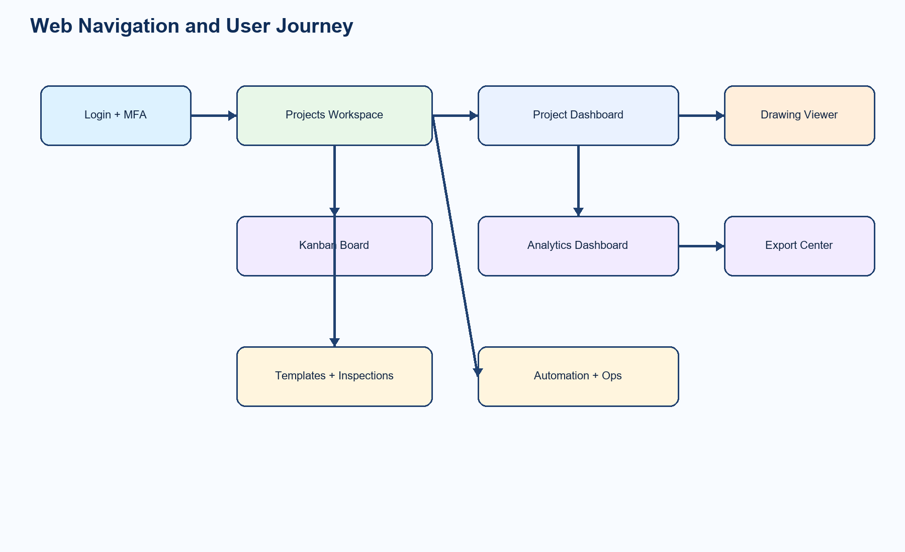

1. Authentication, Organization Context, and Role-based Visibility
Users authenticate with Sanctum session flow, optional MFA, and then operate under a selected organization and role-scoped permissions.
Step / Action | Where to Find It | How to Use It
Sign in (with optional MFA) | Web: /login | Enter email + password. If MFA is required, enter OTP and submit again.
Switch active organization | Top-left org selector in app layout | Choose organization from dropdown to refresh project/data scope.
See only allowed tabs | Left navigation menu | Menu sections and tabs are automatically shown/hidden by permissions and project overrides.
Read notifications | Top-right bell menu | Open bell icon, review unread entries, mark single or all as read.

2. Projects Workspace and Project Dashboard
Projects page is the launch point for daily work. Users can search projects, inspect metrics, and open project dashboards.
Step / Action | Where to Find It | How to Use It
Search projects | Web: Projects tab (/projects) | Use search box, then press Search.
Open project dashboard | Project card button: Open Dashboard | Select the target project to enter its dashboard view.
Navigate to drawing viewer | Web: /projects/{projectId}/drawings/{drawingId} | From project dashboard, open any drawing to start snagging workflows.

3. Drawing Viewer, Pin Plotting, and Snag Management
Drawing viewer supports revision control, comparison, intelligent location assistance, barcode resolution, and bulk actions.
Step / Action | Where to Find It | How to Use It
Select drawing context | Drawing Viewer: building/floor/revision controls | Choose building, floor, current revision, and optional compare revision.
Create snag from pin | Click on drawing canvas -> Create Snag dialog | Click drawing to place normalized pin (0..1), fill fields, then create.
Use location suggestions | Drawing Viewer intelligence panel | After placing a pin, review suggested locations and confidence score.
Compare revisions + highlight changes | Compare mode + Highlight changes switches | Enable compare mode, pick second revision, then toggle change overlay.
Migrate pins between revisions | Intelligence panel -> Pin Migration | Run Preview to inspect migration, then Apply to persist migrated coordinates.
Resolve location by barcode/QR | Scan QR/Barcode input + Open button | Enter or scan barcode to deep-link into location-filtered snag view.
Bulk update and export snags | Bulk panel above snags table | Select rows, set assignee/due date, then run bulk assign/update/export.

4. Snag Drawer - Full Collaboration Surface
Snag drawer centralizes status transitions, assignment/dispatch, closeout, watchers, threaded comments with mentions, attachments, and status history.
Step / Action | Where to Find It | How to Use It
Transition status | Snag Drawer -> Change Status panel | Choose target status, add note, apply transition.
Assign and dispatch | Snag Drawer -> Company/Team/Assignee fields | Set stakeholder company/team and assignee, then Save Assignment or Dispatch.
Add watchers | Snag Drawer -> Watchers | Select member and click Watch. Remove watchers from chips if needed.
Threaded comments + mentions | Snag Drawer -> Comments | Write comment, optionally set reply parent, mention users/teams, attach files, then Add Comment.
Upload attachments | Snag Drawer -> Attachments | Choose type (photo/video/markup) and upload supporting files.
Review history | Snag Drawer -> Status History | Read full transition audit trail including actor and timestamp.

Diagram 2 - Snag Status and Closeout Guard
Closing is guarded by closeout completion unless user has override permission.
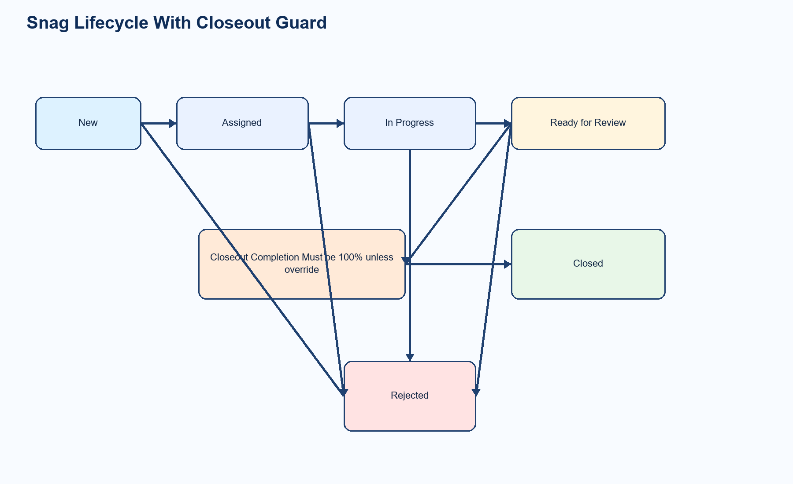

5. Closeout Templates and Closeout Instances
Closeout module supports template library management and per-snag checklist execution with evidence rules.
Step / Action | Where to Find It | How to Use It
Manage template library | Web: /templates -> Closeout tab | Create, edit, clone-to-project, and delete closeout templates and checklist items.
Initialize closeout for snag | Snag Drawer -> Closeout panel | Select template and initialize/update closeout instance for the snag.
Complete checklist and upload evidence | Snag Drawer -> checklist items | Mark items complete, add notes, upload evidence files for required items.
Review closeout | Snag Drawer -> Mark Reviewed | When completion reaches 100%, reviewer can mark closeout as reviewed.

6. Kanban Board
Kanban presents snag cards by status and supports quick transitions plus deep linking into full snag details.
Step / Action | Where to Find It | How to Use It
Open board | Web: /board | Select project filter to scope board lanes.
Quick move cards | Buttons on each card | Use available transition buttons to move snag status quickly.
Open full detail | Click card content | Open selected snag in drawer to complete richer updates.

7. Analytics Dashboard and KPI Cards
Advanced analytics include SLA metrics, Pareto/root cause views, trend/cost analysis, and custom dashboard configurations.
Step / Action | Where to Find It | How to Use It
Open analytics | Web: /dashboard | Choose project, period, and filters.
Review KPI and chart groups | Dashboard widgets | Inspect open/overdue counts, closure timing, root causes, cost and trends.
Create saved dashboard config | Config controls on dashboard page | Select cards and filters, save new preset, update existing, or delete.

8. Export Center
Export center queues PDF/CSV/XLSX jobs and provides download once processing is completed.
Step / Action | Where to Find It | How to Use It
Request export | Web: /exports | Choose project + export type and submit request.
Track status | Jobs grid in Export Center | Monitor queued, processing, completed, failed states.
Download output | Download button on completed row | Open generated artifact from /api/exports/{id}/download.

9. Inspection Templates, Submissions, Approvals, Signatures, and Requests
Inspections module delivers schema-driven forms, role-based approval chain, decision messaging, digital signatures, and MIR/WIR/IR request tracking.
Step / Action | Where to Find It | How to Use It
Build templates | Web: /templates -> Inspection tab | Define sections/fields and approval workflow steps, then save or clone.
Create submission | Web: /inspections/submissions | Pick template and project, create draft submission.
Submit and approve/reject | Web: /inspections/submissions/{id} | Submit draft, reviewers record decision and notes per workflow step.
Capture signature | Submission detail -> signature area | Sign required approvals and upload signature image.
Track MIR/WIR/IR requests | Web: /inspections/requests | Create request, assign, schedule, progress status to closure.
Inspect reports and export | Web: /inspections/reports | Review inspection KPIs and queue report exports.

Diagram 3 - Inspection Approval and Signature Flow
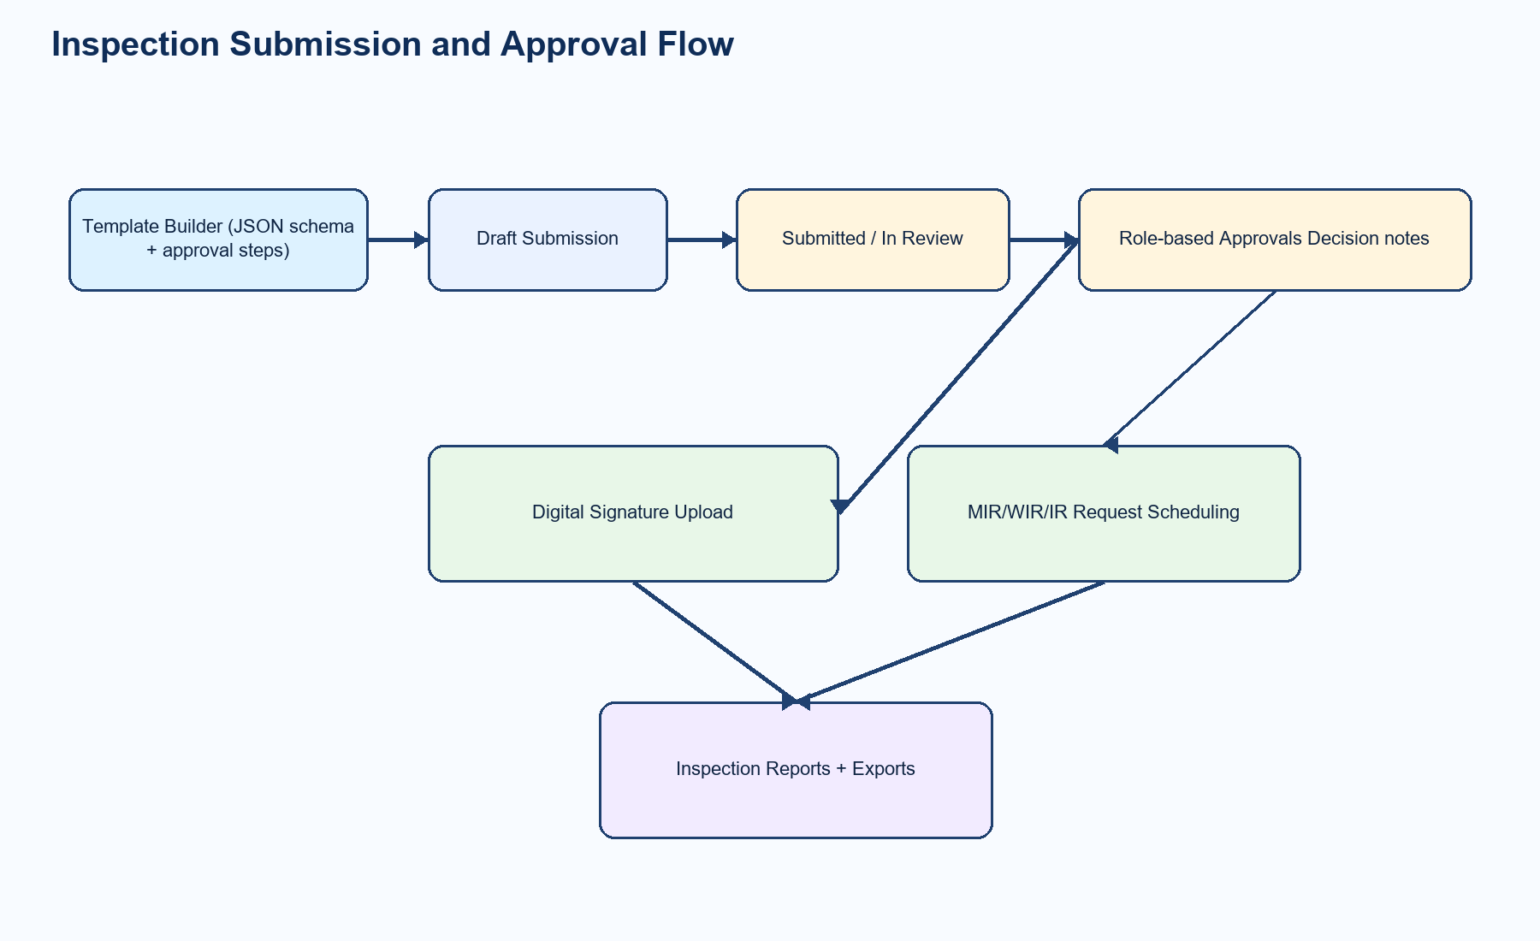

10. Access Control, Stakeholders, Delegation, and Permission Diff
Advanced RBAC supports org roles, project-level role overrides, company/team assignment structures, delegation windows, and preset comparison.
Step / Action | Where to Find It | How to Use It
Manage project role overrides | Web: /access-control | Choose project, then set role override per member and save.
Manage companies and teams | Web: /access-control stakeholder sections | Create stakeholder companies and teams for assignment workflows.
Set temporary delegations | Web: /access-control delegation section | Define from-user, to-user, date window, and scope.
Compare permission preset diff | Web: /access-control preset comparison | Select preset and compare resulting permissions against project context.

11. Workflow Automation Engine
Automation module supports conditional assignment/escalation rules, reminder policies, and recurring inspection schedules.
Step / Action | Where to Find It | How to Use It
Create automation rules | Web: /automation | Set conditions and resulting actions, then save rule.
Configure reminder nudges | Web: /automation reminder policies | Define reminder interval and trigger scope.
Create recurring inspections | Web: /automation recurring schedules | Bind schedule to template and project cadence.

12. Equipment and Maintenance Logs
Equipment module tracks asset status, maintenance records, and linkage to snags, including optional barcode-based operations.
Step / Action | Where to Find It | How to Use It
View equipment list | Web: /equipment | Filter by project/status and open equipment details.
Create equipment record | Web: /equipment -> Create | Enter equipment metadata and location linkage.
Add maintenance logs | Web: equipment detail/log dialog | Record maintenance action, health status, and optional snag reference.
Barcode flow | Web and Mobile equipment tools | Scan barcode to locate equipment/location instantly.

13. Notification Preferences, Digests, and Onboarding Tours
Users can tune immediate alerts, digest cadence, and quiet hours. Guided tours are persisted per user/org and can be replayed by support.
Step / Action | Where to Find It | How to Use It
Update notification preferences | Web: /preferences/notifications | Toggle channels/events and save digest frequency/timezone.
Run guided tours | Auto-run on first entry to feature pages | Tours include core, board, closeout, inspections, approvals, requests, exports, automation.
Replay tours or reset onboarding | Web: /ops support tools | Admin/support can reset onboarding state or replay selected tours for users.

14. Ops Console and Enterprise Controls
Ops console includes feature flags, usage limits, security policies, health indicators, and self-serve support operations.
Step / Action | Where to Find It | How to Use It
Feature flags | Web: /ops -> Feature Flags | Enable/disable modules per organization and project override.
Usage limits | Web: /ops -> Usage Limits | Manage storage quota, max exports/day, and max users.
Security controls | Web: /ops -> Security | Manage MFA policy, IP allowlist, antivirus mode, and PII redaction policy.
Health dashboard | Web: /ops -> Health | Track sync errors, queue depth, and storage failures.
Support actions | Web: /ops -> Support Tools | Resend invite, reset MFA, reset onboarding, replay tours.

15. Mobile App (Expo) - Offline-first Field Workflow
Mobile app includes offline snagging, local queue, background sync policies, chunked upload, conflict resolution UI, push/deep links, and floor map navigation.
Step / Action | Where to Find It | How to Use It
Open snags list | Mobile tab: Snags | Review local snags, queue size, and run manual sync.
Create snag offline | Mobile: Snags -> New | Fill form and queue operation. It syncs automatically later.
Use floor map | Mobile: Snags -> Floors | Navigate floors/locations quickly even when drawings are not loaded.
Queue comments/status/attachments | Mobile: Snag Detail | Add comments, queue status transitions, optimize + queue attachments.
Annotate attachments offline | Mobile: Snag Detail -> Add + Annotate Offline | Draw markups and queue both media and markup payload for sync.
Resolve conflicts manually | Mobile tab: Conflicts | Choose Use Server, Retry Local, or Merge field-by-field.
Tune sync windows/throttling | Mobile tab: Settings -> Sync Engine | Set background sync, interval, runs/minute, and active sync window.
Manage mobile devices and push | Mobile tab: Settings | Register push token, review authorized devices, revoke devices.

Diagram 4 - Mobile Sync and Conflict Handling
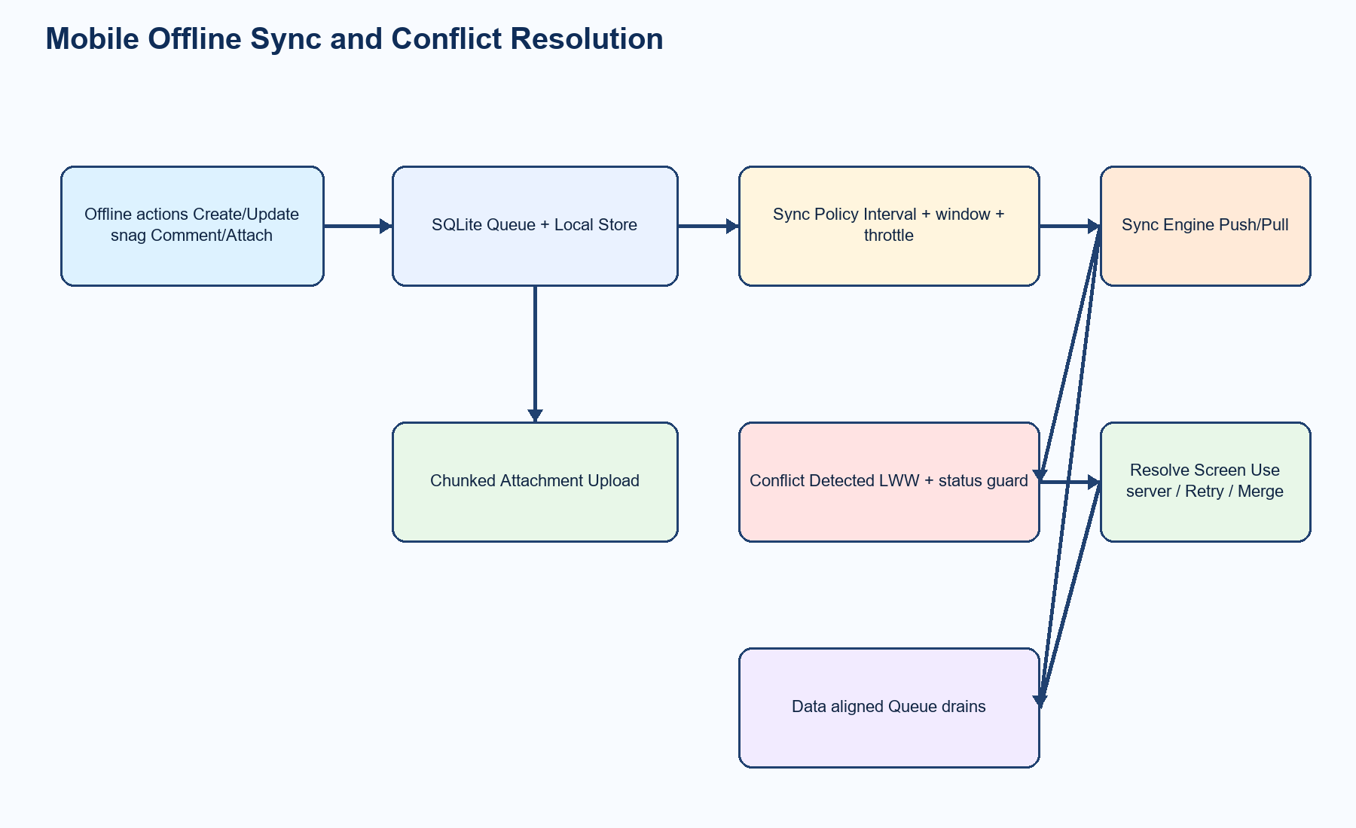

16. Page and Route Index (Web)
Use this index when onboarding users quickly or documenting SOPs.
- /projects - Projects catalog and search
- /projects/{projectId} - Project dashboard
- /projects/{projectId}/drawings/{drawingId} - Drawing viewer + pin workflow
- /board - Snags Kanban board
- /dashboard - Analytics and custom KPI configs
- /exports - Export center
- /templates - Template library hub (inspection + closeout)
- /inspections/submissions - Inspection submissions list
- /inspections/submissions/{id} - Submission details, approvals, signatures, chat log
- /inspections/requests - MIR/WIR/IR request module
- /inspections/reports - Inspection reports and export queue
- /equipment - Equipment and maintenance logs
- /access-control - RBAC, stakeholders, delegation, preset diff
- /automation - Rules, reminders, recurring inspections
- /preferences/notifications - Notification and digest settings
- /ops - Feature flags, limits, health, security, support operations

17. Error Handling and Troubleshooting Pointers
The platform includes request correlation and structured logs for fast incident diagnosis.
- Every API response includes X-Request-Id; keep this value when reporting issues.
- Frontend error messages append support reference when available.
- Primary logs: backend/storage/logs/api-YYYY-MM-DD.log and backend/storage/logs/laravel.log.
- Use Ops Health view to identify sync, queue, and storage failure trends quickly.

Appendix - Main API Capability Groups
- Auth + MFA + mobile auth devices
- Organizations, projects, drawings, revisions, barcode location resolver
- Snags CRUD, transitions, dispatch, watchers, comments, attachments, escalation rules
- Closeout templates and closeout instances with evidence
- Kanban, dashboards, dashboard configs
- Exports and inspection report exports
- Inspection templates, submissions, approvals, signatures, requests, recurring schedules
- Automation rules and reminder policies
- Equipment and maintenance logs
- Ops controls (feature flags, limits, security, health, support)
- Mobile sync endpoints and chunked upload endpoints
- Notifications, preferences, onboarding progress

