1.First error to fix :
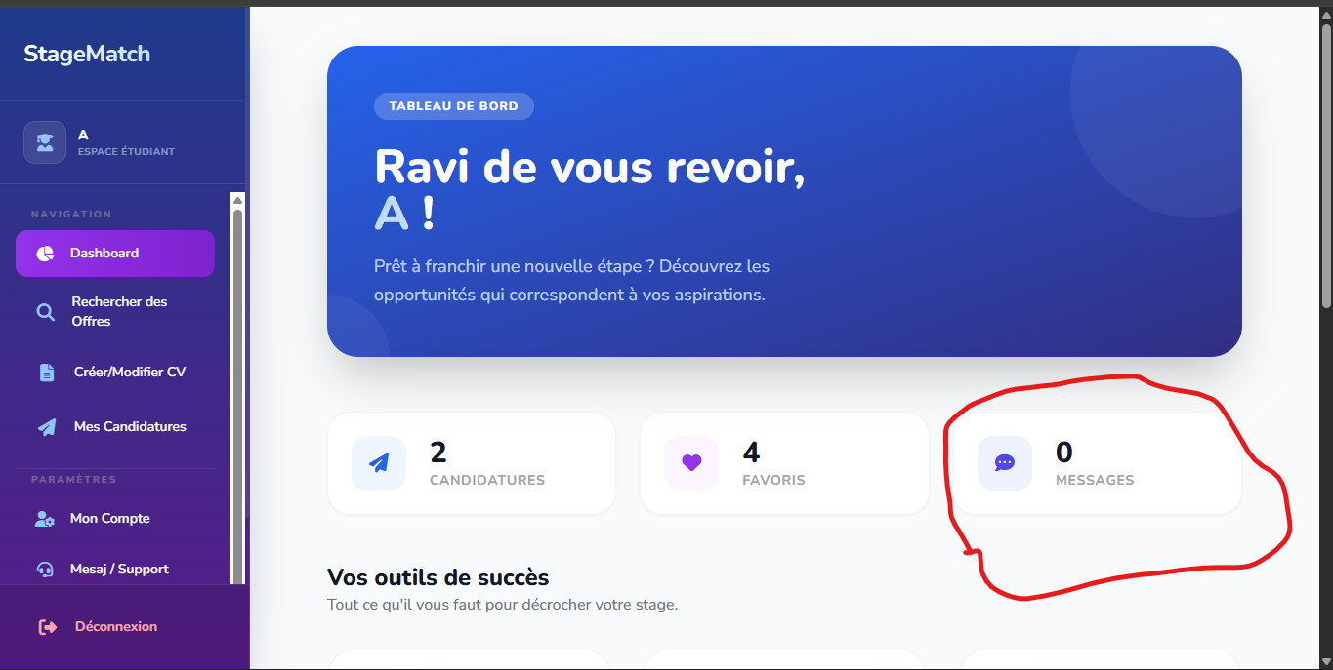

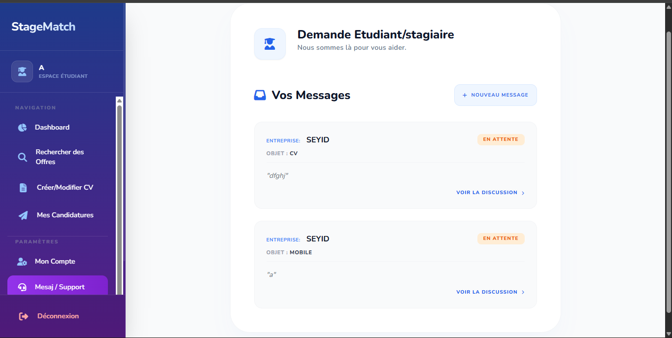
Look, the message button in the Student Party Dashboard needs to be linked to the number of messages in the Messages list, for example, in the Support section. If a message is sent to the OBJ Mobile, and a message arrives, it must be one in the Card Messages section. This means you have to keep track of the number of messages for each issue, whether it's a mobile issue or a CV issue. It counts the number of messages, but the messages that come in are counted in the Support section, the Message section, and the View Discussion section. If 20 or 30 messages come in from the company, nothing changes; it doesn't add 50 or 60 messages. The messages are counted based on the number of OBJs that have been answered. I have a DOBJ; if any message is sent, it counts as one, of course, the one for the OBJ Mobile. If the manager sends a message to the OBJ Mobile in the CV, the second message is counted. If the OBJ Mobile sees it, if they access the OBJ Mobile or rent the message (see the discussion), one is deleted because I saw it. You see, the message means that when you see the message, one is deducted. For example, if I do five OPGs (OPGs 1, 2, 3, 4, and 5), and the company only answers two, I get two. If I answer one, I get one. If I don't answer it, of course, it's zero. If I answer five, I'll get five messages. But if I go into the message section, the company can send me fifty or sixty messages. That's what I want to explain to you.
2.seconde error to fix :
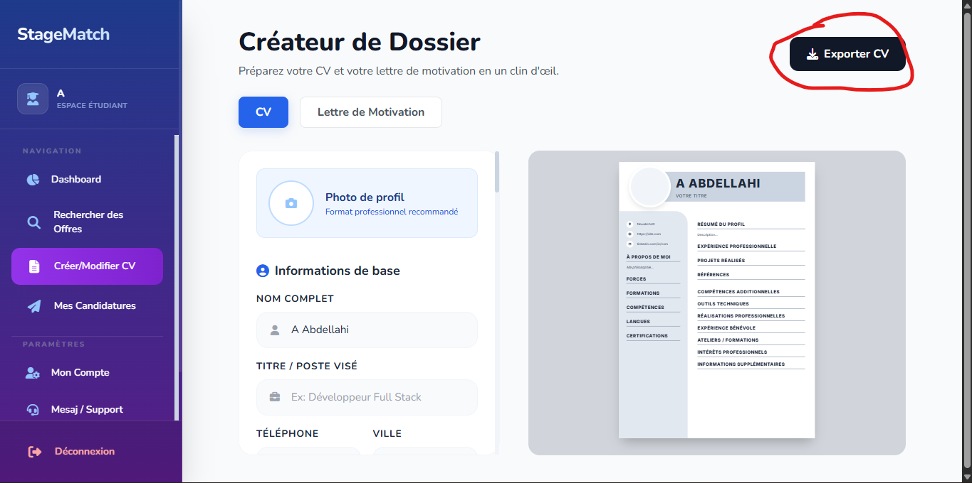

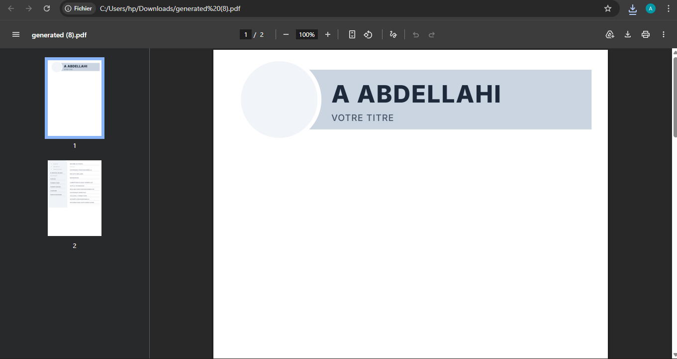
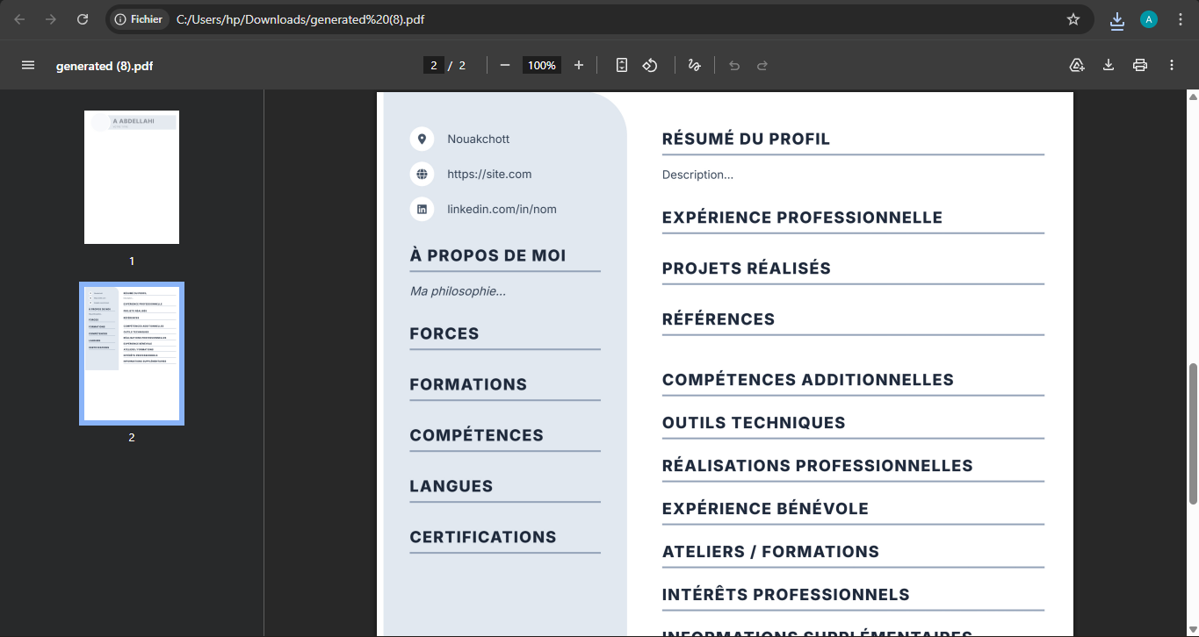
In the CV template or "creation de dossier" in the student section, when I put all the information in the input field and export the CV, when I open the PDF CV, the first page is blank except for the name, the title, and the photo. On the second page, I find information. This is an error. I put all the information on one page. When I export, I get one page, but this is a mistake. There's a problem with the database. I don't know how to fix this. It should be one page. I put all the data on one page and exported the CV. It should be one page with the photo, title, and everything else. It shouldn't be two pages. This is an error. You see the error: two pages. It shouldn't be two pages. When I open the PDF, I get two pages. This is an error. It should be one page because I put all my data on one page. It should fix the error in the code or the database.
3.third error to fix :
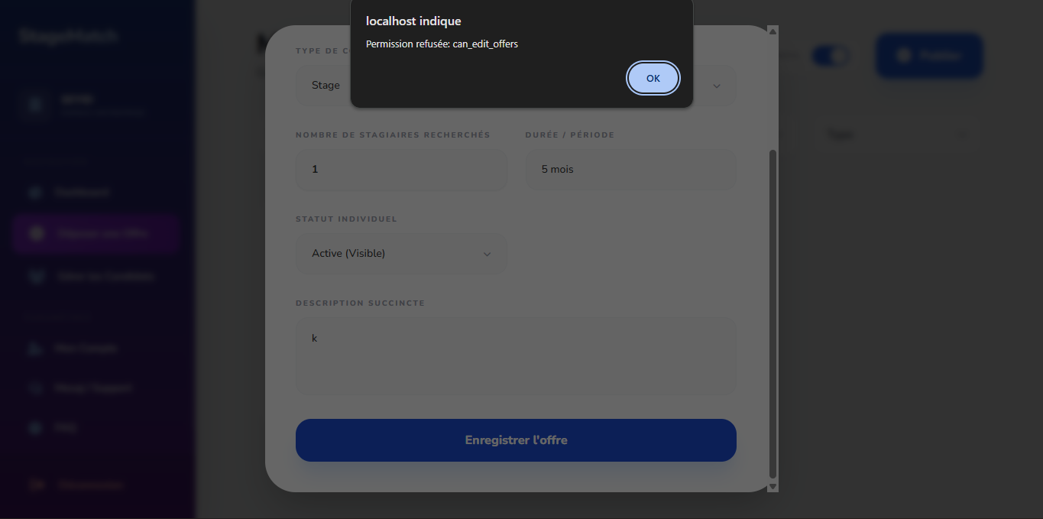
On the dépôt offer page, in the entreprise section, when I click on "modification" (meaning "update" or "change"), I get this message: "This error needs to be fixed. It needs to fix the error in the database or the code. It needs to fix the error."
4.fourth error to fix :
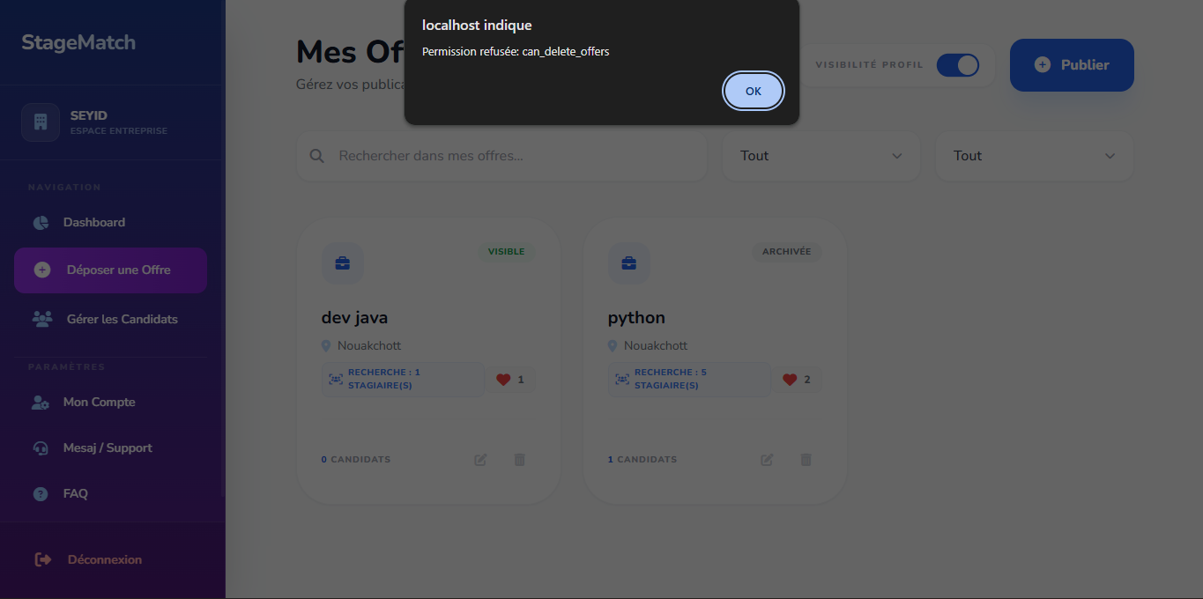
On this page, specifically the Depositing offer page, when you delete the offer, we don't add a delete option. It has to fix the error. It has to fix the error, whether it's from the database or the code. Whether it's in the code or the database, it has to fix the error. It has to fix the error.
5.fifth error to fix :
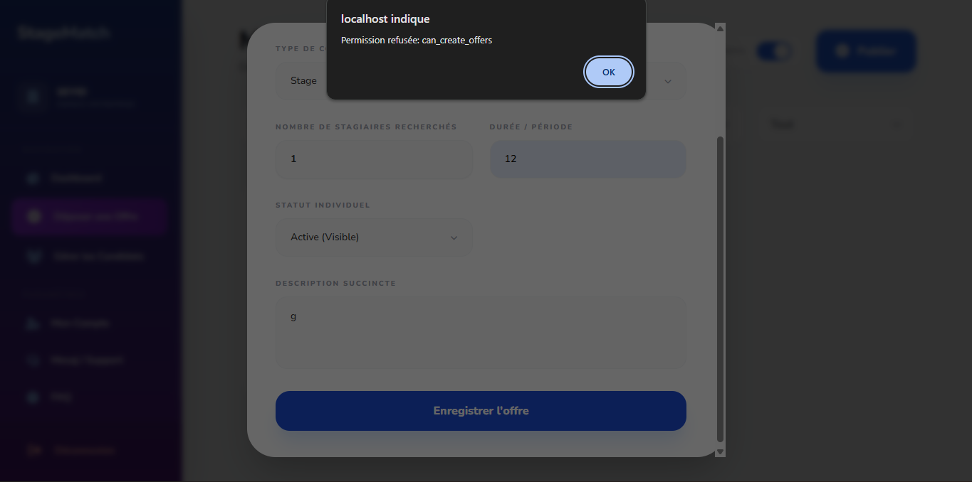
And if on the same morning I can't make a career for the database from off, I can't, the error must be fixed, whether it's in the database or in the code, the error must be fixed.
6.sixth error to fix :
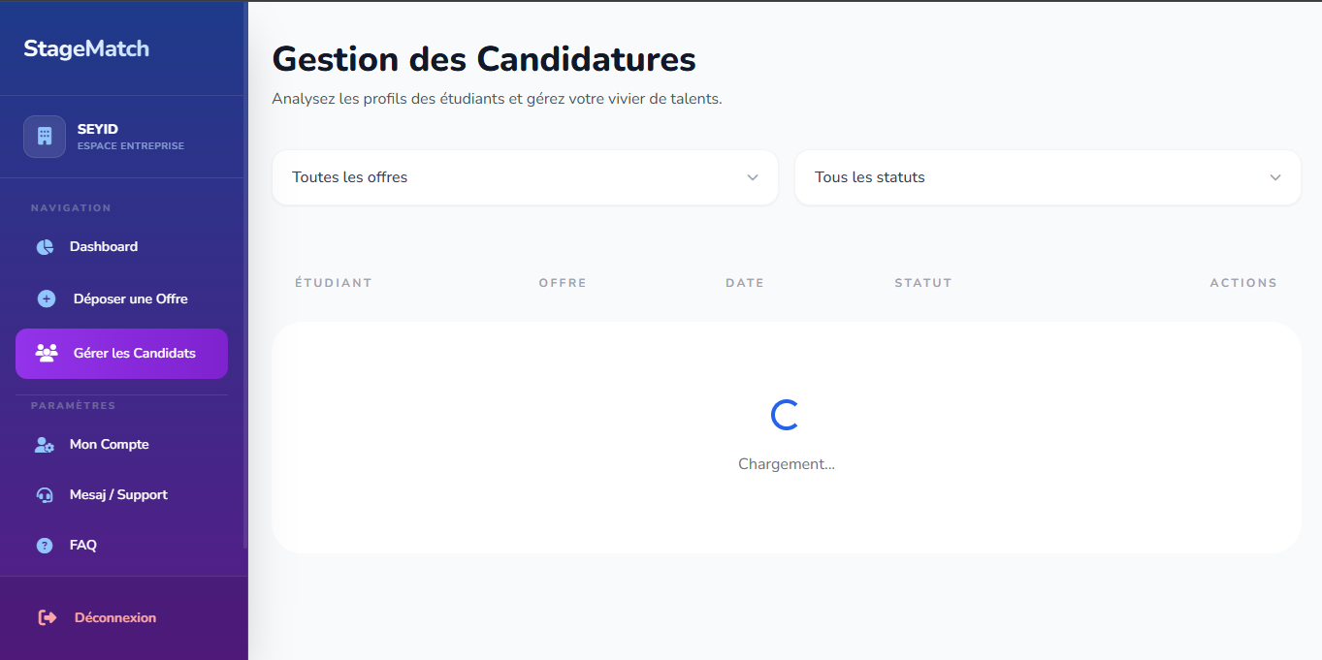
Look, the "candidate" option isn't working properly because, on the "candidate" page, I don't have any candidates listed. However, on the "Dipozé offer" page, you'll notice that a candidate has been listed in Python, and this is incorrect because the error must be addressed in "Gestion de kandidaat" (candidate management). The error must be corrected whether it's in the database or the code.
7.seventh error to fix :
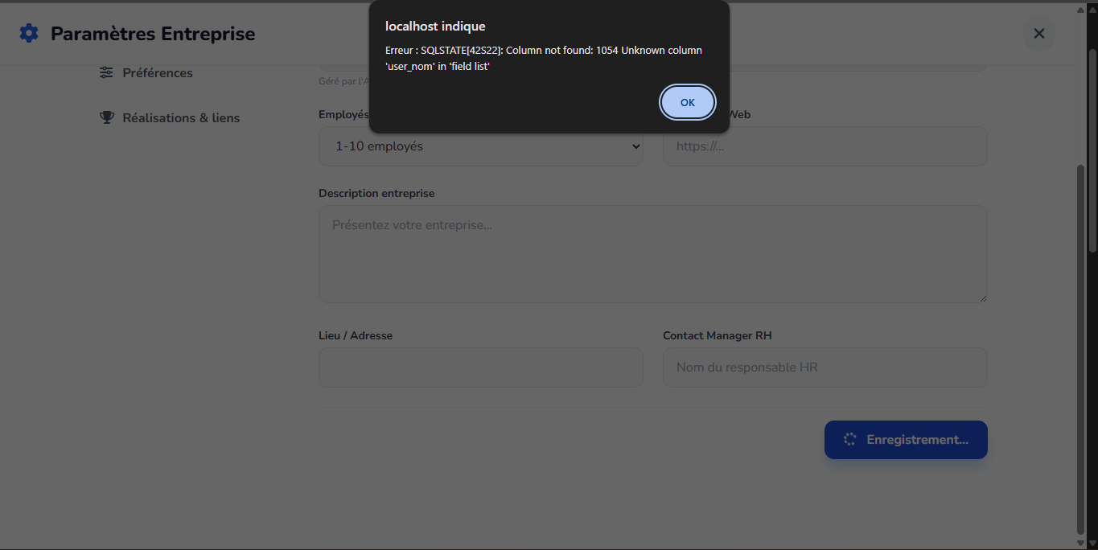
I can't make any changes to the parameters. I can't make any changes. If I make any changes, it refreshes and gives me an error page. It has to correct the error; it has to correct the error in the database and the code. It has to fix the errors. It has to fix the errors.

Note : First, look at these pages from point three to point seven. This means all these errors in Part Enterprise must be corrected because this page is one of the pages. Of course, one of the examples that the manager added from his side entered Part Enterprise and found these problems. All the errors must be dealt with, whether they are in the database or in the code. They must be dealt with and corrected, and he does a test so that all the errors are not here.

9.eight error to fix :
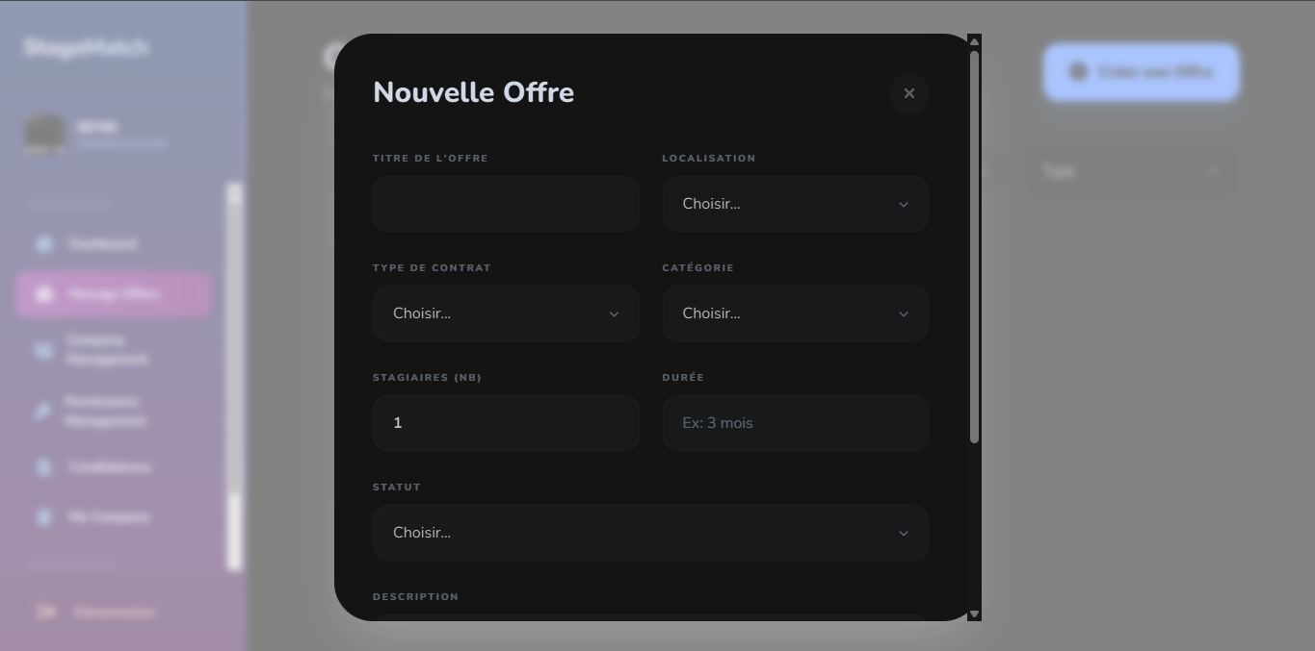
Look, in the Administrator section, under "Create an Offer," when you click on "Create an Offer," the optional group means "Localization Category." "Stat" means "Active" and "Archive." Of course, the data you see in "Create an Offer" must include categories like "Informatics" and "Telecomics," and so on. Also, in "Localization," there are other categories in some regions, and in "Contract," there are "Alternation" and "Stage." "Stat" must also include "Active" and "Archive." So, all the data you see in "Create an Offer" within the Alternation Enterprise management must be in the administrator position to create an offer. And that's all.
9.ninth error to fix :
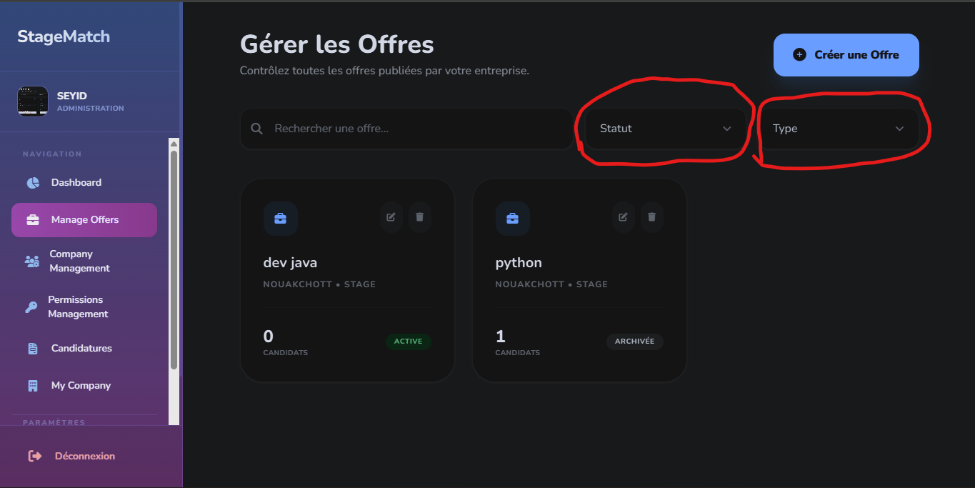
On the Manage Offers page, the "Offers" option in the Administrator Group option, Status and Type, are not working. They're not working because Status contains Archive and Active, and Type contains Alternance and Stages. When I click on it, nothing happens. It shouldn't show anything, not even the Search in Offer option. It needs to fix the errors on this page, whether they're in the code or the database.
10.tenth error to fix :
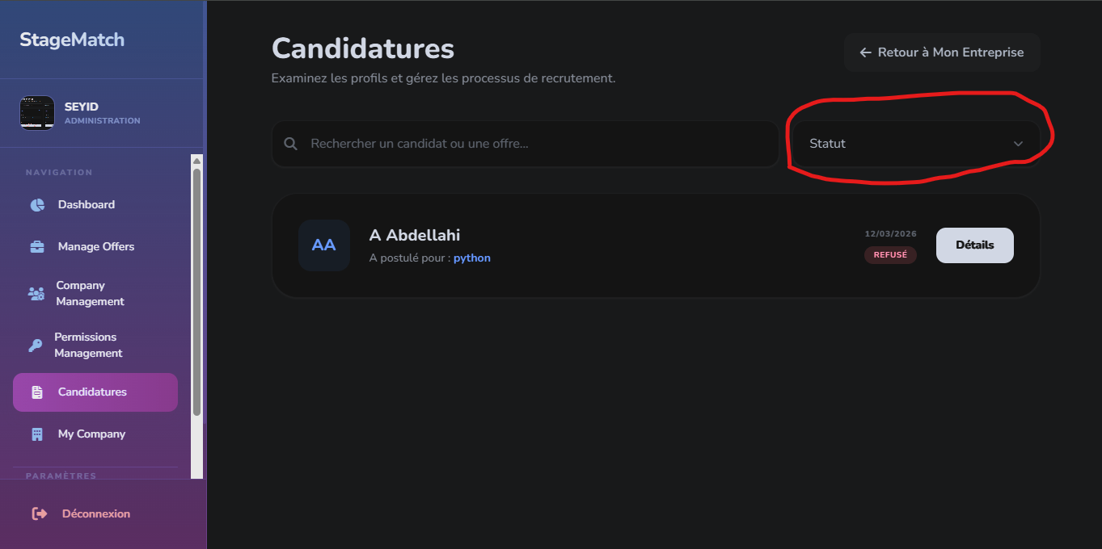
Look, on the Candidates page in the Party Administrator section, when you click on Group Option Status, if it's Alternation and Stag, then if it's Alternation, I'll get the candidate's name. If it's Stag, I'll get the candidate's name. But when I click on Status, nothing happens. I don't get anything in the Group Option, not even the search bar (search in Candidates in Offers). I don't get anything. The database needs to be corrected; the error needs to be fixed.
11.eleventh error to fix :
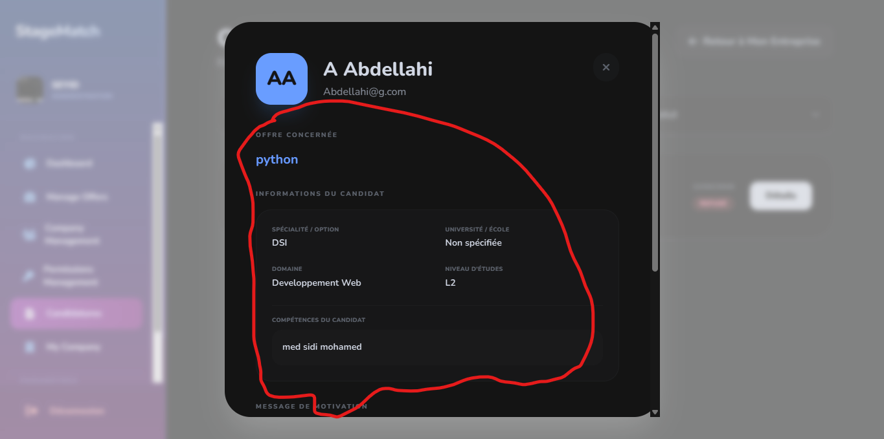


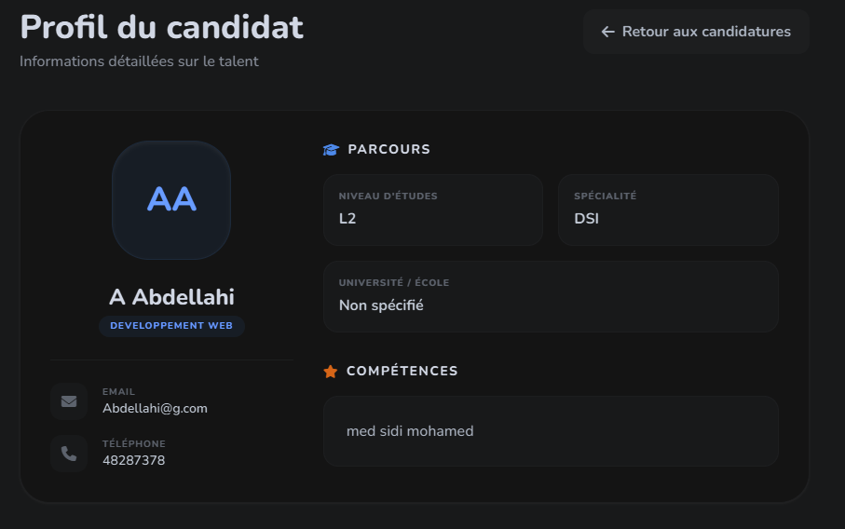
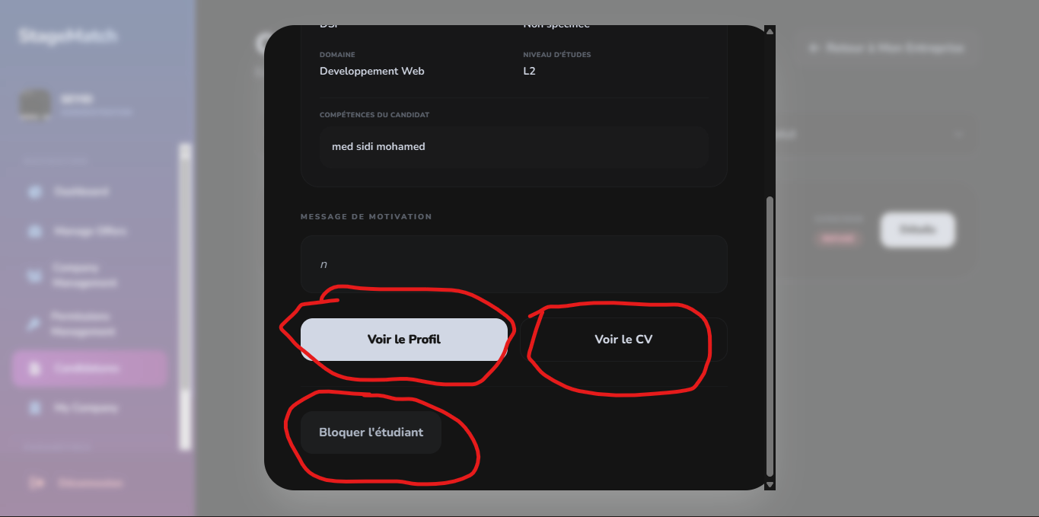
Look, there's a mistake here in the design. The content on the bio page, when I click on "detail," shows me this profile page. It should appear like this, under the arrow. It should be displayed like this. Also, the "voir le profil" button needs to be removed and replaced with the "lettre de motivation" button for the applicant's offer. And the "voir le cv" button—I should be able to see the CV, but I can't. I don't know why I can't see the CV. There's a mistake that needs fixing. Also, the database needs fixing and linking everything to the database. And the "black" button needs to be enabled. When it's blacked out, it disappears. In the Enterprise section, everything is blacked out. The manager can double-block it, but it's just blacked out.
12.twelfth error to fix :
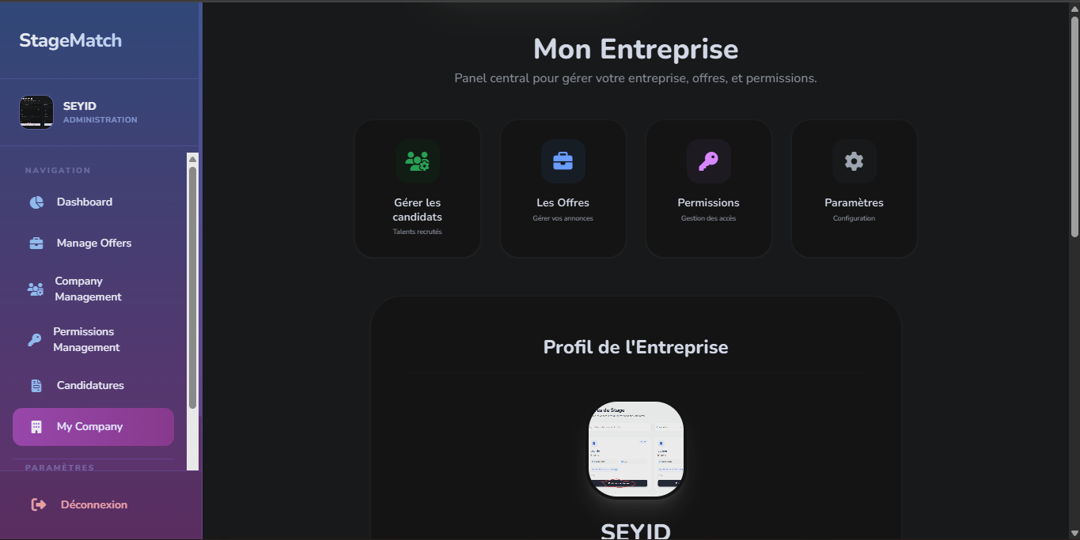

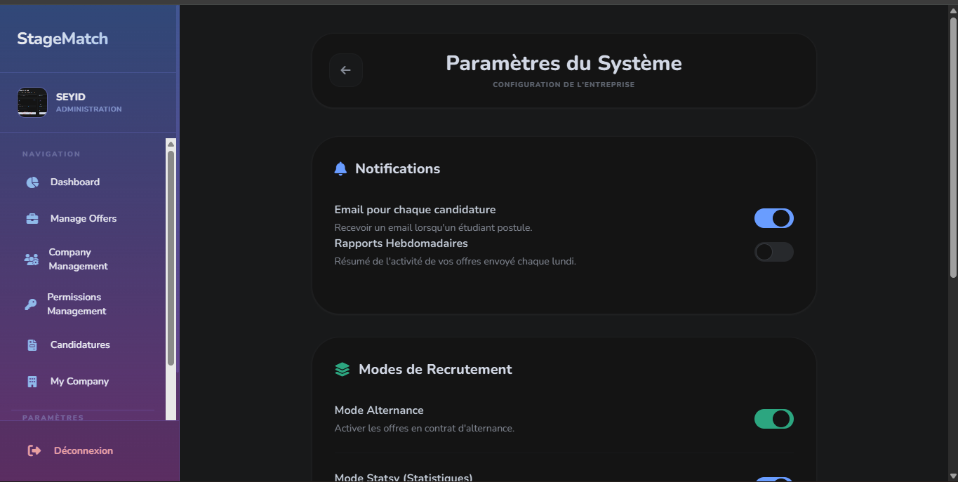
On my company page, if I click on paramètre, I get the paramètre system page. It only gets the paramètre system page. Okay, and it also fixes the error in the company profile. I can change the picture and put a picture in its place and make it an app, and I can delete it. Okay, this must be added to my company profile. That is, the property of changing the picture and searching for the picture must be added. This is stored in the database and corrects errors in the code.
13.thirteenth error to fix :
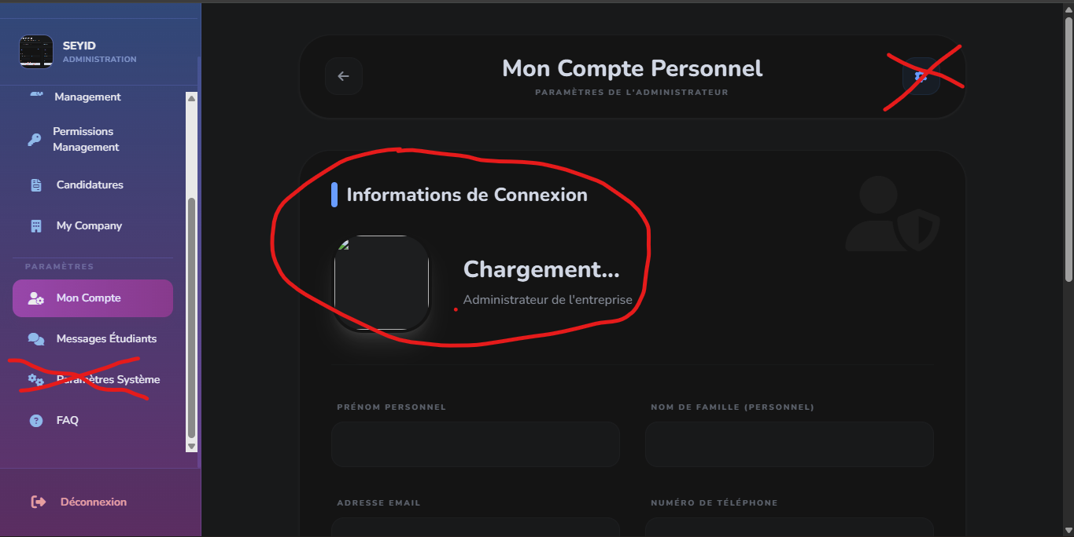
Look, on this Monkent page, in the Administrator section, the settings icon needs to be deleted, and the slide bar parameter system also needs to be deleted. The connection information also needs to be addressed. For example, the company logo or company page logo needs to be added. When the manager adds their company logo, it's like a "mise à jour" (update). The Administrator section needs to add the logo and apply it to the enterprise because it's related to it. The "personal" and "family" sections are also relevant to the manager. These errors need to be corrected. The connection information needs to be updated. The name needs to be added, and when there's a picture in the slide bar, it needs to be applied here in the connection information. The name also needs to appear, and we can change the company language. The settings icon and the slide bar parameter system also need to be deleted. This also fixes the error in the white bar you see. The white bar needs to be modified before scrolling. The same applies to the Student section. The data needs to be saved in the database. It links the pages to the database and handles errors in the code and also in the pages.

14.fourteenth error to fix :
FINAL WEBSITE SYSTEM CORRECTION

This is the final system correction and stabilization for the website.
All errors must be fixed and the system must be fully consistent.

The website contains three main sections:

1. Administrator section
2. Enterprise section
3. Student / Stagiaire section

These three sections must work together correctly and communicate properly with the database and backend logic.

GENERAL REQUIREMENTS

All pages must work without errors.
There must be no broken routes, no "Not Found" pages, and no database conflicts.

The system must ensure that:
- The backend logic communicates correctly with the database.
- All pages interact correctly with the backend.
- The roles and permissions are respected.
- The navigation between pages is correct.

DATABASE STRUCTURE

The database must be cleaned and corrected.
Tables must be consistent and properly linked.

Important entities include:
- companies
- users
- offers
- candidatures
- permissions

Each user must be correctly linked to a company using a company_id.

COMPANY REGISTRATION

When a company registers (Enterprise inscription), the system must automatically:

1. Create the company in the database.
2. Create an Administrator account linked to that company.

After login, the administrator must be redirected to the Administrator Dashboard.

ENTERPRISE WORKSPACE

Each company has its own enterprise workspace.

Example:
If the company name is "Tazias", all employees belonging to that company must access the Tazias enterprise workspace.

Employees and the administrator work inside the same enterprise environment.

ADMINISTRATOR ROLE

The administrator manages the company and must be able to:

- Manage company profile
- Access Company Management
- Create employees
- Manage employees
- Assign permissions
- Manage offers
- Manage candidatures

The administrator account must always remain ADMIN and must never be automatically converted into an employee account.

EMPLOYEE ROLE

Employees are created by the administrator and belong to the same company.

When employees log in, they must access the enterprise workspace of their company.

Their actions must depend on permissions given by the administrator.

PERMISSION SYSTEM

The administrator must control permissions for employees.

Possible permissions include:
- Create Offer
- Modify Offer
- Delete Offer
- Manage Candidatures

VISIBILITY RULES

All offers created inside a company must be visible to authorized employees of the same company.

Employees must never see data from other companies.

STUDENT / STAGIAIRE SECTION

Students or stagiaires can:

- Browse available offers
- Apply for offers (candidature)
- Manage their applications

They must only access the student part of the platform.

FINAL SYSTEM REQUIREMENT

Administrator, Enterprise, and Student sections must work together as a single stable system.

All errors must be fixed:
- database errors
- backend logic errors
- routing errors
- permission conflicts

The final website must be stable, clear, and fully functional.

