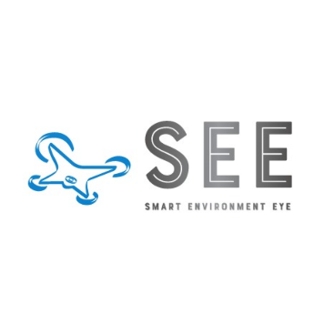

**Smart Environment Eye [SEE]** is an advanced AI-powered object detection system that can detect and classify visual pollutants in real-time. The system is equipped with state-of-the-art computer vision techniques to accurately detect and classify pollutants such as graffiti, garbage, sand on roads, potholes, cluttered sidewalks, bad billboards, etc...

The system can be installed on an Android device, an Edge device, or can be integrated with city surveillance cameras, the system will be connected to GPS and the Internet and can send detected visual pollutants, their type, and their location in real-time to city officials and display them via a monitoring dashboard, allowing them to take immediate action and keep the city clean.

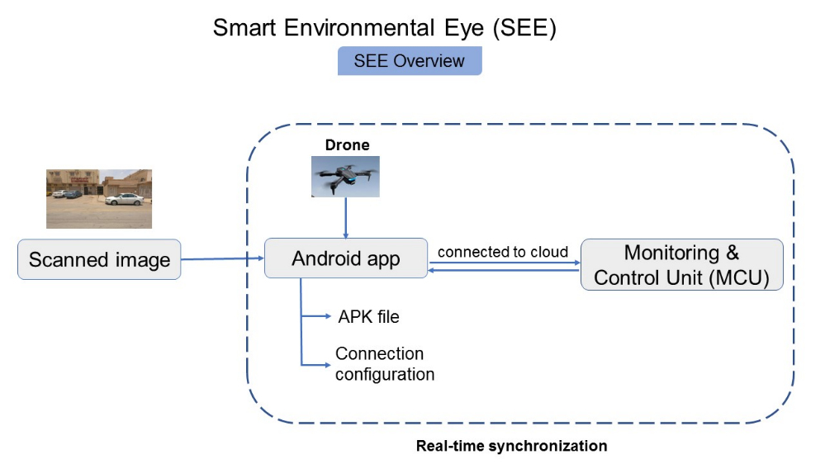

Figure 1: SEE Overview

[GitHub (source code)](https://github.com/abdelmageed95/SEE) YouTube video [[1]](https://www.youtube.com/watch?v=Cl3qzpoNr-U) , [[2]](https://www.youtube.com/watch?v=YcwFNqkJR9I) [Demo (Gradio)](https://huggingface.co/spaces/alshimaa/SEE) [Android app](https://drive.google.com/file/d/1-0rna-jzAHyEjBUvbf3qIy2G3foGiIZo/view?usp=sharing)

***The Workflow of Smart Environment Eye System:***

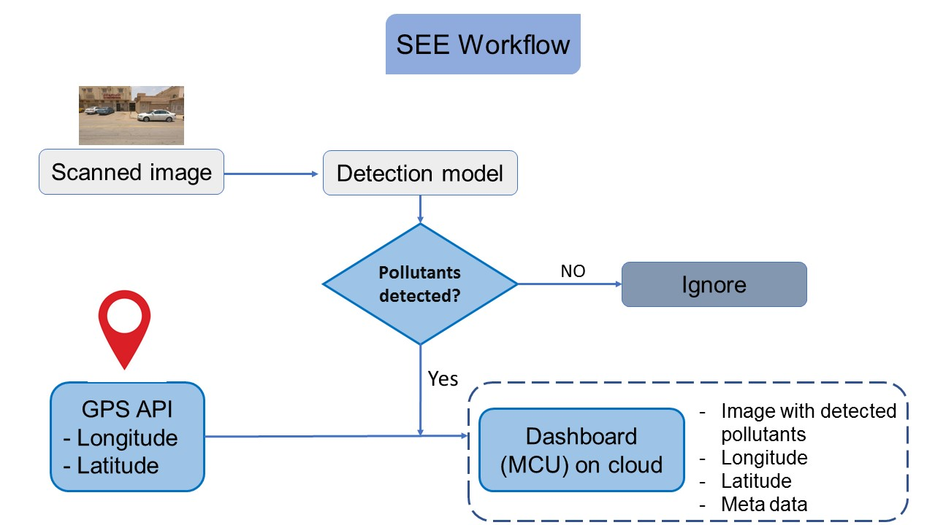

Figure 2: SEE Workflow

The project involves the following steps:

1. Preparing data for Modelling Stage

2. Training an object detection model and

3. Export the detection model into APK file which suitable for android devices.

4. Installing the APK file on the drone's digital camera which support android OS.

4. Connect the system to GPS and the Internet.

5. Deploying the drone in streets and roads and scanning for visual pollutants.

6. If any pollutants are detected, the system will send the image of the detected pollutants, the type of pollutants, and the coordinates of the site to a dashboard for monitoring and storing the data.

**Tools & Software:**

* [Yolov7 object detection algorithm](https://github.com/WongKinYiu/yolov7) , and [Yolov7 for android](https://github.com/xiang-wuu/ncnn-android-yolov7/tree/master/app/src/main/assets)
* Python programming
* Juypter Notebook
* Android Studio
* Gradio (demo builder)

**How our Solution can scale the process of detection:**

SEE is an Edge-based deployment:

* which running the model on edge devices like cameras (drone), this will remove the need of sending unnecessary images back to the server and running the model, which can be resource intensive.
* It allows for the deployment of multiple models in parallel on different edge devices, making the system more scalable and able to handle a larger number of inputs.
* Reduced Bandwidth: By running the model on the edge device, the need to send images back to the server for processing is eliminated, which reduces the amount of data that needs to be transmitted over the network, thus reducing the bandwidth required
* Cost-effective: Edge-based deployment can reduce costs associated with cloud computing and data transfer, as the processing is done locally on the device.
* Increased Privacy and Security: By keeping the data processing on the edge device, the risk of data breaches is minimized, and only sending the detected pollution images with their location rather than sending every collected photo, hence the data can be kept more private.

**Challenges in data:**

in preparing the data we follow two approaches:

**In the first approach**, we used the original data as it is to get a model that can generalize in case of inaccurate annotation, and partially annotated images, which can also impact the model's performance, also, the data come in Pascal VOC format we convert it into yolo format so we can train YOLO over it, this approach is for designed submission file.

**The second approach** is designed to make an accurate model that is used in annotating large amounts of data for building a more robust model that can monitor and detect visual pollutants in the city with highly accurate results, so we get our hands dirty with data and manually correct the incorrect labels, annotate the unannotated objects, and adjust the boxes of some object that doesn’t match/cover the whole object

***Automation of Data Annotation***

***Scaling The Project Over Millions of Collected Images is very difficult task to be achieved with traditional data annotation method***

*Data annotation can be time-consuming and labor-intensive especially for large amount of data. Additionally, it requires a high level of expertise and attention to detail to ensure that the annotations are accurate and consistent. Furthermore, manual annotation may lead to errors and biases that can negatively impact the performance of machine learning models*

We can use AI to help in data annotation

1. **CLIP Segmentation Transformer**
2. **Yolo with Human in The Loop**
3. **CLIP Segmentation Transformer**

CLIP (Contrastive Language-Image Pre-training) is a transformer-based model that was trained using a novel contrastive learning objective on a dataset of images and their associated textual captions. It is designed to perform a task called "segmentation", which involves identifying and locating specific objects within an image. The model learns to associate the textual information in the captions with the visual information in the images, allowing it to make predictions about the location and identity of objects within new images.

We can use CLIPSeg to annotate simple objects in images like Garbage. However, we can train it to annotate complicated objects on a few thousand manually annotated data

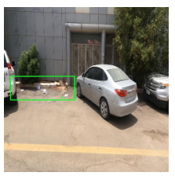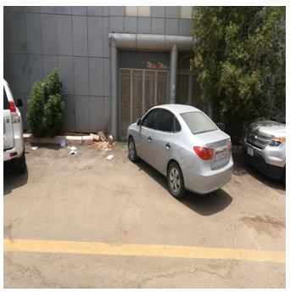

1. **Yolo with Human in The Loop**

we can use a pre-trained custom model trained on a few thousands of manually annotated data that achieved a high mAP on testing data to help in annotation , Using the prediction of the model as an annotation, and human to correct the wrong prediction

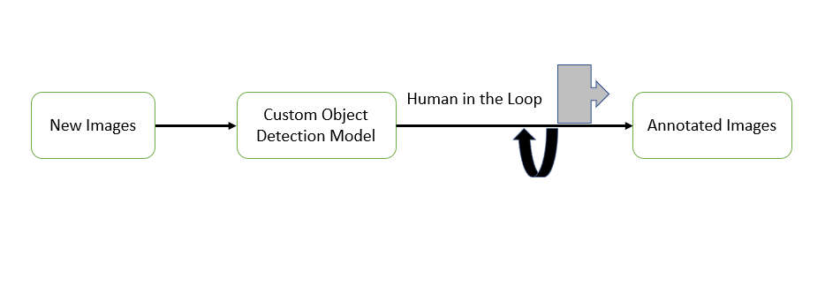

As we have limited time , resource, and data we just built a prototype of the model and the android app, while with more data we can use the prototype model to annotate large amount of data with the human in the loop to correct the wrong annotation , in case we have more resource like drone / camera support android we can run the apk file on a drone / camera and build a custom dashboard to monitor and visualize the detected results.

The system can also be used to track and analyze the effectiveness of cleanup efforts over time, by providing detailed reports and statistics. With more resources and data, the system could potentially be expanded to detect and classify other forms of pollution, such as air and water pollution, making it a comprehensive solution to keep the environment clean and safe.

SEE will be a reliable and efficient system for monitoring and detecting pollutants. It will be able to detect and classify different types of pollutants and send the data to a dashboard for monitoring and storing the data to enable the authorities to take an action. This will help reduce pollution and keep environment clean.