Signal processing using MATLAB

Prof:

Ayman Mustafa

Made by:

Abdelmounime mohamad

# Part 1

## A screenshot of a computer screen AI-generated content may be incorrect.Main message and filtered message time domains

Cutoff frequency is f**C** =3400Hz

## Main message spectrums(frequency domains)

## Main Filtered message spectrums(frequency domains)

## Testing multiple cutoff frequency

The cutoff frequency after which the signal becomes unintelligible was 350Hz

## Letter F

### Signal-F and filtered Signal- F time domains.

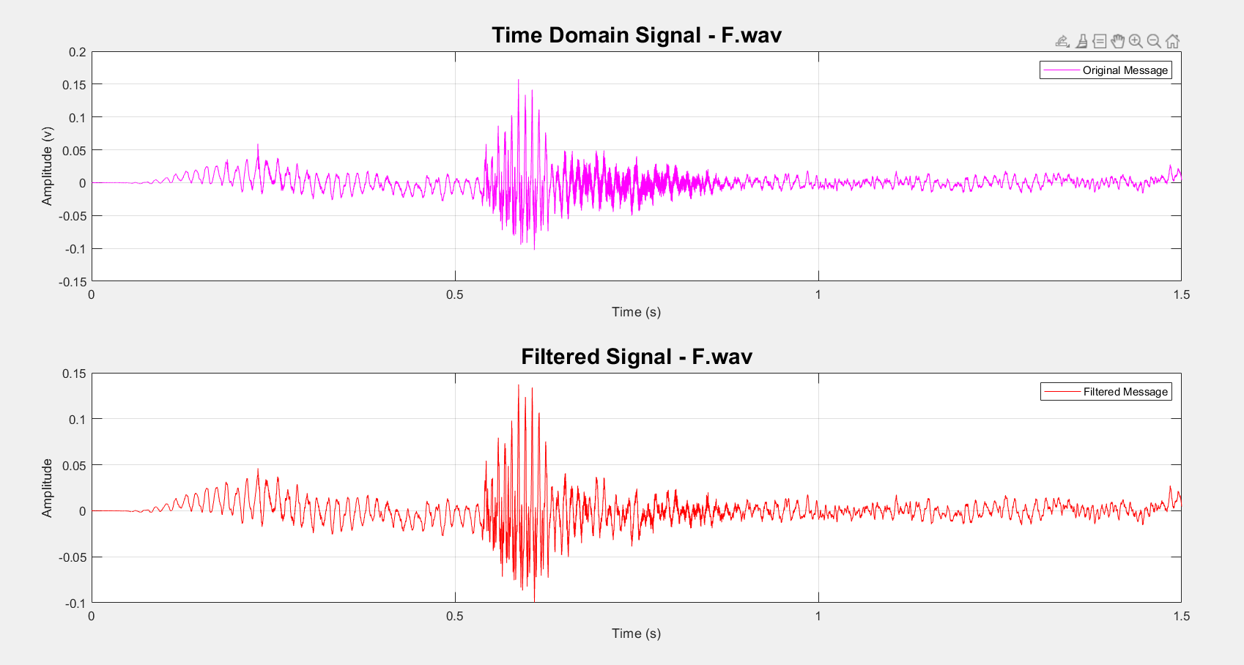

### signal-F spectrum

### A red line graph on a white background AI-generated content may be incorrect.Signal-F filtered spectrum

## Letter S

### Signal-S and filtered Signal- S time domains

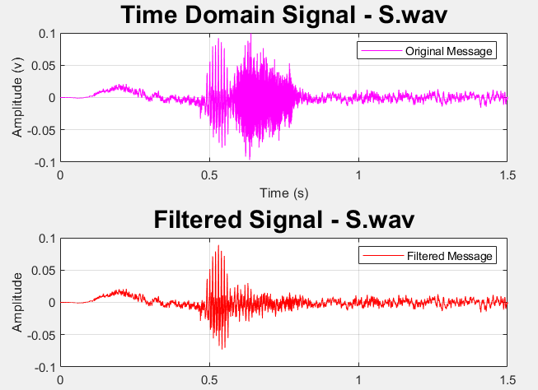

### Signal-S spectrum

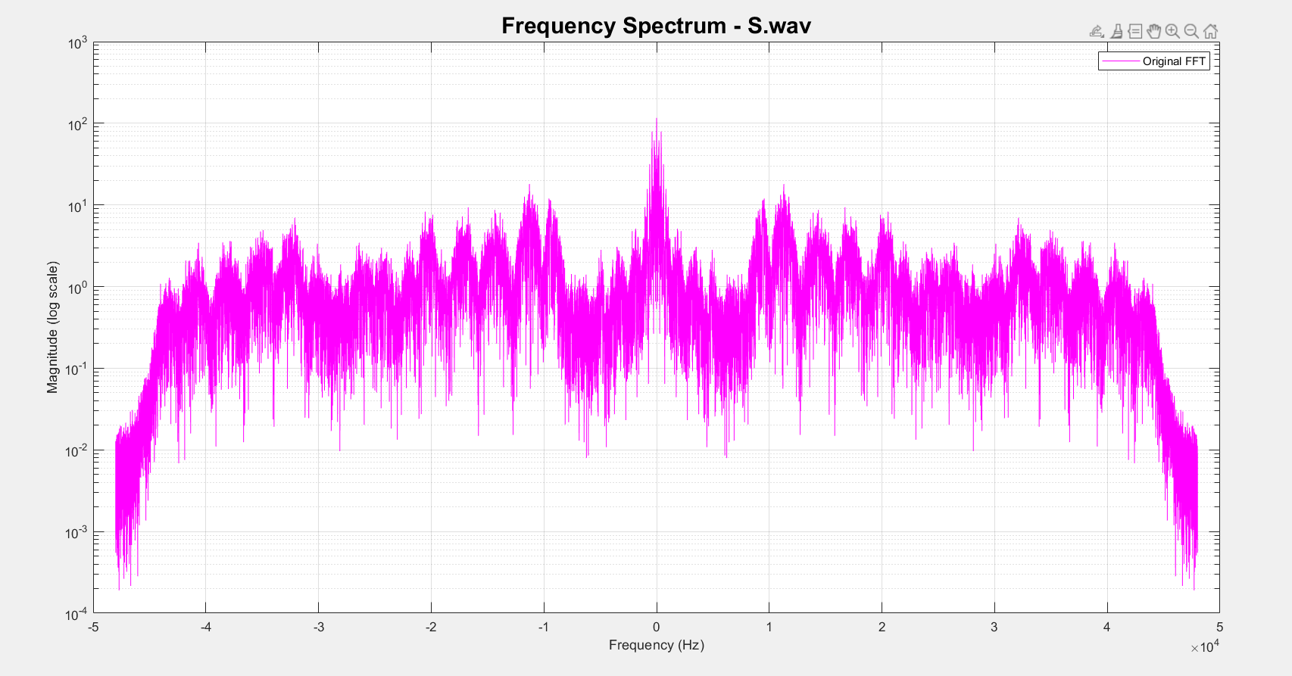

### Signal-S filtered spectrum

### A screenshot of a computer screen AI-generated content may be incorrect.Signal-M and filtered signal-M time domain

### Signal-M spectrum

### Signal-M filtered spectrum

### A screenshot of a computer screen AI-generated content may be incorrect.Signal-N and filtered signal-N time domain

### Signal-M spectrum

### A screen shot of a graph AI-generated content may be incorrect.Signal-N filtered spectrum

### A screenshot of a computer screen AI-generated content may be incorrect.Signal-B and filtered signal-B time domain

### A screen shot of a graph AI-generated content may be incorrect.Signal-B spectrum

### A red graph with black text AI-generated content may be incorrect.Signal-B filtered spectrum

### A screenshot of a computer screen AI-generated content may be incorrect.Signal-D and filtered signal-D time domain

### A screen shot of a graph AI-generated content may be incorrect.Signal-D spectrum

### A screen shot of a graph AI-generated content may be incorrect.Signal-D filtered spectrum

## Testing multiple cutoff frequencies

|  |  |
| --- | --- |
| Letter | Unintelligible Below (Hz) |
| F | 750 |
| B | 850 |
| S | 200 |
| D | 150 |
| M | 300 |
| N | 300 |

## DSB-LC

### DSB-LC parameters

* f**c**= 48 KHz
* Modulation index (µ)=0.8

### DSB-LC plots

#### DSB-LC modulation and demodulation time domain

#### DSB-LC: modulated message spectrum

#### DSB-LC: demodulated message spectrum

### DSB-LC: energy after and before modulation

When using the function envelope() which represent an envelope detector, the result will be almost identical to the message which is not practical, so the other method used is the envelope using the method named square-law detector.

Any factor affecting amplitude is going to square in energy that is why the appropriate scaling factor is:

Note we Pm here is the power of the message recorded after being filtered at cutoff frequency equal to 3400Hz.

# Part2:

## DSB

### DSB-SC modulation and demodulation/time domain

### A graph of a diagram AI-generated content may be incorrect.DSB-SC MODULATION spectrum

### DSB-SC demodulation spectrum

## SSB

### SSB modulation and demodulation/time domain

### SSB modulated Spectrum

### A screen shot of a graph AI-generated content may be incorrect.A graph of a signal spectrum AI-generated content may be incorrect.SSB demodulated spectrum

## OBSERVATION ON MULTIPLE OFFSETS

If the offset is small there is almost no disruption around offset equal to 10 hertz,

An offset near the 30Hz cause a medium disturbance.

An offset near 100hz cause huge disturbance.

# Part3:

## FM for main audio

### FM time domain:

### FM spectrum

### FM demodulation spectrum

## FM for single tone

### Properties of the single tone signal

Frequency is 3KHz

Duration is 1 second

Sampling frequency of the tone signal is the same as the message in FM which is 480kHz

Beta list(β) = [0.1,0.5, 1, 3, 5, 10];

#### Time domain

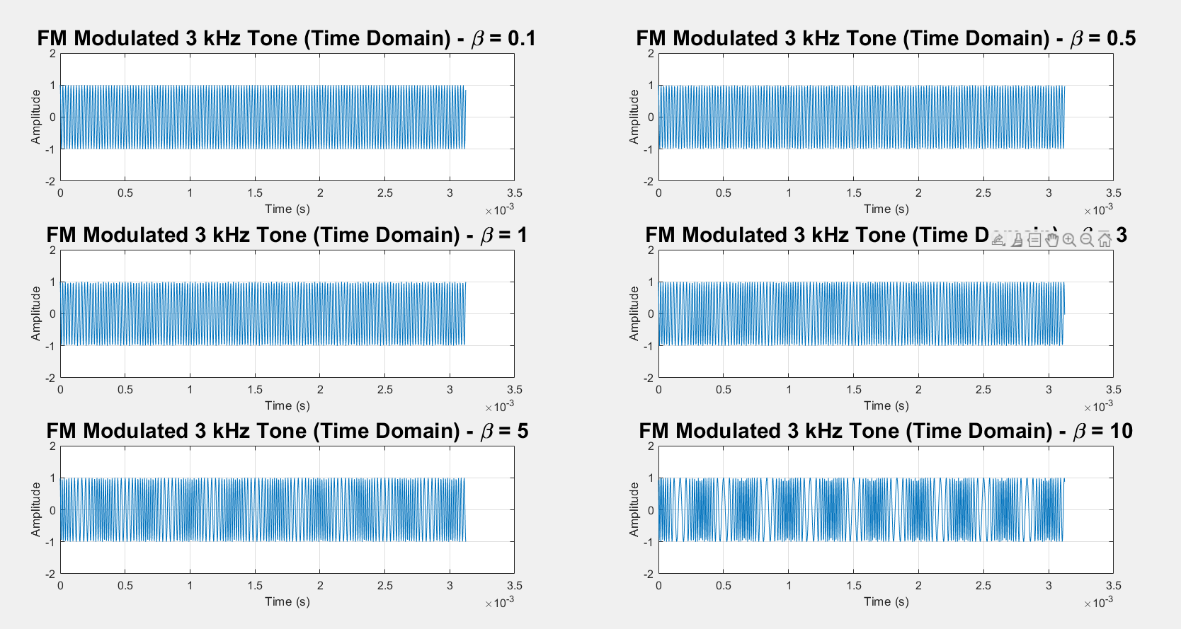

#### Frequency domain

# Part4:

## ADDING GAUSSAIN NOISE

### For β =3

I tried to add noise with an average power around 0.0000001 unit and the sound hasn't changed at all and SNR_in = 67.00 dB | SNR_out = 43.22 dB

When I tried 0.01 unit, almost no sound at all from the message and the SNR_in = 16.99 dB | SNR_out = 4.12 dB

When I tried 0.1 unit there were completely no message in that sound and SNR_in = 6.99 dB | SNR_out = -3.76 dB

### For β =5

Overall observation is that with β =5 the message was more resistant to noise.

an average power around 0.0000001 unit and the sound hasn't changed at all and SNR_in = 67.00 dB | SNR_out = 43.22 dB, the sound was clear

Noise Power = 0.010000 | SNR_in = 16.99 dB | SNR_out = 3.93 dB, the disturbance was huge from the noise but still some of the message can be heard.

Noise Power = 0.100000 | SNR_in = 6.99 dB | SNR_out = -3.42 dB, no sign of message in that sound.

## Testing Threshold effect

|  |  |
| --- | --- |
|  |  |
|  |  |
|  |  |
|  |  |
|  |  |
|  |  |