**Exercise 7.2**

**objective**

Using unity to perform a simple task which is writing my name on the screen and printing it in the console.

This was done by linking the C# script to the main camera and adding text component from canvas to the text component field in the script

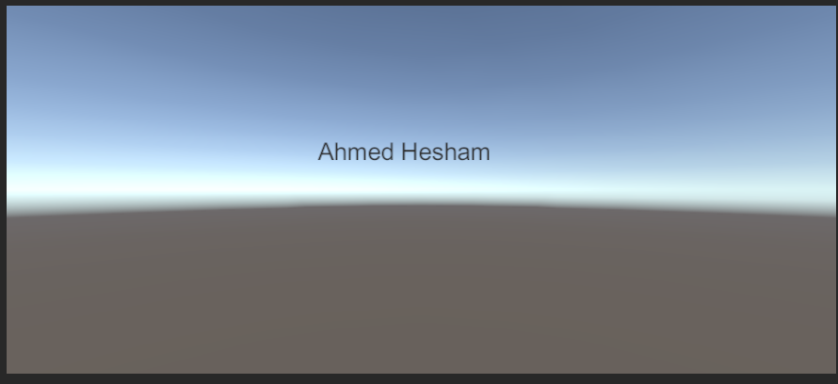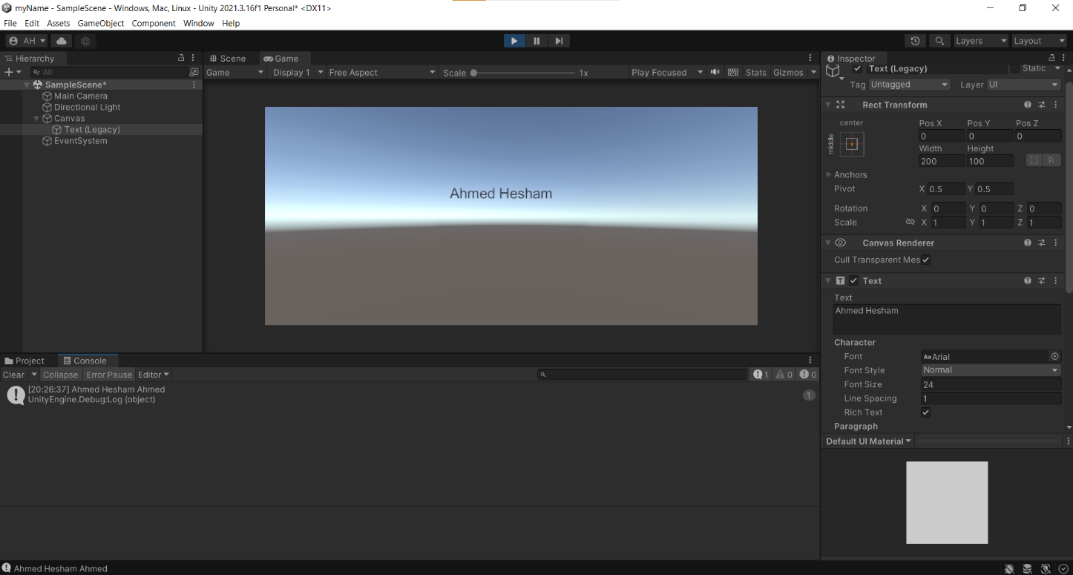**output**



**code** 