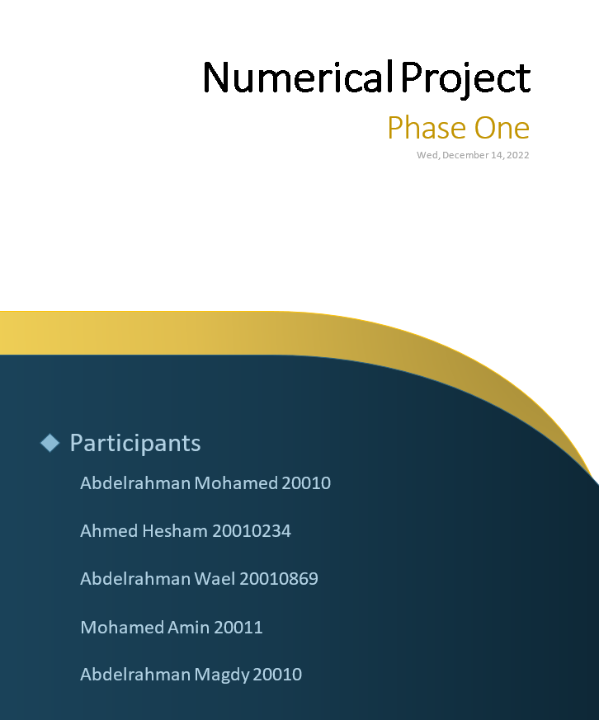

HCI project

**Phase 3**

851

502

829

**Prototype**

A prototype is way of design by which designers can communicate together, shows how it interacts and tests its stability.

**Low fidelity prototype**

Does not look very much like the initial product and does not provide the same functionality! Low-fidelity prototypes are useful because they tend to be simple, cheap, and quick to produce and modify.

**High fidelity prototype**

Prototype looks like the final product and/or provides more functionality than a low-fidelity prototype Useful for Selling Ideas to People

**Low fidelity design**

**Design link**

**https://marvelapp.com/whiteboard/N3O9jEjIJwFIBVa3UsVj**

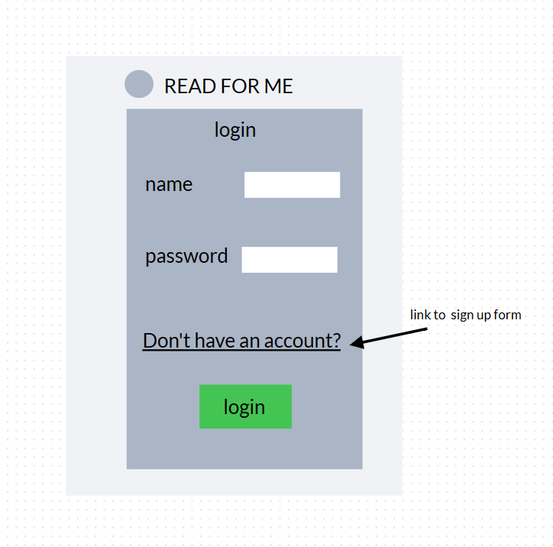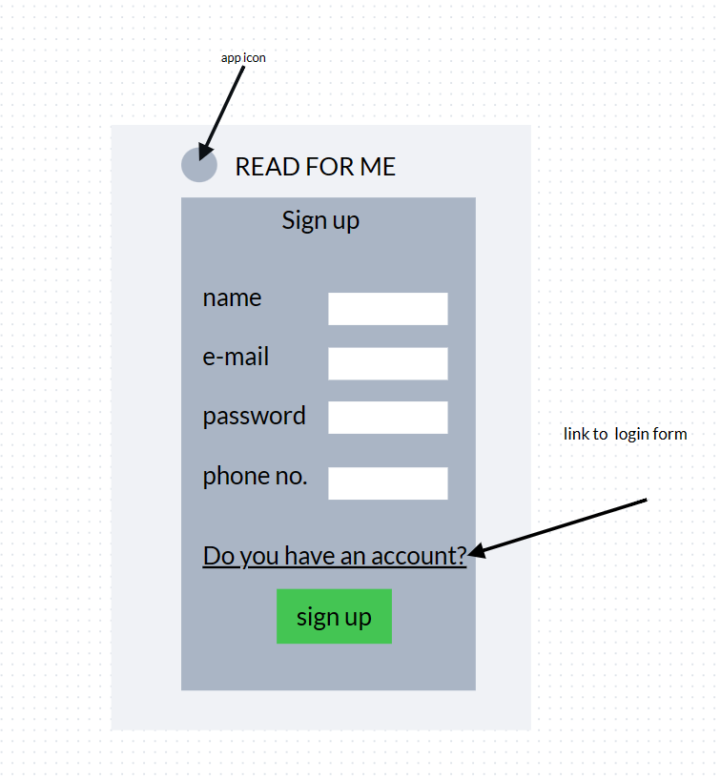**sign up page login page**

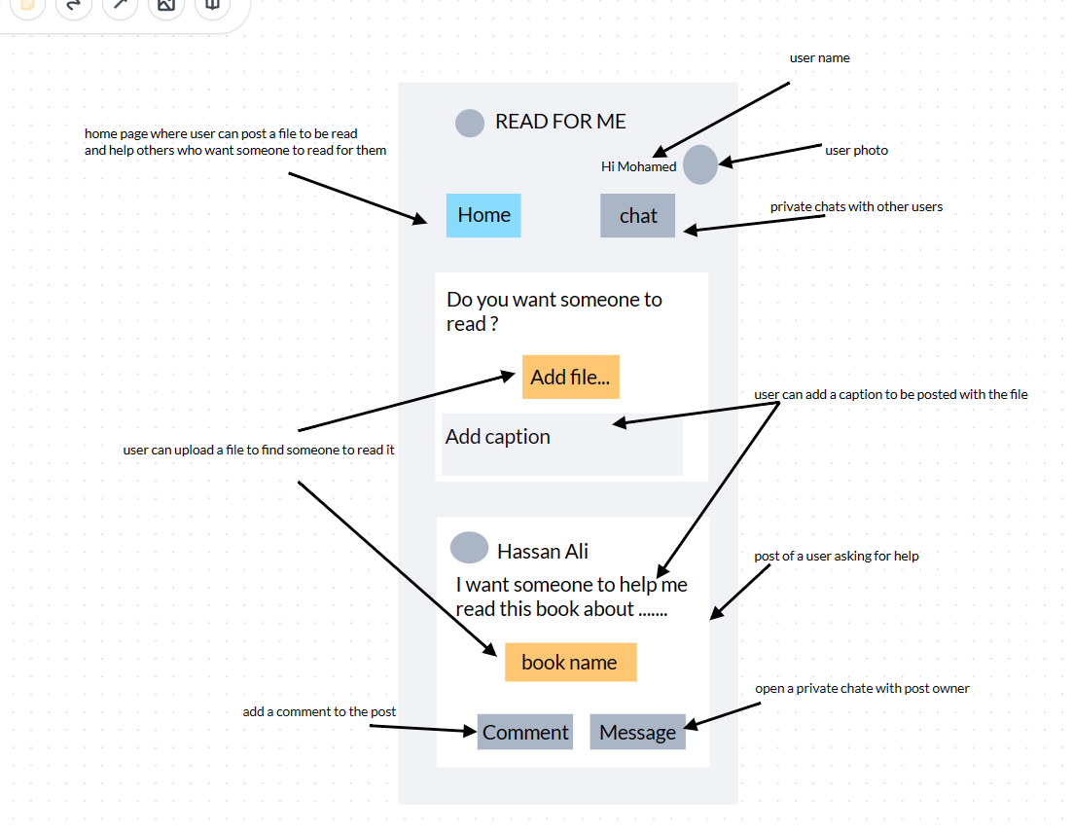**Home page**

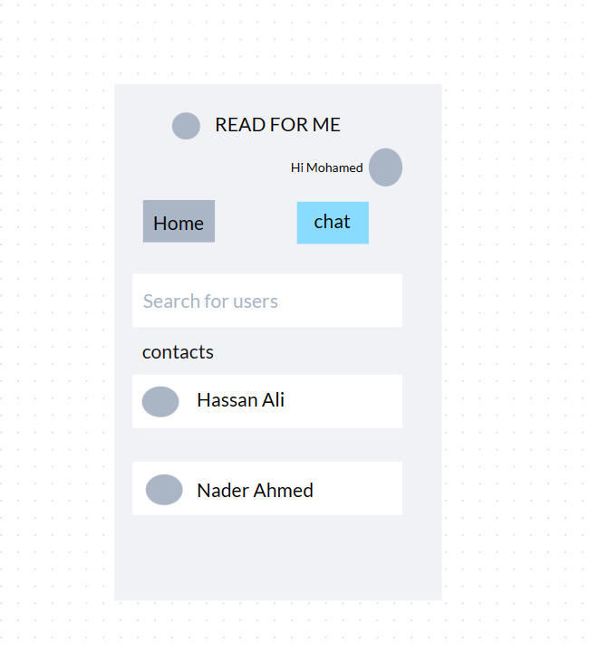**Chat page**

**High fidelity design**

**Video link**

**https://drive.google.com/file/d/15CWvcyKd5NtaCEDA5E6AtA4MT_kavvBJ/view?usp=sharing**