STRICTLY PRIVATE AND CONFIDENTIAL
Green Square
Commercial and office development, El Mostakbal City, Cairo
INVESTMENT MEMORANDUM
Private placement of EGP 125 million (USD 2.6 million at EGP 48 per USD)
Option A: units. Option B: cash.
Issued by Jalour Developments, a subsidiary of Al Jalal Holding, Cairo
October 2026. Draft for discussion with the named investor only.

Important notice
This memorandum has been prepared by Jalour Developments (Jalour) for the sole use of the investor to whom it is addressed. It is confidential. It must not be copied, distributed or disclosed to any other person without Jalour's written consent.
It is not an offer to the public and is not a prospectus. It has not been reviewed or approved by any regulator. Whether this placement requires any regulatory filing, approval or exemption in Egypt or elsewhere is a matter for legal counsel; nothing here is legal, tax or investment advice.
All forecasts, returns, multiples, internal rates of return, cash flows and market statements are projections or reported third-party statements, not statements of fact or guarantees. Actual results may differ materially. Every return figure in this memorandum is labelled with its case (base, downside or upside).
Figures come from the Jalour financial model for the project and are reproduced in the Financial Annex, whose Summary sheet is the reference for every number below. Market data are taken from third-party publications identified in the text and in Appendix D; Jalour has not independently verified them. Property listings are asking prices, not transaction prices.
Items shown in square brackets are provided after the investor signs a non-disclosure agreement. Terms are indicative until set out in definitive agreements, which prevail over this memorandum.
Jalour may raise further capital at project or holding level, subject to the investor's stated rights as to ranking, collateral and information. This memorandum creates no exclusivity in favour of any investor.
The investment has no exposure to other Jalour projects: the project is held in its own company, with no cross-collateral and no cross-default to any other project.

Contents
1. Executive summary 4
2. Transaction overview 5
3. Investment thesis 6
4. Market analysis 7
5. Project description 10
6. The Al Ahly Sabbour agreement and consents 11
7. Sponsor and management 11
8. Business plan and assumptions 13
9. Sales and collections model 14
10. Cost model 15
11. Funding plan and use of funds 16
12. Investment terms 19
13. Returns analysis and sensitivities 21
14. Security and ranking 25
15. Governance and information rights 25
16. Exit and liquidity 26
17. Risk factors 27
18. Tax and legal considerations 28
Appendices 29

1. Executive summary
Jalour is raising EGP 125 million from a single investor to part-fund Green Square, a 13,023 m2 commercial and office development of G+2 buildings on a 14,470 m2 plot in El Mostakbal City, east of New Cairo. The land belongs to Al Ahly Sabbour. Jalour is developer and operator: it designs, obtains permits, builds to core-and-shell standard, markets, sells, collects and operates. Collections are shared 35% to the landowner (subject to a minimum guarantee of EGP 800 million over six years) and 65% to Jalour.
The investor chooses one of two instruments at signing:
- Option A, units. Units with a face value of EGP 250 million, twice the ticket, priced at the launch list (retail EGP 225,000 per m2, offices EGP 135,000 per m2), allocated from the first two sales tranches. At the model's delivery list prices the units are worth EGP 358 million. Projected investor IRR: 26.4% base, 18.6% downside, 29.2% upside.
- Option B, cash. EGP 288 million (2.3x the ticket) in 12 equal quarterly instalments of EGP 23.96 million after a 24-month grace period, from month 30 to month 63. Projected investor IRR 26.5%, contractual if Jalour pays.
Table 1: Headline figures
Key figures (EGP million unless stated) | Value
Investor ticket | 125.0
Modelled peak cumulative cash shortage (month 6) | 102.5
Total uses at the funding peak | 113.0
Total sales at 80% of units (sales plan) | 2,253
Jalour net cash flow, nominal | 375.4
NPV of Jalour net cash flow at 14% | 215.3
Handover (project month) | 48
Option A units, face value | 250
Option B total return | 288

Three points deserve the investor's attention before the detail.
- Pricing. The plan relies on list prices rising from EGP 225,000 to 300,000 per m2 for retail (+33%) and from 135,000 to 200,000 for offices (+48%) across the sales window. Recent evidence of price growth is lower than this at its low end and similar at its high end (section 4). Option B removes unit price exposure; Option A does not.
- Timing of cash. The model collects the delivery payment (20% to 25% of price) on a contractual milestone ahead of handover. If it were collected at handover the peak funding need would be EGP 269 million instead of EGP 102.5 million. Jalour has said it will cover project funding gaps above project cash from its cash reserves and from cash generated by other projects it is constructing (section 11).
- Payout capacity (Option B). Net project cash flow is negative in the construction peak (months 39 to 48, inside the payout window), so quarter-by-quarter coverage of instalments is below 1.5x in 9 of 12 quarters. Pooled cash including the ticket covers every instalment at least 1.4x in the base case (section 13).
The balance of project funding is provided by Jalour sponsor equity, project collections and other capital sources.

2. Transaction overview

2.1 Parties and instrument
Table 2: Principal terms
Item | Description
Sponsor and developer | Jalour Developments, the real estate arm of Al Jalal Holding, Cairo
Landowner | Al Ahly Sabbour
Issuer | The project company for this development [name and jurisdiction to be confirmed]
Investor | [Name of investor]
Instrument | Contractual entitlement to units (Option A) or to cash payments (Option B). Whether it is documented as equity, a loan or a contractual entitlement is to be confirmed by counsel and affects tax, regulation and enforceability
Ticket | EGP 125 million
Choice | Option A or Option B, selected at signing; not both
Balance of funding | The balance of project funding is provided by Jalour sponsor equity, project collections and other capital sources.

2.2 Conditions and timetable
- Due diligence by the investor and its advisers on the data room (Due Diligence Memorandum).
- Written consent of Al Ahly Sabbour to the unit allocation (Option A) and to any assignment or encumbrance that affects its share.
- Definitive agreements, including security documents reviewed by counsel for both sides.
- Funding in cash into the project company, expected for project month 3 (the month the landlord down payment falls due in the model).

2.3 No exclusivity; further capital
Jalour may raise further capital at project or holding level, subject to the investor's stated rights: ranking of the investor's claim, collateral over the earmarked units, and information rights. The project company will not grant security over the investor's earmarked units or rank any new instrument ahead of the investor's entitlement without the consent given in the definitive agreements.

2.4 Separation from other projects
The project is held in its own company. There is no cross-collateral and no cross-default with any other Jalour project, and the investor has no exposure to other Jalour projects. The funds are project funding, not a restricted or segregated account; payment protections are contractual and described in section 14.

3. Investment thesis
The case for the investment, with the main reservation against each point:
Table 3: Thesis and reservations
Thesis | Reservation
A defined, permitted-scale asset: two G+2 buildings of 13,023 m2 in a state-planned city of about 11,000 feddans and about 1 million planned residents. | Mostakbal City is early in its build-out; current resident population and occupancy were not found in public sources.
Land is owned by an established developer, Al Ahly Sabbour, and is not an acquisition cost for Jalour: the landowner is paid from collections. | The landlord's guarantee (EGP 800 million over six years) is payable even if sales are slow.
Sales begin at a launch list of EGP 225,000 (retail) and 135,000 (offices) per m2, with list price steps built into the plan. | Asking prices for Mostakbal City offices today are about EGP 106,000 to 120,000 per m2; the plan assumes higher.
Project funding peaks at EGP 102.5 million in the base case and the project generates EGP 375 million of net cash flow before the value of retained units. | Funding peak is EGP 269 million if delivery payments arrive at handover.
Two ways to participate: units with price upside, or cash with a fixed return. | Option A carries price and resale risk; Option B depends on Jalour's ability to fund payouts during the construction peak.

Jalour retains 20% of the units. They sit outside the sales plan, outside the cash flows shown here, and outside this offering.

4. Market analysis
Market statements below are reported by the third parties named. They are drawn from published summaries as at October 2026; Jalour has not audited them. Where sources use different definitions (for example, Knight Frank and JLL measure Cairo office stock differently) the figures are not additive.

4.1 Cairo and New Cairo offices
- Cairo office stock of about 1.0 million m2 (Knight Frank definition), with a further 818,000 m2 in the pipeline to 2029, equal to +82% of stock (Knight Frank, Cairo office review H2 2025, via Arabian Business (July 2026)).
- New Cairo holds 73% of current and future Cairo office stock; Grade A occupancy is about 90% (Knight Frank via Arabian Business (July 2026)).
- Office vacancy averaged about 9% and was stable in Q1 2026; over 100,000 m2 of Grade A and B space was delivered in the quarter (JLL Q1 2026 Cairo, via Invest-Gate).
- Grade A business-park rent in New Cairo of USD 348/m2/yr (market average USD 325); EGP rents up about 20% y/y after the pound's fall (Knight Frank Q2 2026, via Enterprise (8 July 2026)).
Reading across: occupancy and rents are firm today, but the pipeline is large relative to stock. New Cairo is where most of that supply will land, so absorption of new supply by 2029 is the main market risk for the offices.

4.2 Retail and commercial
- Cairo retail stock above 3.3 million m2 after about 89,000 m2 delivered in Q1 2026, mostly small malls in New Cairo and Giza; about 331,300 m2 more due by end 2026 (JLL Q1 2026 Cairo, via Invest-Gate).
- Comparable commercial schemes are under way: Hassan Allam's HAPTOWN (offices G+1 to G+4, retail, healthcare) in Mostakbal City (Invest-Gate).
- Retail rents rose 0.8% to 3.6% y/y in Q1 2026 depending on format (JLL via Invest-Gate); vacancy fell from 9.2% in Q2 2024 to 7.2% in Q2 2025 (JLL).
The product here, ground-floor retail beneath two office floors in a G+2 form, is close to the mixed-use commercial boulevards now being launched in Mostakbal City. Retail sales in a new city depend on resident and worker footfall that builds over years.

4.3 Mostakbal City
- Mostakbal City covers about 11,000 feddans, with a planned population of about 1 million; master developer is the state-linked Mostakbal for Urban Development (MIDAR) (MIDAR; Nawy).
- Connected by the Regional (Middle) Ring Road and the East Cairo monorail corridor to Shorouk, Obour, Badr and the New Administrative Capital (Presidency of Egypt; Bayut guide).
- Al Ahly Sabbour is active in the city (residential schemes and a mixed-use plot), which supports the landowner's interest in the success of this development (Invest-Gate).

4.4 Pricing evidence and the plan
Table 4: Plan prices against market asking prices
Measure (EGP per m2) | Evidence (asking prices) | Plan: launch | Plan: delivery list | Plan: average
Offices | 106,000 to 120,000 (Mostakbal City listings) | 135,000 | 200,000 | 163,125
Retail | 139,000 to 325,000 (New Cairo listings, individual) | 225,000 | 300,000 | 268,125

Table 5: Launch, average realised and delivery list prices against today's asking prices
EGP per m2 | Launch list | Average realised | Delivery list | Delivery vs launch | Average vs launch | Today's asking | Delivery list vs today's asking | Growth a year to handover
Offices | 135,000 | 163,125 | 200,000 | +48% | +21% | 106,000 to 120,000 | +77% (mid-point 113,000) | 14.7%
Retail | 225,000 | 268,125 | 300,000 | +33% | +19% | 139,000 to 325,000 (listings) | Within the listed range | n/a

The delivery list is the last list price in the plan and is unchanged to handover (month 48). Measured from launch it is +33% for retail and +48% for offices (43% weighted by the launch tranches), against the 40% to 60% range Jalour expects. Measured from today's office asking prices, the delivery list is +77%, or about 15% a year over 4.2 years if the model timeline starts in December 2026.
The plan's launch price for offices (135,000) is above current Mostakbal City asking prices, and it then rises by 48%. New Cairo secondary-market prices rose 3.1% y/y in Q1 2026 (JLL via Enterprise); broker estimates for 2026 price growth are 10% to 16% a year (a blog estimate, not an index). A 40% to 60% rise over three to four years needs about 12% to 13% a year, which is at the upper end of that range and depends on continued inflation (14.5% in August 2026). Sales prices may therefore be lower or slower than planned; section 13 shows the effect.

4.5 Demand drivers and macro
- CBE overnight deposit rate 19.00%, unchanged at the September 2026 meeting; urban headline inflation 14.5% in August 2026 (CBE via Bnok24; CAPMAS via Ahram Online).
- Top 10 developers' sales reached EGP 670 bn in H1 2026 against EGP 651 bn in H1 2025 (+2.9%), with units sold down 5% y/y (Daily News Egypt (2026)).
- Typical off-plan payment plans run 8 to 12 years with 1.5% to 10% down payments (Bayut and Property Finder listings (2026)).
- Real estate is widely used in Egypt as an inflation hedge, but affordability is stretched and the share of investor buyers fell in 2025 (Enterprise).

4.6 Regulation of off-plan sales
Prime Minister Decree 2184 of 2022 requires developers on state-allocated land to hold a separate project bank account and to follow approved timelines before announcing sales (Invest-Gate; Mondaq). Jalour's position is that this requirement does not apply to these plots; the basis is provided in the data room after the investor signs a non-disclosure agreement. Counsel should confirm which other rules apply to a private placement of this kind. Resale of contracts is common but developer approval and fees are contractual; no specific rule on developer consent to resale was found.
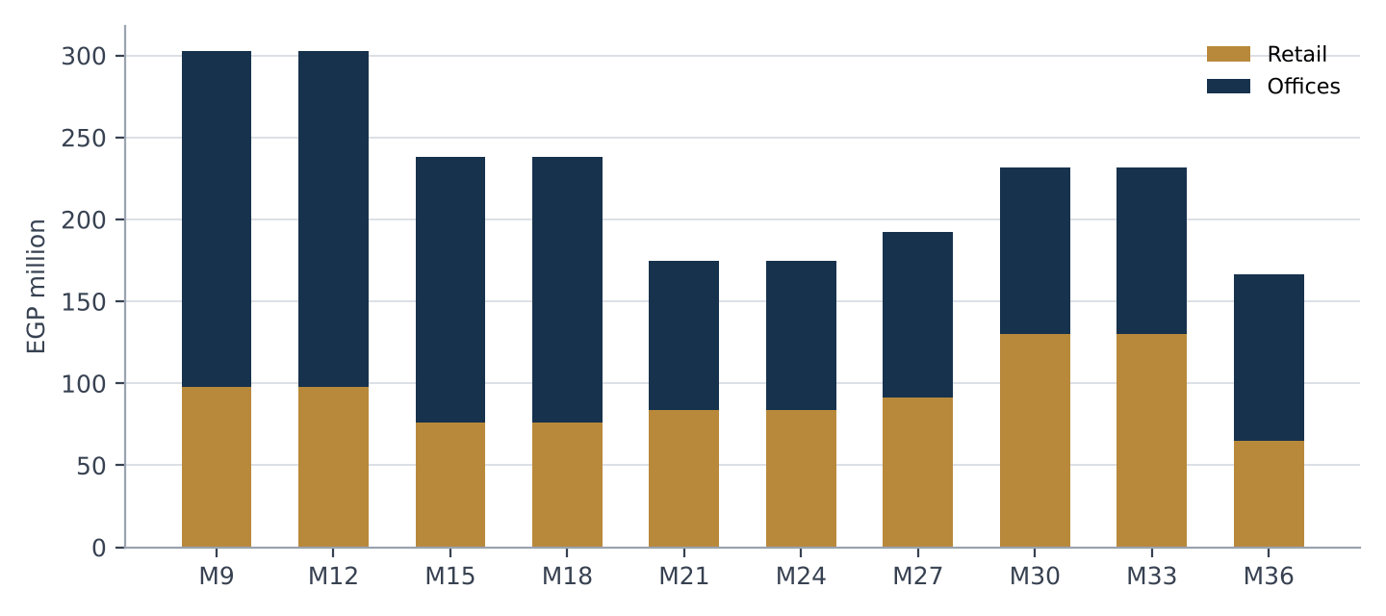
Figure 1: Sales value by quarter of sale. Source: Jalour financial model; Financial Annex, Source_Data sheet

5. Project description
Table 6: Project facts (source: Jalour financial model)
Item | Detail
Land area | 14,470 m2
Footprint (30% of land) | 4,341 m2
Height | G+2
Retail built-up area | 4,341 m2
Office built-up area | 8,682 m2
Total built-up area | 13,023 m2
Finishing standard | Core and shell
Sales start | Project month 7
Construction | Months 13 to 48 (36 months)
Handover | Project month 48
Retained by Jalour | 20% of units (not offered, not in the cash flows)

The development comprises retail on the ground floor and offices above, in G+2 buildings over a 30% footprint. Retail accounts for 33% of built-up area and offices for 67%. Jalour is responsible for design, permits and licences, construction to core and shell, project branding, marketing, sales and collection, and for operation, management and maintenance directly or through a facility management company.
The model sells offices on a sellable area of 10,129 m2, which is larger than the 8,682 m2 of office built-up area. The area schedule that reconciles the two is provided after the investor signs a non-disclosure agreement; the investor should require it in due diligence.
Phasing: sales launch in project month 7, construction starts in month 13 and runs 36 months to handover in month 48. Permits, licences and title status are listed in the Due Diligence Memorandum [available after the investor signs a non-disclosure agreement].

6. The Al Ahly Sabbour agreement and consents
The following terms are taken from the Jalour financial model and are to be verified against the signed agreement in the data room.
Table 7: Agreement terms
Term | Detail
Landlord share of collections | 35%
Developer (Jalour) share | 65%
Minimum guaranteed amount | EGP 800 million over six years
Down payment | EGP 80 million (10% of the guarantee), paid up front
Payment rule | 35% of collections or the guaranteed instalment, whichever is higher
Settlement of any excess over the guarantee | From year 8
Jalour scope | Design, permits, construction (core and shell), marketing, sales, collection, project name, operation and maintenance
Delivery | Month 48

Table 8: Minimum guarantee schedule
EGP million | Down payment | Year 1 | Year 2 | Year 3 | Year 4 | Year 5 | Year 6 | Total
Guaranteed payment | 80 | 45 | 90 | 135 | 180 | 180 | 90 | 800

In the plan the landlord receives EGP 986 million in total, equal to 35% of the value of all units at modelled prices, including the 20% retained by Jalour. EGP 186 million of that is the excess over the guarantee, settled from year 8. Jalour pays the landlord share on the retained units in cash and keeps those units.

6.1 Consents
Al Ahly Sabbour's written consent is required for:
- allocation of units to the investor (Option A) and the investor's right to assign the contract;
- any assignment of collections or encumbrance on units that affects the landlord's 35% share;
- earmarking of unsold units as collateral (Option B);
- any variation of the unit mix, prices or payment plans that changes the landlord's entitlement.
Under the structure proposed here Jalour bears the landlord's 35% on the units allocated to the investor: landlord payments are unchanged and the landlord does not waive any share. Consent status: [provided after the investor signs a non-disclosure agreement]. Receipt of consent is a condition precedent to signing.

7. Sponsor and management
Jalour Developments is the real estate arm of Al Jalal Holding, Cairo. In this project it acts as developer and operator and carries all design, permit, construction, marketing, sales, collection and operating costs.
Table 9: Sponsor information pending
Information | Status
Completed projects, area delivered, units handed over | [Provided after the investor signs a non-disclosure agreement]
Management team biographies | [Provided after the investor signs a non-disclosure agreement]
Audited financial statements, Jalour and Al Jalal Holding | [Provided after the investor signs a non-disclosure agreement]
References from landlords, contractors and buyers | [Provided after the investor signs a non-disclosure agreement]
Contractor and consultant appointments for this project | [Provided after the investor signs a non-disclosure agreement]

Jalour has stated that it will cover project funding gaps, including those caused by timing differences in collections, from its cash reserves and from cash generated by other projects it is constructing. The form, amount and conditions of that undertaking are to be documented. It is a commitment to fund the project, not a guarantee of the investor's return. Jalour's capacity therefore rests on its own cash reserves and on distributions from those other projects, which are subject to those projects' own agreements and progress and are not held for this project. Jalour's audited accounts and track record are provided after the investor signs a non-disclosure agreement.

8. Business plan and assumptions
Table 10: Key assumptions
Assumption | Value | Basis
Discount rate | 14% a year | Jalour model (labelled cost of capital)
Sales plan | 80% of units sold; 20% retained | Jalour model
Sales window | Months 7 to 36 | Jalour model
Launch list prices | Retail 225,000; offices 135,000 EGP per m2 | Jalour model, first sales column
Delivery list prices | Retail 300,000; offices 200,000 EGP per m2 | Jalour model
Payment plans | Down payment 5% to 20%; equal second payment after 3 months; instalments 2 to 8 years; delivery payment 20% to 25% | Jalour model
Construction cost | EGP 697.2 million, flat in nominal terms | Jalour model
Sales commission | 4% of sales value, paid 12 months after the sale quarter | Jalour model
SG&A and others | 15% of construction cost (5% contingency, 5% professional fees, 5% overhead) | Jalour model
Landlord | 35% share; guarantee schedule; excess from year 8 | Agreement terms (section 6)
Timeline | Month 1 is the start of the model; investor funds in month 3 | Assumption

The model is quarterly, in EGP million. Net cash flow equals collections less landlord payments, construction, commission and SG&A. It excludes the retained units, any financing costs and taxes, and any cost escalation.

9. Sales and collections model
Table 11: Sales plan by tranche (80% of units)
Quarter of sale | Retail (EGP m) | Offices (EGP m) | Retail price (EGP k/m2) | Office price (EGP k/m2)
Month 9 | 97.7 | 205.1 | 225 | 135
Month 12 | 97.7 | 205.1 | 225 | 135
Month 15 | 76.0 | 162.1 | 250 | 160
Month 18 | 76.0 | 162.1 | 250 | 160
Month 21 | 83.6 | 91.2 | 275 | 180
Month 24 | 83.6 | 91.2 | 275 | 180
Month 27 | 91.2 | 101.3 | 300 | 200
Month 30 | 130.2 | 101.3 | 300 | 200
Month 33 | 130.2 | 101.3 | 300 | 200
Month 36 | 65.1 | 101.3 | 300 | 200
Total | 931.1 | 1,321.8

Total sales at 100% of units are EGP 2,816 million at modelled prices; the plan sells 80%, EGP 2,253 million. The first two tranches (months 9 and 12) carry the launch list and total EGP 606 million; Option A units come from these.
Table 12: Annual cash flow, EGP million (years 1 to 11; year 1 = months 1 to 12)
Project year | Collections | Landlord payments | Construction, commission, SG&A | Net cash flow | Cumulative
Year 1 | 45.4 | -125.0 | -0.0 | -79.6 | -79.6
Year 2 | 235.1 | -90.0 | -153.9 | -8.8 | -88.4
Year 3 | 937.7 | -135.0 | -105.9 | 696.8 | 608.4
Year 4 | 308.0 | -180.0 | -632.0 | -504.1 | 104.3
Year 5 | 224.0 | -180.0 | -0.0 | 44.0 | 148.4
Year 6 | 175.7 | -90.0 | -0.0 | 85.7 | 234.1
Year 7 | 123.9 | -0.0 | -0.0 | 123.9 | 357.9
Year 8 | 100.4 | -140.7 | -0.0 | -40.3 | 317.6
Year 9 | 89.6 | -39.2 | -0.0 | 50.4 | 368.0
Year 10 | 13.2 | -5.8 | -0.0 | 7.4 | 375.4
Year 11 | 0.0 | -0.0 | -0.0 | 0.0 | 375.4
Total | 2,253.0 | -985.7 | -891.9 | 375.4

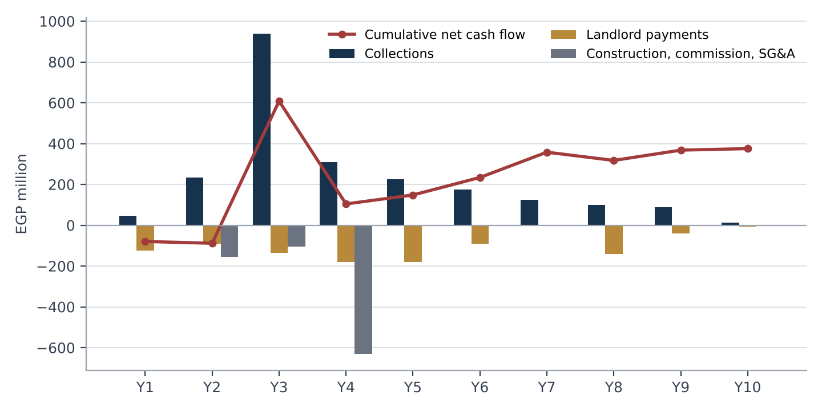
Figure 2: Project cash flow by year. Source: Jalour financial model; Financial Annex, Project_CF sheet
The model collects the delivery payment on a contractual milestone ahead of handover, which produces a large collection in project month 30. This timing is a key sensitivity (sections 11 and 13). Evidence of the contractual milestone is to be provided in the data room.

10. Cost model
Table 13: Cost model
Cost line | EGP million | Basis
Construction (core and shell) | 697.2 | About EGP 53.5 thousand per m2 of built-up area; stage schedule over 36 months
Sales commission | 90.1 | 4% of sales value, paid 12 months after each sale quarter
SG&A and others | 104.6 | 15% of construction: contingency 5%, professional fees 5%, overhead 5%
Total | 891.9

- Cost basis (contractor pricing, bill of quantities) is to be provided in the data room; the model uses a flat nominal cost with no inflation over the build period.
- A 10% overrun lowers project NPV from EGP 215 million to EGP 162 million; a 20% overrun to EGP 109 million.
- Pre-construction costs (design, permits) are not separately modelled; section 11 adds an allowance of EGP 10.5 million as an assumption.

11. Funding plan and use of funds
Table 14: Uses
Uses at the funding peak | EGP million
Down payment to the landowner | 80.0
Guarantee instalments and working capital to the peak, net of collections | 22.5
Design, permits and pre-construction (assumption) | 10.5
Total uses | 113.0

Table 15: Sources
Sources | EGP million | % of uses
Investor ticket (applied to uses) | 113.0 | 100%
Balance of project funding | 0.0 | 0%
Ticket above modelled uses (general project liquidity) | 12.0
Total | 125.0

The balance of project funding is provided by Jalour sponsor equity, project collections and other capital sources.
The ticket equals 122% of the modelled peak cumulative shortage of EGP 102.5 million (month 6).
Ticket above the modelled peak. The ticket exceeds the modelled peak shortage by EGP 22.5 million (12.0 million above total modelled uses). The excess is general project liquidity, not held in a restricted account. It is available for the timing risk on delivery payments (peak shortage EGP 269 million if they arrive at handover) and for pre-construction cost overruns. Returns are contractual on the full ticket, so Jalour's cost of capital is measured on the full amount.

11.1 Funding gaps in stress cases
Table 16: Project cash position by case, before any investor instrument
Case | Peak cumulative shortage (EGP m) | NPV (EGP m)
Base case | 102 | 215
Downside: sales +12 months, prices -10% | 441 | -34
Upside: prices +10% | 102 | 315
Construction cost +10% | 102 | 162
Collections slip 2 quarters | 236 | 125
Delivery payments at handover | 269 | 155
Handover payments and downside combined | 729 | -81

Jalour will fund the gap between project cash and the cases above from its cash reserves and from cash generated by other projects it is constructing; it does not expect the investor to fund it. The investor should note that in the downside and combined cases the funding need is several times the ticket and depends on Jalour's capacity to provide it.

11.2 Sponsor-level view: both projects together
Jalour has said it will cover project funding gaps from its cash reserves and from cash generated by other projects it is constructing. To show what that means in numbers, this section sets Green Square beside L'avenir, Jalour's other project in this model, before any investor instrument. The figures are projections from the same Jalour model. They cover these two projects only; Jalour's cash reserves and its other projects are not included.
Table 17: The two projects side by side (base case)
EGP million | Green Square | L'avenir
Handover (project month) | 48 | 54
Landlord minimum guarantee | 800 | 850
Sales plan, 80% of units | 2,253 | 2,674
Collections | 2,253.0 | 2,673.7
Landlord payments | 985.7 | 1,169.8
Construction, commission and SG&A | 891.9 | 908.7
Net cash flow, nominal | 375.4 | 595.3
NPV at 14% | 215.3 | 307.5
Peak cumulative shortage (month) | 102.5 (6) | 102.0 (30)

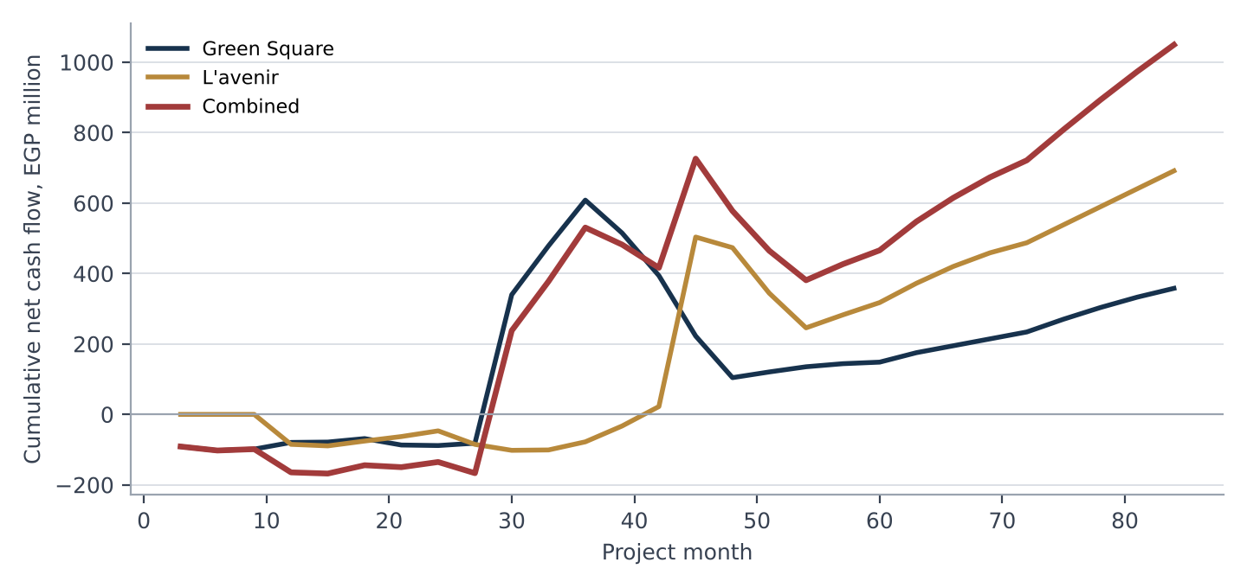
Figure 3: Cumulative net cash flow of the two projects and combined. Source: Jalour financial model; Financial Annex, Combined_Position sheet
Table 18: Peak shortage by case, each project and combined
Peak cumulative shortage (EGP million) | Green Square | L'avenir | Combined | Month of combined peak
Base case | 102 | 102 | 168 | 15
Downside: sales +12 months, prices -10% | 441 | 849 | 1,089 | 54
Upside: prices +10% | 102 | 88 | 160 | 12
Construction cost +10% | 102 | 117 | 193 | 27
Collections slip 2 quarters | 236 | 381 | 478 | 30
Delivery payments at handover | 269 | 244 | 318 | 45
Handover payments and downside combined | 729 | 849 | 1,531 | 54

In the base case the combined position is lowest at EGP 168.0 million in month 15 and is positive from month 30. At the month 39 peak of Green Square's own downside, L'avenir's base-case cumulative position is EGP -33 million.
The stress cases matter more than the base case. When sales slip or delivery payments arrive late, both projects are short at the same time, and the combined need is the sum of the two, not the offset of one against the other. Jalour's ability to cover gaps therefore rests mainly on its cash reserves and on its other projects' cash outside these two, which are not shown here. Showing the two projects together does not create any cross-collateral or cross-default; the investor's claim is on this project's company only.

12. Investment terms

12.1 Option A: units
Table 19: Option A terms
Term | Detail
Face value | EGP 250 million: 2.0x the ticket, priced at the launch list
Source of units | Unsold units in the first two sales tranches (months 9 and 12), EGP 606 million at list; the investor receives 41.3% of them. The 20% of units retained by Jalour are not used
Unit mix | Pro rata to those tranches: retail EGP 80.6 million (358 m2) and offices EGP 169.4 million (1,254 m2)
Value at delivery list | EGP 358 million (1.434x face), before resale costs
Day-one holding | A registered unit allocation and reservation contract, assignable with the consents below
Landlord share | Jalour bears the landlord 35% on the allocated units (EGP 88 million at face); landlord payments are unchanged
Resale (assumption) | Handover in month 48; resale over four quarters from month 51; 3% cost (broker and developer transfer fee)
Consents | Jalour consent and landlord acknowledgement for assignment of a contract before handover [fee to be agreed]

The investor holds no physical unit until handover. Before handover the investor can sell only the contract, with consent, and a buyer is likely to require a discount. Section 16 shows the effect of early assignment. Jalour cannot promise liquidity that the structure does not provide.

12.2 Option B: cash
Table 20: Option B terms
Term | Detail
Total return | EGP 288 million (2.3x the ticket), including return of capital
Grace period | 24 months from funding, no payments
Payments | 12 equal quarterly instalments of EGP 23.96 million in months 30 to 63
Obligor | The project company; no guarantee of return by Jalour or Al Jalal Holding
Default | Instalment unpaid for 30 days: payment priority covenant applies; step-in right over earmarked units [terms to be agreed]
Funding gaps | Jalour will fund project funding gaps; this supports delivery of the project and is not a guarantee of the return

Table 21: Option B payment schedule
Instalment | Project month | Amount (EGP m) | Cumulative (EGP m)
1 | 30 | 23.96 | 23.96
2 | 33 | 23.96 | 47.92
3 | 36 | 23.96 | 71.88
4 | 39 | 23.96 | 95.83
5 | 42 | 23.96 | 119.79
6 | 45 | 23.96 | 143.75
7 | 48 | 23.96 | 167.71
8 | 51 | 23.96 | 191.67
9 | 54 | 23.96 | 215.62
10 | 57 | 23.96 | 239.58
11 | 60 | 23.96 | 263.54
12 | 63 | 23.96 | 287.50

Alternatives considered and not recommended are in section 13.4: a percentage of collections with floor and cap, and a hybrid of a fixed minimum plus a share of collections.

13. Returns analysis and sensitivities
All returns are projections, labelled by case. IRRs are annual, compounded from quarterly flows; the investor funds in month 3.

13.1 Option A
Table 22: Option A investor returns
Case | Assumption | Investor IRR | Investor MOIC
Base | Resale at delivery list price; 3% cost | 26.4% | 2.78x
Downside | Resale 12 months later and 10% lower | 18.6% | 2.50x
Upside | Resale 10% higher | 29.2% | 3.06x
Appreciation 40% | Launch to resale +40% | 25.7% | 2.72x
Appreciation 60% | Launch to resale +60% | 29.6% | 3.10x
No appreciation | Resale at launch list | 16.4% | 1.94x

Break-even: the units can fall to 36% of the delivery list price before the investor loses money on the ticket. The base case relies on list prices rising by 33% (retail) and 48% (offices); with no appreciation the units return 1.94x.
Table 23: Sensitivity to the face multiple
Face multiple | Investor IRR | Investor MOIC | Jalour cost of capital
1.50x | 18.3% | 2.09x | 10.4%
1.75x | 22.6% | 2.43x | 15.7%
2.00x | 26.4% | 2.78x | 20.7%
2.25x | 29.9% | 3.13x | 25.7%
2.50x | 33.0% | 3.48x | 30.6%

Cost to Jalour. Giving the investor units from the first two sales tranches removes 41% of those tranches' collections. Jalour receives the ticket at funding and forgoes those collections (the units' face value of EGP 250 million at list) as they would have been received, partly offset by commission saved. The landlord share is unchanged. On this basis Jalour's cost of capital is 20.7%; the NPV effect at 14% is EGP -23.9 million and the project NPV after the deal is EGP 191 million (before: 215). Peak cumulative shortage before the ticket rises to EGP 125.3 million. If the same area were taken pro rata from all tranches (at higher average prices) the cost would be 30.7%.
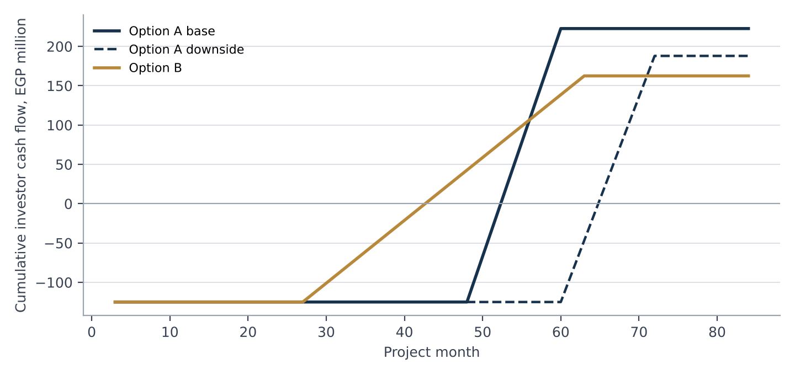
Figure 4: Cumulative investor cash flow by option. Source: Financial Annex, Option_A and Option_B sheets; projections

13.2 Option B
Table 24: Option B (fixed instalments)
Measure | Base | Downside | Upside | Handover payments
Investor IRR if paid | 26.5% | 26.5% | 26.5% | 26.5%
Investor MOIC | 2.30x | 2.30x | 2.30x | 2.30x
Jalour cost of capital | 26.5% | 26.5% | 26.5% | 26.5%
Lowest pooled cash after ticket and payouts (EGP m) | 10 | -412 | 22 | -288

In the base case the lowest pooled cash of EGP 9.8 million arises in month 60, before any instalment is due; it is the amount by which the modelled peak shortage exceeds the ticket and is funded by Jalour. Instalments are fixed, so the investor's IRR is the same in every case if Jalour pays. What changes is the cash available to pay: in the downside and handover cases pooled cash falls below zero and Jalour must fund the difference. Negative figures above are the amount Jalour would have to provide from sponsor equity or other capital sources.

13.3 Payout coverage
Table 25: Payout coverage, base case
Month | Net cash flow before payout (EGP m) | Instalment (EGP m) | Coverage: net cash flow / instalment | Coverage: cash available / instalment
30 | 421.6 | 23.96 | 17.6x | 19.4x
33 | 138.8 | 23.96 | 5.8x | 24.2x
36 | 129.7 | 23.96 | 5.4x | 28.6x
39 | -93.4 | 23.96 | -3.9x | 23.7x
42 | -121.0 | 23.96 | -5.0x | 17.7x
45 | -171.6 | 23.96 | -7.2x | 9.5x
48 | -118.2 | 23.96 | -4.9x | 3.6x
51 | 16.2 | 23.96 | 0.7x | 3.2x
54 | 14.7 | 23.96 | 0.6x | 2.9x
57 | 8.7 | 23.96 | 0.4x | 2.2x
60 | 4.4 | 23.96 | 0.2x | 1.4x
63 | 26.9 | 23.96 | 1.1x | 1.5x

Coverage on net cash flow alone is below the 1.5x threshold in 9 of 12 quarters, because instalments fall in the construction peak and in the quarters after handover when collections are thin. "Cash available" adds pooled project cash, including the ticket and earlier collections, and is at least 1.4x in every quarter. Because nothing is ring-fenced, pooled cash is available to the project company but is also exposed to construction spending and to Jalour's own funding capacity. The investor should read the net-cash-flow measure as the stricter test.

13.4 Alternatives considered
Table 26: Option B structures compared
Structure | Investor IRR (base) | Quarters < 1.5x (net cash flow) | Lowest pooled cash, downside (EGP m) | Last payment (month)
S1 Fixed multiple, equal instalments (recommended) | 26.5% | 9 of 12 | -412 | 63
S2 30.9% of collections, floor 0.4x, cap 1.5x of instalment | 29.0% | 8 of 12 | -391 | 66
S3 Fixed 1.8x plus 4.3% of collections, cap 2.8x | 27.8% | 9 of 12 | -402 | 63

S2 and S3 front-load payments into the large delivery-payment quarter and so show a higher IRR, but they pay by taking a share of collections that are themselves needed for construction, and they do not improve coverage in the construction peak. S1 is recommended for simplicity and certainty of the schedule. None of the three meets a 1.5x net-cash-flow test in every quarter; this is disclosed rather than cured by reducing the return, and it is the reason for Jalour's funding undertaking and the payment priority covenant.

13.5 Project sensitivities
Table 27: Project sensitivities (Jalour net cash flow before any investor instrument)
Case | Net cash flow (EGP m) | NPV at 14% (EGP m) | Peak shortage (EGP m)
Base | 375 | 215 | 102
Prices -19% | 129 | 13 | 184
Prices -9% | 258 | 116 | 114
Prices +10% | 493 | 315 | 102
Prices +19% | 611 | 414 | 102
Sales delayed 6 months | 375 | 129 | 217
Sales delayed 12 months | 375 | 49 | 408
Sales delayed 18 months | 375 | -26 | 825
Sales delayed 24 months | 375 | -97 | 1,075
Construction cost +10% | 295 | 162 | 102
Construction cost +19% | 215 | 109 | 114
Collections slip 1 quarter | 375 | 170 | 162
Collections slip 2 quarters | 375 | 125 | 236
Collections slip 4 quarters | 375 | 41 | 440

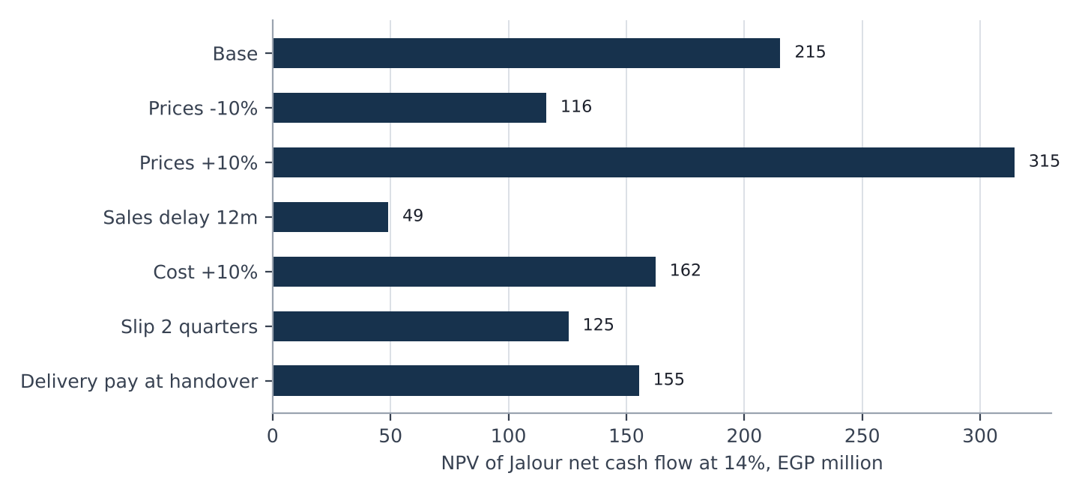
Figure 5: Project NPV by case. Source: Financial Annex, Scenarios and Sensitivity sheets

14. Security and ranking
This is a proposal for review by Jalour's lawyers and the investor's counsel. Nothing in the structure is ring-fenced: there is no restricted account, escrow or segregated collection account, and security is contractual or over specific units.

14.1 Base package
Table 28: Security and protections
Protection | Option A | Option B
Specific units | Registered allocation of identified units from the first two sales tranches; the units are the investor's asset | Earmark of unsold units with a list value of at least the ticket (substitution of equal value allowed); Jalour retained units not used
Payment priority covenant | Not applicable | No shareholder distributions or repayment of shareholder loans while an instalment is overdue
Negative pledge | On the allocated units | On the earmarked units
Information rights | Monthly report, annual audited accounts, audit right | Same
Sponsor funding undertaking | Funds project funding gaps; supports delivery | Same; not a guarantee of the return
Landlord acknowledgement | Of the allocation and assignment rights | Of the earmark

14.2 Optional protections (for counsel)
- Promissory note or post-dated cheques for each Option B instalment, common in Egyptian practice.
- Independent engineer reporting on construction progress and cost to complete.
- Step-in right to market the earmarked units after a payment default.
- Parent guarantee: not offered. Jalour has chosen not to guarantee the return; the investor should price this.

14.3 Ranking
Proposed ranking, for counsel: the investor's entitlement ranks as an obligation of the project company. It ranks behind amounts owed to the landowner under its agreement (which are paid from collections and take the first 35%) and behind construction and operating creditors in the ordinary course, and ahead of distributions to shareholders only to the extent of the payment priority covenant. Further project-level financing, if any, requires the investor's consent where it would rank ahead of the investor or encumber the earmarked units.

15. Governance and information rights
- Monthly report within 15 days of month-end: units sold and value, collections against plan, costs against budget, construction progress against programme, cash position, any payment overdue to the landlord.
- Quarterly review with the investor, including cost to complete and the sales pipeline.
- Annual audited accounts of the project company within 120 days of year-end.
- Audit and inspection rights on reasonable notice over books, the sales register and the site.
- Consent matters: changes to the unit allocation or earmarked units, new project-level debt or security that would rank ahead, related-party transactions above an agreed threshold, and amendment of the landlord agreement that changes payments.
- Notice events: landlord dispute or default, loss or change of a permit, delay of more than three months to the construction programme, any payment overdue to the investor.
Reporting thresholds and timings are indicative. Because there is no restricted account, the investor's monitoring rests on reporting and audit rather than on control of cash.

16. Exit and liquidity

16.1 Option A
- Handover is in project month 48; units can be registered and sold from handover. The base case assumes sale over four quarters from month 51.
- Before handover the investor may assign the contract with Jalour's consent and the landlord's acknowledgement [transfer fee to be agreed]. The buyer takes handover risk and will price it.
- Jalour continues to sell its own inventory; the investor's resale competes with it. The agreements may include an orderly-sales covenant (for example, no more than an agreed share of the allocated area marketed in any quarter).
Table 29: Early assignment of the contract at month 27 (units valued at face, 3% cost)
Assignment at month 27 | Investor IRR | Investor MOIC
Discount to face 0% | 39.3% | 1.94x
Discount to face 10% | 32.1% | 1.75x
Discount to face 20% | 24.6% | 1.55x
Discount to face 30% | 16.5% | 1.36x

16.2 Option B
Cash is returned through the instalments in section 12.2. There is no market for the entitlement. Transfer of the entitlement to a third party requires Jalour's consent. Payback (cumulative cash returned equals the ticket) occurs in month 45; for Option A, payback in the base case is month 54.

17. Risk factors
The following is not exhaustive. Each risk is stated with the main mitigant.

Market and price risk
Unit prices may rise less than the plan, or fall. The plan needs list prices to rise by 33% (retail) and 48% (offices). Option A returns depend on resale value; with no appreciation they fall to 1.94x. Mitigant: downside case shown; Option B has no unit price exposure.

Sales pace and absorption
The pipeline of Cairo offices equals 82% of current stock by 2029 (Knight Frank). If sales are delayed 12 months the project NPV falls to EGP 49 million and the peak funding need rises to EGP 408 million. Mitigant: Jalour funding undertaking; phased sales.

Inflation and cost risk
Construction cost is flat in the model. A 10% overrun lowers NPV by EGP 53 million. Mitigant: 5% contingency; contractor pricing in the data room; fixed-price contracting to be sought.

Currency risk
Returns are in EGP. USD value falls if the pound weakens; foreign investors should assess FX and repatriation (section 18). The USD equivalents shown use EGP 48 per USD; the market rate in September 2026 was about EGP 50 to 51.

Delivery and construction risk
The development must be built in 36 months from month 13. Delay delays resale of units and the collection of delivery payments. Mitigant: independent engineer (optional); reporting; Jalour funding undertaking.

Delivery-payment timing
The plan collects delivery payments ahead of handover under the sale contracts. If buyers do not pay until handover, the peak funding need is EGP 269 million. Mitigant: contractual milestone; Jalour funding.

Landlord risk
The landlord's guarantee is payable regardless of sales and its consent is required for allocations and encumbrances. A dispute could delay or prevent the allocation. Mitigant: consent as a condition precedent; guarantee schedule funded in the plan.

Legal and regulatory risk
Rules on off-plan sales (Jalour's position is that the state-land rules in Decree 2184 of 2022 do not apply to these plots), on assignment of contracts, on private placements and on foreign ownership may affect structure, timing or cost. Mitigant: counsel review before signing.

Counterparty and credit risk (Option B)
Instalments are an obligation of the project company without a parent guarantee. In the downside case pooled cash is negative and payment depends on Jalour's support. Mitigant: payment priority covenant; earmarked units; funding undertaking; optional promissory notes.

Concentration
The investment is exposed to a single project, in a single city, in two property types. There is no cross-collateral or cross-default with other projects.

Model and information risk
Figures derive from a Jalour model that has known simplifications: the admin sales area exceeds office built-up area, prices are stepped by assumption, costs are not inflated and pre-construction costs are not separately modelled. Mitigant: reconciliation and data room evidence.

Liquidity risk
There is no market for the Option B entitlement and Option A units cannot be sold in practice before handover without a discount.

18. Tax and legal considerations
The following are issues for counsel and tax advisers. Jalour gives no legal or tax conclusion.
- Nature of the instrument (equity, loan or contractual entitlement) and its tax, regulatory and enforceability consequences in Egypt.
- Regulatory position of a private placement of this kind (Financial Regulatory Authority and any other body), including investor eligibility.
- Tax on the investor's return under each option: withholding tax, corporate or personal income tax, and VAT on supplies.
- Taxes and registration fees on the transfer of units (including real estate disposal tax and stamp duty) and who bears them on resale.
- The basis on which the separate project-account rule for developers on state-allocated land does not apply to these plots (Jalour's position).
- Foreign investor treatment: ownership of units, repatriation of proceeds, foreign-exchange availability and any central bank requirements.
- Enforceability of security over unsold units, the earmark, negative pledge and any promissory notes; stamp duty on security documents.
- Anti-money-laundering and know-your-customer requirements for the investor and for unit buyers.
- Corporate approvals, project company formation and the effect of Jalour or Al Jalal Holding insolvency on the project company.

Appendices

Appendix A: Definitions
Table 30: Definitions
Term | Meaning
Launch list | Price list in force at the first sales tranche: retail EGP 225,000, offices EGP 135,000 per m2
Face value | Units valued at the launch list
Pooled cash | Cumulative project net cash flow plus the ticket less payouts; not a restricted account
Coverage (net cash flow) | Quarterly project net cash flow before payouts divided by the instalment
Coverage (cash available) | Pooled cash at the start of the quarter plus the quarter's net cash flow, divided by the instalment
Peak shortage | Lowest cumulative net cash flow in the model, before the ticket
MOIC | Multiple of invested capital: cash received divided by cash invested

Appendix B: Reconciliation to the Financial Annex
Each headline figure in this memorandum is computed in the Financial Annex (Summary sheet). The Reconciliation sheet of the annex ties the project cash flow to the Jalour model (net cash flow, NPV, peak shortage, collections, landlord payments and costs) and to an independent recomputation; all differences are zero.
Table 31: Key figures and annex locations
Figure | Value | Annex location
Net cash flow, nominal (EGP m) | 375.4 | Summary; Project_CF
NPV at 14% (EGP m) | 215.3 | Summary; Project_CF
Peak shortage (EGP m) | 102.5 | Summary; Project_CF
Total uses (EGP m) | 113.0 | Sources_Uses
Option A investor IRR / MOIC | 26.4% / 2.78x | Option_A
Option A Jalour cost of capital | 20.7% | Option_A
Option B investor IRR / MOIC | 26.5% / 2.30x | Option_B
Option B lowest pooled cash, base (EGP m) | 9.8 | Option_B
Downside peak shortage (EGP m) | 441 | Scenarios

Appendix C: Financial Annex contents
Cover, Summary, Inputs, Source_Data, Project_CF, Sources_Uses, Option_A, Option_B, Scenarios, Sensitivity, Reconciliation. Inputs are in blue; every calculation is a formula.

Appendix D: Market sources
Table 32: Market sources (reported; not independently verified)
Source | Used for
Knight Frank, Cairo office review H2 2025, via Arabian Business (July 2026) | Cairo office stock of about 1.0 million m2 (Knight Frank definition), with a further 818,000 m2 in the pipelin...
Knight Frank via Arabian Business (July 2026) | New Cairo holds 73% of current and future Cairo office stock; Grade A occupancy is about 90%
JLL Q1 2026 Cairo, via Invest-Gate | Office vacancy averaged about 9% and was stable in Q1 2026; over 100,000 m2 of Grade A and B space was deliver...
Knight Frank Q2 2026, via Enterprise (8 July 2026) | Grade A business-park rent in New Cairo of USD 348/m2/yr (market average USD 325); EGP rents up about 20% y/y ...
JLL Q1 2026 Cairo, via Invest-Gate | Cairo retail stock above 3.3 million m2 after about 89,000 m2 delivered in Q1 2026, mostly small malls in New ...
MIDAR; Nawy | Mostakbal City covers about 11,000 feddans, with a planned population of about 1 million; master developer is ...
Presidency of Egypt; Bayut guide | Connected by the Regional (Middle) Ring Road and the East Cairo monorail corridor to Shorouk, Obour, Badr and ...
Invest-Gate | Comparable commercial schemes are under way: Hassan Allam's HAPTOWN (offices G+1 to G+4, retail, healthcare) i...
Property Finder listings, Sumou Boulevard and Zizinia (2026) | Office asking prices in Mostakbal City listings: about EGP 106,000 to 120,000 per m2
Property Finder listings (August 2026) | Retail unit asking prices in New Cairo (Fifth Settlement) listings range from about EGP 139,000 to 325,000 per...
JLL via Enterprise (2026) | New Cairo secondary-market sale prices rose 3.1% y/y in Q1 2026, while asking rents rose 10.0%
Sands of Wealth, drawing on Aqarmap data (2026) | Broker estimates put 2026 price growth at 10 to 15% in New Cairo and 12 to 16% in Mostakbal City (blog estimat...
CBE via Bnok24; CAPMAS via Ahram Online | CBE overnight deposit rate 19.00%, unchanged at the September 2026 meeting; urban headline inflation 14.5% in ...
Daily News Egypt (2026) | Top 10 developers' sales reached EGP 670 bn in H1 2026 against EGP 651 bn in H1 2025 (+2.9%), with units sold ...
Invest-Gate; Mondaq | Prime Minister Decree 2184 of 2022 requires developers on state-allocated land to hold a separate project bank...
Bayut and Property Finder listings (2026) | Typical off-plan payment plans run 8 to 12 years with 1.5% to 10% down payments

