STRICTLY PRIVATE AND CONFIDENTIAL
Green Square and L'avenir
Two commercial and office developments, El Mostakbal City, Cairo
INVESTMENT MEMORANDUM
Private placement of EGP 125 million (USD 2.6 million at EGP 48 per USD): EGP 62.5 million in each project
Option A: units. Option B: cash. One option applies to both projects.
ALL INFORMATION IN THIS DOCUMENT IS CONFIDENTIAL AND SUBJECT TO THE NON-DISCLOSURE AGREEMENT.
Issued by Jalour Developments, a subsidiary of Al Jalal Holding, Cairo
October 2026. Draft for discussion with the named investor only.

Important notice
ALL INFORMATION IN THIS DOCUMENT, IN THE OTHER DOCUMENTS OF THIS PACK AND IN THE DATA ROOM IS CONFIDENTIAL. It is provided only under the non-disclosure agreement between the recipient and Jalour, and must not be disclosed, copied, forwarded or used for any other purpose.

This memorandum has been prepared by Jalour Developments (Jalour) for the sole use of the investor to whom it is addressed. It is confidential. It must not be copied, distributed or disclosed to any other person without Jalour's written consent. The non-disclosure agreement covers every document, figure and statement in this pack, including the financial information of both projects.
It is not an offer to the public and is not a prospectus. It has not been reviewed or approved by any regulator. Whether this placement requires any regulatory filing, approval or exemption in Egypt or elsewhere is a matter for legal counsel; nothing here is legal, tax or investment advice.
All forecasts, returns, multiples, internal rates of return, cash flows and market statements are projections or reported third-party statements, not statements of fact or guarantees. Actual results may differ materially. Every return figure is labelled with its case (base, downside or upside).
Figures come from the Jalour financial model for the two projects and are reproduced in the Financial Annex, whose Combined_Summary sheet is the reference for every number below. Market data are taken from third-party publications identified in the text and in Appendix D; Jalour has not independently verified them. Property listings are asking prices, not transaction prices.
Items shown in square brackets are provided after the investor signs the non-disclosure agreement. Terms are indicative until set out in definitive agreements, which prevail over this memorandum.
Jalour may raise further capital at project or holding level, subject to the investor's stated rights as to ranking, collateral and information. This memorandum creates no exclusivity in favour of any investor.
Each project is held in its own company, with no cross-collateral and no cross-default between the projects. The two projects are presented together because this placement is a single investment of EGP 62.5 million in each.

Contents
1. Executive summary 4
2. Transaction overview 6
3. Investment thesis 7
4. Market analysis 8
5. Project descriptions 11
6. The Al Ahly Sabbour agreements and consents 12
7. Sponsor and management 12
8. Business plan and assumptions 14
9. Sales and collections model 15
10. Cost model 17
11. Funding plan, use of funds and combined cash position 19
12. Investment terms 22
13. Returns analysis and sensitivities 24
14. Security and ranking 29
15. Governance and information rights 29
16. Exit and liquidity 30
17. Risk factors 31
18. Tax and legal considerations 32
Appendices 33

1. Executive summary
Jalour is raising EGP 125 million from a single investor: EGP 62.5 million into Green Square and EGP 62.5 million into L'avenir. The projects are two commercial and office developments in El Mostakbal City, east of New Cairo, of 13,023 m2 and 13,419 m2 of built-up area on plots of 14,470 and 14,910 m2. Both plots belong to Al Ahly Sabbour. Jalour is developer and operator of each: it designs, obtains permits, builds to core-and-shell standard, markets, sells, collects and operates. Collections are shared 35% to the landowner (subject to minimum guarantees of EGP 800 million and EGP 850 million over six years) and 65% to Jalour.
The investor chooses one of two instruments at signing, and the choice applies to both projects:
- Option A, units. In each project, units with a face value of EGP 125 million, twice the ticket, priced at the launch list, allocated from the first two sales tranches: EGP 250 million in total. At the delivery list prices the units are worth EGP 364 million. Projected investor IRR on the combined EGP 125 million: 27.7% base, 19.5% downside, 30.6% upside.
- Option B, cash. EGP 143.75 million (2.3x the ticket) from each project, EGP 287.5 million in total, in 12 equal quarterly instalments per project of EGP 11.98 million after a 24-month grace period (Green Square months 24 to 57; L'avenir months 27 to 60). Projected investor IRR 26.5%, contractual if Jalour pays.
Table 1: Headline figures
Key figures (EGP million unless stated) | Green Square | L'avenir | Combined
Investor ticket | 62.5 | 62.5 | 125.0
Modelled peak cumulative shortage, base case | 102.5 | 102.0 | 168.0
Total uses at the funding peak | 113.0 | 112.5 | 225.4
Total sales in the sales plans | 2,253 | 2,674 | 4,927
Jalour net cash flow, nominal | 375.4 | 595.3 | 970.7
NPV of Jalour net cash flow at 14% | 229.9 | 350.6 | 580.5
Handover (project month) | 42 | 42
Option A units, face value | 125 | 125 | 250
Option B total return | 143.8 | 143.8 | 287.5

Three points deserve the investor's attention before the detail.
- Pricing. The plans rely on list prices rising from launch to delivery by 33% (retail) and 48% (offices) in Green Square and by 44% and 50% in L'avenir. Recent evidence of price growth is lower at its low end and similar at its high end (section 4). Option B removes unit price exposure; Option A does not.
- Timing of cash. The model collects each project's delivery payment (20% to 25% of price) on a contractual milestone ahead of handover. If it were collected at handover the peak funding need would be EGP 269 million (Green Square) and EGP 244 million (L'avenir) instead of EGP 102.5 and 102.0 million. Jalour has said it will cover project funding gaps above project cash from its cash reserves and from cash generated by other projects it is constructing (section 11).
- Both projects together. The combined base-case position is lowest at EGP 168.0 million in month 9 and positive from month 24 (common calendar: month 1 is the Green Square launch; L'avenir launches in month 7), but in the stress cases both projects are short at the same time: the combined peak is EGP 318 million if delivery payments arrive at handover and EGP 1,089 million in the downside. One project's cash cannot be assumed to fund the other.
The balance of project funding is provided by Jalour sponsor equity, project collections and other capital sources. This applies in each project.

2. Transaction overview

2.1 Parties and instrument
Table 2: Principal terms
Item | Description
Sponsor and developer | Jalour Developments, the real estate arm of Al Jalal Holding, Cairo
Landowner | Al Ahly Sabbour (both plots)
Issuers | One project company for each development [names and jurisdiction to be confirmed]
Investor | [Name of investor]
Instrument | Contractual entitlement to units (Option A) or to cash payments (Option B), in each project. Whether it is documented as equity, a loan or a contractual entitlement is to be confirmed by counsel and affects tax, regulation and enforceability
Ticket | EGP 125 million in total: EGP 62.5 million into Green Square and EGP 62.5 million into L'avenir
Choice | Option A or Option B, selected at signing; the same option applies to both projects
Balance of funding | The balance of project funding is provided by Jalour sponsor equity, project collections and other capital sources. This applies in each project.

2.2 Conditions and timetable
- Signature of the non-disclosure agreement (template provided with this pack), which covers all information provided.
- Due diligence by the investor and its advisers on the data room (Due Diligence Memorandum).
- Written consent of Al Ahly Sabbour to the unit allocation (Option A) and to any assignment or encumbrance that affects its share, for each project.
- Definitive agreements for each project, including security documents reviewed by counsel for both sides.
- Funding in cash into each project company, expected in project month 3 for Green Square and month 12 for L'avenir (the months the landlord down payments fall due in the model).

2.3 No exclusivity; further capital
Jalour may raise further capital at project or holding level, subject to the investor's stated rights: ranking of the investor's claim, collateral over the earmarked units, and information rights. A project company will not grant security over the investor's earmarked units or rank any new instrument ahead of the investor's entitlement without the consent given in the definitive agreements.

2.4 Separate projects, single investment
Each project is held in its own company. There is no cross-collateral and no cross-default between the projects. The investor's EGP 62.5 million in each project is that project's funding, not a restricted or segregated account; payment protections are contractual and described in section 14. The investment is made as one transaction under one non-disclosure agreement.

2.5 Confidentiality
Everything in this pack is confidential: this memorandum, the presentation, the Financial Annex, the Due Diligence Memorandum, the data room and any information about either project, the landowner, Jalour or Al Jalal Holding that the investor receives. The non-disclosure agreement template in this pack is to be signed before the sponsor, permit, title and landlord-consent materials are released.

3. Investment thesis
The case for the investment, with the main reservation against each point:
Table 3: Thesis and reservations
Thesis | Reservation
Two defined assets of G+2 buildings (13,023 and 13,419 m2) in a state-planned city of about 11,000 feddans and about 1 million planned residents. | Mostakbal City is early in its build-out; current resident population and occupancy were not found in public sources.
Land is owned by an established developer, Al Ahly Sabbour, and is not an acquisition cost for Jalour: the landowner is paid from collections. | The landlord guarantees (EGP 800 million and EGP 850 million over six years) are payable even if sales are slow.
Sales begin at launch lists of EGP 135,000 to 225,000 (Green Square) and 160,000 to 250,000 (L'avenir) per m2, with list price steps built into the plans. | Asking prices for Mostakbal City offices today are about EGP 106,000 to 120,000 per m2; the plans assume higher.
Project funding peaks at EGP 102.5 million and EGP 102.0 million in the base case, in different months; the projects generate EGP 971 million of net cash flow. | Combined funding peak is EGP 318 million if delivery payments arrive at handover.
Two ways to participate: units with price upside, or cash with a fixed return, across two projects with different timelines. | Option A carries price and resale risk; Option B depends on Jalour's ability to fund payouts during the construction peak.

4. Market analysis
Market statements below are reported by the third parties named. They are drawn from published summaries as at October 2026; Jalour has not audited them. Where sources use different definitions (for example, Knight Frank and JLL measure Cairo office stock differently) the figures are not additive.

4.1 Cairo and New Cairo offices
- Cairo office stock of about 1.0 million m2 (Knight Frank definition), with a further 818,000 m2 in the pipeline to 2029, equal to +82% of stock (Knight Frank, Cairo office review H2 2025, via Arabian Business (July 2026)).
- New Cairo holds 73% of current and future Cairo office stock; Grade A occupancy is about 90% (Knight Frank via Arabian Business (July 2026)).
- Office vacancy averaged about 9% and was stable in Q1 2026; over 100,000 m2 of Grade A and B space was delivered in the quarter (JLL Q1 2026 Cairo, via Invest-Gate).
- Grade A business-park rent in New Cairo of USD 348/m2/yr (market average USD 325); EGP rents up about 20% y/y after the pound's fall (Knight Frank Q2 2026, via Enterprise (8 July 2026)).
Reading across: occupancy and rents are firm today, but the pipeline is large relative to stock. New Cairo is where most of that supply will land, so absorption of new supply by 2029 is the main market risk for the offices.

4.2 Retail and commercial
- Cairo retail stock above 3.3 million m2 after about 89,000 m2 delivered in Q1 2026, mostly small malls in New Cairo and Giza; about 331,300 m2 more due by end 2026 (JLL Q1 2026 Cairo, via Invest-Gate).
- Comparable commercial schemes are under way: Hassan Allam's HAPTOWN (offices G+1 to G+4, retail, healthcare) in Mostakbal City (Invest-Gate).
- Retail rents rose 0.8% to 3.6% y/y in Q1 2026 depending on format (JLL via Invest-Gate); vacancy fell from 9.2% in Q2 2024 to 7.2% in Q2 2025 (JLL).
The product, ground-floor retail beneath two office floors in a G+2 form, is close to the mixed-use commercial boulevards now being launched in Mostakbal City. Retail sales in a new city depend on resident and worker footfall that builds over years.

4.3 Mostakbal City
- Mostakbal City covers about 11,000 feddans, with a planned population of about 1 million; master developer is the state-linked Mostakbal for Urban Development (MIDAR) (MIDAR; Nawy).
- Connected by the Regional (Middle) Ring Road and the East Cairo monorail corridor to Shorouk, Obour, Badr and the New Administrative Capital (Presidency of Egypt; Bayut guide).
- Al Ahly Sabbour is active in the city (residential schemes and a mixed-use plot), which supports the landowner's interest in the success of these developments (Invest-Gate).

4.4 Pricing evidence and the plans
Table 4: Plan prices against market asking prices (GS = Green Square, LA = L'avenir)
Measure (EGP per m2) | Evidence (asking prices) | GS launch | GS delivery list | LA launch | LA delivery list
Offices | 106,000 to 120,000 (Mostakbal City listings) | 135,000 | 200,000 | 160,000 | 240,000
Retail | 139,000 to 325,000 (New Cairo listings, individual) | 225,000 | 300,000 | 250,000 | 360,000

Table 5: Launch, average realised and delivery list prices (EGP per m2)
Project and type | Launch list | Average realised | Delivery list | Delivery vs launch | Delivery list vs today's asking
Green Square: offices | 135,000 | 163,125 | 200,000 | +48% | +77% (mid-point 113,000)
Green Square: retail | 225,000 | 268,125 | 300,000 | +33% | Within the listed range
L'avenir: offices | 160,000 | 191,250 | 240,000 | +50% | +112% (mid-point 113,000)
L'avenir: retail | 250,000 | 300,938 | 360,000 | +44% | Within the listed range

The delivery list is the last list price in each plan and is unchanged to handover. Measured from launch, the blended rise is 43% in Green Square and 48% in L'avenir (weighted by the launch tranches), against the 40% to 60% range Jalour expects. Measured from today's office asking prices, the delivery lists are +77% and +112%, or about 15% and 18% a year measured from today (assumed to be December 2026).
The plans' launch prices for offices are above current Mostakbal City asking prices, and then rise. New Cairo secondary-market prices rose 3.1% y/y in Q1 2026 (JLL via Enterprise); broker estimates for 2026 price growth are 10% to 16% a year (a blog estimate, not an index). A 40% to 60% rise over three to four years needs about 12% to 13% a year, which is at the upper end of that range and depends on continued inflation (14.5% in August 2026). Sales prices may therefore be lower or slower than planned; section 13 shows the effect.

4.5 Demand drivers and macro
- CBE overnight deposit rate 19.00%, unchanged at the September 2026 meeting; urban headline inflation 14.5% in August 2026 (CBE via Bnok24; CAPMAS via Ahram Online).
- Top 10 developers' sales reached EGP 670 bn in H1 2026 against EGP 651 bn in H1 2025 (+2.9%), with units sold down 5% y/y (Daily News Egypt (2026)).
- Typical off-plan payment plans run 8 to 12 years with 1.5% to 10% down payments (Bayut and Property Finder listings (2026)).
- Real estate is widely used in Egypt as an inflation hedge, but affordability is stretched and the share of investor buyers fell in 2025 (Enterprise).

4.6 Regulation of off-plan sales
Prime Minister Decree 2184 of 2022 requires developers on state-allocated land to hold a separate project bank account and to follow approved timelines before announcing sales (Invest-Gate; Mondaq). Jalour's position is that this requirement does not apply to these plots; the basis is provided in the data room after the investor signs the non-disclosure agreement. Counsel should confirm which other rules apply to a private placement of this kind. Resale of contracts is common but developer approval and fees are contractual; no specific rule on developer consent to resale was found.

5. Project descriptions

5.1 Green Square
Table 6: Green Square: project facts (source: Jalour financial model)
Item | Detail
Land area | 14,470 m2
Footprint (30% of land) | 4,341 m2
Height | G+2
Retail built-up area | 4,341 m2
Office built-up area | 8,682 m2
Total built-up area | 13,023 m2
Finishing standard | Core and shell
Sales start | Project month 1
Construction | Months 7 to 42 (36 months)
Handover | Project month 42

Retail accounts for 33% of built-up area and offices for 67%. The model sells offices on a sellable area of 10,129 m2, larger than the 8,682 m2 of office built-up area; the area schedule that reconciles the two is provided after the investor signs the non-disclosure agreement and should be required in due diligence.

5.2 L'avenir
Table 7: L'avenir: project facts (source: Jalour financial model)
Item | Detail
Land area | 14,910 m2
Footprint (30% of land) | 4,473 m2
Height | G+2
Retail built-up area | 4,473 m2
Office built-up area | 8,946 m2
Total built-up area | 13,419 m2
Finishing standard | Core and shell
Sales start | Project month 1
Construction | Months 7 to 42 (36 months)
Handover | Project month 42

Retail accounts for 33% of built-up area and offices for 67%. The model sells offices on a sellable area of 10,437 m2, larger than the 8,946 m2 of office built-up area; the area schedule that reconciles the two is provided after the investor signs the non-disclosure agreement and should be required in due diligence.
Jalour is responsible in each project for design, permits and licences, construction to core and shell, project branding, marketing, sales and collection, and for operation, management and maintenance directly or through a facility management company. Permits, licences and title status are listed in the Due Diligence Memorandum [available after the investor signs the non-disclosure agreement].

6. The Al Ahly Sabbour agreements and consents
The following terms are taken from the Jalour financial model and are to be verified against the signed agreements in the data room.
Table 8: Agreement terms
Term | Green Square | L'avenir
Landlord share of collections | 35% | 35%
Developer (Jalour) share | 65% | 65%
Minimum guaranteed amount | EGP 800 million over six years | EGP 850 million over six years
Down payment | EGP 80 million | EGP 85 million
Payment rule | 35% of collections or the guaranteed instalment, whichever is higher | Same
Excess over the guarantee | Settled from year 8 | Settled from year 8
Delivery | Month 42 | Month 42

Table 9: Minimum guarantee schedules
EGP million | Down payment | Year 1 | Year 2 | Year 3 | Year 4 | Year 5 | Year 6 | Total
Green Square | 80 | 45 | 90 | 135 | 180 | 180 | 90 | 800
L'avenir | 85 | 0 | 90 | 180 | 225 | 180 | 90 | 850

In the plans the landlord receives EGP 986 million (Green Square) and EGP 1,170 million (L'avenir), calculated on the full project sales value (EGP 2,816 million and EGP 3,342 million) at modelled prices.

6.1 Consents
Al Ahly Sabbour's written consent is required, in each project, for:
- allocation of units to the investor (Option A) and the investor's right to assign the contract;
- any assignment of collections or encumbrance on units that affects the landlord's 35% share;
- earmarking of unsold units as collateral (Option B);
- any variation of the unit mix, prices or payment plans that changes the landlord's entitlement.
Under the structure proposed here Jalour bears the landlord's 35% on the units allocated to the investor: landlord payments are unchanged and the landlord does not waive any share. Consent status: [provided after the investor signs the non-disclosure agreement]. Receipt of consent is a condition precedent to signing.

7. Sponsor and management
Jalour Developments is the real estate arm of Al Jalal Holding, Cairo. In both projects it acts as developer and operator and carries all design, permit, construction, marketing, sales, collection and operating costs.
Table 10: Sponsor information pending
Information | Status
Completed projects, area delivered, units handed over | [Provided after the investor signs the non-disclosure agreement]
Management team biographies | [Provided after the investor signs the non-disclosure agreement]
Audited financial statements, Jalour and Al Jalal Holding | [Provided after the investor signs the non-disclosure agreement]
References from landlords, contractors and buyers | [Provided after the investor signs the non-disclosure agreement]
Contractor and consultant appointments for each project | [Provided after the investor signs the non-disclosure agreement]

Jalour has stated that it will cover project funding gaps, including those caused by timing differences in collections, from its cash reserves and from cash generated by other projects it is constructing. The form, amount and conditions of that undertaking are to be documented. It is a commitment to fund the projects, not a guarantee of the investor's return. Jalour's capacity therefore rests on its own cash reserves and on distributions from those other projects, which are subject to those projects' own agreements and progress and are not held for these projects. Jalour's audited accounts and track record are provided after the investor signs the non-disclosure agreement.

8. Business plan and assumptions
Table 11: Key assumptions
Assumption | Green Square | L'avenir | Basis
Discount rate | 14% a year | 14% a year | Jalour model (labelled cost of capital)
Sales plan | EGP 2,253 million over the sales window | EGP 2,674 million over the sales window | Jalour model
Sales window | Months 1 to 30 | Months 1 to 36 | Jalour model
Launch list prices (EGP per m2) | Retail 225,000; offices 135,000 | Retail 250,000; offices 160,000 | Jalour model, first sales column
Delivery list prices (EGP per m2) | Retail 300,000; offices 200,000 | Retail 360,000; offices 240,000 | Jalour model
Payment plans | Down payment 5% to 20%; second payment after 3 months; instalments 2 to 8 years; delivery payment 20% to 25% | Same structure | Jalour model
Construction cost (EGP m) | 697.2, flat in nominal terms | 697.2, flat in nominal terms | Jalour model
Sales commission | 4% of sales value, paid 12 months after the sale quarter | Same | Jalour model
SG&A and others | 15% of construction cost | Same | Jalour model
Investor funding month | 3 | 12 | Month the landlord down payment falls due

The model is quarterly, in EGP million. Net cash flow equals collections less landlord payments, construction, commission and SG&A. It excludes any financing costs and taxes, and any cost escalation.

9. Sales and collections model

9.1 Green Square
Table 12: Green Square: sales plan by tranche
Quarter of sale | Retail (EGP m) | Offices (EGP m) | Retail price (EGP k/m2) | Office price (EGP k/m2)
Month 3 | 97.7 | 205.1 | 225 | 135
Month 6 | 97.7 | 205.1 | 225 | 135
Month 9 | 76.0 | 162.1 | 250 | 160
Month 12 | 76.0 | 162.1 | 250 | 160
Month 15 | 83.6 | 91.2 | 275 | 180
Month 18 | 83.6 | 91.2 | 275 | 180
Month 21 | 91.2 | 101.3 | 300 | 200
Month 24 | 130.2 | 101.3 | 300 | 200
Month 27 | 130.2 | 101.3 | 300 | 200
Month 30 | 65.1 | 101.3 | 300 | 200
Total | 931.1 | 1,321.8

The sales plan totals EGP 2,253 million at modelled prices; the landlord share is calculated on the full project sales value of EGP 2,816 million. The first two tranches (months 3 and 6) carry the launch list and total EGP 606 million; Option A units come from these.
Table 13: Green Square: annual cash flow, EGP million (year 1 = months 1 to 12)
Project year | Collections | Landlord payments | Construction, commission, SG&A | Net cash flow | Cumulative
Year 0 | 0.0 | -102.5 | 0.0 | -102.5 | -102.5
Year 1 | 154.7 | -67.5 | -53.4 | 33.8 | -68.7
Year 2 | 701.4 | -112.5 | -180.3 | 408.6 | 339.9
Year 3 | 530.7 | -157.5 | -319.1 | 54.2 | 394.0
Year 4 | 260.3 | -180.0 | -339.1 | -258.8 | 135.3
Year 5 | 194.6 | -135.0 | 0.0 | 59.6 | 194.9
Year 6 | 153.6 | -45.0 | 0.0 | 108.6 | 303.4
Year 7 | 104.7 | -118.7 | 0.0 | -14.0 | 289.4
Year 8 | 98.2 | -43.0 | 0.0 | 55.2 | 344.6
Year 9 | 54.8 | -24.0 | 0.0 | 30.8 | 375.4
Year 10 | 0.0 | 0.0 | 0.0 | 0.0 | 375.4
Total | 2,253.0 | -985.7 | -891.9 | 375.4

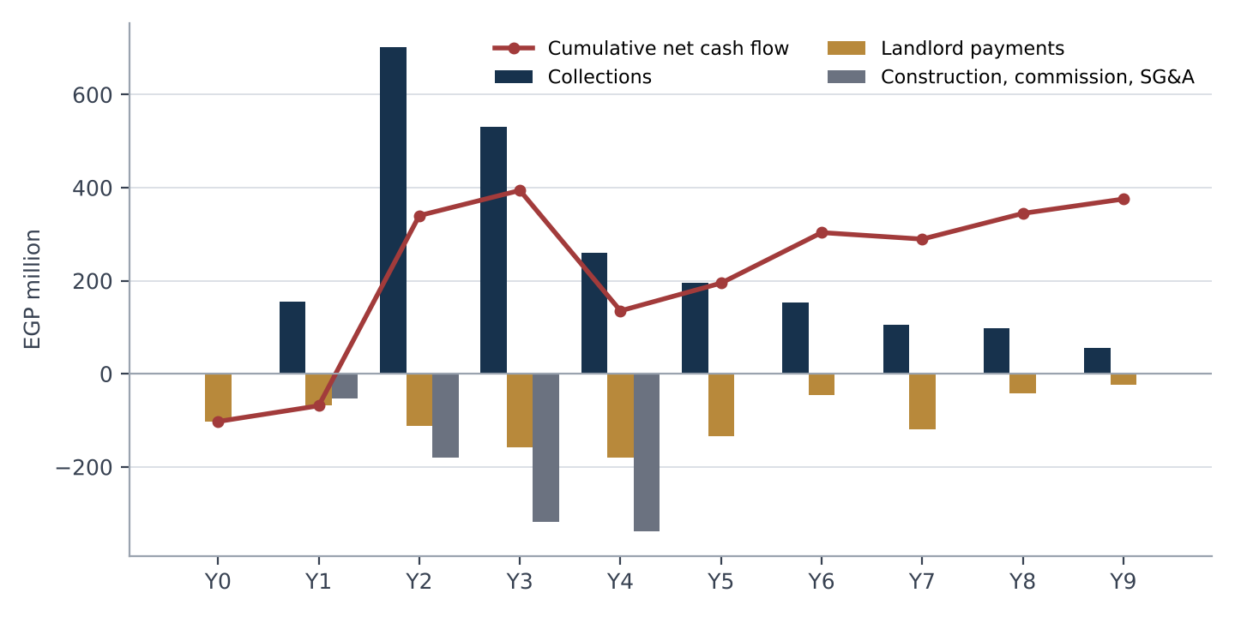
Figure 1: Green Square: project cash flow by year. Source: Jalour financial model; Financial Annex, project cash flow sheets

9.2 L'avenir
Table 14: L'avenir: sales plan by tranche
Quarter of sale | Retail (EGP m) | Offices (EGP m) | Retail price (EGP k/m2) | Office price (EGP k/m2)
Month 3 | 111.8 | 250.5 | 250 | 160
Month 6 | 111.8 | 250.5 | 250 | 160
Month 9 | 123.0 | 187.9 | 275 | 180
Month 12 | 86.1 | 93.9 | 275 | 180
Month 15 | 93.9 | 104.4 | 300 | 200
Month 18 | 80.5 | 104.4 | 300 | 200
Month 21 | 73.8 | 114.8 | 330 | 220
Month 24 | 73.8 | 114.8 | 330 | 220
Month 27 | 80.5 | 125.2 | 360 | 240
Month 30 | 80.5 | 125.2 | 360 | 240
Month 33 | 80.5 | 62.6 | 360 | 240
Month 36 | 80.5 | 62.6 | 360 | 240
Total | 1,076.9 | 1,596.9

The sales plan totals EGP 2,674 million at modelled prices; the landlord share is calculated on the full project sales value of EGP 3,342 million. The first two tranches (months 3 and 6) carry the launch list and total EGP 725 million; Option A units come from these.
Table 15: L'avenir: annual cash flow, EGP million (year 1 = months 1 to 12)
Project year | Collections | Landlord payments | Construction, commission, SG&A | Net cash flow | Cumulative
Year 0 | 0.0 | -85.0 | 0.0 | -85.0 | -85.0
Year 1 | 181.6 | -90.0 | -53.4 | 38.3 | -46.7
Year 2 | 334.5 | -180.0 | -185.7 | -31.2 | -77.9
Year 3 | 1,094.9 | -225.0 | -318.6 | 551.3 | 473.4
Year 4 | 375.2 | -180.0 | -351.1 | -155.9 | 317.5
Year 5 | 259.8 | -90.0 | 0.0 | 169.8 | 487.4
Year 6 | 204.2 | 0.0 | 0.0 | 204.2 | 691.5
Year 7 | 142.8 | -284.4 | 0.0 | -141.6 | 549.9
Year 8 | 66.2 | -29.0 | 0.0 | 37.2 | 587.1
Year 9 | 14.5 | -6.3 | 0.0 | 8.2 | 595.3
Year 10 | 0.0 | 0.0 | 0.0 | 0.0 | 595.3
Total | 2,673.7 | -1,169.8 | -908.7 | 595.3

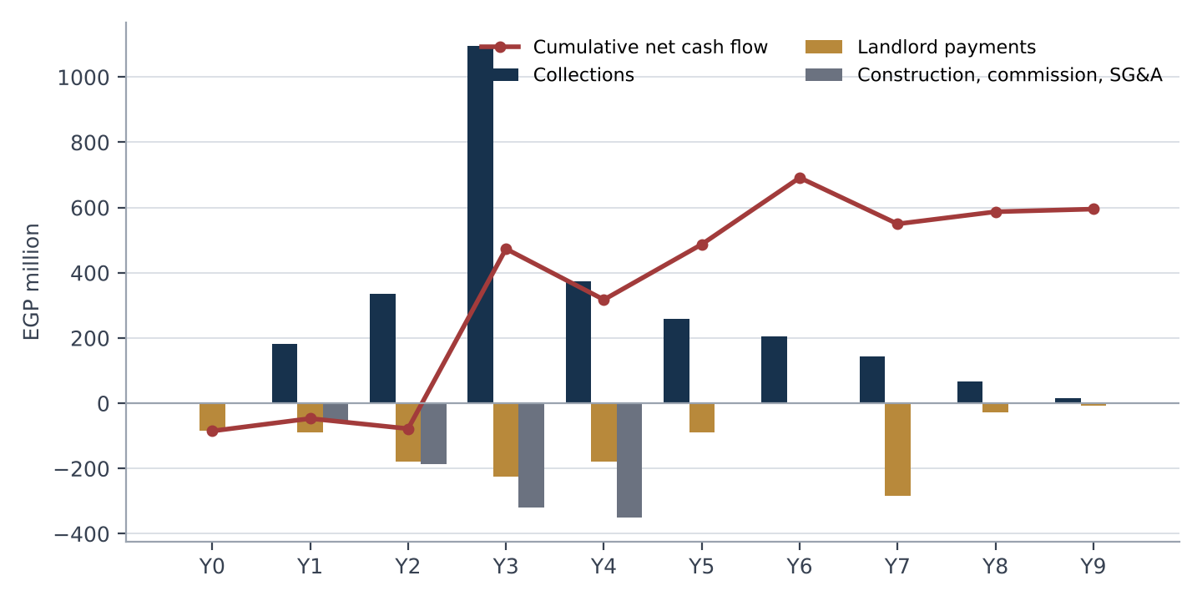
Figure 2: L'avenir: project cash flow by year. Source: Jalour financial model; Financial Annex, project cash flow sheets
Each model collects the delivery payment on a contractual milestone ahead of handover (project month {G["dp_month"]} in Green Square and month {L["dp_month"]} in L'avenir), which produces a large collection in that month. This timing is a key sensitivity (sections 11 and 13). Evidence of the contractual milestone is to be provided in the data room.

10. Cost model
Table 16: Cost model
Cost line (EGP million) | Green Square | L'avenir | Basis
Construction (core and shell) | 697.2 | 697.2 | Stage schedule over 36 months; flat nominal
Sales commission | 90.1 | 106.9 | 4% of sales value, paid 12 months after each sale quarter
SG&A and others | 104.6 | 104.6 | 15% of construction: contingency, professional fees, overhead (5% each)
Total | 891.9 | 908.7

- Cost basis (contractor pricing, bill of quantities) is to be provided in the data room; the models use a flat nominal cost with no inflation over the build period.
- A 10% overrun lowers project NPV from EGP 230 to 173 million (Green Square) and from EGP 351 to 294 million (L'avenir); a 20% overrun to EGP 117 and 237 million.
- Pre-construction costs (design, permits) are not separately modelled; section 11 adds an allowance of EGP 10.5 million per project as an assumption.

11. Funding plan, use of funds and combined cash position

11.1 Green Square: uses and sources
Table 17: Green Square: uses
Uses at the funding peak | EGP million
Down payment to the landowner | 80.0
Guarantee instalments and working capital to the peak, net of collections | 22.5
Design, permits and pre-construction (assumption) | 10.5
Total uses | 113.0

Table 18: Green Square: sources
Sources | EGP million | % of uses
Investor ticket | 62.5 | 55%
Balance of project funding | 50.5 | 45%
Total | 113.0

The balance of project funding is provided by Jalour sponsor equity, project collections and other capital sources.
The ticket equals 61% of the modelled peak cumulative shortage of EGP 102.5 million (month 0). If delivery payments arrive at handover the peak is EGP 269 million; in the downside case EGP 441 million.

11.2 L'avenir: uses and sources
Table 19: L'avenir: uses
Uses at the funding peak | EGP million
Down payment to the landowner | 85.0
Guarantee instalments and working capital to the peak, net of collections | 17.0
Design, permits and pre-construction (assumption) | 10.5
Total uses | 112.5

Table 20: L'avenir: sources
Sources | EGP million | % of uses
Investor ticket | 62.5 | 56%
Balance of project funding | 50.0 | 44%
Total | 112.5

The balance of project funding is provided by Jalour sponsor equity, project collections and other capital sources.
The ticket equals 61% of the modelled peak cumulative shortage of EGP 102.0 million (month 18). If delivery payments arrive at handover the peak is EGP 244 million; in the downside case EGP 849 million.

11.3 Funding gaps in stress cases
Table 21: Project cash position by case, before any investor instrument (EGP million; GS = Green Square, LA = L'avenir)
Case | GS NPV | GS peak shortage | LA NPV | LA peak shortage
Base case | 230 | 102 | 351 | 102
Downside: sales +12 months, prices -10% | -36 | 441 | 45 | 849
Upside: prices +10% | 336 | 102 | 469 | 88
Construction cost +10% | 173 | 102 | 294 | 117
Collections slip 2 quarters | 134 | 236 | 239 | 381
Delivery payments at handover | 166 | 269 | 313 | 244
Handover payments and downside combined | -86 | 729 | 16 | 849

Jalour will fund the gap between project cash and the cases above from its cash reserves and from cash generated by other projects it is constructing; it does not expect the investor to fund it. The investor should note that in the downside and combined cases the funding need is several times the tickets and depends on Jalour's capacity to provide it.

11.4 Combined cash position of the two projects
Jalour has said it will cover project funding gaps from its cash reserves and from cash generated by other projects it is constructing. To show what that means in numbers, this section adds the two projects together, before any investor instrument. The figures are projections from the same Jalour model. They cover these two projects only; Jalour's cash reserves and other projects are not included.
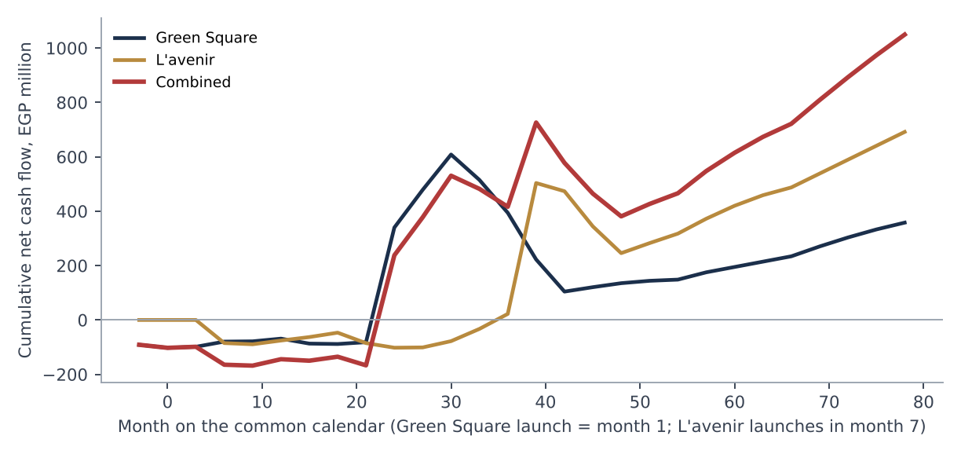
Figure 3: Cumulative net cash flow of the two projects and combined (common calendar). Source: Jalour financial model; Financial Annex, Combined_Position sheet. Months are counted from the Green Square launch (month 1); L'avenir launches in month 7, as in the combined Jalour model
Table 22: Peak shortage by case, each project and combined
Peak cumulative shortage (EGP million) | Green Square | L'avenir | Combined | Month of combined peak
Base case | 102 | 102 | 168 | 9
Downside: sales +12 months, prices -10% | 441 | 849 | 1,089 | 48
Upside: prices +10% | 102 | 88 | 160 | 6
Construction cost +10% | 102 | 117 | 193 | 21
Collections slip 2 quarters | 236 | 381 | 478 | 24
Delivery payments at handover | 269 | 244 | 318 | 39
Handover payments and downside combined | 729 | 849 | 1,531 | 48

In the base case the combined position is lowest at EGP 168.0 million in month 9 and is positive from month 24, counting months on the common calendar (Green Square launch = month 1; L'avenir launch = month 7). The stress cases matter more than the base case. When sales slip or delivery payments arrive late, both projects are short at the same time and the combined need is the sum of the two, not the offset of one against the other. Jalour's ability to cover gaps therefore rests mainly on its cash reserves and on other projects' cash outside these two, which are not shown here. Presenting the projects together creates no cross-collateral or cross-default; the investor's claim in each project is on that project's company only.

12. Investment terms

12.1 Option A: units
Table 23: Option A terms
Term | Detail
Face value | EGP 125 million in each project (EGP 250 million in total): 2.0x the ticket, priced at the launch list
Source of units | Unsold units in the first two sales tranches of each project (Green Square months 3 and 6, EGP 606 million at list; L'avenir months 3 and 6, EGP 725 million). The investor receives 20.6% and 17.3% of them.
Unit mix | Pro rata to those tranches: Green Square retail EGP 40.3 million and offices EGP 84.7 million; L'avenir retail EGP 38.6 million and offices EGP 86.4 million
Value at delivery list | EGP 179 million (Green Square) and EGP 185 million (L'avenir), before resale costs
Day-one holding | A registered unit allocation and reservation contract in each project, assignable with the consents below
Landlord share | Jalour bears the landlord 35% on the allocated units (EGP 88 million at face in total); landlord payments are unchanged
Resale (assumption) | Handover in month 42 (Green Square) and 42 (L'avenir); resale over four quarters from three months later; 3% cost
Consents | Jalour consent and landlord acknowledgement for assignment of a contract before handover [fee to be agreed]

The investor holds no physical unit until handover. Before handover the investor can sell only the contract, with consent, and a buyer is likely to require a discount. Jalour cannot promise liquidity that the structure does not provide.

12.2 Option B: cash
Table 24: Option B terms
Term | Detail
Total return | EGP 288 million (2.3x the ticket), including return of capital: EGP 143.75 million from each project
Grace period | 24 months from funding in each project, no payments
Payments | 12 equal quarterly instalments of EGP 11.98 million per project: Green Square months 24 to 57; L'avenir months 27 to 60
Obligor | Each project company for its own instalments; no guarantee of return by Jalour or Al Jalal Holding; no cross-guarantee between the project companies
Default | Instalment unpaid for 30 days: payment priority covenant applies; step-in right over earmarked units in that project [terms to be agreed]
Funding gaps | Jalour will fund project funding gaps; this supports delivery of the projects and is not a guarantee of the return

Table 25: Option B payment schedule (GS = Green Square, LA = L'avenir)
Instalment | GS month | LA month | Per project (EGP m) | Combined (EGP m) | Cumulative combined (EGP m)
1 | 24 | 27 | 11.98 | 23.96 | 23.96
2 | 27 | 30 | 11.98 | 23.96 | 47.92
3 | 30 | 33 | 11.98 | 23.96 | 71.88
4 | 33 | 36 | 11.98 | 23.96 | 95.83
5 | 36 | 39 | 11.98 | 23.96 | 119.79
6 | 39 | 42 | 11.98 | 23.96 | 143.75
7 | 42 | 45 | 11.98 | 23.96 | 167.71
8 | 45 | 48 | 11.98 | 23.96 | 191.67
9 | 48 | 51 | 11.98 | 23.96 | 215.62
10 | 51 | 54 | 11.98 | 23.96 | 239.58
11 | 54 | 57 | 11.98 | 23.96 | 263.54
12 | 57 | 60 | 11.98 | 23.96 | 287.50

Alternatives considered and not recommended are in section 13.4.

13. Returns analysis and sensitivities
All returns are projections, labelled by case. IRRs are annual, compounded from quarterly flows, on the combined EGP 125 million; the investor funds in month {G["t0"]} in Green Square and month {L["t0"]} in L'avenir, on each project's own timeline.

13.1 Option A
Table 26: Option A investor returns, combined
Case | Assumption | Investor IRR | Investor MOIC
Base | Resale at delivery list price; 3% cost | 27.7% | 2.83x
Downside | Resale 12 months later and 10% lower | 19.5% | 2.54x
Upside | Resale 10% higher | 30.6% | 3.11x
Appreciation 40% | Launch to resale +40% | 26.5% | 2.72x
Appreciation 60% | Launch to resale +60% | 30.5% | 3.10x
No appreciation | Resale at launch list | 16.9% | 1.94x

Table 27: Option A returns by project (EGP 62.5 million each)
Project | Base IRR | Base MOIC | Downside IRR | Upside IRR | Break-even price (share of delivery list)
Green Square | 26.4% | 2.78x | 18.6% | 29.2% | 36%
L'avenir | 29.2% | 2.87x | 20.4% | 32.3% | 35%

Cost to Jalour. Giving the investor units from the first two sales tranches of each project removes that share of those tranches' collections. Jalour receives the tickets at funding and forgoes those collections (the units' face value of EGP 250 million at list) as they would have been received, partly offset by commission saved. The landlord share is unchanged. On this basis Jalour's combined cost of capital is 21.6% and the NPV effect at 14% is EGP -26.6 million. Peak cumulative shortage before the tickets rises to EGP 106.9 million (Green Square) and EGP 123.8 million (L'avenir).
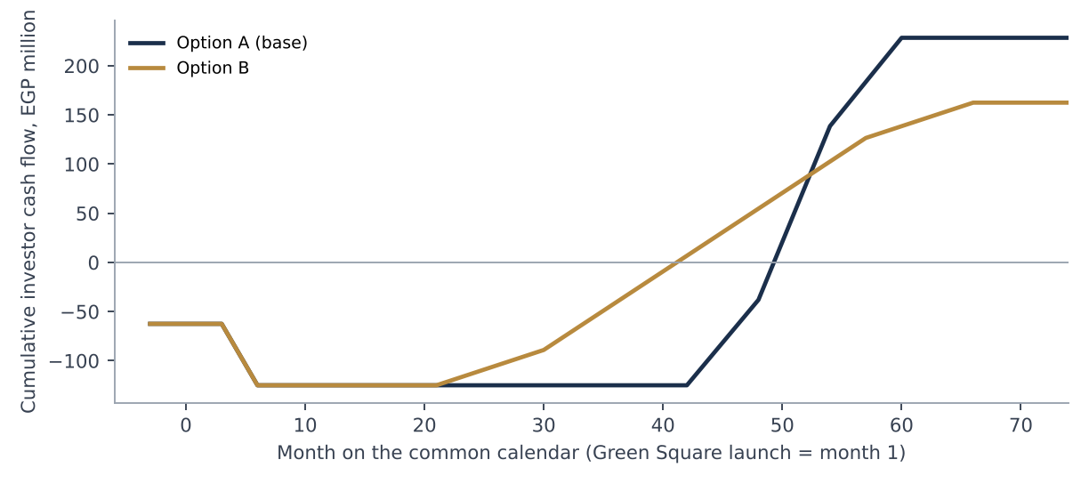
Figure 4: Cumulative investor cash flow by option (combined). Source: Financial Annex, Combined_Summary; projections

13.2 Option B
Table 28: Option B (fixed instalments)
Measure (combined) | Base | Downside | Upside | Handover payments
Investor IRR if paid | 26.5% | 26.5% | 26.5% | 26.5%
Investor MOIC | 2.30x | 2.30x | 2.30x | 2.30x
Jalour cost of capital | 26.5% | 26.5% | 26.5% | 26.5%
Lowest pooled cash after tickets and payouts (EGP m) | -43 | -1,144 | -40 | -301

In the base case the lowest combined pooled cash is EGP -43.0 million in month 9. Instalments are fixed, so the investor's IRR is the same in every case if Jalour pays. What changes is the cash available to pay: in the downside and handover cases pooled cash falls below zero and Jalour must fund the difference. Negative figures above are the amount Jalour would have to provide from sponsor equity or other capital sources.

13.3 Payout coverage
Table 29: Payout coverage, base case, Option B
Project | Quarters with net cash flow below 1.5x the instalment | Lowest cash-available coverage
Green Square | 8 of 12 | 7.6x
L'avenir | 3 of 12 | 2.5x

Table 30: Green Square: payout coverage by instalment, base case
Month | Net cash flow before payout (EGP m) | Instalment (EGP m) | Coverage: net cash flow / instalment | Coverage: cash available / instalment
24 | 421.6 | 11.98 | 35.2x | 33.6x
27 | 138.8 | 11.98 | 11.6x | 44.2x
30 | 129.7 | 11.98 | 10.8x | 54.0x
33 | -93.4 | 11.98 | -7.8x | 45.2x
36 | -121.0 | 11.98 | -10.1x | 34.1x
39 | -171.6 | 11.98 | -14.3x | 18.8x
42 | -118.2 | 11.98 | -9.9x | 7.9x
45 | 16.2 | 11.98 | 1.4x | 8.3x
48 | 14.7 | 11.98 | 1.2x | 8.5x
51 | 8.7 | 11.98 | 0.7x | 8.2x
54 | 4.4 | 11.98 | 0.4x | 7.6x
57 | 26.9 | 11.98 | 2.2x | 8.8x

Table 31: L'avenir: payout coverage by instalment, base case
Month | Net cash flow before payout (EGP m) | Instalment (EGP m) | Coverage: net cash flow / instalment | Coverage: cash available / instalment
27 | 45.0 | 11.98 | 3.8x | 2.5x
30 | 55.2 | 11.98 | 4.6x | 6.1x
33 | 481.3 | 11.98 | 40.2x | 45.3x
36 | -30.2 | 11.98 | -2.5x | 41.7x
39 | -129.2 | 11.98 | -10.8x | 29.9x
42 | -98.4 | 11.98 | -8.2x | 20.7x
45 | 36.8 | 11.98 | 3.1x | 22.8x
48 | 35.0 | 11.98 | 2.9x | 24.7x
51 | 54.8 | 11.98 | 4.6x | 28.3x
54 | 47.7 | 11.98 | 4.0x | 31.3x
57 | 38.8 | 11.98 | 3.2x | 33.5x
60 | 28.5 | 11.98 | 2.4x | 34.9x

Coverage on net cash flow alone is below the 1.5x threshold in some quarters of each project, because instalments fall in the construction peak and in the quarters after handover when collections are thin. "Cash available" adds pooled project cash, including the ticket and earlier collections. Because nothing is ring-fenced, pooled cash is available to the project company but is also exposed to construction spending and to Jalour's own funding capacity. The investor should read the net-cash-flow measure as the stricter test.

13.4 Alternatives considered
Table 32: Option B structures compared
Structure (combined) | Investor IRR (base) | Lowest pooled cash, downside (EGP m) | Lowest pooled cash, handover stress (EGP m)
S1 Fixed multiple, equal instalments (recommended) | 26.5% | -1,144 | -301
S2 Share of collections, with floor and cap | 28.9% | -1,142 | -328
S3 Fixed 1.8x plus share of collections, cap 2.8x | 27.6% | -1,139 | -298

S2 and S3 front-load payments into the large delivery-payment quarters and so show a higher IRR, but they pay by taking a share of collections that are themselves needed for construction, and they do not improve coverage in the construction peak. S1 is recommended for simplicity and certainty of the schedule. None of the three meets a 1.5x net-cash-flow test in every quarter; this is disclosed rather than cured by reducing the return, and it is the reason for Jalour's funding undertaking and the payment priority covenant.

13.5 Project sensitivities
Table 33: Green Square: project sensitivities (Jalour net cash flow before any investor instrument)
Case | Net cash flow (EGP m) | NPV at 14% (EGP m) | Peak shortage (EGP m)
Base | 375 | 230 | 102
Prices -19% | 129 | 13 | 184
Prices -9% | 258 | 124 | 114
Prices +10% | 493 | 336 | 102
Prices +19% | 611 | 442 | 102
Sales delayed 6 months | 375 | 138 | 217
Sales delayed 12 months | 375 | 52 | 408
Sales delayed 18 months | 375 | -28 | 825
Sales delayed 24 months | 375 | -103 | 1,075
Construction cost +10% | 295 | 173 | 102
Construction cost +19% | 215 | 117 | 114
Collections slip 1 quarter | 375 | 181 | 162
Collections slip 2 quarters | 375 | 134 | 236
Collections slip 4 quarters | 375 | 44 | 440

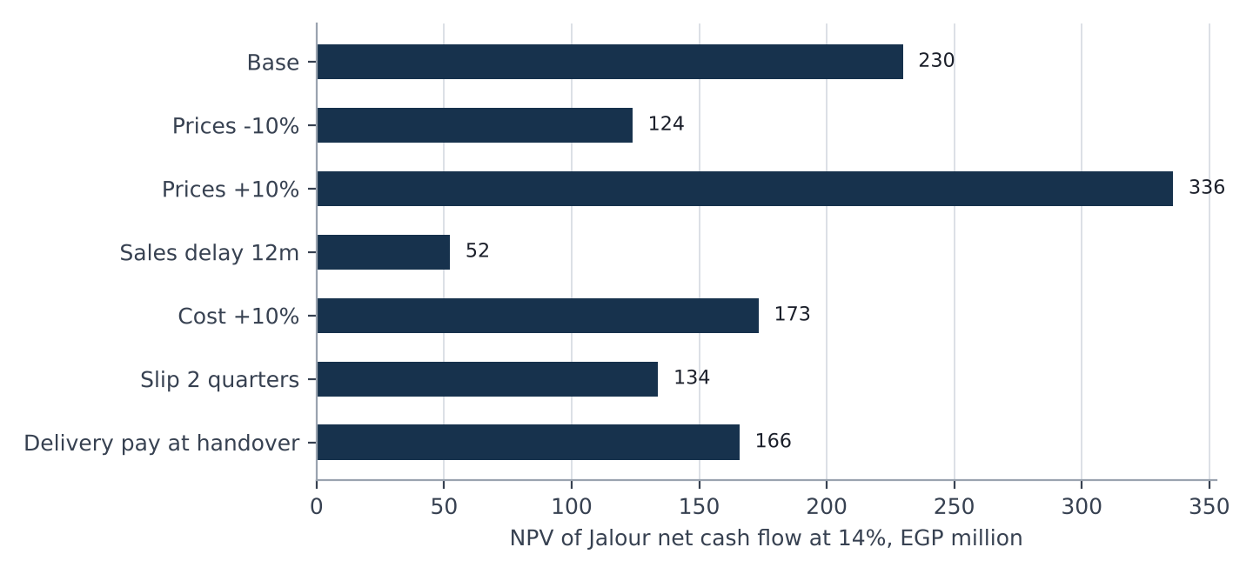
Figure 5: Green Square: project NPV by case. Source: Financial Annex, Scenarios and Sensitivity sheets
Table 34: L'avenir: project sensitivities (Jalour net cash flow before any investor instrument)
Case | Net cash flow (EGP m) | NPV at 14% (EGP m) | Peak shortage (EGP m)
Base | 595 | 351 | 102
Prices -19% | 316 | 113 | 175
Prices -9% | 456 | 232 | 138
Prices +10% | 735 | 469 | 88
Prices +19% | 875 | 588 | 86
Sales delayed 6 months | 595 | 244 | 366
Sales delayed 12 months | 595 | 143 | 779
Sales delayed 18 months | 595 | 49 | 1,004
Sales delayed 24 months | 595 | -38 | 1,179
Construction cost +10% | 515 | 294 | 117
Construction cost +19% | 435 | 237 | 133
Collections slip 1 quarter | 595 | 294 | 190
Collections slip 2 quarters | 595 | 239 | 381
Collections slip 4 quarters | 595 | 134 | 811

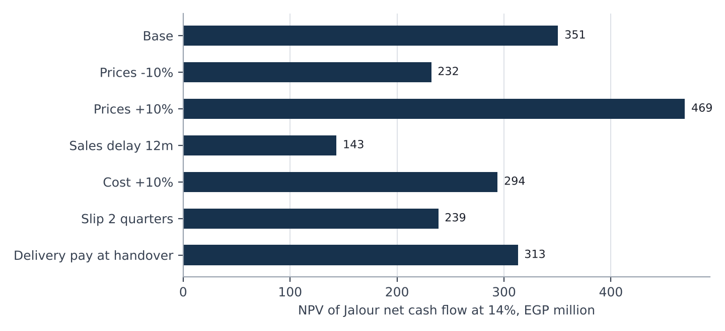
Figure 6: L'avenir: project NPV by case. Source: Financial Annex, Scenarios and Sensitivity sheets

14. Security and ranking
This is a proposal for review by Jalour's lawyers and the investor's counsel. Nothing in the structure is ring-fenced: there is no restricted account, escrow or segregated collection account, and security is contractual or over specific units. Each project has its own security; there is no cross-collateral and no cross-default.

14.1 Base package, in each project
Table 35: Security and protections
Protection | Option A | Option B
Specific units | Registered allocation of identified units from the first two sales tranches; the units are the investor's asset | Earmark of unsold units with a list value of at least the ticket (substitution of equal value allowed)
Payment priority covenant | Not applicable | No shareholder distributions or repayment of shareholder loans while an instalment is overdue
Negative pledge | On the allocated units | On the earmarked units
Information rights | Monthly report, annual audited accounts, audit right | Same
Sponsor funding undertaking | Funds project funding gaps; supports delivery | Same; not a guarantee of the return
Landlord acknowledgement | Of the allocation and assignment rights | Of the earmark

14.2 Optional protections (for counsel)
- Promissory note or post-dated cheques for each Option B instalment, common in Egyptian practice.
- Independent engineer reporting on construction progress and cost to complete.
- Step-in right to market the earmarked units after a payment default.
- Parent guarantee: not offered. Jalour has chosen not to guarantee the return; the investor should price this.

14.3 Ranking
Proposed ranking, for counsel: in each project the investor's entitlement ranks as an obligation of that project company. It ranks behind amounts owed to the landowner under its agreement (which are paid from collections and take the first 35%) and behind construction and operating creditors in the ordinary course, and ahead of distributions to shareholders only to the extent of the payment priority covenant. Further project-level financing, if any, requires the investor's consent where it would rank ahead of the investor or encumber the earmarked units.

15. Governance and information rights
- Monthly report for each project within 15 days of month-end: units sold and value, collections against plan, costs against budget, construction progress against programme, cash position, any payment overdue to the landlord.
- Quarterly review with the investor, including cost to complete and the sales pipeline, and the combined position of the two projects.
- Annual audited accounts of each project company within 120 days of year-end.
- Audit and inspection rights on reasonable notice over books, the sales register and the sites.
- Consent matters: changes to the unit allocation or earmarked units, new project-level debt or security that would rank ahead, related-party transactions above an agreed threshold, and amendment of a landlord agreement that changes payments.
- Notice events: landlord dispute or default, loss or change of a permit, delay of more than three months to a construction programme, any payment overdue to the investor.
- Confidentiality: all reports and information are confidential under the non-disclosure agreement.
Reporting thresholds and timings are indicative. Because there is no restricted account, the investor's monitoring rests on reporting and audit rather than on control of cash.

16. Exit and liquidity

16.1 Option A
- Handover is in project month 42 (Green Square) and 42 (L'avenir); units can be registered and sold from handover. The base case assumes sale over four quarters from three months after handover.
- Before handover the investor may assign the contract with Jalour's consent and the landlord's acknowledgement [transfer fee to be agreed]. The buyer takes handover risk and will price it.
- Jalour continues to sell its own inventory; the investor's resale competes with it. The agreements may include an orderly-sales covenant.

16.2 Option B
Cash is returned through the instalments in section 12.2. There is no market for the entitlement. Transfer to a third party requires Jalour's consent. Combined payback (cumulative cash returned equals the combined tickets) occurs in month 42 for Option B and month 51 for Option A in the base case.

17. Risk factors
The following is not exhaustive. Each risk is stated with the main mitigant.

Market and price risk
Unit prices may rise less than the plans, or fall. Option A returns depend on resale value; with no appreciation the combined MOIC falls to 1.94x. Mitigant: downside case shown; Option B has no unit price exposure.

Sales pace and absorption
The pipeline of Cairo offices equals 82% of current stock by 2029 (Knight Frank). If sales are delayed 12 months project NPV falls to EGP 52 million (Green Square) and EGP 143 million (L'avenir), and peak funding needs rise to EGP 408 and 779 million. Mitigant: Jalour funding undertaking; phased sales.

Both projects short at once
In stress cases the two projects need funding at the same time: combined peak EGP 318 million with delivery payments at handover and EGP 1,089 million in the downside. Mitigant: combined view disclosed; Jalour's reserves and other projects' cash; evidence after the non-disclosure agreement.

Inflation and cost risk
Construction cost is flat in the models. A 10% overrun lowers combined NPV by EGP 113 million. Mitigant: 5% contingency; contractor pricing in the data room; fixed-price contracting to be sought.

Currency risk
Returns are in EGP. USD value falls if the pound weakens; foreign investors should assess FX and repatriation (section 18). The USD equivalents shown use EGP 48 per USD; the market rate in September 2026 was about EGP 50 to 51.

Delivery and construction risk
Each development must be built in 36 months. Delay delays resale of units and the collection of delivery payments. Mitigant: independent engineer (optional); reporting; Jalour funding undertaking.

Delivery-payment timing
The plans collect delivery payments ahead of handover under the sale contracts. If buyers do not pay until handover, peak funding needs are EGP 269 and 244 million. Mitigant: contractual milestone; Jalour funding.

Landlord risk
The landlord guarantees are payable regardless of sales and its consent is required for allocations and encumbrances. A dispute could delay or prevent the allocation. Mitigant: consent as a condition precedent; guarantee schedules funded in the plans.

Legal and regulatory risk
Rules on off-plan sales (Jalour's position is that the state-land rules in Decree 2184 of 2022 do not apply to these plots), on assignment of contracts, on private placements and on foreign ownership may affect structure, timing or cost. Mitigant: counsel review before signing.

Counterparty and credit risk (Option B)
Instalments are an obligation of each project company without a parent guarantee. In the downside case pooled cash is negative and payment depends on Jalour's support. Mitigant: payment priority covenant; earmarked units; funding undertaking; optional promissory notes.

Concentration
The investment is exposed to two projects in one city, on land of one landowner, in two property types. Each project has its own company, security and reporting, with no cross-collateral or cross-default.

Model and information risk
Figures derive from a Jalour model that has known simplifications: the admin sales area exceeds office built-up area, prices are stepped by assumption, costs are not inflated and pre-construction costs are not separately modelled. Mitigant: reconciliation and data room evidence.

Liquidity risk
There is no market for the Option B entitlement and Option A units cannot be sold in practice before handover without a discount.

Confidentiality
The pack contains the financial information of both projects. Disclosure outside the non-disclosure agreement is prohibited and may cause Jalour loss; the investor's own advisers must be bound by the same terms.

18. Tax and legal considerations
The following are issues for counsel and tax advisers. Jalour gives no legal or tax conclusion.
- Nature of the instrument (equity, loan or contractual entitlement) and its tax, regulatory and enforceability consequences in Egypt.
- Regulatory position of a private placement of this kind (Financial Regulatory Authority and any other body), including investor eligibility.
- Tax on the investor's return under each option: withholding tax, corporate or personal income tax, and VAT on supplies.
- Taxes and registration fees on the transfer of units (including real estate disposal tax and stamp duty) and who bears them on resale.
- The basis on which the separate project-account rule for developers on state-allocated land does not apply to these plots (Jalour's position).
- Foreign investor treatment: ownership of units, repatriation of proceeds, foreign-exchange availability and any central bank requirements.
- Enforceability of security over unsold units, the earmark, negative pledge and any promissory notes; stamp duty on security documents.
- Anti-money-laundering and know-your-customer requirements for the investor and for unit buyers.
- Corporate approvals, project company formation and the effect of Jalour or Al Jalal Holding insolvency on the project companies.
- Terms, governing law and forum of the non-disclosure agreement.

Appendices

Appendix A: Definitions
Table 36: Definitions
Term | Meaning
Launch list | Price list in force at the first sales tranche of each project
Face value | Units valued at the launch list
Pooled cash | Cumulative project net cash flow plus the ticket less payouts; not a restricted account
Coverage (net cash flow) | Quarterly project net cash flow before payouts divided by the instalment
Coverage (cash available) | Pooled cash at the start of the quarter plus the quarter's net cash flow, divided by the instalment
Peak shortage | Lowest cumulative net cash flow in the model, before the ticket
MOIC | Multiple of invested capital: cash received divided by cash invested

Appendix B: Reconciliation to the Financial Annex
Each headline figure in this memorandum is computed in the Financial Annex (Combined_Summary and the project sheets prefixed GS_ and LA_). The Combined_Reconciliation sheet ties each project cash flow to the Jalour model and to an independent recomputation; all differences are zero.
Table 37: Key figures and annex locations
Figure | Value | Annex location
Net cash flow, nominal (EGP m), GS / LA | 375.4 / 595.3 | GS_Project_CF; LA_Project_CF
NPV at 14% (EGP m), GS / LA | 229.9 / 350.6 | GS_Project_CF; LA_Project_CF
Peak shortage (EGP m), GS / LA | 102.5 / 102.0 | GS_Sources_Uses; LA_Sources_Uses
Combined lowest position, base (EGP m) | -168.0 | Combined_Position
Option A investor IRR / MOIC (combined) | 27.7% / 2.83x | Combined_Summary
Option A Jalour cost of capital (combined) | 21.6% | Combined_Summary
Option B investor IRR / MOIC (combined) | 26.5% / 2.30x | Combined_Summary
Option B lowest pooled cash, base (EGP m) | -43.0 | Combined_Summary

Appendix C: Financial Annex contents
Cover, Combined_Summary, Combined_Position, Combined_Reconciliation, and for each project (prefixes GS_ and LA_) Summary, Inputs, Source_Data, Project_CF, Sources_Uses, Option_A, Option_B, Scenarios, Sensitivity and Reconciliation. Inputs are in blue; every calculation is a formula.

Appendix D: Market sources
Table 38: Market sources (reported; not independently verified)
Source | Used for
Knight Frank, Cairo office review H2 2025, via Arabian Business (July 2026) | Cairo office stock of about 1.0 million m2 (Knight Frank definition), with a further 818,000 m2 in the pipelin...
Knight Frank via Arabian Business (July 2026) | New Cairo holds 73% of current and future Cairo office stock; Grade A occupancy is about 90%
JLL Q1 2026 Cairo, via Invest-Gate | Office vacancy averaged about 9% and was stable in Q1 2026; over 100,000 m2 of Grade A and B space was deliver...
Knight Frank Q2 2026, via Enterprise (8 July 2026) | Grade A business-park rent in New Cairo of USD 348/m2/yr (market average USD 325); EGP rents up about 20% y/y ...
JLL Q1 2026 Cairo, via Invest-Gate | Cairo retail stock above 3.3 million m2 after about 89,000 m2 delivered in Q1 2026, mostly small malls in New ...
MIDAR; Nawy | Mostakbal City covers about 11,000 feddans, with a planned population of about 1 million; master developer is ...
Presidency of Egypt; Bayut guide | Connected by the Regional (Middle) Ring Road and the East Cairo monorail corridor to Shorouk, Obour, Badr and ...
Invest-Gate | Comparable commercial schemes are under way: Hassan Allam's HAPTOWN (offices G+1 to G+4, retail, healthcare) i...
Property Finder listings, Sumou Boulevard and Zizinia (2026) | Office asking prices in Mostakbal City listings: about EGP 106,000 to 120,000 per m2
Property Finder listings (August 2026) | Retail unit asking prices in New Cairo (Fifth Settlement) listings range from about EGP 139,000 to 325,000 per...
JLL via Enterprise (2026) | New Cairo secondary-market sale prices rose 3.1% y/y in Q1 2026, while asking rents rose 10.0%
Sands of Wealth, drawing on Aqarmap data (2026) | Broker estimates put 2026 price growth at 10 to 15% in New Cairo and 12 to 16% in Mostakbal City (blog estimat...
CBE via Bnok24; CAPMAS via Ahram Online | CBE overnight deposit rate 19.00%, unchanged at the September 2026 meeting; urban headline inflation 14.5% in ...
Daily News Egypt (2026) | Top 10 developers' sales reached EGP 670 bn in H1 2026 against EGP 651 bn in H1 2025 (+2.9%), with units sold ...
Invest-Gate; Mondaq | Prime Minister Decree 2184 of 2022 requires developers on state-allocated land to hold a separate project bank...
Bayut and Property Finder listings (2026) | Typical off-plan payment plans run 8 to 12 years with 1.5% to 10% down payments

