Variation

Y = B0 + B1 \* X

Correlation 

 Total SS = 

Res SS = 

Reg SS =  

Multiple linear regression -> least square regression line 

Logistic function 

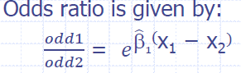 

6- Bays

Assuming all attributes (xi, … xn) are independent

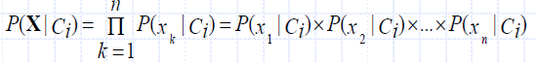

7- Decision Trees

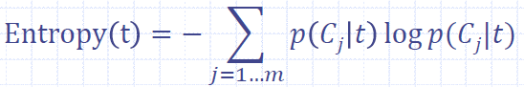

Weighted average



Manhattan distance

Euclidean distance 

Minkowski distance

8- KNN

