2.

From the plot I concluded that form is a linear as points tend toward a straight line. Direction is positive as whenever education level is increased then prestige level is increased too. Strength is strong as points are closed to each other’s

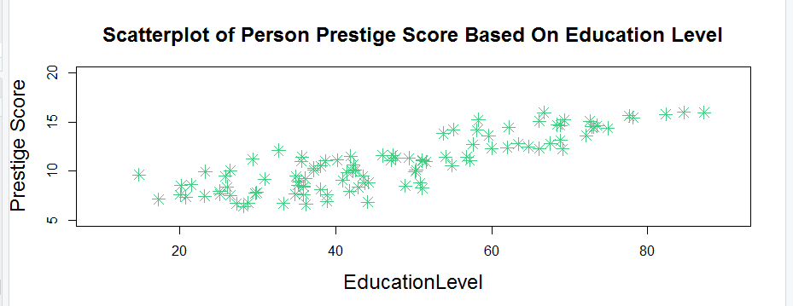

Correlation = 0.8501769, which shows how strong relation exist between education level & prestige score

3.

Least square regression equation:

PrestigeLevel.Expected = -6.794334 + 4.186637 \* EducationLevel + 0.001314 \* Income - 0.008905 \* WomenPercent

4.

R.Square = 0.7981775