1. **WRONG**, **use table, addmargins, prop.table commands**

Data Summary

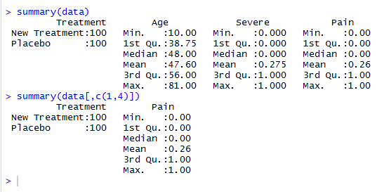

We have 2 possible treatments, and only 2 ranges of values for Pain (dependent variable)

2.

Logistic Regression Equation:

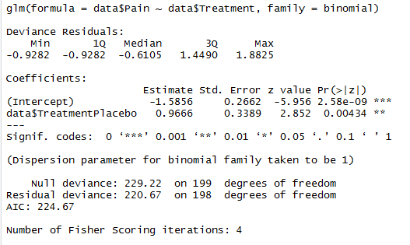

𝑝 = 1/(1 + 𝑒 −β0 −β1x )

P = 1/(1+ e **(1.5856 – 0.9666*X)**)

3.



R.Square = 0.03732699

4.

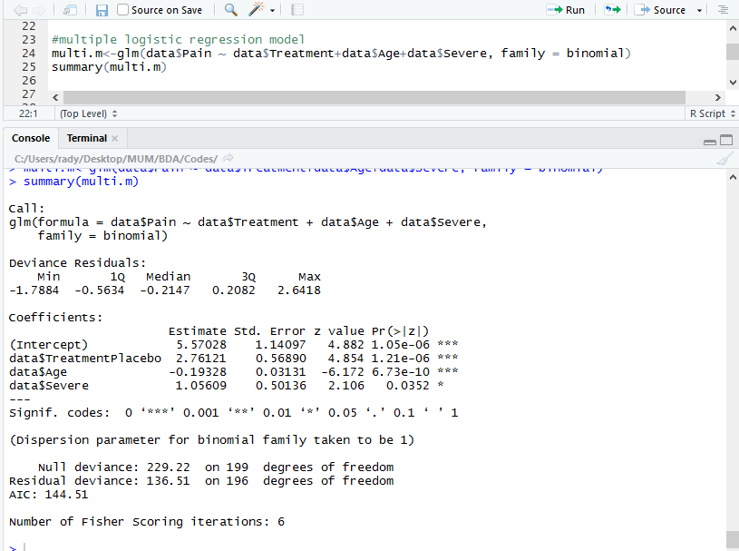

1. Any unit change in treatment would increase odds of pain level by 2.76121 if other factors are fixed/adjusted.
2. Any unit change in age would decrease odd of pain level by -0.19328 if other factors are fixed.
3. Any unit change in severe level would affect odds pain level by 1.05609.

5.

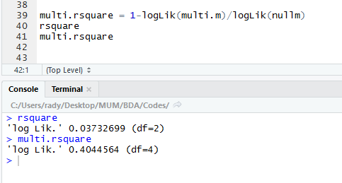

R.Square for first model = 0.03732699

R.Square for second model = 0.4044564

As R.Square is an indicator on how good the model is, then we can conclude that multiple logistic regression model in this problem is better that single model.