1

‘YES’ objects: (2,4) (3,3) (3,5) (4,8) (5,5)

‘NO’ objects: (2,6) (2,8) (5,7)

K = 3

Class for (1, 5) is required

Step A: calculate distances

Squareroot ((1-2)2 + (5-4) 2) = 1.414 | class: Yes

Squareroot ((1-3) 2 + (5-3) 2) = 2.8284 | class: Yes

Squareroot ((1-2) 2 + (5-5) 2) = 1 | class: Yes

Squareroot ((1-4) 2 + (5-8) 2) = 4.2426 | class: Yes

Squareroot ((1-5) 2 + (5-5) 2) = 4 | class: Yes

Squareroot ((1-2) 2 + (5-6) 2) = 1.414 | class: No

Squareroot ((1-2) 2 + (5-8) 2) = 3.1623 | class: No

Squareroot ((1-5) 2 + (5-7) 2) = 4.472 | class: No

K/3 smallest distances =

Squareroot ((1-2) 2 + (5-4) 2) = 1.414 | class: Yes

Squareroot ((1-2) 2 + (5-5) 2) = 1 | class: Yes

Squareroot ((1-2) 2 + (5-6) 2) = 1.414 | class: No

Majority class is Yes among K least distances, then predicted class for (1, 5) is **Yes**

2.

|  |  |  |  |  |
| --- | --- | --- | --- | --- |
|  | Predicted Class | | | |
| Actual Class |  | C1 | C2 |  |
| C1 | TP = 425 | FN = 58 | P = 483 |
| C2 | FP = 63 | TN = 241 | N = 304 |
|  |  | P’ = 488 | N’ = 299 | All = 787 |

Accuracy = (TP + TN)/All

666 / 787 = **0.846** ~ 85%

Error rate = (FP + FN)/All

(58 + 63) / 787 = **0.154** ~ 15%

Sensitivity = TP/P

425 / 483 = **0.8799** ~ 88% of the positive classes are correctly classified

Specificity = TN/N

241 / 304 = **0.792** ~ 79% of the negative classes are correctly classified

Precision = TP/(TP+FP)

425 / (425 + 63) = **0.871** ~ 87%

F-measure = (2∗𝑝𝑟𝑒𝑐𝑖𝑠𝑖𝑜𝑛∗𝑟𝑒𝑐𝑎𝑙𝑙) (𝑟𝑒𝑐𝑎𝑙𝑙+𝑝𝑟𝑒𝑐𝑖𝑠𝑖𝑜n)

(2*0.871*0.8799) / (0.8799 + 0.871) = 1.5327858 / 1.7509 = **0.875**

3.

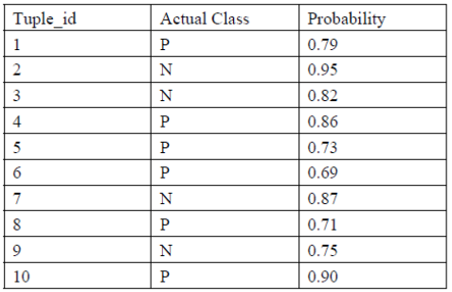

Step A: Sort in descending order

|  |  |  |
| --- | --- | --- |
| Tuple_Id | Actual Class | Probability |
| 2 | N | 0.95 |
| 10 | P | 0.90 |
| 7 | N | 0.87 |
| 4 | P | 0.86 |
| 3 | N | 0.82 |
| 1 | P | 0.79 |
| 9 | N | 0.75 |
| 5 | P | 0.73 |
| 8 | P | 0.71 |
| 6 | P | 0.69 |

Step B: Calculate TPR, FPR

|  |  |  |  |  |  |  |  |  |
| --- | --- | --- | --- | --- | --- | --- | --- | --- |
| Tuple_Id | Actual Class | Probability | TP | FP | TN | FN | TPR | FPR |
| 2 | N | 0.95 | 0 | 1 | 3 | 6 | 0 | 1/4 |
| 10 | P | 0.90 | 1 | 1 | 3 | 5 | 1/6 | 1/4 |
| 7 | N | 0.87 | 1 | 2 | 2 | 5 | 1/6 | 2/4 |
| 4 | P | 0.86 | 2 | 2 | 2 | 4 | 2/6 | 2/4 |
| 3 | N | 0.82 | 2 | 3 | 1 | 4 | 2/6 | 3/4 |
| 1 | P | 0.79 | 3 | 3 | 1 | 3 | 3/6 | 3/4 |
| 9 | N | 0.75 | 3 | 4 | 0 | 3 | 3/6 | 1 |
| 5 | P | 0.73 | 4 | 4 | 0 | 2 | 4/6 | 1 |
| 8 | P | 0.71 | 5 | 4 | 0 | 1 | 5/6 | 1 |
| 6 | P | 0.69 | 6 | 4 | 0 | 0 | 1 | 1 |

* Microsoft Word Diagram from above data
* R Diagram

