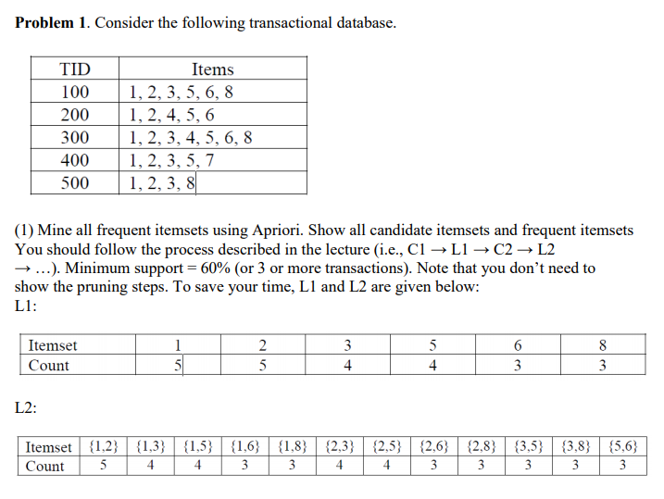

C3 (after pruning)

|  |  |  |  |  |  |  |  |  |  |
| --- | --- | --- | --- | --- | --- | --- | --- | --- | --- |
| {1,2,3} | {1,2,5} | {1,2,6} | {1,2,8} | {1,3,5} | {1,3,8} | {1,5,6} | {2,3,5} | {2,3,8} | {2,5,6} |
| 4 | 4 | 3 | 3 | 3 | 3 | 3 | 3 | 3 | 3 |

L3 =

|  |  |  |  |  |  |  |  |  |  |
| --- | --- | --- | --- | --- | --- | --- | --- | --- | --- |
| {1,2,3} | {1,2,5} | {1,2,6} | {1,2,8} | {1,3,5} | {1,3,8} | {1,5,6} | {2,3,5} | {2,3,8} | {2,5,6} |
| 4 | 4 | 3 | 3 | 3 | 3 | 3 | 3 | 3 | 3 |

C4

|  |  |  |
| --- | --- | --- |
| {1,2,3,5} | {1,2,3,8} | {1,2,5,6} |
| 3 | 3 | 3 |

L4

|  |  |  |
| --- | --- | --- |
| {1,2,3,5} | {1,2,3,8} | {1,2,5,6} |
| 3 | 3 | 3 |

C5 is empty {}

Problem 2.

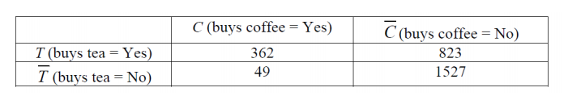

c(𝑋→𝑌) = support(X ∪ Y) / support(X)

362/(362+823) = 0.305 ~ 31%

𝑙𝑖𝑓𝑡 𝑋 → 𝑌 = 𝑐𝑜𝑛𝑓𝑖𝑑𝑒𝑛𝑐𝑒(𝑋→𝑌) / 𝑠𝑢𝑝𝑝𝑜𝑟𝑡(𝑌)

31% / ((362+49) / (362+823+49+1527)) = 31% / 15% = 2.1

So, it’s a positive correlation.

Prob. 3

1. Frequency plot for items with support > 0.15

itemFrequencyPlot(Groceries, support = 0.15)

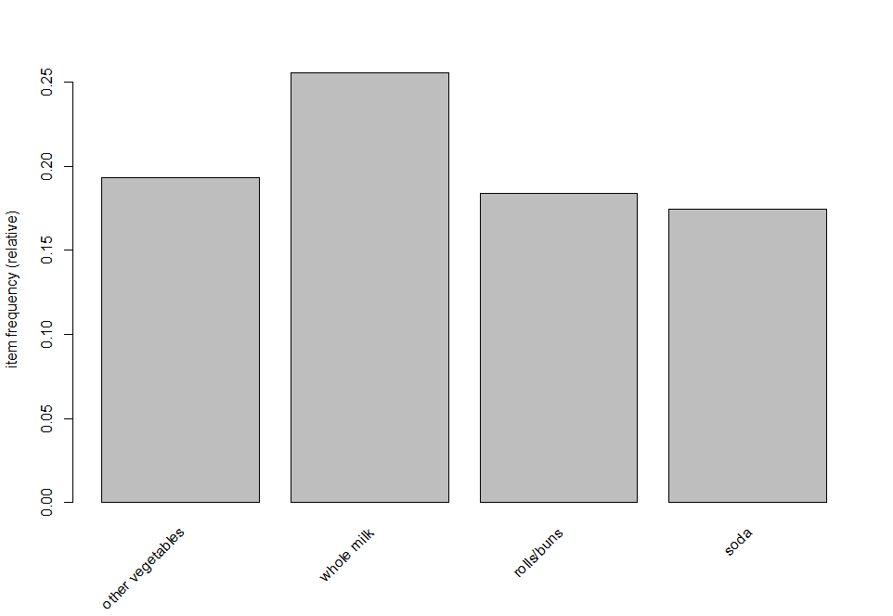

1. "tropical fruit" subset rules

sub.rules <- subset(rules, rhs %in% "tropical fruit")

inspect(sub.rules)

[1] {grapes} => {tropical fruit} 0.006100661 0.2727273

[2] {pip fruit} => {tropical fruit} 0.020437214 0.2701613

[3] {other vegetables,fruit/vegetable juice} => {tropical fruit} 0.006609049 0.3140097

[4] {yogurt,whipped/sour cream} => {tropical fruit} 0.006202339 0.2990196

[5] {other vegetables,whipped/sour cream} => {tropical fruit} 0.007829181 0.2711268

[6] {pip fruit,yogurt} => {tropical fruit} 0.006405694 0.3559322

[7] {pip fruit,other vegetables} => {tropical fruit} 0.009456024 0.3618677

[8] {pip fruit,whole milk} => {tropical fruit} 0.008439248 0.2804054

[9] {citrus fruit,yogurt} => {tropical fruit} 0.006304016 0.2910798

[10] {citrus fruit,other vegetables} => {tropical fruit} 0.009049314 0.3133803

[11] {citrus fruit,whole milk} => {tropical fruit} 0.009049314 0.2966667

[12] {yogurt,bottled water} => {tropical fruit} 0.007117438 0.3097345

[13] {other vegetables,bottled water} => {tropical fruit} 0.006202339 0.2500000

[14] {root vegetables,yogurt} => {tropical fruit} 0.008134215 0.3149606

[15] {root vegetables,other vegetables} => {tropical fruit} 0.012302999 0.2596567

[16] {yogurt,rolls/buns} => {tropical fruit} 0.008744281 0.2544379

[17] {other vegetables,yogurt} => {tropical fruit} 0.012302999 0.2833724

[18] {whole milk,yogurt} => {tropical fruit} 0.015149975 0.2704174

[19] {root vegetables,other vegetables,whole milk} => {tropical fruit} 0.007015760 0.3026316

[20] {other vegetables,whole milk,yogurt} => {tropical fruit} 0.0076

c.

sub.rules.2 <- subset(rules, (items %in% "berries" | items %in% "yogurt") & lift > 3)

inspect(sub.rules.2)

[1] {berries} => {whipped/sour cream} 0.009049314

[2] {tropical fruit,whipped/sour cream} => {yogurt} 0.006202339

[3] {pip fruit,yogurt} => {tropical fruit} 0.006405694

[4] {root vegetables,yogurt} => {tropical fruit} 0.008134215

[5] {tropical fruit,other vegetables,whole milk} => {yogurt} 0.007625826

[6] {other vegetables,whole milk,yogurt} => {tropical fruit} 0.007625826

[7] {other vegetables,whole milk,yogurt} => {root vegetables} 0.007829181