TCP/IP Suite Weaknesses

Communication on the Internet is based on the Transmission Control Protocol/Internet Protocol (TCP/IP) protocol suite. The TCP/IP protocol suite was developed in the mid-1970s as part of research by the Defense Advanced Research Projects Agency (DARPA).

With the introduction of personal computers as standalone devices, the strategic importance of interconnected networks was quickly realized. The strategic importance of networks was first realized in the development of local-area networks (LANs) that shared printers and hard drives. The importance of networks increased in a second phase with the development of worldwide applications such as e-mail and file transfers. The globalization of business caused web applications to be developed to support customers and clients all over the world with a focus on increasing efficiency and productivity for organizations. Now TCP/IP is seen as the de jure standard for Internet communication, enabling millions of users to communicate globally. Computer systems in general communicate with each other by sending streams of data (bytes.

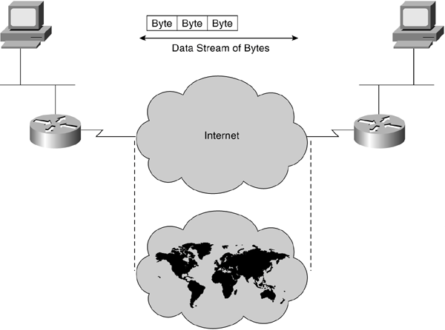

TCP/IP Protocol Mapped to the OSI Model
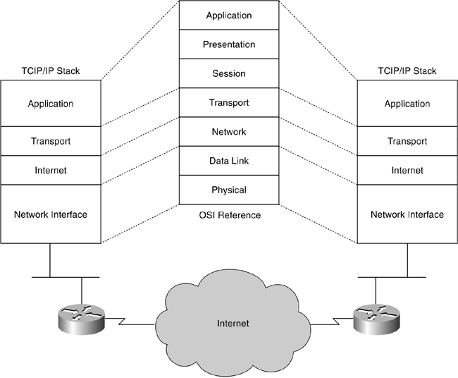

IP

The IP layer of the TCP/IP stack corresponds to the OSI network layer. IP is a connectionless protocol providing routing of datagrams in a best-effort manner. The IP datagram is a combination of a number of bytes (IP header) that prefixes the data received from the transport (and higher) layer.
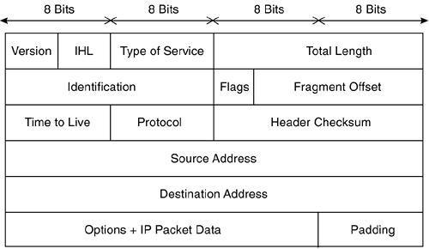

IP addressing (both the source IP address and the destination IP address) is used to identify the end stations involved in the transport of datagrams for communication.

End stations with source IP addresses and destination IP addresses on the same segment have direct delivery of packets. When source and destination end stations are not on the same network, there can be multiple paths. Path selection and decision is made by specialized computer systems whose primary function is routing network traffic. These systems are referred to as routers for the remainder of this book.

IP fragmentation offset is used to keep track of the different parts of a datagram. Splitting larger datagrams may be necessary as they travel from one router to the next router in a small packet network, for example, because of interface hardware limitations. The information or content in the offset field is used at the destination to reassemble the datagrams. All such fragments have the same Identification field value, and the fragmentation offset indicates the position of the current fragment in the context of the original packet. Also important to keep in mind is the existence of the IP Options field. This makes the IP header variable in length.

IP Header Fields

Header Field | Description
Version | Indicates the format of the Internet header (4 bits)
Internet Header Length (IHL) | Specifies the length of the Internet header in 32-bit words (4 bits)
Type of Service | Provides an indication of the abstract parameters of the quality of service desired (8 bits)
Total Length | Specifies the length of the datagram, measured in octets (16 bits
Identification | Value assigned by the sender to aid in assembling the fragments (16 bits)
Flags | Various control flags (3 bits)
Fragment Offset | Indicates where in the datagram this fragment belongs (13 bits)
Time to Live | Indicates the maximum time the datagram is allowed to remain in the Internet system (8 bits)
Protocol | Indicates the next level protocol used (8 bits)
Header Checksum | A checksum on the header (16 bits)
Source Address | The source IP address (32 bits)
Destination Address | The destination IP address (32 bits)
Options | The Options field is variable in length
Padding | Internet header padding used to ensure that the Internet header ends on a 32-bit boundary

TCP

The TCP or transport layer of the TCP/IP stack corresponds to the OSI transport layer. TCP is a connection-oriented protocol providing delivery of segments in a reliable manner. Some TCP characteristics are highlighted in the next section because they might be used to exploit some vulnerability in the TCP/IP protocol suite.

The TCP segment is a combination of a number of bytes (TCP header) that prefixes the data received from the upper layers.

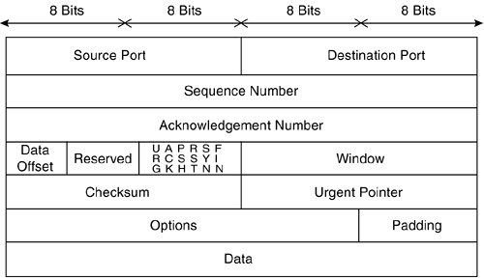

TCP uses port or socket numbers to pass information to the upper layers. This mechanism enables the protocol to multiplex communication between different processes in the end stations. In other words, the port numbers keep track of the different conversations crossing the network at the same time. Port numbers assigned by the operating system are also called sockets

Application Layer | Port Number
FTP | 21
Telnet | 23
SMTP | 25
HTTP | 80
HTTPS | 443

An established connection between two end stations can be uniquely identified by four parameters: source and destination IP addresses and source and destination port numbers. It is important to understand the underlying mechanism in order to configure extended access lists on routers to implement pass/block filtering decisions based on these numbers. Firewalls can also be configured to filter based on TCP ports.

Data exchange using TCP does not happen until a three-way handshake has been successfully completed. The connection needs to be initialized or established first on sequence numbers. These numbers are used in multiple packet transmissions for reordering and to ensure that no packets are missing. The Acknowledgment number defines the next expected TCP octet and is used for reliability of the transmission. The sequence number in combination with the Acknowledgment number serves as a ruler for the sliding window mechanism. This sliding window mechanism uses the window field to define the size of the receiving buffers. In other words, the window field is used to define the number of octets that the sender is willing to accept.

TCP/IP Security Issues

Now that you understand some parameters of the TCP/IP protocol stack, it is easy to understand that the TCP/IP suite has many design weaknesses. Most of its weaknesses are likely because the development of the protocol dates from the mid-1970s. Vendors of network equipment and operating systems have made code improvements over time to disable many of the attacks that are described in the following sections.

IP Address Spoofing

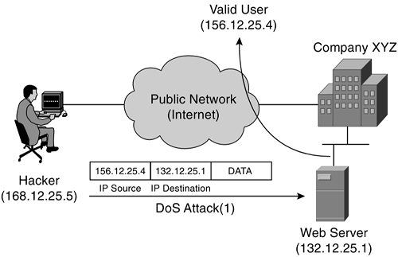
In this type of attack, the attacker replaces the IP address of the sender, or in some rare cases the destination, with a different address. IP spoofing is normally used to exploit a target host. In other cases, it is used to start a denial-of-service (DoS) attack. In a DoS attack, an attacker modifies the IP packet to mislead the target host into accepting the original packet as a packet sourced at a trusted host. The attacker must know the IP address of the trusted host to modify the packet headers (source IP address) so that it appears that the packets are coming from that host.

Let's now assume that a DoS attack is launched from the attacker's workstation on Company XYZ's web server using IP spoofing. Imagine that a spoofed IP address of 156.12.25.4 is used by the workstation, which is a valid host. Company XYZ's web server executes the web page request by sending the information or data to the IP address of what it believes to be the originating end station (156.12.25.4). This workstation receives the unwanted connection attempts from the web server, but it simply discards the received data. It's becoming clear that multiple simultaneous attacks of this sort deny the use of service that the web server provides to valid users. As you can imagine, locating the origin of the attacker launching the DoS attack is very complex when IP address spoofing is used.

Covert Channels

A covert channel can be best described as a pipe or communication channel between two entities that can be exploited by a process or application transferring information in a manner that violates the system's security specifications.

More specifically for TCP/IP, in some instances, covert channels are established, and data can be secretly passed between two end systems. Let's take Internet Control Message Protocol (ICMP) as an example. In the following types of circumstances, ICMP messages are sent to provide error and control mechanisms:
  - Testing connectivity/reachability using datagramsecho and Echo-Reply messages
  - Reporting unreachable destinations for datagramsDestination Unreachable message
  - Reporting buffer capacity problems for forwarding datagramsSource Quench message
  - Reporting route changes in the path for datagramsRedirect messages

ICMP resides at the Internet layer of the TCP/IP protocol suite and is implemented in all TCP/IP hosts. Based on the specifications of the ICMP Protocol, an ICMP Echo Request message should have an 8-byte header and a 56-byte payload.
The ICMP Echo Request packet should not carry any data in the payload. However, these packets are often used to carry secret information. The ICMP packets are altered slightly to carry secret data in the payload. This makes the size of the packet larger, but no control exists in the protocol stack to defeat this behavior.

The alteration of ICMP packets gives intruders the opportunity to program specialized client-server pairs. These small pieces of code export confidential information without alerting the network administrator. Blocking ICMP packets that exceed a certain limit size is the only solution to protect against this vulnerability.

An example of a tool that uses this covert channel technique is Loki. The concept of the Loki tool is simple: It is a client-server application that tunnels arbitrary information in the data portion of ICMP_ECHO and ICMP_ECHO REPLY packets. Loki exploits the covert channel that exists inside of ICMP_ECHO traffic.

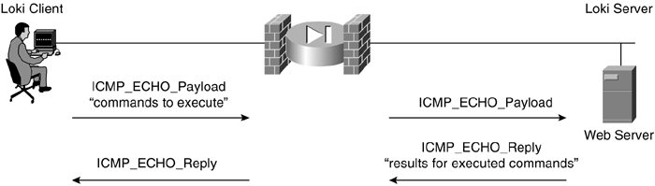

IP Fragment Attacks

The TCP/IP protocol suite, or more specifically IP, allows the fragmentation of packets. IP fragmentation offset is used to keep track of the different parts of a datagram. The information or content in this field is used at the destination to reassemble the datagrams. All such fragments have the same Identification field value, and the fragmentation offset indicates the position of the current fragment in the context of the original packet.

Let's go into a little more detail. The ingeniously constructed second fragment of a packet can have an offset value that is less than the length of the data in the first fragment. Upon packet reassembly at the end station, the second fragment overrides several bytes of the first fragment. These malformed IP packets cause the operating system at the end station to function improperly or even to crash.

A good example of an IP fragmentation attack is the Ping of Death attack. The Ping of Death attack sends fragments that, when reassembled at the end station, create a larger packet than the maximum permissible length.

One of the uses of this attack is to get past intrusion detection system (IDS) sensors. The individual fragments do not match any known signature, but after the overlap addresses overwrite some data, the result is an attack that can be recognized. A decent IP filtering code and configuration are required at the access router and firewalls to be assured that these attacks are blocked. These devices need to enforce a minimum fragment offset for fragments that have nonzero offsets so that overlaps can be prevented.

TCP Flags

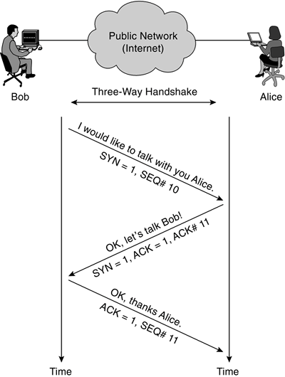
As discussed previously, data exchange using TCP does not happen until a three-way handshake has been successfully completed. This handshake uses different flags to influence the way TCP segments are processed. There are 6 bits in the TCP header that are often called flags. Six different flags are part of the TCP header: Urgent pointer field (URG), Acknowledgment field (ACK), Push function (PSH), Reset the connection (RST), Synchronize sequence numbers (SYN), and sender is finished with this connection (FIN).

Bob wants to start talking with Alice, so he initiates the TCP session with the SYN bit (flag) set in the first TCP segment. If Alice is happy to talk to Bob, she responds with the SYN flag and ACK flag set to 1. If she is unwilling to talk to Bob, she responds with an RST (reset) flag set to 1.

Abuse of the normal operation or settings of these flags can be used by attackers to launch DoS attacks. This causes network servers or web servers to crash or hang. The attacker's ultimate goal is to write special programs or pieces of code that are able to construct these illegal combinations resulting in an efficient DoS attack.

SYN | FIN | PSH | RST | Validity
1 | 1 | 0 | 0 | Illegal combinations
1 | 1 | 1 | 0 | Illegal combinations
1 | 1 | 0 | 1 | Illegal combinations
1 | 1 | 1 | 1 | Illegal combinations

Connection Hijacking(steal)

TCP connections can be hijacked by unauthorized users without much difficulty. In the following figure, an authorized user (Employee X) sends HTTP requests over a TCP session with the web server.

The web server accepts the packets from Employee X only when the packet has the correct SEQ/ACK numbers. As seen previously, these numbers are important for the web server to distingish between different sessions and to make sure it is still talking to Employee X. Imagine that the cracker starts sending packets to the web server spoofing the IP address of Employee X, using the correct SEQ/ACK combination. The web server accepts the packet and increments the ACK number.

In the meantime, Employee X continues to send packets but with incorrect SEQ/ACK numbers. As a result of sending unsynchronized packets, all data from Employee X is discarded when received by the web server. The attacker pretends to be Employee X using the correct numbers. This finally results in the cracker hijacking the connection, whereby Employee X is completely confused and the web server replies assuming the cracker is sending correct synchronized data.

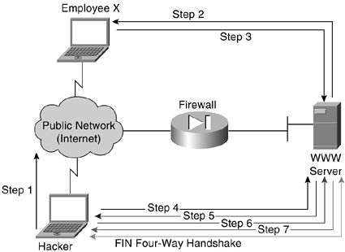

Attack Taxonomy

Attack taxonomies are almost always inaccurate in some way. They either create conditions in which attacks exist in more than one category or conditions in which a given attack doesn't have a clear home. These attacks are referenced throughout the remainder of the book. The main families (also called classes) of attacks are as follows:

  - Read Gain access to unauthorized information
  - Manipulate Modify information
  - Spoof Provide false information or offer false services
  - Flood Overflow a computer resource
  - Redirect Change the flow of information
  - Composite Comprise more than one listed method

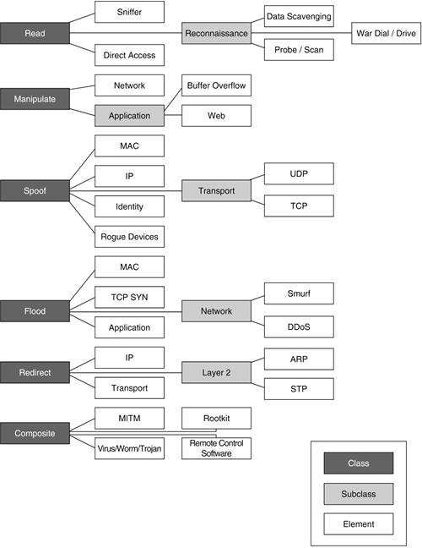


Cryptography

Crypto Basics

The word cryptography comes from two Greek words meaning "secret writing" and is the art and science of concealing meaning. Cryptanalysis is the breaking of codes. The basic component of cryptography is a cryptosystem.

Cryptography is about scrambling data so that it looks like babble to anyone except those who know the trick to decoding it. Almost anything in the world can be hidden from sight and revealed again.

Cryptography is the art of concealing information.

The magician David Copperfield has made his living from hiding enormous things from plain view — like elephants and the Statue of Liberty — and then magically revealing them again.

Any magician will tell you that in order to make things disappear and appear again, you have to have a plan of action — a formula or recipe — to make the magic work.

In cryptography, the magic recipe for hiding data is called an algorithm. An algorithm is a precise set of instructions that tells programs how to scramble and unscramble data.

Why?

Computers and use of the Internet have fostered new interest in cryptography partly due to the new emphasis on personal privacy. Little did I realize that in our efforts to make it easy for computers to share stuff, it would make it easy for other people to see all of our personal stuff, too. Perhaps you’ve discovered for yourself that it is far too easy for unknown persons to read your e-mail, private documents, love letters, financial information, and so on.

The Internet is truly the Global Village . . . a village where everyone can see what you do and hear what you say. The good news is that you can use cryptography to protect yourself from the eavesdroppers and Peeping Toms of the village.

Not only can cryptography scramble your files, but it can also be used to prove who you are (and maybe who you aren’t!).

Cryptography can be used to alert you if the contents of a file have been changed, attest to the identity of the person who sent you a message, keep online communications safe and secure, and, of course, hide important data.

And the best news of all is that not every cryptographic solution is expensive, and you don’t need to be a rocket scientist to incorporate crypto solutions into your network.

Cryptographic Protocols!

Plus throw some math at the problem!
    - Messages should get to destination
    - Only the recipient should see it
    - Only the recipient should get it
    - Prof of the sender’s identity
    - Message shouldn’t be corrupted in transit
    - Message should be sent/received once

Terminology

Plaintext, clear text: an “unhidden message”

Encrypt: transform a message to hide its meaning

Ciphertext: encrypted message

Cipher: cryptographic algorithm

Decrypt: recover meaning from encrypted message

Cryptography: art/science of keeping message secure

Cryptanalysis: art/science of breaking Ciphertext

Cryptology: study of both cryptography and cryptanalysis

Key: A complex sequence of alpha-numeric characters, produced by the algorithm, that allows you to scramble and unscramble data.

Encryption and Decryption

Decryption
Method
plaintext, cleartext
ciphertext
Encryption Method
ciphertext
plaintext, cleartext

Definition

A cryptosystem is a 5-tuple (E, D, M, K, C), where:
  - P plaintext
  - C ciphertext
  - E encryption function
  - D decryption function
  - K a set of keys

Some algorithms use the same key for encryption and decryption :
EK(P) = C
DK(C) = P

Some algorithms use a different encryption key and decryption key :
EK1(P) = C
DK2(C) = P

Understanding physical cryptography

In general, physical cryptography refers o any method that does not alter the value using a mathematical process.

Physical cryptography includes several approaches . The most common methods involves transposition or substation of characters or words. Physical cryptography include a method of encryption called stegangraphy, which is the science of hiding information within other information , such as a picture.

A cipher is a method used to encode characters o hide their value. Ciphering is the process of using a cipher to encode a message

Substitution ciphers

Just as it sounds, a substitution cipher substitutes one letter or character for another. As a child you may have gotten a secret decoder ring from an offer on a cereal box or chocolate milk powder. The decoder ring consisted of two dials, both containing all the letters of the alphabet. The trick was to twirl one dial around the other so that the letters of the alphabet did not match up. Then you found the letter you wanted to use on one ring and substituted the letter on the other ring. Carry on letter by letter and then you have a secret message. Although this is technically not a ring shown below, here’s an example of how the substitutions would line up:

A B C D E F G H I J K L M N O P Q R S T U V W X Y Z
S T U V W X Y Z A B C D E F G H I J K L M N O P Q R

Using the graph above, you would locate your letter and then substitute it with the letter directly below it. Therefore, the phrase:

ATTACK AT DAWN AT THE NORTHERN BRIDGE
would become:
SLLSUC SL VSOF SL LZW FGJLZWJF TJAVYW

Of course to decrypt your message, your intended recipient would also have to have a decoder ring and he would need to know how far to twirl his dial so it matched yours. This number would indicate the switch in letters — and it is also the key to decrypting the message. In the example above, the switch is 18 letters to the right of the letter A; therefore, the key is “18.” This cipher is probably one of the best known in the world and is also referred to as the “Caesar Cipher” because of historical references linking Julius Caesar and this type of cipher.

The Caesar cipher is the widely known cipher in which letters are shifted. For example, if the key is 3, the letter A becomes D, B becomes E, and so forth, ending with Z becoming C. So the word "HELLO" is enciphered as "KHOOR." Informally, this cipher is a cryptosystem with:
  - M = { all sequences of Roman letters }
  - K = { i | i an integer such that 0 i 25 }
  - E = { Ek | k K and for all m M, Ek(m) = (m + k) mod 26 }
  - Representing each letter by its position in the alphabet (with A in position 0), "HELLO" is 7 4 11 11 14; if k = 3, the ciphertext is 10 7 14 14 17, or "KHOOR."
  - D = { Dk | k K and for all c C, Dk(c) = (26 + c k) mod 26 }
  - Each Dk simply inverts the corresponding Ek.
  - C = M
  - because E is clearly a set of onto functions.

Write a complete C# application to implement the Caesar cipher for different values of keys.

Transposition ciphers V.Important

One of the oldest known ciphers is called a transposition cipher. This type of cipher changes the order of the letters of the original message. One method is to write the message in a series of columns and rows in a grid — or you could write the message backwards.

While substitution ciphers preserve the order of the letters used in the message, transposition ciphers reorder the letters. Transposition ciphers are rarely used nowadays, but they have been very important in the past. Although there are literally hundreds of different types, I’m going to show you one of the simpler ones. You can do this one yourself — all you need is paper and a pencil.

The encrypted message gets to you looking like this:

GRYSO IISAU VNTFS EKOEE EEAHX

The key to this cipher is a block grid. If you know how many rows and columns are on the grid, then you can decrypt the message. Looking at the grid below, can you see how the message was created and what the message really says?

GRYSO IISAU VNTFS EKOEE EEAHX

G | I | V | E | E
R | I | N | K | E
Y | S | T | O | A
S | A | F | E | H
O | U | S | E | X

Solution: if you read down the columns, you see the encrypted message. If you read across the rows, you can decrypt the message, which reads:

GIVE ERIN KEYS TO A SAFEHOUSE X.

You may have noticed that the encrypted message did not match the same spacing as the decrypted message. That’s done on purpose to (hopefully) confuse you further. If you don’t know where one word starts and another begins, it makes it harder for a casual viewer to make any sense of what’s written. In many old encrypted messages you’ll note that the messages are in all caps and are written out in groups of five letters.

The German Enigma cipher machine

The most commonly known substitution cipher is the Enigma machine that was used by the Germans in World War II to encrypt their secret military messages. The Enigma machine looked roughly like a typewriter except that it had a number of different rotors, sort of like the odometer on your car. These rotors were placed next to one another on a shaft and then spun to set the shift in letters for substitution. But because there was more than one substitution involved, the messages were even more scrambled than using the single substitution I used in the example above.

The Enigma machine was one of the first usages of a strong cipher. It took the concerted effort of many nations, many minds, and a number of years to finally crack the Enigma code.

Understanding mathematical cryptography

Mathematical cryptography deals with the mathematical process on characters or messages. The most common is a function called hashing.

A hash is not meant to be decrypted. “What,” you say? That’s right. A hash is what is referred to as a one-way function — you use a hash to encrypt something, but the result is never decrypted.

The purpose of a hash is to create a “fingerprint” of your data. The hash algorithm goes through its permutations, and the result is a bunch of alpha-fixed lengths.) The purpose of a hash is to prove the integrity of the data (encrypted or not) that has been sent. When you receive the data, the hash is included at the bottom of the data. You can run the same hash algorithm against the data you receive, and if the data has not been changed en route, you will get the same set of alpha-numeric characters. If your result is not the same, then something happened during the transmission and the data you received was changed from the original.

Hashing refers to the performing a calculation on a message and converting it into a numeric hash value.
Example:

Encryption algorithm: Multiply the plaintext by 2, adding those results together, and then dividing the sum
by 10.
  - Message: this
  - ASCII values: 116 104 105 115
  - Calculated values:232 208 210 230
  - Hash value calculation: (232+208+210+230/10)
  - Hash value:88

XOR what?

Now I’ll probably be slammed by all the brilliant crypto-geeks in the world for putting XOR here because it is not really a cipher. It’s actually a mathematical operation. I’ll justify putting it here because a majority of modern algorithms use the XOR operation during the encryption process.

Yes, the operation is pronounced just like it looks: Ex-Or. XOR stands for Exclusive-Or. it’s one of those things that you are bound to hear associated with modern cryptography.

Example:
  - Plaintext = baby = 01100010 01100001 01100010 01111001
  - XOR key = data = 01100100 01100001 01110100 01100001
  - Ciphertext = ???? 00000110 00000000 00010110 00011000

you can get back to the plaintext by reversing the operation:
  - Ciphertext =???? 00000110 00000000 00010110 00011000
  - XOR key = data = 01100100 01100001 01110100 01100001
  - Plaintext = baby = 01100010 01100001 01100010 01111001

Breaking Ciphers

One big problem with ancient ciphers is that they were easily figured out, and the secret messages weren’t secret for very long. As cryptography got more complex, the secret messages stayed secret for a longer period.

Cryptanalysis is the art of breaking ciphers, and the National Security Agency (NSA) is renowned as one of the world’s largest employers of cryptanalysts. The CIA is also very into crypto (which makes sense, as they are the home of spy versus spy), and they have a crypto challenge for anyone who wants to give it a try. When the new CIA headquarters was built in 1990, a sculpture called “Kryptos” was installed in front of the main entrance. The sculpture is an encrypted message. Part of the code has been cracked, but the man who got it spent more than 400 hours on it before he even got close to cracking just the first part. He finally managed all but the last 97 characters.

Key-length is mentioned a lot in books and articles about cryptography. That’s because the longer the key (drum roll, please), the harder it is to guess what the key is!

Known plaintext
  - If you know for certain both a plaintext word and its cipher text mate in a message, it can make cracking the message a piece of cake. For example, if you look at an encrypted message with a string of characters like XROL and you know that it means CAKE, you can go through the entire message substituting all the Xs with Cs, Rs with As, and so on. If nothing else, it can certainly give you a clue as to what the words might be. It’s kind of like playing Wheel of Fortune. If you play around with these variations long enough, you might just discover the key for the entire message.
Pattern recognition
  - The first thing you look for when you’re trying to break a code is a pattern in the encrypted message. For example, the letter E is the most commonly used letter in the English language, so you look for a letter in the message that is used more than any of the others. That may indicate that that particular letter is actually the letter E. Failing that, the second most common letter in the English language is the letter T.
  - Finding a pattern was part of the solution for the man who has partially cracked the Krypton sculpture at the CIA headquarters building (which I talk about a couple sections back). He looked long and hard for a grouping of letters that would correspond to the word the. Because the is extremely common in the English language, it’s usually a safe bet to start there, and many cryptanalysts do.

What a brute (شخص وحشي‏)
  - If you’ve failed to decrypt a secret message by trying to figure out the key or by looking for patterns, you might just try banging your head against the wall. Brute force might just work.
  - I’m kind of joking and kind of not when I list brute force as a method of breaking an encrypted message or file. Actually it’s done quite often thanks to computers getting faster and the ability of linking computers together for strength and will power. In some cases, computers working in parallel can be more powerful than one of the most powerful computers used by the NSA.
  - Brute force is a trial and error method of trying every possible combination of characters against the encrypted data in an attempt to discover the key. That’s one of the reasons I always stress that you use the longest keys possible. For example, a 56-bit key has 256 possible keys. That’s more than 72 quadrillion keys that must potentially be tried in order to find the correct one. You might think that, given those numbers, a 56-bit key would be pretty safe then. Wrong. In 1997, a distributed computing effort cracked the RSA’s 56-bit RC5 encryption in less than 250 days. One of the more famous brute force cracks was that of the DES algorithm. Many people didn’t think it was possible to crack DES by using brute force, and everyone in the crypto world was talking about it when it happened.

Types of attacks

The goal of cryptography is to keep enciphered information secret. Assume that an adversary wishes to break a cipher text. Standard cryptographic practice is to assume that she knows the algorithm used to encipher the plaintext, but not the specific cryptographic key (in other words, she knows D and E). She may use three types of attacks:
  - In a cipher text only attack, the adversary has only the cipher text. Her goal is to find the corresponding plaintext. If possible, she may try to find the key, too.
  - In a known plaintext attack, the adversary has the cipher text and the plaintext that was enciphered. Her goal is to find the key that was used.
  - In a chosen plaintext attack, the adversary may ask that specific plaintexts be enciphered. She is given the corresponding cipher texts. Her goal is to find the key that was used.

Cryptosystems

By definition, a cryptosystem is the combination of three elements: the encryption engine, keying information, and operational procedures for their secure use. In other words, almost every encryption program can be considered a cryptosystem because it has everything together in one package.
  - The encryption engine is the part of the software that starts the encryption with the selected algorithm.
  - The keying system is the portion of the software that creates (and sometimes manages) the keys needed to encrypt and decrypt data.
  - The operational procedures are how all of these parts interact and how the output, or result, is formatted and what file extension (if any) is used.

So, almost every encryption product you buy off the shelf is, in a sense, a cryptosystem. Some people may argue that a cryptosystem is the complete infrastructure of encryption programs, hardware, and network connections, but I’ll stick to the more traditional definition.

Many of the self programs include more than one algorithm for you to use for encryption. Usually these programs give you a one type of algorithm — such as symmetric or asymmetric algorithms — for you to decide upon. Sometimes you’ll see a drop-down list of the algorithms for use, or there will be a configuration setting in which you choose which you care to use. it’s safe to say that they come in two types: symmetric, which means one key is used, and asymmetric, which means two keys are used.
Because symmetric algorithms work much faster than asymmetric algorithms, some cryptosystems use both types in their software package. This is referred to as hybrid cryptosystems. Usually with this type of system asymmetric algorithms are used to exchange two keys between sender and recipient, and a symmetric algorithm actually does the encryption.
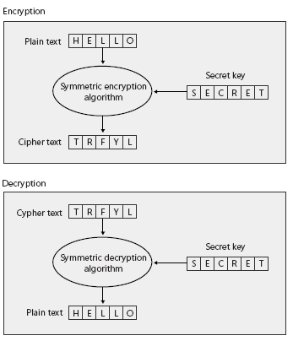
Encrypting and Decrypting Data with Symmetric Keys

Symmetric key encryption, also known as secret-key encryption, is a cryptography technique that uses a single secret key to both encrypt and decrypt data. Symmetric encryption algorithms (also called ciphers) process plain text with the secret encryption key to create encrypted data called cipher text. The cipher text cannot easily be decrypted into the plain text without possession of the secret key.

Symmetric algorithms are extremely fast and are well suited for encrypting large quantities of data. Even though symmetric encryption is very secure, an attacker can identify the plain text, given the cipher text and enough time. To identify the plain text, the attacker needs to use only a brute force attack to sequentially generate symmetric keys until the attacker has tried every single possibility. Typically, the time required to try all keys is hundreds of years, if not longer, because the attacker would need to try at least 256 key possibilities. More secure symmetric algorithms use longer keys that would take exponentially longer to crack.

The disadvantage of secret-key encryption is that it presumes that two parties have already agreed on a key. Agreeing on a symmetric key is a challenge because the key itself cannot be encrypted. If you’ve decided to use encryption, it must be because you don’t trust your system to prevent an attacker from gaining access to your data. Therefore, users must find a secure way to exchange secret keys. After the secret keys are exchanged, encrypted data can be freely exchanged between the parties. However, keys should be changed on a regular basis for the same reasons that passwords should be changed regularly. Each time the key must be changed, users must resort to the secure communication mechanism.

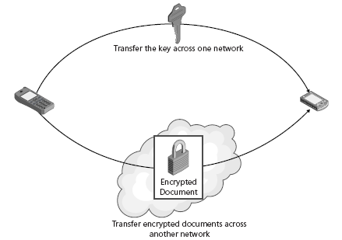
Keys are often transferred by voice across the phone network, sent physically through the mail system, or carried to the recipient. After the shared secret has been established, the two peers can use it to encrypt and decrypt any number of messages.

DES
  - DES stands for Digital Encryption Standard and was created in 1975 with some assistance from the National Security Agency (NSA). In 1981, DES became an accepted standard and was widely used. DES is a block cipher that uses a 56-bit key to create the key table. Then it goes through the process of combining a key from the key table with the block of plaintext. After the key and the plaintext have been combined, DES goes through 16 more changes (called rounds) to thoroughly mix up the ciphertext. To decrypt the data, DES just goes through all the changes in reverse order.

  - Given that a 56-bit key has about 72 quadrillion different combinations of numbers, most people felt that DES would be secure for a very long time. What people failed to consider was that computers got faster and cheaper and that it wouldn’t cost very much to create a computer specifically to break DES. In 1999, DES was broken in less than 24 hours on a specially built computer.

Triple DES
  - Many years before DES was broken, cryptographers began working on its replacement. It wasn’t that DES was badly flawed; it was that the crypto community could see the end coming and they wanted to be prepared. So Triple DES (also referred to as 3DES) was created. Because a lot of software and hardware was already coded with DES, it made sense to make changes to an algorithm that was already in use, rather than creating an entirely new one. In that way, many of the older products were able to upgrade to 3DES (or a very similar variant) without having to completely rebuild the hardware or software.
  - As its name implies, Triple DES does something three times more than normal DES. That triple threat comes from using three keys on each block of plaintext. Instead of using one 56-bit key from the key table, Triple DES encrypts the plaintext with the first key, encrypts that ciphertext with another 56-bit key, and then encrypts the ciphertext with another 56-bit key. That may seem like overkill, but it works. 3DES is also able to work with longer keys to make it more secure. The most commonly longer key lengths (at present) are 112 bits and 168 bits.

  - In order to crack this algorithm you would need to figure out three separate keys. Not only that, but the ciphertext will decrypt only when all three correct keys are used and in the correct order. It might be possible to guess one key, but you’d never know if it was correct until you combine it with the other two keys. The number of permutations is outrageously high, and no one wants to spend that amount of time attacking something of unknown value. What if you went to all the trouble to find all three keys, in the correct order, only to find the data was an e-mail message reminding everyone that there was leftover birthday cake in the break area? A lot of effort spent on nothing, I’d say.

AES
  - AES stands for Advanced Encryption Standard. Many expect this algorithm to be the heir apparent to DES and 3DES. It’s the first algorithm that was created through organized competition.

  - The contest was announced by NIST (National Institute of Standards and Technology) in 1997 in an attempt to find a good algorithm that would become the next government standard. In 1998, the list of competing algorithms had been whittled down to 15 candidates. Then the heavy duty testing began. The contestants began dropping like flies as weaknesses were found in most of the algorithms under consideration. By 1999, the cast of players had been cut to just five and another round of testing began.
  - Late in 2000, NIST announced it had a winner — an algorithm called Rijndael (after Vincent Rijmen and Joan Daemen, pronounced rine-doll). It had survived all the tests, and people generally liked the way it worked. The government has called it their Advanced Encryption Standard (AES), but it isn’t quite the standard in the real world yet. Again, because it’s relatively new, there is some distrust and a feeling that it has not been tested enough for weaknesses. Regardless, there are products on the market that openly use AES and will continue to do so until it’s proven weak or breakable.

Symmetric Algorithm Classes in the .NET

Most of the .NET Framework’s cryptography functionality is built into the System. Security.Cryptography namespace, including the four implementations of symmetric encryption algorithms

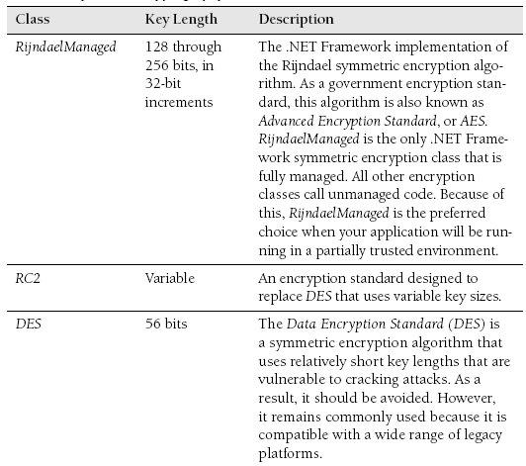
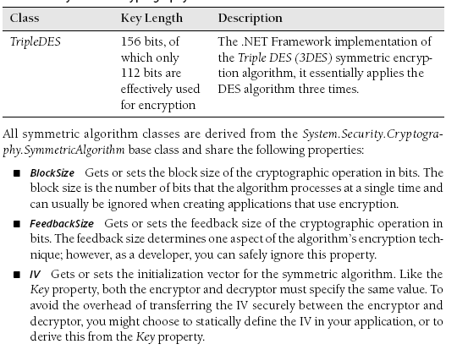
■ Key Gets or sets the secret key for the symmetric algorithm. Keys are automatically generated if you have not specifically defined them. After encryption, you must store this value and transfer it to the decryptor. During decryption, you must specify the same key used during encryption.

■ KeySize Gets or sets the size of the secret key used by the symmetric algorithm
m in bits. When you create a symmetric algorithm object, the runtime will choose the largest key size supported by the platform. As a result, you can usually ignore this property. However, if the message’s recipient does not support the same key sizes as the sender, you must set this property to the highest value supported by both the encryptor and the decryptor.

LegalBlockSizes A KeySizes array that gets the block sizes that are supported by the symmetric algorithm. Each array member contains MinSize and MaxSize properties, which define the valid key ranges in bits; and a SkipSize property that specifies in bits the interval between valid key sizes.

LegalKeySizes A KeySizes array that gets the key sizes that are supported by the symmetric algorithm. Each array member contains MinSize and MaxSize properties that define the valid key ranges in bits, and a SkipSize property that specifies the interval between valid key sizes in bits.

Mode A property set to one of the CipherMode enumeration values that determines one aspect of the encryption algorithm’s behavior. This property is usually set to Cipher Block Chaining (CBC), the default. You should usually leave this set to CBC. If you do change this value, you must change it at both the encryptor and decryptor.
Padding A PaddingMode enumeration value, this property determines how the encryption algorithm fills out any difference between the algorithm’s block size and the length of the plain text. You should generally not change this property.

Additionally, the symmetric algorithm classes each share the following methods (standard object methods have been omitted):
  - CreateDecryptor To decrypt messages, you must create a symmetric algorithm object and call this method to create an ICryptoTransform object that a Crypto-Stream object can use to decrypt the stream.
  - CreateEncryptor Creates a symmetric encryptor object used by CryptoStream objects to encrypt a stream.
  - GenerateIV Generates a random IV to be used for the algorithm. Generally, there is no need to call this method because IVs are automatically randomly generated unless you specifically define them. You will call this method only if you have defined IV and later need to use a different random IV.
  - GenerateKey Generates a random key to be used for the algorithm. Like GenerateIV, you need to call this method only if you have already defined the Key property and later need to use a random key.
  - ValidKeySize Determines whether the specified key size is valid for the current algorithm and returns a Boolean value. Use this method when you are working with an unknown symmetric algorithm class to verify that your key is valid for the given algorithm.

BEST PRACTICES choosing a symmetric key algorithm

  - Use the Rijndael algorithm whenever both the encryptor and decryptor are running on Windows XP or later operating systems; otherwise, use Triple DES. Out of all symmetric-key algorithms supported by the .NET Framework, the U.S. government–approved Rijndael algorithm is considered the most secure. This algorithm supports 128-, 192-, and 256-bit keys. Another reason to choose Rijndael is that it is the only implementation that is natively supported by the .NET Framework. The other algorithms must make calls to unmanaged code.

How to Establish a Symmetric Key

Before you can encrypt and decrypt messages by using symmetric encryption, both the encryptor and decryptor must have the same key. You can’t use just any piece of data as a key, however. Symmetric encryption algorithms must use keys of a specific length, so you cannot simply set the Key property to a user-provided password. To generate a random key, simply create and use a symmetric algorithm object. If you specify a value for the Key property and later want to use a random key, call the GenerateKey method.

You can also generate a valid key based on a user-provided password if you can rely on users to transfer the password between the encryptor and decryptor. You cannot directly use passwords as encryption keys, but you can use the System.Security.Cryptography.Rfc2898DeriveBytes class to turn a password into a key. This is particularlyuseful when a shared secret has already been established between an encryptor and a decryptor. For example, if you create a custom authentication mechanism and your application is privy to the user’s user name and password, you could concatenate the user’s own user name and password to derive the same key at both the encryptor and decryptor.

Rfc2898DeriveBytes requires three values in addition to the user’s password: a salt value, an IV, and the number of iterations used to generate the key. Ideally, all these values are randomly generated. Changing any of these values produces a different key, requiring you to use the same values at both the encryptor and decryptor. Therefore, when random values are used, the values must be exchanged in the same way the password is exchanged. For this reason, it is usually not possible to securely exchange these values in addition to the password. Instead, you can specify static values that both the encryptor and decryptor applications have stored within their source code, but it is more secure to generate the values based on other shared secret information, such as the password.

Creating symmetric keys based on a password requires several different values to be synchronized between the encryptor and decryptor:
  - The password
  - The salt value

The number of iterations used to generate the key (or you can accept the default)

The simplest way to specify these values is to pass them to the Rfc2898DeriveBytes constructor. After initialization, you can retrieve a key by calling the Rfc2898DeriveBytes .GetBytes method. GetBytes accepts the number of bytes to return as an integer. When deriving a key, determine the length based on the number of bits required by the algorithm object’s KeySize and BlockSize properties. Note that both KeySize and BlockSize are defined as a number of bits, whereas the Rfc2898DeriveBytes.GetBytes method requires a number of bytes. You must divide the number of bits required for the key by 8 to determine the number of bytes required.

Besides the key, the encryption algorithm must also have the same IV specified at both the encryptor and decryptor. For optimal security, when only a password is shared between the encryptor and decryptor, you should also generate the IV based on the password. Whereas the length of the key being generated must be based on the KeySize property, the length of the IV must be based on the encryption algorithm’s BlockSize property.

The following sample code generates a key and IV for the myAlg SymmetricAlgorithm object using a static password, which should be provided by the user in practice:

// In practice, the user would provide the password

string password = "P@S5w0r]>";

// Create an algorithm object

RijndaelManaged myAlg = new RijndaelManaged();

// Derive the key and use it to define the algorithm

byte[] salt = Encoding.ASCII.GetBytes("This is my sa1t");
Rfc2898DeriveBytes key = new Rfc2898DeriveBytes(password, salt);
myAlg.Key = key.GetBytes(myAlg.KeySize / 8);
myAlg.IV = key.GetBytes(myAlg.BlockSize / 8);

How to Encrypt and Decrypt Messages Using Symmetric Keys

After both the encryptor and decryptor have the same key, they can begin exchanging encrypted messages. The .NET Framework makes this process easy. In fact, using encryption is similar to reading and writing to standard files and streams, and it requires only a few additional lines of code. To encrypt or decrypt messages in your application, perform the following tasks:
- Create a Stream object to interface with the memory or file that you will be reading from or writing to.
- Create a SymmetricAlgorithm object.
- Specify the algorithm’s key, the IV, or both.
- Call SymmetricAlgorithm.CreateEncryptor() or SymmetricAlgorithm.CreateDecryptor() to create a ICryptoTransform object.
- Create a CryptoStream object using the Stream object and the ICryptoTransform object.
- Read from or write to the CryptoStream object just like any other Stream object.
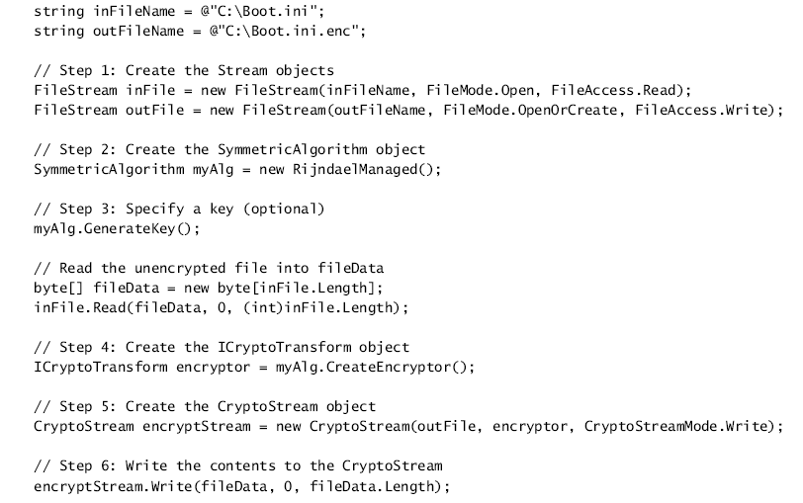
The following console application demonstrates these steps by reading an unencrypted file (the C:\Boot.ini file), encrypting it with the Rijndael algorithm, and saving the encrypted results as a new file. The application requires the System.IO and System.Security.Cryptography namespaces.

Exercises
Lab: Encrypting and Decrypting Files
In this lab, you will write console applications that encrypt and decrypt files using a password. The console applications should take three parameters: the file name of the unencrypted file to read, the file name of the encrypted file to write, and the password.
Exercise 1: Write a Console Application to Encrypt Files
In this exercise, you create a console application that encrypts files using a password.
Exercise 2: Write a Console Application to Decrypt Files
In this exercise, you create a console application that decrypts files using a password.

