Tips , Tricks &Notes
Constants:
1-vbCrLf … Carriage Return & Line Feed As(Enter Key) or
Console.writeline()
2-vbtab … which represents a tab character

- Chap. 5 ::Dietel
1- "{0:C}", the first digit (0) serves the same purpose. The information specified after the colon (:) is called the formatting code. The C (for “currency”) formatting code indicates that its corresponding argument
(amount) should be displayed in monetary format.
2- If (gender = "F" And Console.ReadLine() >= 65) Then
Console.WriteLine("You are a female senior citizen.")
End If
Here, the And operator guarantees that the condition Console.ReadLine() >= 65 is evaluated, so ReadLine is called regardless of whether the overall expression is true or false………. Except of AndAlso which execute the first part (gender = "F") if it true ,execute second part & Call Procedure (Console.ReadLine())

- Chap.6 ::Dietel
- When procedures are contained in a class, we refer to them as methods.
- .NET Framework Class Library (FCL)
- keywords Return and Exit Sub can be used anywhere in a procedure to return control to the point at which a Sub procedure was invoked.
- Remember that all forms inherit from class System.Windows.Forms.Form
5- Visual Basic also provides the IntelliSense feature, which displays all the members in a class. For instance, when the programmer types the dot (.) operator (also called the member access operator) after the class name, Math, in Fig. 6.6, IntelliSense provides a list of all the available methods in class Math.
6- The constant Math.PI (3.14159265358979323846) of class Math is the ratio of a circle’s circumference to its diameter
7- The constant Math.E (2.7182818284590452354) is the base value for natural logarithms (calculated with the Math.Log method).
8- In function Calls : When arguments are enclosed in parentheses, (), a copy of the value of the argument is passed to the procedure, even if the procedure header includes keyword ByRef
9- display the frequency of each roll as percentages using the "P" format code>>>"{0:P}"

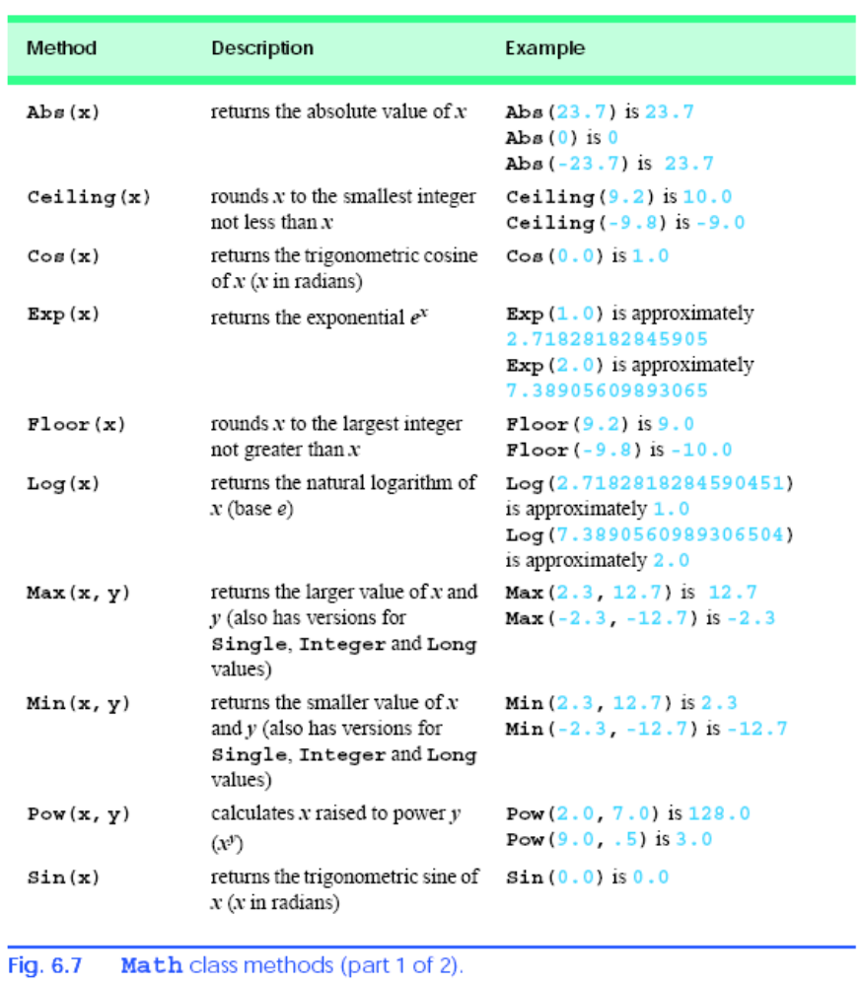
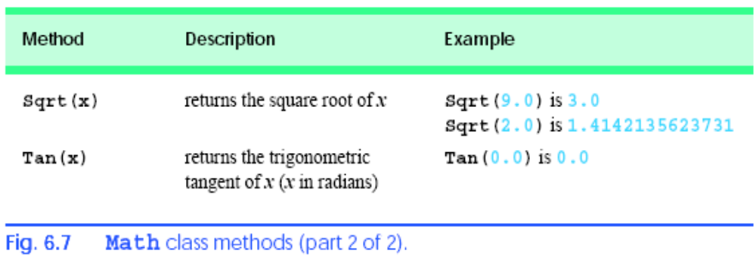

10- passes to the method the format control string "{0}:{1:D2}:{2:D2}", which indicates that argument 0 (the first argument after the format String argument) should take the default format; and that arguments 1 and 2 (the last two arguments after the format String argument) should take the format D2 (base 10 decimal number format using two digits) for display purposes—thus, 8 would be converted to 08. The two colons that separate the curly braces } and { represent the colons that separate the hour from the minute and the minute from the second, respectively.

- Useful Functions:

Property or Function | Description
TimeString | This property returns the current time from the system clock.
DateString | This property returns the current date from the system clock.
Now | This property returns an encoded value representing the current date and time. This property is most useful as an argument for other system clock functions.
Hour (time) | This function returns the hour portion of the specified time (0 through 23).
Minute (time) | This function returns the minute portion of the specified time (0 through 59).
Second (time) | This function returns the second portion of the specified time (0 through 59).
Day (date) | This function returns a whole number representing the day of the month (1 through 31).
Month (date) | This function returns a whole number representing the month (1 through 12).
Year (date) | This function returns the year portion of the specified date.
Weekday (date) | This function returns a whole number representing the day of the week (1 is Sunday, 2 is Monday, and so on).

- Error Handlers:
some errors don’t appear as you might expect them to, so you’ll need to specifically test the error numbers (when possible) by observing how the Err.Number property changes during program execution. Unused error numbers in the range 1–1000 are reserved for future use by Visual Basic .NET.
Error number | Default error message
5 | Procedure call or argument is not valid
6 | Overflow
7 | Out of memory
9 | Subscript out of range
11 | Division by zero
13 | Type mismatch
48 | Error in loading DLL
51 | Internal error
52 | Bad file name or number
53 | File not found
55 | File already open
57 | Device I/O error
58 | File already exists
61 | Disk full
62 | Input past end of file
67 | Too many files
68 | Device unavailable
70 | Permission denied
71 | Disk not ready
74 | Can’t rename with different drive
75 | Path/File access error
76 | Path not found
91 | Object variable or With block variable not set
321 | File format is not valid
322 | Cannot create necessary temporary file
380 | Property value is not valid
381 | Property array index is not valid
422 | Property not found
423 | Property or method not found
424 | Object required
429 | Cannot create Microsoft ActiveX component
430 | Class does not support Automation or does not support expected interface
438 | Object does not support this property or method
440 | Automation error
460 | Clipboard format is not valid
461 | Method or data member not found
462 | The remote server machine does not exist or is unavailable
463 | Class not registered on local machine
481 | Picture is not valid
482 | Printer error

