INCREASED PREDICTION ACCURACY IN THE GAME OF

CRICKET USING MACHINE LEARNING

Everything was implemented in python language

First data collection:

Data was scraped from “[www.cricinfo.com](http://www.cricinfo.com)” by python web scraping tools we used the statics provided on the site for every player to get the data for batting and blowing and was filtered to be just the statics associated for One Day International (ODI) matches only as the paper assumed.

For Example, We will log in to this page and scrap the ODI’s information

.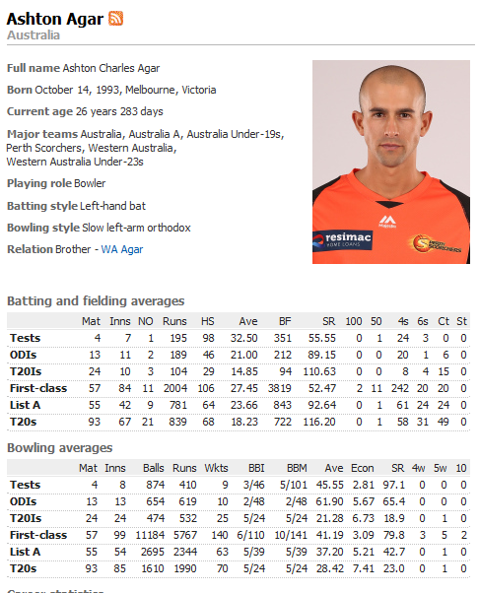

The second important thing to make Data ready before applying ML Algorithms is to generate an output column depends on the paper assumption:

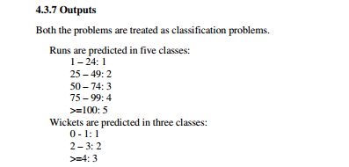

Now, our data were ready

Using scikit-learn library in python all the algorithms

Three different algorithms have been done for batsman classification and the same three algorithms have been made again for bowing classification. Grid search was used to achieve the best performance.

For bowing: “https://colab.research.google.com/drive/1taRIRB2wso3Cr9E3LrAHJ5A9fcFo2tvt#scrollTo=why6ePf32-V0”

Random Forest Decision Tree SVM

Precision: 0.86294 0.944 0.9289

Recall: 0.86294 0.9441 0.9289

For batting:

Random Forest Decision Tree SVM

Precision: 0.8020 0.867102 0.9238

Recall: 0.80203 0.8071 0.92385