Software Design Document (SDD) Template

Software design is a process by which the software requirements are translated into a representation of software components, interfaces, and data necessary for the implementation phase. The SDD shows how the software system will be structured to satisfy the requirements. It is the primary reference for code development and, therefore, it must contain all the information required by a programmer to write code. The SDD is performed in two stages. The first is a preliminary design in which the overall system architecture and data architecture is defined. In the second stage, i.e. the detailed design stage, more detailed data structures are defined and algorithms are developed for the defined architecture.

This template is an annotated outline for a software design document adapted from the IEEE Recommended Practice for Software Design Descriptions. The IEEE Recommended Practice for Software Design Descriptions have been reduced in order to simplify this assignment while still retaining the main components and providing a general idea of a project definition report. For your own information, please refer to [IEEE Std 1016­1998](http://www.cs.concordia.ca/~ormandj/comp354/2003/Project/ieee-SDD.pdf)[1] for the full IEEE

Recommended Practice for Software Design Descriptions.

(Conquer team)

**(Luxor guide)**

Software Design Document

Name (s):

*Mohamed Osama*

*Yousef Ibrahim Mammon*

*Mohamed Gamal*

*Abdel Rahman Ahmed Mohamed*

*Ahmed Mohamed Elsaghier*

*Mahmoud Haggag Mahmoud*

Lab Section: Workstation:

Date: (5/24/2023)

**TABLE OF CONTENTS**

1. INTRODUCTION 2

1.1 Purpose 2

1.2 Scope 3

1.3 Overview 3

1.4 Definitions and Acronyms 4

2. SYSTEM OVERVIEW 5

3. DATA DESIGN 5

3.1 Data Description 5

4. COMPONENT DESIGN 6

5. HUMAN INTERFACE DESIGN 8

5.1 Overview of User Interface 8

5.2 Screen Images 9

5.3 Screen Objects and Actions 12

6. REQUIREMENTS MATRIX 13

# 

# INTRODUCTION

## Purpose

he purpose of the tourist desktop app is to provide users with a comprehensive and user-friendly platform to explore and navigate through various tourist attractions, including temples, restaurants, cafes, hospitals, hotels, and chatbots. The app aims to assist users in finding relevant information about these places, making informed decisions, and enhancing their overall travel experience.

## Scope

# we define what the app will include and the specific goals it aims to achieve. The scope can be summarized as follows:

# Main Features: The app will provide users with information and assistance related to temples, restaurants, cafes and other places in a specific location or multiple locations.

# Search Functionality: Users will be able to search for specific temples, restaurants, or cafes based on various criteria of the places.

# Detailed Information: The app will display detailed information for each place, including descriptions, addresses, contact information, opening hours, photos.

# User-Friendly Interface: The app will have an intuitive and user-friendly interface, ensuring ease of navigation, clear presentation of information, and a visually appealing design.

# Technical support: the user can contact to the application system to make complains about anything in the application.

# Chabot: the user can ask the application about anything he need to know about any places.

## Overview

## The tourist guide application is designed to assist users in exploring and discovering temples, restaurants, cafes and other places in a specific location or multiple locations. It provides a convenient and user-friendly platform for users to access information, make informed decisions, and enhance their overall experience while visiting different places.

## 1.4 Definitions and Acronyms

* Tourist Guide Application: The mobile/desktop application developed to assist users in exploring and discovering temples, restaurants, and cafes in a specific location or multiple locations.
* Temple: A place of worship or religious significance for various faiths, typically offering a tranquil and spiritual atmosphere.
* Restaurant: An establishment where meals are prepared and served to customers, offering a variety of cuisines and dining experiences.
* Cafe: A casual eating and socializing establishment that serves beverages, light meals, and desserts, often providing a relaxed ambiance.
* Hotels: An establishment that provides accommodation, lodging, and hospitality services to travelers and tourists.
* Hospitals and clinics: A medical facility where patients receive medical care, treatment, and specialized services for various health conditions.
* User: An individual who accesses and interacts with the tourist guide application to search for information, read reviews, and utilize its features.
* Chatbot: An automated software program that interacts with users through a chat-based interface, providing information, answering queries, and assisting with various tasks.

# SYSTEM OVERVIEW

The tourist guide application is designed to provide users with a comprehensive platform to explore and discover various places of interest, including temples, restaurants, cafes, hospitals, hotels, and interact with chatbots. The system consists of multiple components and functionalities that work together to deliver a seamless user experience.

# DATA DESIGN

## Data Description

The data in the tourist guide application consists of various types of information that are collected, stored, and utilized to provide users with a comprehensive guide to temples, restaurants, cafes, hospitals, hotels, and chatbots. The data can be categorized into the following:

**Place Information:**

Each place (temple, restaurant, cafe, hospital, hotel) has specific data associated with it, including:

Name: The name or title of the place.

Description: A brief overview or description of the place.

Photos: Visual representations or images of the place.

**Chatbot Interactions**:

Data related to user interactions with chatbots, including user queries, chatbot responses, and contextual information, may be stored to improve the chatbot's performance and user experience.

## 

# COMPONENT DESIGN

**User Interface (UI) Component:**

Responsible for presenting the user interface to the users.

Includes screens, forms, buttons, menus, and other visual elements.

Handles user interactions and input.

**Search and Filtering Component:**

Enables users to search for specific places based on various criteria (name, location, ratings, etc.).

**Detailed Information Component:**

Displays comprehensive details about each place, including descriptions, addresses, contact information, opening hours, amenities/services, and photos.

Retrieves information from the database component based on user requests.

**Chatbot Integration Component**:

Integrates chatbot functionality into the application.

Handles user interactions with chatbots, including processing user queries, generating responses, and providing recommendations.

**Performance and Scalability Component:**

Optimizes the performance of the application to ensure fast response times and smooth user experience.

Implements caching mechanisms, query optimization techniques, and other performance tuning strategies.

Designs the system to handle scalability, accommodating a large number of users and data.

# HUMAN INTERFACE DESIGN

## Overview of User Interface

1- Navigation: The application should have a clear and user-friendly navigation system, allowing users to easily explore different sections such as temples, restaurants, and cafes. This can be achieved through a sidebar.

2- Listings: The UI should present listings of temples, restaurants, and cafes and other places in an organized and visually appealing manner. Each listing may include key information of the desired places.

3- Detailed View: When users select a specific temple, restaurant, or cafe and other places from the listings, a detailed view should present comprehensive information including address, contact details, opening hours, photos and other information of the places.

4- Making programs: If the person who uses the program wants an additional service so that he wants to choose the places he wants to visit, then the program helps him and arranges a special program for the user.

5- Technical support: If the user wants to ask about anything in the program, rate the program, or file a complaint about a specific thing, the program allows the user this feature.

6- Chatbot bar: A prominent Chatbot bar enables users to quickly search for specific temples, restaurants, or cafes and other places based on keywords or other relevant criteria.

## Screen Images

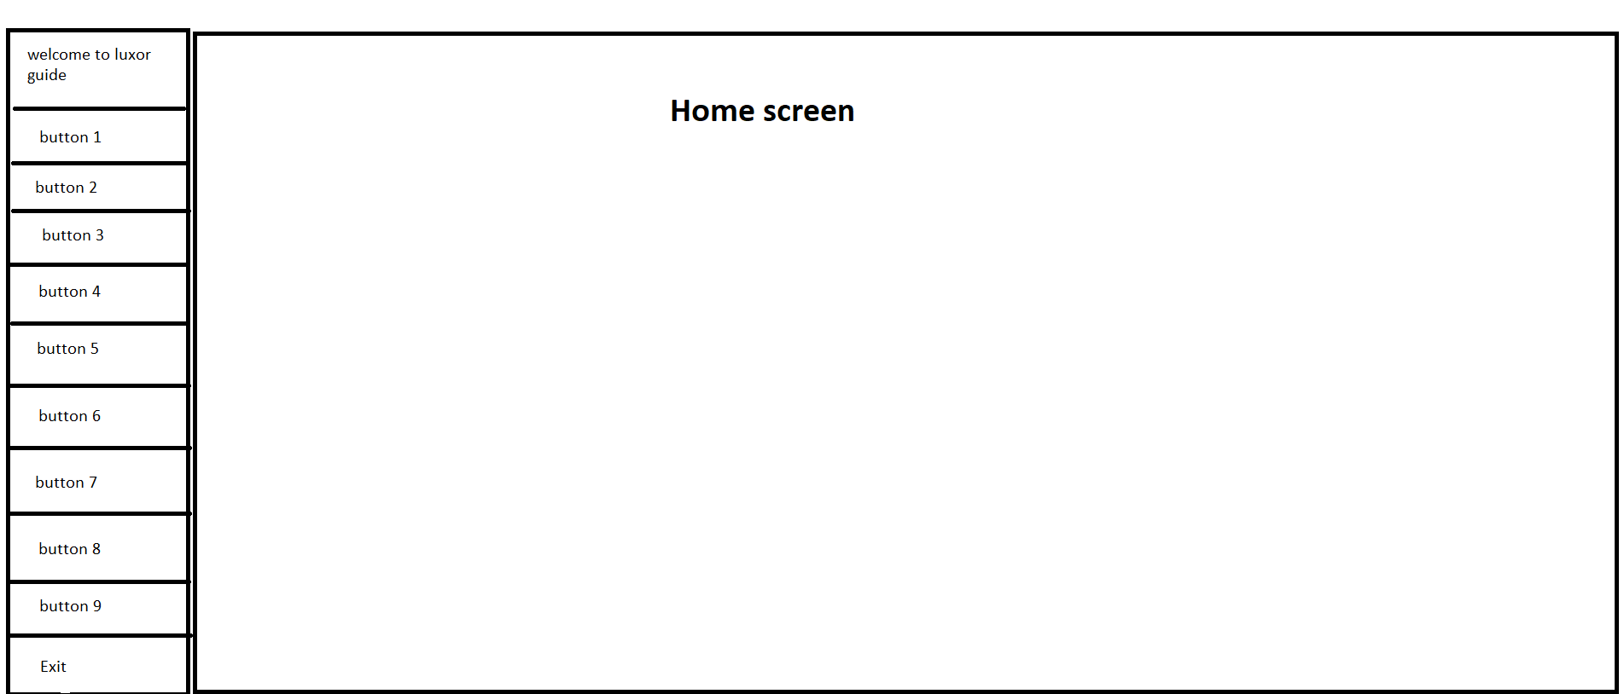

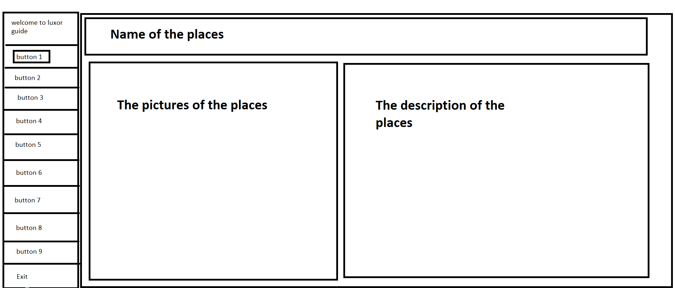

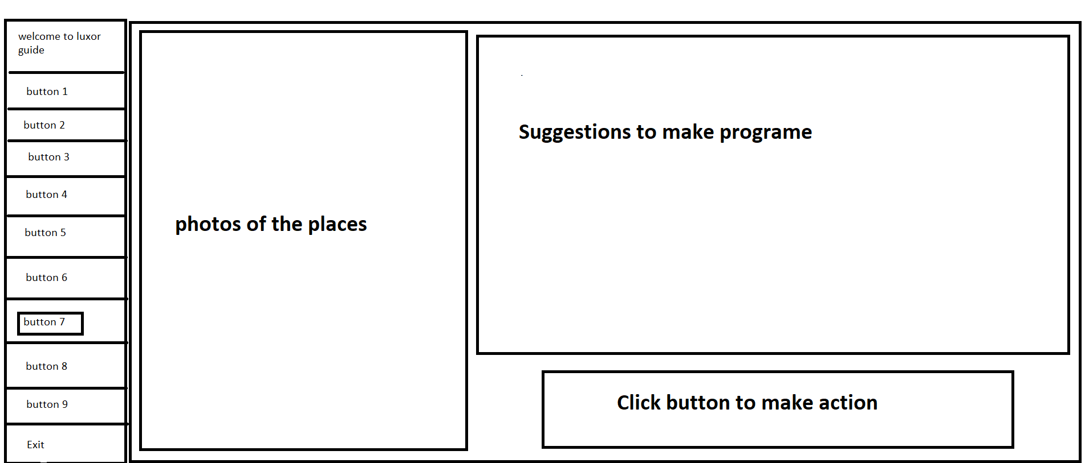

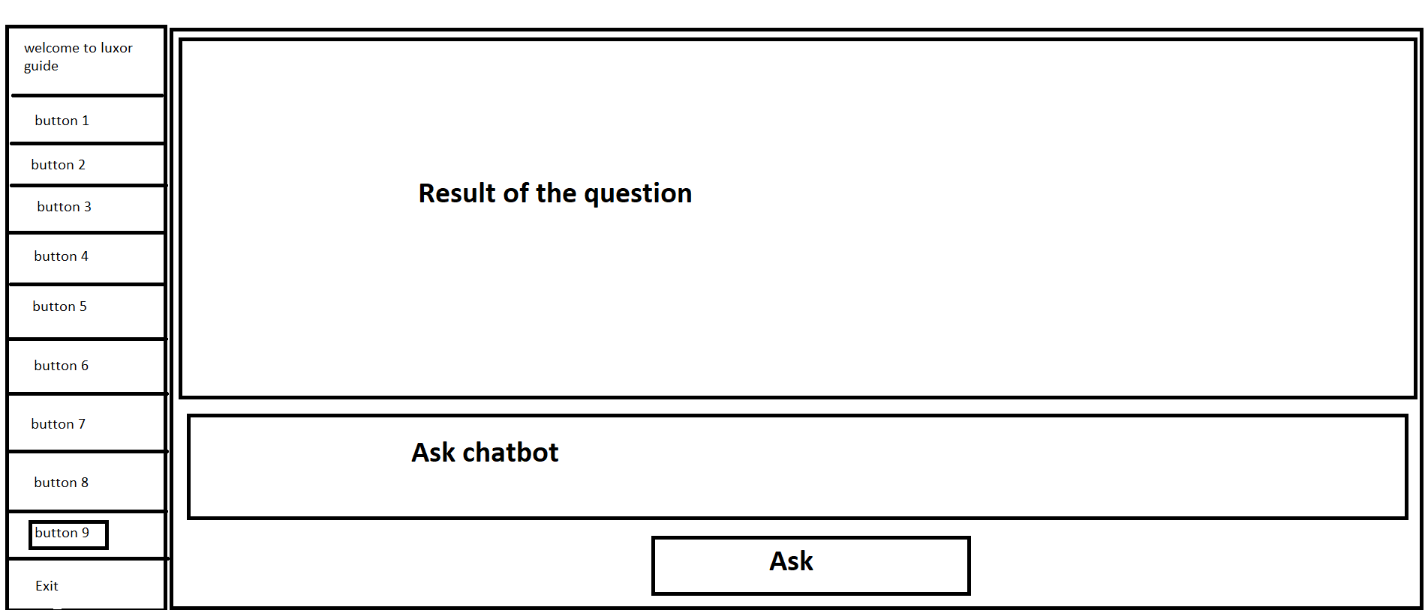

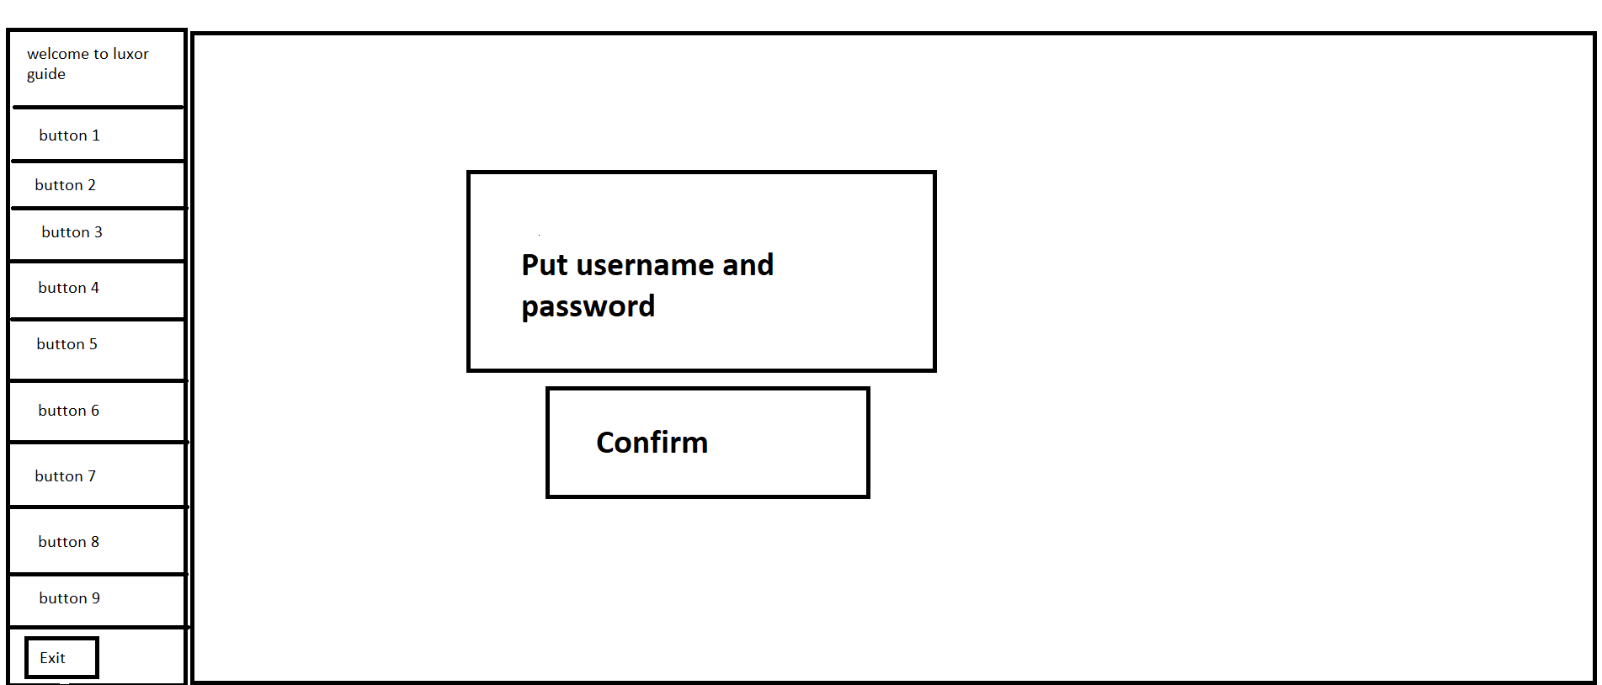

## Screen Objects and Actions

**Home Screen:**

Objects: app branding, featured places or categories and the other features of the app.

Actions: click on any button of "places", browse featured categories.

**Detailed Place Screen:**

Objects: Place details.

Actions: Call or navigate to the place to know information of the place.

**Technical support screen:**

Objects: WhatsApp links

Actions: Use the links in this screen to inform the system any think that the user need.

**Chatbot screen**:

Objects: search bar and result bar

actions: The user enter any question he need to know about any place and the results appear in result bar.

# REQUIREMENTS MATRIX

|  |  |  |  |  |
| --- | --- | --- | --- | --- |
| **Requirement ID** | **Requirement Description** | **Priority** | **Functional Requirement** | **Non-Functional Requirement** |
| RQ1 | admin enters data | High | Yes |  |
| RQ2 | customer clicks icon | High | Yes |  |
| RQ3 | customer specify the data of destination | High | Yes |  |
| RQ4 | customer destination of location | High | Yes |  |
| RQ5 | chatbot handle errors | High | Yes |  |
| RQ6 | chatbot can answer user queries | High | Yes |  |
| RQ7 | Customer click chatbot | medium | Yes |  |
| RQ8 | chatbot personalize responses | Low | Yes |  |
| RQ9 | Know another places | Low | Yes |  |
| RQ10 | Performance | High |  | Yes |
| RQ11 | Reliability | High |  | Yes |
| RQ12 | Accessibility | medium |  | Yes |
| RQ13 | Usability | High |  | Yes |
| RQ14 | Maintainability | medium |  | Yes |
| RQ15 | Security | medium |  | Yes |
| RQ16 | Backup and Recovery | Low |  | Yes |

1.