# General Description

## **2.1 Product Perspective**

The App doesn't work independently. It has to work together with the GPS and the bot.

**2.2User Characteristics**

There are several users of the Application:

**Customer**

The customer interacts with the Application using screens. It must be very easy for them to use the Application. They should be supported by the system in every possible way.

**Admin**

It should be easy to maintain the whole system. The Admin should be the only person that is allowed to connect a new applicatio

# Specify Requirements

## 3.1 Functional Requirements

The functional requirements are organized in three sections: First requirements of the Admin, second requirements of the System and third one of the bot.

### 3.1.1 Requirements of the Admin

The requirements for the automated teller machine are organized in the following way: General requirements, requirements for authorization, requirements for a transaction.

**General**

Functional requirement 1

**Description**

The admin administrates the application

**Input**

The admin puts the username and password to login the app

**Processing**

Check the password and username

**Output**

The admin has all the authorization of the app

Functional requirement 2

**Description**

The admin initializes the zone the devices contains the app (Location).

**Process**

Know the app location

**Output:**

specify the location

Functional requirement 3

**Description**

The admin enters the data of the app (Restaurants, Temples, Hostels, …..)

**Input**

the data of the app

**Processing**

Save the data of the app

**Output**

Saves the data

Functional requirement 4

**Description**

The customer clicks icon.

**Input**

Touch icon.

**Processing**

Display icon clicked.

O**utput**

Data icon clicked.

Functional requirement 5

**Description**

The customer specify the destination desired.

**Input**

Touch icon clicked.

**Processing**

Process the data of location desired.

**Output**

Data information.

Functional requirement 6

**Description**

The customer destination of location desired.

**Input**

Touch icon clicked.

**Processing**

Process the data of location desired.

**Output**

Data information.

Functional requirement 7

**Description**

The location of the place.

**Input**

Click map.

**Processing**

Enter GPS.

**Output**

Display the location of the place.

Functional requirement 8

**Description**

The customer clicks chat bot if the place not found.

**Input**

Click chat bot.

P**rocessing**

Enter Chat bot.

**Output**

Display chat bot.

Functional requirement 9

**Description**

Know another places.

**Input**

Click back.

**Processing**

Back home page.

**Output**

Display home page.

Functional Requirement:10

Chatbot Integration

**Description:**

The application should include a chatbot that can answer user queries and provide recommendations for things to do and see in the city.

**Input:**

User queries in natural language format.

**Processing:**

The chatbot should be able to analyze the user query and identify the intent of the request.

It should then search through the available data (e.g. descriptions of tourist attractions, restaurant recommendations, etc.) to find the most relevant information.

The chatbot should then provide a response to the user in natural language format, using appropriate phrasing and tone.

**Output:**

Responses to user queries and recommendations for things to do and see in the city.

Functional Requirement 11:

Chatbot Personalization

**Description:**

The chatbot should be able to personalize its responses based on the user's preferences and past interactions.

**Input:**

User preferences and past interactions.

**Processing:**

The chatbot should be able to remember previous conversations with the user and use that information to provide more relevant recommendations and advice.

It should also be able to analyze user preferences (e.g. dietary restrictions, preferred types of activities, etc.) to provide personalized recommendations.

The chatbot should be able to adapt its responses based on the user's tone and style of communication.

**Output:**

Personalized responses and recommendations based on the user's preferences and past interactions.

Functional Requirement 12:

Chatbot Error Handling

**Description:**

The chatbot should be able to handle errors and misunderstandings gracefully.

**Input:**

User queries that the chatbot cannot understand or process.

**Processing:**

The chatbot should be able to recognize when it doesn't understand a query and ask the user to rephrase or clarify their request.

It should also be able to recognize when the user is frustrated or confused and offer additional assistance.

The chatbot should be able to provide error messages that are clear and easy to understand.

**Output:**

Clear error messages and assistance for users who have trouble communicating with the chatbot.

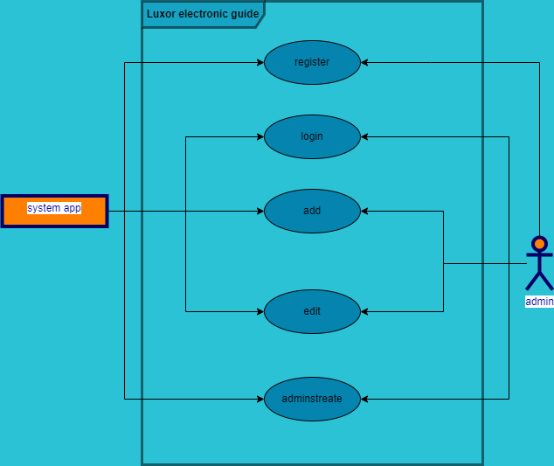

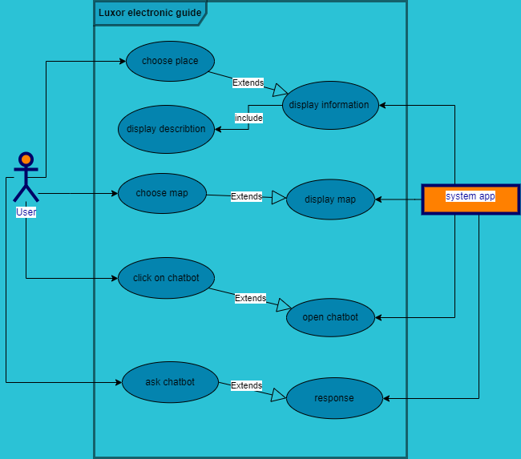

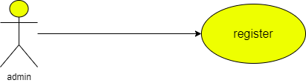

|  |  |  |
| --- | --- | --- |
| **Use case name** | Register | |
| **Unique ID** | 001 | |
| **Area** | Application | |
| **Actor(s)** | Admin | |
| **Description** | Admin creates account | |
| **Triggering Event** | Admin click “Register” button in the application | |
| **Preconditions** | * The admin needs to download application on monitor | |
| **Post conditions** | - Admin has successfully created account | |
| **Assumptions** | * Admin has application * A valid data | |
| **Steps Performed** | | **Information for Steps** |
| 1. Open application 2. Click on “Create Account” button   3- Validation of entered data by application | | Step 3: Name, Username, Password, E-mail |
| **Extensions (Alternative Flows)** | * If the downloading interrupted for any reason, use should try again and download it * If admin entered a non-valid data, a warning message should   appear to him | |

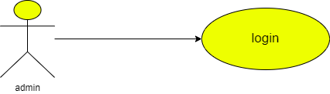

|  |  |  |
| --- | --- | --- |
| **Use case name** | Login | |
| **Unique ID** | 002 | |
| **Area** | Application | |
| **Actor(s)** | Admin | |
| **Description** | Admin login to his account | |
| **Triggering Event** | Admin click “Login” button in the application | |
| **Preconditions** | * The admin needs to download application then open it * The admin needs to have account | |
| **Post conditions** | - Admin has successfully logged in to his account | |
| **Assumptions** | * Admin have application * A valid data | |
| **Steps Performed** | | **Information for Steps** |
| 1. Open application 2. Admin enters his data 3. Click on “Login” button 4. Validation of entered data by application | | Step 2: E-mail, Password |
| **Extensions**  **(Alternative Flows)** | - If admin entered a non-valid data, a warning message should  appear to him | |

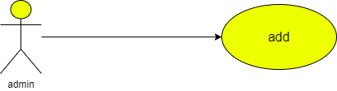

|  |  |  |
| --- | --- | --- |
| **Use case name** | Adding information | |
| **Unique ID** | 001 | |
| **Area** | Application | |
| **Actor(s)** | Admin | |
| **Description** | Admin adds data | |
| **Triggering Event** | Admin enters to database | |
| **Preconditions** | - The admin needs to login in to his account | |
| **Post conditions** | - Admin has successfully added data to application | |
| **Assumptions** | * Admin has application * A valid data | |
| **Steps Performed** | | **Information for Steps** |
| 1- Open application 2- Admin log in  3- admin enters database  4- Admin adds the new information in the system   1. Validation message | | Step 2: E-mail, Password |
| **Extensions (Alternative Flows)** | - If admin entered a non-valid data, a warning message should appear to him | |

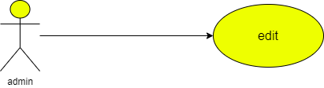

|  |  |  |
| --- | --- | --- |
| **Use case name** | Edit information | |
| **Unique ID** | 001 | |
| **Area** | Application | |
| **Actor(s)** | Admin | |
| **Description** | Admin edits data | |
| **Triggering Event** | Admin enters to database | |
| **Preconditions** | - The admin needs to login in to his account | |
| **Post conditions** | - Admin has successfully added data to application | |
| **Assumptions** | * Admin has application * A valid data | |
| **Steps Performed** | | **Information for Steps** |
| 1- Open application 2- Admin log in  3- admin enters database  4- Admin edits the information in the system   1. Validation message | | Step 2: E-mail, Password |
| **Extensions (Alternative Flows)** | - If admin entered a non-valid data, a warning message should appear to him | |

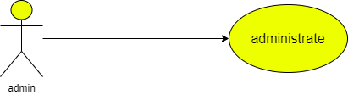

|  |  |  |
| --- | --- | --- |
| **Use case name** | Administrates information | |
| **Unique ID** | 001 | |
| **Area** | Application | |
| **Actor(s)** | Admin | |
| **Description** | Admin administrates the data about the app | |
| **Triggering Event** | Admin enters to database | |
| **Preconditions** | - The admin needs to login in to his account | |
| **Post conditions** | - Admin has successfully added data to application | |
| **Assumptions** | * Admin has application * A valid data | |
| **Steps Performed** | | **Information for Steps** |
| 1- Open application 2- Admin log in  3- admin enters database  4- Admin edits the information in the system   1. Validation message | | Step 2: E-mail, Password |
| **Extensions (Alternative Flows)** | - If admin entered a non-valid data, a warning message should appear to him | |

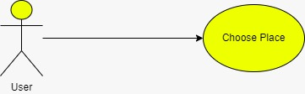

|  |  |  |
| --- | --- | --- |
| **Use case name** | * Choose place | |
| **Area** | * Application | |
| **Actor(s)** | * User | |
| **Description** | * The user select the desired place | |
| **Triggering Event** | * User selects the place on the screen | |
| **Preconditions** | - The user needs to be on the application | |
| **Post conditions** | - User has successfully entered the application | |
| **Assumptions** | * User has to use application | |
| **Steps Performed** | | **Information for Steps** |
| 1- Open application 2- User enters the application  3- User selects the icon | |  |
| **Extensions (Alternative Flows)** | - If user entered a non-valid data, a warning message should appear to him | |

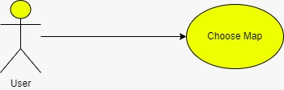

|  |  |  |
| --- | --- | --- |
| **Use case name** | * Choose map | |
| **Area** | * Application | |
| **Actor(s)** | * User | |
| **Description** | * The user select the map to locate the place | |
| **Triggering Event** | * User selects the map button | |
| **Preconditions** | - The user needs to be on the application | |
| **Post conditions** | - User has successfully entered the application | |
| **Assumptions** | * User has to use application | |
| **Steps Performed** | | **Information for Steps** |
| 1- Open application 2- User enters the application  3- User selects the icon  4-User selects the map icon | |  |
| **Extensions (Alternative Flows)** | - If user entered a non-valid data, a warning message should appear to him | |

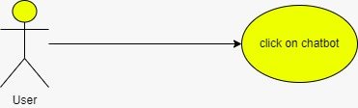

|  |  |  |
| --- | --- | --- |
| **Use case name** | * Click on chat bot | |
| **Area** | * Application | |
| **Actor(s)** | * User | |
| **Description** | * The user select the Chat bot | |
| **Triggering Event** | * User selects the chat bot icon | |
| **Preconditions** | - The user needs to be on the application | |
| **Post conditions** | - User has successfully entered the application | |
| **Assumptions** | * User has to use application | |
| **Steps Performed** | | **Information for Steps** |
| 1- Open application 2- User enters the application  3- User selects the chat bot icon | |  |
| **Extensions (Alternative Flows)** | - If user entered a non-valid data, a warning message should appear to him | |

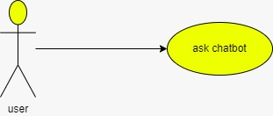

|  |  |  |
| --- | --- | --- |
| **Use case name** | * Ask chat bot | |
| **Area** | * Application | |
| **Actor(s)** | * User | |
| **Description** | * The user ask the Chat bot | |
| **Triggering Event** | * User selects the chat bot icon | |
| **Preconditions** | - The user needs to be on the application | |
| **Post conditions** | - User has successfully entered the application | |
| **Assumptions** | * User has to use application | |
| **Steps Performed** | | **Information for Steps** |
| 1- Open application 2- User enters the application  3- User selects the chat bot icon  4-User starts to ask it about what he needs to know | |  |
| **Extensions (Alternative Flows)** | - If user entered a non-valid data, a warning message should appear to him | |

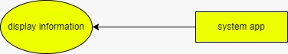

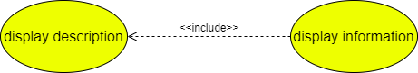

|  |  |  |
| --- | --- | --- |
| **Use case name** | * Display information | |
| **Area** | * Application | |
| **Actor(s)** | * System | |
| **Description** | * The data user selects shown on the application | |
| **Triggering Event** | * Non | |
| **Preconditions** | - The system need to be used | |
| **Post conditions** | - User has successfully entered the application and the application is on | |
| **Assumptions** | * The system is on | |
| **Steps Performed** | | **Information for Steps** |
| 1- Open application 2- User enters the application  3- User selects the desired information | |  |
| **Extensions (Alternative Flows)** | - If there is non-valid data, a warning message should appear to him | |

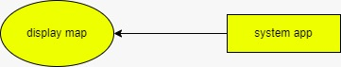

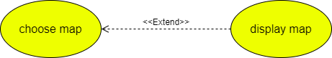

|  |  |  |
| --- | --- | --- |
| **Use case name** | * Display map | |
| **Area** | * Application | |
| **Actor(s)** | * System | |
| **Description** | * The user selects map to know the location | |
| **Triggering Event** | * Non | |
| **Preconditions** | - The system need to be used | |
| **Post conditions** | - User has successfully entered the application and the application is on | |
| **Assumptions** | * The system is on | |
| **Steps Performed** | | **Information for Steps** |
| 1- Open application 2- User enters the application  3- Click on the map | |  |
| **Extensions (Alternative Flows)** | - If there is no internet , a warning message should appear to him | |

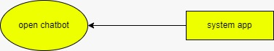

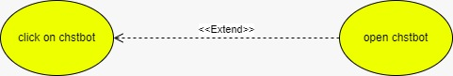

|  |  |  |
| --- | --- | --- |
| **Use case name** | * Open chat bot | |
| **Area** | * Application | |
| **Actor(s)** | * System | |
| **Description** | * The system calls chat bot | |
| **Triggering Event** | * Non | |
| **Preconditions** | - The system need to be used | |
| **Post conditions** | - User has successfully entered the application and the application is on | |
| **Assumptions** | * The system is on | |
| **Steps Performed** | | **Information for Steps** |
| 1- Open application 2- User enters the application  3- User selects the chat bot | |  |
| **Extensions (Alternative Flows)** | - If there is non-valid data, a warning message should appear to him | |



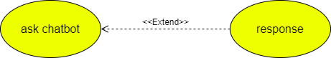

|  |  |  |
| --- | --- | --- |
| **Use case name** | * Response | |
| **Area** | * Application | |
| **Actor(s)** | * System | |
| **Description** | * Application response to user | |
| **Triggering Event** | * Non | |
| **Preconditions** | - The system need to be used | |
| **Post conditions** | - User has successfully entered the application and the application is on | |
| **Assumptions** | * The system is on | |
| **Steps Performed** | | **Information for Steps** |
| 1- Open application 2- User enters the application  3- User askes chat bot  4- System response to him | | Step1- Ask chat bot |
| **Extensions (Alternative Flows)** | - If there is non-valid data, a warning message should appear to him | |