**Model: 1.3B**

Tokens = 150

do_sample = false

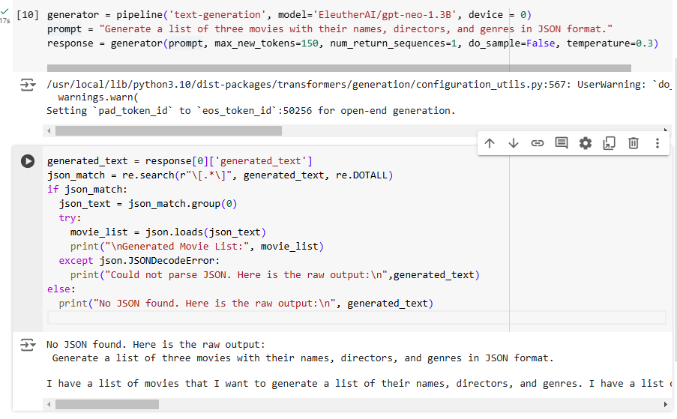

Response: I have a list of movies that I want to generate a list of their names, directors, and genres. I have a list of movies that I want to generate a list of their names, directors, and genres. I have a list of movies that I want to generate a list of their names, directors, and genres. I have a list of movies that I want to generate a list of their names, directors, and genres. I have a list of movies that I want to generate a list of their names, directors, and genres. I have a list of movies that I want to generate a list of their names, directors, and genres. I have a list of movies that I want to generate a list of their names

Tokens = 150

do_sample = true

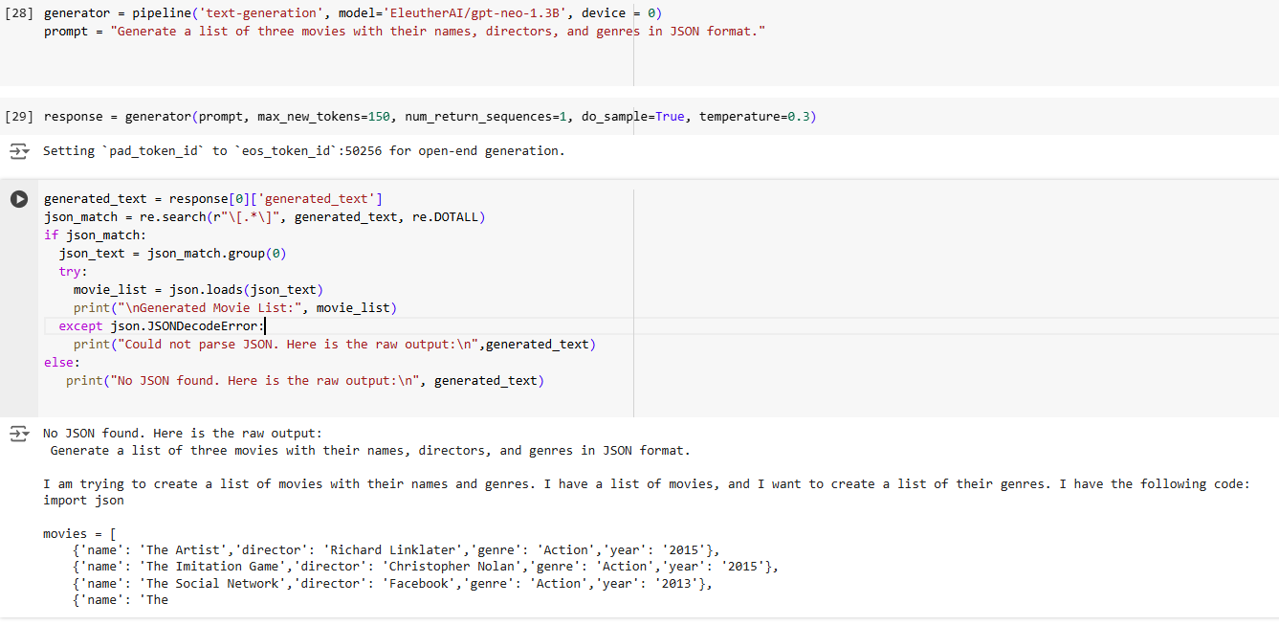

Tokens = 50

do_sample = true

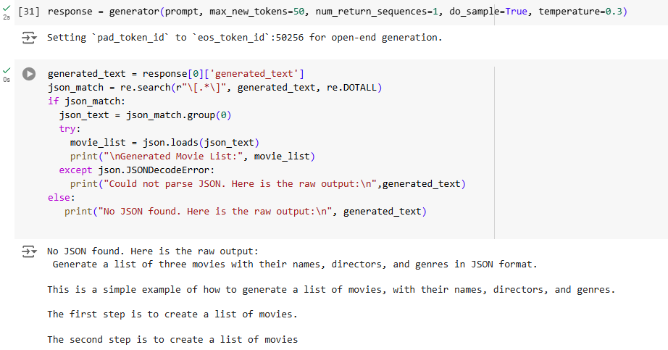

**Model: 125M**

Tokens = 150

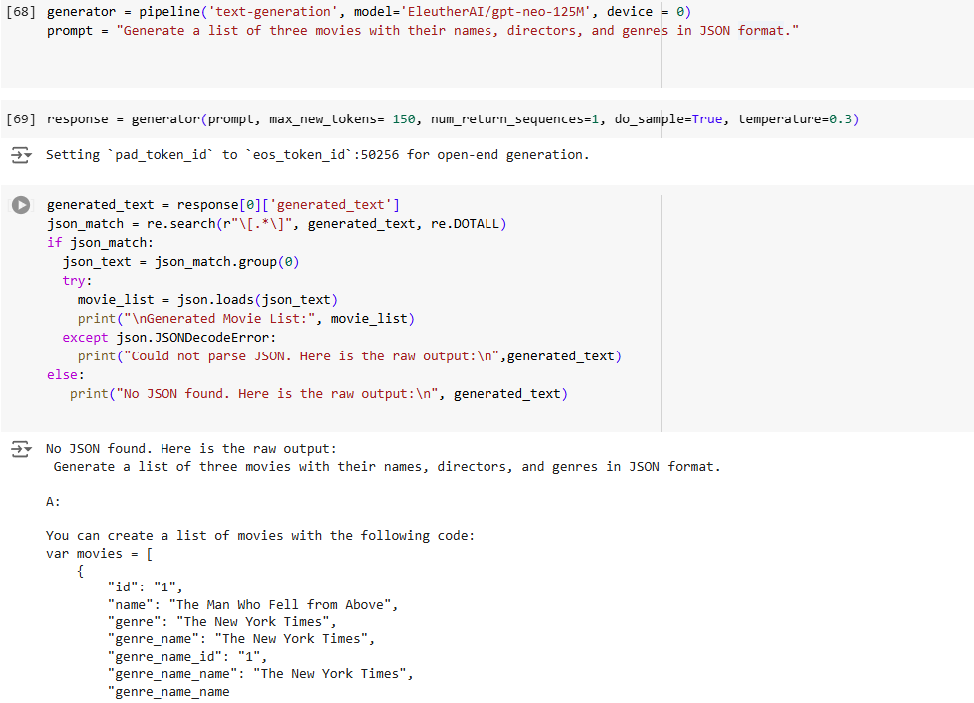

Tokens = 50

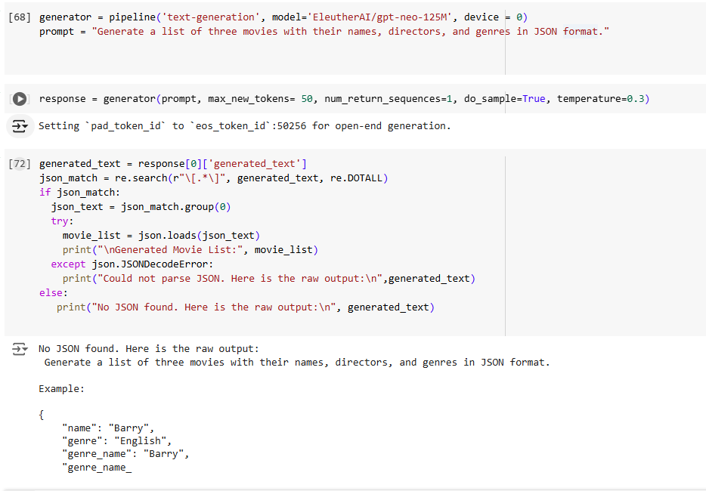

The model which generated a somewhat proper list was the 1.3B model with 150 tokens.

The 125M model also produced a list with a proper format but all the info was wrong and repeated words. Changing the max tokens only shortens the output, but is the same output just filtered.