**TaskTracker**

**Digital Egypt Pioneers Initiative**

**Company**

Eyouth

**Team:**

Abdelrahman Elkhateeb

Ahmed Abdelrashed Hassan

Ahmed Abo Raya

Mahmoud Said Romeh

**Abstract**

**TaskTracker** is a sophisticated task and project management system aimed at enhancing team collaboration and individual productivity. Utilizing a modern technology stack—including React.js, Node.js, Express, and MongoDB—TaskTracker offers a unified platform for efficiently managing tasks, projects, and missions.

Key functionalities encompass task creation, deletion, updating, and filtering, alongside project management features that allow for role assignments and streamlined team interactions. The mission management aspect ensures timely notifications and progress tracking, facilitating accountability in project completion.

Designed with user experience in mind, TaskTracker employs React.js for dynamic interfaces and Tailwind CSS for responsive and visually appealing design. Its architecture, supported by MongoDB and Express, ensures scalability, security, and reliability for users ranging from individuals to larger teams.

By delivering a comprehensive solution for task management and project collaboration, TaskTracker serves as an essential tool for boosting productivity and enhancing team efficiency.

Contents

**Abstract** 2

**1. Introduction** 4

**2. Getting Started** 7

**3. User Authentication** 9

**4. Dashboard** 11

**5. Task Management** 12

**6. Project Management** 14

**7. Mission Management** 18

**9. Member Management** 19

**10. Technical Stack and Architecture** 22

**11. Conclusion** 23

1. **Introduction**
   1. **Overview of Depi Final Project**

**TaskTracker** is an advanced and versatile task and project management system designed to significantly improve the organization, collaboration, and productivity of both teams and individuals. Whether you're working solo or as part of a team, **TaskTracker** simplifies the process of managing tasks, projects, and missions, all within a unified platform. The system is built with modern web technologies, including React.js for the user interface and Tailwind CSS for responsive, elegant design, ensuring that users can navigate and utilize the platform with ease, regardless of their technical proficiency.

At its core, **TaskTracker** provides users with powerful features that allow them to manage day-to-day tasks, oversee entire projects, assign missions, and collaborate seamlessly with team members. By offering functionalities such as task creation, priority setting, filtering, role assignment, and project member management, the platform caters to a wide variety of use cases, from personal productivity to complex team projects involving multiple contributors.

The system incorporates essential project management elements like real-time notifications, secure role-based access control, and a robust mission-tracking mechanism. This ensures that team leaders can delegate tasks effectively while team members remain up-to-date on their responsibilities and deadlines. The task and project data is persistently stored in a MongoDB database, enabling scalable performance even as teams and projects grow in size and complexity.

Moreover, **TaskTracker** prioritizes security with features such as secure user authentication and authorization, ensuring that only authorized individuals have access to sensitive project and task information. This combination of ease-of-use, security, and functionality makes **TaskTracker** a highly effective tool for personal use, small teams, or larger organizations looking to streamline their workflow, manage resources, and track progress across different projects.

In summary, **TaskTracker** is a comprehensive solution for task and project management, designed to enhance productivity and foster collaboration by delivering a clean, user-friendly interface, a range of task and project management features, and a solid technical foundation that supports scalable, secure, and efficient use.

### **Purpose and Objectives**

The primary objective of **TaskTracker** is to deliver a comprehensive and efficient solution for organizing, tracking, and managing tasks and projects. Designed to cater to both individuals and teams, the platform aims to simplify the complexity of project management by providing a user-friendly environment where tasks can be created, assigned, prioritized, and monitored with ease.

Whether a user is managing personal tasks or collaborating on team projects, **TaskTracker** ensures smooth workflow management through features such as task prioritization, role assignment, and progress tracking. By offering a centralized space for task and project oversight, it helps users stay on top of deadlines, allocate resources effectively, and streamline communication among team members. Additionally, project owners can manage team roles, ensuring that tasks are delegated appropriately and that everyone remains accountable.

The platform's main goals include:

* **Boosting Productivity**: Allow users to efficiently organize their work, prioritize tasks, and stay focused on deadlines.
* **Improving Collaboration**: Enhance team communication and coordination by providing clear task assignment, progress tracking, and role-based access.
* **Simplifying Project Management**: Offer an intuitive and powerful tool for managing multiple projects and tasks, reducing the complexity of overseeing both small and large-scale projects.
* **Ensuring Accountability**: Enable project owners to track progress and hold team members accountable for their assigned tasks.
* **Enhancing Flexibility**: Support a wide range of use cases, from individual task management to collaborative projects with multiple team members.

### **1.3 - Key Features Summary**

**TaskTracker** offers a comprehensive set of features designed to enhance task and project management for both individuals and teams. Below is a summary of the platform's key features:

* **User Authentication**:
  + Users can securely sign up, log in, and reset their passwords. The authentication system ensures that only authorized users have access to their tasks and projects, providing a personalized experience for each user.
* **Task Management**:
  + **Task Creation, Updating, and Deletion**: Easily add new tasks, update existing ones, or delete tasks as needed, allowing users to manage their workload efficiently.
  + **Filtering and Sorting**: Tasks can be filtered by priority level or completion status, and sorted by due date or priority, helping users stay organized and focused on what matters most.
* **Project Management**:
  + **Project Creation and Deletion**: Users can create and delete projects, with checks in place to ensure only the project owner can delete them, providing secure control over the project's lifecycle.
  + **Member Management**: Project owners and managers can add members to a project, assign roles, update roles, or remove members, facilitating seamless team collaboration.
* **Mission Management**:
  + **Mission Creation, Updating, and Deletion**: Project owners and managers can manage missions by creating, updating, or deleting them as part of their project planning process.
  + **Status Updates**: Users can update mission statuses from "Not Started" to "In Progress" or "Completed," ensuring clear tracking of progress on project missions.
* **Real-time Notifications**:
  + Users receive real-time notifications for important updates, including new tasks or missions assigned to them. This feature helps users stay informed and respond promptly to changes or new responsibilities.

1. **Getting Started**

**2.1- System Requirements**

To successfully run **TaskTracker**, ensure that your development environment meets the following prerequisites:

* **Node.js**: Version 14 or higher is required for running the backend and managing dependencies. Download it from [here](https://nodejs.org/).
* **MongoDB**: You can use either a local instance of MongoDB (download [here](https://www.mongodb.com/try/download/community)) or a cloud service like MongoDB Atlas for storing and retrieving data.
* **Web Browser**: A modern web browser is recommended for running the front-end interface. This includes:
  + Google Chrome (latest version)
  + Mozilla Firefox (latest version)
  + Microsoft Edge (latest version)
* **Basic Knowledge**: Familiarity with React.js, Node.js, and basic REST API concepts is recommended to understand the structure and make modifications as needed.

2.2- Installation Guide

To set up the TaskTracker project on your local machine, follow these steps:

* Clone the repository:

git clone <https://github.com/abdelrahman-elkhateeb/depi-final-project.git>

* Navigate to the project directory:

cd depi-final-project

* Install dependencies:

npm install

* Navigate to the frontend directory:

cd frontend

* Start the development fronrend:

npm run dev

* Navigate to the backend directory:

cd backend

* Start the development server:

npm run dev

* **Open the application** in your browser by navigating to http://localhost:5173

**2.3- Initial Setup and Configuration**

Once you've completed the installation, follow these steps to ensure everything is configured properly:

* **Admin User Creation**: After launching the application, navigate to the Sign-Up page and create the first admin account. This user will have the ability to manage projects and tasks.
* **Database Connectivity**: Verify that your MongoDB connection is working by checking the terminal output. A successful connection message should appear indicating the app is connected to the MongoDB instance.

1. **User Authentication**

#### **3.1 Account Creation**

To begin using **TaskTracker**, you need to create an account:

1. Navigate to the **Sign-Up** page from the main screen.
2. Fill out the required fields:
   * **Username**
   * **Email**
   * **Password** (minimum 6 characters)
   * **Confirmation Password**
   * **Gender** (male – female)
3. After registration, you will be automatically redirected to the **Login** page, where you can log in using your new credentials.

#### **3.2 Login/Logout Process**

* On the **Login** page, enter your email and password to access the application.
* Upon successful login, your session will remain active until you manually log out.
* To log out, click on the **Logout** button in the top-right corner of the dashboard. This will end your session securely.

**3.3- Login Page**

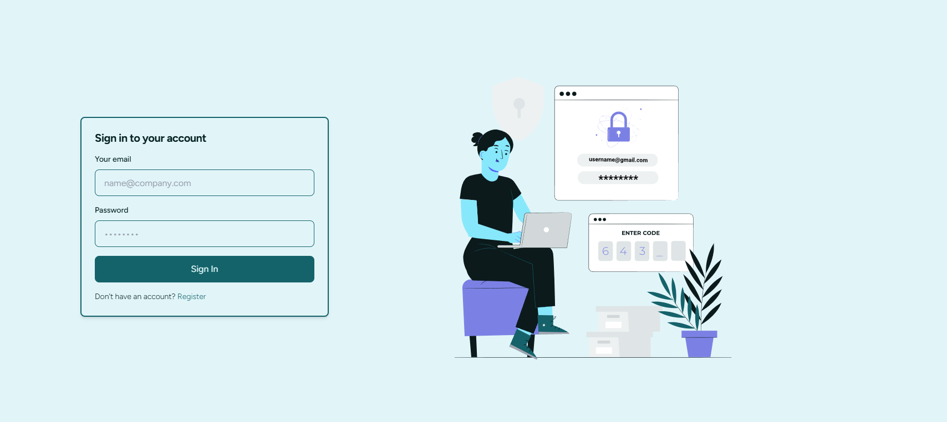

**3.4- Register Page**

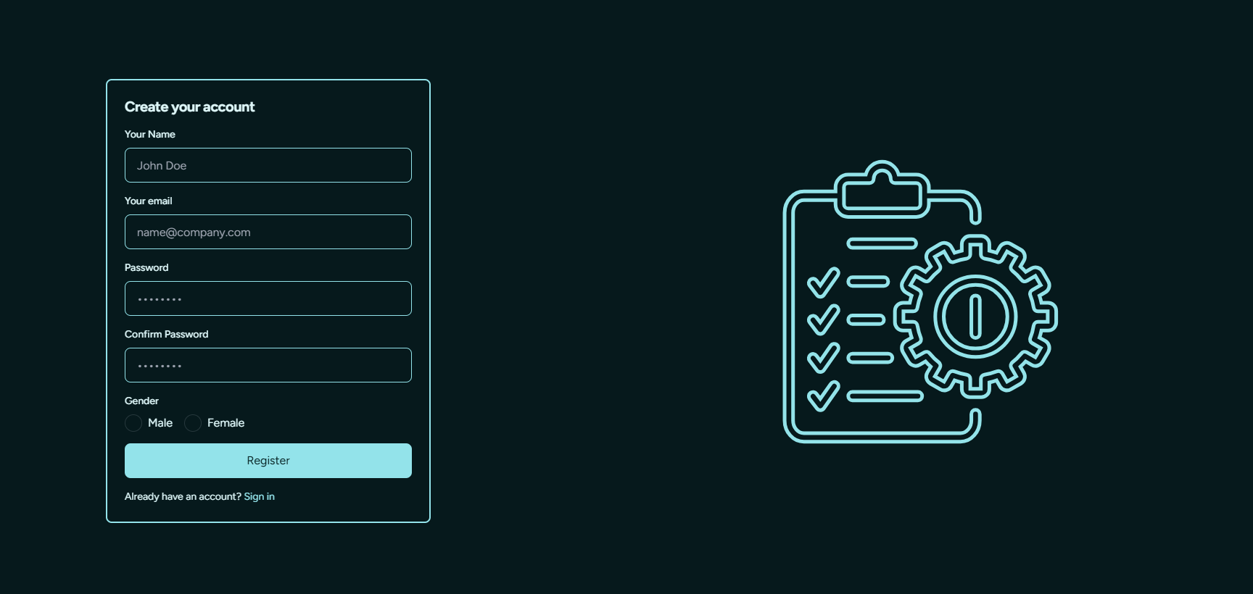

### **4. Dashboard**

#### **4.1 Overview of the Dashboard**

The **Dashboard** serves as a central hub for managing tasks, projects, and missions. It provides the following information:

* **Active Tasks**: A count of all ongoing tasks.
* **Upcoming Deadlines**: An alert system for tasks and projects nearing their due dates.
* **Recent Missions**: A quick summary of newly assigned missions and their statuses.

#### **4.2 Navigating Through Tasks and Projects**

* **Tasks**: You can quickly navigate to the Tasks page by clicking on the **Tasks** section on the dashboard. Tasks are categorized by:
  + **Completion Status**: Pending, In Progress, Completed.
  + **Priority Level**: High, Medium, Low.
* **Projects**: Similarly, the Projects section allows you to view and manage projects based on their completion progress and deadlines.

#### **4.3 Managing Recent Activity**

The **Recent Activity** panel provides a feed of updates to tasks, missions, and projects. These updates include:

* Changes to task status
* New missions assigned to you
* Project modifications made by team members

### **5. Task Management**

#### **5.1. Adding New Tasks**

To add a new task:

1. Navigate to the **Tasks** page from the sidebar or dashboard.
2. Click the **Add Task** button.
3. Fill in the required details:
   * **Title**
   * **Description**
   * **Due Date**
   * **Priority Level** (High, Medium, Low)
4. Click **Save** to add the task.

#### **5.2 Updating and Deleting Tasks**

* To **update** a task, click on the **edit icon** next to the task, make your changes, and save.
* To **delete** a task, click on the **trash icon**. A confirmation dialog will appear before permanently deleting the task.

#### **5.3 Filtering Tasks by Priority and Status**

You can filter tasks using the dropdown menu on the **Tasks** page:

* **Priority**: View tasks marked as High, Medium, or Low.
* **Completion Status**: Filter tasks that are Pending, In Progress, or Completed.

You can also combine multiple filters for more precise task management.

#### **5.4 Searching and Sorting Tasks**

Use the search bar to find tasks by title or description. Tasks can also be sorted by:

* **Due Date**: Display tasks with upcoming deadlines first.
* **Priority**: Sort tasks based on their assigned priority.

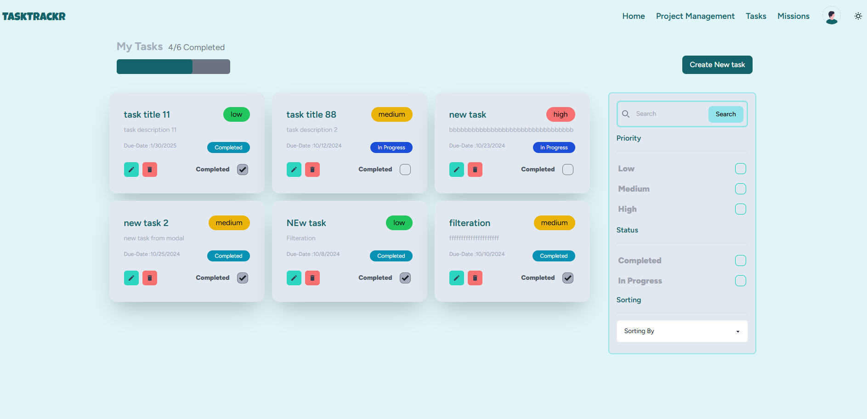 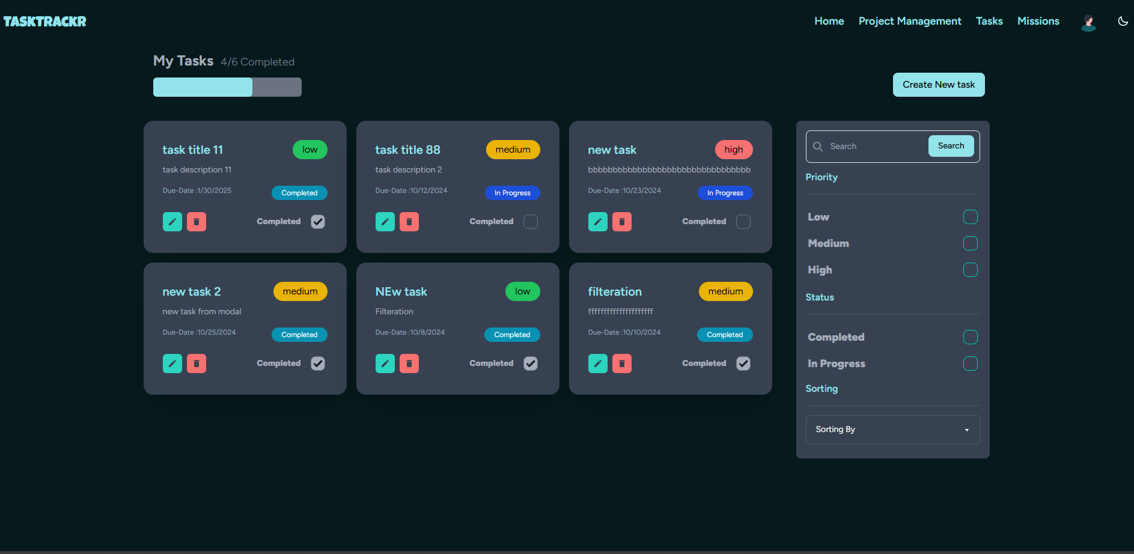

### **6. Project Management**

#### **6.1- Creating New Projects**

To create a new project:

1. Navigate to the **Projects Management** page.
2. Click the **Create Project** button.
3. Fill in the project details:
   * **Title**
   * **Description**
4. Save the project. As the creator, you will automatically become the **Owner**.

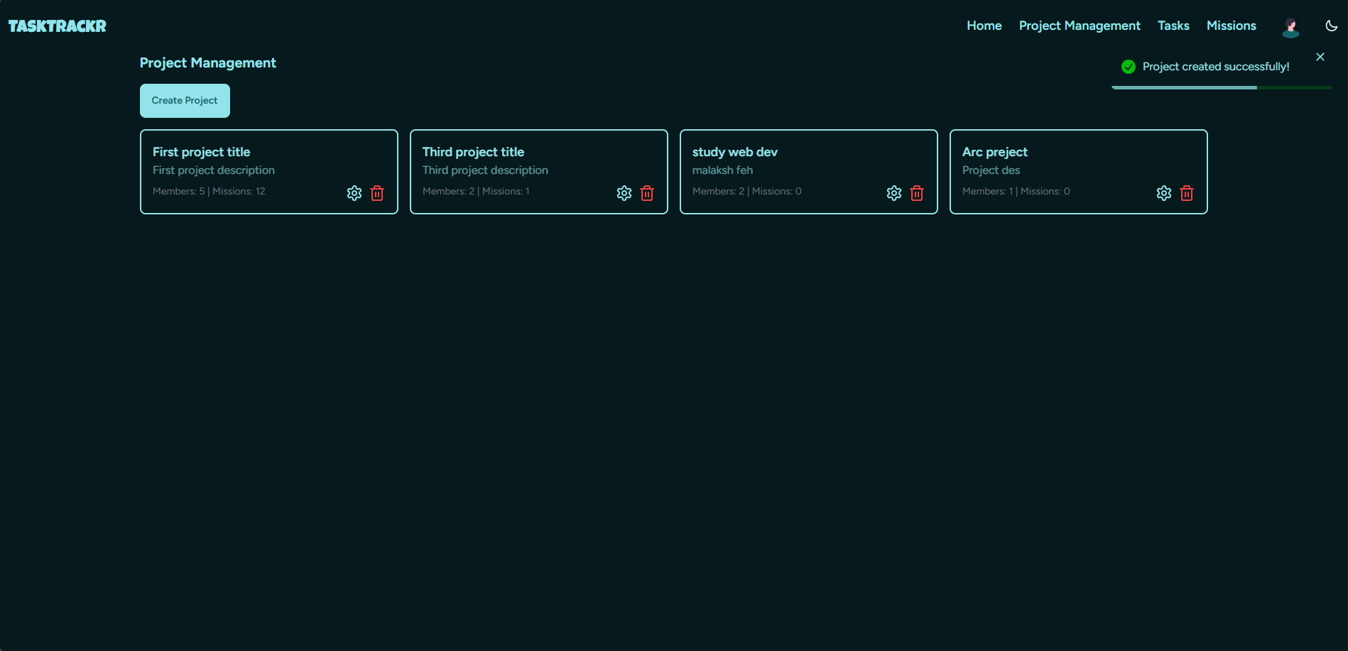

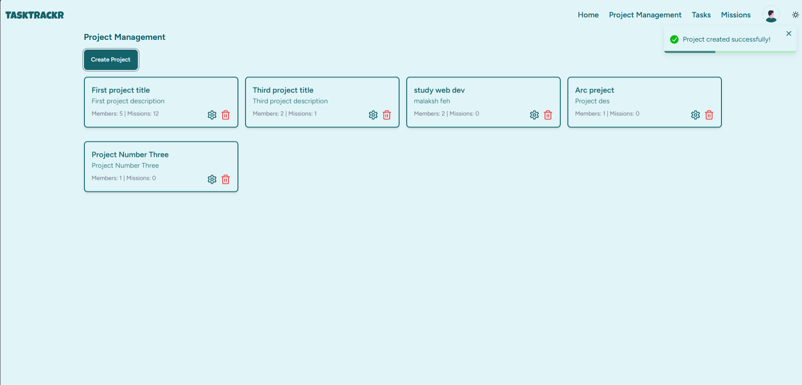

#### **6.2 Deleting Projects**

* Only the **Owner** of a project can delete it. To delete a project, click on the **delete icon** next to the project’s name.
* Confirm the deletion in the popup dialog.

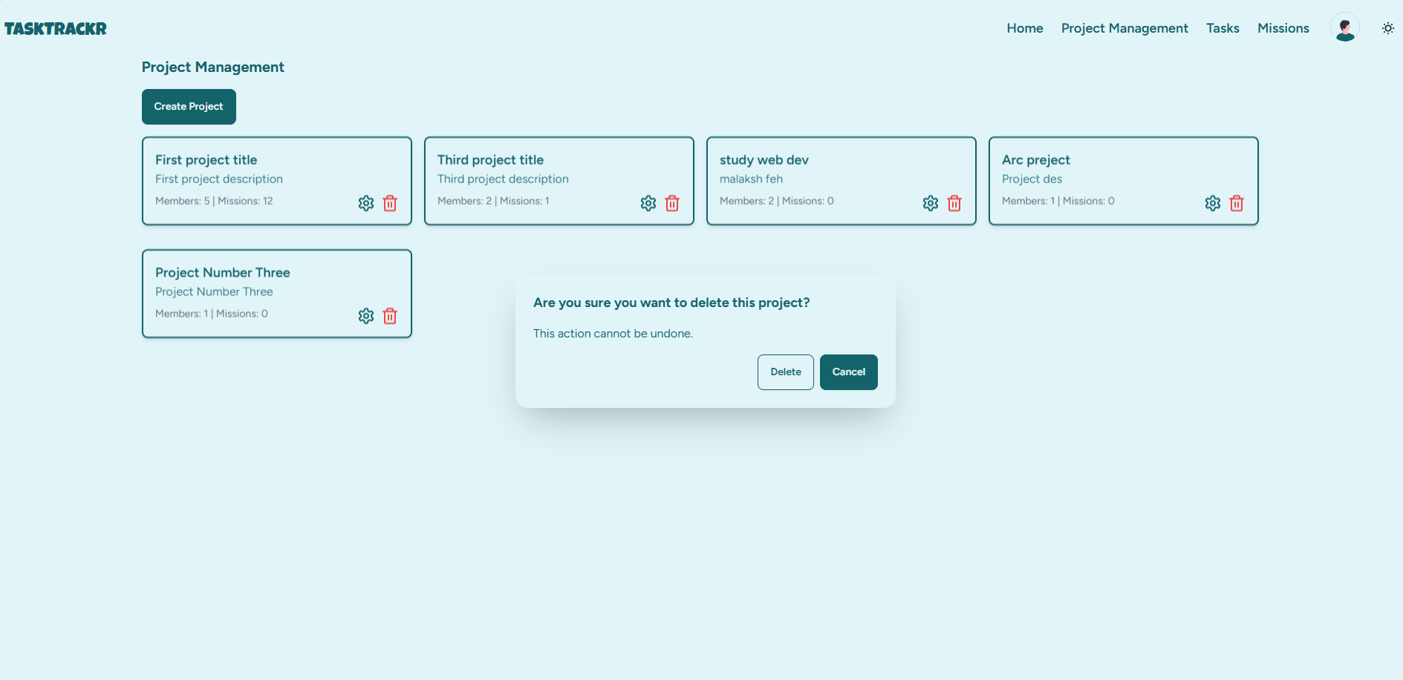

If you not the Owner of project

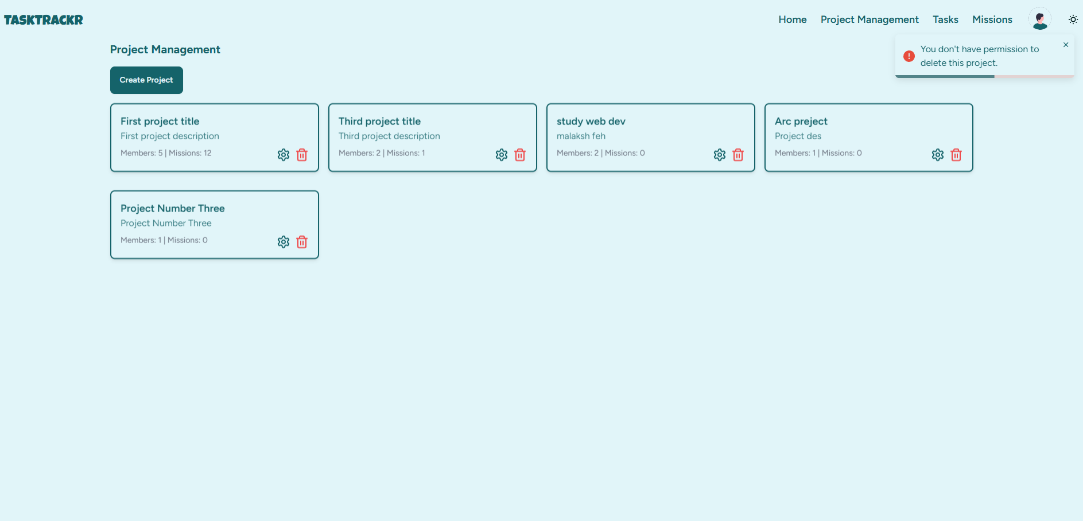

#### **6.3 Adding and Managing Project Members**

* On the project details page, click **Manage Members** to invite users by entering their email addresses.
* Assign roles to each member (Owner, Manager, Contributor, Viewer) based on their responsibilities.

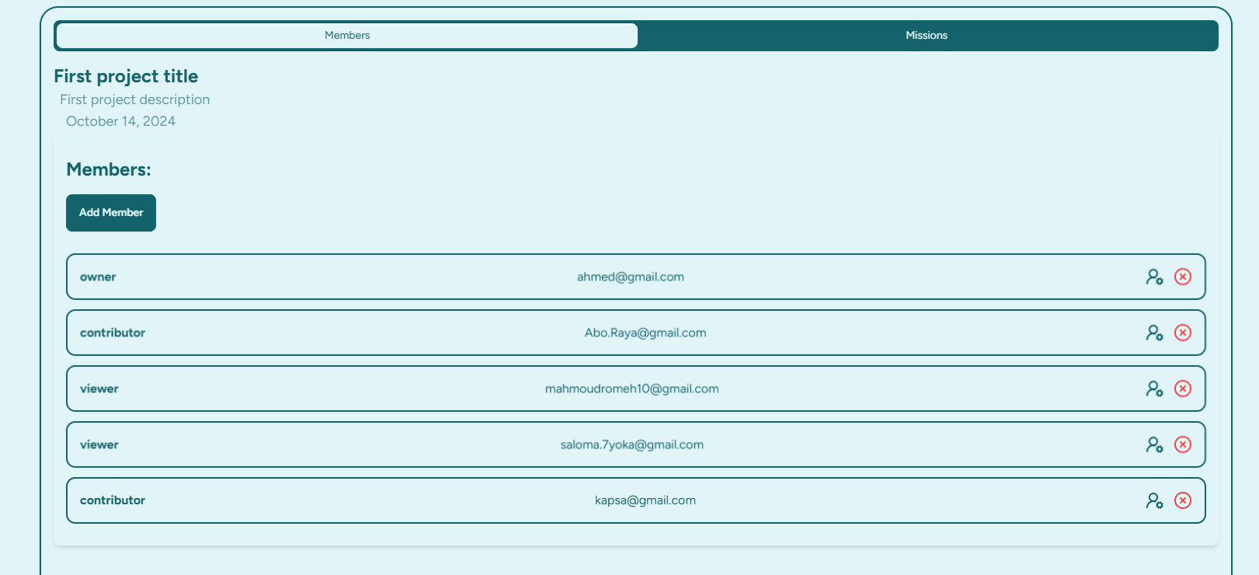

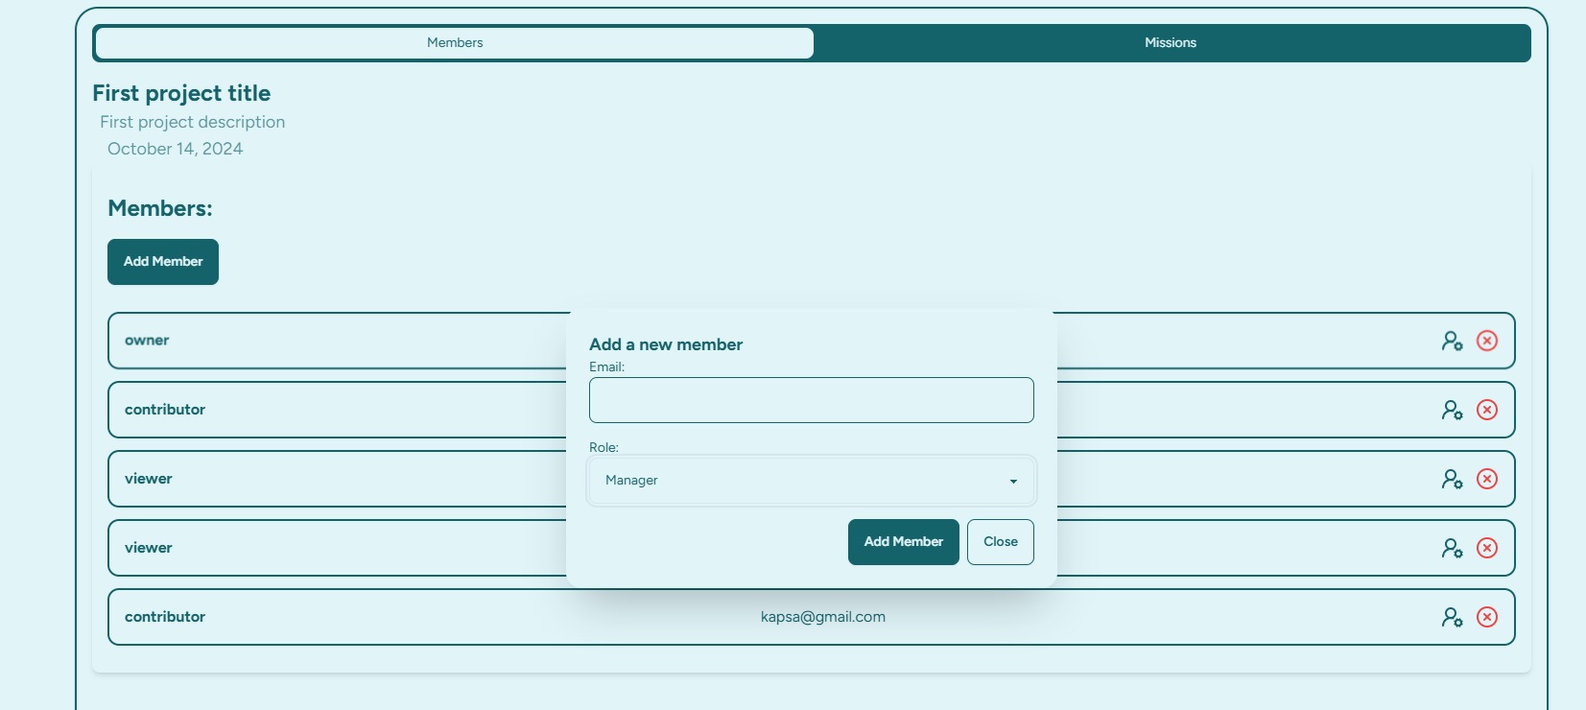

* Screen of contributor of viewer members

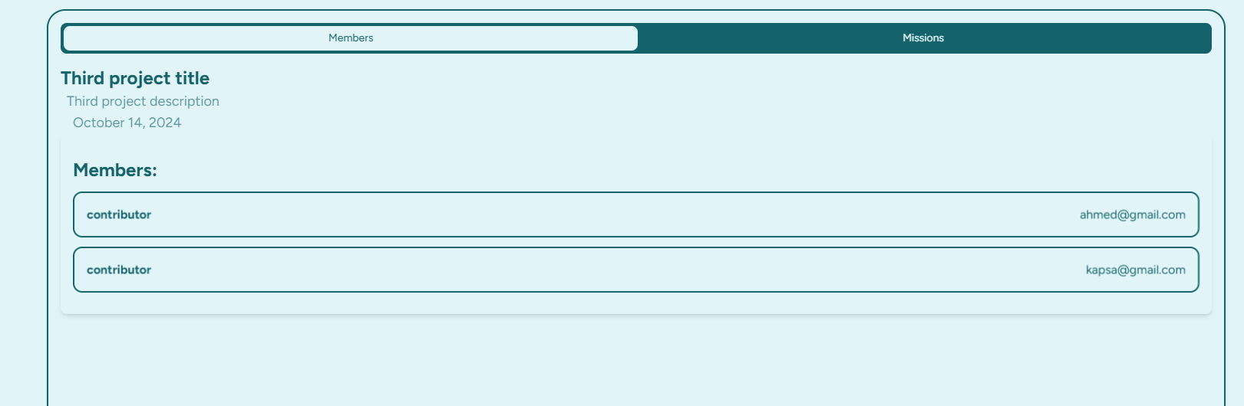

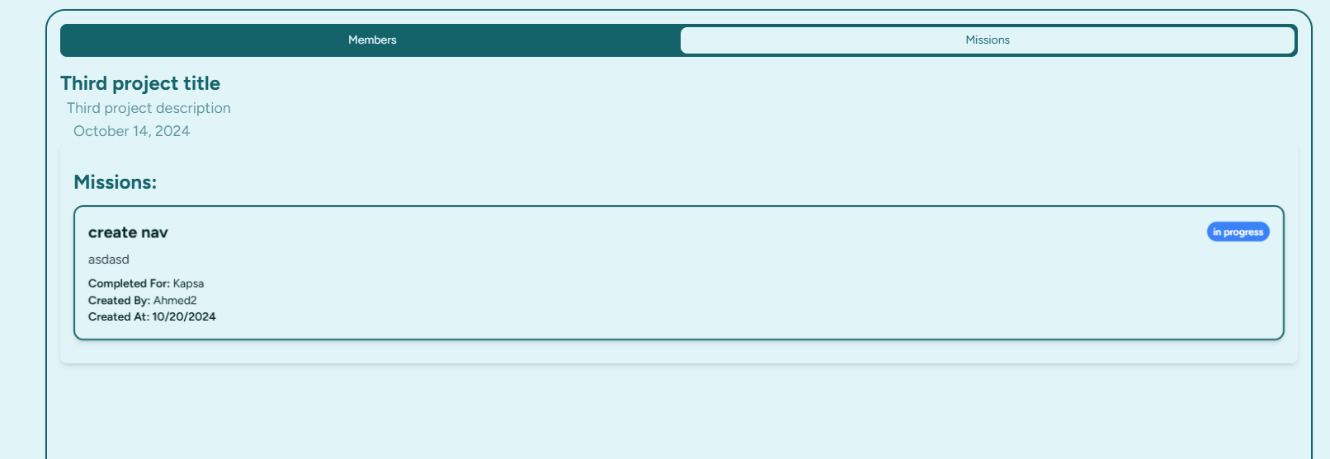

#### **6.4 Assigning and Updating Roles**

* **Owner**: Full access to the project, tasks, and member management.
* **Manager**: Can manage missions and members.
* **Contributor**: Completes missions.
* **Viewer**: view members and missions.
* Roles can be updated by the project owner at any time via the **Manage Members** page.

### **7. Mission Management**

#### **7.1 Creating and Assigning Missions**

To create a mission:

1. Navigate to the **Missions** tab.
2. Click **Create Mission**.
3. Fill in mission details:
   * **Title**
   * **Description**
   * **Assigned Members**
   * **Due Date**
4. Save the mission. Assigned members will receive notifications.

#### **7.2 Updating Mission Status**

Users can update the status of their missions (Not Started, In Progress, Completed) from the mission details page.

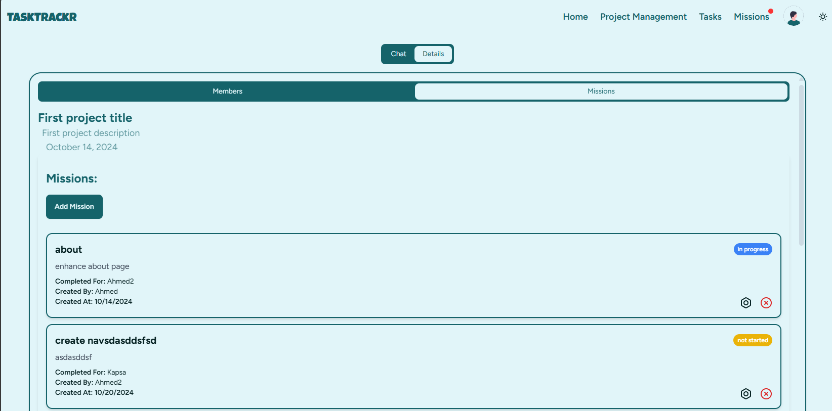

#### **7.3 Notifications for Assigned Missions**

Users will receive notifications for:

* Newly assigned missions

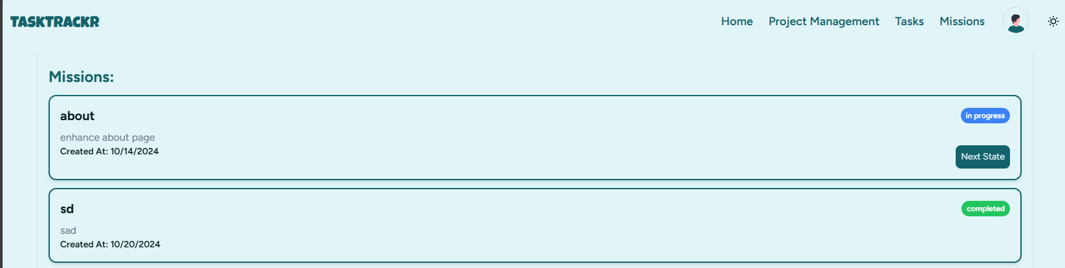

### **9. Member Management**

#### **9.1 Adding New Members to Projects**

* As a project **Owner** or **Manager**, invite new members by entering their email addresses in the **Manage Members** section of a project.
* Invited members will receive an email with a link to join the project.

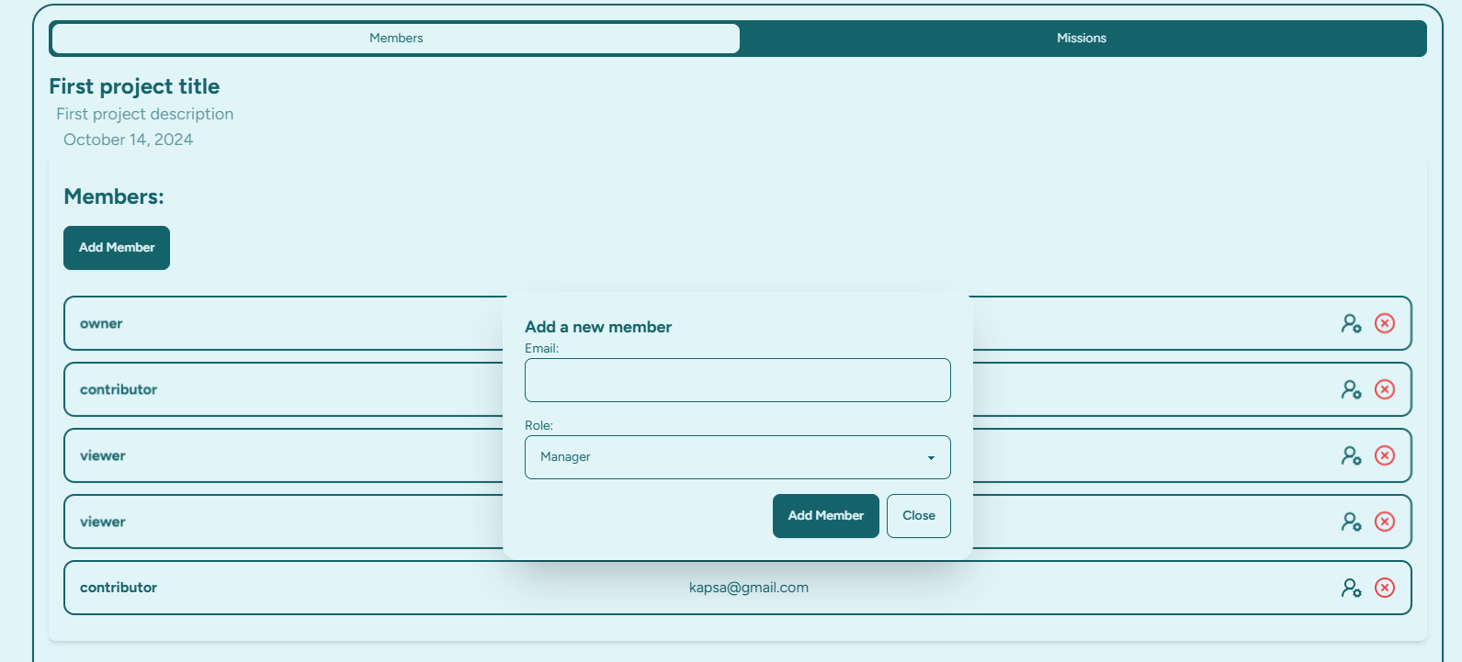

#### **9.2 Assigning and Updating Roles**

* When adding members, assign them roles ( Manager, Contributor, Viewer). These roles determine their level of access within the project.
* Project owners can update roles at any time.

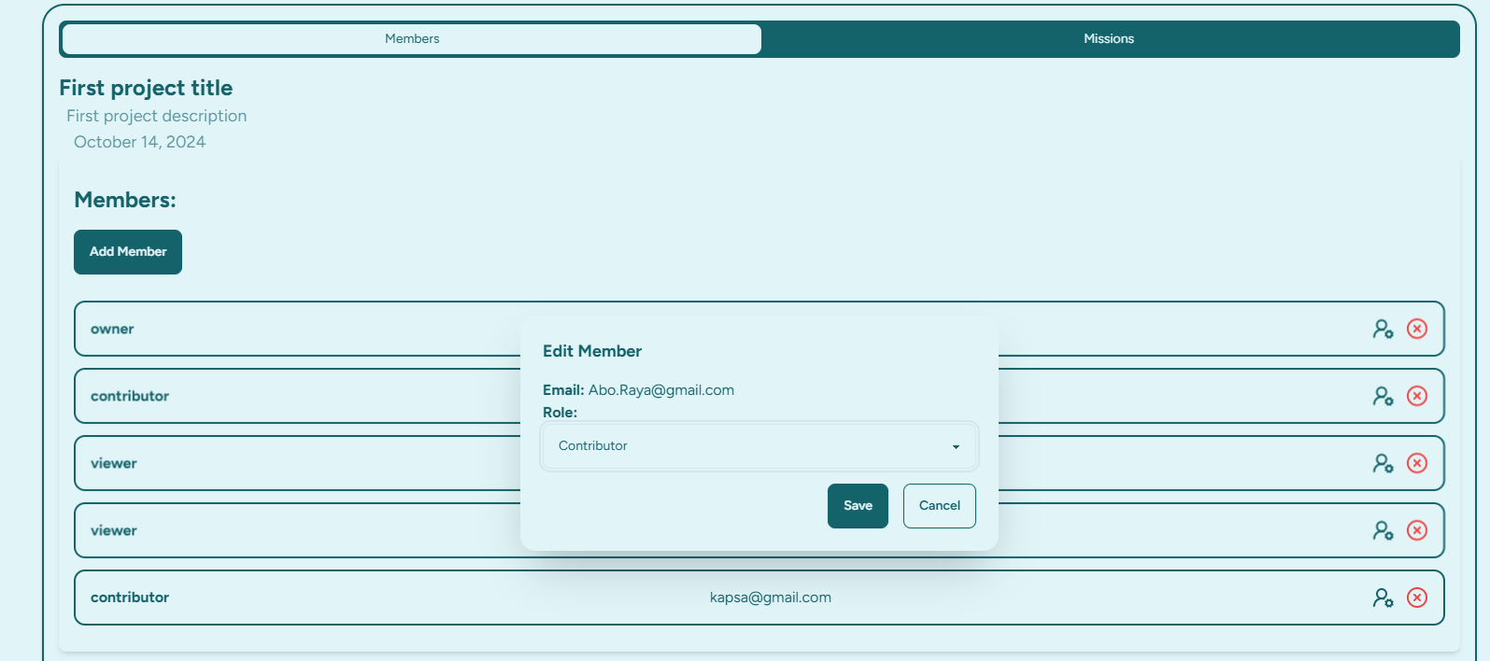

#### **9.3 Removing Members from Projects**

* Project owners can remove members from a project by clicking the **Remove** button next to a member's name in the **Manage Members** section.

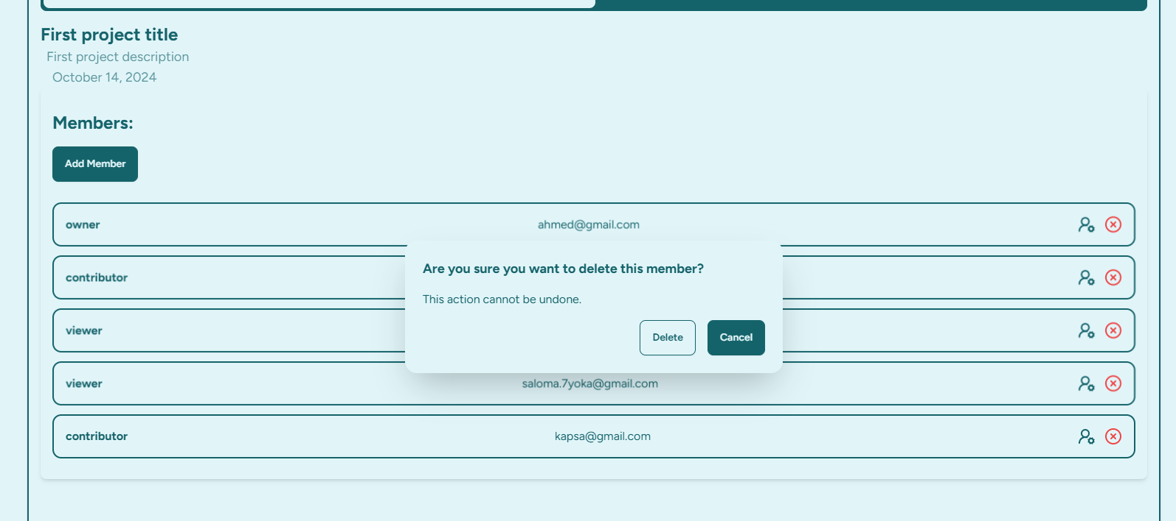 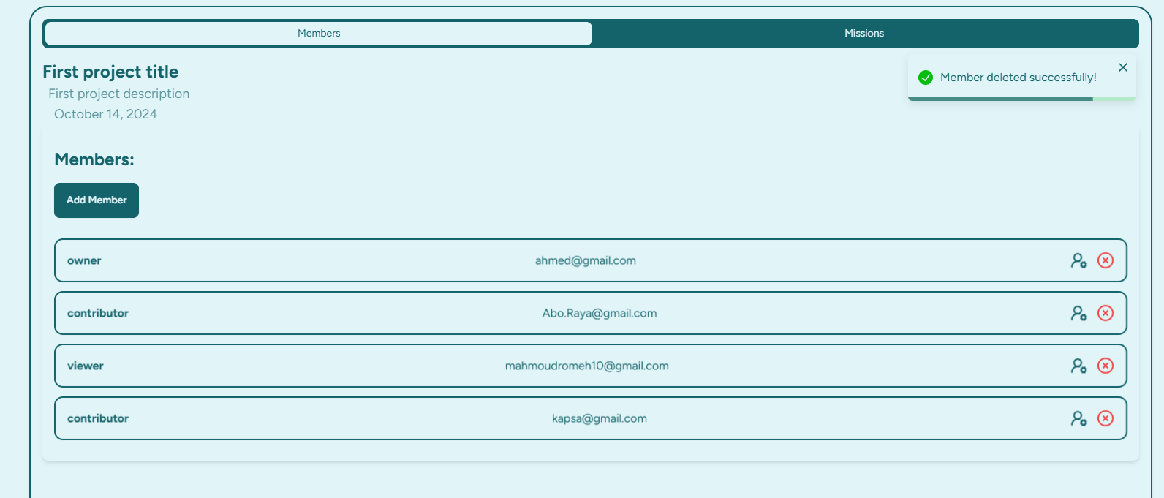

### **10. Technical Stack and Architecture**

#### **10.1 Frontend: React.js and Tailwind CSS**

* **React.js** is used for building reusable and dynamic UI components.
* **Tailwind CSS** is used for styling the frontend, allowing for quick and responsive designs with utility classes.

#### **10.2 Backend: Node.js and Express**

* **Node.js** handles the backend logic, including API endpoints for managing tasks, projects, and users.
* **Express** is used to create a robust REST API.

#### **10.3 Database: MongoDB**

* **MongoDB** is used as the database to store task, project, and user data.
* Mongoose is used as an Object Data Modeling (ODM) library for MongoDB.

### **11- Conclusion**

**TaskTracker** is a powerful and versatile application designed to streamline task and project management for individuals and teams. By leveraging modern web technologies such as React.js for the frontend, Node.js for the backend, and MongoDB for data storage, it provides a seamless user experience and robust functionality.

Throughout this documentation, we've covered essential features, including user authentication, task and project management, mission assignment, and member management. With a focus on ease of use and efficiency, **TaskTracker** enables users to stay organized, collaborate effectively, and track progress effortlessly.

We encourage users to explore the application fully and customize it to meet their specific needs. Your feedback is invaluable, and we welcome contributions that enhance the functionality and user experience of **TaskTracker**.

Thank you for choosing **TaskTracker**—let's manage your tasks and projects with efficiency and clarity!