 | CMPS 312 Project Phase 1 – Design and Implementation
Group Id: |  | T7
Group Members: |  | Ali Abouelkhir Email: aa2206551@qu.edu.qa  Amro Mohamed Email: am2109913@qu.edu.qa  Albaraa Samak Email: as2210562@qu.edu.qa  Abdelrahman Abdelvahed Email: aa2207121@qu.edu.qa

Grading rubric
In the Functionality column specify either: Working (completed x%), Not Working (completed x%) or Not done.
Criteria |  | % | Functionality* | Quality of the implementation
- Entities & Repositories Class Diagram.  - Correctness and completeness of class relationships.  - Proper use of naming conventions and entity-repository design. |  | 5
2) Design and implementation |  | 90
 | U1 - List and search learning packages | 8
 | U2 - Play Flash Cards | 10
 | U3 - Unscramble Sentences | 10
 | U4 - Match Word & Definition | 10
 | U5 - Login | 5
 | U6 - Delete Learning Package | 5
 | U7 - Add/Update Learning Package, including: | 10
 | U7.1 – Add/Update/Delete Words | 8
 | U7.2 - Add/Update/Delete Definitions | 8
 | U7.3 - Add/Update/Delete Sentences | 8
 | U7.4 - Attach Multimedia (as Web links) | 8
3) Testing documentation with evidence using screen shots illustrating the testing of UI and Repositories. |  | 5
4) Project contribution and individual responsibilities of each team member clearly documented [-10pts if not done]
Total |  | 100
Copying and/or plagiarism or not being able to explain or answer questions about the implementation |  | -  100
Grading Notes
- Working Functionality: A feature that works end-to-end earns up to 70% of its allocated marks for functionality; the remaining 30% is awarded for overall solution quality.
- Partially Working Features: Receive a 40% penalty for that item. The remaining 60% will be based on how close the solution is to full functionality and on its quality.
- Not Implemented: Awarded 0 marks.
Solution Quality considers:
- Modularity, simplicity, and robustness of the design.
- Clear and intuitive UI/UX.
- Meaningful and consistent naming of identifiers (following Flutter conventions).
- Clean, efficient implementation without redundancy.
- Proper use of comments, formatting, and indentation.
Marks will be reduced for:
- Overly complex or poorly designed user interfaces.
- Code duplication or poor coding practices.
- Weak or inconsistent naming conventions.
- Messy, disorganized submissions.

Application Design

Entities Class Diagram
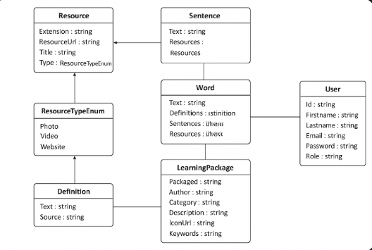

Repositories Class Diagram

Testing

U1 - List and search learning packages
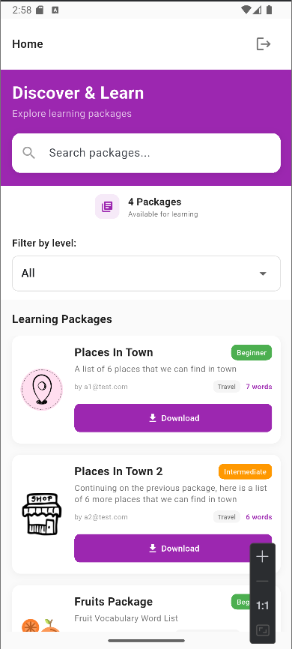
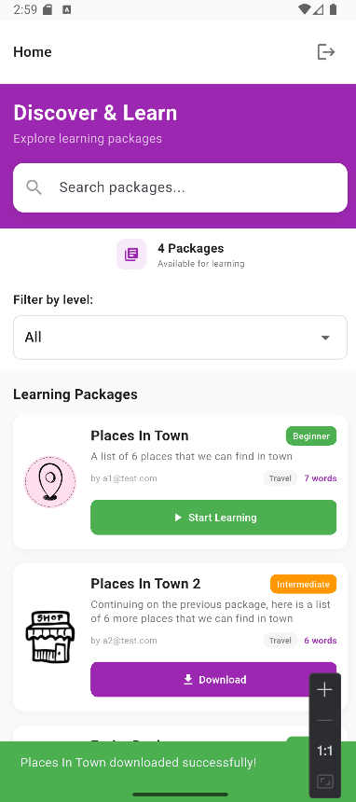
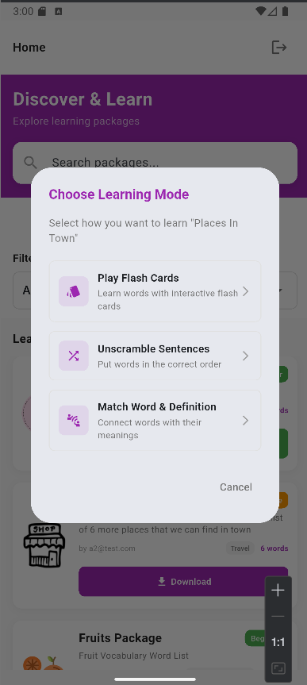

U2 - Play Flash Cards
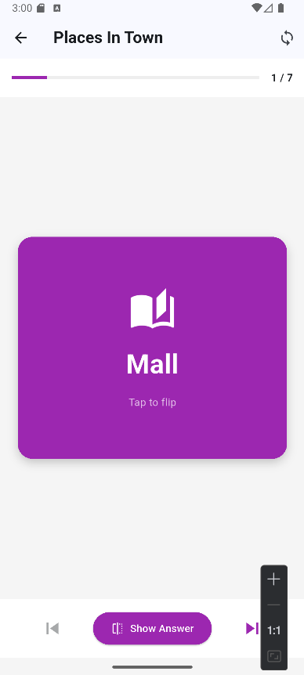
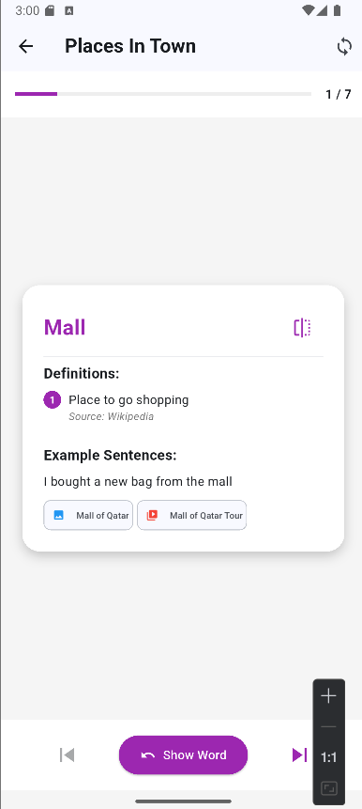
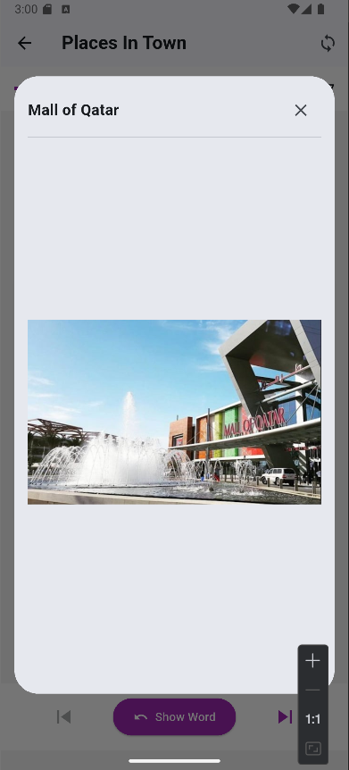
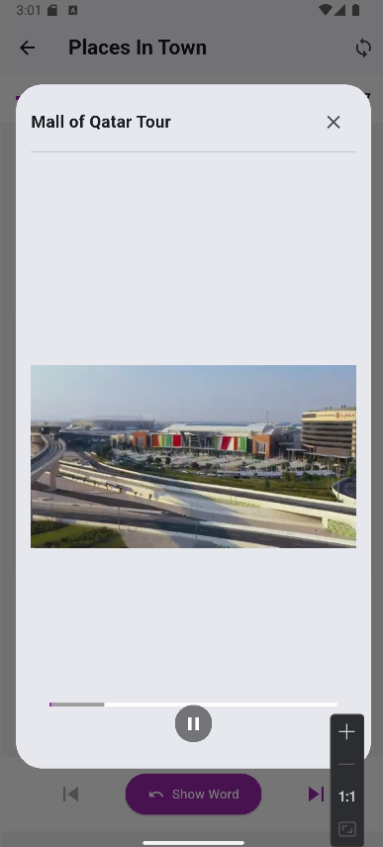
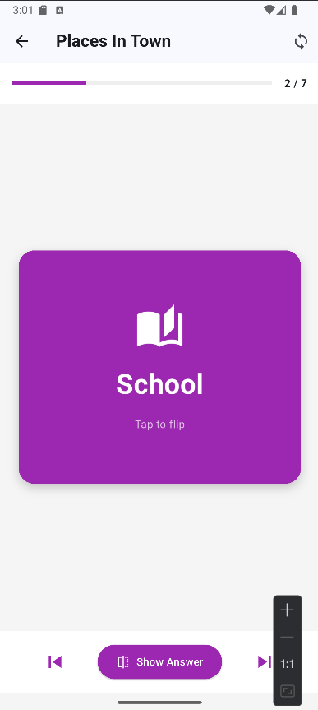

U3 - Unscramble Sentences
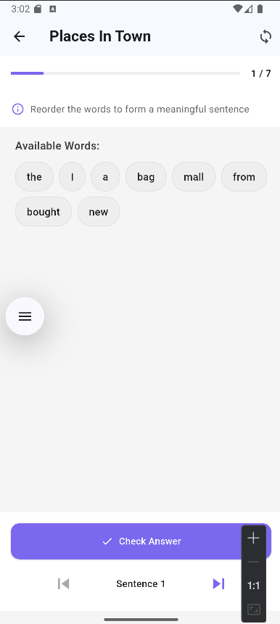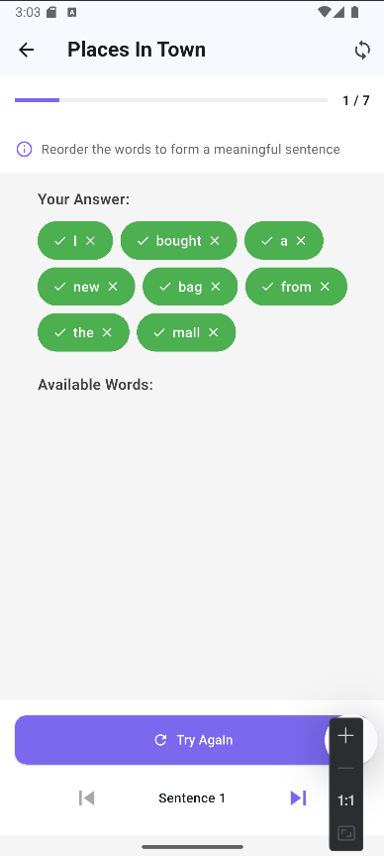
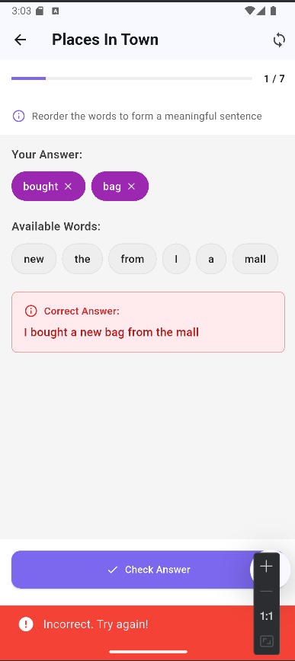

U4 - Match Word & Definition
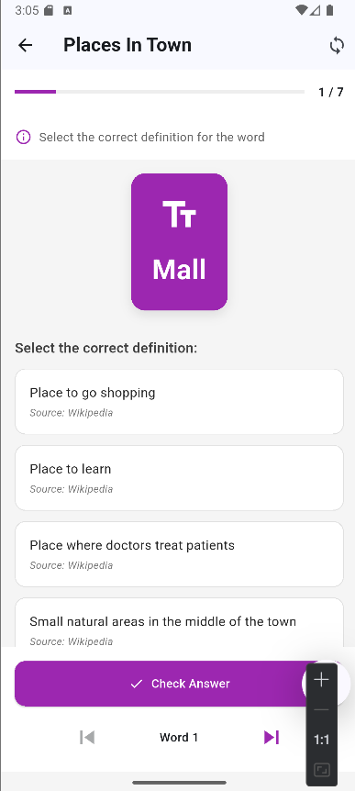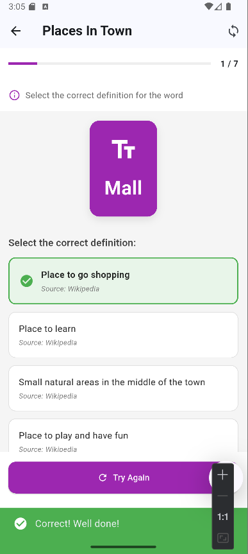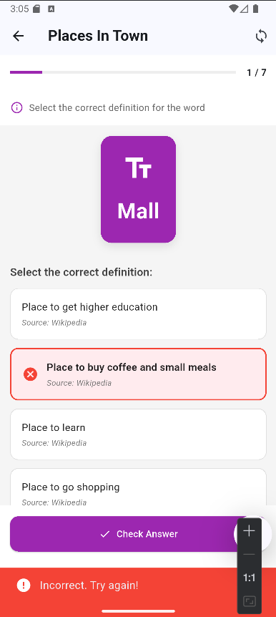

U5 – Login
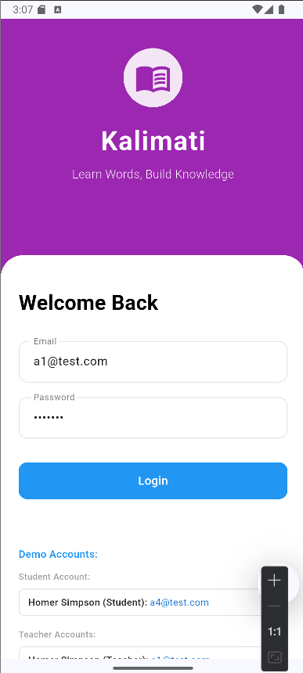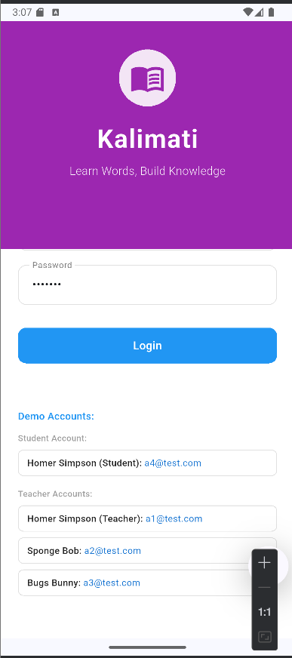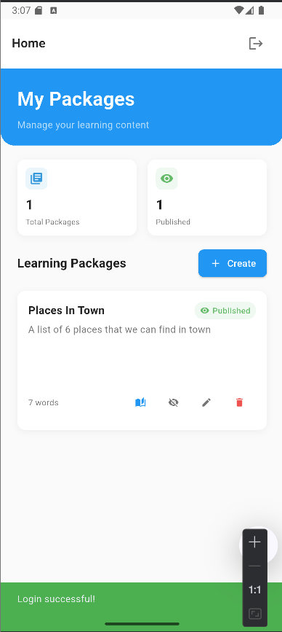

U6 - Delete Learning Package
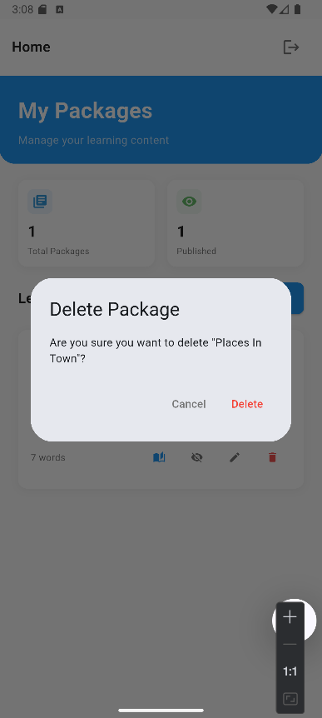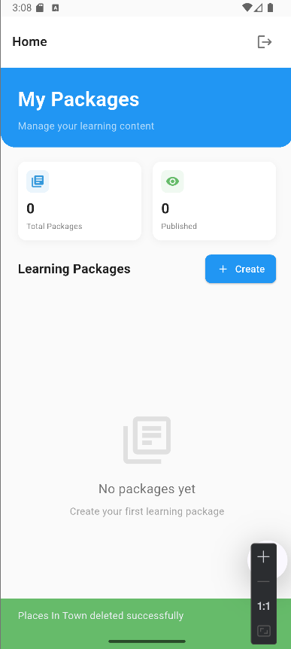

U7 - Add/Update Learning Package, including:

U7.1 – Add/Update/Delete Words
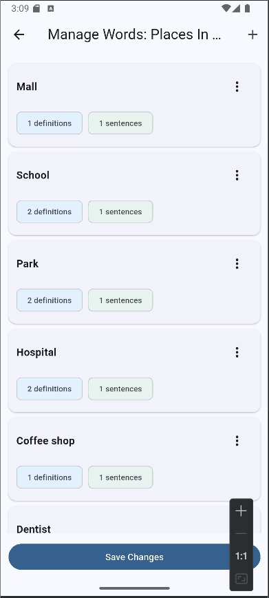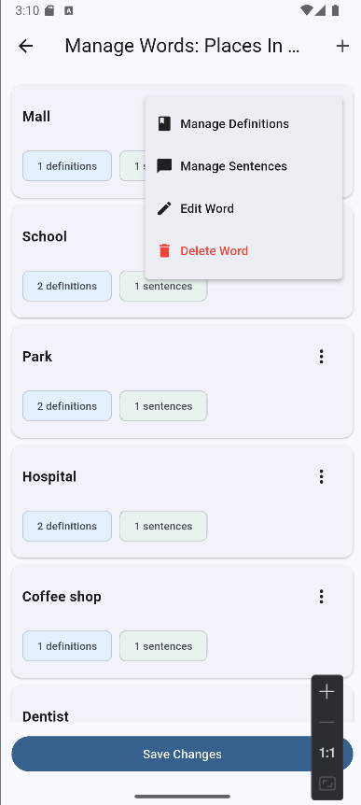
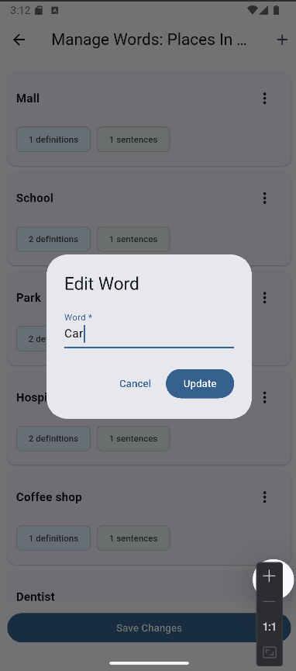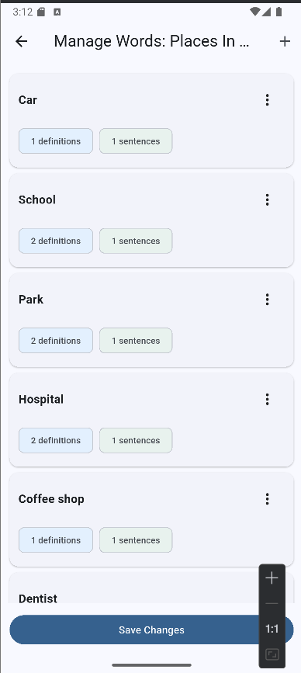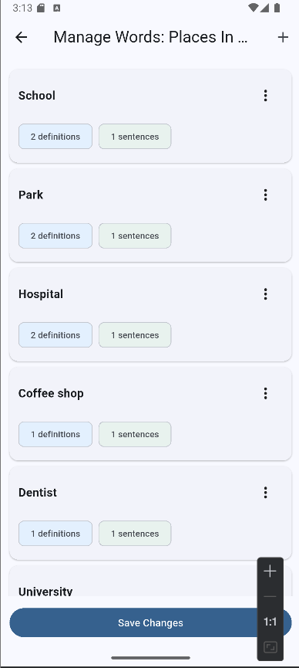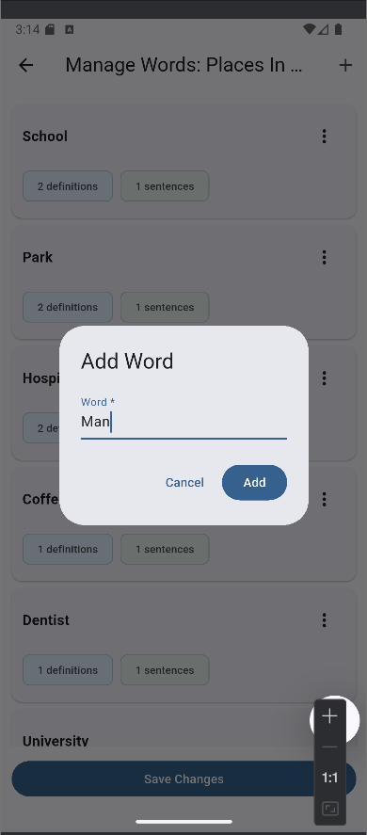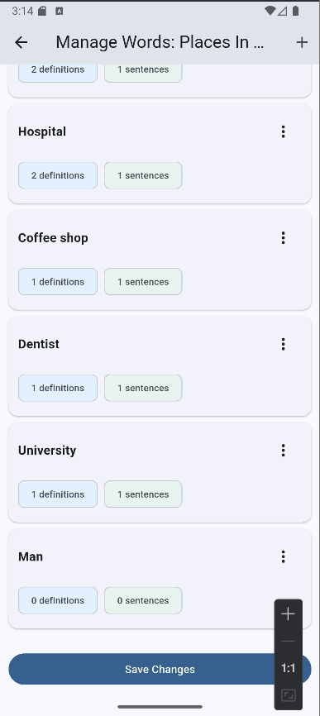

U7.2 - Add/Update/Delete Definitions
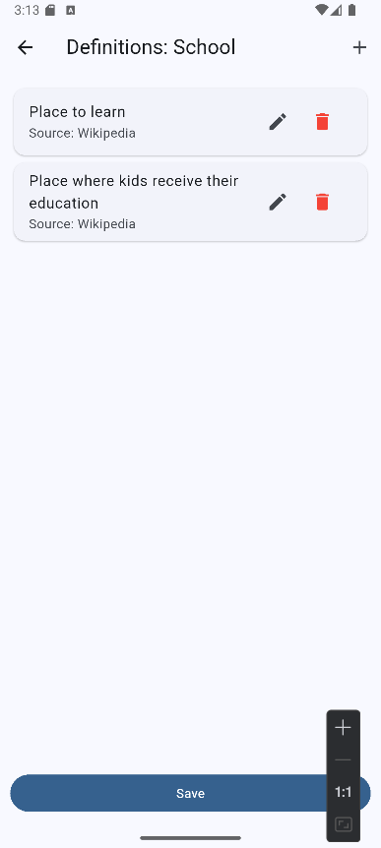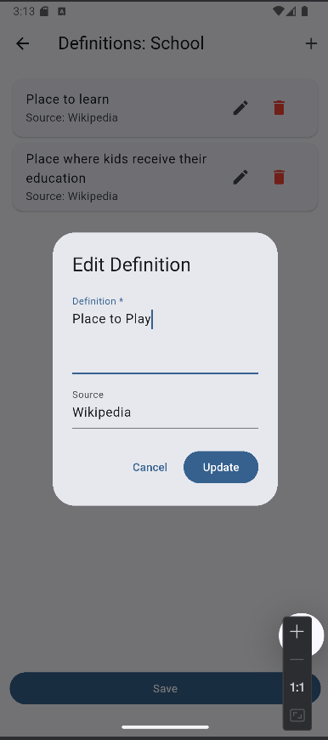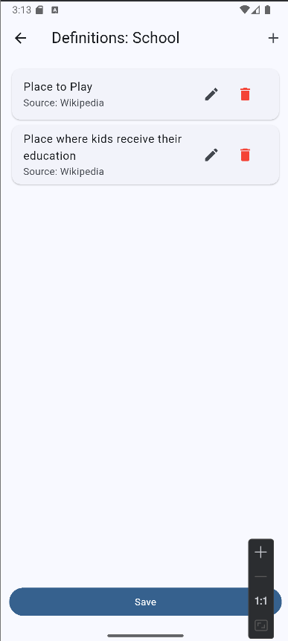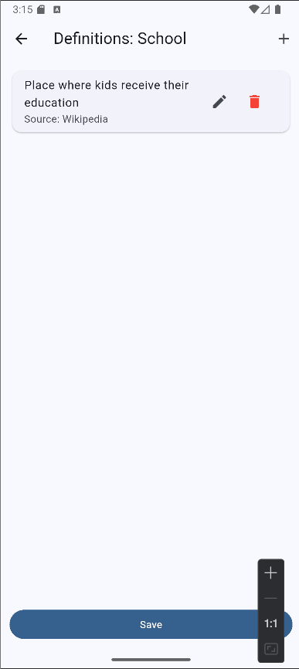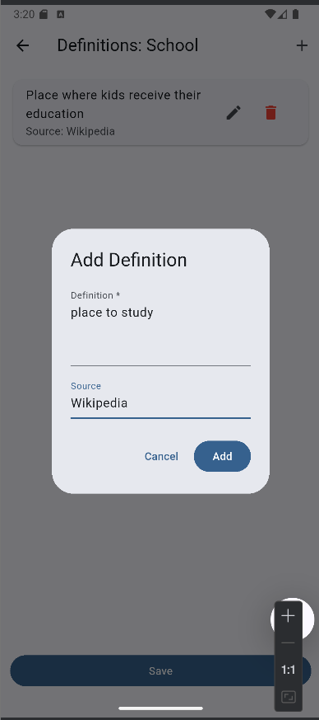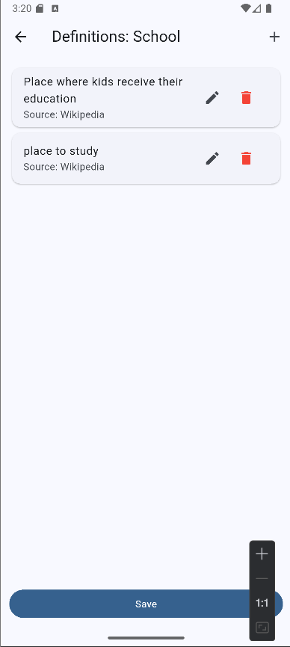

U7.3 - Add/Update/Delete Sentences
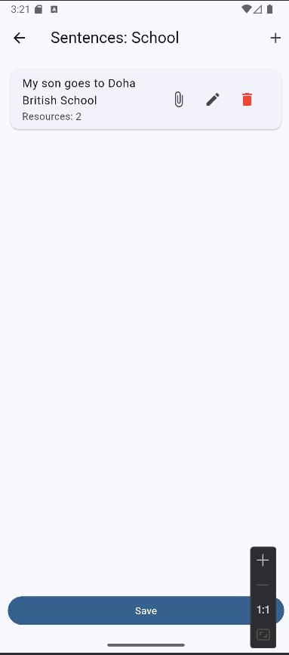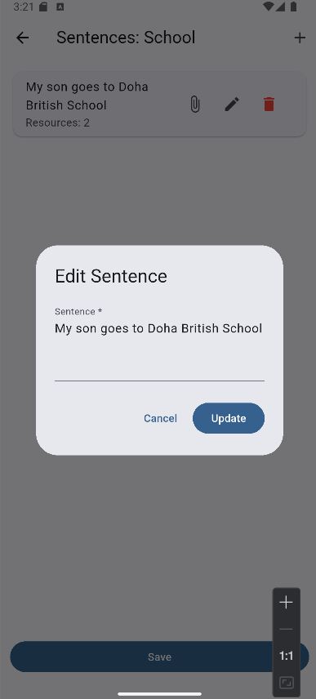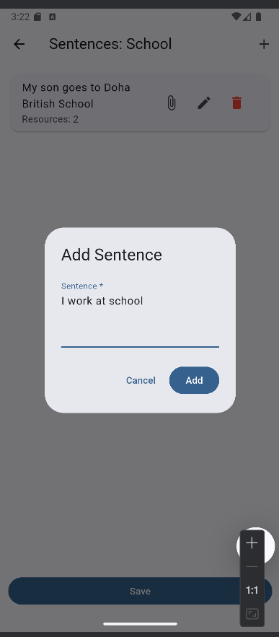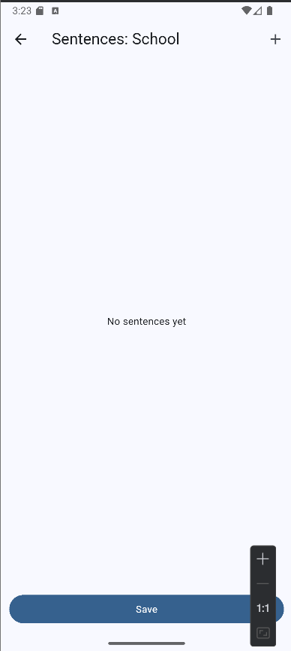

U7.4 - Attach Multimedia (as Web links)
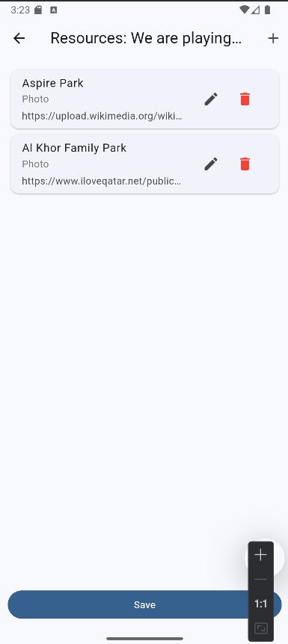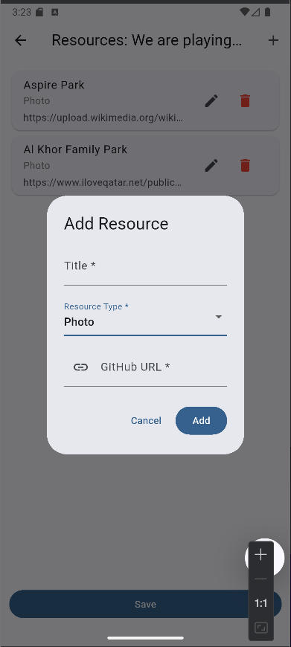

Summary of team member contributions
Member | Completed use cases / tasks
Ali Abouelkhir | U1 and backend
Amro Mohamed | U2 and U3
Albaraa Samak | U4 and U5
Abdelrahman Abdelvahed | U6 and U7

