Data base assig.1

Question 1 :

Q1.1)

select Ename

from dbo.Department, dbo.Employee

where SSN=Dmgr_ssn

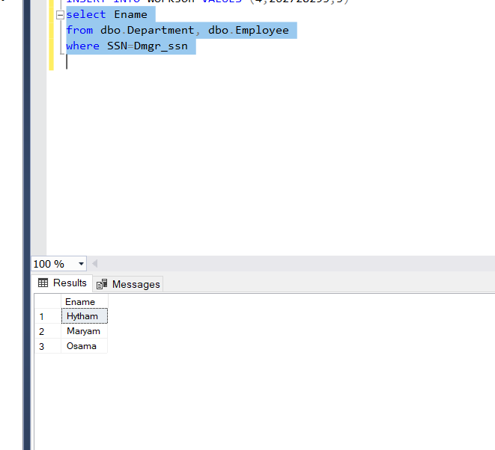

Relational Algebra:

π(Ename ,asDname) σ (SSN=Dmgr_SSS)(dbo.Employee , dbo.Departmentsa)

Q1.2)

Select distinct Dnumber

From dbo.project

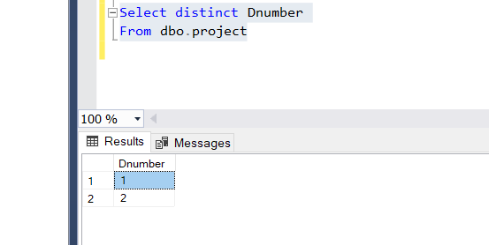

Relational Algebra:

π(Dnumber )(dbo.project)

Q1.3)

Select *

From dbo.Employee

Where Dnumber = 3

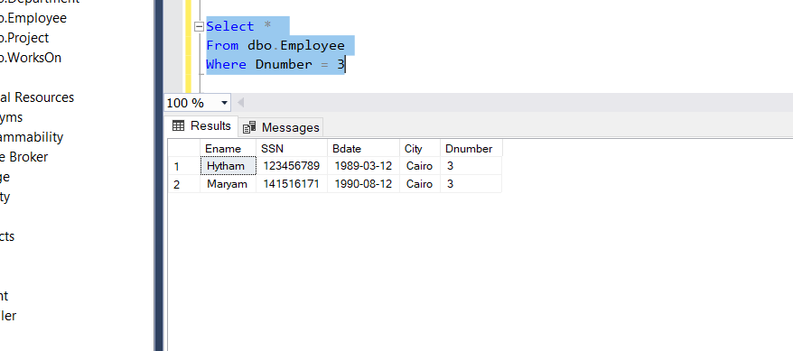

Relational algebra

σ (Dnumber=3)(dbo.Department , dbo.Employee) start between start

PQ1.4)

Select ename

From dbo.employee

Where Dnumber=2 and city ='cairo'

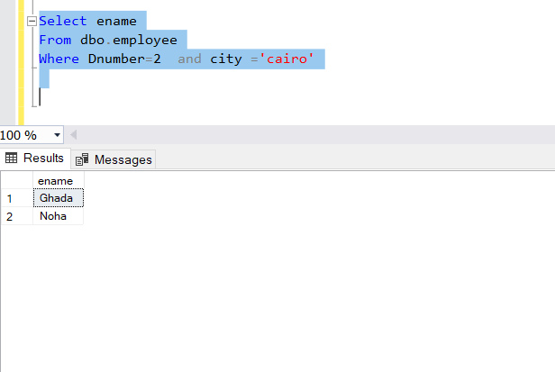

Relational Algebra

π(Ename) σ (Dnumber =2 and city = “cairo”)( dbo.Employee)

Q1.5)

Select ename

From dbo.employee

Where Dnumber=2 or Dnumber = 1

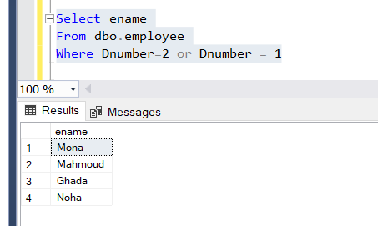

Relational algebra

π(Ename) σ (Dnumber =2or Dnumber=1 )( dbo.Employee)

Q1.6)

Select ename

From dbo.employee ,dbo.department

Where SSN=Dmgr_SSN

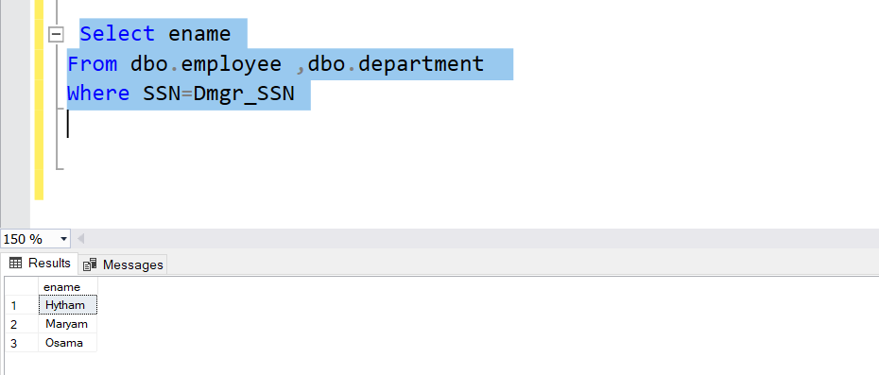

Relational algebra

π(Ename) σ (SSN=Dmgr_SSN)( dbo.employee , dbo.Department )

Q1.7)

select Pname,Dname

from Project , Department

WHERE Dnumber=dno

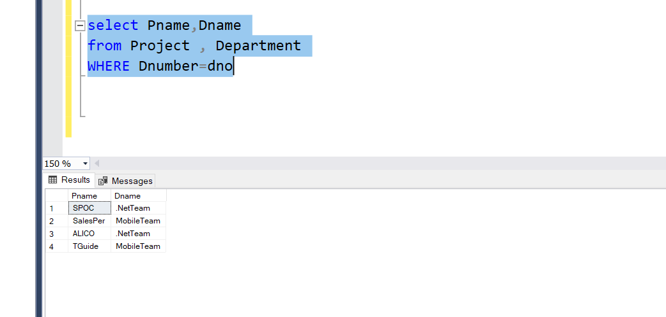

Relational algebra

π(pname,dname) σ (Dno=Dnumber)( dbo.Department ,dbo.project)

Q1.8)

Select ename , pname

From dbo.workson,dbo.employee,dbo.project

Where workson.ssn = employee.ssn and workson.pnumber = projet.pnumber

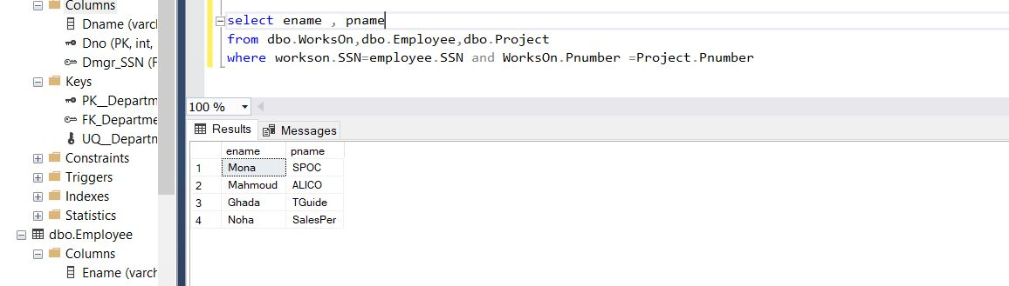

Relational algebra

π(pname,ename) σ (Workson.SSN=employee.SSN and WorksOn.Pnumber = Project.Pnumber)( dbo.workson, dbo.employee,dbo.project)

Q1.9)

Select distinct ename

From dbo.employee , dbo.project , dbo.workson

Where employee.city=project.plocation and employee.ssn=workson.ssn and workson.pnumber=project.pnumber

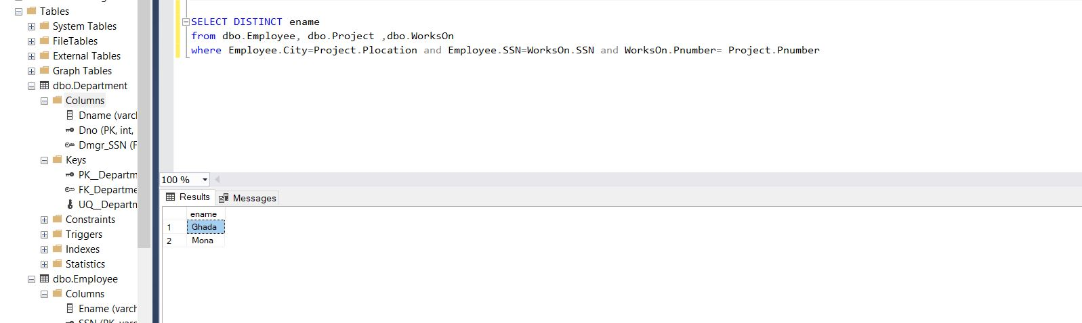

Relational algebra

π(ename) σ (Workson.SSN=employee.SSN and WorksOn.Pnumber = Project.Pnumber and employee.city=Project.Ploctaion)( dbo.workson, dbo.employee,dbo.project)

Q1.10

Select ename , workson.hours

From dbo.employee , dbo.project , dbo.workson

Where employee.city=project.plocation and employee.ssn=workson.ssn and employee.dnumber!=project.dnumber and workson.pnumber=project.pnumber )

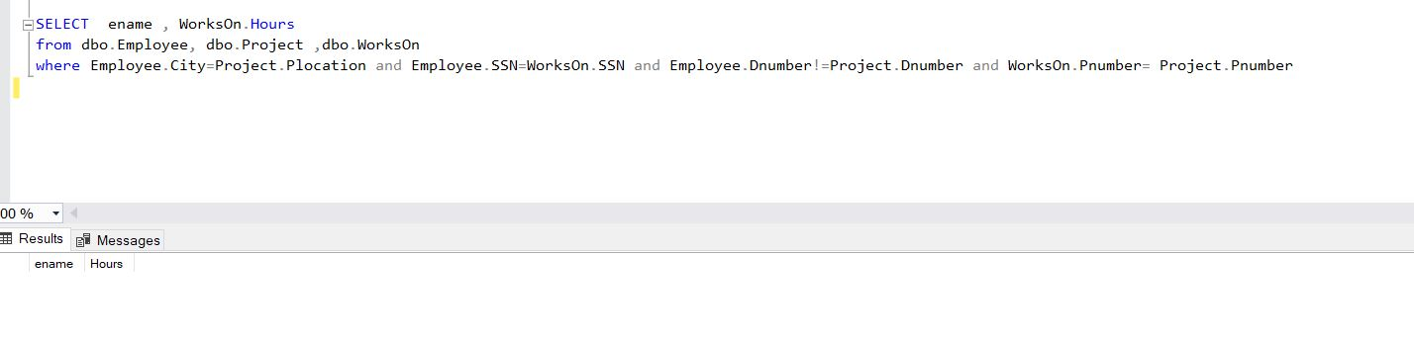

Relational algebra

π(ename, workson.hours) σ (Workson.SSN=employee.SSN and WorksOn.Pnumber = Project.Pnumber and employee.city=Project.Ploctaion and employee.dnumber != project.Dnumber)( dbo.workson, dbo.employee,dbo.project)

Question two :

Q (2.1)

Select distinct pname,sname

From p , s , spj

Where spj.s#=s.s# and spj.p#=p.p#

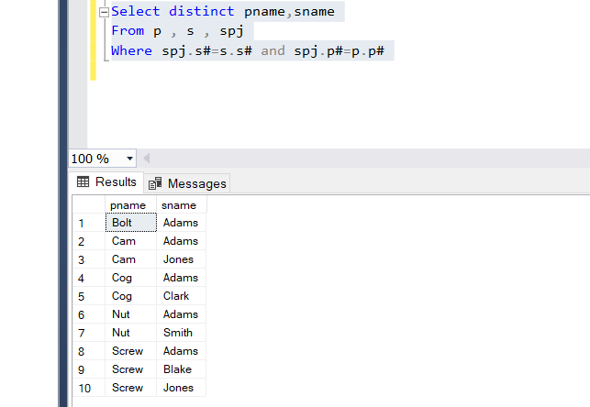

Q (2.2)

Select spj.s#

From SPJ Join(

select avg(qty) as AverageQuantityP1 from SPJ

Where p# = 'P1') as AverageQuantityTable

On SPJ.qty>AverageQuantityTable.AverageQuantityP1 and SPJ.p# IN ('P1')

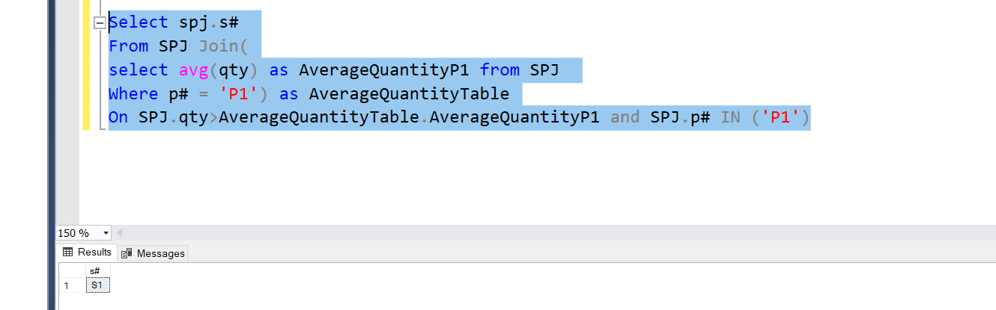

Q (2.3)

Select j#

From spj

Where spj.s#='s1'

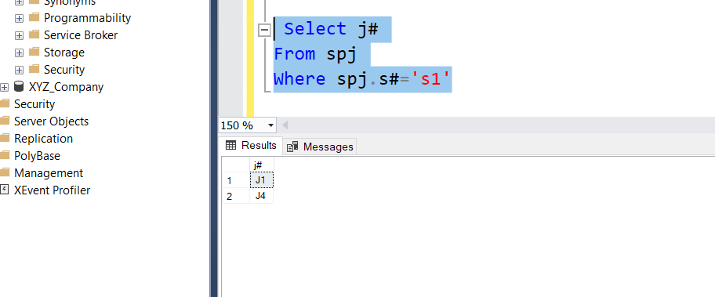

Q (2.4)

select distinct S.sname

from S inner join SPJ

on S.s#=SPJ.s#

WHERE not exists (select SPJ.s# from SPJ

where SPJ.p# in ('P2') and S.s# =SPJ.s#

);

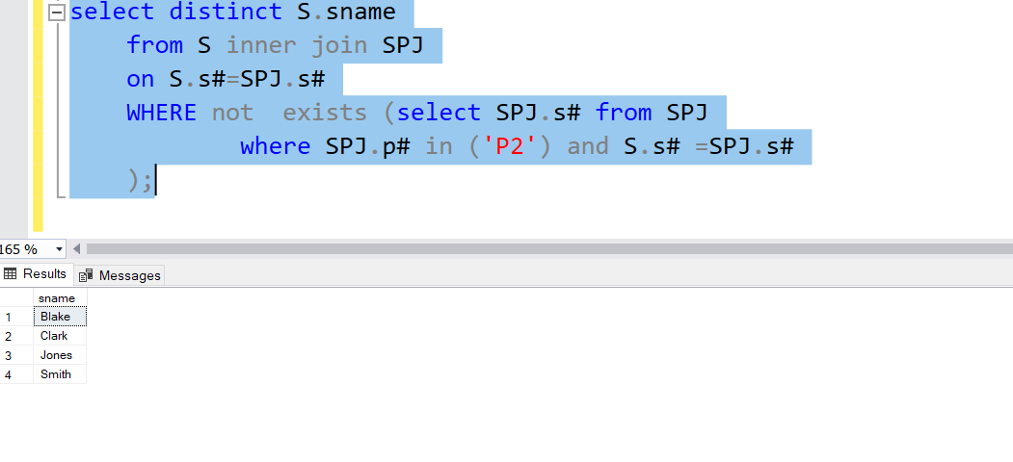

Q (2.5)

Select distinct S.sname

from S inner join SPJ on S.s#=SPJ.s# AND SPJ.p# in ('P1') and [status]=S.[status];

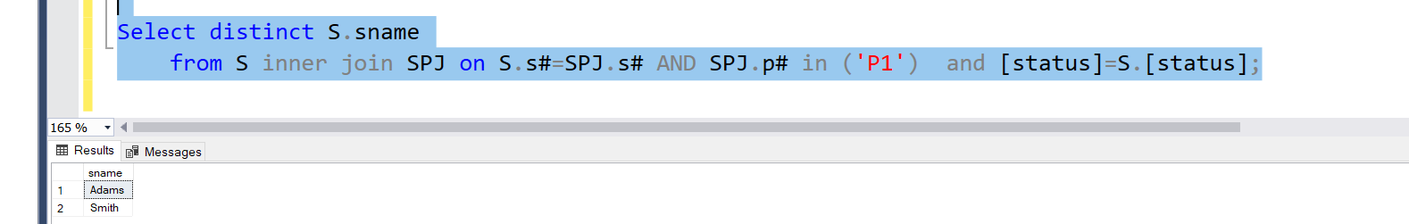

Q (2.6)

Select distinct s.sname

From s,spj

Where s.s# in (select spj.s# from spj where spj.p# in (select spj.p# from spj))

