Cairo University Faculty of Computers and Artificial Intelligence



**Software design specification document**

**2022**

**Project Team**

|  |  |  |
| --- | --- | --- |
| **ID** | **Name** | **Email** |
| 20210201 | Abdelrahman Hossam Eldin Ahmed | bodyhossam62@gmail.com |
| 20211046 | Sara Adel Hanafy | saraadel6122@gmail.com |
| 20211057 | Doha Tarek Farouk | dohatarek155@gmail.com |
| 20211098 | Mai Mohamed Khalil | maim51084@gmail.com |

Contents

Instructions[To be removed] 2

Class diagram design 2

Class diagram Explanation 3

Sequence diagram design 3

Github repository link 4

# Class diagram design

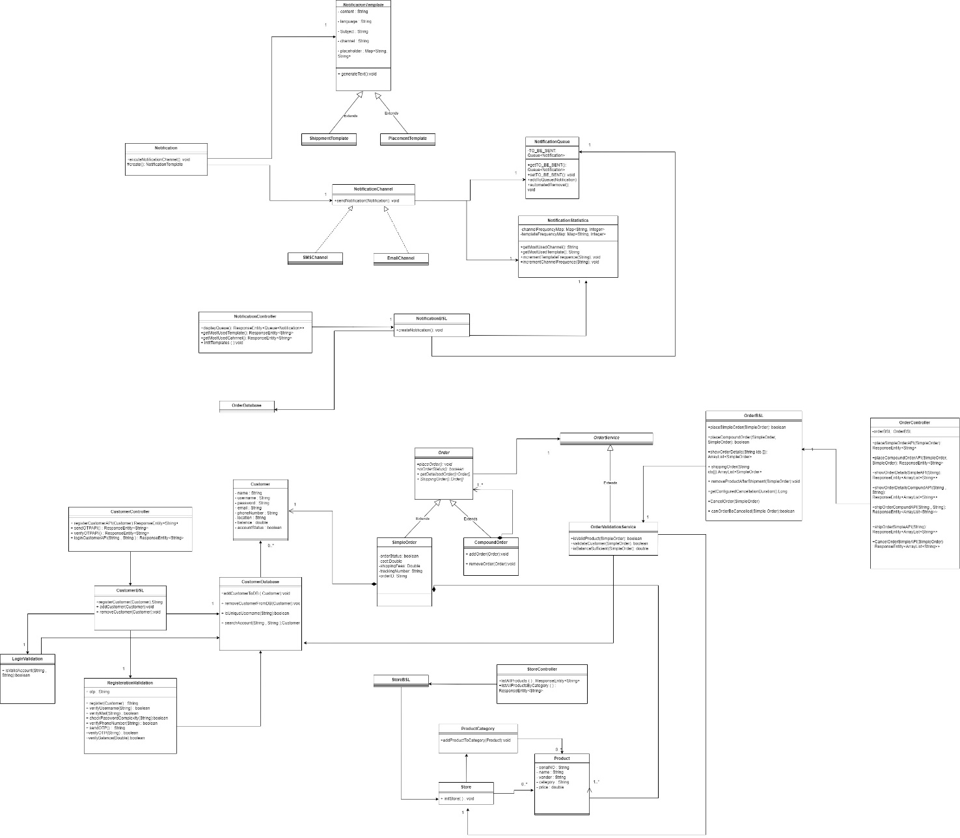

#### Pdf file is provided for clearer version

# Class diagram Explanation

#### Composite Pattern in Order Module :

#### Classes -> Order , CompoundOrder , Simple Order

#### With the Composite Pattern, both simple orders (SimpleOrder) and compound orders (CompoundOrder) can be treated uniformly as instances of the common interface or abstract class (Order).

#### This allows you to work with a collection of orders in a consistent manner, regardless of whether they are simple or compound.

#### Strategy Pattern in various places like

#### 1 . Notification , NotificationTemplate , PlacementTemplate , ShipmentTemplate

#### 2 . Notification , NotificationChannel , EmailChannel, SMSChannel

# Requirements Exposure as Web Service API

**Part 1: Exposed Postman Collection**

**Part 2:**

**Explain here the exact mapping between every single requirement and its corresponding web service API operation.**

|  |  |  |
| --- | --- | --- |
| Requirement |  | Exposed API |
| A list of all the products currently available for purchase should be displayed and a count of the remaining parts from each category. |  | 1-GET /products/all  2-GET/ products/allByCategory  This API endpoint retrieves information about all available products and a count of the remaining. |
| The customer creates an account with a specific balance.  1. The system sends OTP for registration validation. 2. The system verifies received OTP during registration. 3. a customer login with his username and password. |  | POST/register This API endpoint allows customers to create an account by providing details.   1. GET/sendOTP   This API endpoint generates and retrieves an OTP for registration validation.   1. POST/verifyOTP/{otp}   This API endpoint verifies the OTP sent during registration along with customer information.   1. Post/login/{username}/{password}   This API endpoint validates a customer's login credentials by checking the username and password provided in the request against the stored records. |
| A customer can place a simple order or compound order. |  | 1-POST /orders/simple2-POST /orders/compound This API endpoint allows a customer to create a simple or compound order |
| A list of all the details of both simple and compound orders. |  | 1-GET /orders/{id}  2-GET/orders/{id1}/{id2}  This API endpoint retrieve information about both simple or compound orders based on the provided order identifiers |
| After placing the order, the user can ship the order. |  | 1-GET /orders/ShipOrder/{id}  2-GET/orders/ShipOrder/{id1}/{id2} This API endpoint allows the user to ship a simple order or compound orders based on the provided order identifiers |
| 1. initializing the notification channels within the system. It includes creating default templates and configuring channels. |  | GET/notify/inti This API endpoint triggers the initialization process for notification channels. |
| Show The most notified email-address/phone-number and the most sent notification template. |  | 1- GET /notify/mostChannel 2- GET /notify/mostTemplate  This API endpoint retrieves information about the most used channel or template. |
| Implement a "notifications Queue", where you insert "notifications" that are to send. |  | GET/notify/display This API endpoint Retrieves the notifications currently in the queue. |
| Order Cancellation |  | Post/CancelOrder/{id} This API endpoint allow customer to cancel  order |
|  |  |  |