WideBot AI Design System
Release Notes & Developer Guide
v1.0.0
March 26, 2026

For Designers & Developers
Dual-Brand | AI-Native | Enterprise-Grade | Token-Driven

42 Components | 86 Tokens | 8 JSON Registries | 19 Governance Rules | 5 Skills
WideBot (WCAG AAA) + Hulul (WCAG AA) | Light + Dark | LTR + RTL | Desktop + Mobile

1. Release Overview
Version 1.0.0 is the foundational release of the WideBot AI Design System. It delivers 42 production-ready components, 86 design tokens, 8 machine-readable JSON registries, and 19 governance enforcement rules in a single-file, token-driven architecture.
The system supports two brands (WideBot + Hulul), two themes (light + dark), two text directions (LTR + RTL), and two viewports (desktop + mobile). This is not a traditional npm package. Like shadcn/ui, you copy the source directly into your project and extend it using the same token and governance architecture.

System Architecture
The following diagram shows how all layers of the design system connect, from the single source of truth (ds-library.html) through JSON registries, skill pipeline, product and Figma outputs, runtime configuration, and governance enforcement.
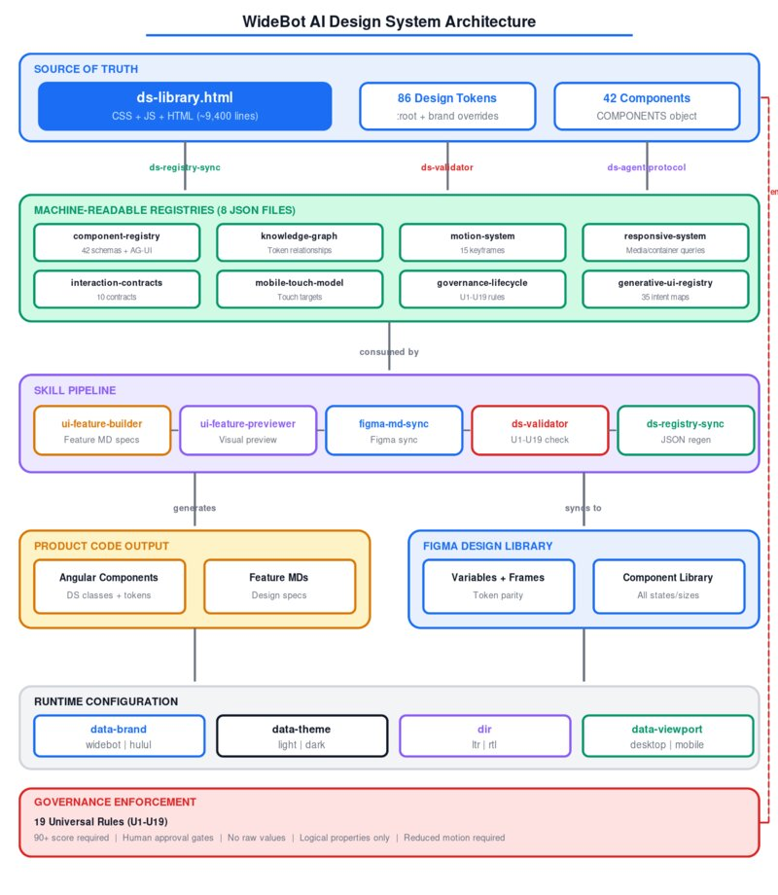
Figure 0: System Architecture Overview

2. What Is Included

Component Library (42 Components)
- Primitives (7): Button, Icon Button, Badge, Chip, Toggle, Avatar, Divider
- Containers (4): Card, Panel, Tabs, Accordion
- Navigation (4): Breadcrumb, Nav Rail, Bottom Nav, Pagination
- Feedback (7): Dialog, Alert, Snackbar, Toast, Tooltip, Popover, Empty States
- Forms (7): Text Field, Selection Controls, Slider, Date Picker, Tag Input, File Upload, Menu
- Data Display (5): List, Data Grid, Tree View, Timeline, Stepper
- AI Components (8): AI Chat, Command Palette, Notification Center, Search, Loading, AI Confidence, Reasoning Trace, Activity Event

Architecture Registries (8 JSONs)
- ai-component-registry.json - 42 component schemas + AG-UI protocol
- ai-knowledge-graph.json - token-to-component relationship graph
- ai-motion-system.json - 15 keyframes, transitions, reduced-motion
- ai-responsive-system.json - media queries, container queries
- ai-interaction-contracts.json - 10 behavioral contracts
- ai-mobile-touch-model.json - touch targets, gestures
- ai-governance-lifecycle.json - U1-U19 enforcement rules
- ai-generative-ui-registry.json - 35 agent-to-UI intent mappings

3. Installation (Step by Step)
Follow these 6 steps to integrate the design system into your Angular project.
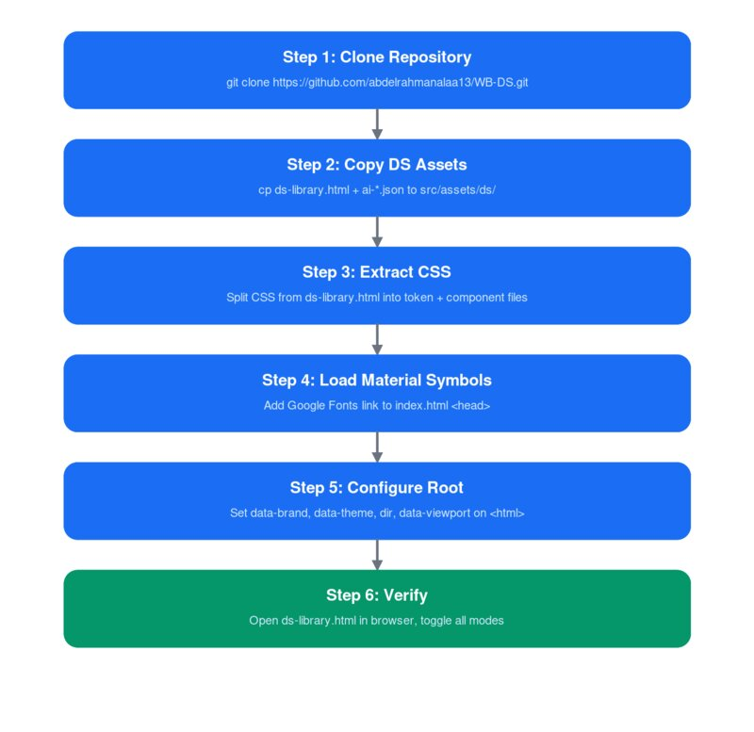
Figure 1: Installation Flow

Step 1: Clone the Repository
git clone https://github.com/abdelrahmanalaa13/WB-DS.git
This gives you ds-library.html, 8 JSON registries, governance specs, skills, and documentation.

Step 2: Copy DS Assets into Your Project
Create a ds/ directory in your project's assets folder and copy the source files:
mkdir -p your-project/src/assets/ds
cp WB-DS/ds-library.html your-project/src/assets/ds/
cp WB-DS/ai-*.json your-project/src/assets/ds/
Recommended project structure:
src/
assets/ds/ds-library.html <- source of truth
assets/ds/ai-*.json <- machine registries
styles/ds-tokens.css <- extracted tokens
styles/ds-components.css <- extracted component CSS

Step 3: Extract the CSS Layers
Open ds-library.html and extract the two CSS sections into standalone files:
- ds-tokens.css: Copy the :root block and all [data-brand], [data-theme] overrides
- ds-components.css: Copy all .ds-* component classes, @media, @keyframes rules
Import both in your root styles (angular.json or styles.scss):
@import 'styles/ds-tokens.css';
@import 'styles/ds-components.css';

Step 4: Load Material Symbols Font
Add to your index.html inside the head tag:
<link href="https://fonts.googleapis.com/css2?family=
Material+Symbols+Rounded:opsz,wght,FILL@20..48,100..700,0..1"
rel="stylesheet" />

Step 5: Configure Root Attributes
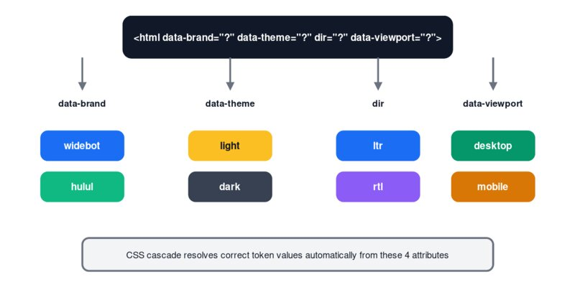
Figure 2: Root Attribute Configuration
Set these 4 attributes on your root HTML element. The CSS cascade resolves correct tokens automatically:
<html data-brand="widebot" data-theme="light" dir="ltr" data-viewport="desktop">
Attribute | Options | Effect
data-brand | widebot | hulul | Switches color palette and WCAG level
data-theme | light | dark | Switches surface/content color tokens
dir | ltr | rtl | Activates logical CSS property direction
data-viewport | desktop | mobile | Activates responsive component rules

Step 6: Verify Installation
Open ds-library.html directly in a browser. Toggle between all brand/theme/direction/viewport combos using the built-in controls. All 42 components should render correctly. This file serves as living documentation and visual regression reference.

4. Skill Ecosystem and Prompts
The design system integrates with 5 Claude skills that form a complete DS pipeline. Each skill has one job and operates on ds-library.html as the source of truth.
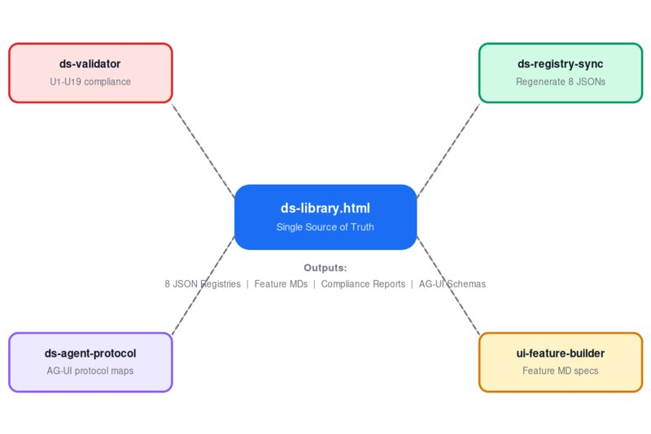
Figure 3: Skill Ecosystem

ds-validator
Job: Check any component against all 19 governance rules (U1-U19). Reports compliance score and specific violations.
When to use: After any component change, before documentation phase.
Example prompts:
> Run ds-validator on the Button component
> Validate all components and show me any violations below 90
> Check if the new Stepper changes pass U10 and U12

ds-registry-sync
Job: Regenerate all 8 JSON registries from ds-library.html. Ensures machine-readable registries always match the source code.
When to use: After any code change to ds-library.html.
Example prompts:
> Sync the registry - I just updated Timeline CSS
> Regenerate all JSON files from ds-library.html
> Run ds-registry-sync and show me what changed

ds-agent-protocol
Job: Map components to AG-UI protocol schemas (readable, actions, events, generativeUI).
When to use: When adding new components or updating interaction contracts.
Example prompts:
> Update the AG-UI protocol mappings for the new AI Confidence component
> What actions can an agent trigger on the Data Grid?

ui-feature-builder
Job: Generate complete UI feature documentation (markdown) for Angular 21 with multi-brand design tokens.
When to use: When building a new feature or page that needs design specs.
Example prompts:
> Build the UI feature spec for a customer approval workflow page
> Generate feature docs for a settings page with WideBot and Hulul tokens
> Create the component architecture for a dashboard analytics panel

ui-feature-previewer
Job: Preview feature-builder output as interactive visual artifacts across brands, themes, and directions.
When to use: After generating feature MDs, to see how components look.
Example prompts:
> Preview the approval workflow MDs I just generated
> Show me the component in WideBot dark RTL
> Gap analysis between old and new tokens for Button

5. Building Products with the DS
When an AI agent or developer builds a new product feature, the workflow follows 6 steps:
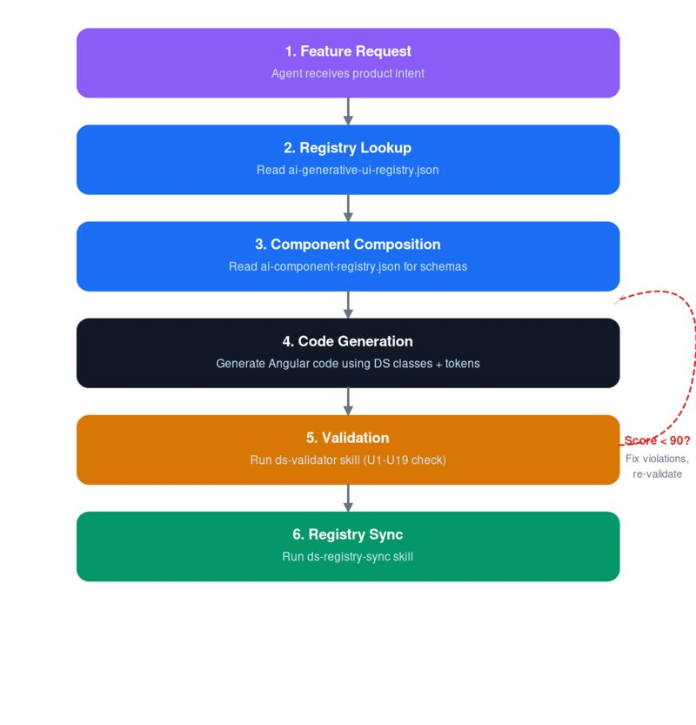
Figure 4: Product Development Workflow

- Intent: Agent receives a feature request (e.g., 'build a customer approval workflow').
- Registry Lookup: Agent reads ai-generative-ui-registry.json to find matching intent mappings and required components.
- Component Composition: Agent reads ai-component-registry.json for schemas, properties, slots, tokens, and ARIA requirements.
- Code Generation: Agent generates Angular code using DS classes, data attributes, and token references. No raw values.
- Validation: Run ds-validator. Score must be 90+ to proceed. If below 90, fix violations and re-validate.
- Registry Sync: Run ds-registry-sync to keep all 8 JSONs current after code changes.

Example: Building a Dashboard Page
Here is the exact prompt sequence a developer would use:
> Use ui-feature-builder to create the feature spec for an analytics dashboard with KPI cards, a data grid, and a chart area
This generates markdown files with component architecture, token mappings, and responsive rules.
> Preview the dashboard feature MDs in WideBot light desktop
This renders an interactive JSX preview showing the dashboard layout.
> Run ds-validator on all components used in the dashboard
This checks U1-U19 compliance and reports the score.
> Sync the registry after dashboard changes
This regenerates all 8 JSONs to reflect any new patterns.

Generative UI Pattern (AG-UI)
The agent proposes WHAT (intent + data + output schema). The frontend decides HOW (using DS components). The agent never outputs raw HTML. It emits structured intents resolved against the component registry. Each component's agentProtocol defines: readable (extractable fields), actions (triggerable mutations), events (subscribable notifications), generativeUI (output schemas).

6. Component Reference
Component | Purpose | Variants | Sizes / Options
Button | Primary action trigger | filled, tonal, outlined, ghost | xs, sm, md, lg, xl
Icon Button | Icon-only action/toggle | filled, tonal, outlined, ghost | xs, sm, md, lg, xl
Badge | Status indicator (dot/count) | dot, count | sm, md, lg
Chip | Compact tag/selection | tonal, outlined | sm, md, lg
Toggle | On/off switch control | off, on | sm, md, lg
Avatar | User representation | image, initials, icon | xs, sm, md, lg, xl
Divider | Visual separator | horizontal, vertical | default, strong
Card | Content container with slots | elevated, outlined, filled | compact, default, comfortable
Tabs | Section navigation | with/without icon | sm, md, lg
Breadcrumb | Navigation trail | 3-10 depth levels | sm, md, lg
Nav Rail | Collapsible side navigation | expanded, collapsed | desktop, mobile
Panel | Persistent content region | elevated, outlined | compact, default, comfortable
Dialog | Modal overlay | alert, confirmation, form | compact, default, comfortable
Alert | Inline status message | tonal, filled, outlined | danger, warning, success, neutral, ai
Snackbar | Brief floating message | with/without action | danger, warning, success, neutral
Toast | Floating notification | single, stacked | danger, warning, success, neutral, ai
Tooltip | Hover/focus info popup | plain, rich | top, bottom, start, end
Popover | Anchored floating content | info, form, actions | compact, default
Menu | Dropdown action list | simple, icons, shortcuts | with/without selection
Text Field | Text input (single/multi) | outlined, filled | sm, md, lg
Selection Controls | Checkbox, radio, switch | checkbox, radio, switch | default, disabled
Slider | Value selection along track | continuous, discrete, range | default, hover, active
Date Picker | Calendar date selection | single, range | default
Tag Input | Multi-value chip input | with autocomplete | default
File Upload | Drag-and-drop upload zone | idle, drag-over, uploading | complete, error
Pagination | Page navigation | numbered | various pages
Stepper | Multi-step progress | horizontal, vertical | with/without error
List | Vertical item collection | 1-line, 2-line, 3-line | compact, default, comfortable
Accordion | Expandable sections | single, multi expand | compact, default, comfortable
Data Grid | Enterprise data table | basic, sortable, actions | compact, default, comfortable
Tree View | Hierarchical data display | navigation, selection | collapsed, expanded
Timeline | Chronological event display | start, center, end | icon, dot, number
Loading | Progress/loading indicators | spinner, progress, skeleton | sm, md, lg
Bottom Nav | Mobile navigation bar | icon + label | with/without badge
AI Chat | Conversational AI interface | full-page, embedded, floating | text, code, system
Command Palette | Global search/action launcher | search, command, nested | results, empty, loading
Notification Center | Notification inbox panel | all, unread, mentions | default, empty
Search | Contextual search with filters | suggestions, results | default, focused
Empty States | No-data placeholder | no-data, no-results, error | full-page, inline, compact
AI Confidence | Model confidence indicator | high, medium, low | 3, 5, 7 segments
Reasoning Trace | AI reasoning steps display | expanded, collapsed | 2, 4, 6 steps
Activity Event | Agent progress cards | search, plan, tool, complete | with/without progress

7. Usage Guide for Designers

Tokens
- DO: Reference semantic tokens by name (--primary-filled-bg, --content-primary, --surface-default).
- DO: Use spacing tokens (--space-1 through --space-12) for all margins, paddings, and gaps.
- DO: Use the emphasis scale (filled > tonal > outlined > ghost) for visual hierarchy.
- DON'T: Never use raw hex values. Always use the token name.
- DON'T: Never invent spacing. Use the nearest token.
- DON'T: Never mix brand tokens across contexts.

Components
- DO: Match the interaction pattern, not the visual similarity.
- DO: Use Alert for inline messages, Snackbar for transient, Toast for persistent.
- DO: Use Nav Rail for desktop, Bottom Nav for mobile. They are separate components.
- DON'T: Never combine parts from different components. Propose a new one through governance.
- DON'T: Never skip Empty State when a view can have zero items.

RTL
- DO: Use logical directions: inline-start/end, not left/right.
- DO: Test every screen in both LTR and RTL.
- DON'T: Never assume padding-left means start-side. It does not in RTL.

Accessibility
- DO: WCAG AAA for WideBot, AA for Hulul.
- DO: Include reduced-motion behavior in motion specs.
- DON'T: Never design touch targets smaller than 44x44px.
- DON'T: Never rely on color alone for state communication.

8. Usage Guide for Developers

Tokens
- DO: Always use var(--token-name). Never raw values.
- DO: Use COMPONENTS[name].tokens() to verify token dependencies.
- DO: Use fluid tokens (--font-size-fluid-base through --font-size-fluid-hero) for responsive text.
- DON'T: Never override a token with a raw value. Propose a new token.
- DON'T: Never use !important. Fix specificity at the source.

Components
- DO: Use exact DS class names from render output. Class names ARE the API.
- DO: Use data attributes (data-size, data-state, data-density) for variants.
- DO: Include ALL ARIA attributes from component output.
- DON'T: Never invent new ds- prefixed class names.
- DON'T: Never strip ARIA attributes.
- DON'T: Never wrap DS components in containers with overflow:hidden (breaks dialogs).

Motion
- DO: Use --ease-spring-linear for interactive feedback.
- DO: Wrap custom animations in @media (prefers-reduced-motion: no-preference).
- DON'T: Never create @keyframes that duplicate existing DS animations.

RTL
- DO: Use CSS logical properties exclusively.
- DON'T: Never use translateX() for layout positioning. It does not flip in RTL.
- DON'T: Never use float. Use flexbox/grid.
- DON'T: Never hardcode text-align:left. Use start.

9. Governance Rules (U1-U19)
Every component must pass all 19 rules with a 90+ score before advancing from implementation to documentation. Enforced by ds-validator.
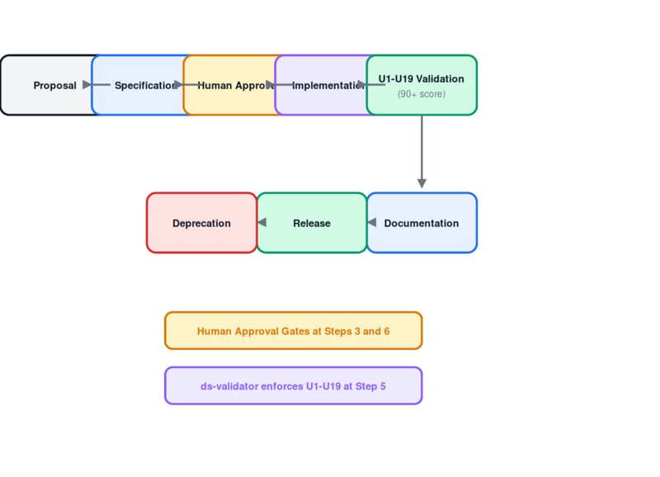
Figure 5: Governance Lifecycle

Interactive (U1-U6)
ID | Rule | What It Enforces
U1 | Dual hover selectors | Every :hover must have a matching .hover class for testing
U2 | Focus-visible ring | Every focusable element must show 2px ring with primary token
U3 | Disabled hover suppression | Disabled elements must not display hover feedback
U4 | Hover overlay pattern | Hover on filled surfaces must use ::before + currentColor + opacity
U5 | Compound input states | Inputs must define .error:hover, .focused.error, .disabled:hover explicitly
U6 | Box-shadow borders | Outlined borders must use box-shadow: inset, not CSS border

Text (U7-U9)
ID | Rule | What It Enforces
U7 | Explicit typography | Every text element must set font-family, font-size, color via tokens
U8 | Disabled color propagation | All child text must switch to --content-disabled when parent is disabled
U9 | Truncation trio | Overflow text must apply text-overflow + white-space + overflow together

Positioning (U10-U13)
ID | Rule | What It Enforces
U10 | Logical positioning | Never use left/right. Always use inset-inline-start/end
U11 | Logical border-radius | Never use physical border-radius. Use logical (start-start, etc.)
U12 | Logical spacing | Never use margin-left/right. Use inline-start/end variants
U13 | Logical text alignment | Never use text-align:left/right. Use start/end

Animation (U14)
ID | Rule | What It Enforces
U14 | Reduced motion | Animations must respect prefers-reduced-motion

Component (U15-U19)
ID | Rule | What It Enforces
U15 | No raw values | No hex, rgb(), or raw px. Only var() token references
U16 | Dynamic token panel | Token function must branch per emphasis and include state tokens
U17 | State class pattern | Components must define .hover, .focused, .error, .disabled classes
U18 | Wrapper state propagation | Input wrappers must cascade state to all children
U19 | RTL directional icons | Directional icons must mirror via [dir='rtl'] scaleX(-1)

10. Do and Don't Summary

Tokens
Do | Don't
var(--primary-filled-bg) | #1B6EF3 or rgb(27,110,243)
var(--space-4) for gaps | 16px or 1rem directly
var(--radius-md) for corners | border-radius: 8px
var(--motion-fast) for transitions | transition: 0.15s ease

Layout and Direction
Do | Don't
margin-inline-start / padding-inline-end | margin-left / padding-right
inset-inline-start: 15px | left: 16px + translateX(-50%)
text-align: start / end | text-align: left / right
border-start-start-radius | border-top-left-radius

Components
Do | Don't
DS class names as-is (ds-button) | Invent new ds- prefixed classes
Include all ARIA from render output | Strip ARIA for shorter markup
data-size, data-state for variants | Custom modifier classes
Nav Rail for desktop, Bottom Nav for mobile | Force Nav Rail into bottom bar
box-shadow: inset for outlined borders | CSS border that shifts layout on hover

11. Key Design Patterns
- State Layer: ::before + currentColor + opacity for hover/active feedback (U4)
- Density: compact | default | comfortable via data attribute on Card, Panel, Dialog, List, Accordion, Data Grid
- Color Roles: primary, danger, warning, success, neutral, ai across all status components
- Emphasis Scale: filled > tonal > outlined > ghost for visual weight
- Slot Architecture: header/content/footer slots in Card, Panel, Dialog
- Mobile Touch Model: hover=tap-reveal, tooltip=bottom-sheet, dropdown=full-screen, context-menu=long-press
- Box-Shadow Borders: inset box-shadow instead of CSS border to prevent layout shift (U6)
- Wrapper Propagation: Input wrappers cascade state to all children (U18)

12. Version History
Version | Date | Description
v1.0.0 | 2026-03-26 | Initial release. 42 components, dual-brand tokens, AG-UI protocol, 8 JSON registries, fluid typography, spring animations, streaming tokens, full RTL/a11y, 19 governance rules, 5 DS skills.

